Electronic supplemental material for

Predicting the zoonotic capacity of mammals to transmit SARS-CoV-2
Ilya R. Fischhoff, Adrian A. Castellanos, João P.G.L.M. Rodrigues, Arvind Varsani, Barbara A. Han
Proceedings of the Royal Society B
DOI: 10.1098/rspb.2021.1651

SUPPLEMENTARY TABLES
Supplementary Table 1. Species with confirmed suitability for SARS-CoV-2 infection from natural infections or in vivo experiments. Asterisks reference species with infection status from preprints (not yet peer-reviewed). Some species (e.g, dogs) with natural infection studies also have in vivo experimental studies.
Species | Susceptibility | Study type | Location | References
Cow  (Bos taurus) | Yes | In vivo experiment | Lab | Ulrich et al. 2020
Dog  (Canis lupus familiaris) | Yes | Natural infection | Multiple countries | Sit et al. 2020, USDA 2020,  OIE 2021, Shi et la. 2020, Hamer et al. 2021
African green monkey  (Chlorocebus aethiops) | Yes | In vivo experiment | Lab | Woolsey et al. 2020
Big brown bat  (Eptesicus fuscus) | No | In vivo experiment | Lab | Hall et al. 2020
Cat  (Felis catus) | Yes | Natural infection | Multiple countries | USDA 2020, OIE 2021,  Hamer et al. 2021,  Zhang et al. 2020
Gorilla  (Gorilla gorilla) | Yes | Natural infection | USA, Zoo | San Diego Zoo 2021
Crab-eating macaque  (Macaca fascicularis) | Yes | In vivo experiment | Lab | Rockx et al. 2020
Rhesus macaque  (Macaca mulatta) | Yes | In vivo experiment | Lab | Munster et al. 2020, Singh et al. 2021
Golden hamster  (Mesocricetus auratus) | Yes | In vivo experiment | Lab | Sia et al. 2020
House mouse  (Mus musculus) | No | In vivo experiment | Lab | Bao et al. 2020  (but see Montagutelli  et al. 2021)
Ferret  (Mustela putorius furo) | Yes | In vivo experiment | Lab | Shi et al. 2020
American mink  (Neovison vison) | Yes | Natural infection | Multiple countries | Shi et al. 2020, OIE et al. 2021, Oreshkova et al. 2020
Raccoon dog  (Nyctereutes procyonoides) | Yes | In vivo experiment | Lab | Freuling et al. 2020
European rabbit  (Oryctolagus cuniculus) | Yes | In vivo experiment | Lab | Mykytyn et al. 2021
Lion  (Panthera leo) | Yes | Natural infection | Multiple countries, Zoos | OIE 2021, Bartlett et al. 2021
Tiger  (Panthera tigris) | Yes | Natural infection | USA and Sweden, Zoos | USDA 2020, OIE 2021, Bartlett et al. 2021, Wang et al. 2020
Deer mouse  (Peromyscus maniculatus)* | Yes | In vivo experiment | Lab | Fagre et al. 2021, Griffin et al. 2021
Cougar  (Puma concolor) | Yes | Natural infection | South Africa, Zoo | OIE 2021
Egyptian fruit bat  (Rousettus aegyptiacus) | Yes | In vivo experiment | Lab | Schlottau et al. 2020
Pig  (Sus scrofa) | No | In vivo experiment | Lab | Shi et al. 2020, Schlottau et al. 2020
Northern treeshrew  (Tupaia belangeri) | Yes | In vivo experiment | Lab | Zhao et al. 2020
Snow leopard  (Uncia uncia) | Yes | Natural infection | USA, Zoo | Louisville Zoo 2020
Bank vole  (Clethrionomys glareolus) | Yes | In vivo experiment | Lab | Ulrich et al. 2021
Asian small-clawed otter  (Aonyx cinereus) | Yes | Natural infection | USA, Zoo | OIE 2021, Georgia Aquarium 2021
White-tailed deer  (Odocoileus virginianus)* | Yes | In vivo experiment | Lab | Palmer et al. 2021
Striped skunk  (Mephitis mephitis) | Yes | In vivo experiment | Lab | Bosco-Lauth et al. 2021
Raccoon  (Procyon lotor) | No | In vivo experiment | Lab | Bosco-Lauth et al. 2021
Wyoming ground squirrel  (Urocitellus elegans) | No | In vivo experiment | Lab | Bosco-Lauth et al. 2021
Fox squirrel  (Sciurus niger) | No | In vivo experiment | Lab | Bosco-Lauth et al. 2021
Bushy-tailed woodrat  (Neotoma cinerea) | Yes | In vivo experiment | Lab | Bosco-Lauth et al. 2021
Campbell’s dwarf hamster  (Phodopus campbelli) | Yes | In vivo experiment | Lab | Trimpert et al. 2020
Roborovski hamster  (Phodopus roborovskii) | Yes | In vivo experiment | Lab | Trimpert et al. 2020
Winter white dwarf hamster  (Phodopus sungorus) | Yes | In vivo experiment | Lab | Trimpert et al. 2020
Common marmoset (Callithrix jacchus) | Yes | In vivo experiment | Lab | Singh et al. 2021
Hamadryas baboon  (Papio hamadryas) | Yes | In vivo experiment | Lab | Singh et al. 2021

References for supplementary table 1.
Bao L et al. 2020 The pathogenicity of SARS-CoV-2 in hACE2 transgenic mice. Nature 583, 830–833. (doi:10.1038/s41586-020-2312-y)
Bartlett SL et al. 2021 SARS-CoV-2 infection and longitudinal fecal screening in Malayan tigers (Panthera tigris jacksoni), Amur tigers (Panthera tigris altaica), and African lions (Panthera leo krugeri) at the Bronx Zoo, New York, USA. J. Zoo Wildl. Med. 51, 733–744. (doi:10.1638/2020-0171)
Bosco-Lauth AM et al. 2021 Peridomestic mammal susceptibility to severe acute respiratory syndrome coronavirus 2 infection. Emerging Infectious Diseases 27, 2073-2080. (doi: 10.3201/eid2708.210180)
Fagre A et al. 2021 SARS-CoV-2 infection, neuropathogenesis and transmission among deer mice: Implications for spillback to New World rodents. PLoS Pathog. 17, e1009585. (doi:10.1371/journal.ppat.1009585)
Freuling CM et al. 2020 Susceptibility of Raccoon Dogs for Experimental SARS-CoV-2 Infection. Emerg. Infect. Dis. 26, 2982–2985. (doi:10.3201/eid2612.203733)
Georgia Aquarium. In press. Asian Small-Clawed Otters at Georgia Aquarium Test Positive for COVID-19. See http://news.georgiaaquarium.org/stories/releases-20210418 (accessed on 13 May 2021).
Griffin BD et al. 2021 SARS-CoV-2 infection and transmission in the North American deer mouse. Nat. Commun. 12, 3612. (doi:10.1038/s41467-021-23848-9)
Hall JS et al. 2020 Experimental challenge of a North American bat species, big brown bat (Eptesicus fuscus), with SARS-CoV-2. Transbound. Emerg. Dis. (doi:10.1111/tbed.13949)
Hamer SA et al. 2021 SARS-CoV-2 Infections and Viral Isolations among Serially Tested Cats and Dogs in Households with Infected Owners in Texas, USA. Viruses 13. (doi:10.3390/v13050938)
Louisville Zoo. 2020 Louisville Zoo Female Snow Leopard Tests Positive for SARS-CoV-2. See https://louisvillezoo.org/louisville-zoo-female-snow-leopard-tests-positive-for-sars-cov-2-media-release/ (accessed on 28 January 2021).
Montagutelli X et al. 2021 The B1.351 and P.1 variants extend SARS-CoV-2 host range to mice. bioRxiv. , 2021.03.18.436013. (doi:10.1101/2021.03.18.436013)
Munster VJ et al. 2020 Respiratory disease in rhesus macaques inoculated with SARS-CoV-2. Nature 585, 268–272. (doi:10.1038/s41586-020-2324-7)
Mykytyn AZ et al. 2021 Susceptibility of rabbits to SARS-CoV-2. Emerg. Microbes Infect. 10, 1–7. (doi:10.1080/22221751.2020.1868951)
OIE. 2021 Events in animals: OIE - World Organisation for Animal Health. See https://www.oie.int/en/scientific-expertise/specific-information-and-recommendations/questions-and-answers-on-2019novel-coronavirus/events-in-animals/ (accessed on 28 January 2021).
Oreshkova N et al. 2020 SARS-CoV-2 infection in farmed minks, the Netherlands, April and May 2020. Euro Surveill. 25. (doi:10.2807/1560-7917.ES.2020.25.23.2001005)
Palmer MV et al. 2021 Susceptibility of white-tailed deer (Odocoileus virginianus) to SARS-CoV-2. bioRxiv. , 2021.01.13.426628. (doi:10.1101/2021.01.13.426628)
Rockx B et al. 2020 Comparative pathogenesis of COVID-19, MERS, and SARS in a nonhuman primate model. Science 368, 1012–1015. (doi:10.1126/science.abb7314)
San Diego Zoo. 2021 Gorilla Troop at the San Diego Zoo Safari Park Test Positive for COVID-19. See https://zoo.sandiegozoo.org/pressroom/news-releases/gorilla-troop-san-diego-zoo-safari-park-test-positive-covid-19 (accessed on 28 January 2021).
Schlottau K et al. 2020 SARS-CoV-2 in fruit bats, ferrets, pigs, and chickens: an experimental transmission study. Lancet Microbe 1, e218–e225. (doi:10.1016/S2666-5247(20)30089-6)
Shi J et al. 2020 Susceptibility of ferrets, cats, dogs, and other domesticated animals to SARS-coronavirus 2. Science 368, 1016–1020. (doi:10.1126/science.abb7015)
Sia SF et al. 2020 Pathogenesis and transmission of SARS-CoV-2 in golden hamsters. Nature 583, 834–838. (doi:10.1038/s41586-020-2342-5)
Singh DK et al. 2021 Responses to acute infection with SARS-CoV-2 in the lungs of rhesus macaques, baboons and marmosets. Nature Microbiology 6, 73-86. (doi: 10.1038/s41564-020-00841-4)
Sit THC et al. 2020 Infection of dogs with SARS-CoV-2. Nature 586, 776–778. (doi:10.1038/s41586-020-2334-5)
Trimpert J et al. 2020 The Roborovski dwarf hamster is a highly susceptible model for a rapid and fatal course of SARS-CoV-2 infection. Cell Reports 33, 108488. (doi:10.1016/j.celrep.2020.108488)
Ulrich L, Wernike K, Hoffmann D, Mettenleiter TC, Beer M. 2020 Experimental Infection of Cattle with SARS-CoV-2. Emerg. Infect. Dis. 26, 2979–2981. (doi:10.3201/eid2612.203799)
Ulrich L, Michelitsch A, Halwe N, Wernike K, Hoffmann D, Beer M. 2021 Experimental SARS-CoV-2 Infection of Bank Voles. Emerg. Infect. Dis. 27, 1193–1195. (doi:10.3201/eid2704.204945)
USDA. 2020 Cases of SARS-CoV-2 in animals in the United States. See https://www.aphis.usda.gov/aphis/ourfocus/animalhealth/sa_one_health/sars-cov-2-animals-us (accessed on 12 January 2021).
Wang L et al. 2020 Complete Genome Sequence of SARS-CoV-2 in a Tiger from a U.S. Zoological Collection. Microbiol Resour Announc 9. (doi:10.1128/MRA.00468-20)
Woolsey C et al. 2020 Establishment of an African green monkey model for COVID-19. bioRxiv , 2020.05.17.100289. (doi:10.1101/2020.05.17.100289)
Zhang Q et al. 2020 SARS-CoV-2 neutralizing serum antibodies in cats: a serological investigation. , 2020.04.01.021196. (doi:10.1101/2020.04.01.021196)
Zhao Y et al. 2020 Susceptibility of tree shrew to SARS-CoV-2 infection. Sci. Rep. 10, 16007. (doi:10.1038/s41598-020-72563-w)

Supplementary table 2. Each row shows the code used in our data, a description of the trait from its source, the units of the trait (or whether it is a binary, count, or has multiple categories), the original source of these data, percent coverage for this trait across our compiled dataset for our vertebrate models (n = 297), percent coverage across our 126 mammal species with ACE2 sequences, and any additional notes. If a trait was not included in either of the vertebrate or mammal datasets, the coverage of this trait is designated by a “-“. Continuous data from Amniote Life History Database (ALHD) represent medians of the raw data, and data from AnAge are the mean value for a species. See PanTHERIA metadata for how central tendencies were calculated for each variable. Binary variables of taxonomic order (or classes of vertebrates for that dataset) are not included here but were also calculated with 100% coverage.
Trait code | Trait description | Units | Original source | Coverage vertebrates (%) | Coverage mammals (%) | Notes
ForStrat.ground | Forages on the ground (or inland waters) | binary | EltonTraits | 91.3 | - | Changed from percentage to a binary
ForStrat.understory | Forages below 2m in the forest | binary | EltonTraits | 89.9 | - | Changed from percentage to a binary
ForStrat.arboreal | Forages in trees | binary | EltonTraits | 90.6 | - | Changed from percentage to a binary
ForStrat.aerial | Forages above vegetation or structures | binary | EltonTraits | 91.3 | - | Changed from percentage to a binary
ForStrat.marine | Forages in open oceanic bodies | binary | EltonTraits | 91.3 | - | Changed from percentage to a binary
ForStrat_terrestrial | Forages in terrestrial habitats | binary | EltonTraits | - | 96.0 | Binary transformation of the sum of ForStrat categories ground, aerial, scansorial, and arboreal
ForStrat_aquatic | Forages in aquatic habitats (freshwater or marine) | binary | EltonTraits | - | 96.0 | Binary transformation of the sum of ForStrat categories ground (for aquatic mammals) and marine
Activity.Nocturnal | Active during the night | binary | EltonTraits | 64.3 | 96.0
Activity.Crepuscular | Active during twilight | binary | EltonTraits | 63.9 | 96.0
Activity.Diurnal | Active during the day | binary | EltonTraits | 63.9 | 96.0
femal_maturity_d | Time to maturity - females | days | ALHD | 55.2 | 81.8
male_maturity_d | Time to maturity - males | days | ALHD | 46.6 | 67.5
weaning_d | Weaning duration | days | ALHD | 37.5 | 83.3
development_d | Gestation/incubation time | days | ALHD | 57.4 | 84.1 | Created from the mean of gestation time (days) and incubation time (days)
log_litterclutch_size_n | Size of litter/clutch | count | ALHD | 68.6 | 93.7 | Log transformed
litters_or_clutches_per_y | Number of litters/clutches in a year | count | ALHD | 55.2 | 81.8
log _inter_litterbirth_interval_y | Time between litters/clutches | years | ALHD | 34.7 | 71.4 | Log transformed
log_birthhatching_weight_g | Weight at birth/hatching | g | ALHD | 51.6 | 84.1 | Log transformed
log_weaning_weight_g | Weight at weaning | g | ALHD | 26.0 | 57.9 | Log transformed
log_adult_body_mass_g | Body mass of an adult | g | ALHD | 78.7 | 96.8 | Log transformed
infantMortalityRate_per_year | Infant mortality rate | count | AnAge | 4.3 | 7.1
mortalityRateDoublingTime_y | Mortality rate doubling time | years | AnAge | 4.7 | 7.9
metabolicRate_W | Basal metabolic rate | W | AnAge | 21.3 | 38.9
temperature_K | Typical body temperature | K | AnAge | 24.9 | 51.6
longevity_y | Mean longevity | years | ALHD | 67.5 | 90.5 | For records with no information, used the value for maximum longevity in years
log_female_body_mass_g | Body mass of a female | g | ALHD | 27.1 | 17.5 | Log transformed
log_male_body_mass_g | Body mass of a male | g | ALHD | 34.7 | 41.3 | Log transformed
adult_svl_cm | Snout vent length of adults | cm | ALHD | 55.2 | 87.3
diet_breadth | Percentage of diet categories | count | EltonTraits, FishBase | 82.3 | 96.0
tnc_ecoregion_breadth | Percentage of ecoregions covered by a species | count | This study | 89.2 | 88.1
mass_specific_production | Mass specific production |  | This study | 46.9 | 77.8 | Calculated from a formula by Hamilton et al. 2010
log_range_size | Range size | km² | This study | 89.5 | 88.1 | Log transformed
AA_83_y | Residue at ACE2 position 83 is a Y (Tyrosine) | binary | This study | 99.6 | 100
AA_30_negative | Residue at ACE2 position 30 is negatively charged | binary | This study | 100 | 100
log_WOS_hits_synonyms | Number of publications queried by a Web of Science topic (title and abstract) search for a species, including synonyms based on GBIF backbone | count | This study | 100 | 100 | Log transformed
X2.1_AgeatEyeOpening_d | Age at first eye opening | days | PanTHERIA | - | 31.0
X9.1_GestationLen_d | Gestation length | days | PanTHERIA | - | 77.8
X10.2_SocialGrpSize | Social group size | count | PanTHERIA | - | 34.9
X24.1_TeatNumber | Number of teats present | count | PanTHERIA | - | 23.8
X6.2_TrophicLevel | Trophic level determined based on any dietary information | categorical (1, 2, 3) | PanTHERIA | - | 76.2
X13.3_WeaningHeadBodyLen_mm | Head and body length at weaning | mm | PanTHERIA | - | 4
X26.2_GR_MaxLat_dd | Maximum latitude of range | decimal degrees | PanTHERIA | - | 74.6
X26.3_GR_MinLat_dd | Minimum latitude of range | decimal degrees | PanTHERIA | - | 74.6
X26.4_GR_MidRangeLat_dd | Median latitude of range | decimal degrees | PanTHERIA | - | 74.6
X26.5_GR_MaxLong_dd | Maximum longitude of range | decimal degrees | PanTHERIA | - | 74.6
X26.6_GR_MinLong_dd | Minimum longitude of range | decimal degrees | PanTHERIA | - | 74.6
X26.7_GR_MidRangeLong_dd | Median longitude of range | decimal degrees | PanTHERIA | - | 74.6
X27.4_HuPopDen_Change | Mean rate of increase of human population density within the species range | count | PanTHERIA | - | 74.6
X28.1_Precip_Mean_mm | Mean monthly precipitation within the species range | mm | PanTHERIA | - | 74.6
X28.2_Temp_Mean_01degC | Mean monthly temperature within the species range | Celsius | PanTHERIA | - | 74.6
X30.1_AET_Mean_mm | Mean monthly actual evapotranspiration rate within the species range | mm | PanTHERIA | - | 74.6
X30.2_PET_Mean_mm | Mean monthly potential evapotranspiration rate within the species range | mm | PanTHERIA | - | 74.6
log_DispersalAge_d | Age at which young leave parent or social group | days | PanTHERIA | - | 16.7 | Log transformed
log_HomeRange_km2 | Size of home range of individuals or groups | km² | PanTHERIA | - | 50.0 | Log transformed
log_HomeRange_Indiv_km2 | Size of home range of individuals | km² | PanTHERIA | - | 39.7 | Log transformed
log_PopulationDensity_n.km2 | Number of individuals within 1 km² | individuals/km² | PanTHERIA | - | 55.6 | Log transformed
log_PopulationGrpSize | Number of individuals within a group | count | PanTHERIA | - | 26.2 | Log transformed
log_HuPopDen_Min_n.km2 | Minimum human population density within the species range | individuals/km² | PanTHERIA | - | 30.2 | Log transformed
log_HuPopDen_Mean_n.km2 | Mean human population density within the species range | individuals/km² | PanTHERIA | - | 74.6 | Log transformed
log_HuPopDen_5p_n.km2 | 5th percentile of human population density within the species range | individuals/km² | PanTHERIA | - | 50.0 | Log transformed
log_NeonateHeadBodyLen_mm | Length from nose to base of the tail of recently birthed infants or near term embryos | mm | PanTHERIA | - | 15.1 | Log transformed

Supplementary Table 3. The various models (continuous binding strength, as measured by HADDOCK score, and the classification of zoonotic capacity or AA30 charge) run for our two datasets (297 vertebrates and 126 mammals) with all associated parameters and evaluation statistics given. Zoonotic capacity is binary and defined by a threshold of binding strength above which it is more likely that both infection and onward transmission will occur based on results of in vivo studies across multiple species. The column “Wild/non-wild” refers to how we dealt with domesticated species in our dataset, either by removing them or including a binary variable on the designation of the species. Parameters used in grid search included learning rate (ETA), max depth, and number of minimum observations in each node. For each bootstrap run of 10 iterations, or 50 iterations for the mammal zoonotic capacity models, we recorded the average number of trees, and the training and the test evaluation statistic (AUC or pseudo-R²). Corrected test AUC or pseudo-R² were calculated using the mean test statistic from an equal number of iterations of a null model. The model that we primarily refer to in the main text is marked with an asterisk.
Dataset | Model | Wild/non- wild | Parameters |  |  | Evaluation
 |  |  | ETA | Max depth | Min obs. in node | Trees | Training eval. | Test eval. | Null test eval. | Corrected eval. | Evaluation statistic
Vertebrates | Binding strength | NA | 0.0001 | 4 | 5 | 36,268 | 0.680 | 0.372 | -0.010 | 0.362 | Pseudo-R²
Vertebrates | Zoonotic capacity | NA | 0.0001 | 2 | 2 | 59,610 | 0.977 | 0.855 | 0.571 | 0.784 | AUC
Vertebrates | AA30 | NA | 0.0001 | 2 | 4 | 46,176 | 0.972 | 0.868 | 0.575 | 0.793 | AUC
Mammals | Binding strength | Removed | 0.0001 | 4 | 3 | 26,889 | 0.754 | 0.157 | -0.048 | 0.109 | Pseudo-R²
Mammals* | Zoonotic capacity | Removed | 0.0001 | 2 | 5 | 44,652 | 0.997 | 0.843 | 0.618 | 0.725 | AUC
Mammals | Zoonotic capacity | Variable | 0.0001 | 2 | 5 | 42,093 | 0.993 | 0.789 | 0.589 | 0.699 | AUC
Mammals | AA30 | Removed | 0.0001 | 2 | 2 | 29,040 | 1.000 | 0.963 | 0.607 | 0.856 | AUC

SUPPLEMENTARY FIGURES
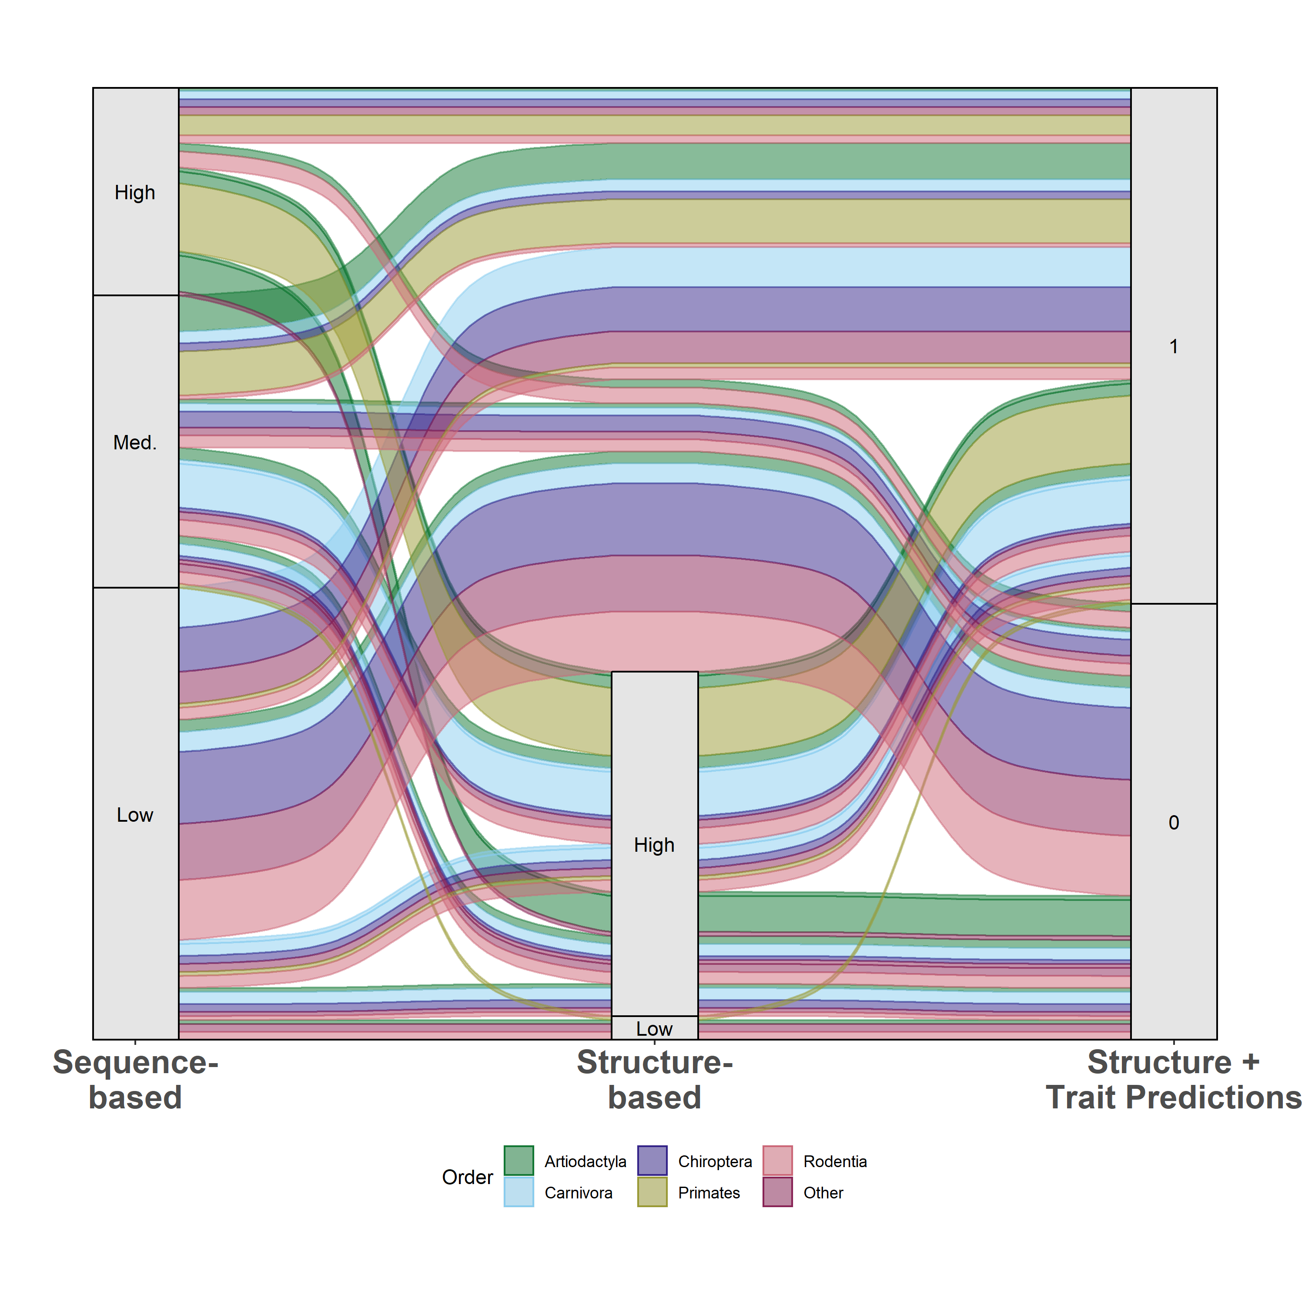
Supplementary Figure 1. An alluvial plot comparing predictions of species susceptibility from multiple methods. Existing studies (listed in Supplementary Methods) are categorized as either sequence-based or structure-based. Predictions from our zoonotic capacity model result from combining structure-based modeling of viral binding with organismal traits using machine learning to distinguish species with zoonotic capacity above (1) or below (0) a conservative threshold value set by domestic cats (Felis catus). Colors represent unique mammalian orders, and the width of colored bands represent the relative number of species with that combination of predictions across methods. See Supplementary Methods for details on how species across multiple studies were assigned to categories (high, medium, low).

Results from supplementary Figure 1
Our model combined species traits with estimates of viral binding strength to predict zoonotic capacity, which encompasses both susceptibility to SARS-CoV-2 and the probability of onward transmission. Zoonotic capacity was defined as a threshold value based on the results of experimental studies confirming intraspecific transmission among animals, and is therefore more conservative than thresholds adopted by other studies (e.g., those based only on estimates of viral binding strength). In addition, our modeling approach (machine learning) and prediction targets (zoonotic capacity) differed compared to existing computational approaches, which applied sequence-based or structure-based analyses constrained by the small number of published ACE2 sequences. Despite these differences, comparing the species predictions generated by multiple different approaches can be useful for gauging consensus, and for comparing how species predictions change from one method to another.

Across approaches, there was general agreement in the predictions for primates as well as for a select group of artiodactyls and carnivores (Supplementary Figure 1). Our model results also agreed with low susceptibility predictions made by several previous studies using sequence-based approaches (e.g., in certain bats and rodents). In general, we note that structure-based models predicted a smaller proportion of species to have low susceptibility compared to sequence-based studies.

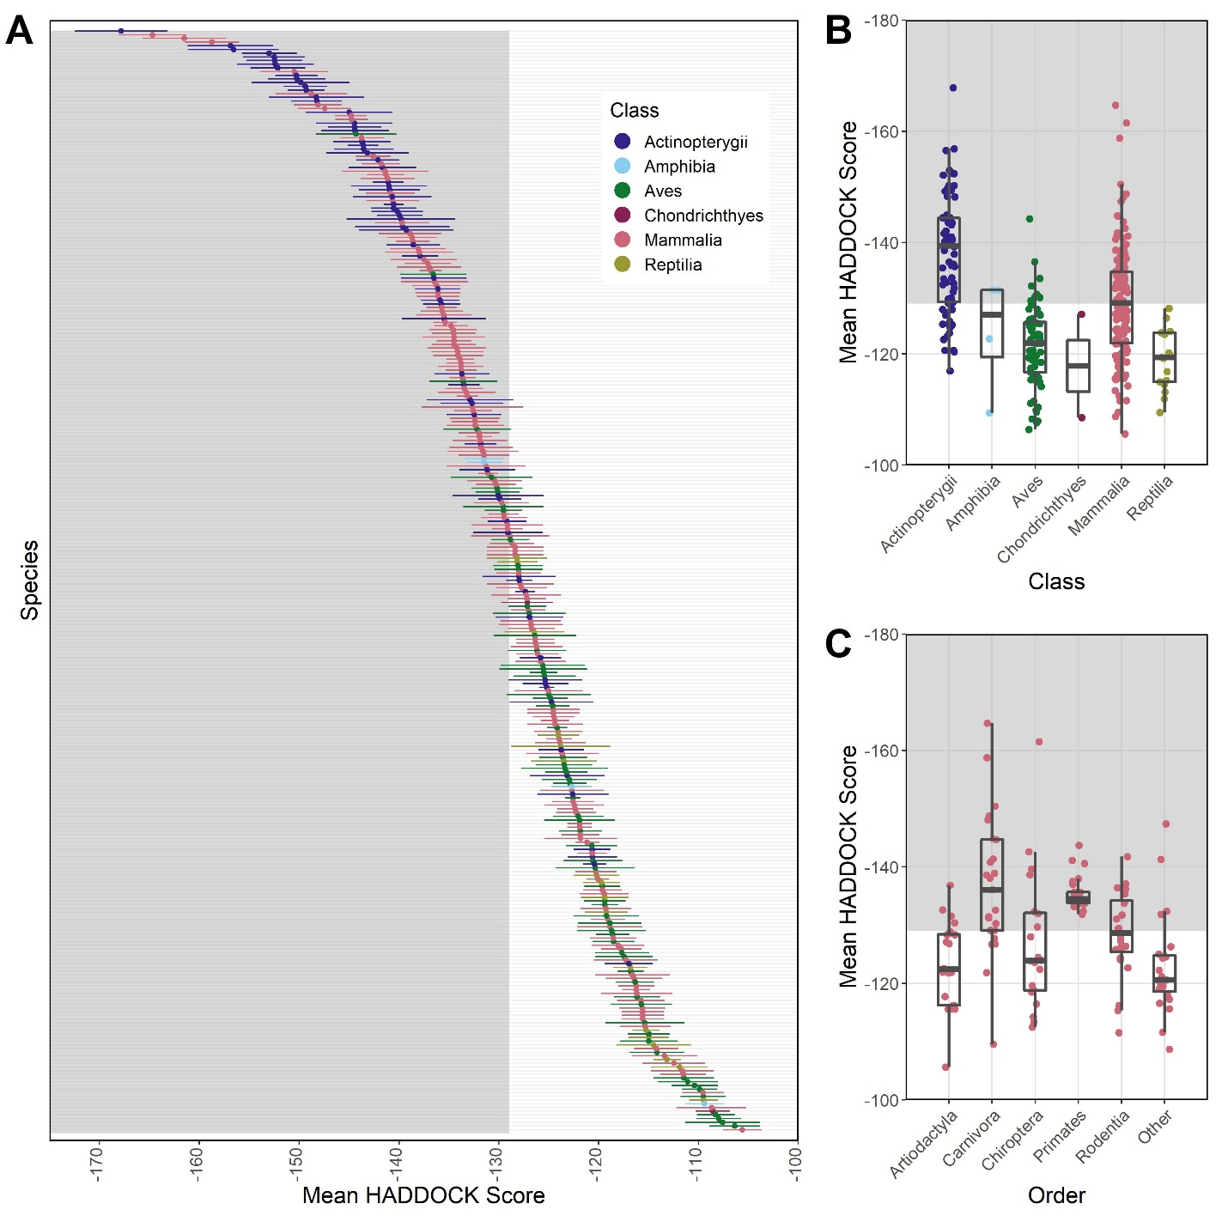
Supplementary Figure 2. Plots showing results from modeling species’ ACE2 interaction with SARS-CoV-2 RBD using HADDOCK to predict binding strength (measured as arbitrary units). HADDOCK scores that predict stronger binding are more negative. The mean and standard deviation of the HADDOCK score for vertebrate species (A) for which ACE2 orthologs are available. Binding strengths vary across vertebrate classes (B) and across the five most speciose mammalian orders (C). The “Other” category contains species across multiple orders for which ACE2 sequences were available, each with fewer than 10 representative species in the order. The shaded regions of all panels represent predicted binding that is as strong or stronger than (more negative values than) the domestic cat (Felis catus), which represents our conservative zoonotic capacity threshold based on currently available empirical evidence.
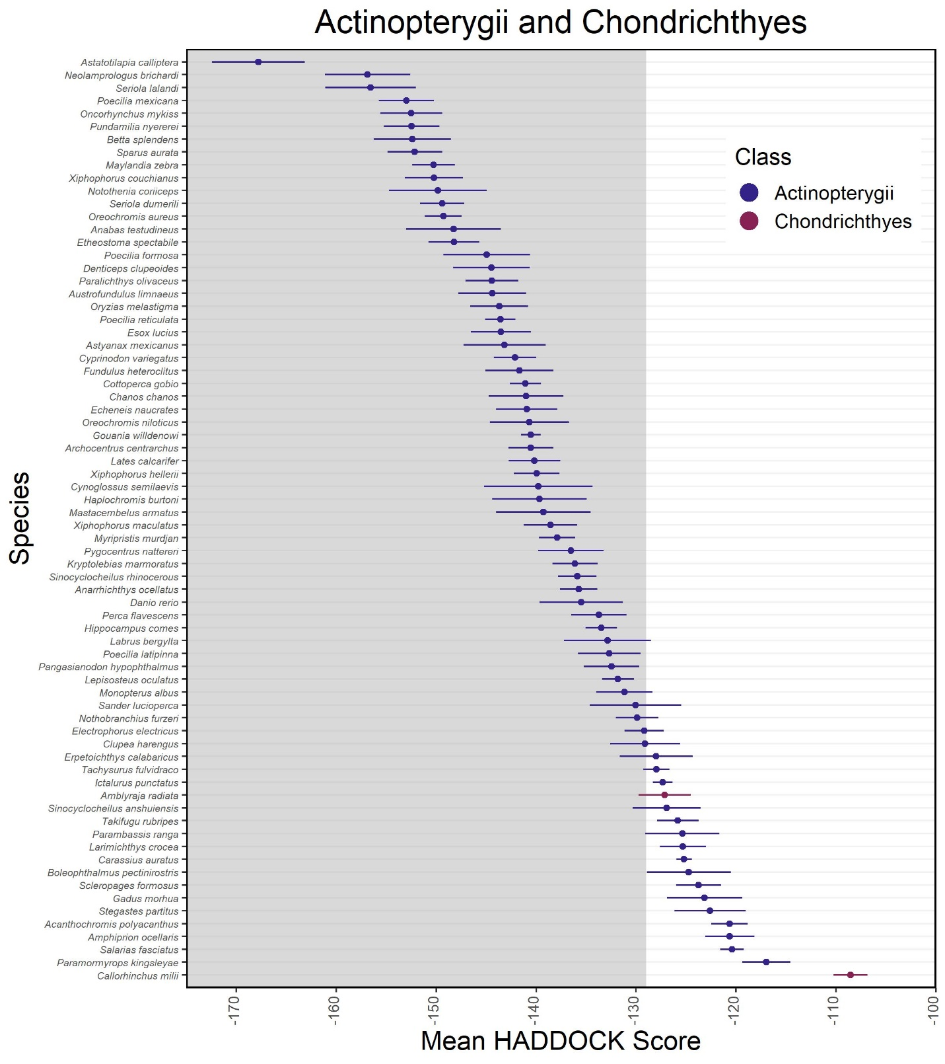
Supplementary Figure 3.. Mean HADDOCK scores (points) and their standard deviations (errorbar) for Actinopterygii and Chondrichthyes.
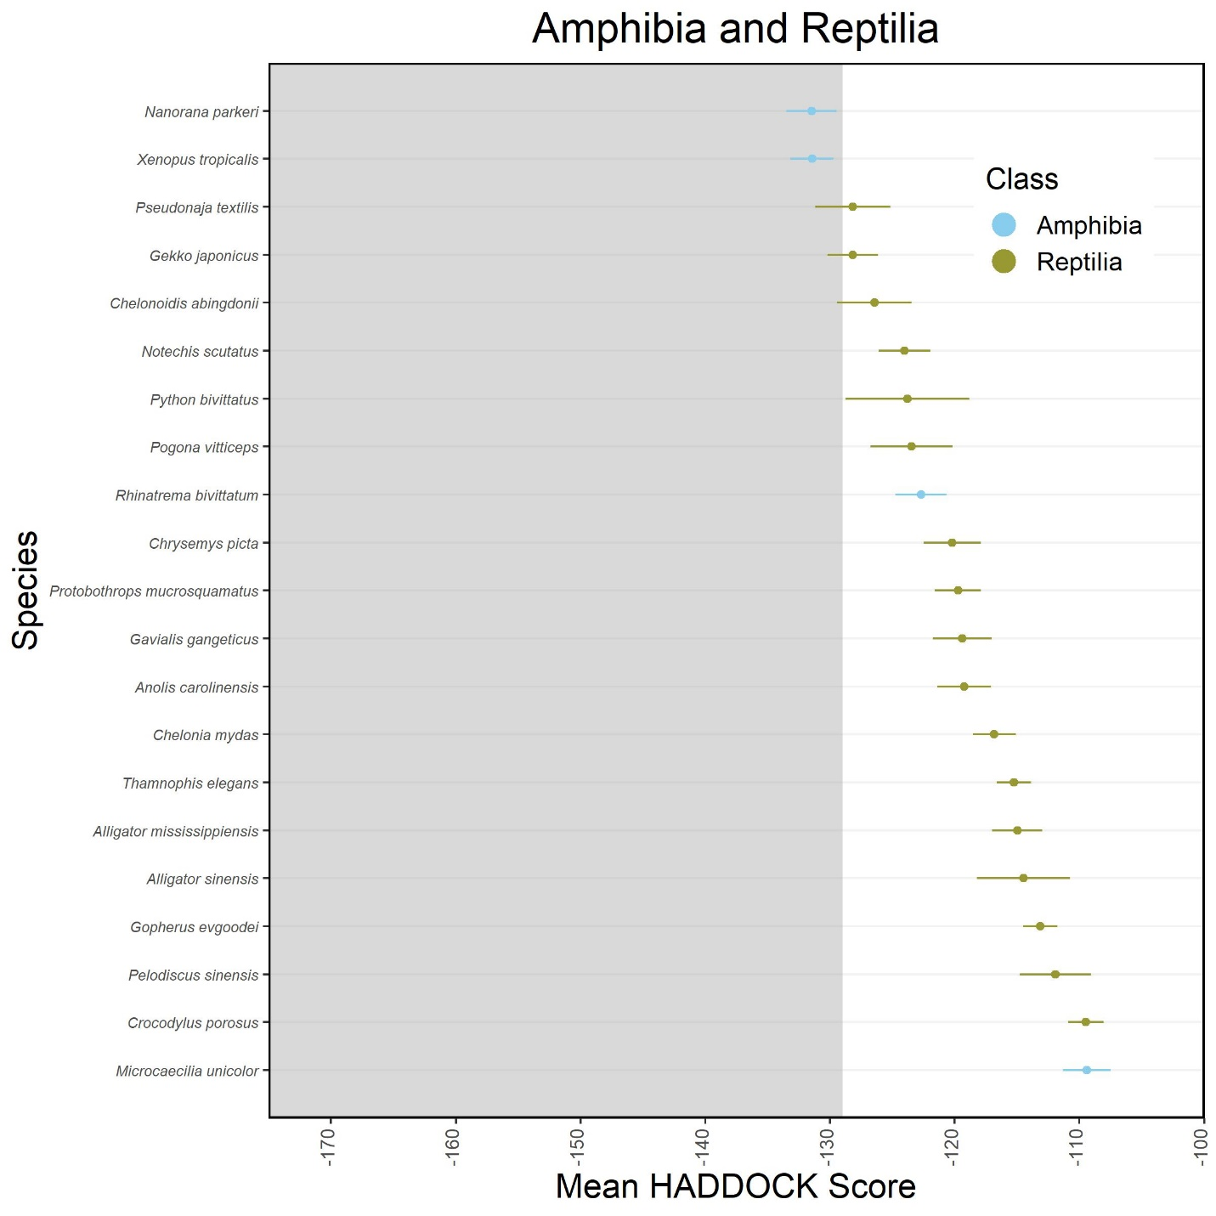
Supplementary Figure 4.. Mean HADDOCK scores (points) and their standard deviations (errorbar) for Amphibia and Reptilia.
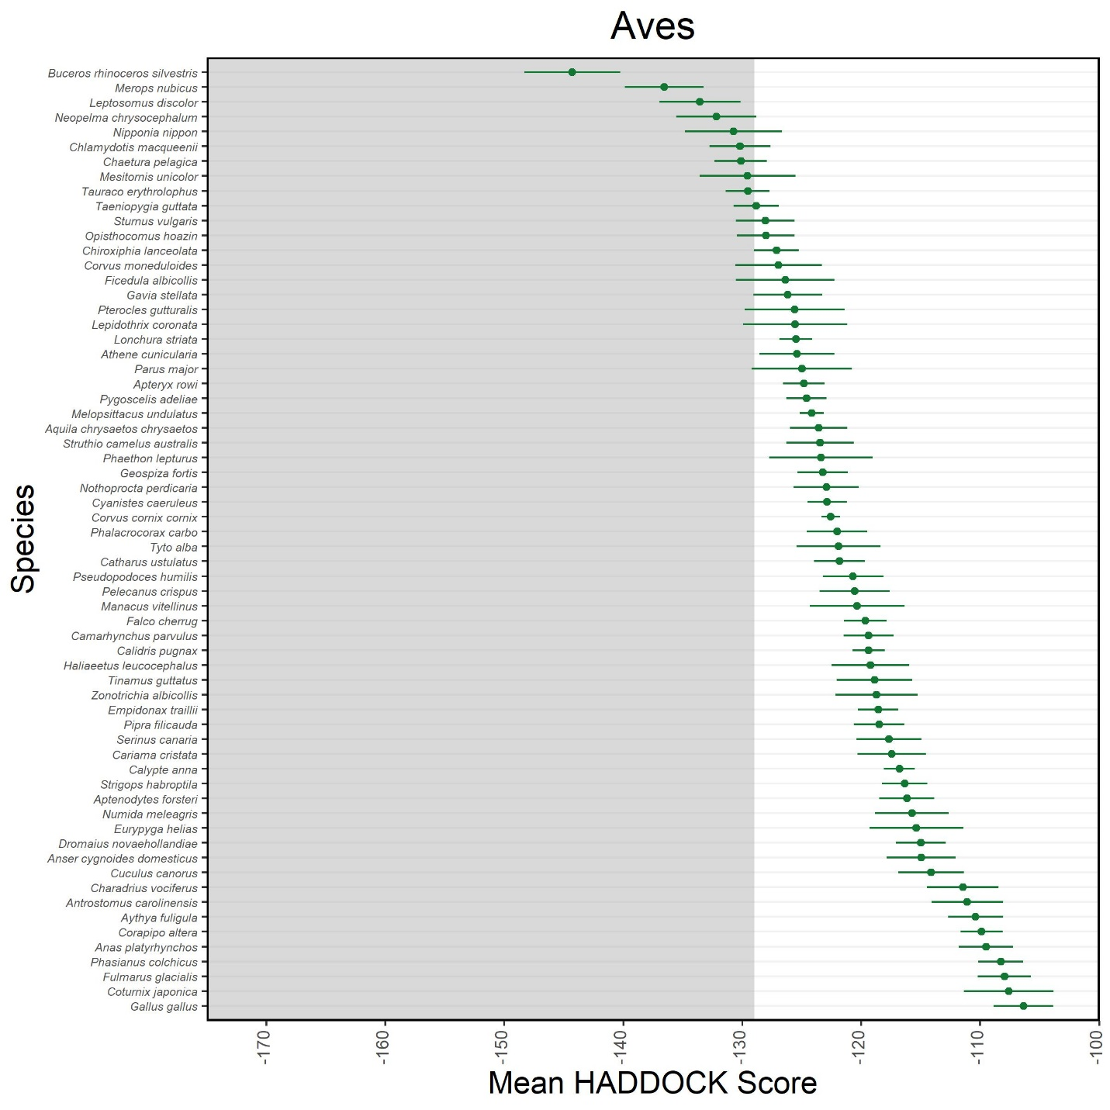
Supplementary Figure 5.. Mean HADDOCK scores (points) and their standard deviations (errorbar) for Aves.
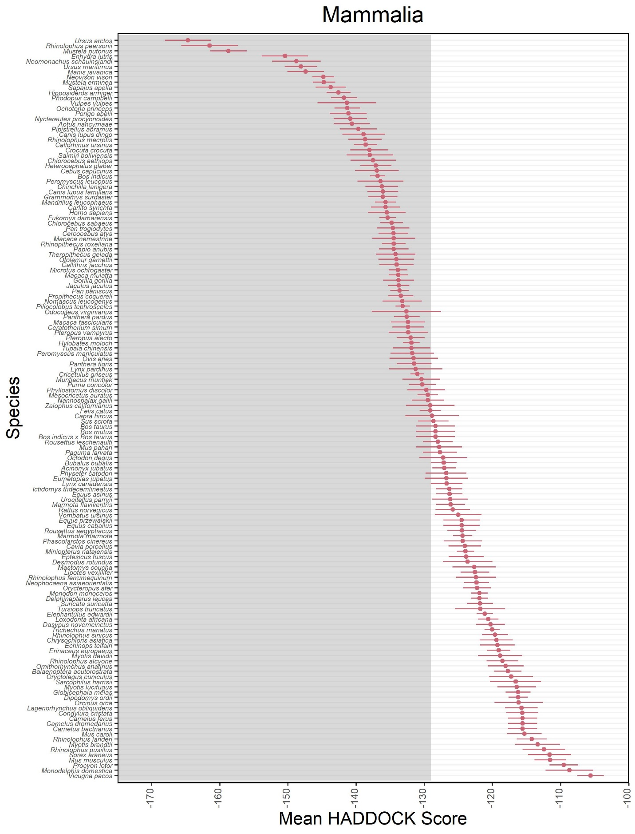
Supplementary Figure 6. Mean HADDOCK scores (points) and their standard deviations (errorbar) for Mammalia.
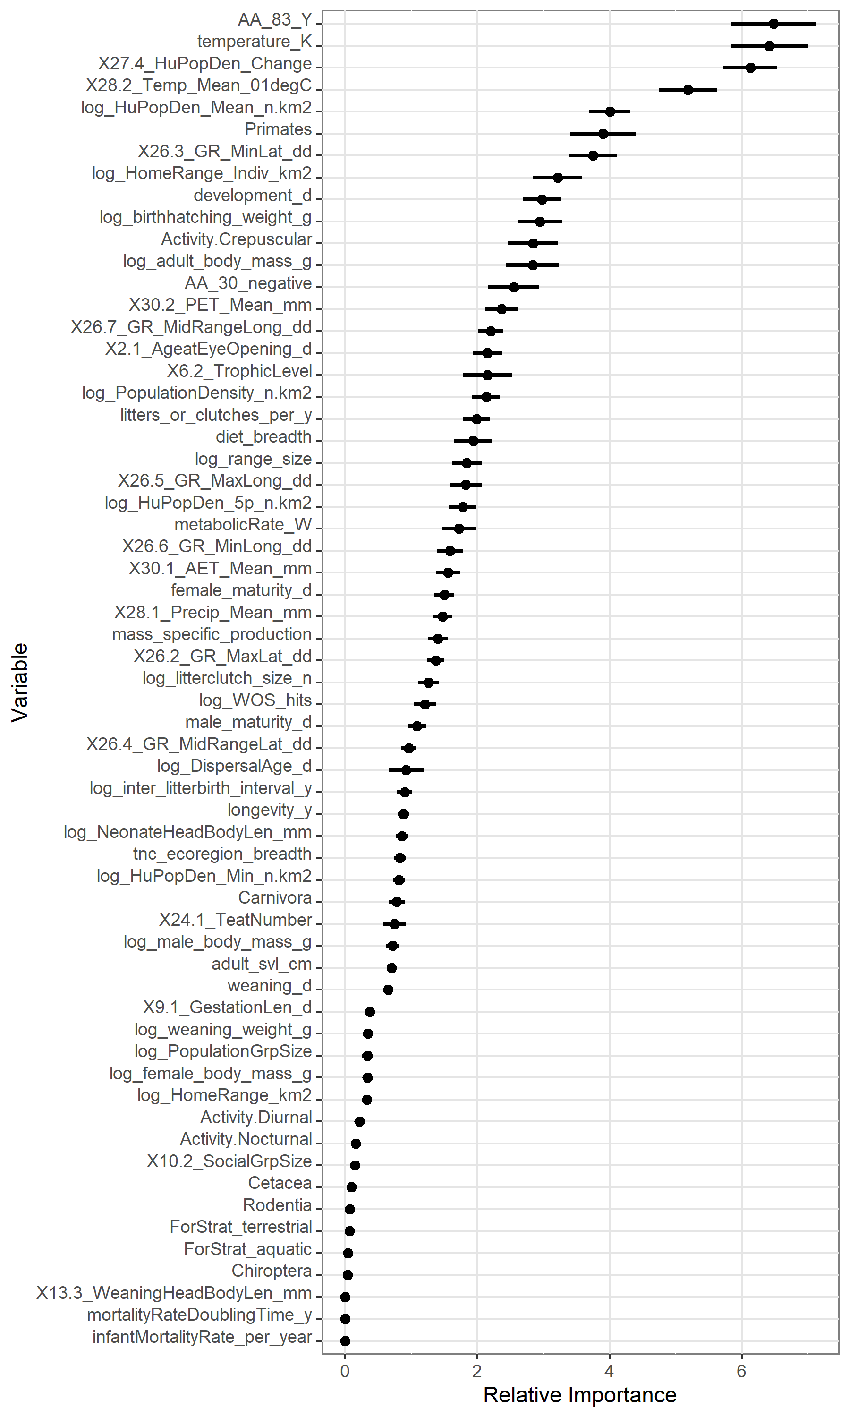
Supplementary Figure 7. Relative importance scores for our 50 bootstrap iterations of the mammal zoonotic capacity model. Variable names are shown on the y-axis and relative importance score is shown on the x-axis. For each variable, the point represents the mean value and the line represents the 95% confidence interval.

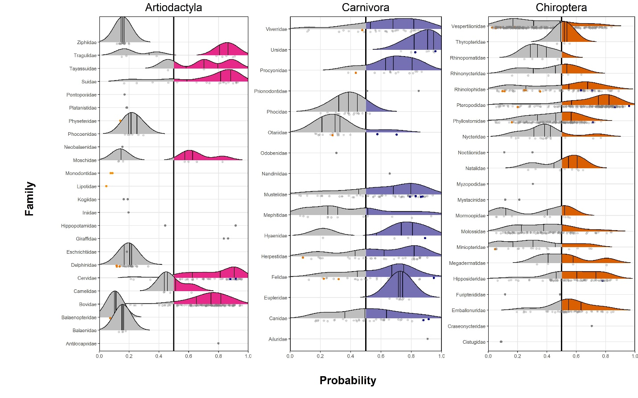
Supplementary Figure 8. Distribution of predictions by family for artiodactyls, carnivores, and chiropterans.
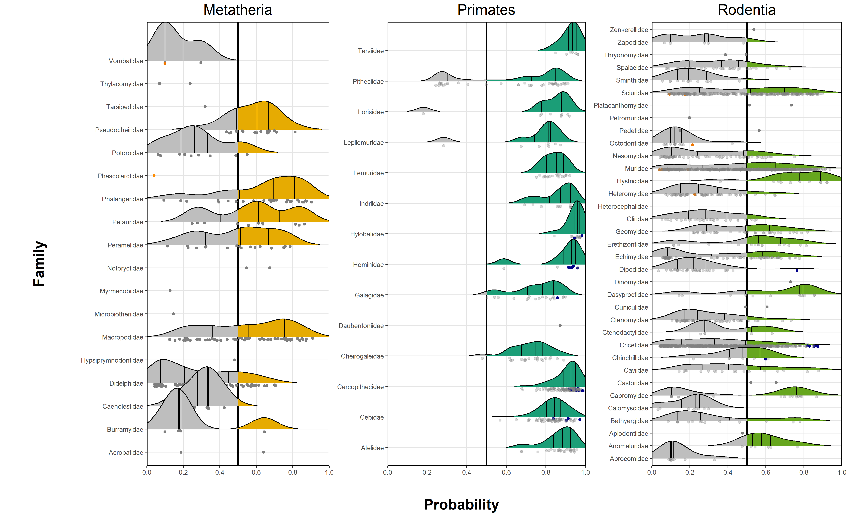
Supplementary Figure 9. Distribution of predictions by family for metatherians, primates, and rodents.
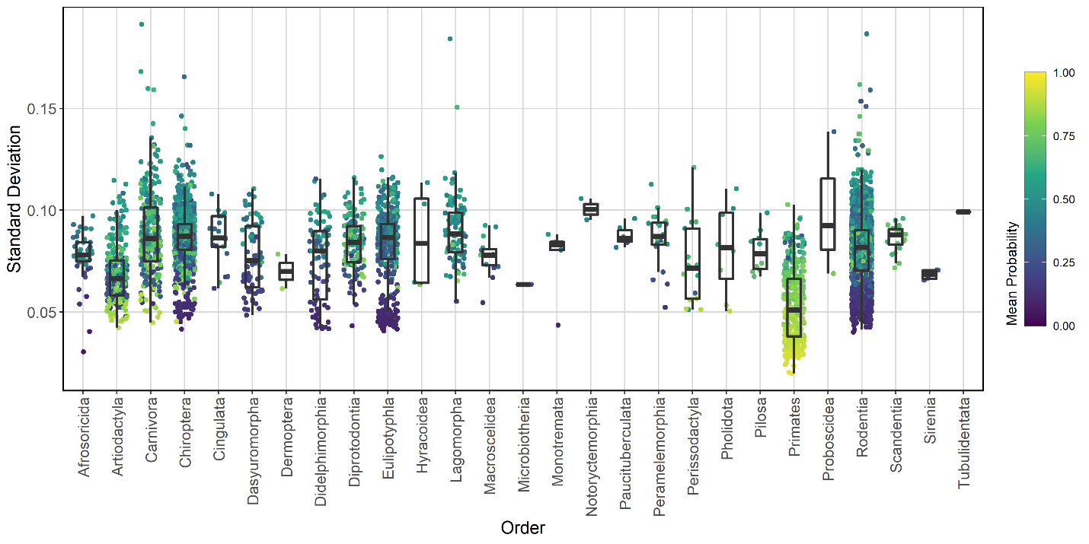
Supplementary Figure 10. Standard deviation of predicted zoonotic capacity probability for our 50 bootstrap iterations. Species are grouped by order with color representing the average zoonotic capacity probability score (warmer colors represent higher scores, indicating higher predicted zoonotic capacity, cooler represent lower scores).

