Supplementary Material - Airborne quantification of net methane and carbon dioxide fluxes from European Arctic wetlands in Summer 2019

CH₄ isotope analysis

In order to confirm the wetland origin of the methane emissions sampled during flight C195, δ¹³C-CH₄ isotopic ratios were calculated from Whole air samples (WAS) collected from the aircraft across flights C195 and C196. Flight C196 also surveyed the same region of Fennoscandian wetland as C195, but CH₄/CO₂ mole fraction gradients were unsuitable for mass balance flux quantification. WAS were collected onboard the aircraft in 3L silica passivated stainless steel canisters (Thames Restek, UK). Sample collection was triggered manually to sample within the boundary layer, guided by the real time methane measurements from the FGGA onboard. Fill times ranged between 10 and 20 seconds depending on sampling altitude, representative of an integrated air sample over a 1 - 2 km track. Methane mole fraction in the WAS flasks was measured in the Royal Holloway greenhouse gas laboratory using a Picarro 1301 cavity ringdown spectroscopy analyser, and δ¹³C ratio analysis was carried out by gas chromatography – isotope ratio mass spectrometry using a Trace Gas preconcentrator and Isoprime mass spectrometer (see Fisher et al. for details of the technique (1)). A Keeling plot analysis of the WAS canister methane and δ¹³C is shown in supplementary figure 1. The intercept and hence δ¹³C source signature of -73 ± 6.6 ‰ is comparable to previous methane isotope measurements from similar study regions. Fisher et al. found a δ¹³C source signature of -71 ± 1 ‰ for Finnish and Swedish peatlands compiled from aircraft samples, groundbased sampling, and chamber measurements (2). Sriskantharajah et al. conducted groundbased Tedlar bag sampling in Finnish subarctic peatlands and found a δ¹³C source signature of -68.5 ± 0.7 ‰ (3). The δ¹³C signature from WAS during this study therefore strongly indicates that the methane emissions originated from a wetland source.

CH₄ flux upscaling
The meridional gradient in fluxes with differing wetland area allows for tentative but limited upscaling the fluxes to a wider area of northern European wetlands for July 2019, assuming that they are representative of analogous land classifications. It is not possible to extrapolate for a longer time period as emissions would be expected to change much more significantly over an annual cycle. Supplementary fig. 4 shows a linear least-squares regression of bulk methane flux vs total wetland area within each of the three flux areas, forced through zero. It can be seen that the relationship between bulk flux and wetland area is broadly linear (R² of 0.85). Using this relationship fluxes obtained for this specific area have been extrapolated to a wider regional area. A similar regression analysis was attempted for CO₂ sink vs total area of vegetated CORINE land-classes (see supplementary fig. 5). However the linear correlation coefficient was not as strong for the CO₂ regression (R² = 0.33). Furthermore, upscaling the CO₂ sink to a wider area would assume that all area-normalised vegetation land classes (e.g. forest and agricultural land) will represent the same CO₂ sink, which would be an inaccurate assumption, so CO₂ sink extrapolations are not reported in this work. For CH₄, Barthelmes et al. provides an estimate of 249,066 km² total peatland area for multiple northern European countries, including Sweden, Finland, Norway, Denmark, Iceland, Greenland, Estonia, Latvia, Lithuania, and selected limited areas of northwest Russia. This comprises the land area approximately between 4° E and 32° E longitude and 54° N and 72° N latitude (4). Substituting the Barthelmes et al. peatland area value into the linear regression equation yields a total emission of 1.009 ± 0.052 Tg CH₄ emitted for the region in July 2019. The upscaling carried out here relies on a few key assumptions. Firstly, this method assumes that the area methane flux from all areas of peatland across the entirety of northern Europe are constant, and that there will be negligible variability in methane fluxes from different areas of peatland. This may be inaccurate as surface temperature will inevitably be different across the entire upscaled region, leading to likely differences in methane flux from areas of peatland. The second assumption is that peatland is the only land type that is emitting methane during this time. Despite peatland likely being the major methane-emitting land type, this may be oversimplified. However, this simple extrapolation provides a useful first order estimate of the regional flux in summer that may inform future model and measurement studies attempting to place Arctic terrestrial carbon sources in a global context.
N₂O flux threshold
A direct flux of N₂O could not be calculated in this work, as there was no observable concentration enhancement downwind of the wetland area. Despite this, an N₂O flux ‘limit of detection’ can be calculated using the mean concentration along the northernmost transect as a background, and knowledge of the instrument uncertainty which can prescribe a maximum possible enhancement within measurement error. This gives a limit of detection for flux that represents the lowest possible statistically significant N₂O flux that can be calculated using the in-flight QCLAS data with the current measurement uncertainty. This also represents a maximum possible upper limit on N2O flux from the study region. This limit of detection for N₂O flux was calculated as 0.726 mg m⁻² h⁻¹, which is noted to be higher than N₂O fluxes in the range of 0.023 – 0.58 mg m⁻² h⁻¹ previously measured from arctic peatlands (5, 6). Hence it is unlikely that statistically significant Arctic fluxes of N₂O can be calculated using the aircraft mass balance method with the QCLAS instrument given its current N₂O measurement uncertainty. This limit may be useful guidance to others attempting similar studies with analogous QCLAS aircraft systems.
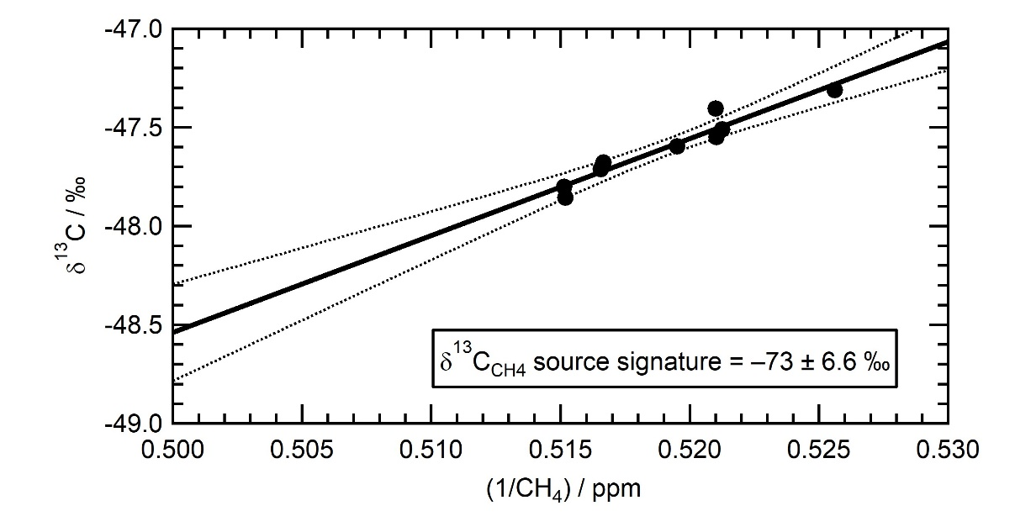

Supplementary Figure 1: Keeling plot (δ¹³C vs 1/CH₄) for WAS taken over the course of flights C195 and C196 over the same area of Fennoscandian wetland. A linear regression is also shown 95% confidence interval. The Y-intercept is displayed as the δ¹³C_{CH4} source signature
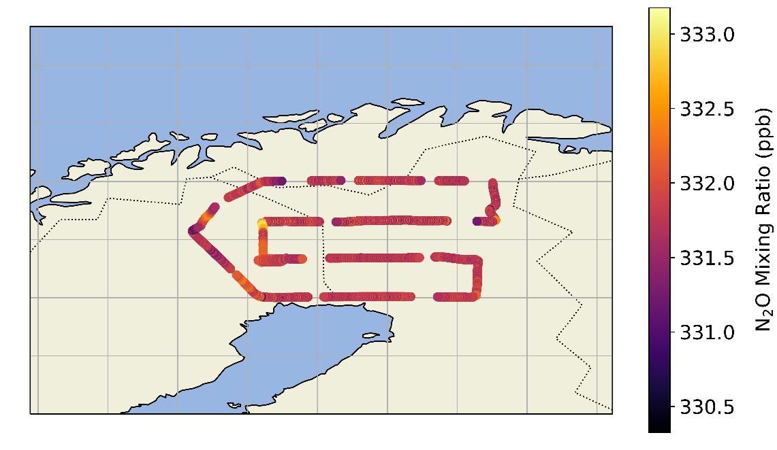

Supplementary Figure 2: Flight track of FAAM flight C195 over northern Fennoscandian wetland areas coloured by N₂O mixing ratio.
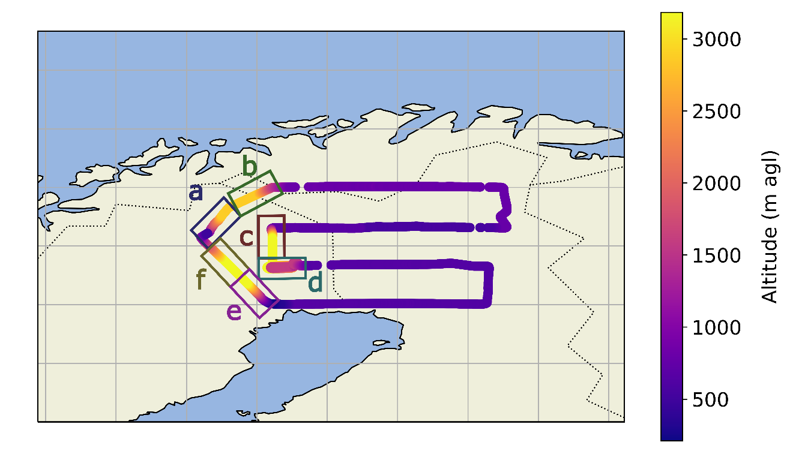

Supplementary Figure 3: Flight track of FAAM flight C195 over northern Fennoscandian wetland areas coloured by altitude. The letters a-f and corresponding boxes highlight the profiles shown in figure 2a-f.
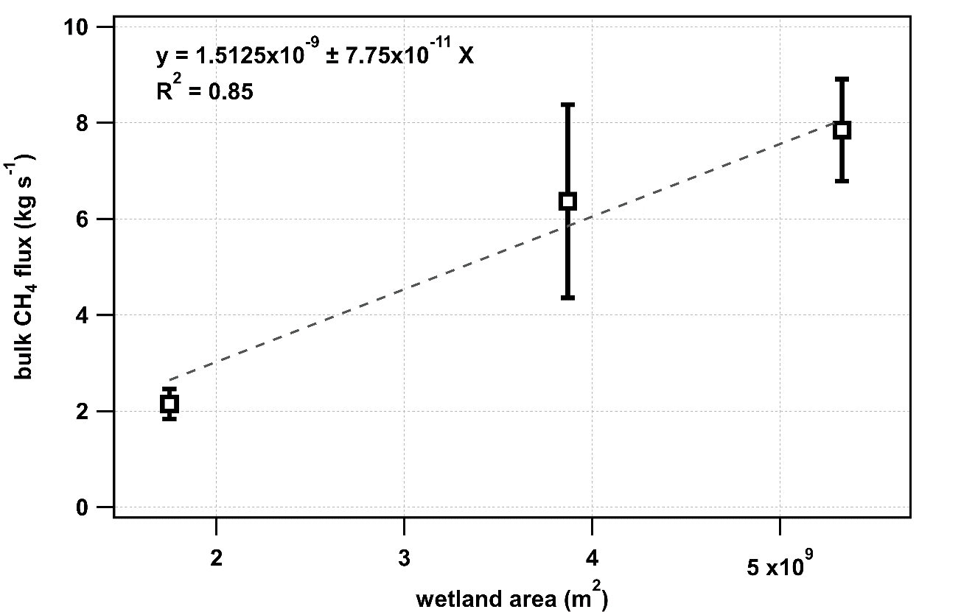
Supplementary Figure 4: Plot of bulk methane flux versus wetland area for the three flux areas identified in section 3.1. A least-squares linear regression is fitted to these points and forced through zero, the equation of this regression is displayed, along with the correlation coefficient.

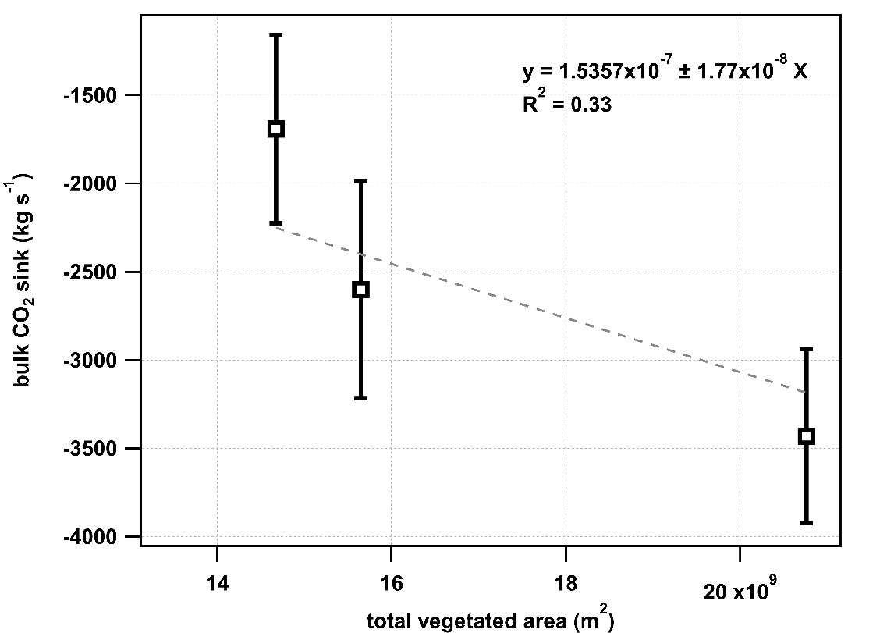

Supplementary Figure 5: Plot of bulk CO₂ sink versus total CORINE vegetated area (non-irrigated arable, pasture, complex cultivation, agriculture, broadleafed forest, coniferous forest, mixed forest, grassland, moors, and woodland) for the three flux areas identified in section 3.1. A least-squares linear regression is fitted to these points and forced through zero, the equation of this regression is displayed, along with the correlation coefficient.

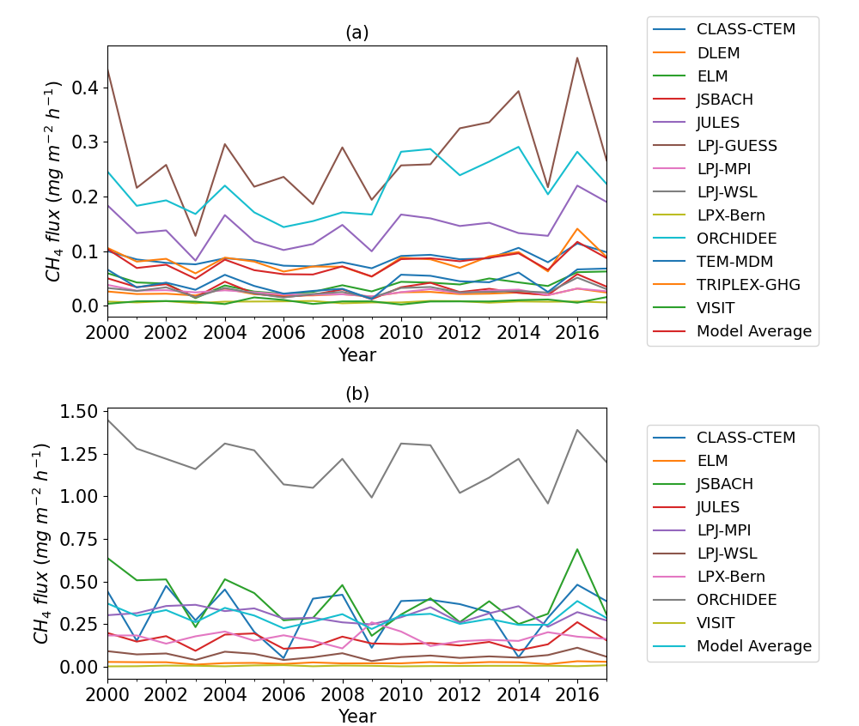

Supplementary Figure 6: Time series of all GCP model CH₄ flux over the period 2000-2017 with (a) diagnostic wetland prescription and (b) prognostic wetland prescription. These area-normalised fluxes are for the entire study area of flight C195 (Areas 1, 2, and 3).

References

1. Fisher R, Lowry D, Wilkin O, Sriskantharajah S, Nisbet EG. 2006. High-precision, automated stable isotope analysis of atmospheric methane and carbon dioxide using continuous-flow isotope-ratio mass spectrometry. Rapid Commun. Mass Spectrom. 20(2), 200-208. (doi:10.1002/rcm.2300)
2. Fisher RE, France JL, Lowry D, Lanoisellé M, Brownlow R, Pyle JA, Cain M, Warwick N, Skiba UM, Drewer J, Dinsmore KJ. 2017. Measurement of the 13C isotopic signature of methane emissions from northern European wetlands. Global Biogeochem. Cycles. 31(3), 605-623. (https://doi.org/10.1002/2016GB005504)
3. Sriskantharajah S, Fisher RE, Lowry D, Aalto T, Hatakka J, Aurela M, Laurila T, Lohila A, Kuitunen E, Nisbet EG. et al. 2012. Stable carbon isotope signatures of methane from a Finnish subarctic wetland. Tellus, Ser. B Chem. Phys. Meteorol. 64, 18818. (doi:10.3402/tellusb.v64i0.18818)
4. Barthelmes A, Couwenberg J, Risager M, Tegetmeyer C, Joosten H. 2015. Peatlands and Climate in a Ramsar context. A Nordic-Baltic Perspective. 1.
5. Marushchak ME, Pitkämäki A, Koponen H, Biasi C, Seppälä M, Martikainen PJ. 2011. Hot spots for nitrous oxide emissions found in different types of permafrost peatlands. Glob. Chang. Biol. 17, 2601–2614. (doi:10.1111/j.1365-2486.2011.02442.x)
6. Voigt C, Marushchak ME, Lamprecht RE, Jackowicz-Korczyński M, Lindgren A, Mastepanov M, Granlund L, Christensen TR, Tahvanainen T, Martikainen PJ, Biasi C. 2017. Increased nitrous oxide emissions from Arctic peatlands after permafrost thaw. Proc. Natl. Acad. 114(24), 6238–6243. (doi:10.1073/PNAS.1702902114)

