Title: Human influence on Brown trout juvenile body size during metapopulation expansion.
Authors:
L. Aulus-Giacosa, F. Guéraud, P. Gaudin, M. Buoro, J.C. Aymes, J. Labonne, M.Vignon.
Affiliations
Universite de Pau et des Pays de l’Adour, E2S UPPA, INRAE, ECOBIOP, Saint-Pée-sur-Nivelle ou Anglet, France.
Corresponding author L. Aulus-Giacosa

Electronic Supplementary Material 2 : Statistical analyses

A) Model Factors

The Linear Mixed Effect Model was fitted using LME4 package in R software.

Variables:
D : Capture Date in Julian day.
M: Metapopulation age.
P: Population age.
S: Status of colonization (TRUE= introduced, FALSE = natural).
River: Categorical factor for random effects on intercept and slope.

B) Model selection using BIC ranking. D = capture day, P = age of population, M = age of the metapopulation, S = status of colonization (natural or introduced). The lowest BIC value indicates the best compromise between model complexity and data fit. Results are ordered from best to poorest BIC ranking.

Fixed factors | Degree of freedom of the model | Bayesian Information Criterion
SxDxPxM | 20 | -20934.27
SxDxP | 12 | -20743.05
SxDxM | 12 | -20735.88
Sx(D+P) | 10 | -20729.35
Sx(DxP+M) | 14 | -20722.64
Sx(D+M) | 10 | -20722.21
Sx(DxM+P) | 14 | -20720.45
Sx(D+P+M) | 12 | -20708.71
Sx(DxP+DxM) | 16 | -20703.51
DxPxM | 12 | -20422.74
DxP | 8 | -20188.29
DxM | 8 | -20181.55
DxP+M | 9 | -20176.35
DxM+P | 9 | -20173.63
DxP+DxM | 10 | -20165.56
D+P | 7 | -20112.55
D+M | 7 | -20106.08
D+P+M | 8 | -20099.80
D | 6 | -19914.63
Null model | 5 | -19892.83
SxD | 8 | -19886.48
S | 6 | -19878.07

The models ranking indicates that several factors strongly improve the fit to the data. First, the models with the S factor are in general better selected than the models without it – as soon as other factors are included. The P factor (Population age) or the M factor (Metapopulation age) always dramatically improves the fit, with or without including the S factor (Status of colonization). P and M factors in interaction with the D factor (day of capture) also always improves the fit. Finally, whatever the value of S, the interaction between P and M also always improves the fit very significantly. As a rule of thumb, a difference of 2 units between two BIC values is usually accepted as a statically significant difference. The difference between the best selected model (SxDxPxM) and the second-best selected model (SxDxP) amounts to 190 units, a quantity that indicates that the best selected model is by far the most able to predict our data.
BIC was preferred over AIC as a measure of fit to the data, because it is expected to behave more efficiently in large data sets than AIC, which will tend to select over fitted models (see Muller et al. 2013, http://dx.doi.org/10.1214/12-STS410, and Peng and Liu 2012 https://doi.org/10.1016/j.jmva.2012.02.005 ).

C) Parameter estimates for fixed effect factors.

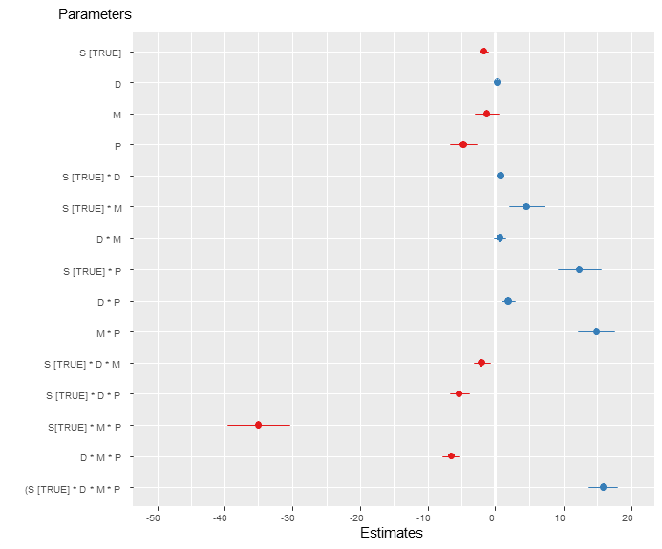

D) Distribution of the river related random effects on the intercept and slope of the body size / capture date relationship.

