Supplemental Figures and tables for the manuscript:
Durland, E., DeWit, P., Langdon, C. (2021) Temporally-balanced selection during development of larval Pacific oysters (Crassostrea gigas) inherently preserves genetic diversity within offspring. Proc R Soc B. DOI: 10.1098/rspb.2020.3223

Please see the file titled ‘Table of Contents Supplement’ for information on all the figures, tables and supplemental data.
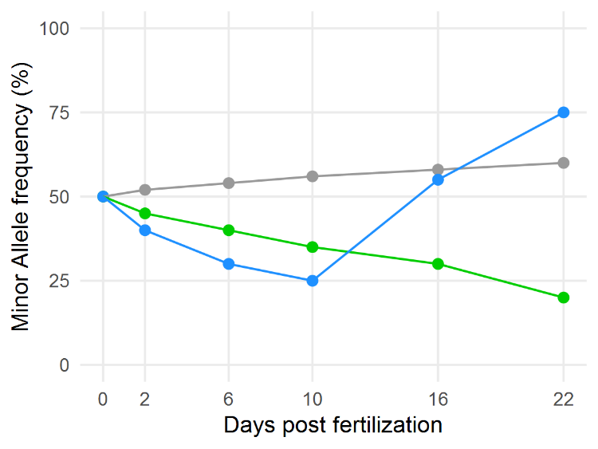
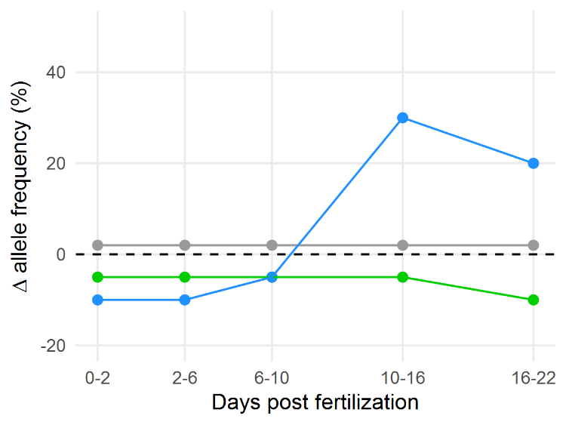
Gradual
Uni-directional
Bi-directional
A
B
Figure S1. Examples of three trajectories of mean allele frequencies in larval pools across development. A) Trajectories of overall minor allele frequencies and B) and relative change (Δ) in allele frequencies for ‘gradual’, ‘uni-directional’ and ‘bi-directional’ changes (grey, green and blue lines, respectively)
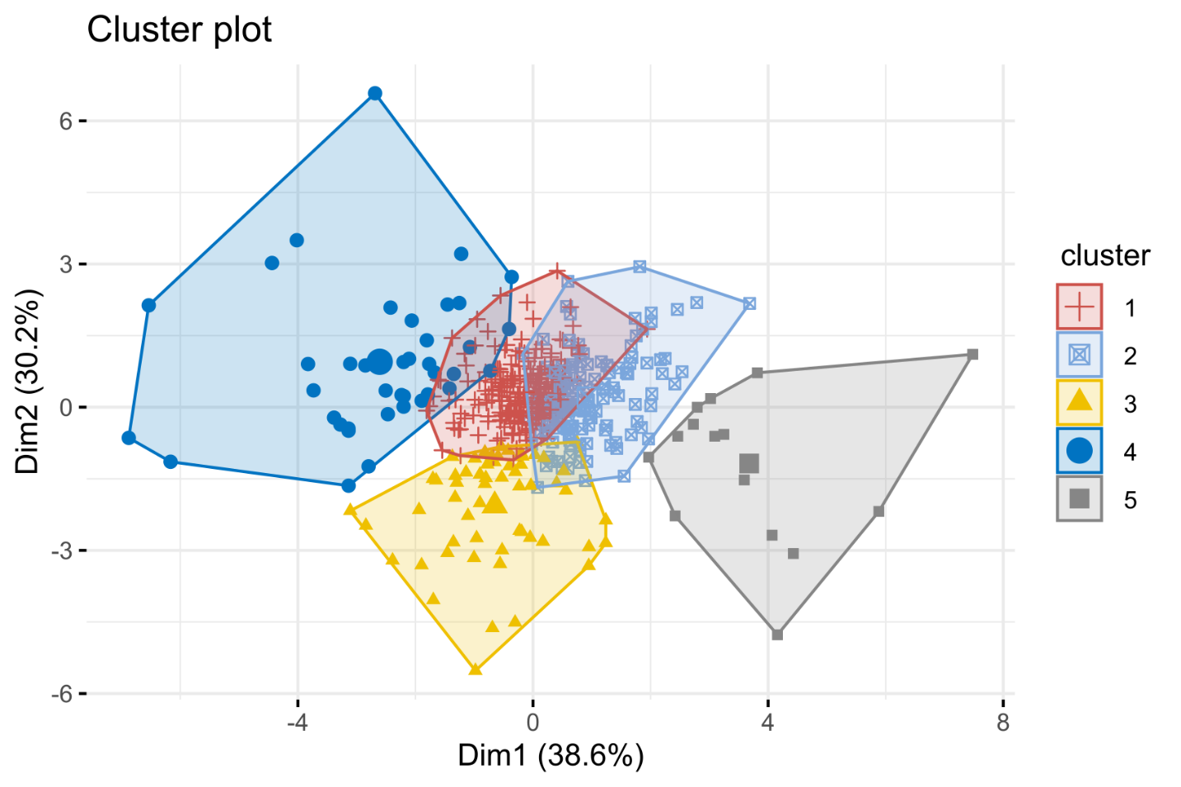
Figure S2. Visualization of k-means clusters, grouping loci by trajectory of changes in allele frequencies (∆AF).

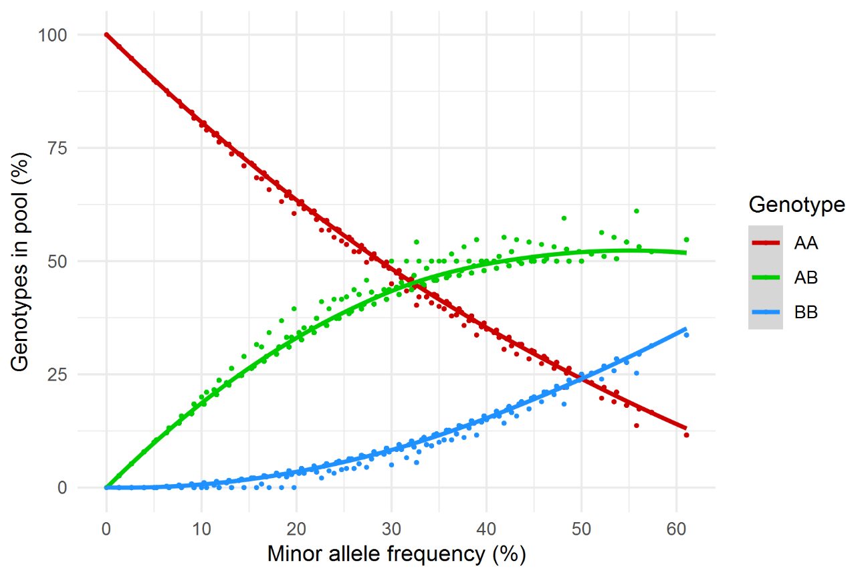
Figure S3. Estimated genotypic proportions in the larval pool based on initial minor allele frequency (MAF) of the fertilized eggs. Estimates were simulated based on Mendelian segregation ratios and a 5x19 factorial cross design. For each 1% increment in MAF, we created an ‘allele pool’ (n=48; two for each parent) reflecting each minor allele frequency (e.g. MAF= 25%; 48 alleles x 0.25= 12 ‘B’ alleles, 36 ‘A’ alleles). Parental genotypes then were randomly drawn from this pool and ‘crossed’ to create a simulated population of genotypes. Simulations were repeated n=50 times for each increment. This method is described in detail at https://github.com/E-Durland/Genotype_simulator .
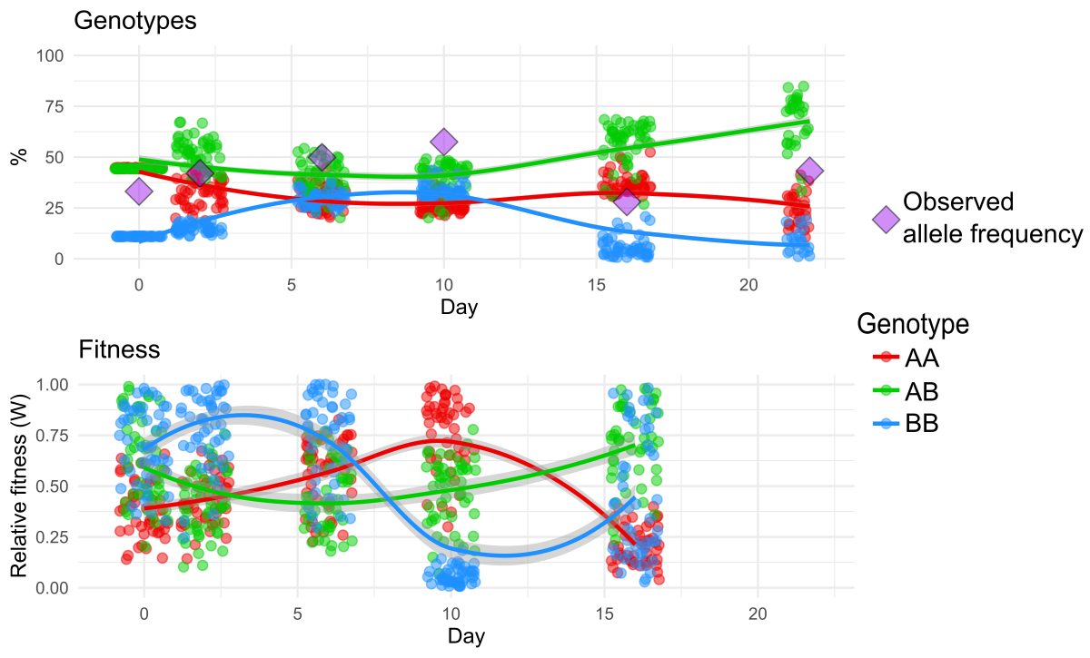
Figure S4. Modeled simulations of change in genotype proportions as a function of minor allele frequency for SNP #91 (see supplementary file). Points represent individual simulations of possible genotype frequency (top) and fitness (bottom) across development. Lines represent mean trajectories of n=50 simulations (± standard error in grey ribbons). Purple diamonds are the measured minor allele frequencies at each time point (mean for 5 replicate cultures).

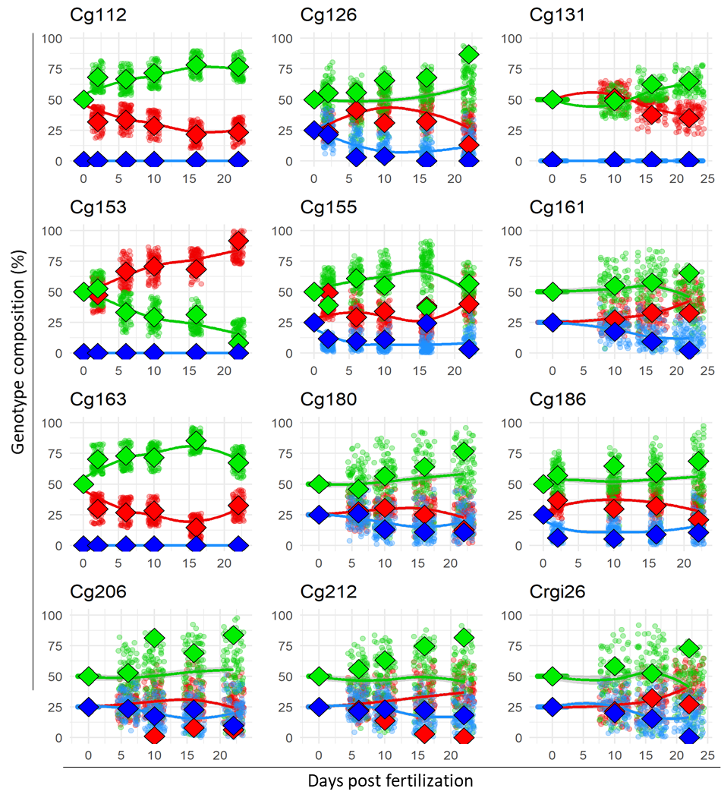
Figure S5. Comparing modeled genotype frequencies (points) to empirical estimates (diamonds; red=AA,blue=BB,green=AB). Bi-allelic markers from Plough and Hedgecock (2016) used to estimate the timing of genotypic distortions in C. gigas were converted to overall minor allele frequencies at each time point (on the x-axis). We then tested our iterative model to predict mean genotype frequencies using n=100 simulations. The accuracy of the simulations are improved by dynamic changes in allele frequency (e.g. marker Cg126 and Cg 163). Markers with little overall change in frequency (e.g. Cg206, Cg212, Crgi26) have many ‘possible outcomes’ leading to increased variance in simulated genotype frequencies across developmental time. More stark disagreements (e.g. Cg155 at days 2 and 16) indicate that either the true patterns are accounted for in a very small number of simulated trajectories, or that the empirical estimates of genotypic composition for these samples are an artifact of sample size or genotyping accuracy.

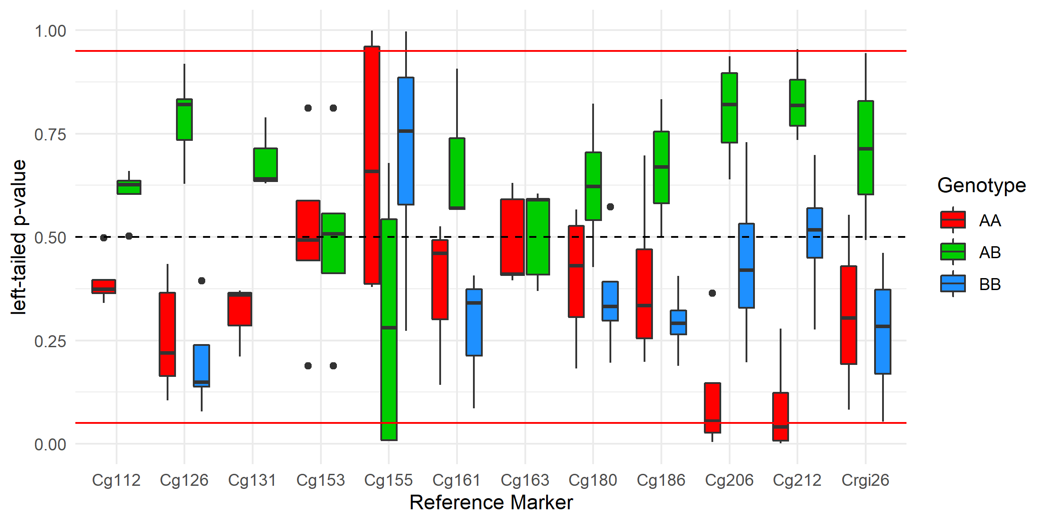
Figure S6. Probability of simulating empirically estimated genotype frequencies for each marker (in Figure S4) with an iterative algorithm based on minor allele frequency and larval mortality. Left-tailed cumulative probability estimates are plotted on the y-axis, colors correspond with each genotype. The black dashed line represents 50% cumulative distribution (empirical estimate = mean modeled frequency). Values above and below 0.5 reflect mean simulated genotype frequencies that are higher and lower than empirical estimates, respectively. Red lines represent 95% probability cutoffs. Only ~7.6% (n=10) empirical estimates are statistically distinct from modeled genotype frequencies (see Figure S5 and S7).

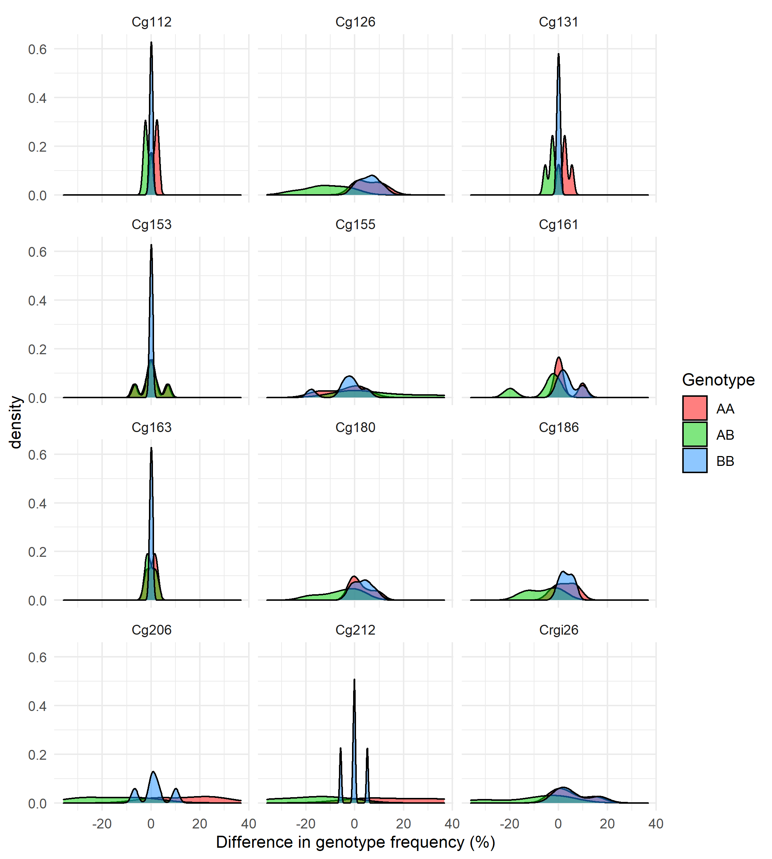
Figure S7. Magnitude of differences in modeled mean estimates of genotype frequency compared with empirical data (from Figure S5). Accuracy of modeled means is marker specific but ~82% of all genotype frequencies (154/186) are within 10% of the empirically estimated values.
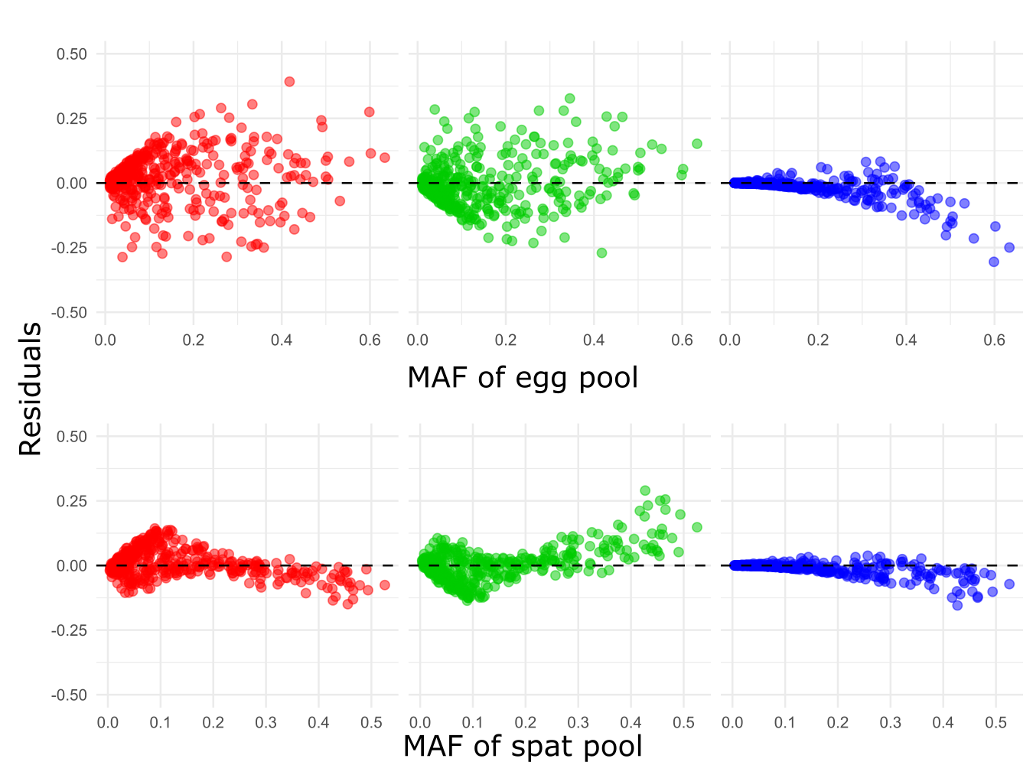
Figure S8. Plot of residuals between genotype frequencies (AA/AB/BB) estimated in the spat population (circles) relative to Hardy-Weinberg Estimates (HWE) from the fertilized eggs (top), spat population (bottom). See Table S2 for full comparison between the two model types and Figure S9 for confidence and prediction intervals for the spat model.
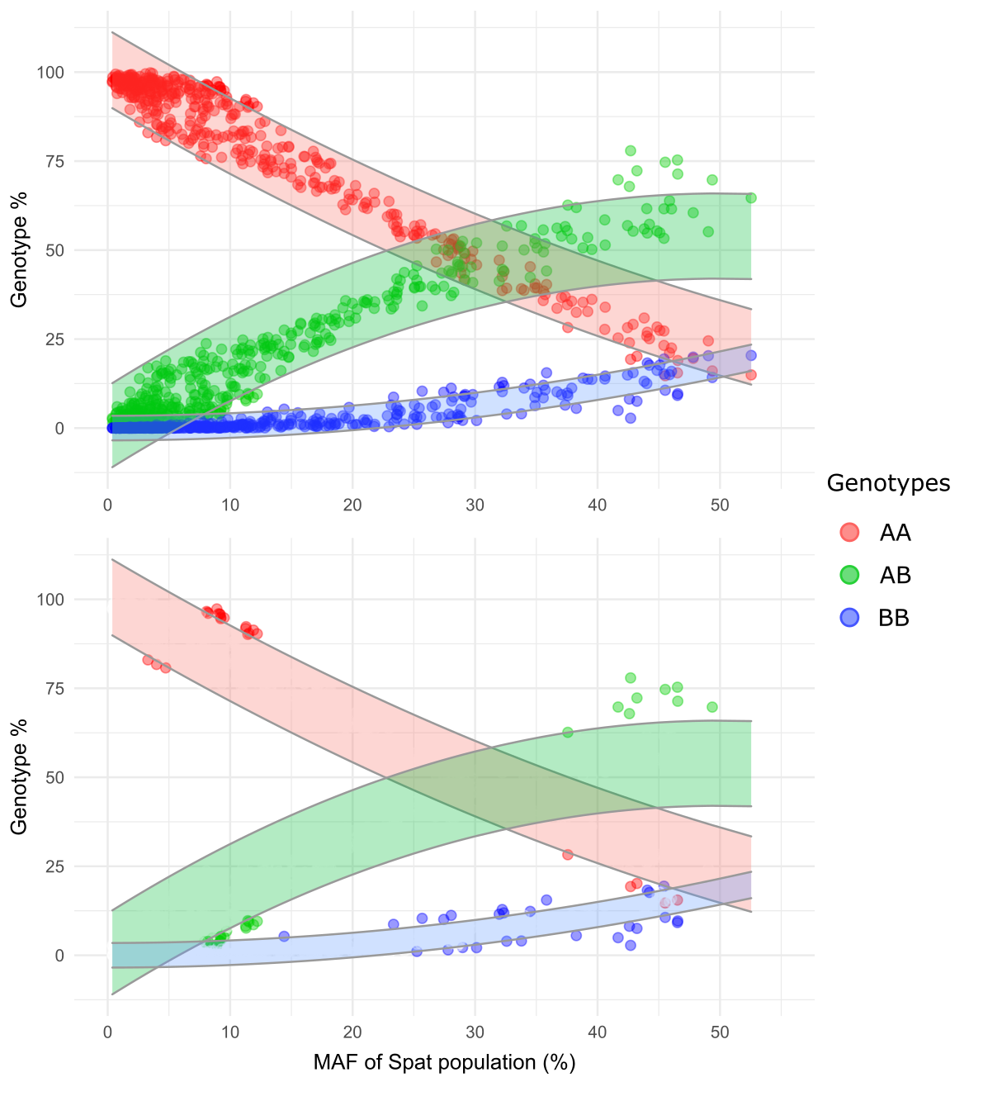
Figure S9. Identifying outliers from HWE estimates from the spat pool. Genotype frequencies of the spat population were used to fit linear models relative to Hardy-Weinberg assumptions based on the MAF of the spat pool. A random subsample (30%) of the data was used to train the model and the remainder (70%) was used to test. Prediction intervals for the models were used to identify genotype frequencies significantly different from HWE expectations. All data is presented in the top pane, only outlier data points are represented on the bottom pane. High and low outliers (H/L) for each genotype were: 16/8 9/19, 13/14 for AA, AB, and BB, respectively.
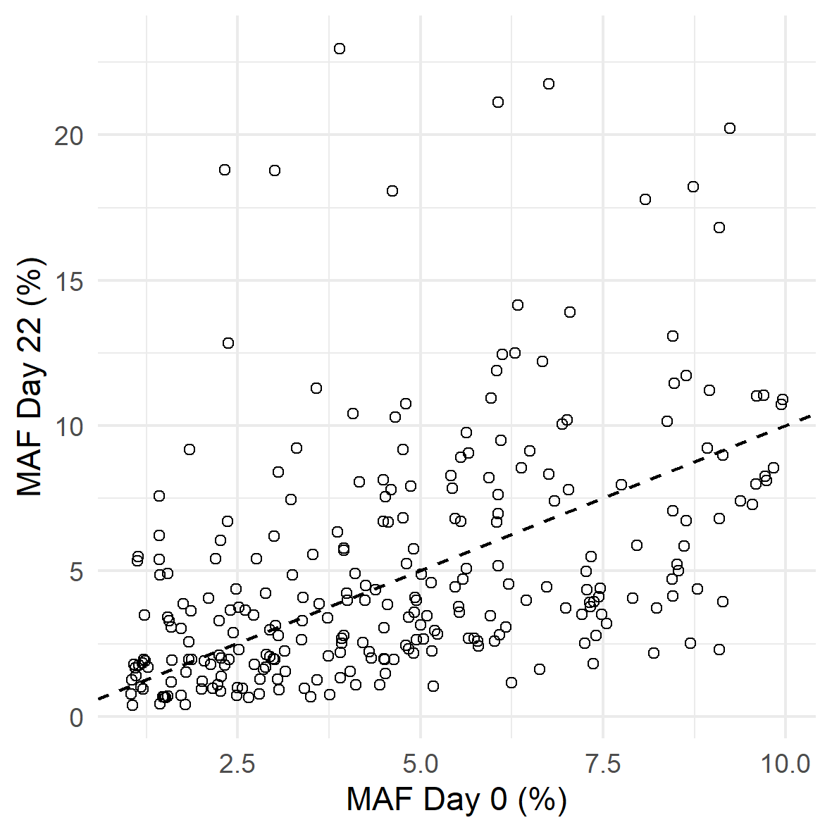
Figure S10. Overall change in allele frequencies for rare variant SNPs. Each point represents one of n=269 SNPs with rare minor alleles (MAF<10%) in the fertilized egg pool (x-axis) and their ‘ending’ allele frequency after 22 days of larval development (y-axis). Dashed line is the 1:1 relationship between the two axes. Points above and below the dashed line indicate an increase or decrease in minor allele frequency, respectively. No markers in this dataset (n=751 in total) had minor alleles that were ‘purged’ through development (MAF=0).

Day | Screen size (µm) | # larvae sampled (± 10%)
0 | 21 | 10,000
2 | 25 | 3000
6 | 37 | 1000
10 | 64 | 800
16 | 240 | 1000
22 | 240 | 266*

Table S1. Size of mesh screens for water change and average size of larval samples at different time points during larval culture. Throughout larval culture, conservative screen sizes were used to retain all living larvae, with no selection of larvae based on size. For sampling, during days 0-16, larval cultures were quantified volumetrically with 3-5 replicate counts of population subsamples (~30 µl). Counts were repeated until <10% coefficient of variation was obtained. Subsamples for DNA analysis (above) were calculated as the volume of larval suspension needed to obtain the target number of larvae. (e.g. 100,000 larvae ml⁻¹ / 3,000 larvae sample⁻¹= 0.03ml = 30µl). The variance in counting estimates (~10%) was, therefore, similarly carried over to sampling estimates (e.g. ± 1,000 eggs at day 0 and ±100 larvae at day 16).
*At day 22, all individuals were counted directly from each replicate culture, one quarter of which were preserved for DNA analysis. For these samples (mean=266, sd=28.2), variance was a product of differential survival between replicates, but still similar in magnitude (28.2/266=0.106= 10.6%) to the variance of the preceding samples.
For full explanation of counting techniques, see methods in Durland et al. (2019).

Genotype | predictor | p-value | F-stat* | AIC | BIC
AA | Egg MAF (HWE) | < 2e-16 | 1788.9 | -810.0 | -797.7
 | Spat MAF (HWE) | < 2e-16 | 8521.5 | -1441.2 | -1428.8
AB | Egg MAF (HWE) | < 2e-16 | 1475.1 | -897.4 | -885.0
 | Spat MAF (HWE) | < 2e-16 | 4651.5 | -1340.4 | -1328.0
BB | Egg MAF (HWE) | < 2e-16 | 937.7 | -2124.8 | -2112.4
 | Spat MAF (HWE) | < 2e-16 | 2532.9 | -2460.8 | -2448.5

Table S2. Testing fit of linear models for estimated spat genotypes relative to Hardy-Weinberg estimates (HWE) from minor allele frequencies in fertilized eggs (Egg MAF), the spat pool (Spat MAF). Bold numbers represent models with the best fit. * F-statistic = F_{1,453} for all models.

 |  | Parametric category
 |  | G | UD | BD | Total SNPs
Cluster # | 1 | 84 | 91 | 44 | 219
 | 2 | 42 | 75 | 26 | 143
 | 3 | 11 | 32 | 14 | 57
 | 4 | 2 | 5 | 32 | 39
 | 5 | 0 | 4 | 11 | 15

Table S3. Distribution of significantly changed loci among patterns of change determined with parametric tests (columns) as gradual (G), uni-directional (UD), and bi-directional (BD) together with membership in each of five clusters determined by k-means (rows).

Cluster | # SNPs | # SNPs mapped | # unique loci | $\overline{x}$ distance between markers (cM)
1 | 219 | 55 | 38 | 13.9
2 | 143 | 35 | 25 | 21.2
3 | 57 | 16 | 14 | 22.0
4 | 39 | 5 | 2 | 27.8
5 | 15 | 15 | 9 | 24.8

Table S4. Metadata for SNPs mapped to linkage groups. A total of n=126 markers with significant changes in allele frequencies (i.e. those included in clustering analysis) were mapped to a linkage map (Hedgecock et al., 2015; see methods). The average distance between markers, across all linkage groups, ranged from 13.9 – 27.8 cM. The mean distance scaled with marker density.

References:
Durland E, Waldbusser G, Langdon C. Comparison of larval development in domesticated and naturalized stocks of the Pacific oyster Crassostrea gigas exposed to high pCO₂ conditions. Mar Ecol Prog Ser 621, 107-125 (2019)
Hedgecock D, Shin G, Gracey AY, Den Berg DV, Samanta MP. Second-Generation Linkage Maps for the Pacific Oyster Crassostrea gigas Reveal Errors in Assembly of Genome Scaffolds. G3 (Bethesda) 5, 2007-2019 (2015)
Plough LV, Hedgecock D. Quantitative trait locus analysis of stage-specific inbreeding depression in the Pacific oyster Crassostrea gigas. Genetics 189, 1473-1486 (2011)
Ouellette LA, Reid RW, Blanchard SG, Brouwer CR. LinkageMapView-rendering high-resolution linkage and QTL maps. Bioinformatics 34, 306-307 (2018).

