Supplementary Material
Bootstrapping Procedure
We therefore used smoothed-cases bootstrapping to generate standard errors and confidence intervals for the model coefficients from models investigating the average cost of parasitism [1-4]. Smoothing was done to improve the coverage of confidence intervals, which may be negatively biased for bootstraps with small sample sizes [4]. We used the boot package for R 4.0 to generate 10,000 bootstrap samples of the associated dataset [2]. For each data point in each bootstrap sample, we added a simulated random deviate from the standard gaussian kernel (mean = 0, variance = 1) multiplied by the smoothing bandwidth h [1,5]. We estimated h using Silverman’s rule of thumb, with the inter quartile range as our measure of scale [5]. Each bootstrap sample was run through its associated meta-analytic model to create the bootstrap distributions of model coefficients. We generated bias-corrected and accelerated bootstrap confidence intervals for each coefficient using the boot package in R 4.0 [2].
References
1. Polansky AM, Schucany WR. 1997 Kernel Smoothing to Improve Bootstrap Confidence Intervals. J. R. Stat. Soc. Ser. B Stat. Methodol. 59, 821–838. (doi:10.1111/1467-9868.00099)
2. Canty A, Ripley BD. 2021 boot: Bootstrap R (S-Plus) Functions.
3. DiCiccio TJ, Efron B. 1996 Bootstrap Confidence Intervals. Stat. sci. 11. 189-228.
4. Davison AC, Hinkley DV. 1997 Bootstrap Methods and Their Applications. Cambridge: Cambridge University Press.
5. Silverman B.W. 1986. Density estimation for statistics and data analysis. New York: Chapman and Hall.
Supplementary Tables

Table S1. Full dataset (k = 85 observations from 64 species) used to quantify the overall survival cost of parasitism, its sex difference, and test the effect of mating system on both. Study is the publication from which the log odds ratio was extracted. Full references are given in the reference list below (pages 15-22). Species gives the species that the information in the respective row is for. Mating System describes the mating system of the associated species (Promiscuous, Polygynous, and Monogamous). % EPP is the percentage of clutches exhibiting extra-pair paternity in “socially monogamous” bird species. Reference for Mating System lists the publication from which the mating system for a species was characterized, the full references are given below (pages 23-26). Taxon describes the broad taxonomic group of the species (Arthropod, Bird, Fish, or Mammal). Age describes the life stage of the individuals the associated data are from, Juvenile = pre-reproductive life stage, Adult = reproductive life stage. Parasite type gives the broad grouping of the parasite/parasites associated with a data set: Bacteria = micro-parasites within the domain Bacteria, Fungi = micro-parasites within the kingdom Fungi, Ectoparasite = external macro-parasites which include organisms belonging to Arthropoda and Monogenea, Helminth = internal macro-parasites which include organisms belonging to Nematoda, Cestoda, Trematoda, and Acanthocephala, Protist = micro-parasites within the phylum Apicomplexa, and Virus = viral micro-parasites. Method describes the methodology used in the associated study: Exp.Inf = experimental infections with the parasite, Exp.Rem = experimental removal of the parasite, Nat.Var = natural variation in parasite level. LO M is the log odds ratio of the survival cost of parasitism for males, LO F = the log odds ratio of the survival cost of parasitism for females, Ave LO = the weighted average log odds ratio of the survival cost of parasitism for males and females, Diff (M-F) = the difference in the log odds ratio of the survival cost of parasitism betetween males and females, Diff var = the sampling variance of the difference in the log odds ratio, Ave Var = the sampling variance of the average log odds ratio, M Var = the sampling variance of the male log odds ratio, F Var = the sampling variance of the female log odds ratio.
Study | Species | Mating System | Reference for mating system | Taxon | Age | Parasite type | Method | LO M | LO F | Ave LO | Diff | Diff | Ave | M | F
 |  |  |  |  |  |  |  |  |  |  | (M-F) | var | Var | Var | Var
Gray 1998 | Acheta domesticus | Promiscuous | Gray 1998 | Arthropod | Adult | Bacteria | Exp.Inf | 2.25 | 1.74 | 2.1 | 0.51 | 0.536 | 0.17 | 0.24 | 0.58
Asghar 2015 | Acrocephalus arundinaceus | Monogamous | Griffith 2002 | Aves | Adult | Protist | Nat.Var | 0.71 | 1.17 | 1.02 | -0.46 | 0.672 | 0.23 | 0.71 | 0.33
Webberley 2002 | Adalia bipunctata | Promiscuous | Haddrill 2008 | Arthropod | Adult | Ectoparasite | Nat.Var | 2.3 | 1.29 | 1.78 | 1.01 | 1.11 | 0.45 | 0.92 | 0.87
Webberley 2002 | Adalia bipunctata | Promiscuous | Haddrill 2008 | Arthropod | Adult | Ectoparasite | Exp.Inf | 2.62 | 1.03 | 1.41 | 1.59 | 1.174 | 0.32 | 1.32 | 0.42
Bedhomme 2004 | Aedes aegypti | Polygynous | Richardson 2015 | Arthropod | Adult | Fungi | Exp.Inf | 0.35 | 0.04 | 0.2 | 0.31 | 0.05 | 0.02 | 0.04 | 0.04
Rau 1991 | Aedes provocans | Polygynous | Yuval 2006 | Arthropod | Adult | Helminth | Exp.Inf | 1.02 | -0.1 | 0.46 | 1.12 | 0.087 | 0.04 | 0.07 | 0.07
Souchay 2013 | Anser caerulescens | Monogamous | Griffith 2002 | Aves | Juvenile | Helminth | Exp.Rem | 0.04 | 0.27 | 0.16 | -0.23 | 0.012 | 0.001 | 0.01 | 0.01
Jhan-Wei 2014 | Apodemus semotus | Promiscuous | Shaner 2018 | Mammal | Adult | Ectoparasite | Nat.Var | 1.1 | 1.49 | 1.23 | -0.39 | 0.354 | 0.12 | 0.18 | 0.37
Lo 2015 | Apodemus semotus | Promiscuous | Shaner 2018 | Mammal | Adult | Helminth | Exp.Rem | -0.26 | -0.69 | -0.39 | 0.43 | 0.261 | 0.08 | 0.12 | 0.28
Córdoba-Aguilar 2013 | Argia anceps | Promiscuous | Caesar 2012 | Arthropod | Adult | Protist | Exp.Inf | 1.65 | 1.87 | 1.76 | -0.22 | 0.149 | 0.06 | 0.12 | 0.12
Córdoba-Aguilar 2013 | Argia extranea | Promiscuous | Caesar 2012 | Arthropod | Adult | Protist | Exp.Inf | 2 | 1.66 | 1.83 | 0.34 | 0.149 | 0.06 | 0.12 | 0.12
Benesh 2007 | Asellus aquaticus | Polygynous | Jormalainen 1998 | Arthropod | Adult | Helminth | Exp.Inf | 1.74 | 0.85 | 1.28 | 0.89 | 0.104 | 0.06 | 0.12 | 0.01
Lanciani 1982 | Buenoa scimitra | Promiscuous | Rowe 1994 | Arthropod | Adult | Ectoparasite | Exp.Inf | 1.01 | 1.89 | 1.33 | -0.88 | 0.407 | 0.15 | 0.23 | 0.41
Morton 2009 | Capnodis tenebrionis | Promiscuous | Bonsignore 2014 | Arthropod | Adult | Helminth | Exp.Inf | 3.26 | 1.18 | 1.74 | 2.08 | 0.954 | 0.28 | 1.05 | 0.39
Morton 2013 | Capnodis tenebrionis | Promiscuous | Bonsignore 2014 | Arthropod | Adult | Helminth | Exp.Inf | 6.89 | 3.35 | 4.35 | 3.54 | 1.413 | 0.44 | 1.54 | 0.61
Weiberg 1997 | Chironomus tentans | Polygynous | Eberhard 2004 | Arthropod | Adult | Ecotoparasite | Exp.Inf | 0.65 | 0.19 | 0.41 | 0.46 | 0.143 | 0.06 | 0.12 | 0.11
Braune 2001 | Coenagrion puella | Promiscuous | Thompson 2011 | Arthropod | Adult | Ecotoparasite | Exp.Rem | 0.02 | 0.08 | 0.05 | -0.06 | 0.106 | 0.04 | 0.09 | 0.08
Joop 2006 | Coenagrion puella | Promiscuous | Thompson 2011 | Arthropod | Adult | Fungi | Exp.Inf | 0.79 | 0.37 | 0.58 | 0.42 | 0.087 | 0.04 | 0.07 | 0.07
Marescot 2018 | Crocuta crocuta | Promiscuous | East 2003 | Mammal | Juvenile | Virus | Nat.Var | 1.21 | 1.21 | 1.21 | 0 | 0.267 | 0.11 | 0.21 | 0.22
Marescot 2018 | Crocuta crocuta | Promiscuous | East 2003 | Mammal | Adult | Virus | Nat.Var | 1.23 | 1.99 | 1.44 | -0.76 | 0.988 | 0.3 | 0.42 | 1.08
Podmokla 2016 | Cyanistes caeruleus | Monogamous | Griffith 2002 | Aves | Adult | Protist | Nat.Var | 0.15 | 0.21 | 0.18 | -0.05 | 0.112 | 0.04 | 0.08 | 0.1
de Roode 2006 | Danaus plexippus | Promiscuous | Svard 1988 | Arthropod | Adult | Protist | Exp.Inf | 4.27 | 4.15 | 4.21 | 0.12 | 0.155 | 0.06 | 0.12 | 0.13
Lindsey 2009 | Danaus plexippus | Promiscuous | Svard 1988 | Arthropod | Adult | Protist | Exp.Inf | 5.11 | 4.45 | 4.8 | 0.66 | 0.794 | 0.32 | 0.61 | 0.67
Magallanes 2017 | Delichon urbicum | Polygynous | Griffith 2002 | Aves | Adult | Protist | Nat.Var | 0.79 | 0.25 | 0.5 | 0.54 | 0.528 | 0.21 | 0.45 | 0.4
Leonard 1999 | Enallagma ebrium | Promiscuous | Fincke 1982 | Arthropod | Adult | Ectoparasite | Exp.Inf | 0.76 | 0.48 | 0.59 | 0.28 | 0.253 | 0.09 | 0.25 | 0.15
Leonard 1999 | Enallagma ebrium | Promiscuous | Forbes 1991 | Arthropod | Juvenile | Ecotoparasite | Exp.Inf | 0.97 | 0.45 | 0.73 | 0.52 | 0.211 | 0.08 | 0.16 | 0.18
Bergallo 2000 | Euryoryzomys russatus | Monogamous | Bergallo 2004 | Mammal | Adult | Ectoparasite | Nat.Var | -0.05 | 1.31 | 0.63 | -1.36 | 0.149 | 0.06 | 0.12 | 0.12
Kulma 2013 | Ficedula albicollis | Polygynous | Griffith 2002 | Aves | Adult | Protist | Nat.Var | -0.39 | -0.35 | -0.37 | -0.04 | 0.068 | 0.03 | 0.06 | 0.05
Kulma 2013 | Ficedula hypoleuca | Monogamous | Griffith 2002 | Aves | Adult | Protist | Nat.Var | 0.48 | 0.87 | 0.7 | -0.39 | 0.131 | 0.05 | 0.12 | 0.09
Arcila 2020 | Forficula auricularia | Promiscuous | Sandrin 2015 | Arthropod | Adult | Fungi | Exp.Inf | 1.74 | 2.3 | 1.89 | -0.56 | 0.578 | 0.17 | 0.23 | 0.64
Arundell 2019 | Gammarus zaddachi | Polygynous | Jormalainen 1998 | Arthropod | Adult | Helminth | Nat.Var | 0.65 | 0.41 | 0.5 | 0.24 | 0.183 | 0.07 | 0.18 | 0.11
Granroth-Wilding 2015 | Gulosus aristotelis | Monogamous | Griffith 2002 | Aves | Adult | Helminth | Exp.Rem | -1.51 | 0.03 | -0.43 | -1.54 | 1.223 | 0.4 | 1.31 | 0.57
Gegner 2018 | Harmonia axyridis | Promiscuous | Awad 2015 | Arthropod | Adult | Bacteria | Exp.Inf | 3.61 | 4.27 | 3.93 | -0.66 | 0.36 | 1.06 | 0.28 | 0.3
Riddick 2010 | Harmonia axyridis | Promiscuous | Awad 2015 | Arthropod | Adult | Fungi | Nat.Var | 1.98 | 0.39 | 1.23 | 1.6 | 1.843 | 0.74 | 1.4 | 1.57
Atkinson 2000 | Hemignathus virens | Monogamous | Ripper 1987 | Aves | Adult | Protist | Exp.Inf | 2.08 | 2.23 | 2.16 | -0.15 | 1.978 | 0.79 | 1.75 | 1.43
Córdoba-Aguilar 2013 | Hetaerina americana | Polygynous | Córdoba-Aguilar 2011 | Arthropod | Adult | Protist | Exp.Inf | 1.94 | 1.02 | 1.45 | 0.92 | 0.143 | 0.06 | 0.12 | 0.11
Duclos 2006 | Hyalella azteca | Polygynous | Wen 1993 | Arthropod | Adult | Helminth | Exp.Inf | 0.55 | 0.68 | 0.62 | -0.13 | 0.186 | 0.08 | 0.15 | 0.15
Kokkotis 2005 | Hyalella azteca | Polygynous | Wen 1993 | Arthropod | Adult | Helminth | Exp.Inf | 1.46 | 1.05 | 1.26 | 0.41 | 0.124 | 0.05 | 0.1 | 0.1
Samish 2000 | Hyalomma excavatum | Promiscuous | Cutulle 2010 | Arthropod | Adult | Helminth | Exp.Inf | 3.45 | 1.62 | 1.97 | 1.83 | 0.902 | 0.2 | 1.04 | 0.25
Bustnes 2006 | Larus hyperboreus | Monogamous | Brouwer 2019 | Aves | Adult | Helminth | Exp.Rem | -0.53 | 0.26 | -0.12 | -0.8 | 0.323 | 0.13 | 0.27 | 0.25
Gagnon 2018 | Listronotus oregonensis | Unknown |  | Arthropod | Adult | Helminth | Exp.Inf | 0.78 | 0.79 | 0.78 | -0.01 | 0.236 | 0.1 | 0.18 | 0.2
Musser 2012 | Lygus lineolaris | Promiscuous | Brent 2010 | Arthropod | Adult | Fungi | Exp.Rem | 1.52 | 1.22 | 1.37 | 0.3 | 0.353 | 0.14 | 0.29 | 0.28
Martinez-Sanchez 2007 | Meccus pallidipennis | Promiscuous | Vitta 2009 | Arthropod | Adult | Ectoparasite | Exp.Inf | 1.07 | 1.16 | 1.12 | -0.09 | 0.136 | 0.06 | 0.11 | 0.11
Schrader 2003 | Melanerpes carolinus | Monogamous | Griffith 2002 | Aves | Adult | Protist | Nat.Var | 0.87 | -0.11 | 0.34 | 0.98 | 1.274 | 0.51 | 1.11 | 0.94
McDonald 2014 | Meles meles | Promiscuous | Dugdale 2007 | Mammal | Adult | Bacteria | Nat.Var | 1.18 | 0.95 | 1.07 | 0.23 | 0.081 | 0.03 | 0.06 | 0.07
Wilkinson 1999 | Meles meles | Promiscuous | Dugdale 2007 | Mammal | Adult | Bacteria | Nat.Var | 1.56 | 0.06 | 0.73 | 1.5 | 0.168 | 0.07 | 0.15 | 0.12
Boonstra 1980 | Microtus townsendii | Monogamous | Lambin 1991 | Mammal | Adult | Ectoparasite | Nat.Var | 0.29 | 0.42 | 0.36 | -0.13 | 0.004 | 0.002 | 0.003 | 0.003
Boonstra 1980 | Microtus townsendii | Monogamous | Lambin 1991 | Mammal | Juvenile | Ectoparasite | Nat.Var | 0.15 | 0.2 | 0.17 | -0.05 | 0.024 | 0.01 | 0.02 | 0.018
Steen 2002 | Microtus townsendii | Monogamous | Wolff 2007 | Mammal | Adult | Ectoparasite | Exp.Rem | 0.42 | 0.59 | 0.51 | -0.17 | 0.472 | 0.19 | 0.41 | 0.35
Arimoto 2012 | Musca autumnalis | Polygynous | Mansour 1987 | Arthropod | Adult | Helminth | Nat.Var | 1.05 | 0.7 | 0.87 | 0.35 | 0.106 | 0.04 | 0.09 | 0.08
Lemaitre 2009 | Myodes gapperi | Polygynous | Tisell 2019 | Mammal | Adult | Ectoparasite | Nat.Var | 1.96 | 0.95 | 1.41 | 1.01 | 0.28 | 0.11 | 0.25 | 0.2
Cayol 2018 | Myodes glareolus | Polygynous | Garcia-Navas 2015 | Mammal | Adult | Bacteria | Exp.Inf | 0 | 0 | 0 | 0 | 0.323 | 0.13 | 0.24 | 0.28
Kallio 2007 | Myodes glareolus | Polygynous | Garcia-Navas 2015 | Mammal | Adult | Virus | Nat.Var | 0.95 | 1.58 | 1.34 | -0.63 | 0.385 | 0.14 | 0.38 | 0.23
Miller 2018 | Nicrophorus vespilloides | Promiscuous | Scott 1998 | Arthropod | Adult | Bacteria | Exp.Inf | 5.64 | 3.97 | 4.54 | 1.67 | 1.164 | 0.41 | 1.2 | 0.62
Botto-Mahan 2012 | Octodon degus | Promiscuous | Ebensperger 2019 | Mammal | Adult | Protist | Nat.Var | -0.07 | 0.5 | 0.25 | -0.57 | 0.673 | 0.27 | 0.61 | 0.47
Currie 2007 | Oncorhynchus mykiss | Promiscuous | Seamons 2004 | Fish | Adult | Protist | Exp.Inf | 0.09 | 2.34 | 1.47 | -2.26 | 2.284 | 0.86 | 2.21 | 1.42
Craig 2009 | Ovis aries | Promiscuous | Soulsbur 2010 | Mammal | Adult | Helminth | Exp.Rem | 0.4 | 0.18 | 0.28 | 0.22 | 0.838 | 0.34 | 0.71 | 0.64
Gulland 1992 | Ovis aries | Promiscuous | Soulsbur 2010 | Mammal | Adult | Helminth | Exp.Rem | 0.47 | 1.79 | 1.36 | -1.32 | 1.861 | 0.63 | 1.95 | 0.94
Gulland 1992 | Ovis aries | Promiscuous | Soulsbur 2010 | Mammal | Juvenile | Helminth | Exp.Rem | 2.17 | 1.28 | 1.04 | 1.84 | 1.043 | 0.35 | 0.9 | 0.78
Gulland 1993 | Ovis aries | Promiscuous | Soulsbur 2010 | Mammal | Juvenile | Helminth | Exp.Rem | 2.66 | 0.33 | 1.8 | 1.38 | 1.201 | 0.48 | 1.28 | 0.57
Lachish 2012 | Parus major | Monogamous | Griffith 2002 | Aves | Adult | Virus | Nat.Var | 1.05 | 1.38 | 1.23 | -0.33 | 0.279 | 0.11 | 0.24 | 0.21
Morton 2013 | Periplaneta americana | Polygynous | Bell 2007 | Arthropod | Adult | Helminth | Exp.Inf | 7.61 | 3.8 | 5.14 | 3.81 | 2.006 | 0.72 | 2.04 | 1.11
Vandergrift 2008 | Peromyscus leucopus | Promiscuous | Xia 1991 | Mammal | Adult | Helminth | Exp.Rem | 1.5 | 0.81 | 1.1 | 0.69 | 0.831 | 0.32 | 0.77 | 0.56
Fuller 1996 | Peromyscus maniculatus | Promiscuous | Xia 1991 | Mammal | Adult | Protist | Exp.Inf | 1.44 | -0.33 | 0.73 | 1.77 | 0.671 | 0.26 | 0.43 | 0.64
Luis 2012 | Peromyscus maniculatus | Promiscuous | Xia 1991 | Mammal | Adult | Virus | Nat.Var | 0.34 | -0.09 | 0.06 | 0.43 | 0.128 | 0.05 | 0.13 | 0.07
Wilde 2019 | Peromyscus maniculatus | Promiscuous | Xia 1991 | Mammal | Adult | Ectoparasite | Nat.Var | 1.43 | 0.36 | 0.64 | 1.07 | 1.145 | 0.33 | 1.27 | 0.45
Lantova 2011 | Phlebotomus sergenti | Polygynous | Yuval 2006 | Arthropod | Adult | Protist | Exp.Inf | 1.43 | 0.75 | 1.07 | 0.68 | 0.41 | 0.17 | 0.35 | 0.31
Chilvers 2009 | Phocarctos hookeri | Polygynous | Foote 2018 | Mammal | Juvenile | Helminth | Exp.Rem | 0.86 | 0.74 | 0.83 | 0.12 | 1.455 | 0.44 | 0.62 | 1.59
Dargent 2015 | Poecilia reticulata | Promiscuous | Neff 2008 | Fish | Adult | Ectoparasite | Exp.Inf | 3.21 | 2.09 | 2.59 | 1.12 | 1.798 | 0.71 | 1.6 | 1.29
Cordoba-aguilar 2013 | Protoneura cara | Promiscuous | Nava Bolanos 2011 | Arthropod | Adult | Protist | Exp.Inf | 2.74 | 1.67 | 2.16 | 1.07 | 0.161 | 0.06 | 0.14 | 0.12
Waite 2012 | Pseudolynchia canariensis | Promiscuous | Bonomi 2011 | Arthropod | Adult | Protist | Exp.Inf | 0.39 | 0.79 | 0.57 | -0.4 | 0.1 | 0.04 | 0.07 | 0.09
Samish 2000 | Rhipicephalus annulatus | Promiscuous | Cutulle 2010 | Arthropod | Adult | Helminth | Exp.Inf | 3.42 | 4.56 | 3.75 | -1.14 | 1.023 | 0.32 | 0.45 | 1.11
Samish 2000 | Rhipicephalus bursa | Promiscuous | Cutulle 2010 | Arthropod | Adult | Helminth | Exp.Inf | 2.33 | 2 | 2.13 | 0.33 | 0.396 | 0.15 | 0.38 | 0.25
Samish 2000 | Rhipicephalus sanguineus | Promiscuous | Cutulle 2010 | Arthropod | Adult | Helminth | Exp.Inf | 2.52 | 1.56 | 1.93 | 0.96 | 0.39 | 0.15 | 0.38 | 0.24
Simmons 1994 | Spodoptera frugiperda | Promiscuous | Murua 2008 | Arthropod | Adult | Helminth | Exp.Inf | 1.29 | 0.85 | 1 | 0.44 | 0.101 | 0.04 | 0.1 | 0.06
Bize 2005 | Tachymarptis melba | Monogamous | Martins 2002 | Aves | Juvenile | Ectoparasite | Exp.Inf | 0.04 | 0.84 | 0.44 | -0.8 | 0.124 | 0.05 | 0.1 | 0.1
Hurd 2001 | Tenebrio molitor | Promiscuous | Drnevich 2003 | Arthropod | Adult | Helminth | Exp.Inf | -0.46 | -1.79 | -1.04 | 1.33 | 0.199 | 0.08 | 0.14 | 0.18
Nguyen 2015 | Theropithecus gelada | Polygynous | Mitani 1996 | Mammal | Adult | Helminth | Nat.Var | 1.61 | 1.45 | 1.5 | 0.16 | 0.479 | 0.15 | 0.52 | 0.21
Hangartner 2015 | Tribolium castaneum | Promiscuous | Pai & Bernasconi 2008 | Arthropod | Adult | Fungi | Exp.Inf | 0.7 | 0.2 | 0.44 | 0.5 | 0.081 | 0.03 | 0.07 | 0.06
Kramarz 2014 | Tribolium castaneum | Promiscuous | Pai & Bernasconi 2008 | Arthropod | Adult | Helminth | Exp.Inf | 2.8 | 2.1 | 2.27 | 0.7 | 0.48 | 0.13 | 0.54 | 0.17
Kramarz 2016 | Tribolium castaneum | Promiscuous | Pai & Bernasconi 2008 | Arthropod | Adult | Helminth | Exp.Inf | 1.79 | 2.18 | 1.95 | -0.39 | 0.931 | 0.36 | 0.63 | 0.86
Shostak 2015 | Tribolium castaneum | Promiscuous | Pai & Bernasconi 2008 | Arthropod | Adult | Helminth | Exp.Inf | 2.1 | 0.94 | 1.42 | 1.15 | 0.106 | 0.29 | 0.1 | 0.07
Atkinson 1995 | Vestiaria coccinea | Monogamous | Kuntz 2008 | Aves | Adult | Protist | Exp.Inf | 3.04 | 4.24 | 3.57 | -1.2 | 2.539 | 1.01 | 1.81 | 2.27
Zylberberg 2015 | Zonotrichia leucophrys | Polygynous | Poesel 2011 | Aves | Adult | Protist | Nat.Var | 0.06 | -0.64 | -0.18 | 0.69 | 0.09 | 0.03 | 0.05 | 0.09
Rosengaus 2000 | Zootermopsis angusticollis | Monogamous | Nalepa & Jones 1991 | Arthropod | Adult | Fungi | Exp.Inf | 0.76 | 1.54 | 1.22 | -0.78 | 0.295 | 0.11 | 0.28 | 0.19

Table S2. The top ten models by AICc value for the survival cost of parasitism. Model structure gives the set of factors included in the meta-analytic model, the value “1” indicates an intercpet, all models also include study and species as random effects. The intercept only model included a correction for phylogenetic signal, details of the phylogenetic correction are given in the Methods section of the main manuscript, this was not done for the other models because there was no evidence of phylogenetic signal for them, Table S7 below. Further, the relative ranking of the models is the same when including a phylogenetic correction for all models. Descriptions of the factors and their levels can be found in the legend of Table S1. AICc gives the small sample corrected Akaike information criterion value for the respective model.

Model structure | AICc
~1 + Method + Age + Mating System | 241.03
~1 +Method + Age | 241.14
~1 + Method + Mating System | 241.31
~1 + Method | 241.37
~1 + Age + Taxon | 244.05
~1 | 244.10
~1 + Taxon | 244.17
~1 + Age + Mating System | 245.40
~1 + Method + Taxon | 245.53
~1 + Method + Age + Taxon | 245.64
~1 + Age + Mating System + Taxon | 246.07

Table S3. Moderators for the survival cost of parasitism and their model averaged importance, calculated as the sum of the weights of the models they appear in.

Moderator | Importance
Method | 0.81
Age | 0.53
Mating System | 0.47
Taxon | 0.19
Parasite type | 0.01

Table S4. The top ten models by AICc value for the sex-difference in the survival cost of parasitism. Model structure gives the set of factors included in the meta-analytic model, the term “1” indicates an intercept, all models also include study and species as random effects. AICc gives the small sample corrected Akaike information criterion value for the respective model.

Model structure | AICc
~1 + Mating System | 187.34
~1 + Mating System + Age | 189.23
~1 + Mating System + Method | 191.54
~1 + Mating System + Method + Age | 193.53
~1 + Mating System + Taxon | 193.71
~1 + Mating Sytem + Parasite | 194.43
~1 + Mating System + Age + Taxon | 195.73
~1 + Mating System + Age + Parasite | 196.85
~1 + Mating System + Method + Parasite | 198.12
~1 + Mating System + Method + Taxon | 198.47
~1 | 206.35

Table S5. Moderators for the sex difference in the survival cost of parasitism and their model averaged importance, calculated as the sum of the weights of the models they appear in.

Moderator | Importance
Mating System | 1.00
Age | 0.28
Method | 0.11
Taxon | 0.04
Parasite | 0.03

Table S6.
List of the twenty three species used in our meta-analysis that were not represented on TimeTree [1], alongside the closest related species on TimeTree that was used to place the focal species on the phylogenies depicted in Figs. 1-2.

Focal species in original study | Closest related species on TimeTree
Ageneotettix deorum | Ceracris kiangsu
Aedes sierrensis | Ochlerotatus triseriatus
Paracalliope novizealandiae | Paralicella caperesca
Paracalliope novizealandiae | Paralicella caperesca
Pseudolynchia canariensis | Glossina morsitans
Capnodis tenebrionis | Anthaxia hungarica
Hyalella Azteca | Caprella mutica
Gammarus zadachi | Gammarus fossarum
Listronotus oregonensis | Listronotus cryptops
Musca autumnalis | Musca domestica
Lygus lineolaris | Lygus rugulipennis
Meccus pallidipennis | Rhodnius prolixus
Phlebotomus_sergenti | Phlebotomus_papatasi
Aedes provocans | Ochlerotatus triseriatus
Buenoa scimitra | Enithares tibialis
Protoneura cara | Neoneura maria
Hyalomma excavatum | Amblyomma triguttatum
Rhipicephalus annulatus | Rhipicephalus sanguineus
Rhipicephalus bursa | Amblyomma triguttatum
Argia anceps | Coenagrion scitulum
Argia extranea | Coenagrion caerulescens
Capnodis tenebrionis | Anthaxia hungarica
Adalia bipunctata | Psyllobora vigintiduopunctata

Table S7. Test statistics and P-values of tests for phylogenetic signal. Residuals are from the regression of species average log odds ratios (LOR, Table S1) on the moderators, or from the regression of sex differences in LOR (male LOR – female LOR, Table S1) on the moderators.

Trait | Pagel’s lambda | P
Average LOR | 0.68 | 0.04
Residuals of LOR on Mating System | 0.03 | 0.67
Residuals of LOR on Method | 0.000 | 1
Residuals of LOR on Age | 0.22 | 0.12
Residuals of LOR on Taxon | 0.000 | 1
Residuals of LOR on Parasite type | 0.28 | 0.053
Average Sex Difference in LOR | 0.11 | 0.10
Residuals of Sex Difference on Mating System | 0.001 | 1
Residuals of Sex Difference on Method | 0.04 | 0.47
Residuals of Sex Difference on Age | 0.000 | 1
Residuals of Sex Difference on Taxon | 0.000 | 1
Residuals of Sex Difference on Parasite type | 0.099 | 0.14

Table S8. Between-study heterogeneity statisitcs for models of the survival cost of parasitisim.
Model | σ² _{Species (95%CI)} | σ² _{Study (95%CI)} | I²
Intercept only | 0.79 (0.22 to 1.68) | 0.45 (0.18 to 0.95) | 96.04
Mating System + Method + Age | 0.32 (0.01 to 0.79) | 0.50 (0.20 to 1.06) | 91.31

Table S9.
Survival cost of parasitism (LOR) as a function of Method, which is a significant modifier of the survival cost of parasitism (QM₂ = 9.03, P = 0.01). LOR estimates are derived from a meta-analytic mixed-effects model with Species and Study as random effects and Method, Mating System, and Age as main effects, while confidence intervals are derived from smoothed-cases boothstraping.
Comparison | Estimate | 95%CI | P
Experimental Infection - 0 | 1.48 | (0.80, 2.10) | < 0.0001
Experimental Removal - 0 | 0.51 | (-0.39, 1.36) | = 0.27
Natural Variation - 0 | 0.97 | (0.16, 1.71) | = 0.02
Exp.Rem - Exp.Inf | -0.97 | (-1.65, -0.34) | = 0.002
Nat.Var - Exp.Inf | -0.51 | (-0.97, -0.07) | = 0.04
Exp.Rem - Nat.Var | -0.46 | (-1.14, 0.14) | = 0.15

Table S10. Between-study heterogeneity statisitcs for models of the sex difference in the survival cost of parasitisim.
Model | σ² _{Species (95%CI)} | σ² _{Study (95%CI)} | I²
Intercept only | 0.12 (0.00 to 0.35) | 0.09 (0.00 to 0.35) | 63.70
Mating System | 0.06 (0.00 to 0.20) | 0.03 (0.00 to 0.18) | 40.03

Supplementary Figures
Figure S1. A PRISMA flow diagram describing the selection of the pool of potential studies and the filtering of these studies down to the final set used in the meta-analysis.

PRISMA Flow Diagram

Identification

Records identified through database searching
(n = 18694 )
Additional records identified through the reference lists of identified studies
(n = 163 )
Records after duplicates removed
(n = 13975)
Records screened: title and abstract
(n = 13975 )
Records excluded
(n = 12841 )
Full-text articles assessed for eligibility
(n = 1134)
Full-text articles excluded
(n = 1062 )
Studies included in quantitative synthesis (meta-analysis)
(n = 72 )

Screening

Eligibility

Included

Figure S2. Funnel plot for the survival cost of parasitim. Black points are observed studies while white points are estimated missing studies from a trim-and-fill analysis.
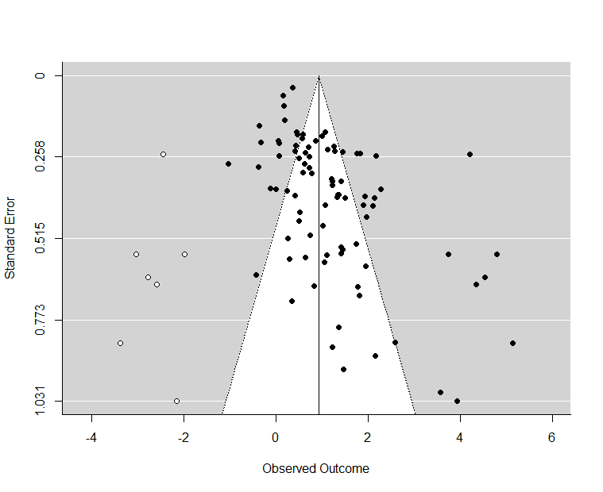

Figure S3. Funnel plot for the sex difference in the survival cost of parasitim. Black points are observed studies while white points are estimated missing studies from a trim-and-fill analysis.
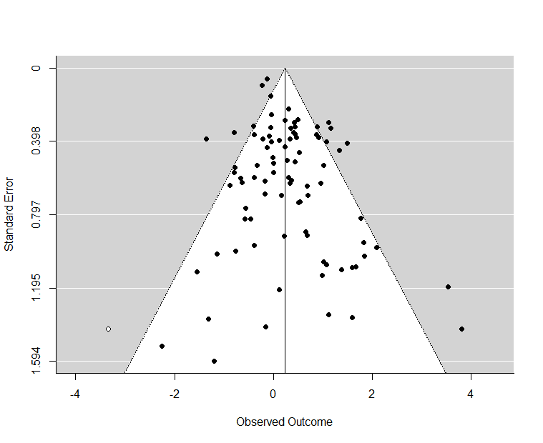
Figure S4. QQplot from the base meta-analytic model for the survival cost of parasitism. Due to non-normality indicated by this plot we used smoothed-cases bootstrapping to estimate standard errors and confidence intervals for models estimating the survival cost of parasitism.
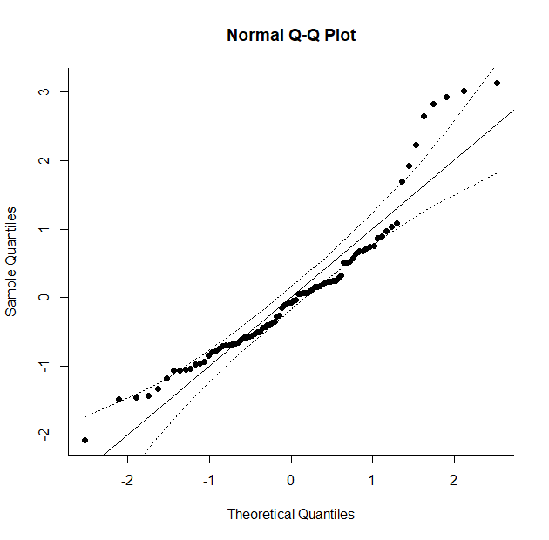
Figure S5. QQplot from the base meta-analytic model for the sex difference in the survival cost of parasitism. This plot did not indicate any departure from normality.
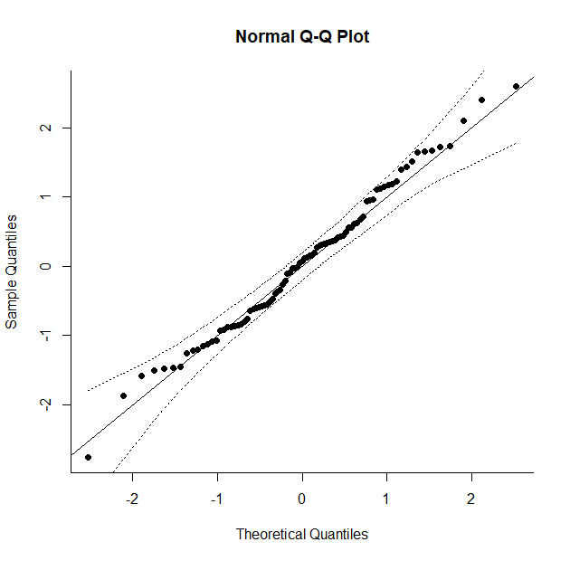
Figure S6. Moderators for the survival cost of parasitism and their model-averaged importance, which is calculated as the sum of the weights of the models they appear in.
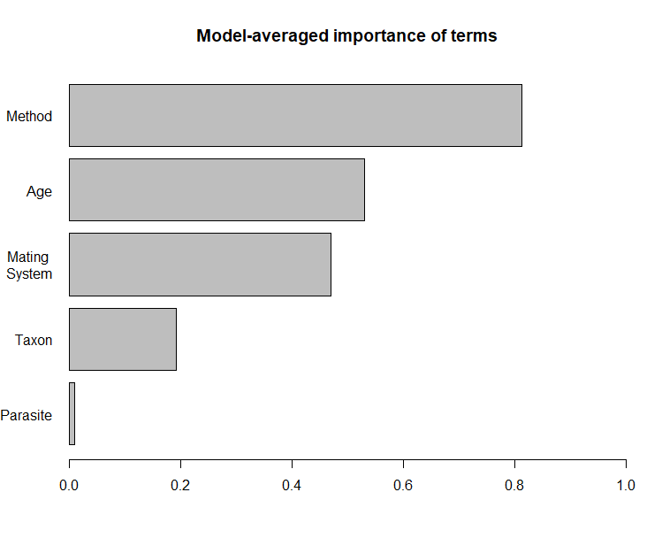
Figure S7. Moderators for the sex difference in the survival cost of parasitism and their model-averaged importance, which is calculated as the sum of the weights of the models they appear in.
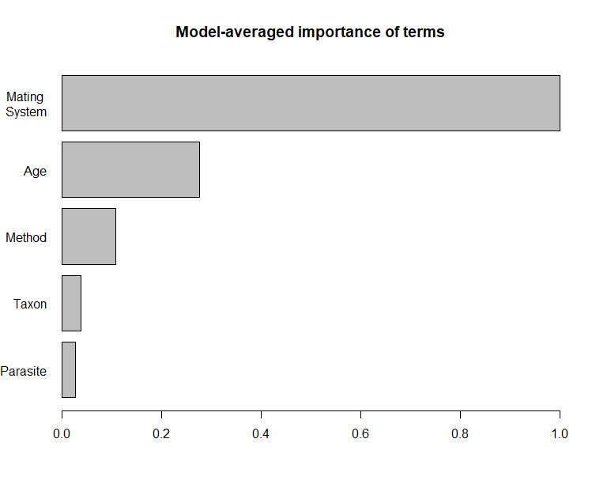

References for survival costs of parasitism from Table S1
Arcila, F., J. Meunier. 2020. Friend or foe? The apparent benefits of gregarine (Apicomplexa: Sporozoa) infection in the European Earwig. Int J Parasitol. 50:461-469
Arimoto H., H.K. Kaya, and E.E. Lewis. 2012. A laboratory study on the effect of Paraiotonchium autumnale parasitism on the longevity of Musca autumnalis. Parasitology. 139:1580–1586.
Arundell, K.L., A. Dubuffet, N. Wedell, J. Bojko, M.S.J. Rogers, A.M. Dunn. 2019. Podocotyl atomon (Trematoda: Digenea) impacts reproductive behaviour, survival and physiology in Gammarus zaddachi. Diseases of Aquatic Organisms. 136:51-62
Asghar M., D. Hasselquist, B. Hansson, P. Zehtindjiev, H Westerdahl, S. Bensch. 2015. Hidden costs of infection: Chronic malaria accelerates telomere degradation and senescence in wild birds. Science. 347:436-438
Atkinson C.T., K.L. Woods, R.J. Dusek, L.S. Sileo, and W.M. Iko. 1995. Wildlife disease and conservation in Hawaii: pathogenicity of avian malaria (Plasmodium relictum) in experimentally infected iiwi (Vestiaria coccinea). Parasitology. 111:S59–S69.
Atkinson C.T., R.J. Dusek, K.L. Woods, W.M. Iko. 2000. Pathogenicity of avian malaria in experimentally-infected Hawaii Amakihi. J Wildl Dis. 36:194-204
Bedhomme S., P. Agnew, C. Sidobre, and Y. Michalakis. 2004. Virulence reaction norms across a food gradient. Proc. R. Soc. B. 271:739–744.
Benesh D.P. and E.T. Valtonen. 2007. Effects of Acanthocephalus lucii (Acanthocephala) on intermediate host survival and growth: implications for exploitation strategies. J. Parasitol. 93:735–741.
Bergallo H.G., F. Martins-Hatano, N. Jucá, D. Gettinger. 2000. The effects of botfly parasitism of Metacuterebra apicalis (Diptera) on reproduction, survival and general health of Oryzomys russatus (Rodentia) in Southeastern Brazil. Mammalia. 64:439-446
Bize P., A. Roulin, J.L. Tella, and H. Richner. 2005. Female-biased mortality in experimentally parasitized Alpine Swift, Apus melba nestlings. Funct. Ecol. 19:405–413.
Boonstra R., C.J. Krebs, and T.D. Beacham. 1980. Impact of botfly parasitism on Microtus townsendii populations. Can. J. Zool. 58:1683-1692
Botto-Mahan C., A. Bacigalupo, J.P. Correa, E. Oda, A. Solari. 2012. Field assessment of Trypanosoma cruzi infection and host survival in the native rodent Octodon degus. Acta Tropica. 122:164-167
Braune P. and J. Rolff. 2001. Parasitism and survival in a damselfly: does host sex matter? Proc. R. Soc. B. 268:1133–7.
Bustnes J.O., K.E. Erikstad, S.A Hanssen, T. Tveraa, I. Folstad, J.U. Skaare. 2006 Anti-parasite treatment removes negative effects of environmental pollutatnts on reproduciton in an Arctic seabird. Proc. R. Soc. B. 273:3117-3122
Cayol C., A. Giermek, A. Gomez-Chamorro, J. Hytönen, E.R. Kallio, T. Mappes, J. Salo, M.J. Voordouw, E. Koskela. 2018. Borrelia afzelii alters reproductive success in a rodent host. Proc. R. Soc. B. 285:20181056
Chilvers B.L., P.J. Duignan, B.C. Robertson, A. Castinel, I.S. Wilkinson. 2008.. Effects of hookworms (Uncinaria sp) on the early growth and survival of New Zealand sea lion (Phocarctos hookeri) pups. Polar Biol. 32:295-302
Còrdoba-Aguilar A., and R. Munguia-Steyer. 2013. The Sicker Sex: Understanding Male Biases in Parasitic Infection, Resource Allocation and Fitness. PLoS One. 8(10):e76246
Craig B.H., O.R. Jones, J.G. Pilkington, and J.M. Pemberton. 2009. Re-establishment of nematode infra-community and host survivorship in wild Soay sheep following anthelmintic treatment. Vet. Parasitol. 161:47–52.
Currie J.L.M, and P.T.K. Woo. 2007. Susceptibility of sexually mature rainbow trout, Oncorhynchus mykiss, to experimental cryptobiosis caused by Cryptobia salmositica. Parasitol Res. 101:1057-1067
Dargent F., A.R. Reddon, W.T. Swaney, G.F. Fussmann, S.M. Reader, M.E. Scott, and M.R. Forbes. 2015. Demasculinization of male guppies increases resistance to a common and harmful ectoparasite. Parasitology. 142:1647–1655.

de Roode J.C., L.R. Gold, and S. Altizer. 2007. Virulence determinants in a natural butterfly-parasite system. Parasitology. 134:657-668.
Duclos L.M., B.J. Canner, B.B. Nickol. 2006. Virulence of Corynosoma constrictum (Acanthocephala: Polymorphidae) in Hyalella azteca (Amphipoda) throughout parasite ontogeny. J. Parasitol. 92:749:755
Fuller C. A. and Andrew R. Blaustein. 1996. Effects of the Parasite Eimeria arizonensis on Survival of Deer Mice (Peromyscus Maniculatus). Ecology. 77:2196–2202.
Gagnon A., G. Boivin, G. Bélair, B. Mimee. 2018. Prevalence of a nematode castrator of the carrot weevil and impact on fecundity and survival. Parasitology. 146:702-707.
Gegner T., T. Carrau, A. Vilcinskas, L. Kwang-Zin. 2018. The infection of Harmonia axyridis by a parasitic nematode is mediated by entomopathogenic bacteria and triggers sex-specific host immune responses. Scientific Reports. 8:15938
Granroth-Wilding H.M.V., S.J. Burthe, S. Lewis, K.A. Herborn, E.A. Takahashi, F. Daunt, E.J.A. Cunningham. 2015. Indirect effects of parasitism: costs of infection to other individuals can be greater than direct costs borne by the host. Proc. R. Soc. B. 282:20150602
Gray D.A. 1998. Sex differences in susceptibility of house crickets, Acheta domesticus, to experimental infection with Serratia liquefaciens. J. Invertebr. Pathol. 71:288–289.
Gulland F.M. 1992. The role of nematode parasites in Soay sheep (Ovis aries L.) mortality during a population crash. Parasitology. 105:493–503.
Gulland F.M.D., S.D. Slbon, J.M. Pemberton, P.R. Moorcroft, and T.H. Clutton-Brock. 1993. Parasite-associated polymorphism in a cyclic ungulate population. Proc. R. Soc. B. 254:7–11.
Hangartner S., L. Michalczyk, M.J.G. Gage, O.Y. Martin. 2015. Experimental removal of sexual selectino leads to decreaed investment in an immune component in female Tribolium castaneum. Infect Genet Evol. 33:212-218
Hurd H., W. Warr, A. Polwart. 2001. A parasite that increaes host lifespan. Proc. R. Soc. B. 22:1749-1753
Joop G., A. Mitschke, J. Rolff, and M.T. Siva-Jothy. 2006. Immune function and parasite resistance in male and polymorphic female Coenagrion puella. BMC. Evol. Biol. 6:1–10.
Kallio E.R., L. Voutilainen, O. Vapalahti, A. Vaheri, H. Henttonen, E. Koskela, and T. Mappes. 2007. Endemic hantavirus infection impairs the winter survival of its rodent host. Ecology. 88:1911–1916.
Kokkotis T., J.D. McLaughlin. 2006. Pathogenicity of the hymenolepidid cestode Microsomacanthus hopkinsi in its intermediate host, Hyalella azteca: Implications for transmission, host fitness, and host populations. Canadian Journal of Zoology. 84(doi: 10.1139/z05-173)
Kramarz P.E., D. Małek, M. Gaweł, S.M. Drobniak, and J. Homa. 2016. Reproductive status of Tribolium castaneum (Coleoptera: Tenebrionidae) affects its response to infection by Steinernema feltiae (Rhabditida: Steinernematidae). Eur. J. Entomol. 113:309–314.
Kulma K., M. Low, S. Bensch, A. Qvarnström. 2013. Malaria infections reinforce competitive asymmetry between two Ficedula flycatchers in a recent contact zone. Molecular Ecology. 22:4591-4601
Lachish S., B. Lawson, A.A. Cunningham, B.C. Sheldon. 2012. Epidemiology of the emergent disease Paridae pox in an intensively studied wild bird population. PLoS One. 7(11)(doi:10.1371/journal.pone.0038316)
Lanciani C.A. 1982. Parasite-mediated reductions in the survival and reproduction of the backswimmer Buenoa scimitra (Hemiptera: Notonectidae). Parasitology. 85:593-603
Lantova L., M. Svobodova, P. Volf. 2011. Effects of Psychodiella sergenti (Apicomplexa, Eugregarinorida) on its natural host Phlebotomus sergenti (Diptera, Psychodidae). Journal of Medical Entomology. 45:985-990
Léonard N.J., M.R. Forbes, and R.L. Baker. 1999. Effects of a mite, Limnochares americana (Hydrachnida: Limnocharidae), on the life-history traits and grooming behaviour of its damselfly host, Enallagma ebrium (Odonata: Coenagrionidae). Can. J. Zool. 77:1615–1622.
Lemaître J., D. Fortin, P. Montiglio, M. Darveau. 2009. Bot fly parasitism of the red-backed vole: host survival, infection risk, and population growth. Oecologia. 159:283-294
Lin J, H. Lo, H. Wang, and P.L. Shaner. 2014. The effects of mite parasitism on the reproduction and survival of the Taiwan field mice (Apodemus semotus). Zool. Stud. 53:1–11.
Lindsey E. and S. Altizer. 2009. Sex differences in immune defenses and response to parasitism in monarch butterflies. Evol. Ecol. 23:607–620.
Lo H., and P.L. Shaner. 2015. Sex-specific effects of parasitism on survival and reproduction of a rodent host in a subtropical montane region. Oecologia. 177:657–667.
Luis A.D., R.J Douglass, P.J. Hudson, J.N. Mills, O.N Bjornstad. 2012. Sin Nombre hantavirus decreases survival of male deer mice. Oecologia. 169:431-439
Magallanes S., L Garcia-Longoria, C. Lopez-Calderon, M. Reviriego, F. de Lope, A.P. Moller, A. Marzal. 2017. Uropygial gland volume and malaria infection are related to survival in migratory house martins. Journal of Avian Biology. 48:1355-1359
Marescot L., S. Benhaiem, O. Gimenez, H. Hofer, J. Lebreton, X.A. Olarte-Castillo, S. Kramer-Schadt, M.L. East. 2018. Social status mediates the fitness costs of infection with canine distemper virus in Serengeti spotted hyenas. Functional Ecology. 32:1237-1250
Martinez-Sanchez A., A.D. Camacho, M.T. Quintero-Martinez, R. Alejandre-Aguilar. 2007. Effect of ectoparasitic Pimeliaphilus plumifer mites (Acari Pterygosomatidae) on Meccus pallidipennis (Hemiptera: Reduviidae) and several other Chagas’ disease vectors under laboratory conditions. Experimental and Applied Acarology. 42:139-149
McDonald J.J., G.C. Smith, R.A. McDonald, R.J. Delahay, D. Hodgson. 2014. Mortality trajectory analysis reveals the drivers of sex-specific epidemiology innatural wildlife-disease interactions. Proc. R. Soc. B. 281:20140526
Miller C.V.L., S.C. Cotter. 2018. Journal of Animal Ecology. Resistance and tolerance: The role of nutrients on pathogen dynamics and infection outcomes in an insect host. Journal of Animal Ecology. 87:500-510
Morton A., and F. Garćia-del-Pino. 2009. Virulence of entomophatogenic nematodes to different stages of the flatheaded root borer Capnodis tenebrionis (L.) (Coleoptera: Buprestidae). Nematology. 11:365-373
Morton A., and F. Garćia-del-Pino. 2013. Sex-related differences in the susceptibility of Periplaneta americana and Capnodis tenebrionis to the entomopathogenic nematode Steinernema carpocapsae. Journal of Invertebrate Pathology. 112:203-207
Musser, F.R., K.S. Knighten, S.R. Self. 2012. Impace of Nosema (Microsporidia) infection and fumagillin treatment on Lygus lineolaris (Hemiptera: Miridae). 2012. Journal of Invertebrate Pathology. 111:101-105
Nguyen N., P.J. Fashing, D.A. Boyd, T.S. Barry, R.J. Burke, C.B. Goodale, S.C. Jones, J.T. Kerby, B.S. Kellogg, L.M. Lee, C.M. Miller, N.O. Nurmi, M.S. Ramsay, J.D. Reynolds, K.M. Stewart, T.J. Turner, V.V. Venkataraman, Y. Knauf, C. Roos, and S. Knauf. 2015. Fitness impacts of tapeworm parasitism on wild gelada monkeys at Guassa, Ethiopia. Am. J. Primatol. 77:579–594.
Podmokla E., A. Dubiec, S.M. Drobniak, J. Sudyka, A. Krupski, A. Arct, l. Gustafsson, M. Cichon. 2017. Effects of haemosporidian infections on host survival and recapture rate in the blue tit. Journal of Avian Biology. 48:796-803
Rau M., S.S. Ahmed, D.J. Lewis. 1991. Impact of the entomophilic Digenean Plagiorchis-Noblei (Trematoda, Plagiorchiidae) on the survival of Aedes provocans under field conditions. Journal of the American Mosquito Control Association. 7:194-197
Riddick E.W. 2010. Ectoparasitic mite and fungus on an invasive lady beetle: parasite coexistence and influence on host survival. Bulletin on Insectology. 64:13-20
Rosengaus R.B., J.F.A., Trainello, M.L., Lefebvre, and D.M. Carlock. 2000. The social transmission of disease between adult male and female reproductives of the dampwood termite Zootermopsis angusticollis. Ethol. Ecol. Evol. 12:419-433
Samish M., E. Alekseev, I. Glazer. 2000. Mortality rate of adult ticks due to infection by entomopathogenic nematodes. Journal of Parasitology. 86:679-684
Schrader M.S., E.L. Walters, F.C. James, E.C. Greiner. 2003. Seasonal prevalence of a haematozoan parasite of red-bellied woodpeckers (Melanerpes carolinus) and its association with host condition and overwinter survival. Auk. 120:130-137
Schostak A.W. K.G. Van Buuren, R. Cook. 2015. Response of flour beetles to multple stressors of parasitic (Hymenolepis diminuta) environmental 9Diatomaceous earth) and host (reproduction) origin. Journal of Parasitology. 101:405-417
Simmons A.M., and C.E. Rogers. 1994. Effect of an ectoparasitic nematode, Noctuidonema-Guyanese, on adult longevity and egg fertility in Podoptera frugiperda (Lepidoptera, Noctuidae). Biological Control. 4:285-289
Souchay G., G. Gauthier, and R. Pradel. 2013. Temporal variation of juvenile survival in a long-lived species: The role of parasites and body condition. Oecologia. 173:151–160.
Steen H., M. Taitt, C.J. Krebs. 2002. Risk of parasite-induced predatin: an experimental field study on Townsend’s voles (Microtus townsendii). Canadian Journal of Zoology. 80:1286-1292
Vandegrift K.J., T.R. Raffel, and P.J. Hudson. 2008. Parasites prevent summer breeding in white-footed mice, Peromyscus leucopus. Ecology. 89:2251–2258.
Waite J.L., A.R. Henry, F.R. Adler, and D.H. Clayton. 2012. Sex-specific effects of an avian malaria parasite on an insect vector: Support for the resource limitation hypothesis. Ecology. 93:2448–2455.
Webberley K.M., G.D.D Hurst. 2002. The effect of aggregative overwintering on an insect sexually transmitted parasite system. Journal of Parasitology. 88:707-712
Weiberg M. and D.D. Edwards. 1997. Survival and reproductive output of Chironomus tentans (Diptera: Chironomidae) in response to parasitism by larval Unionicola foili). J. Parasitol. 83:173–175.
Wilde L.R., C.J. Wolf, S.M. Porter, M. Stager, Z.A. Cheviron, N.R. Senner. 2019. Botly infections impair the aerobic performance and survival of montane populations of deer mice, Peromyscus maniculatus rufinus. Functional Ecology. 33:608-618
Wilkinson D., G.C. Smith, R.J. Delahay, L.M. Rogers, C.L. Cheeseman, R.S. Clifton-Hadley. 2000. The effects of bovine tuberculosis (Mycobacterium bovis) on mortality in a badger (Meles meles) population in England. Journal of Zoology. 250:389-395
Zylberberg M., E.P. Derryberry, C.W. Breuner, E.A. Macdougall-Shackleton, J.M. Cornelius, T.P. Hahn. 2015. Haemoproteus infected birds have increased lifetime reproductive success. Parasitology. 142:1033-1043
References for host mating systems from Table S1
Awad, M., Laugier, G.J.M., Loiseau, A. et al. 2015. Unbalanced polyandry in wild-caught ladybirds Harmonia axyridis (Coleoptera: Coccinellidae). Appl Entomol Zool 50, 427–434
Bell, W.J., L.M. Roth, C.A. Nalepa. 2007. Cockraoches Ecology, Behavior and Natural History. John Hopkins University Press.
Bergallo, H.G., and W.E. Magnusson. 2004. Factors affecting the use of space by two rodent species in Brazilian Atlantic forest. Mammalia. 68:2-3
Bonomi, A. et. al. 2011. Polyandry is a Common Event in Wild Populations of the tsetse fly Glossina fuscipes fuscipes and May Impact Population Reduction Measures. PLoS Negl Trop Dis. 5(6): e1190
Bonsignore, C.P. and T.M. Jones. 2014. Aggregation and mating success of Capnodis tenebrionis (Coleoptera: Buprestidae). Insect. Science. 21:203-212
Brent, C.S. 2010. Reproduction of the western tarnished plant bug, Lygus Hesperus in relation to age, gonadal activity and mating status. Journal of Insect Physiology. 56:28-34
Brouwer, L. and S.C. Griffith. 2019. Extra-pair paternity in birds. Molecular Ecology. 28(0.1111/mec.15259)
Caesar, R.W. 2012. Phylogeny of the Genus Argia (Odonata: Coenagrionidae) with Emphasis on Evolution of Reproductive Morphology. The Ohio State University. PhD Disseratation.
Córdoba-Aguilar, A. 2006. Sperm ejection as a possible cryptic female choice mechanism in Odonata (Insecta). Physiological Entomology. 31:146-153
Cutullé C., N.N. Johnsson, J.M. Seddon. 2010. Multiple paternity in Rhipicephalus (Boophilus) micropus confirmed by microsatellite analysis. Experimental and Applied Acarology. 50:51-58
Drnevich, J.M. 2003. Number of mating males and mating interval affect last-male sperm precedence in Tenebrio molitor L. Animal Behaviour. 66:249-357
Dugdale, H.L., D.W. Macdonald, L.C. Pope, T. Burke. 2007. Polygynandry, extra-group paternity and multiple-paternity litters in European badger (Meles meles) social groups. Mol Ecol. 2007:5294-5360
East, M.L., T. Burke, K. Wilhelm, C. Greig, H. Hofer. 2003. Sexual Conflicts in Spotted hyenas: Male and Female Mating Tactics and Their Reproducive Outcome with Respect to Age, Social Status and Tenure. Proc. R. Soc. B. 270:1247-1254
Ebensperger, L.A., L.A. Correa, A.L. Prieto, F.P. de Arce, S. Abades, L.D. Hayes. 2019. Multiple mating is linked to social setting and benefits the males ina communally rearing male. Behavioral Ecology. 30:675-687
Eberhard, W.G. 2004. Male-female conflict and genitalia: failure to confirm predictions in insects and spiders. Biol. Rev. 79:121-186
Fincke, O.M. 1982. Lifetime Mating success in a Natural Population of the Damselfly, Enallagma hageni (Walsh) (Odonata: Coenagrionidae). Behavioral Ecology and Sociobiology. 10:293-302
Foote, I.N.M. 2018. The role of social structure and kin associations in the mating system of the polygynous New Zealand sea lion (Phocarctos hookeri). University of Otago. Masters Thesis. http://hdl.handle.net/10523/8211
Forbes, M.R.L. 1991. Ectoparasites and mating success of male Enallagma ebrium damselflies (Odonate: Coenagrionidae). Oikos. 60:336-342
García-Navas, V., T. Bonnet, R. Bonal, & E. Postma. 2015. The role of fecundity and sexual selection in the evolution of size and sexual size dimorphism in new world and old-world voles (Rodentia: Arvicolinae). Oikos. 125:1250-1260
Gray D.A. 1998. Sex differences in susceptibility of house crickets, Acheta domesticus, to experimental infection with Serratia liquefaciens. J. Invertebr. Pathol. 71:288–289
Griffith, S.C., I.P. Owens, and K.A. Thuman. 2002. Extra pair paternity in birds: a review of interspecific variation and adaptive function. Mol Ecol. 11:2195-2212
Haddrill, P.R., D.M. Shuker, W. Amos, M.E.N. Majerus, S. Mayes. 2008. Female multiple mating in wild and laboratory populations of the two-spot ladybird, Adalia bipunctata. Molecular Ecology. 17:3189-3197
Jormalainen, V. 1998. Precopulatory Mate Guarding in Crustaceans: Male Competitive Strategy and Intersexual Conflict. The Quarterly Review of Biology. 73:275-304
Kuntz, W.A. 2008. The importance of individual behavior to life history and conservation: breeding and movement biology in the ‘I’Iwi (Vestiaria coccinea). PhD diss. University of Hawai’i
Lambin, X., & C.J. Krebs. 1991. Spatial organization and mating system of Microtus townsendii. Behavioural Ecology and Sociobiology. 28:353-363
Mansour, M.Y. 1987. The effects of ionizing radiation on the face fly, Musca autumnalis DeGeer, irradiated in nitrogen. Iowa State University. PhD dissertation.
Martins, T., J.K. Blakey, J. Wright. 2002. Low incidence of extra-pair paternity in the colonially nesting common swift Apus apus. Journal of Avian Biology. 33:441-446
Mitani, J.C., J. Gros-Louis, A.F. Richards. 1996. Sexual Dimorphism, the Operational Sex Ratio, and the Intensity of Male competition in Polygynous Primates. American Naturalist. 147(doi: 10.1086/285888)
Murúa, M.G., M. T. Vera, S. Abraham, M. L. Juarçz, S. Prieto, G. P. Head, E. Willink. 2008 Fitness and Mating Compatibility of Spodoptera frugiperda (Lepidoptera: Noctuidae) Populations from Different Host Plant Species and Regions in Argentina. Annals of the Entomological Society of America. 10:639–649
Nalepa, C.A., and S.C. Jones. 1991. Evolution of Monogamy in Termites. Biol. Rev. 66:83-97
Nava‐Bolaños, A., Córdoba‐Aguilar, A. and Munguía‐Steyer, R. 2012. A Test of Genital Allometry Using Two Damselfly Species does not Produce Hypoallometric Patterns. Ethology. 118: 203-213.
Neff, B.D., T.E. Pitcher, I.W. Ramnarine. 2008. Inter-population variation in multiple paternity and reproductive skew in the guppy. Molecular Ecology. 17:2975-2984
Pai, A., & G. Bernasconi. 2008. Polyandry and female control: The red flour beetle Tribolium castaneum as a case study. Journal of Experimental Zoology. 310:148-159
Poesel, A., H. Gibbs, D. Nelson. 2011 Extrapair fertilizations and the potential for sexual selection in a socially monogamous songbird. The Auk. 125:770-776
Richardson, J.B., S.B. Jameson, A. Gloria-Soria, D.M. Wesson, J. Powell. 2015. Evidence of Limited Polyandry in a Natural Population of Aedes Aegypti. Am J Trop Med Hyg. 8:189-193
Ripper, C. 1987. Breeding Ecology of the Hawaii Common Amakihi. The Condor. 89:85-102
Rowe, L. 1994. The costs to mating and mate choice in water striders. Animal Behaviour. 48:1049-1056
Scott, M.P. 1998. The Ecology and Behavior of Burying Beetles. Annual Review of Entomology. 43:595-618
Sandrin, L., Meunier, J., Raveh, S., Walser, J.‐C. And Kölliker, M. 2015, Multiple paternity and mating group size in the European earwig, Forficula auricularia. Ecol Entomol, 40: 159-166.
Seamons, T.R., P. Bentzen, T.P. Quinn. 2004. The Mating system of Steelhead, Oncorhynchus mykiss, Inferred by Molecular Analysis of Parents and Progeny. Environmental Biology of Fishes. 69:333-344.
Shaner, P.L., A. Yu, S. Li, and C. Hou. 2018. The effects of food and parasitism on reproductive performance of a wild rodent. Ecol Evol. 8:4162-4172
Soulsbur, C.D. 2010. Genetic patterns of paternity and testes size in mammals. PLoS ONE 5:e9581
Svärd, L., C. Wiklund. 1988. Prolonged Mating in the Monarch Butterfly Danaus plexippus and Nightfall as a Cue for Sperm Transfer. Oikos, 51(3), 351-354
Tisell, H.B., A.L. Degrassi, R.B. Stephens, R.J. Rowe. 2019. Influence of field technique, density and sex on home range and overlap of the southern red-backed vole (Myodes gapperi). Canadian Journal of Zoology. 17(doi: 10.1139/cjz-2018-0338)
Thompson, D.J., C. Hassall, C.D. Lowe, P.C. Watts. 2011. Field estimates of reproductive success in a model insect: behavioural surrogates are poor predictors of fitness. Ecology Letters. 14:905-913.
Vitta, A.C., M.G. Lorenzo. 2009. Copulation and Mate Guarding Behaviour in Triatoma brasiliensis (Hemiptera: Reduviidae). Journal of Medical Entomology. 46:789-795
Wolff, J.O., and P.W. Sherman. 2007. Rodent societies: an ecological & evolutionary perspective. [Chicago] The University of Chicago Press
Wen, Y.H. 1993. Sexual Dimorphism and Mate Choice in Hyalella Azteca (Amphipods). The American Midlands Naturalist. 129:153-160
Xia, X., and J.S. Millar. 1991. Genetic evidence of promiscuity in Peromyscus leucopus. Behavioral Ecology and Sociobiology. 28:171-178
Yuval, B. 2006. Mating systems of blood-feeding flies. Annu. Rev. Entomol. 51:413-440

