Supporting Information
Additional field methods. In Austral Summers 2013 and 2014, one whisker was plucked from each of 19 seals, and the follicle location recorded. Whiskers were selected based on the following criteria: 1) The whisker was at asymptotic length (e.g., similar in length to its adjacent whiskers (1)) and 2) The whisker was fully intact (e.g., tapered at end, with no clear breakage or splintering). Seal masses were measured directly using an electronic scale (MSI-7300 Dyna-Link 2, resolution ± 0.25 kg) suspended from a tripod.

Diving data analysis. Zero-offset correction and dive identification were achieved using the IKNOS toolbox in MATLAB (The MathWorks, Inc., Y. Tremblay). Dives were identified as excursions from the surface reaching a maximum depth of at least 10 meters and lasting a minimum duration of 30 seconds. Jaw motion events were identified from the raw acceleration data using a 0.3g amplitude surge acceleration threshold in IGOR PRO (WaveMetrics, Inc.). Mass gain per hour diving was calculated as mass gain between deployment and recovery divided by the total number of hours diving.

Dives were considered benthic if they had (1) minimal bottom phase vertical excursions (2) square corners; and (3) a bottom phase slope close to zero. To characterize the bottom phase vertical excursions, we calculated a kernel density of bottom phase vertical rate for each dive. If the peak fell within the range of ± 0.08 meters per second (nearly flat bottom) and the height of the peak exceeded a density of 1.5 (consistent vertical rate), it was classified as a benthic dive. Additionally, best-fit lines were drawn for the descent phase and the bottom phase, and the intersection between the two lines was checked against the animal’s actual trajectory. If the actual trajectory was less than 15 meters from the intersection point (i.e., switch from descent phase to bottom phase was sharp), it was identified as a benthic dive (n=1,423). All other dives (those with gradual changes from descent to bottom phase, variable vertical rates) were considered pelagic (n=137,083, or 99% of all dives). The limited frequency of benthic dives during the entire summer (mean 1% of dives, ranging from 0% to 16% among individuals, Figure S6) indicates that seals focused their foraging efforts on pelagic or under-ice, rather than on benthic prey.

To differentiate the shallow diving period from the preceding and following periods of deeper diving, we calculated the full-time duration at 25% minimum depth (adapted from full-width-at-half-maximum waveform analysis) using: [Depth_{cutoff}=Y_{max}-[(Y_{max}-Y_{min})*0.25], where Y_{max} is the shallowest daily mean depth (105 meters) and Y_{min} is the deepest daily mean depth (245 meters). The Depth_{cutoff} was 140 meters and resulted in a shallow period of 19 days before ice break-out to 4 days after ice break-out. We compared diving depth, wiggles per minute bottom time (hereafter, feeding rates) and percent bottom time (hereafter, foraging efficiency) across the first ten days of deployment (preceding deep period, 60 to 51 days before ice break-out), shallow period (19 days before ice break-out to 4 days after ice break-out) and last ten days of deployment (following deep period, 6 to 15 days after ice break-out). We report the total effect of increased feeding rates and foraging efficiency by summing the values for the early and late periods.

Diet analysis. Because tissue catabolism (i.e. mass loss) can elevate tissue δ¹⁵N values independently of dietary changes, we limited our analysis to the 9 seals that gained mass across the deployment period. Each whisker was measured and then washed for 30 minutes in a reciprocal shaking ultrasonic bath (20°C, 180 rpm; Thermo Fisher Scientific, Waltham, MA, USA) with petroleum ether to remove exogenous lipids. The base of each whisker was removed to avoid the ¹⁵N bias associated with the sub-dermal whisker portion. The remaining whisker was then subsampled into 0.45-0.55 mg sequential segments and placed into tin boats for analysis. In addition, the distance of each subsample from the whisker tip was recorded so that growth dates could be estimated. Samples were analyzed for δ¹³C and δ¹⁵N using an ECS 4010 elemental analyzer (Costech, Valencia, CA, USA) coupled to a ThermoFinnigan Delta V Advantage continuous-flow isotope ratio mass spectrometer (Thermo Scientific, Bremen, Germany) at the University of Alaska Anchorage Environment and Natural Resources Institute Stable Isotope Laboratory. Homogenized peach leaf (NIST 1547, δ¹³C=-25.89‰, δ¹⁵N=1.89‰), bowhead whale baleen (University of Alaska; δ¹³C=-18.37‰, δ¹⁵N=14.44‰) and purified methionine (Alfa Aesar, Heysham, UK; δ¹³C=-34.58‰, δ¹⁵N=-0.94‰) were used as internal standards. All values are reported in parts per thousand deviations from the standard value (‰) using the equation δ^{h}X=[((R_{sample}-R_{standard})/R_{standard})*1000] where X represents the element, h is the heavy atomic mass number, and R is the heavy-to-light isotope ratio found in the sample or standard (¹³C/¹²C or ¹⁵N/¹⁴N).

Average whisker δ¹³C and δ¹⁵N values for each seal (mean±SD, 5±2 segments, range 3 to 8) were incorporated into a stable-isotope mixing model using R package SIAR along with bulk isotope values from five prey groups (values from (2), Table S1), the ∆¹³C trophic enrichment factor (TEF) used in Goetz, Burns (2) (mean±SD 0.8±0.12‰), and the ∆¹⁵N TEF from Beltran, Peterson (3) (mean±SD 3.2±0.5‰).

To estimate the dates during which each whisker segment was grown, we first calculated a growth rate for each whisker using the asymptotic growth equations appropriate for phocid seals (1). The curvature constant k was calculated for each whisker using k= -(log(1-(L/ L∞))/T) where L is the total length of the whisker upon recovery (cm), T is the duration of whisker growth (i.e. number of days between the first handling and recapture), and L∞ is the asymptotic length of the whisker (cm), which was assumed to be the length of the first whisker from that follicle when it was plucked during the first handling in November/December. The ages of segments along each whisker were then calculated using Age=(-1/k)*log(1-Distance/ L∞) where k is the previously determined curvature constant, Distance is the distance of each regrown whisker segment from the tip of the whisker (cm), and L∞ is the previously determined asymptotic length of each whisker (cm). The age of each whisker subsample was thus the number of days since the whisker had started growing (i.e., initiation date). The tip of the whisker (i.e., oldest growth) was treated as day zero, and the base of the whisker (i.e., newest growth) represented the maximum age of growth that also corresponded to the number of days between the first handling and recapture. The date of starting growth for each whisker was calculated by subtracting the age of the subsample closest to the base from the date of the recovery procedure. Finally, the starting date of growth for each whisker segment was calculated as the difference between the starting growth date of each whisker and the age of each subsample.

Table S1. Group of Weddell seal prey species from (2) along with the diet contribution estimated from a SIAR mixing model. Due to statistically indistinguishable isotopic values, prey species were combined into prey groups before using mixing models.

Prey Group | Prey Species | Diet Proportion  mode (95% confidence intervals)
a | Dissostichus mawsoni | 0.01 (0.00-0.10)
b | Trematomus hansoni | 0.01 (0.00-0.13)
c | Pagothenia borchgrevinki  Trematomus nicolai  Trematomus bernacchii  Trematomus pennellii | 0.20 (0.06-0.39)
d | Pleurogramma antarcticum Trematomus newnesi | 0.72 (0.34-0.86)
e | Neopagetopsis ionaha | 0.02 (0.00-0.16)

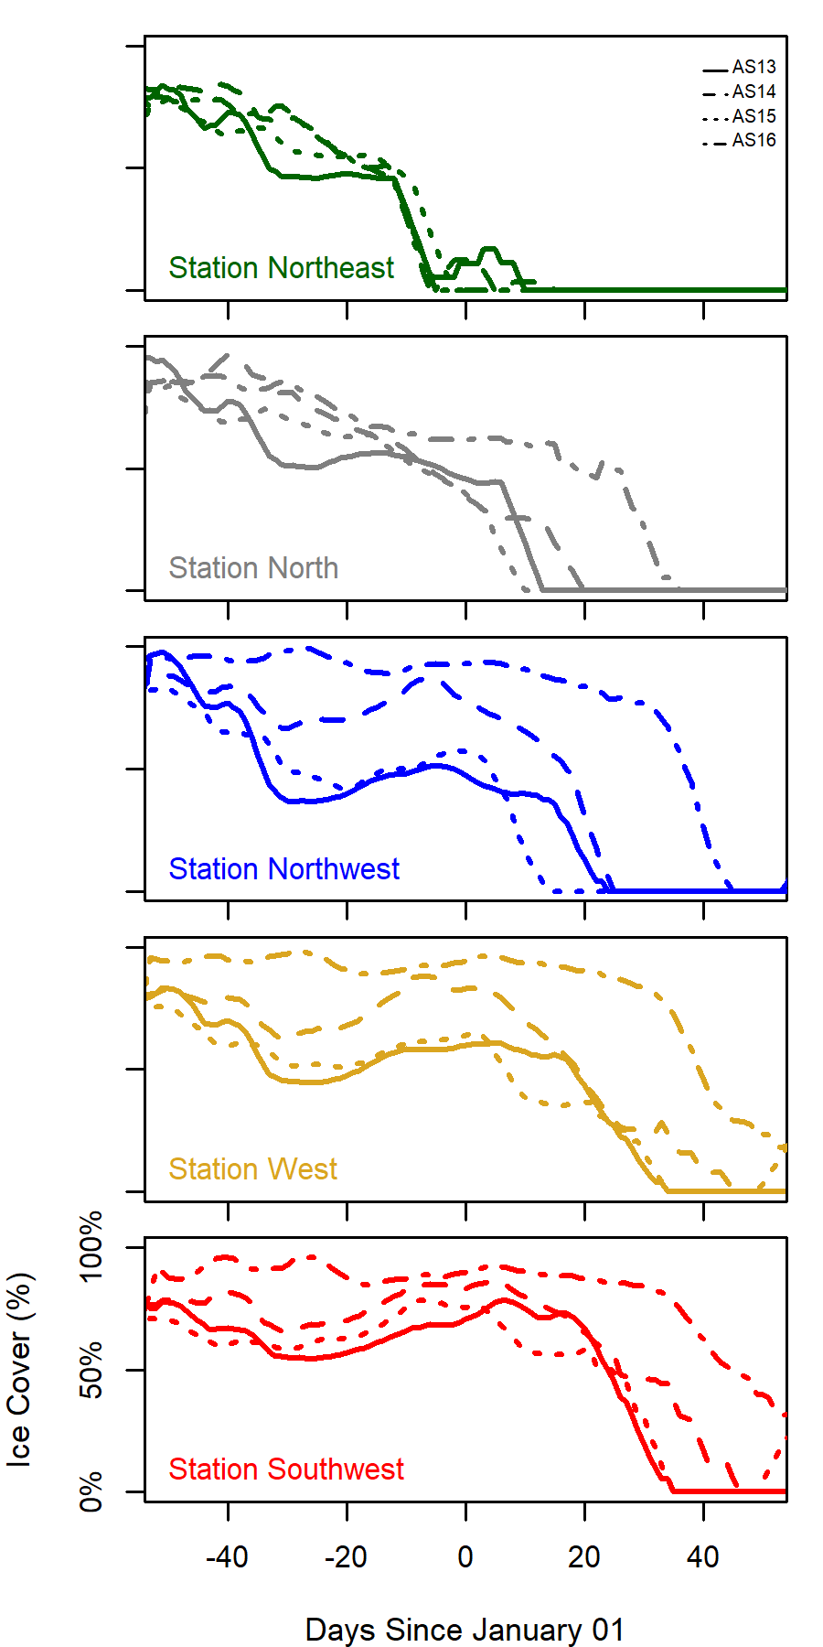

Figure S1. Seven-day running mean of percent ice cover for the four study years (line types) and five stations (panels/colors) around Ross Island, Antarctica. Satellite-derived sea ice concentration courtesy of the US National Snow and Ice Data Center; NASA Bootstrap SMMR-SSM/I combined dataset). Ice break-out in the manuscript is defined as <50% ice cover.
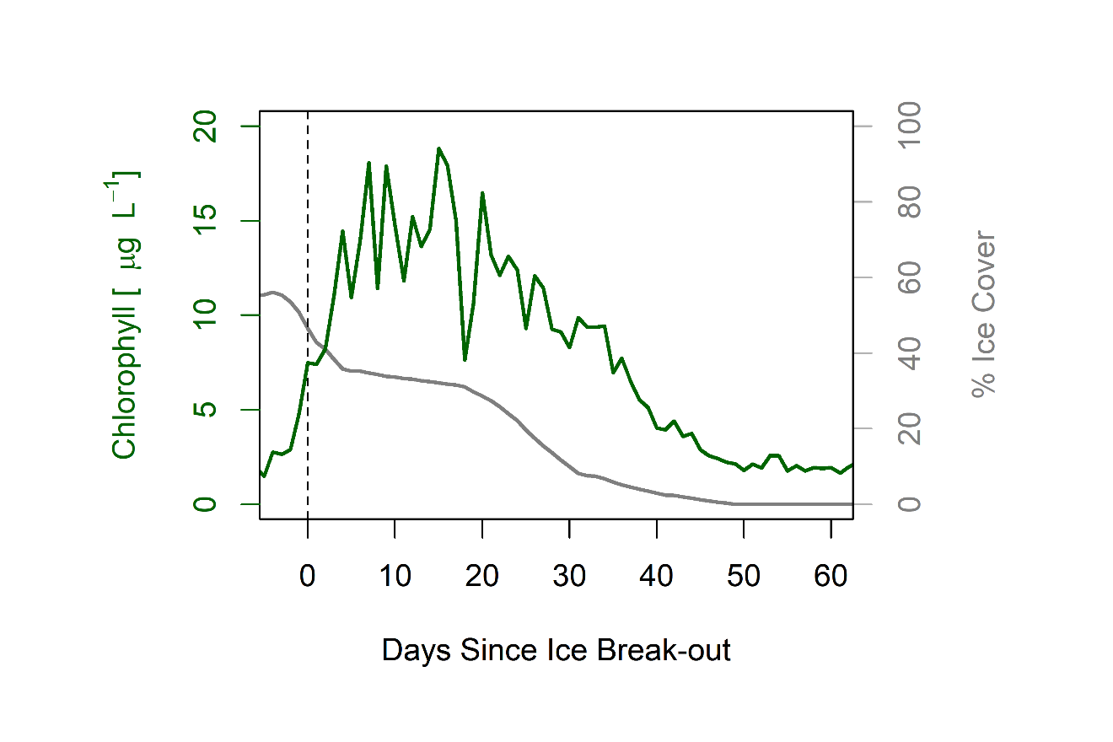
Figure S2. Phytoplankton biomass (green line) begins to increase as percent ice cover (grey line) breaks out (decreases below 50%; dashed black line) in austral summer 2012 at Cape Crozier, 100km away from our study site. Average 0–50 m chlorophyll concentrations (green, redrawn from Jones and Smith Jr. (4)) and 7-day running mean of percent ice cover (grey). Ocean currents result in phytoplankton bloom being advected into our study area occurring days to weeks earlier than local sea ice break-out.

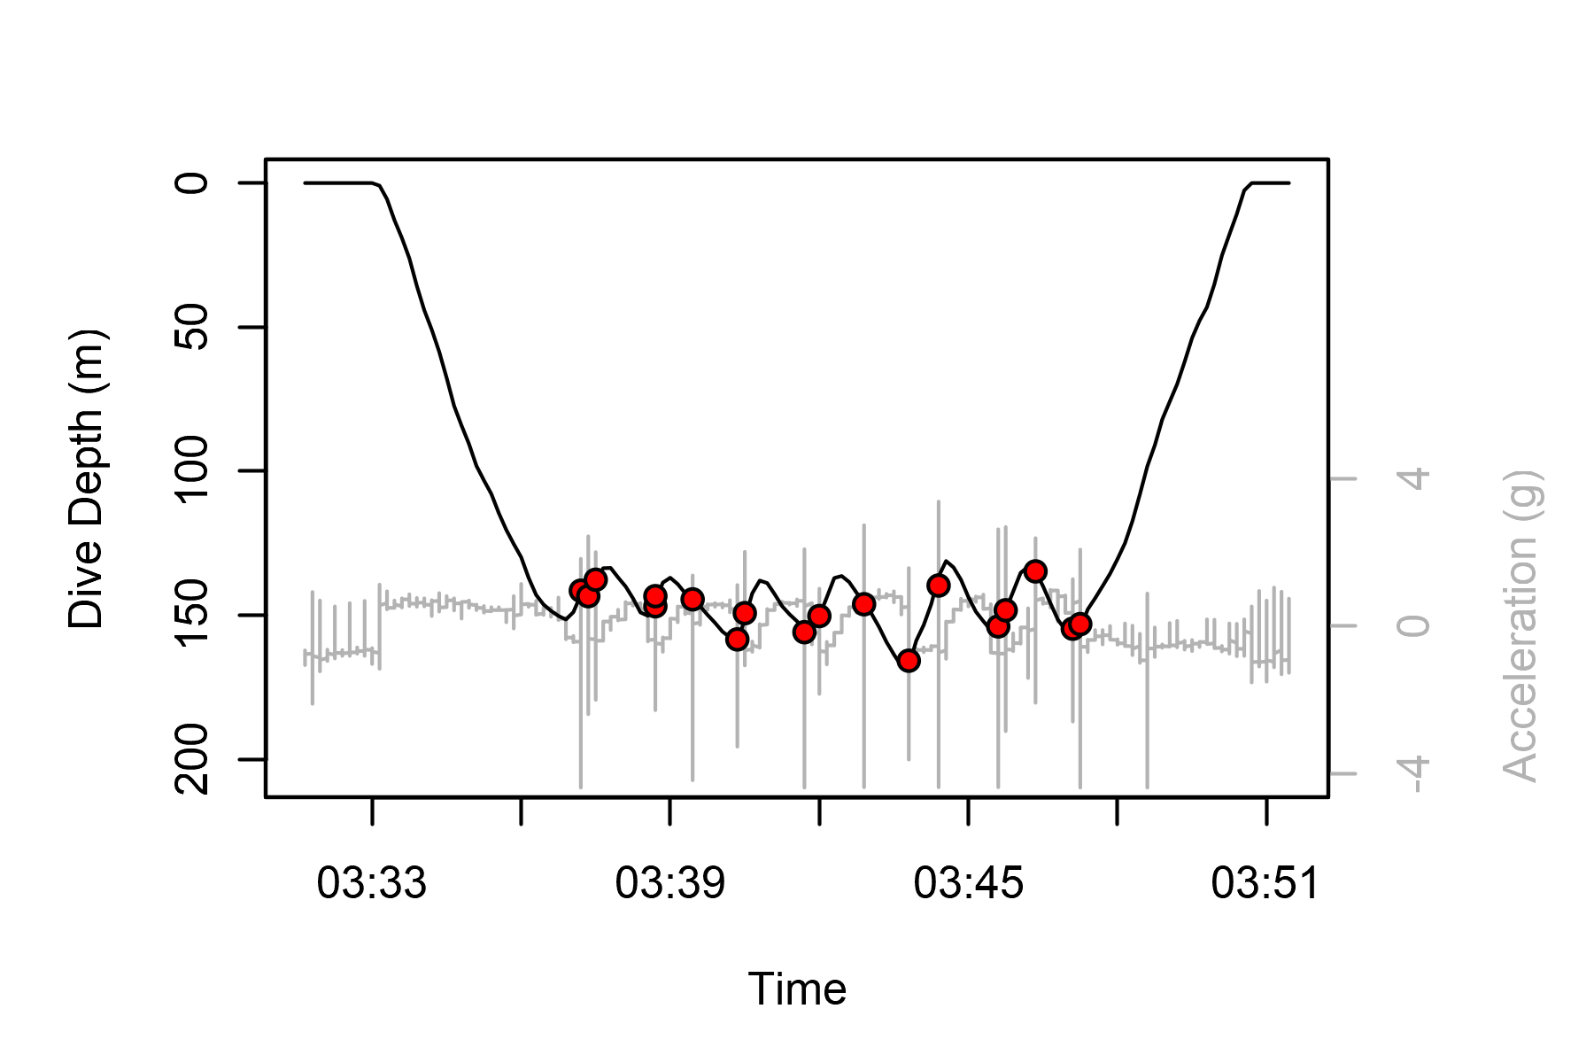
Figure S3. Lower jaw acceleration (grey line) and resulting prey capture attempts (red points; >0.3g amplitude in acceleration) overlayed on a dive depth profile (black line) for an individual seal. This 17-minute dive contained 15 bottom wiggles (inflection points) and 35 jaw motion events. Raw acceleration surges during pre- and post-dive interval (left and right of dive) represent head movement associated with breathing.
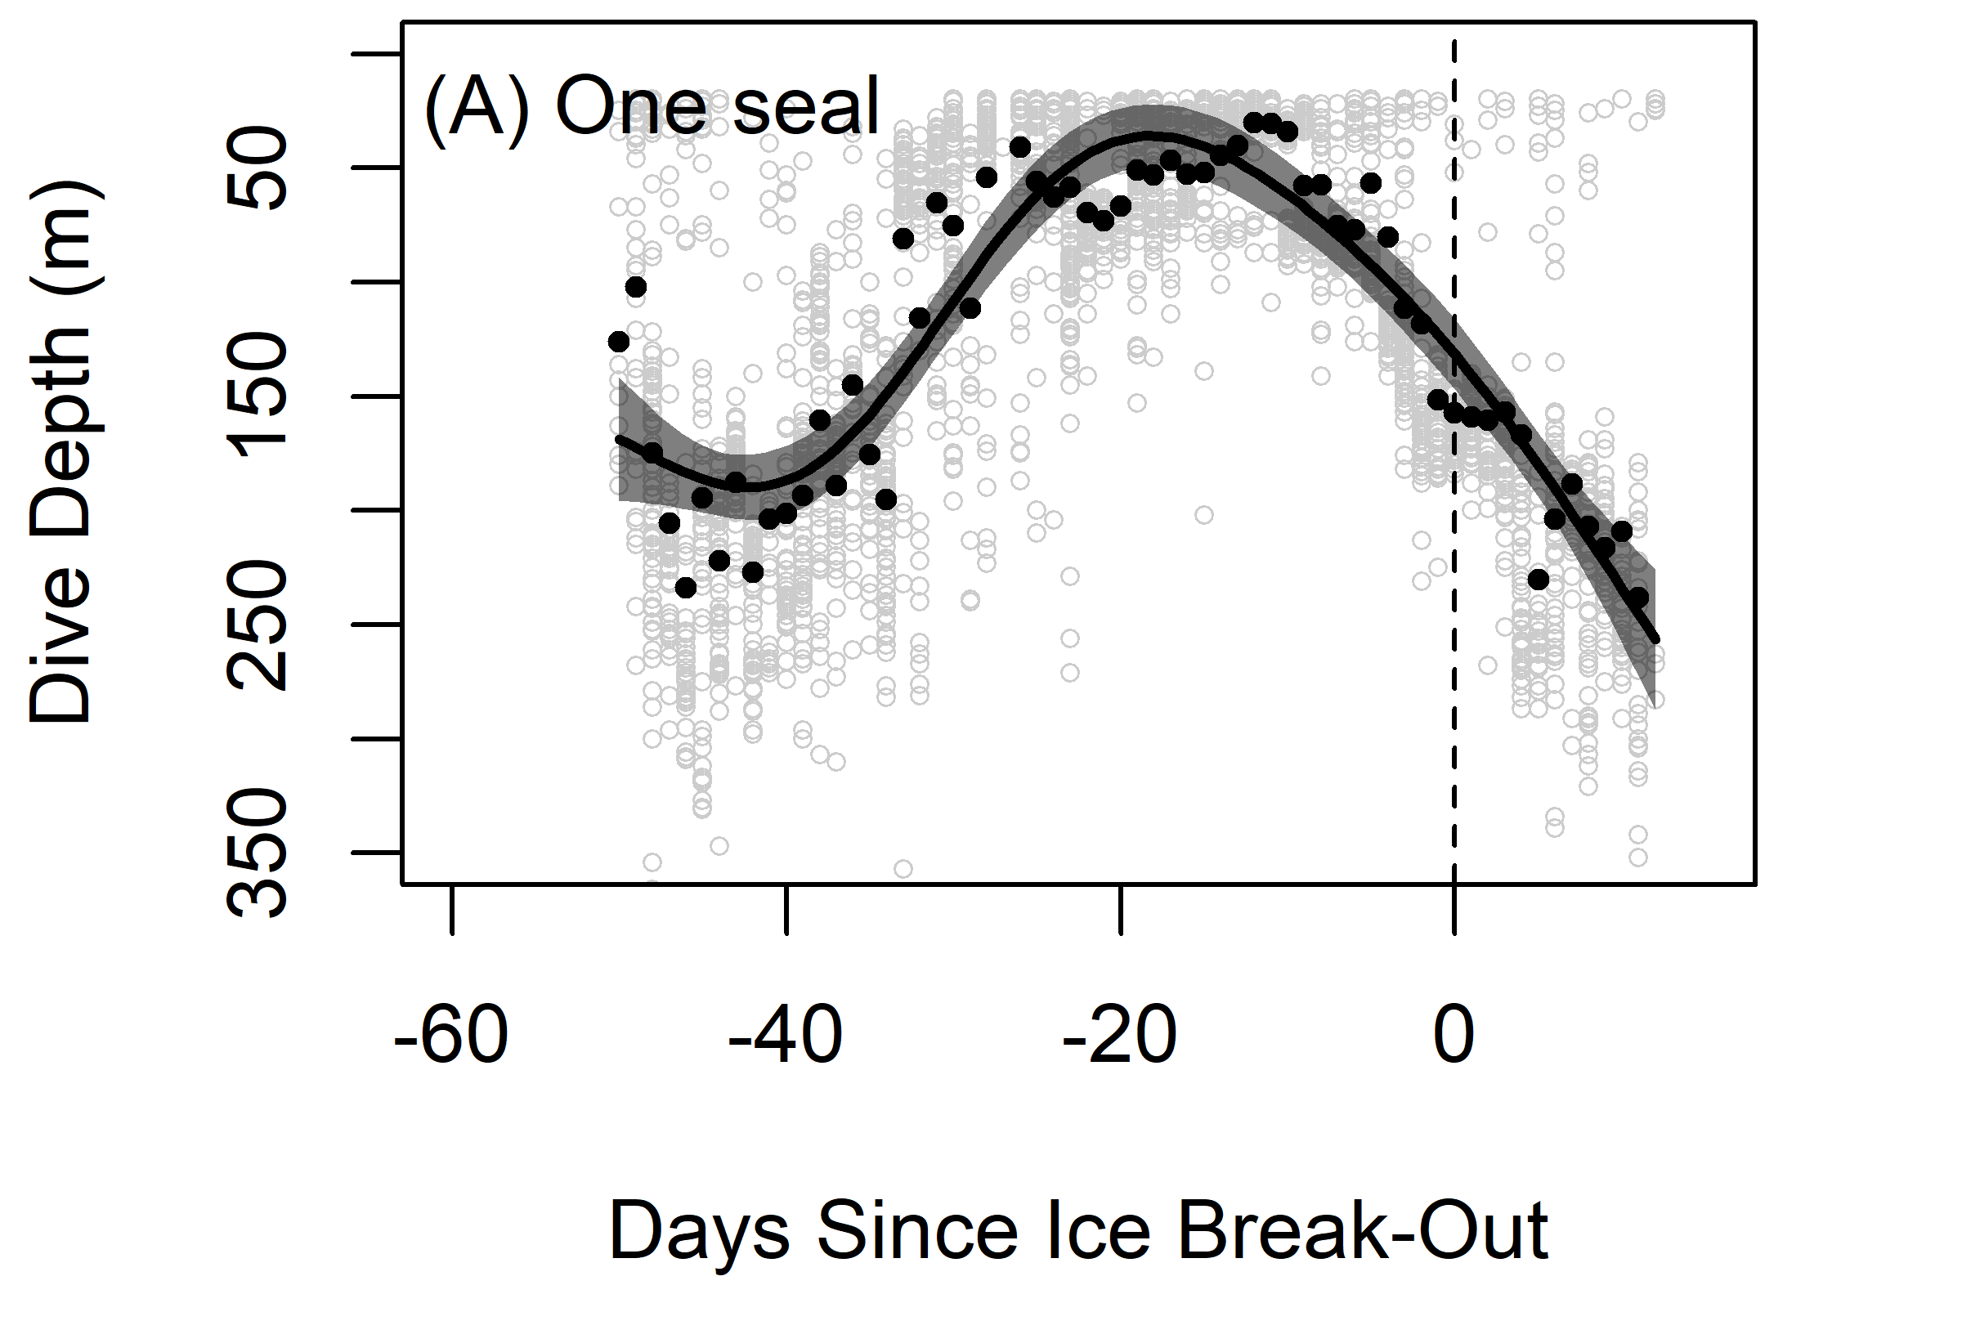

Figure S4. (A) Maximum depth of each dive (grey points) for one seal across austral summer 2014, and daily mean dive depth (black points). Black line and grey band show a Generalized Additive Mixed Model and 95% CI fit to the daily means and black dashed line represents the date of 50% ice cover.

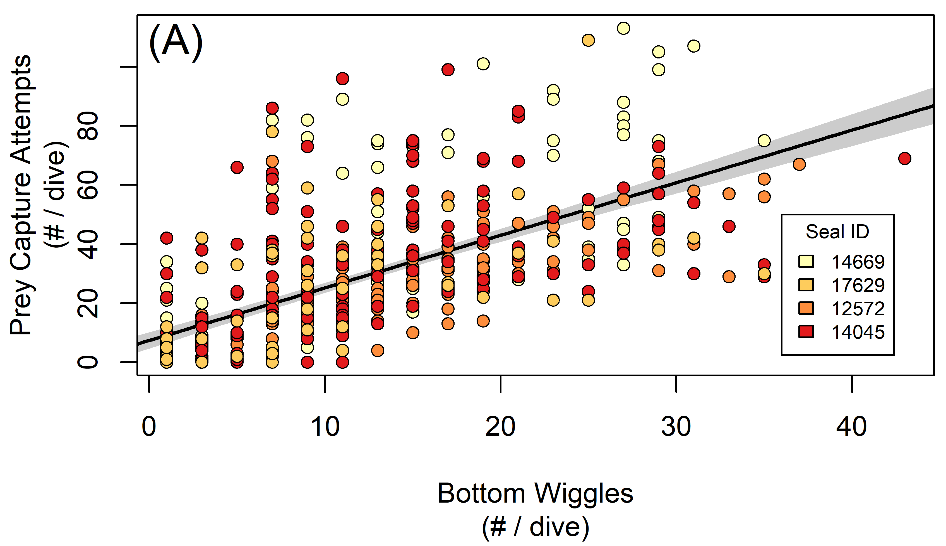

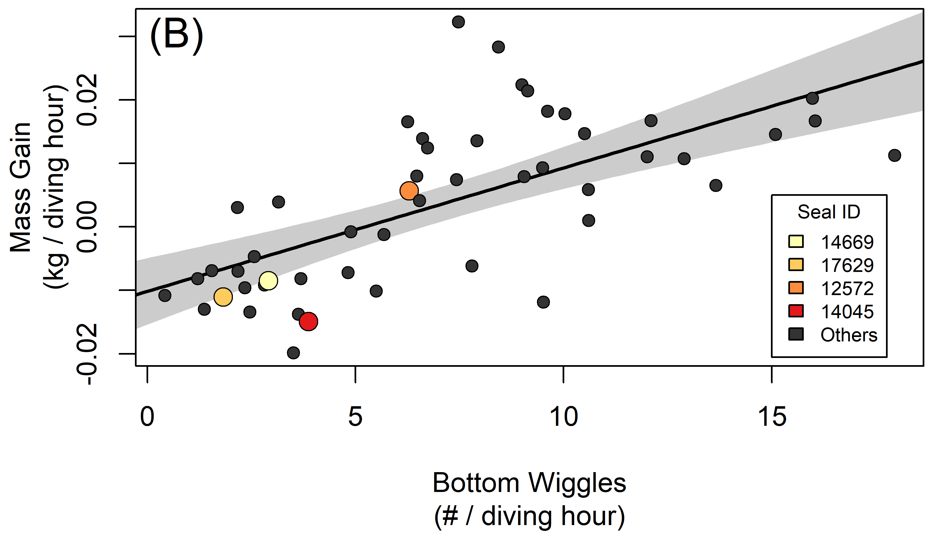

Figure S5. (A) Prey capture attempts per dive (measured with jaw accelerometers) plotted against bottom wiggles (measured with time-depth recorders). Points show data for individual dives, colors indicate different seals, and line and gray band shows the fitted relationship and 95% CI (PreyCaptureAttempts = 1.779 (± SE = 0.094) * Wiggles + 7.377 , R² = 0.42, P < 0.0001, n = 495 dives from 4 seals). (B) Mass gain per hour diving plotted against bottom wiggles. Points show data for individual seals, and line and gray band shows the fitted relationship and 95% CI (MassGain = 0.0020 (± SE = 0.0003 ) * Wiggles - 0.0100 , R² = 0.43, P < 0.0001, n = 51 seals).

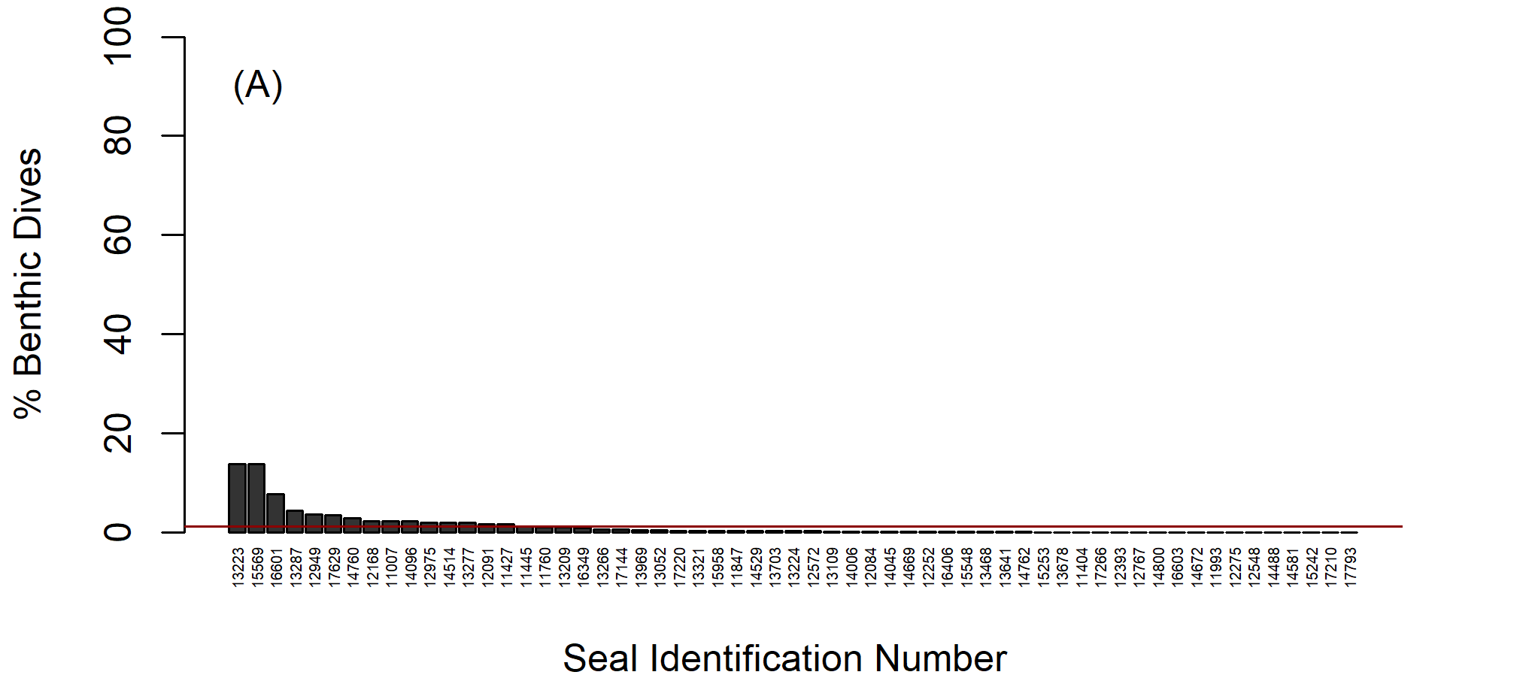
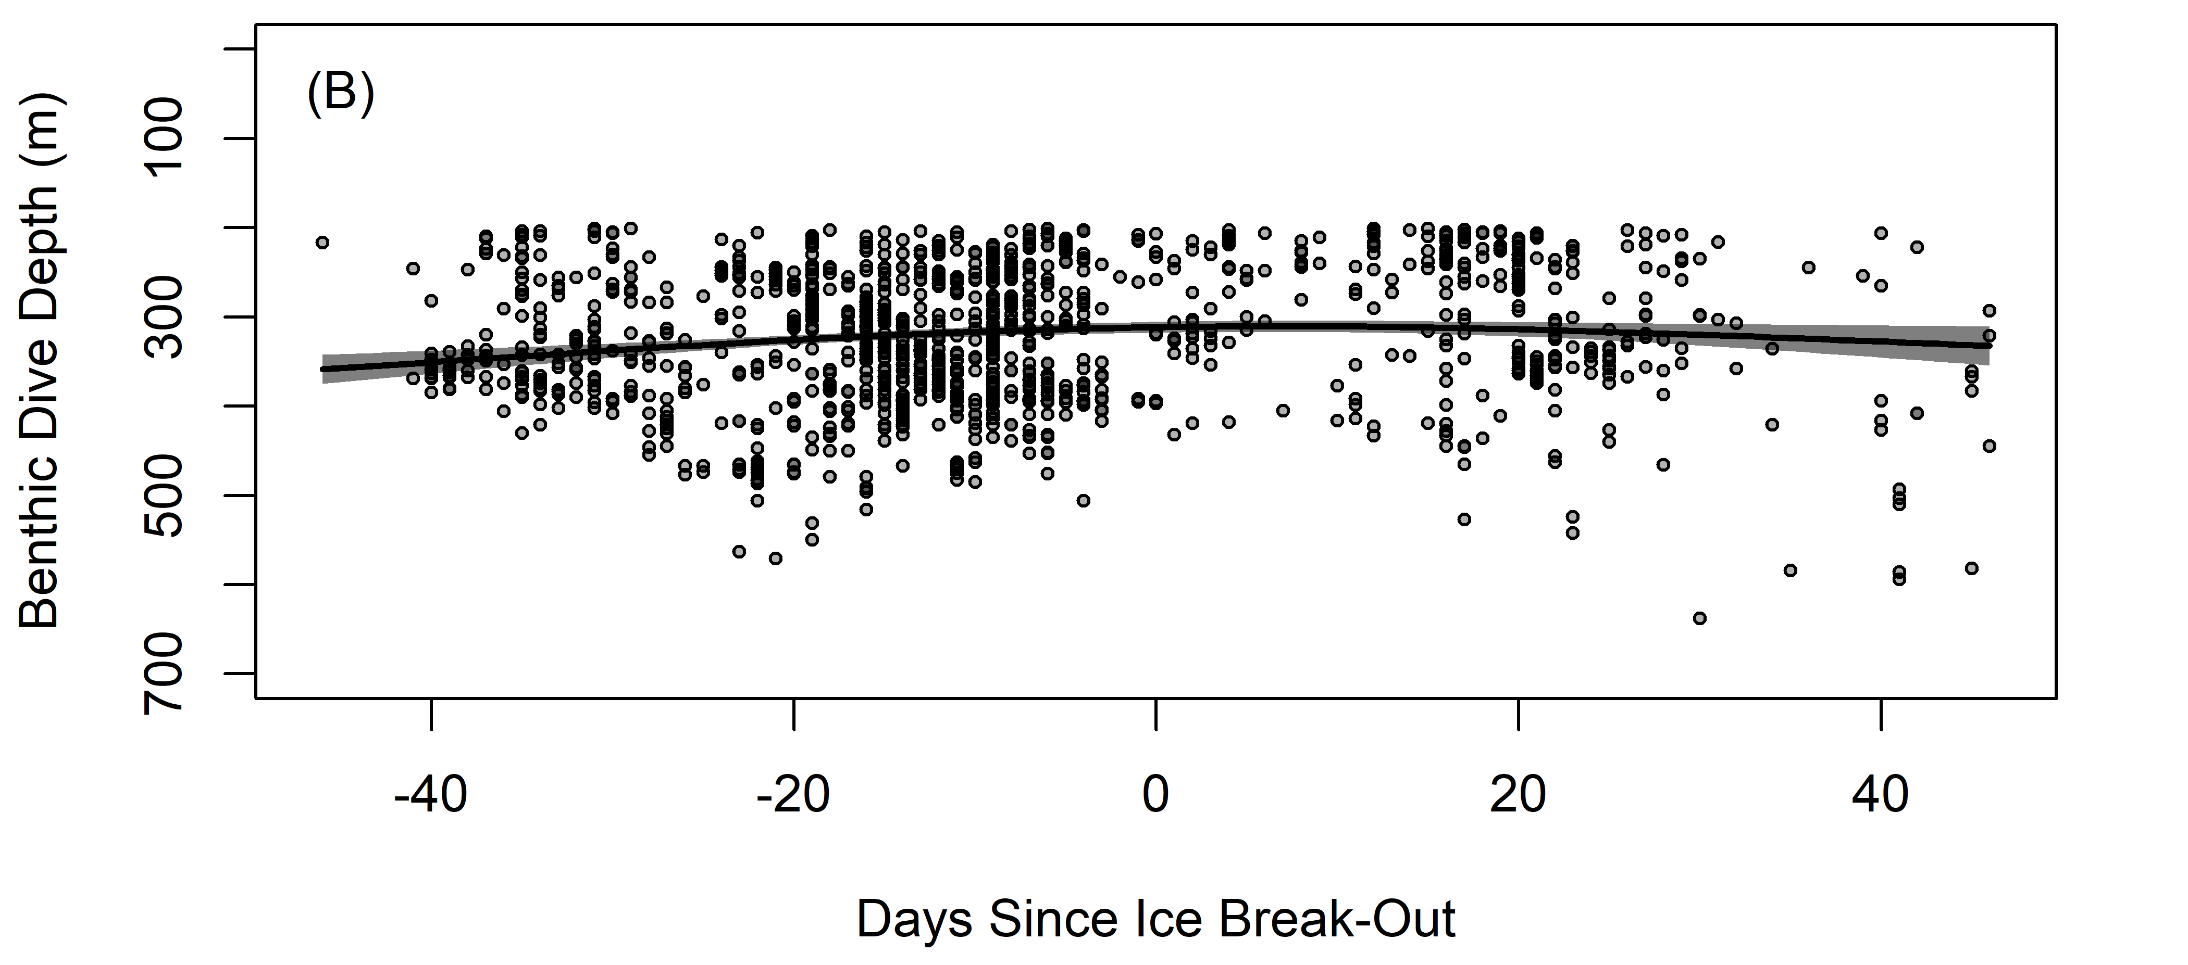
Figure S6. (A) Proportion of benthic dives for each seal including mean (1%) as horizontal red line and (B) benthic dive depth across summer for all seals. Points show individual dives, and line and gray band shows the fitted GAMM relationship and 95% CI (n = 495 dives).
References Cited
1. Beltran RS, Sadou M, Condit R, Peterson S, Reichmuth C, Costa D. Fine-scale whisker growth measurements can reveal temporal foraging patterns from stable isotope signatures. Marine Ecology Progress Series. 2015;523:243-53.
2. Goetz KT, Burns JM, Hückstӓdt LA, Shero MR, Costa DP. Temporal variation in isotopic composition and diet of Weddell seals in the western Ross Sea. Deep Sea Research II. 2017;140:36-44.
3. Beltran RS, Peterson SH, McHuron EA, Reichmuth C, Hückstädt LA, Costa DP. Seals and sea lions are what they eat, plus what? Determination of trophic discrimination factors for seven pinniped species. Rapid Communications in Mass Spectrometry. 2016;30(9):1115-22.
4. Jones RM, Smith Jr. WO. The influence of short-term events on the hydrographic and biological structure of the southwestern Ross Sea. Journal of Marine Systems. 2017;166:184-95.

