Supplementary Information

Within-trio tests provide little support for post-copulatory selection on MHC haplotypes in a free-living population.
W. Huang and J.M. Pemberton
Institute of Evolutionary Biology, School of Biological Sciences, University of Edinburgh, EH9 3FL, UK.

Supplementary Table 1. Number of twin and triplet offspring in the current study. Twins and triplets are categorized as half-sib and full-sib twins or triplets. Note that to get into the study, all members of a trio had to be identified and diplotyped; if only one member of a twin pair had all information, this leads to odd numbers in the twin (and triplet) column.
Offspring birthyear | Offspring born as singleton | Offspring born as twin | Offspring born as triplet | Half-sib twin or triplet | Full-sib twin
1987 | 12 | 5 | 1 | 6 | 0
1988 | 10 | 1 | 0 | 1 | 0
1989 | 21 | 6 | 0 | 4 | 2
1990 | 41 | 13 | 0 | 5 | 8
1991 | 55 | 22 | 0 | 18 | 4
1992 | 71 | 20 | 0 | 14 | 6
1993 | 73 | 46 | 0 | 20 | 26
1994 | 70 | 17 | 2 | 11 | 8
1995 | 71 | 18 | 0 | 12 | 6
1996 | 55 | 24 | 0 | 20 | 4
1997 | 73 | 22 | 0 | 18 | 4
1998 | 93 | 27 | 0 | 21 | 6
1999 | 61 | 5 | 0 | 5 | 0
2000 | 62 | 16 | 0 | 14 | 2
2001 | 48 | 18 | 0 | 16 | 2
2002 | 65 | 4 | 0 | 2 | 2
2003 | 96 | 37 | 0 | 21 | 16
2004 | 144 | 50 | 0 | 30 | 20
2005 | 107 | 14 | 2 | 6 | 10
2006 | 110 | 31 | 0 | 25 | 6
2007 | 85 | 37 | 0 | 29 | 8
2008 | 113 | 37 | 0 | 23 | 14
2009 | 135 | 26 | 0 | 14 | 12
2010 | 6 | 1 | 0 | 1 | 0
2011 | 139 | 18 | 0 | 16 | 2
2012 | 84 | 8 | 0 | 8 | 0
NA | 25 | 6 | 0 | 6 | 0
Grand Total | 1925 | 529 | 5 | 366 | 168

Supplementary Table 2. Number of dam and sire by the birthyear of the offspring in the current study.
Year | Number of dam | Number of sire
1987 | 18 | 10
1988 | 11 | 9
1989 | 26 | 15
1990 | 50 | 20
1991 | 71 | 32
1992 | 83 | 46
1993 | 99 | 41
1994 | 81 | 39
1995 | 82 | 38
1996 | 70 | 41
1997 | 87 | 51
1998 | 111 | 45
1999 | 65 | 37
2000 | 74 | 35
2001 | 62 | 42
2002 | 68 | 37
2003 | 118 | 44
2004 | 172 | 66
2005 | 116 | 53
2006 | 126 | 51
2007 | 110 | 52
2008 | 135 | 57
2009 | 150 | 57
2010 | 7 | 7
2011 | 150 | 65
2012 | 89 | 39
NA | 31 | 28

Supplementary Table 3. Summary of parentage data in the current study.
Index | Mean | Median | Maximum
Number of offspring per dam per year | 1.09 | 1 | 2
Number of offspring per sire per year | 2.37 | 2 | 16
Total number of offspring per dam | 3.43 | 3 | 15
Total number of offspring per sire | 5.13 | 2 | 54
Number of partner per dam per year | 1.05 | 1 | 2
Number of partner per sire per year | 2.28 | 1 | 14
Total number of partner per dam | 3.21 | 3 | 12
Total number of partner per sire | 4.79 | 2 | 44

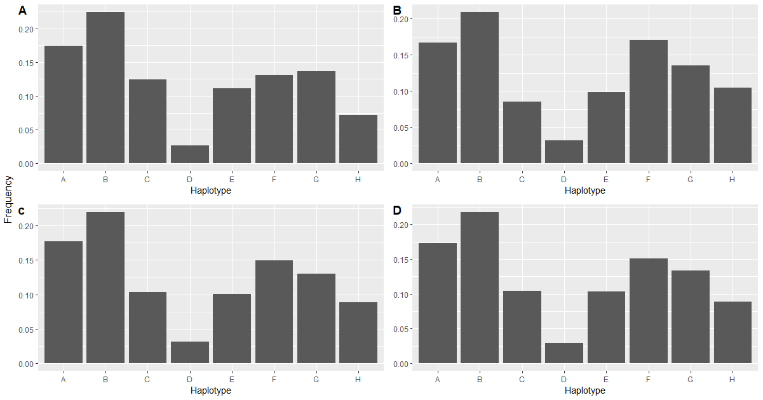
Supplementary Figure 1. MHC haplotype frequency in mothers (A), fathers (B), offspring and all individuals (D).
Supplementary Table 4. The proportion of amino acid differences (p-distance) within exon 2 between Soay sheep MHC haplotypes.
Each MHC locus consists of a single allele except for haplotype G which has two alleles at DQB2. We used allele (DQB2*12*01) identified from a Soay RNA sequence to calculate p-distance. There are seven expressed loci identified in sheep but each haplotype only consists of five loci with either DRB1+DQA2+DQB2+DQA1+DQB1 or DRB1+DQA2+DQB2+DQA2-like+DQB2-like combinations. To tackle the problem of null alleles at certain loci, we aligned DQA1 alleles with DQA2-like alleles and DQB1 alleles with DQB2-like alleles. Thus, p-distance was calculated from an alignment composed of five loci for each haplotype.

 | A | B | C | D | E | F | G | H
A
B | 0.1462
C | 0.2088 | 0.1624
D | 0.2390 | 0.1671 | 0.1810
E | 0.1907 | 0.1791 | 0.2605 | 0.2512
F | 0.1949 | 0.1323 | 0.1926 | 0.1694 | 0.2279
G | 0.1465 | 0.1651 | 0.2512 | 0.2651 | 0.0674 | 0.2093
H | 0.1949 | 0.0974 | 0.1601 | 0.1879 | 0.2233 | 0.1392 | 0.2140

Test 1 Results
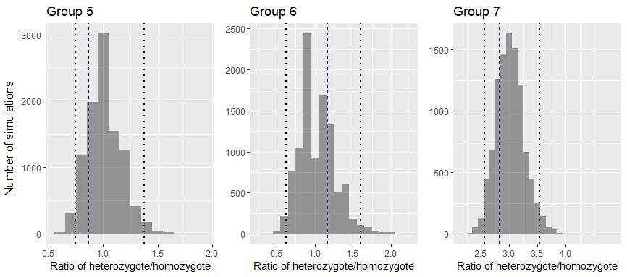
Supplementary Figure 2. The ratio of heterozygote: homozygote diplotypes in each informative group (5,6 and 7). Histograms represents the result of simulations (10000 iterations of each offspring) with the dotted lines representing the 2.5% and 97.5% tails of the distributions and the dashed blue lines representing the observed data.

Supplementary Table 5. Results of test 1. The 2.5th percentile, mean and 97.5th percentile of simulated data with the observed value and p value are shown in the table.
Group | 2.5th per centile | Mean | 97.5th percentile | Observed value | P value
Group 5 | 0.745 | 1.000 | 1.377 | 0.864 | 0.1519
Group 6 | 0.625 | 1.000 | 1.600 | 1.167 | 0.2892
Group 7 | 2.567 | 3.015 | 3.540 | 2.823 | 0.2350

Test 2 Results
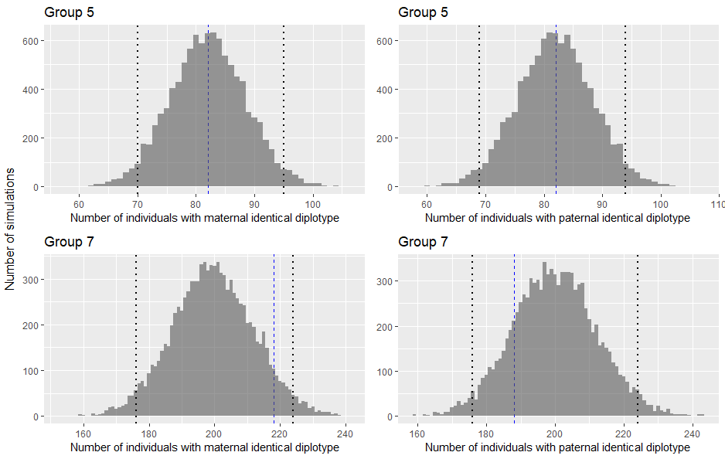
Supplementary Figure 3. Number of offspring with maternal or paternal identical diplotypes in informative groups 5 and 7. Histograms represent the result of simulations (10000 iterations of each offspring) with the dotted lines representing the 2.5% and 97.5% tails of the distributions and the dashed blue lines representing the observed data.

Supplementary Table 6. Results of test 2. The 2.5th percentile, mean and 97.5th percentile of simulated data with the observed value and p value are shown in the table.
Group | 2.5th percentile | Mean | 97.5th percentile | Observed value | P value
Group 5 (maternal identical) | 70 | 82 | 95 | 82 | 0.4655
Group 5 (paternal identical) | 69 | 82 | 94 | 82 | 0.4716
Group 7 (maternal identical) | 176 | 199 | 224 | 218 | 0.0630
Group 7 (paternal identical ) | 176 | 200 | 224 | 188 | 0.1731

Test 3 Results
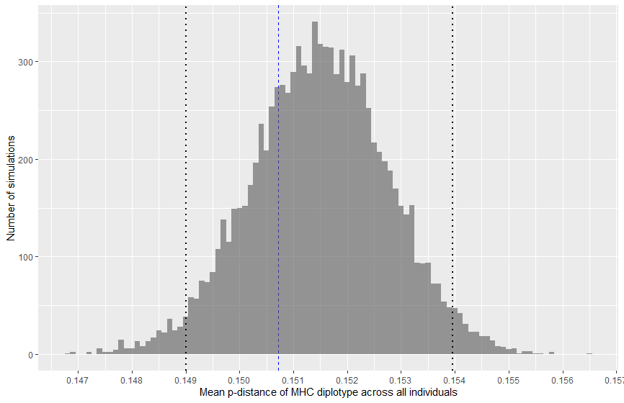
Supplementary Figure 4. The mean p-distance of MHC diplotypes across all offspring in groups 3-7. Histograms represent the result of simulations (10000 iterations per offspring) while the dashed blue line shows the observed data.
Supplementary Table 7. Results of test 3. The 2.5th percentile, mean and 97.5th percentile of simulated data with the observed value and p value are shown in the table.
2.5th percentile | Mean | 97.5th percentile | Observed value | P value
0.149 | 0.151 | 0.154 | 0.151 | 0.2670

Test 4 Results
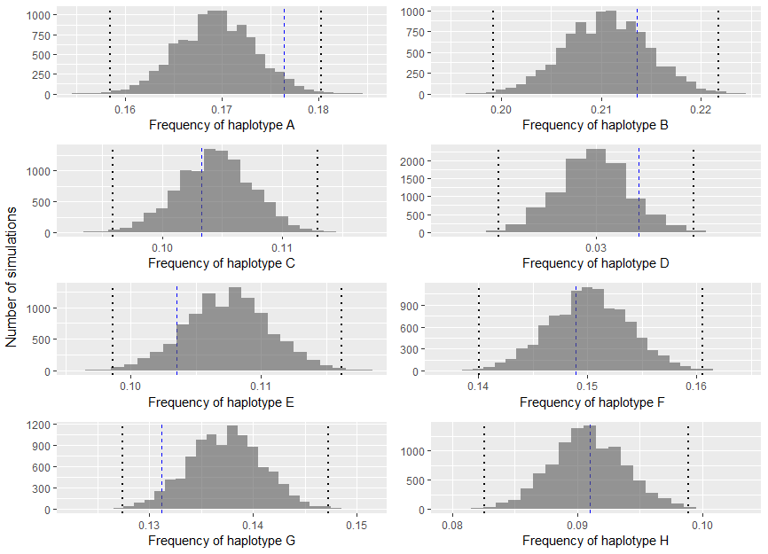
Supplementary Figure 5. The frequency of each MHC haplotype across all informative groups 3-7. Histograms represent the result of simulations (10000 iterations per offspring) with the dotted lines representing the 2.5% and 97.5% tails of the distributions and the dashed blue lines representing the observed data.
Supplementary Table 8. Results of test 4. The 2.5th percentile, mean and 97.5th percentile of simulated data with the observed value and p value are shown in the table.
Haplotype | 2.5th percentile | Mean | 97.5th percentile | Observed value | P value
A | 0.162 | 0.169 | 0.177 | 0.176 | 0.0382
B | 0.202 | 0.211 | 0.219 | 0.214 | 0.2255
C | 0.098 | 0.104 | 0.110 | 0.103 | 0.3443
D | 0.026 | 0.030 | 0.033 | 0.032 | 0.0914
E | 0.101 | 0.108 | 0.114 | 0.104 | 0.1097
F | 0.143 | 0.150 | 0.157 | 0.149 | 0.3586
G | 0.130 | 0.137 | 0.144 | 0.131 | 0.0433
H | 0.085 | 0.091 | 0.097 | 0.091 | 0.4536

Tests 5 & 6 Results
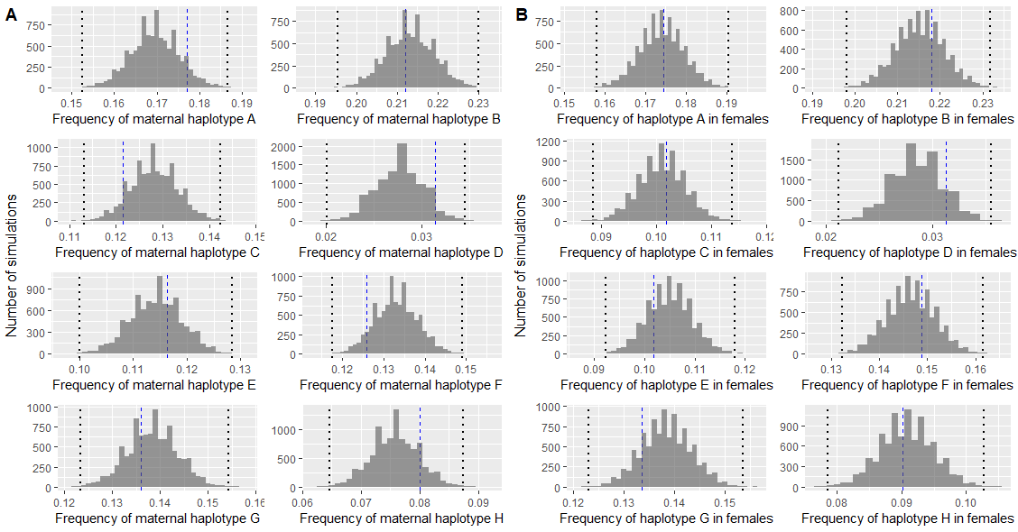
Supplementary Figure 6. The frequency of each maternal haplotype (A) and each MHC haplotype received in female (B) in informative groups 3 - 7. Histograms represent the result of simulations (10000 iterations per offspring) while the dashed blue lines show the observed data.

Supplementary Table 9. Results of test 5&6. The 2.5th percentile, mean and 97.5th percentile of simulated data with the observed value and p value are shown in the table.
Haplotype | Group | 2.5th percentile | Mean | 97.5th percentile | Observed value | P value
A | Haplotype transmitted from mothers | 0.158 | 0.170 | 0.181 | 0.177 | 0.0925
B |  | 0.201 | 0.213 | 0.225 | 0.212 | 0.3991
C |  | 0.118 | 0.128 | 0.138 | 0.122 | 0.0825
D |  | 0.023 | 0.028 | 0.032 | 0.031 | 0.0486
E |  | 0.105 | 0.115 | 0.124 | 0.116 | 0.3272
F |  | 0.123 | 0.133 | 0.143 | 0.126 | 0.0717
G |  | 0.128 | 0.139 | 0.149 | 0.136 | 0.3040
H |  | 0.068 | 0.076 | 0.084 | 0.080 | 0.1332
A | Haplotype transmitted from fathers | 0.154 | 0.165 | 0.176 | 0.174 | 0.0450
B |  | 0.194 | 0.205 | 0.216 | 0.209 | 0.2124
C |  | 0.076 | 0.083 | 0.090 | 0.087 | 0.1383
D |  | 0.028 | 0.034 | 0.039 | 0.035 | 0.3348
E |  | 0.094 | 0.102 | 0.111 | 0.091 | 0.0065
F |  | 0.154 | 0.165 | 0.175 | 0.169 | 0.2228
G |  | 0.126 | 0.136 | 0.146 | 0.127 | 0.0378
H |  | 0.101 | 0.111 | 0.120 | 0.108 | 0.2544
A | Haplotype received in female offspring | 0.163 | 0.174 | 0.185 | 0.174 | 0.4600
B |  | 0.204 | 0.215 | 0.227 | 0.218 | 0.2982
C |  | 0.093 | 0.101 | 0.109 | 0.102 | 0.4244
D |  | 0.024 | 0.028 | 0.033 | 0.031 | 0.1163
E |  | 0.097 | 0.105 | 0.114 | 0.102 | 0.2198
F |  | 0.137 | 0.147 | 0.156 | 0.149 | 0.3209
G |  | 0.129 | 0.138 | 0.148 | 0.134 | 0.1568
H |  | 0.083 | 0.091 | 0.099 | 0.090 | 0.4231
A | Haplotype received in male offspring | 0.153 | 0.165 | 0.176 | 0.157 | 0.0070
B |  | 0.194 | 0.205 | 0.217 | 0.210 | 0.2126
C |  | 0.099 | 0.108 | 0.118 | 0.105 | 0.2545
D |  | 0.027 | 0.032 | 0.037 | 0.034 | 0.2243
E |  | 0.101 | 0.110 | 0.120 | 0.106 | 0.1554
F |  | 0.143 | 0.154 | 0.165 | 0.150 | 0.1969
G |  | 0.124 | 0.134 | 0.144 | 0.125 | 0.0475
H |  | 0.082 | 0.091 | 0.099 | 0.091 | 0.4532

Supplementary Table 10. Results of tests using data excluding repeated parental pairs. The 2.5th percentile, mean and 97.5th percentile of simulated data with the observed value and p value are shown in the table.
Test | Index | 2.5th percentile | Mean | 97.5th percentile | Observed value | P
1 | Group 5 | 0.719 | 0.987 | 1.391 | 0.821 | 0.1286
 | Group 6 | 0.622 | 1.028 | 1.607 | 1.147 | 0.2476
 | Group 7 | 2.548 | 3.005 | 3.571 | 2.706 | 0.1177
2 | Group 5(maternal) | 64 | 76 | 88 | 75 | 0.3722
 | Group 5(paternal) | 65 | 77 | 89 | 78 | 0.3722
 | Group 7(maternal) | 163 | 186 | 210 | 198 | 0.1511
 | Group 7(paternal) | 163 | 186 | 210 | 169 | 0.0659
3 | Divergence | 0.149 | 0.152 | 0.154 | 0.150 | 0.1527
4 | Haplotype A | 0.162 | 0.170 | 0.178 | 0.177 | 0.0488
 | Haplotype B | 0.201 | 0.209 | 0.217 | 0.212 | 0.2468
 | Haplotype C | 0.100 | 0.106 | 0.113 | 0.105 | 0.2907
 | Haplotype D | 0.027 | 0.031 | 0.035 | 0.033 | 0.0897
 | Haplotype E | 0.099 | 0.105 | 0.112 | 0.102 | 0.1545
 | Haplotype F | 0.142 | 0.150 | 0.157 | 0.148 | 0.3412
 | Haplotype G | 0.129 | 0.137 | 0.144 | 0.131 | 0.0713
 | Haplotype H | 0.086 | 0.092 | 0.098 | 0.092 | 0.4683
5 (maternal) | Haplotype A | 0.157 | 0.168 | 0.180 | 0.177 | 0.0629
 | Haplotype B | 0.201 | 0.213 | 0.225 | 0.212 | 0.4032
 | Haplotype C | 0.120 | 0.129 | 0.140 | 0.121 | 0.0371
 | Haplotype D | 0.024 | 0.029 | 0.034 | 0.033 | 0.0495
 | Haplotype E | 0.101 | 0.111 | 0.121 | 0.113 | 0.3546
 | Haplotype F | 0.122 | 0.133 | 0.143 | 0.125 | 0.0639
 | Haplotype G | 0.128 | 0.139 | 0.150 | 0.137 | 0.3894
 | Haplotype H | 0.070 | 0.079 | 0.086 | 0.083 | 0.1059
5 (paternal) | Haplotype A | 0.157 | 0.168 | 0.179 | 0.176 | 0.0759
 | Haplotype B | 0.190 | 0.202 | 0.214 | 0.206 | 0.2599
 | Haplotype C | 0.077 | 0.085 | 0.093 | 0.090 | 0.0893
 | Haplotype D | 0.029 | 0.035 | 0.040 | 0.036 | 0.3397
 | Haplotype E | 0.092 | 0.101 | 0.110 | 0.092 | 0.0184
 | Haplotype F | 0.154 | 0.164 | 0.175 | 0.169 | 0.2200
 | Haplotype G | 0.124 | 0.135 | 0.145 | 0.126 | 0.0498
 | Haplotype H | 0.101 | 0.111 | 0.121 | 0.107 | 0.1876
6 (maternal) | Haplotype A | 0.163 | 0.174 | 0.185 | 0.176 | 0.3739
 | Haplotype B | 0.201 | 0.213 | 0.225 | 0.215 | 0.3636
 | Haplotype C | 0.096 | 0.105 | 0.113 | 0.105 | 0.4220
 | Haplotype D | 0.025 | 0.030 | 0.035 | 0.032 | 0.1762
 | Haplotype E | 0.093 | 0.102 | 0.111 | 0.100 | 0.3029
 | Haplotype F | 0.135 | 0.145 | 0.156 | 0.146 | 0.4100
 | Haplotype G | 0.129 | 0.139 | 0.149 | 0.135 | 0.1998
 | Haplotype H | 0.084 | 0.092 | 0.101 | 0.091 | 0.3798
6 (paternal) | Haplotype A | 0.155 | 0.167 | 0.179 | 0.159 | 0.0135
 | Haplotype B | 0.192 | 0.204 | 0.216 | 0.209 | 0.2286
 | Haplotype C | 0.099 | 0.108 | 0.118 | 0.105 | 0.1848
 | Haplotype D | 0.027 | 0.033 | 0.038 | 0.035 | 0.1499
 | Haplotype E | 0.100 | 0.109 | 0.120 | 0.105 | 0.1686
 | Haplotype F | 0.143 | 0.154 | 0.165 | 0.151 | 0.2567
 | Haplotype G | 0.122 | 0.132 | 0.143 | 0.124 | 0.0653
 | Haplotype H | 0.083 | 0.092 | 0.101 | 0.092 | 0.4709

