**Electronic Supplementary Material for: Trophic consequences of terrestrial eutrophication for a threatened ungulate**

Proceedings of the Royale Society of London B, Biological Sciences

DOI: 10.1098/rspb.2020.2811

Serrouya, R., M. Dickie, C. Lamb, H. van Oort, A. Kelley, C. DeMars, P. McLoughlin, N. Larter, D. Hervieux, A. Ford, S. Boutin.

**APPENDIX 1**. Pearson Correlation matrix among all variables for the 14 wolf survey units.

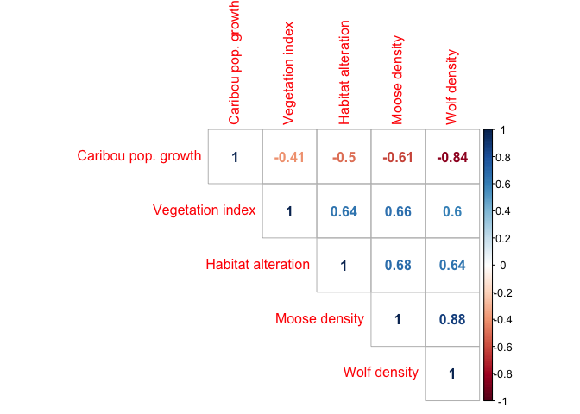

**Figure A1-1**.Pearson correlation matrix of all variables considered in the path analysis. Caribou pop.growth is the caribou population growth rate (λ), Habitat alteration is the % of wolf survey unit that is altered by human activity, veg. index is the ΔEVI (see main text for explanation). Code is presented at <https://github.com/ctlamb/borealcaribou-pathanalysis>

**APPENDIX 2.** Factors affecting Δ Enhanced Vegetation Index across the study area

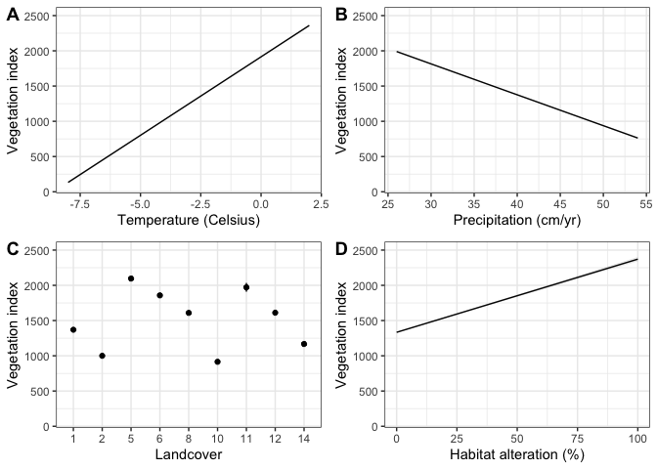

**Figure A2-1**: Factors predicting the Enhanced Vegetation Index (ΔEVI), including temperature (Celsius), precipitation (cm / year), landcover and habitat alteration (%). Predicted linear relationships are depicted for continuous variables, whereas landcover depicts the average ΔEVI for each landcover class. Landcover classes are: 1= Temperate or sub-polar needleleaf forest; 2= Sub-polar taiga needleleaf forest; 5= Temperate or sub-polar broadleaf deciduous forest, 6= Mixed forest; 8= Temperate or sub-polar shrubland;10= Temperate or sub-polar grassland, 11= Sub-polar or polar shrubland-lichen-moss;12= Sub-polar or polar grassland-lichen-moss, 14= Sub-polar or polar barren-lichen-moss.

We conducted a spatial analysis of factors that predict the vegetation index (ΔEVI) across the 598,000-km2 study area. We used a linear model including all 500-m pixels in the study (n > 127,000). The R2 was 0.44 (F = 9293, df = 127088, p < 0.0001). P-values are not meaningful with such high sample size, but the point was to show the magnitude of multiple factors affecting the vegetation index. This is why we did not link habitat alteration (on its own) directly to vegetation index in the path analysis (even though they are highly correlated, Appendix 1), because vegetation index interacts with landcover, temperature, and precipitation. Raw code and parameter estimates for this analysis are on GitHub: <https://github.com/ctlamb/borealcaribou-pathanalysis/tree/master/seral_mechs_spatial>

**APPENDIX 3**: Estimating Moose Densities

We obtained moose densities using aerial moose surveys conducted by the provincial governments, academic, and industry partners between 2008 and 2018 (Table A3.1). Moose surveys were primarily conducted using either the ver Hoef (2008) geospatial or a stratified random block design (Gasaway,1986) but distance sampling became more frequently used as of 2010 (Buckland et al. 2004; Appendix 3). Moose density estimates from aerial surveys were not available in the Cold Lake Saskatchewan Wolf Survey Unit (WSU). We therefore estimated the density of moose using remote wildlife cameras, and corrected camera estimates to aerial survey estimates using a correlation analysis. We first evaluated the relationship between moose densities estimated using remote wildlife cameras to densities estimated using aerial surveys across Alberta, and applied this correction factor to estimated moose densities in Saskatchewan from wildlife cameras.

Table A3.1: Estimated moose density (animals / km2) in each Wolf Survey Unit (WSU). The Year in which the estimate was calculated, method, and citation source are provided.

|  |  |  |  |  |  |  |
| --- | --- | --- | --- | --- | --- | --- |
| **WSU #** | **WSU Name** | **Sub-Area** | **Moose Density** | **Year** | **Method** | **Citation** |
| 6 | Fort Liard |  | 0.0716 | 2017 | Geospatial Population Survey | Larter, personal communication |
| 8 | Fort Providence South FMA |  | 0.029 | 2012 | Geospatial Population Survey | Kelly, personal communication |
| 7 | Fort Providence Reference |  | 0.029 | 2012 | Geospatial Population Survey | Kelly, personal communication |
| 9 | Fort Resolution FMA |  | 0.013 | 2009 | Geospatial Population Survey | Kelly and Cox, 2017 |
| 10 | Fort Resolution Reference |  | 0.013 | 2009 | Geospatial Population Survey | Kelly and Cox, 2017 |
| 11 | Hay River Lowlands |  | 0.029 | 2012 | Geospatial Population Survey | Kelly, personal communication |
| 1 | Calendar |  | 0.018 | 2010 | Distance Sampling | Theisen 2010 |
| 2 | Chinchaga RRA |  | 0.157 | 2016 | Distance Sampling | Webster and Lavellee 2016 |
| 3 | Clarke |  | 0.074 | 2016 | Distance Sampling | Webster and Lavellee 2016 |
| 5 | Cold Lake Saskatchewan |  | 0.0789 | 2017 | cameras | unpublished data |
| 12 | Northern Saskatchewan |  | 0.0457 | 2008-2015 | Aerial surveys, various designs | McLoughlin et al, 2016 |
| 4 | Cold Lake Alberta | WMU 529 | 0.089 | 2017 | Distance Sampling | Government of Alberta, 2019 |
| 4 |  | WMU 512 | 0.3 | 2013 | Stratified Random block | Government of Alberta, 2018 |
| 4 |  | WMU 519 | 0.14 | 2015 | Distance Sampling | Government of Alberta, 2019 |
| 4 |  | WMU 517 | 0.085 | 2018 | Stratified Random block | Government of Alberta, 2019 |
| 13 | Whati (TASR Impact) |  | 0.011 | 2018 | Distance Sampling | Kelly, personal communication |
| 14 | Jean Marie River |  | 0.045 | 2018 | Geospatial Population Survey | Kelly, personal communication |

To compare density estimates for moose from cameras deployed, we related the estimated moose density from each of the provincial aerial surveys to estimated moose densities from a wildlife camera program deployed by the Alberta Biodiversity Monitoring Institute (ABMI) across Alberta’s boreal forest. The results can be used to calibrate camera density estimates for moose to the aerial survey estimates from government surveys within Wildlife Survey Units, to maintain consistency with density estimates used in the remainder of the analyses.

ABMI deployed cameras across 1197 sites from 2013 to 2018 across 38 Wildlife Management Units. Density estimates for moose were calculated for each ABMI camera, using the time-in-field-of-view method. Density was calculated per camera using the time-in-field-of-view method, similar to that of methods presented in Nakashima *et al.* (2018). The time-in-field-of-view model uses cumulative time in the camera detection zone to estimate population density:

$$D=\frac{\sum{(N ∙T_{F})}}{A_{F}∙T_{O}}$$

Where density *D*, is calculated as the total number of individuals observed *N* multiplied by the time in front of the camera field-of-view *TF*, divided by the area of the camera field-of-view *AF* multiplied by the total camera operating time *TO*. The units are animal-seconds per area-seconds, which equates to the number of animals per area.

The probability of detecting an animal decreases as the distance from the camera increases, and this is likely species- and habitat-specific. Therefore, the effective detection distance (*EDD*) in which each species, in each season was calculated using a prominently coloured pole 5 m from the camera. All animals are recorded as being closer than the pole or farther than the pole, with additional categories for animals that are uncertain (near 5m but not directly in line with the pole), investigating the pole or investigating the camera. Simple geometry gives the effective detection distance from the proportion of locations that are <5m away versus >5m (excluding the uncertain and investigating images): EDD (m) = 5 / sqrt(1-p>5m), where p>5m is the proportion of images with the species >5m away. The area surveyed by a camera is:

$$A_{F}=\frac{π ∙{EDD}^{2}∙∠}{360}$$

Where *AF*, in m2, is calculated as $π$ multiplied by *EDD*, multiplied by the camera field-of-view’s angle in degrees, ∠, which is 42° with the cameras used here, all of which are divided by 360°.

Density estimates were calculated for summer and winter seasons and averaged with equal weight to compensate for any differences in seasonal deployment times between cameras. Average density for each Wildlife Management Unit was calculated from all cameras in the Wildlife Management Unit. Confidence intervals were based on a compound distribution of binomial presence/absence and log-normal abundance-given-presence. Aerial survey estimates were provided by the Government of Alberta. Estimates were provided with 90% confidence intervals.

We fit models of camera density as a function of aerial survey density, including Generalized Additive Models (GAMs) with smoothing splines using both normal and log-normal (log-link) error distributions, and a linear model both with and without an intercept. Points were weighted in inverse proportion to the width of the camera confidence intervals, which vary widely due to large differences in number of cameras per Wildlife Management Units and inherent variability of camera estimates. Confidence interval width for aerial estimates were a consistent proportion of the mean estimate, and so were not used for weighting points.

One outlying point with aerial density of 0.5 per km2 but camera density of 7.1 per km2 was omitted. The extreme camera estimate is from a Wildlife Management Units with only 4 cameras, and is largely due to a single camera with an extended visit from one moose. The 90% confidence intervals for that camera estimate are 1.4-35.3 per km2, showing an extremely uncertain estimate. One point with an outlying aerial estimate of 0.77 per km2 was included in the model fits.

There was a general positive relationship between camera estimates and aerial-survey estimates of moose across Wildlife Management Units, but wide scatter as densities increase (Figure A3.1). The very wide confidence intervals on the GAM included the linear fit line. The linear models with and without intercepts were very similar. Because the models produced similar results and the linear model without intercept is the simplest for calibration, we use that model. The calibration coefficient, 1/slope of the linear model without intercept, is 0.478 (90% Confidence Interval: 0.415-0.568). The aerial estimate for moose density in a Wildlife Management Units is 0.478 times the camera estimate. Equivalently, the camera estimate is 2.09 times higher than the aerial estimate.



**Figure A3-1**: The relationship between moose density (moose / km2) calculated using remote wildlife cameras and via aerial surveys across Alberta Wildlife Management Units. Thick black line represents a linear model with no intercept (dotted lines = 90% Confidence Intervals); pale blue line represents a normal GAM curve (pale grey dotted lines = 90% Confidence Intervals).

The substantial overestimation of moose densities by cameras is expected. ABMI cameras are put in open micro-habitats so that vegetation doesn’t hide animals for at least 5m; moose prefer those open areas for foraging, particularly in summer. Additionally, moose are attracted to the cameras themselves, often spending time at the camera investigating it. This inflates densities estimates by increasing the time that moose spend in the camera’s field-of-view and also reducing the effective detection distance that shows what area the camera is surveying.

We then applied this correction factor to moose densities estimated in Saskatchewan using remote cameras. Wildlife cameras were placed randomly within a 12.5 x 4 - km area and a minimum spacing of 1 km between each camera. Cameras collected data from January 2017 to March 2018. Density was calculated using the approach as described above for each camera, and averaged across the 25 cameras to get one density estimate for that region. The density within the Saskatchewan Cold Lake Reference area was calculated as 0.0789 moose / km2. We then corrected the estimated density by multiplying by 0.478, such that 0.0789 moose / km2 * 0.478 = 0.0377 moose / km2 or 3.77 moose / 100 km2.

References

Buckland ST, Anderson DR, Burnham KP, Laake JL, Borchers DL, Thomas L. 2004 *Advanced distance sampling*. Oxford University Press Oxford.

Gasaway WC. 1986 *Estimating moose population parameters from aerial surveys*. Fairbanks: Institute of Arctic Biology.

Nakashima Y, Fukasawa K, Samejima H. 2018 Estimating animal density without individual recognition using information derivable exclusively from camera traps. J. Appl. Ecol. 55, 735–744.

Ver Hoef JM. 2008 Spatial methods for plot-based sampling of wildlife populations. *Environ. Ecol. Stat.* **15**, 3–13.

**APPENDIX 4:** Estimating Wolf Densities: Spatial simulations to optimize transect spacing and time since snowfall for aerial surveys

The wolf survey methodology attempted to conduct a complete wolf census at each WSU based on the principle that independent wolf track networks (viewable track segments) will be isolated from each other and readily countable shortly after snowfall events. The survey was conducted by flying parallel transects, and the probability of intercepting track networks depended on transect spacing (survey intensity) and the size of the track network, which in turn was related to the time since snowfall. There is a trade-off between the expediency of a survey and the level of intensity at which the survey is conducted.

To inform survey intensity, and how much time should elapse after a snowfall prior to surveying (to accumulate tracks), we examined 12 wolf location time series, each from wolves collared with GPS collars, from different packs, with collars programmed to record a wolf location every 5 minutes. Only data from December through March were considered to be consistent with winter survey conditions. Each time series included between 9 and 65 days of tracking (mean = 67 days per time series).

To simulate a survey, a segment from each time series was extracted to represent a network of observable tracks following a snowstorm. The date of segment initiation was chosen randomly, as was the number of days represented in each segment. Track segments were 1, 2, or 3 days in length. Each track segment was over-plotted against a set of simulated survey transects that were always oriented north-south, positioned randomly in the east-west direction, and spaced 1, 2, 3, 5, or 7 km apart. Detection was determined if wolf track segments intercepted a survey transects at least once.

The simulated trail outlined above was repeated 100 times for each time series. For each time series, the proportion of trials with successful detection was calculated for each combination of transect spacing and segment length. These proportions were presented using box plots.

As expected, detection rates increased when transect spacing was reduced and when the number of days included in a track segment increased (figures A4-1). The results indicated that 3 days of tracks are reliably intercepted using transect spacing from 1 to 3 km apart, and that 3 km spacing detects 91.6% of the track networks 2 days following a snowfall. 3 km spacing was chosen based on this simulation.

These estimates are conservative because (1) this analysis was based on a single animal, whereas wolves travelling in packs have multiple tracks at times, and (2), old tracks are often evident under recent snowfall and these are also noted and considered when searching for fresh tracks. Finally, because WSUs were large and surveyed in one effort over several days, track detectability increased over time (e.g., 2, 3, 4, 5 etc nights worth of tracks as survey progressed).

All programming was conducted in R using the following packages: rgdal, lubridate, plyr, reshape, and ggplot2.

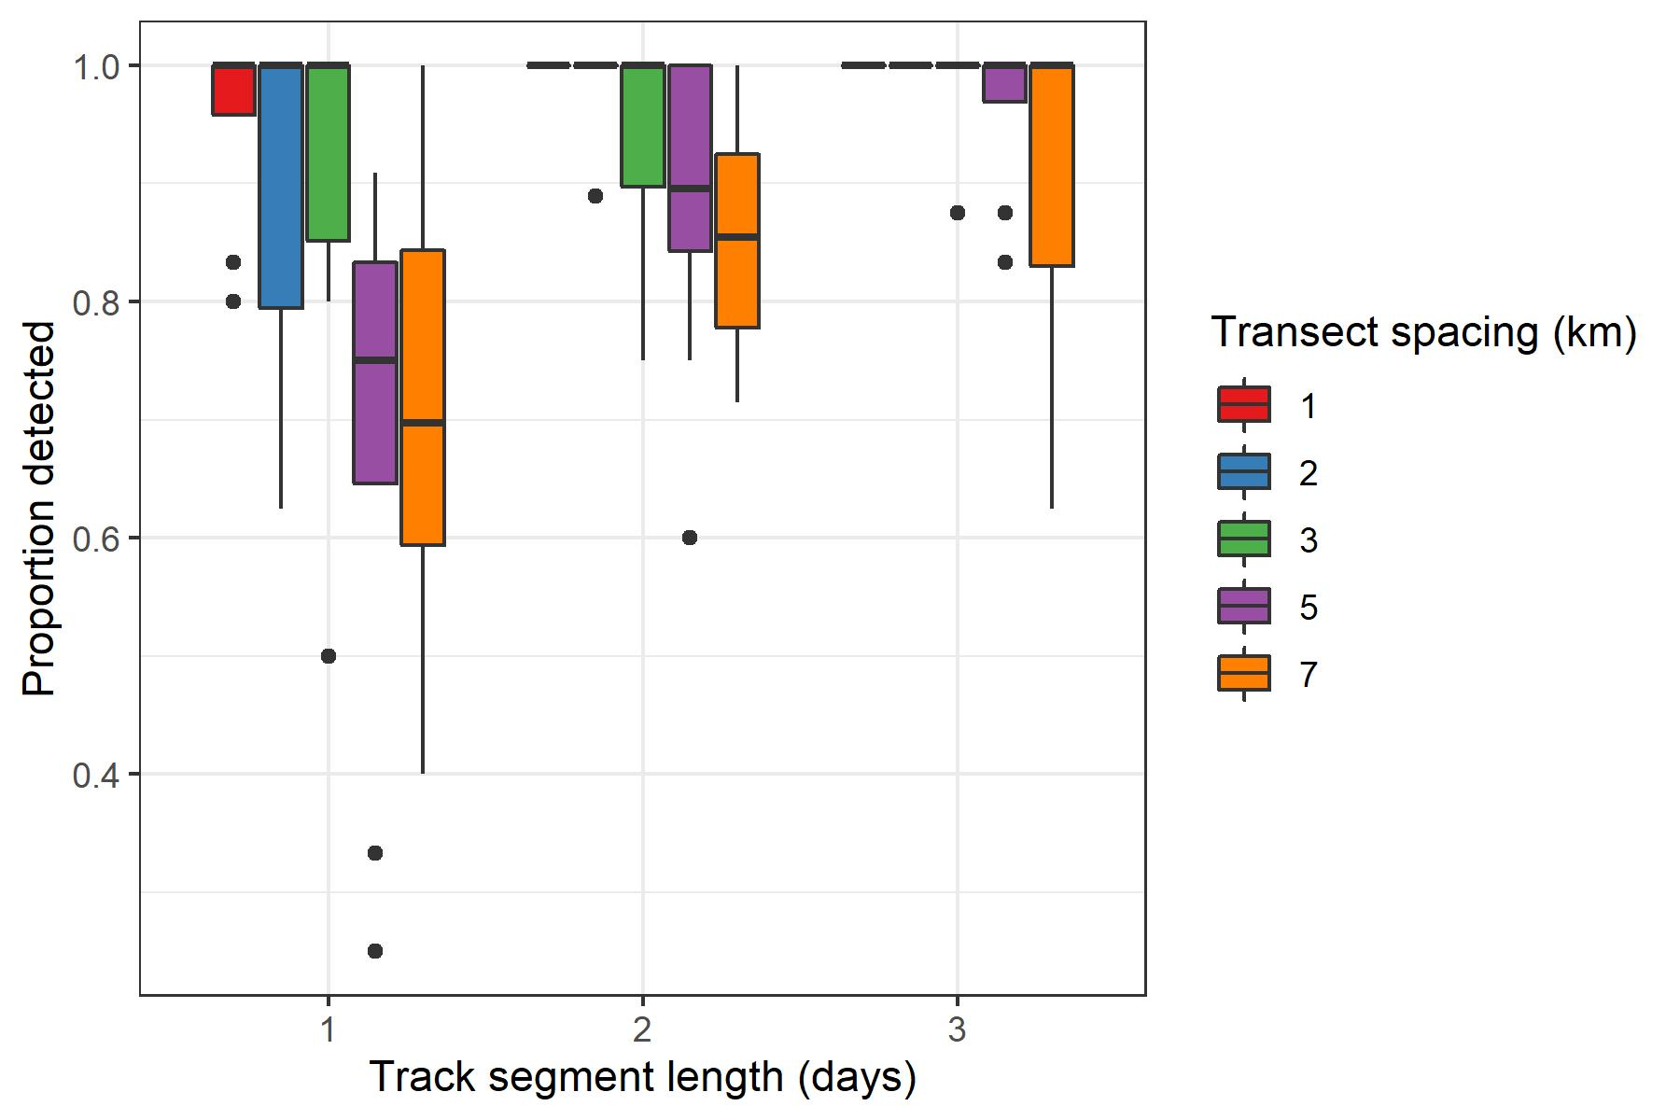

**Figure A4-1**. The proportion of track segments detected based on their length and transect spacing (km). The track segment length represents “time since snowfall” to guide when surveys should begin following a snowfall event.