Electronic Supplementary Materials for:
LACK OF PHENOLOGICAL SHIFT LEADS TO INCREASED CAMOUFLAGE MISMATCH IN MOUNTAIN HARES
Marketa Zimova, Sean T. Giery, Scott Newey, J. Joshua Nowak, Michael Spencer, L. Scott Mills
Proceedings of the Royal Society B

Figures S1-S7
Tables S1-S2

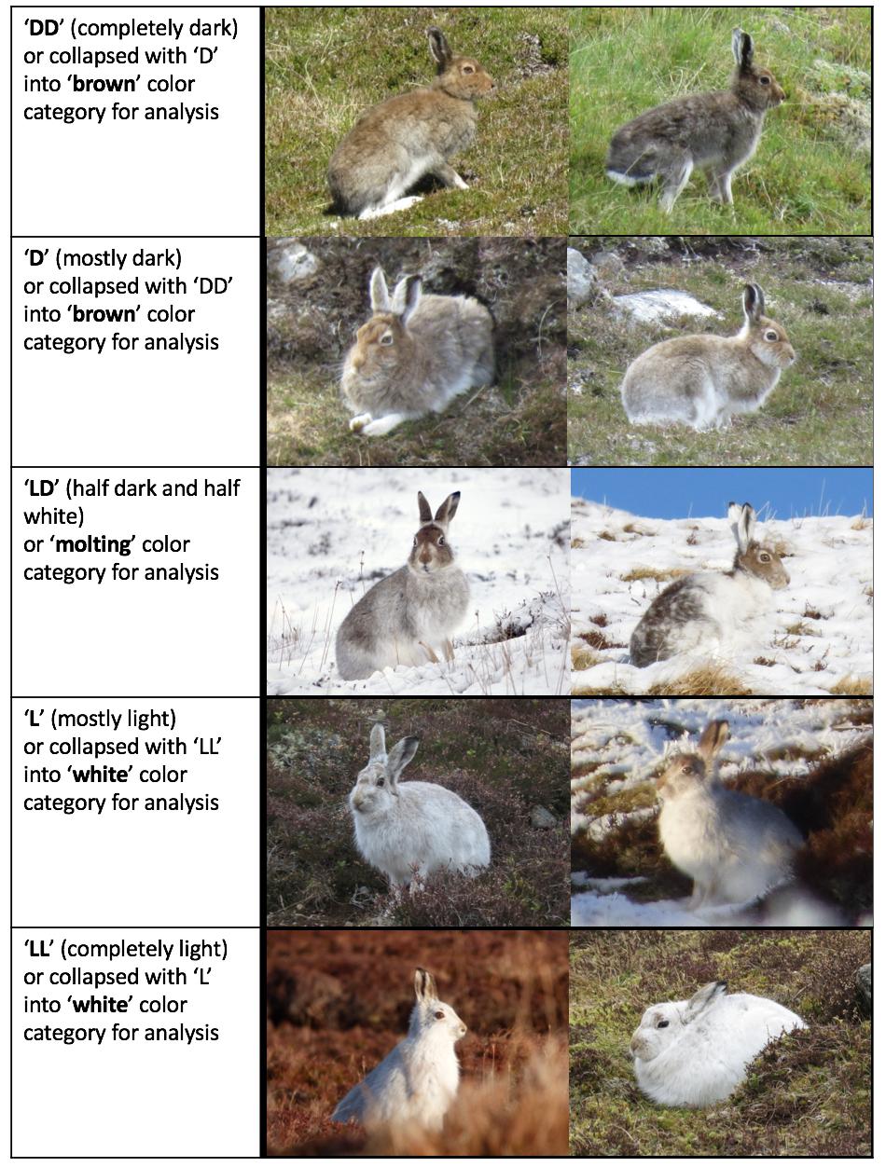
Figure S1. Coat color categories used to score mountain hares in the field and in the analysis (based on Watson 1973). Each category is given two example photos to illustrate range of variation.

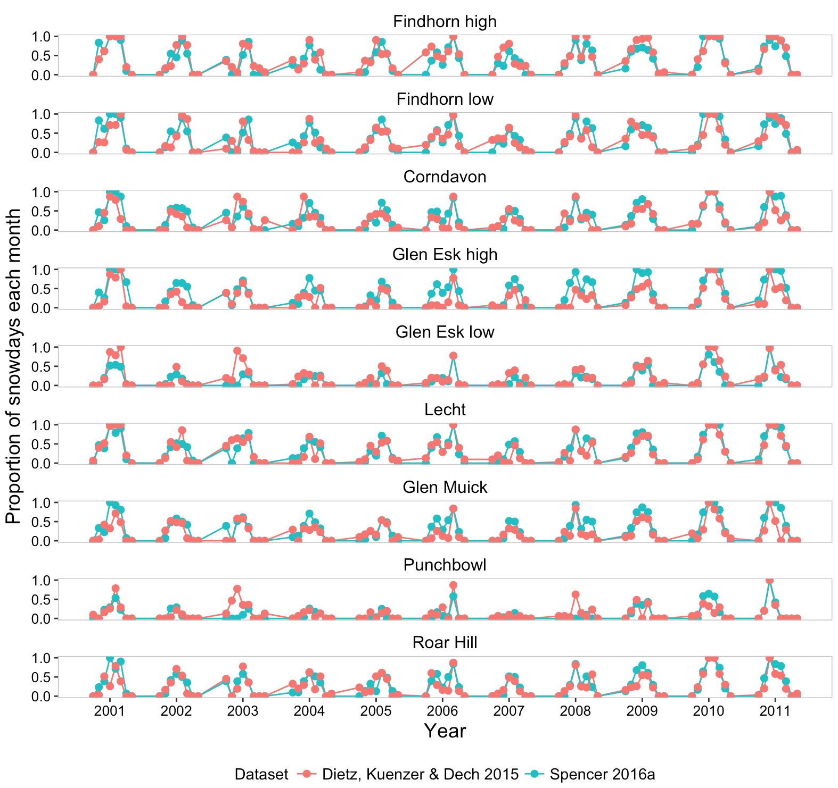
Figure S2. Comparison between two different snow cover datasets for the period 2000-2011. The points show proportion of snow days each month (October-May) at each study site.
- 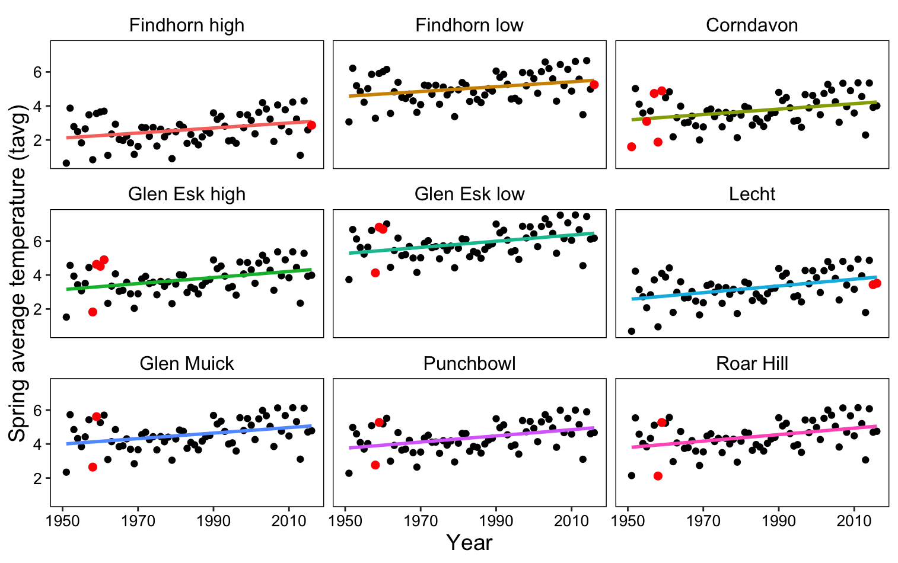
- 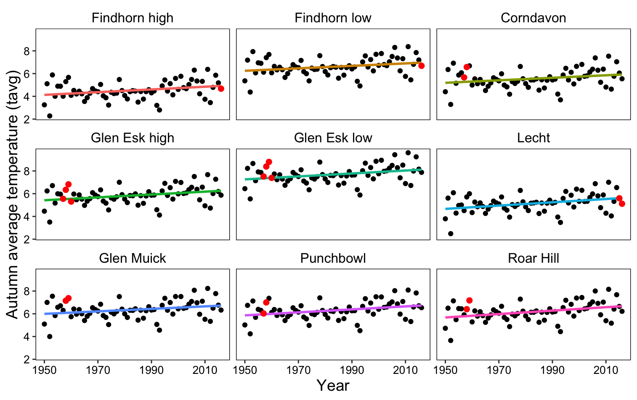
Figure S3. Average spring (a) and autumn (b) seasonal temperature (tavg) at the study site between 1950-2016. Dashed line is based on linear regression at each site. Red points indicate years and sites of historic and present-day surveys.
a. 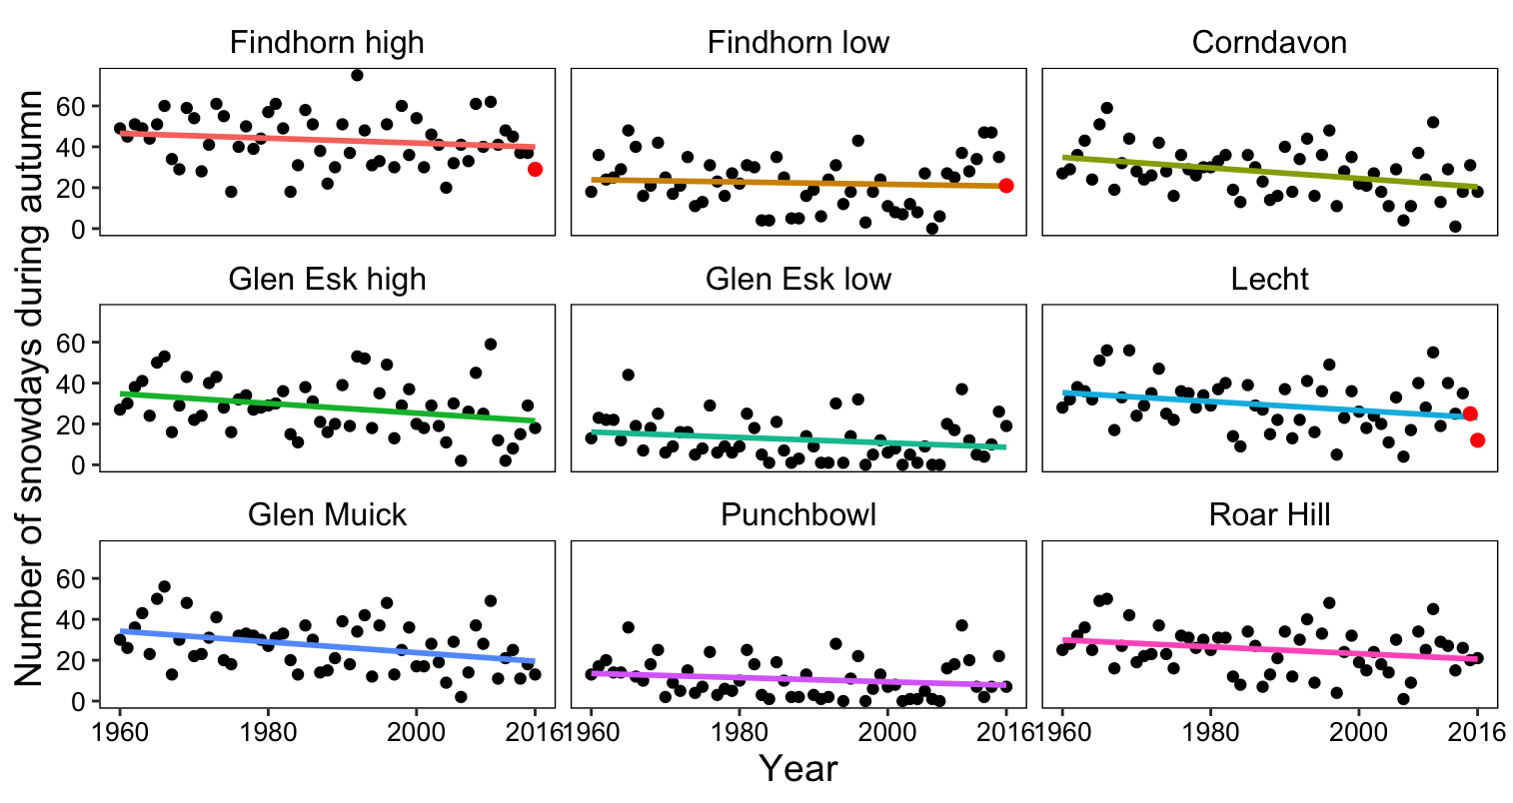
b. 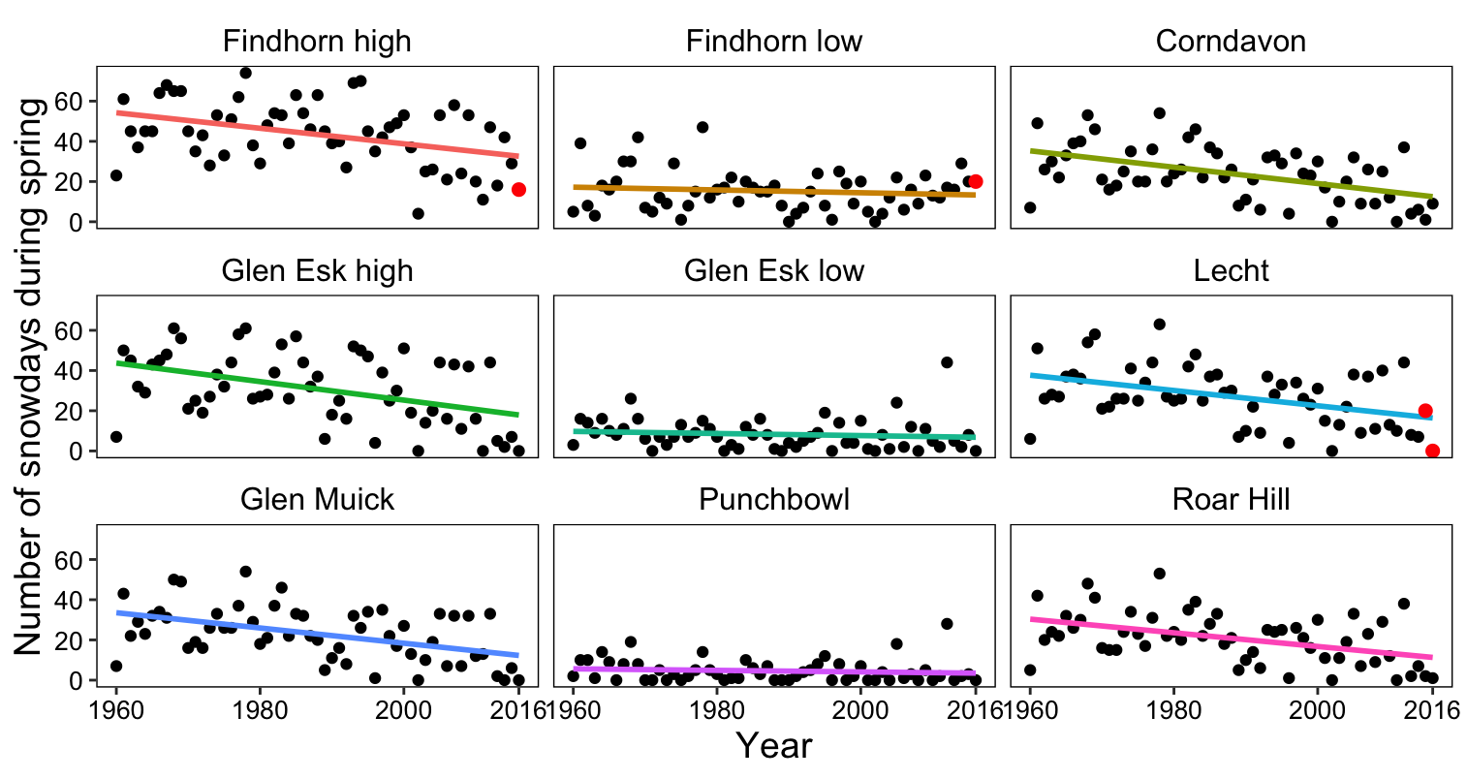
c. 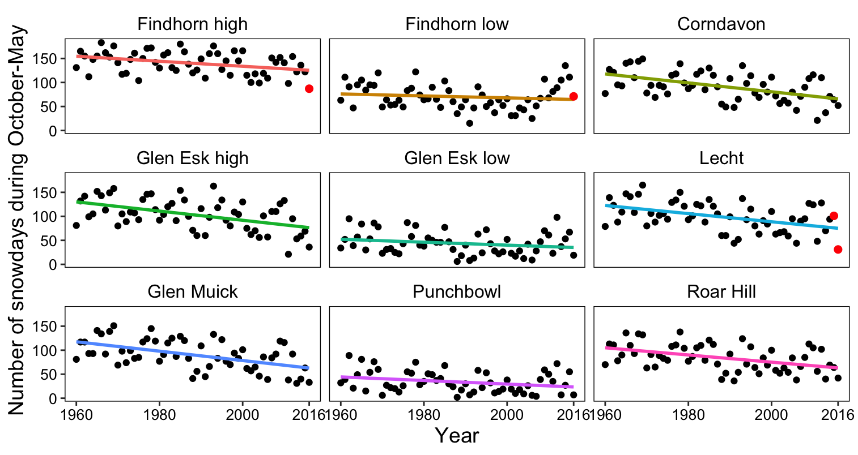
Figure S4. Number of snow days during autumn (a), spring (b) and snow season (c) at study sites in the highlands of Scotland between 1960-2016. Colored lines are based on linear regressions at each site. Red points indicate years and sites of present-day surveys.
a. 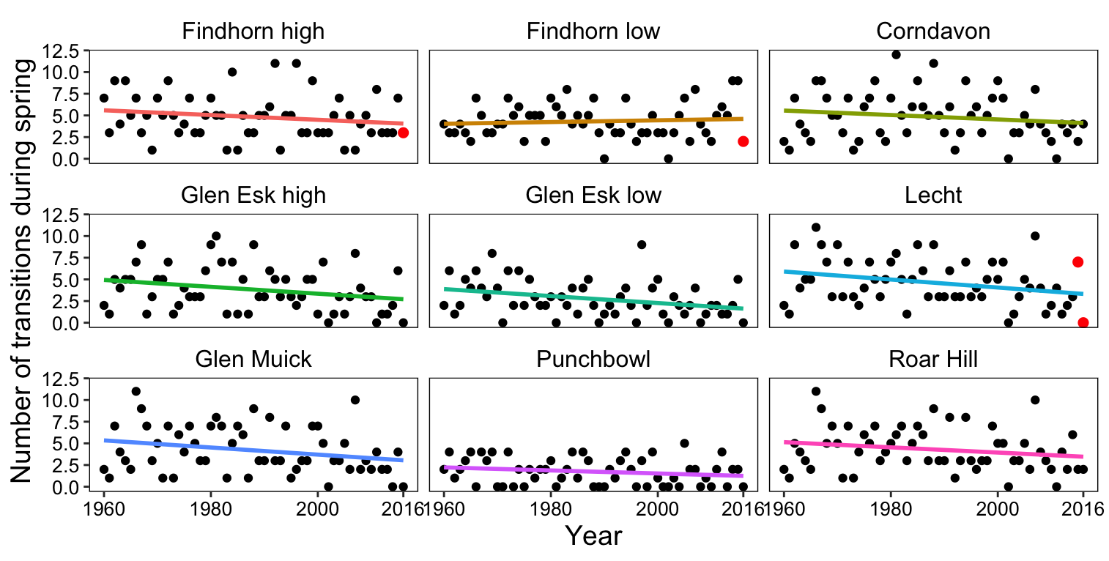
b.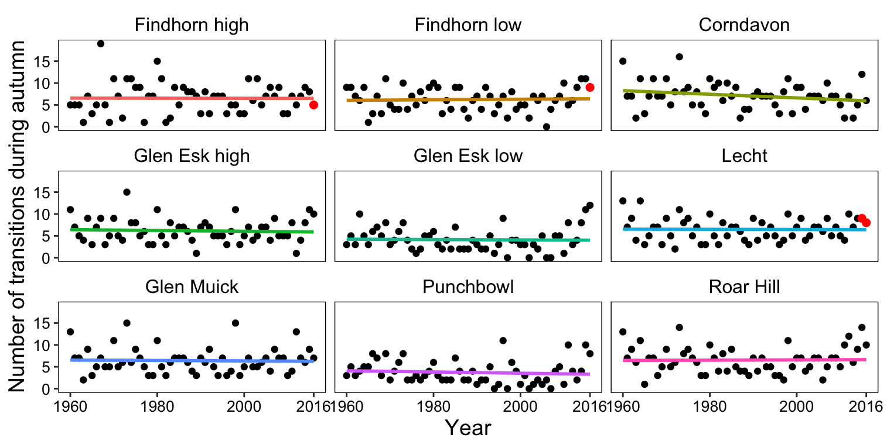
c.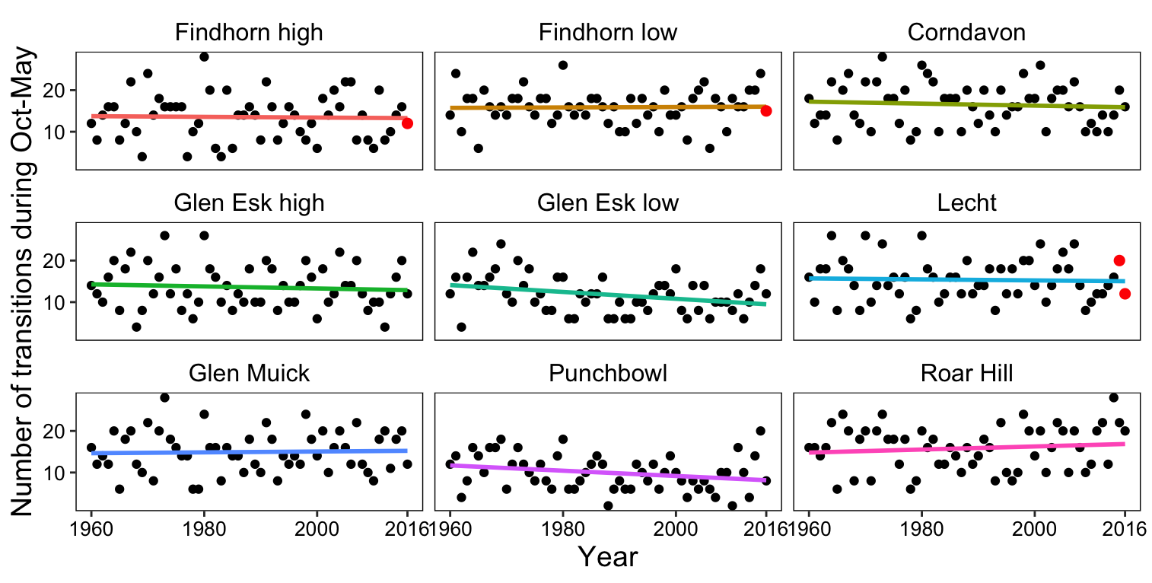
Figure S5. Number of transitions between bare and snow-covered ground during spring (a), autumn (b) and snow season (c) at the study sites between 1960-2016. Colored lines are based on linear regressions at each site. Red points indicate years and sites of present-day surveys.
a. 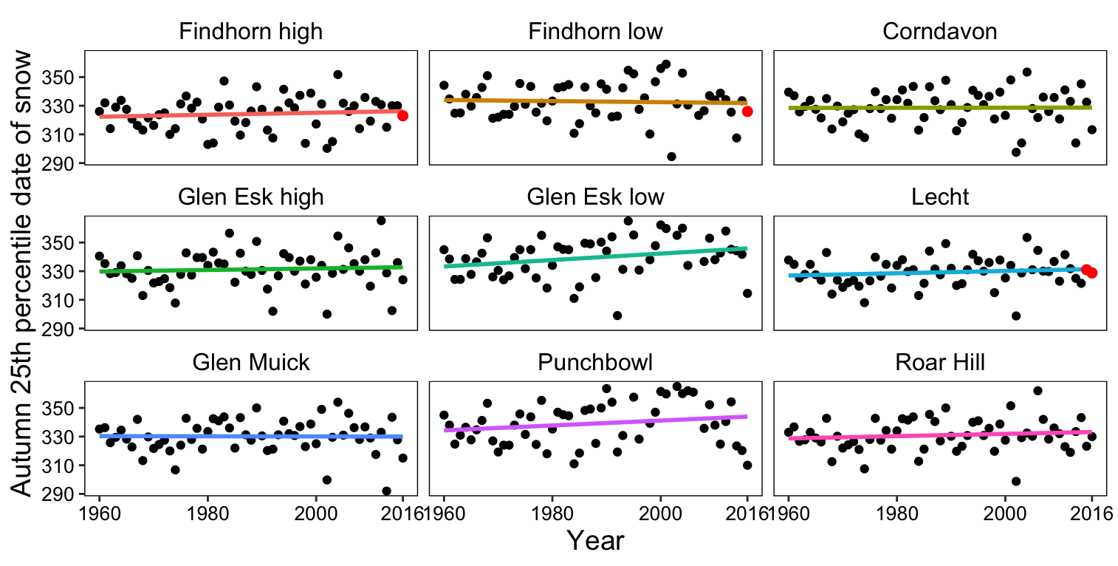
b. 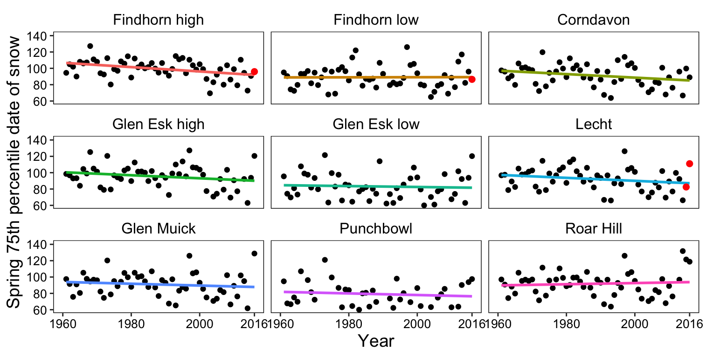
Figure S6. Annual 25th percentile date of snow days in the autumn (a; early autumn snow) and 75th percentile date of snow days in the spring (b; late spring snow) at the study sites between 1960-2016. Coloured lines are based on linear regressions at each site. Red points indicate years and sites of present-day surveys.
a. 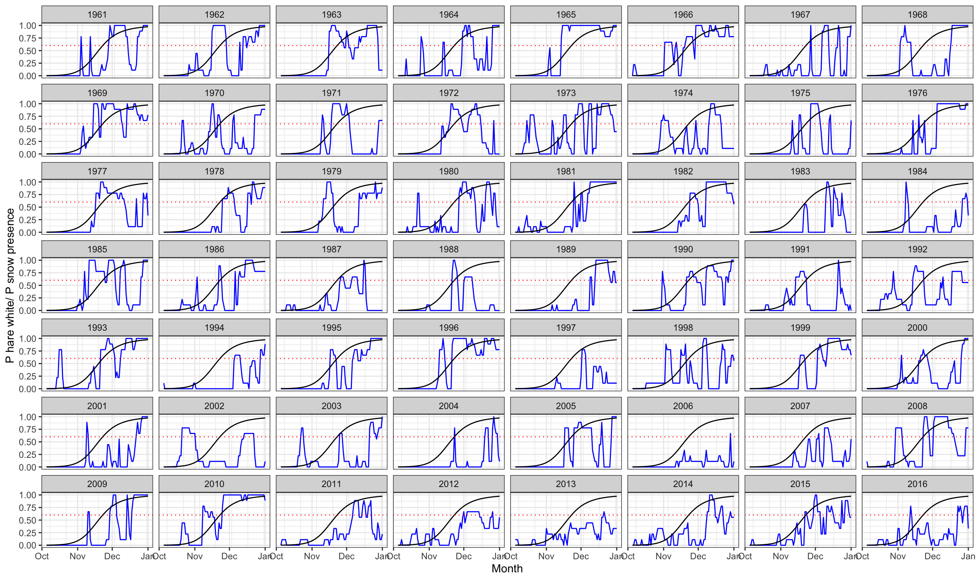
b.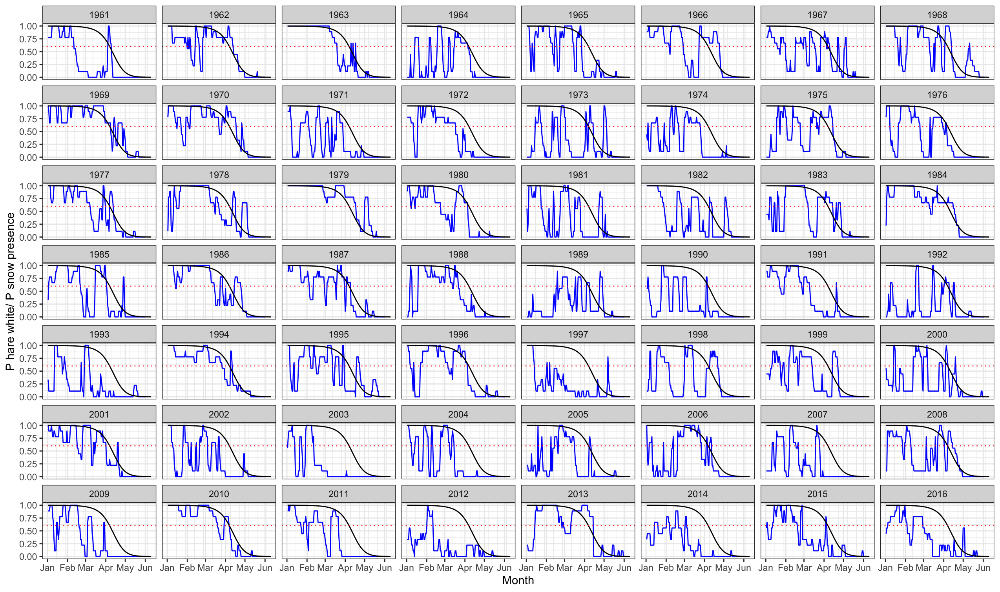

Fig. S7. Phenology of hare coat colour and snow cover presence at the study sites during a) autumn and b) spring moult seasons during 1961-2016. Black lines depict mean predicted probabilities of being white over time. Blue lines depict mean probability of snow presence calculated as the mean snow cover across all sites. Red dotted line intersects the black line at a point when the probability of being white = 60% to denote the time after which hares are considered being white.

Table S1. Present and historical survey sample sizes. Number of surveys carried out at each site during particular year and season. Last three columns give mean number of hares, its standard deviation and minimum number of hares observed during a survey that season.
Site | Season | Year | n surveys | mean n hares/ survey | sd n hares/ survey | min n hares/ survey
Findhorn high | spring | 2016 | 10 | 37.1 | 11.5 | 27
Findhorn high | autumn | 2016 | 6 | 39.7 | 9.4 | 30
Findhorn low | spring | 2016 | 11 | 26.7 | 4.9 | 19
Findhorn low | autumn | 2016 | 6 | 14.0 | 10.3 | 6
Lecht | spring | 2015 | 6 | 46.3 | 7.5 | 36
Lecht | autumn | 2015 | 5 | 37.4 | 6.9 | 30
Lecht | spring | 2016 | 6 | 38.5 | 5.5 | 31
Lecht | autumn | 2016 | 6 | 36.5 | 10.4 | 23
Corndavon | spring | 1951 | 4 | 15.3 | 5.7 | 8
Corndavon | spring | 1955 | 4 | 30.3 | 41.3 | 6
Corndavon | spring | 1957 | 4 | 410.3 | 413.3 | 36
Corndavon | autumn | 1957 | 3 | 49.7 | 42.5 | 7
Corndavon | spring | 1958 | 4 | 114.8 | 43.5 | 75
Corndavon | autumn | 1958 | 3 | 78.7 | 28.7 | 48
Corndavon | spring | 1959 | 2 | 38.5 | 17.7 | 26
Glen Esk high | autumn | 1957 | 8 | 60.8 | 55.1 | 17
Glen Esk high | spring | 1958 | 9 | 116.9 | 100.2 | 10
Glen Esk high | autumn | 1958 | 7 | 44.0 | 24.9 | 18
Glen Esk high | spring | 1959 | 8 | 73.5 | 32.2 | 26
Glen Esk high | autumn | 1959 | 9 | 66.7 | 49.0 | 15
Glen Esk high | spring | 1960 | 4 | 61.0 | 33.0 | 18
Glen Esk high | autumn | 1960 | 6 | 56.5 | 57.2 | 9
Glen Esk high | spring | 1961 | 5 | 70.0 | 42.5 | 19
Glen Esk low | autumn | 1957 | 7 | 26.3 | 18.9 | 8
Glen Esk low | spring | 1958 | 9 | 47.2 | 63.4 | 11
Glen Esk low | autumn | 1958 | 7 | 24.9 | 12.6 | 15
Glen Esk low | spring | 1959 | 8 | 37.3 | 13.0 | 22
Glen Esk low | autumn | 1959 | 7 | 17.9 | 7.5 | 6
Glen Esk low | spring | 1960 | 2 | 13.0 | 11.3 | 5
Glen Esk low | autumn | 1960 | 6 | 12.5 | 8.0 | 2
Glen Muick | spring | 1958 | 2 | 22.0 | 5.7 | 18
Glen Muick | autumn | 1958 | 2 | 21.5 | 0.7 | 21
Glen Muick | spring | 1959 | 2 | 36.0 | 15.6 | 25
Glen Muick | autumn | 1959 | 1 | 56.0 | NA | 56
Punchbowl | autumn | 1957 | 2 | 26.5 | 6.4 | 22
Punchbowl | spring | 1958 | 3 | 98.7 | 29.4 | 67
Punchbowl | autumn | 1958 | 2 | 18.5 | 7.8 | 13
Punchbowl | spring | 1959 | 1 | 35.0 | NA | 35
Roar Hill | spring | 1958 | 9 | 27.8 | 8.3 | 25
Roar Hill | autumn | 1958 | 9 | 25.0 | 0.0 | 25
Roar Hill | spring | 1959 | 12 | 25.0 | 0.0 | 25
Roar Hill | autumn | 1959 | 9 | 25.0 | 0.0 | 25

Table S2. Observed and predicted occurrence of mismatch (in days) with white hares defined either as mean p_{white}> 60% or mean p_{white}> 90%. The first five columns show mean number of mismatch days during 1950s and 2010s, their standard deviations, and the observed difference in mismatch days between the two time periods means. The last three columns show slopes, their standard errors (SE) and the predicted increase in mismatch days based on the mixed linear regression.
mean p_{white} > 60%
Season | mean 1950s | SD | mean 2010s | SD | Observed increase since 1950s | β_{Year} | SE | Predicted increase since 1950s
Snow season | 44.3 | 24.8 | 69.9 | 30.1 | 25.6 | 0.521 | 0.004 | 34.9
Autumn | 13.7 | 9.7 | 19.5 | 11.3 |  | 0.138 | 0.003
Spring | 14.6 | 10.8 | 25.7 | 22.6 |  | 0.184 | 0.003
mean p_{white} > 90%
Season | mean 1950s | SD | mean 2010s | SD | Observed increase since 1950s | β_{Year} | SE | Predicted increase since 1950s
Snow season | 23.7 | 17.4 | 38.2 | 22.3 | 14.5 | 0.289 | 0.003 | 19.4
Autumn | 4.9 | 4.6 | 8.2 | 7.0 |  | 0.059 | 0.002
Spring | 3.1 | 5.1 | 5.8 | 7.1 |  | 0.034 | 0.001

