Supplementary Information for

A phenotypic switch in the dispersal strategy of breast cancer cells selected for metastatic colonization

Authors
George Butler,¹ Shirley Keeton,¹ Louise Johnson¹, Philip Dash¹*

Affiliations
¹ School of Biological Sciences, University of Reading, UK

*Corresponding author
Email: p.r.dash@reading.ac.uk

Journal
Proceedings of the Royal Society B

DOI
10.1098/rspb.2020.2523

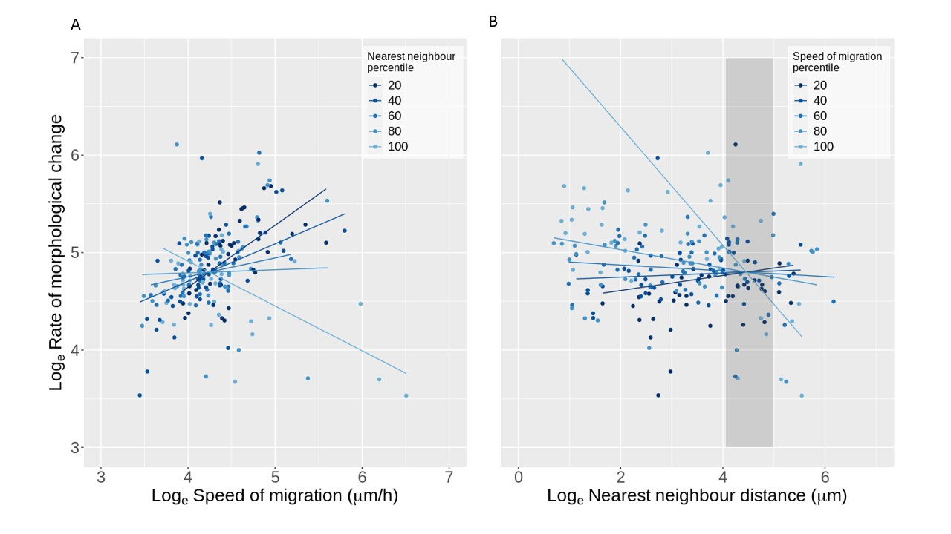
Fig. S1. A dynamic switch in the morphological behaviour within cells selected for colonization with data points. The speed of migration (p = 5.418 x10⁻¹⁴), the distance to the nearest neighbouring cell (p = 2.207 x10⁻¹⁰) and the interaction of the two (2.219 x10⁻¹¹) was significant in the colonization population (N = 210). (A) The natural log-transformed rate of morphological change against the natural log-transformed speed of migration. The data point colour relates to the distance from a neighbouring cell. The lighter the data point the further away from a neighbouring cell. The shaded lines represent the predicted natural log-transformed rate of morphological change against the natural log-transformed speed of migration. The shaded lines indicate the natural log-transformed nearest neighbour percentile. The light the line the further away from a neighbouring cell. (B) The natural log-transformed rate of morphological change against the natural log-transformed nearest neighbour distance. The data point colour relates to the speed of migration. The lighter the data point the faster the speed of migration. The shaded lines represent the predicted natural log-transformed rate of morphological change against the natural log-transformed nearest neighbour distance. The shaded lines indicate the speed of migration percentile. The lighter the line the faster the speed of migration. The shaded region indicates the range of distances over which there is no significant relationship in the rate of morphological change and the speed of migration when the data is centred at these distances, between 57.9µm and 147.2µm.

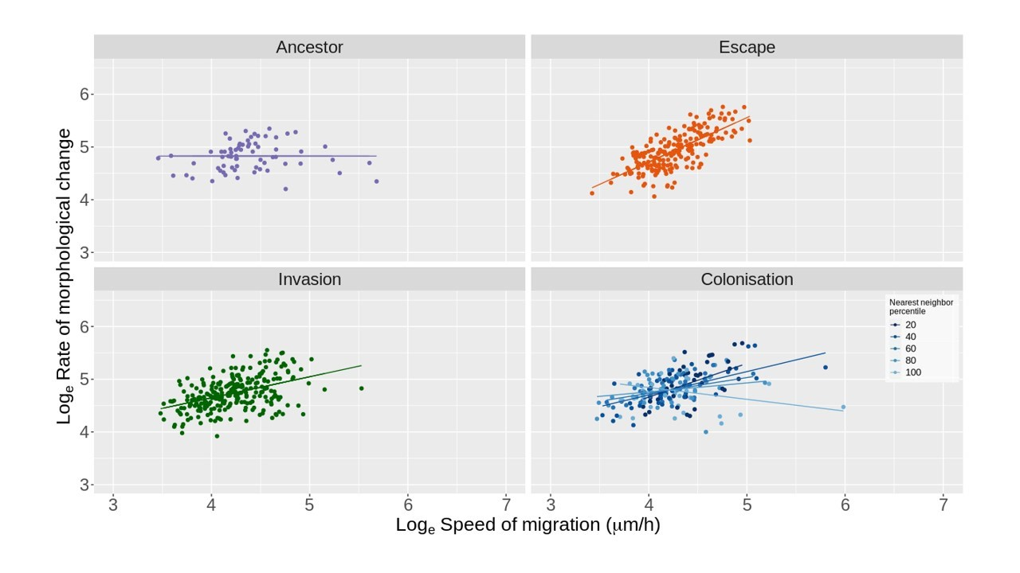Fig. S2. The reduced model for each treatment after the removal of influential data points. The natural log-transformed rate of morphological change against the natural log-transformed speed of migration. In the colonization populations the shaded lines indicate the natural log-transformed nearest neighbour percentile. The lighter the line the further away from a neighbouring cell. Influential data points, Cook's distance > (4 / N) where N is the sample size (1), have been removed to test whether a small subset of points influencing the result. After the removal of these points we found that the speed of migration was still significant in the escape and invasion populations. Likewise, we found that the speed of migration, distance to the nearest neighbouring cell and the interaction of the two was still significant in the colonization populations.

Treatment | Mean rate of morphological change | SE rate of morphological change | Mean speed of migration | SE speed of migration | N
Ancestor | 4.782 | 0.074 | 4.466 | 0.096 | 88
Escape | 4.900 | 0.037 | 4.238 | 0.045 | 230
Invasion | 4.717 | 0.033 | 4.234 | 0.040 | 283
Colonization | 4.822 | 0.038 | 4.310 | 0.045 | 212

Table S1. The natural log-transformed mean and standard error for the rate of morphological change and the speed of migration. Displayed are the natural log mean and standard error for the rate of morphological change and speed of migration for each of the four treatments. The escape populations have a significantly higher rate of morphological change compared with the invasion populations, p = 0.0289.

SI References
1. Bollen KA, Jackman RW. Regression Diagnostics: An Expository Treatment of Outliers and Influential Cases. Sociol Methods Res 1985:510–42.

