Supporting Figures S1-S55 for:

Dispersal ability correlates with range sizes in Amazonian habitat restricted birds
João M. G. Capurucho^{1,2}, Mary Ashley¹, Brian Tsuru², Jacob C. Cooper^{2,3}, John Bates²

¹ Department of Biological Sciences, University of Illinois at Chicago, 845 W. Taylor Street, Chicago, IL 60607, USA
² Life Sciences Section, Negaunee Integrative Research Center, The Field Museum of Natural History, 1400 S. Lake Shore Drive, Chicago, IL 60605, USA
³ Committee on Evolutionary Biology, The University of Chicago, 1025 E 57th Street, Chicago, IL 60637, USA

Short running title: Correlates of range size in birds

Figure S1. Maximum Clade Credibility tree based on 10,000 trees downloaded from birdtree.org; JT tree. WSE specialists are identified in yellow and non-WSE sister taxa in blue.
Figure S2. Maximum Likelihood phylogenetic hypothesis; ML tree. WSE specialists are identified in yellow and non-WSE sister taxa in blue.
Figure S3. Bayesian Inference phylogenetic hypothesis; BI tree. WSE specialists are identified in yellow and non-WSE sister taxa in blue.

Figure S4. Comparison between the phylogenetic hypotheses and species pool from JT and ML trees.
Figure S5. Comparison between the phylogenetic hypotheses and species pool from JT and BI trees.
Figure S6. Comparison between the phylogenetic hypotheses and species pool from ML and BI trees.

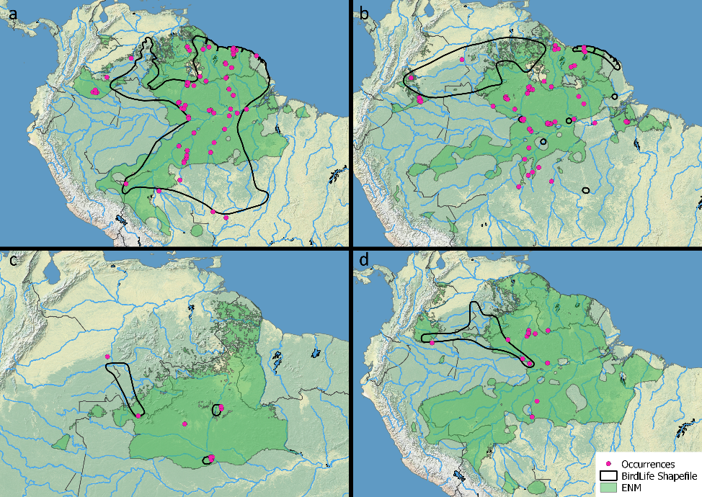
Figure S7. Examples of variability among Birdlife shapefiles and Ecological Niche Models (ENMs) in approximations of the “true” range of species. In some cases, both ENMs and Birdlife range maps line up closely with occurrence data (a, Galbula leucogastra). In others, the ENMs may better approximate knowledge of the species range (b, Elaenia ruficeps) or may underperform compared to expert knowledge (c, Aprositornis disjuncta). Still other species have distributions based on occurrence data that may not be particularly well represented by either approximation (d, Sporophila fringilloides).

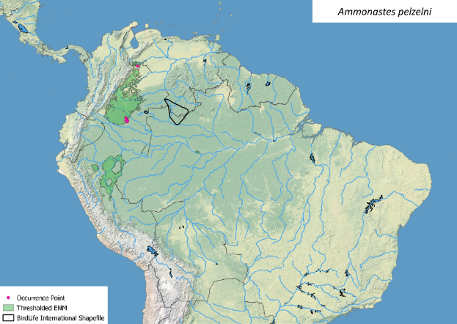
Figure S8. BirdLife range map and thresholded ENM for the WSE specialist Ammonastes pelzelni.
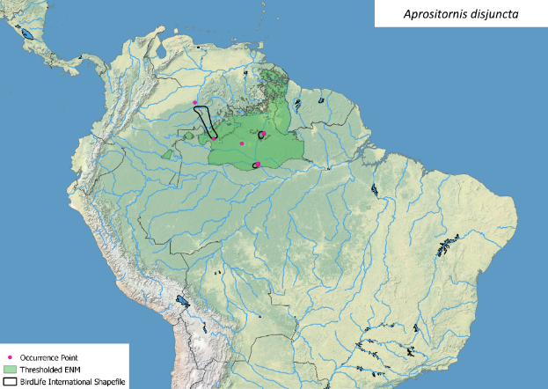
Figure S9. BirdLife range map and thresholded ENM for the WSE specialist Aprositornis disjuncta.

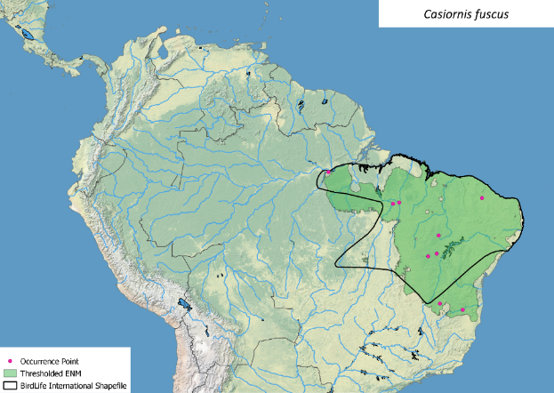
Figure S10. BirdLife range map and thresholded ENM for Casiornis fuscus.

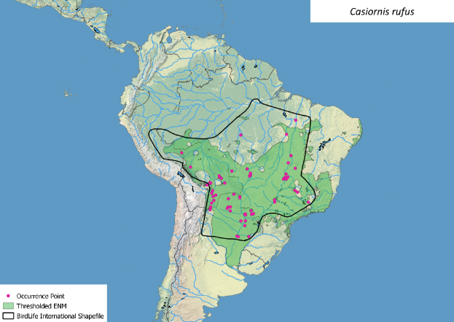
Figure S11. BirdLife range map and thresholded ENM for Casiornis rufus.

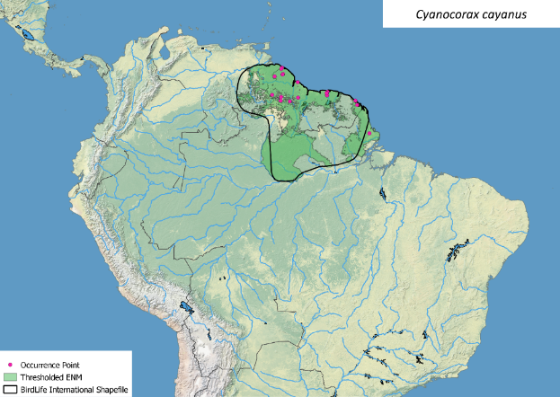
Figure S12. BirdLife range map and thresholded ENM for Cyanocorax cayanus.

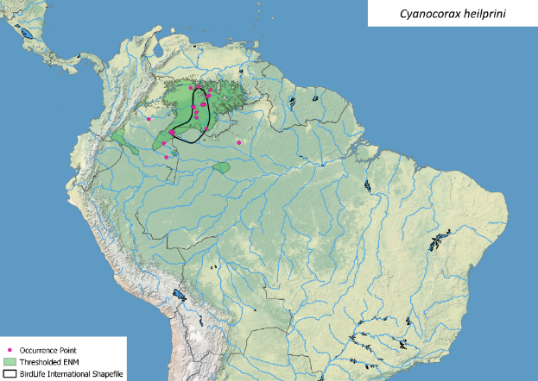
Figure S13. BirdLife range map and thresholded ENM for the WSE specialist Cyanocorax heilprini.

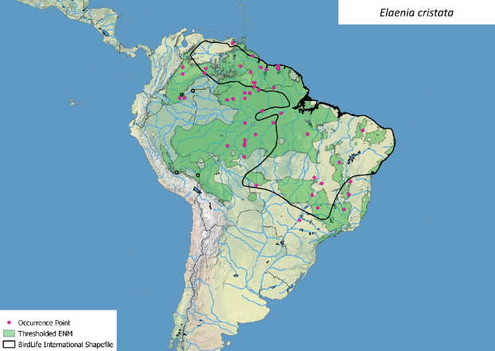
Figure S14. BirdLife range map and thresholded ENM for Elaenia cristata.

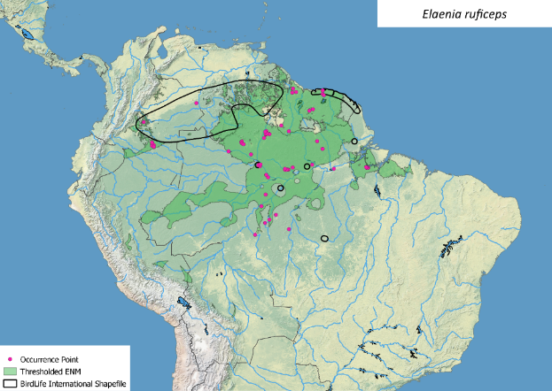
Figure S15. BirdLife range map and thresholded ENM for the WSE specialist Elaenia ruficeps.

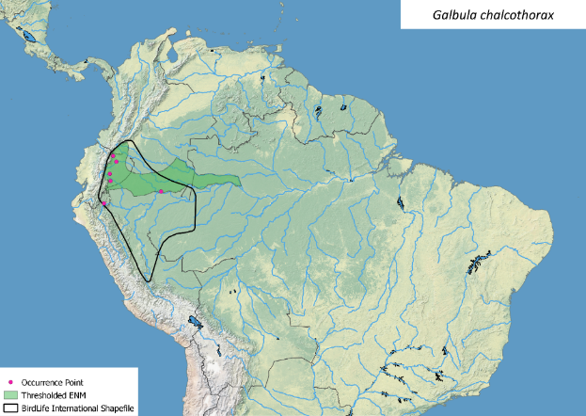
Figure S16. BirdLife range map and thresholded ENM for Galbula chalcothorax.

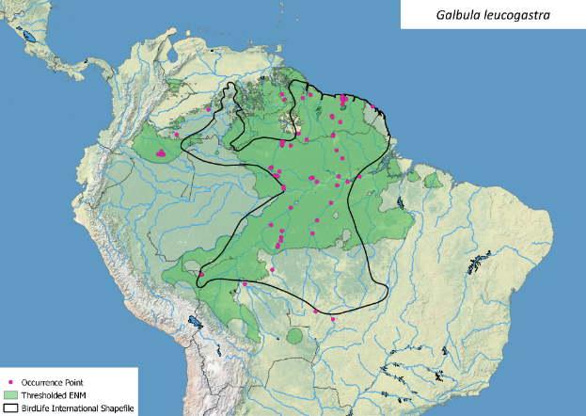
Figure S17. BirdLife range map and thresholded ENM for the WSE specialist Galbula leucogastra.

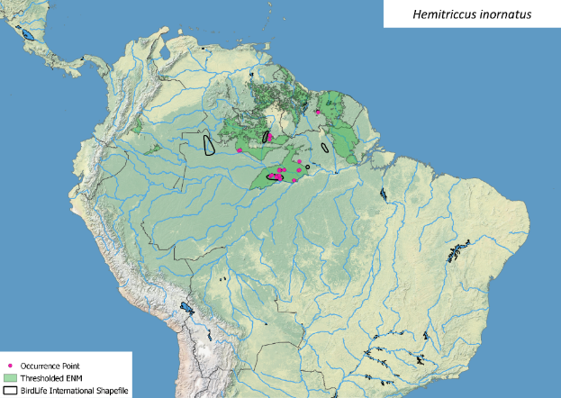
Figure S18. BirdLife range map and thresholded ENM for the WSE specialist Hemitriccus inornatus.

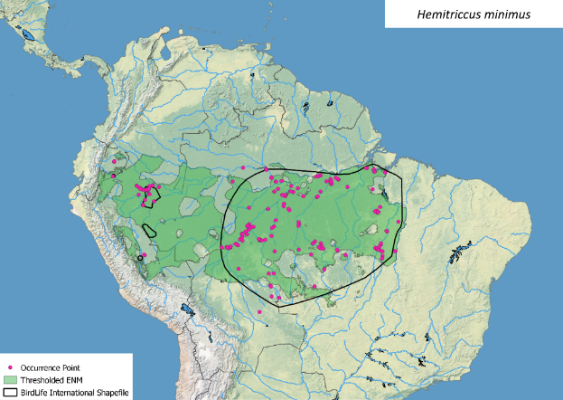
Figure S19. BirdLife range map and thresholded ENM for the WSE specialist Hemitriccus minimus.

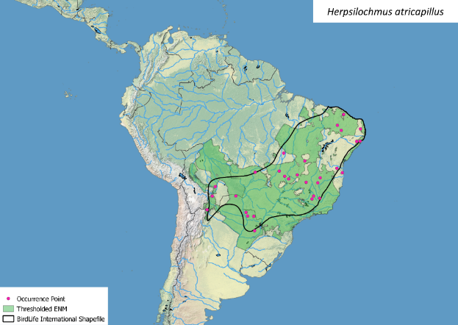
Figure S20. BirdLife range map and thresholded ENM for Herpsilochmus atricapillus.

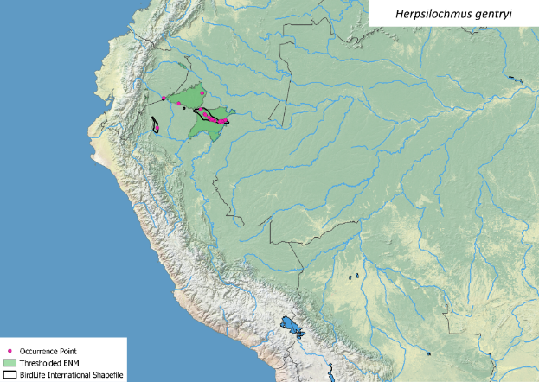
Figure S21. BirdLife range map and thresholded ENM for the WSE specialist Herpsilochmus gentryi.

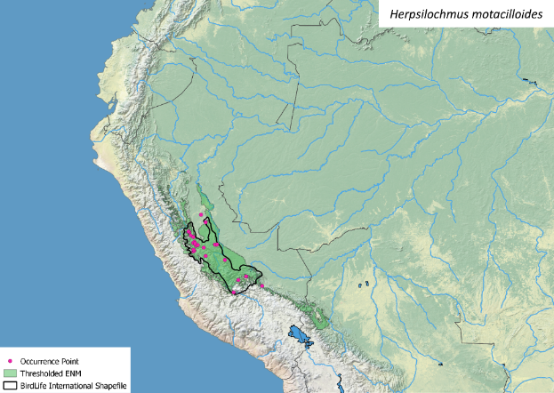
Figure S22. BirdLife range map and thresholded ENM for Herpsilochmus motacilloides.

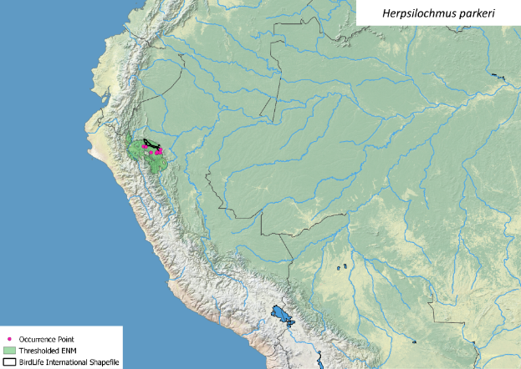
Figure S23. BirdLife range map and thresholded ENM for Herpsilochmus parkeri.

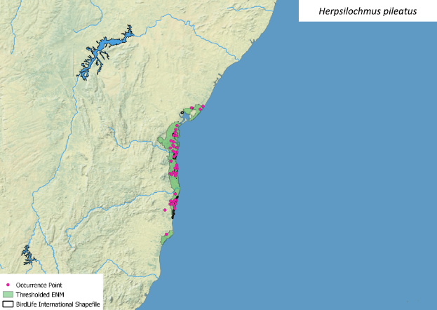
Figure S24. BirdLife range map and thresholded ENM for Herpsilochmus pileatus.

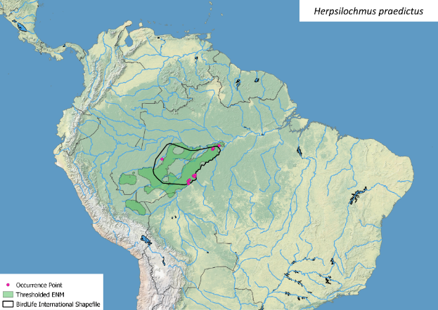
Figure S25. BirdLife range map and thresholded ENM for the WSE specialist Herpsilochmus praedictus.

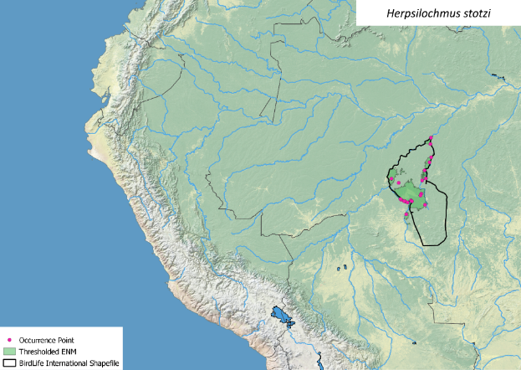
Figure S26. BirdLife range map and thresholded ENM for the WSE specialist Herpsilochmus stotzi.

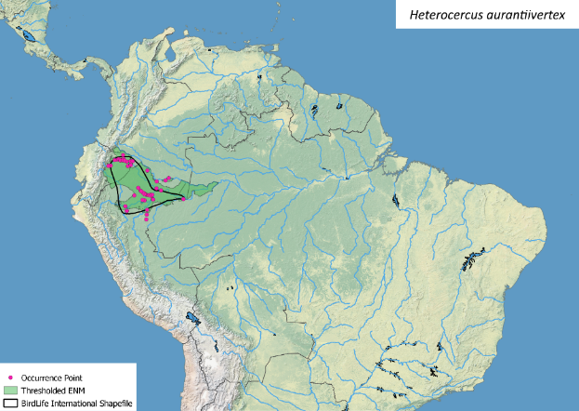
Figure S27. BirdLife range map and thresholded ENM for the WSE specialist Heterocercus aurantiivertex.

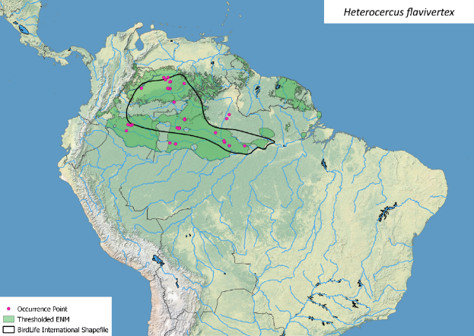
Figure S28. BirdLife range map and thresholded ENM for the WSE specialist Heterocercus flavivertex.

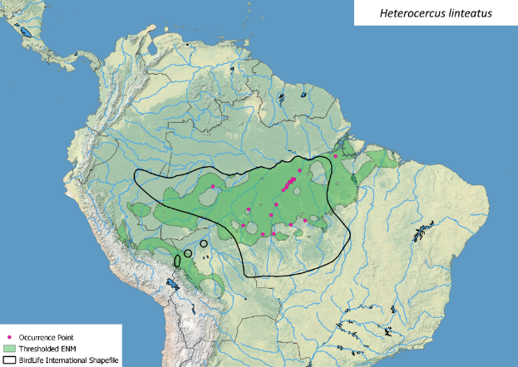
Figure S29. BirdLife range map and thresholded ENM for Heterocercus linteatus.

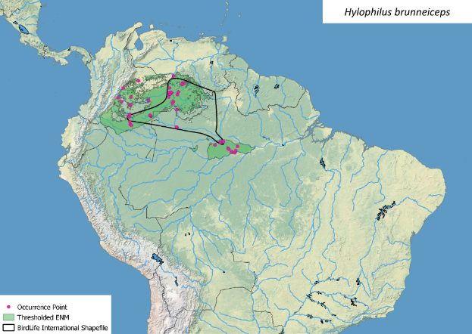
Figure S30. BirdLife range map and thresholded ENM for the WSE specialist Hylophilus brunneiceps.

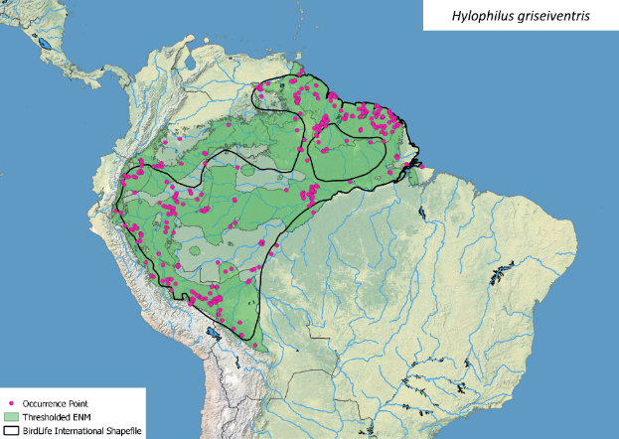
Figure S31. BirdLife range map and thresholded ENM for Hylophilus griseiventris.

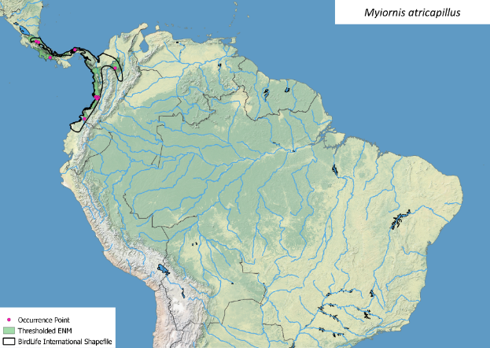
Figure S32. BirdLife range map and thresholded ENM for Myiornis atricapillus.

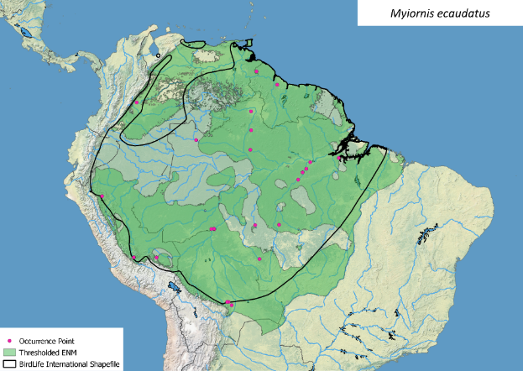
Figure S33. BirdLife range map and thresholded ENM for Myiornis ecaudatus.

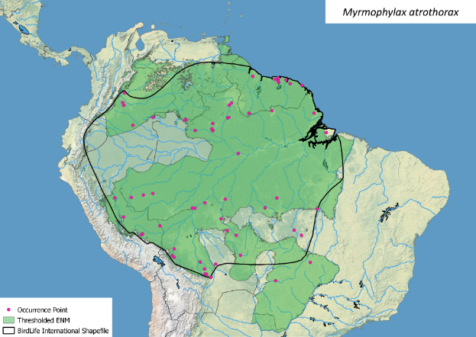
Figure S34. BirdLife range map and thresholded ENM for Myrmophylax atrothorax.

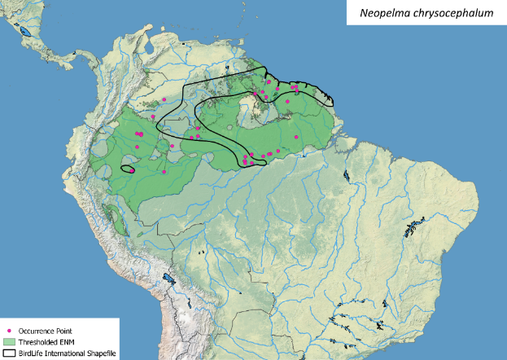
Figure S35. BirdLife range map and thresholded ENM for the WSE specialist Neopelma chrysocephalum.

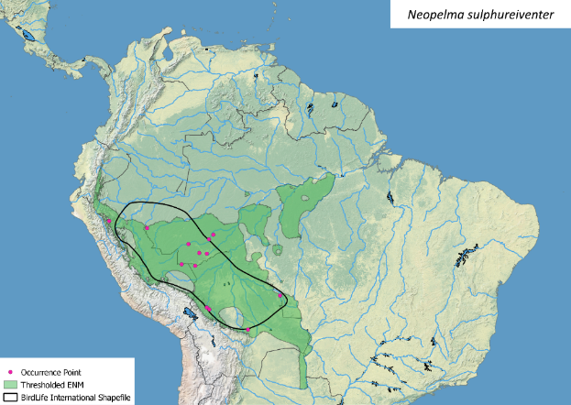
Figure S36. BirdLife range map and thresholded ENM for Neopelma sulphureiventer.

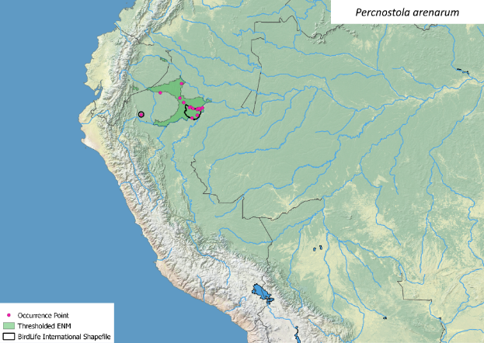
Figure S37. BirdLife range map and thresholded ENM for the WSE specialist Percnostola arenarum.

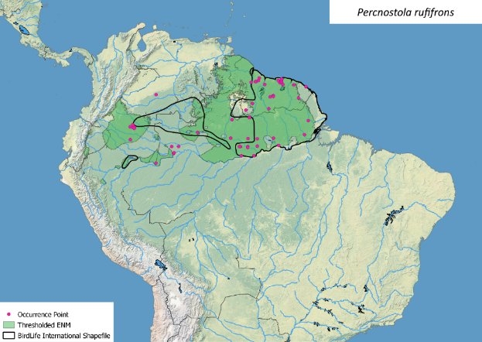
Figure S38. BirdLife range map and thresholded ENM for Percnostola rufifrons.

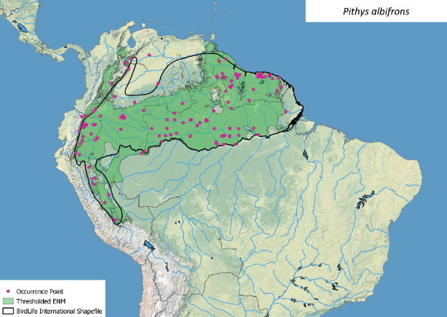
Figure S39. BirdLife range map and thresholded ENM for Pithys albifrons.

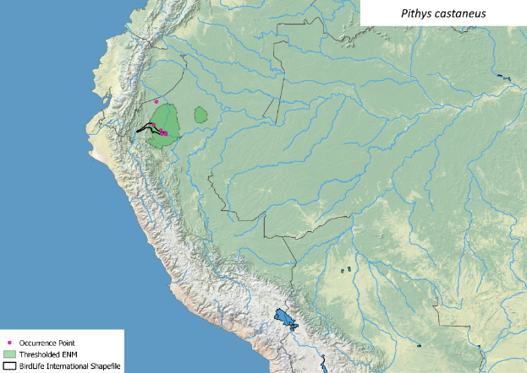
Figure S40. BirdLife range map and thresholded ENM for the WSE specialist Pithys castaneus.

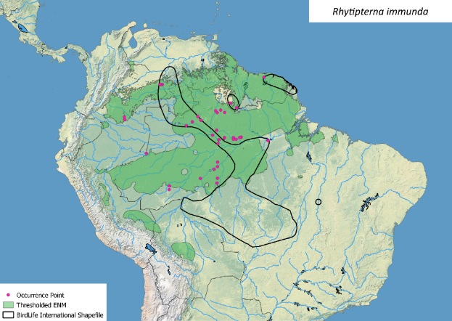
Figure S41. BirdLife range map and thresholded ENM for the WSE specialist Rhytipterna immunda.

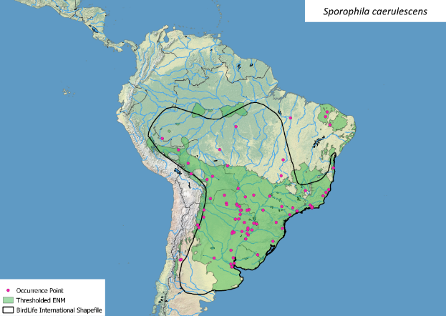
Figure S42. BirdLife range map and thresholded ENM for Sporophila caerulescens.

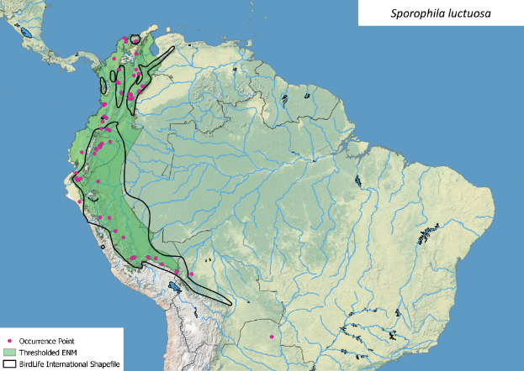
Figure S43. BirdLife range map and thresholded ENM for the WSE specialist Sporophila luctuosa.

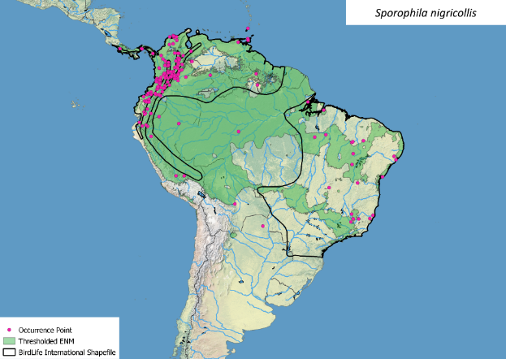
Figure S44. BirdLife range map and thresholded ENM for Sporophila nigricollis.

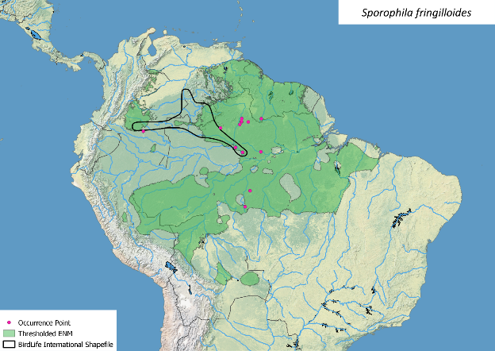
Figure S45. BirdLife range map and thresholded ENM for the WSE specialist Sporophila fringilloides.

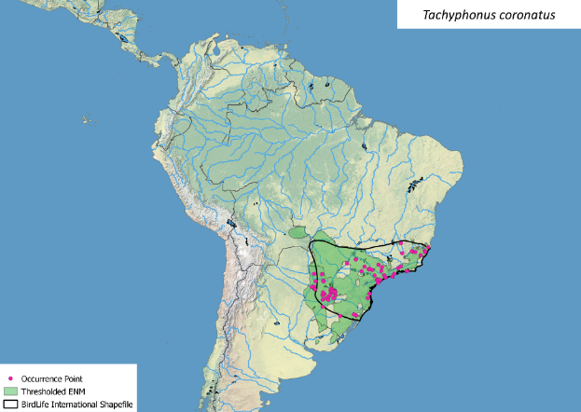
Figure S46. BirdLife range map and thresholded ENM for Tachyphonus coronatus.

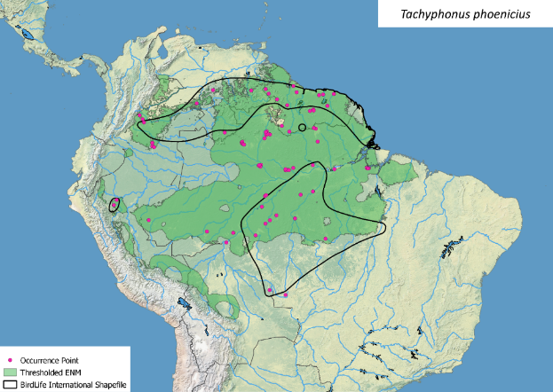
Figure S47. BirdLife range map and thresholded ENM for the WSE specialist Tachyphonus phoenicius.

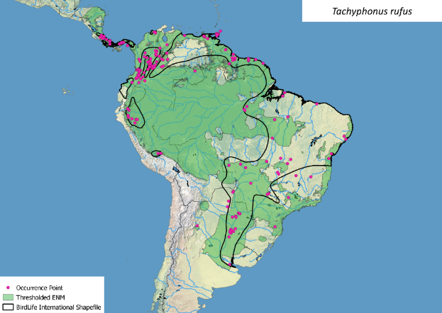 Figure S48. BirdLife range map and thresholded ENM for Tachyphonus rufus.

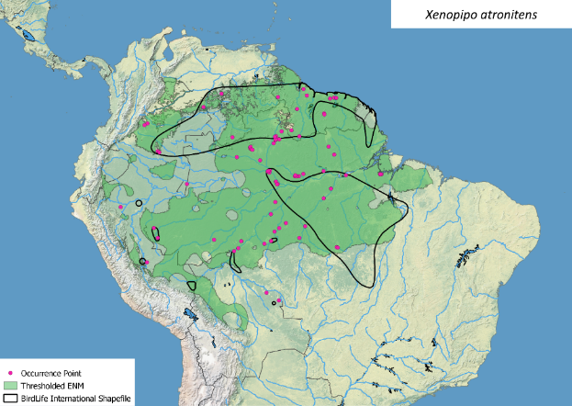
Figure S49. BirdLife range map and thresholded ENM for the WSE specialist Xenopipo atronitens.

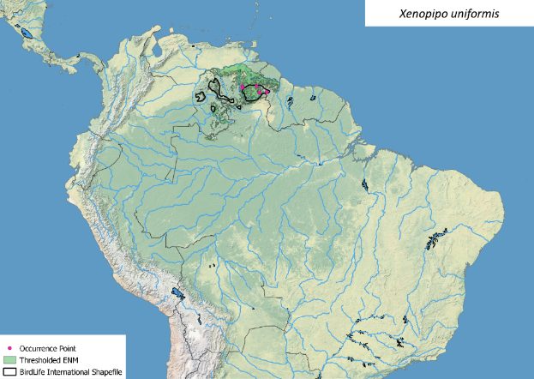
Figure S50. BirdLife range map and thresholded ENM for Xenopipo uniformis.

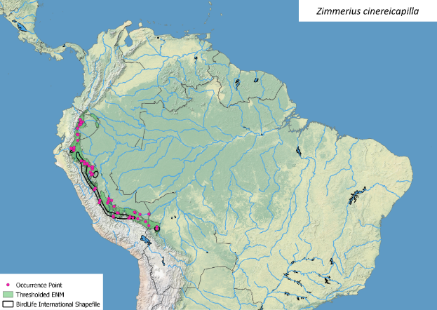
Figure S51. BirdLife range map and thresholded ENM for Zimmerius cinereicapilla.

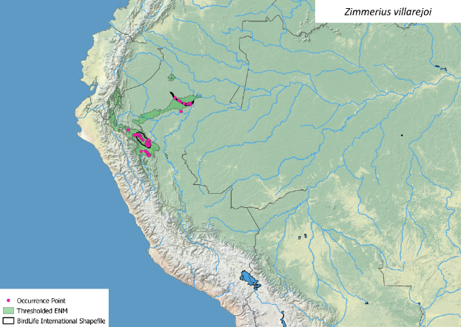
Figure S52. BirdLife range map and thresholded ENM for the WSE specialist Zimmerius villarejoi.

Figure S53. Differences in the estimated range size from the Birdlife maps (BL) and the Ecological Niche Models (ENM).

Figure S54. Hand-wing index values for WSE specialist birds and its non-WSE sister taxa.
Figure S55. Hand-wing index values (HWI) of the study species showing the mean value (dot) and standard errors (vertical lines).

