ELECTRONIC SUPPLEMENTARY MATERIAL

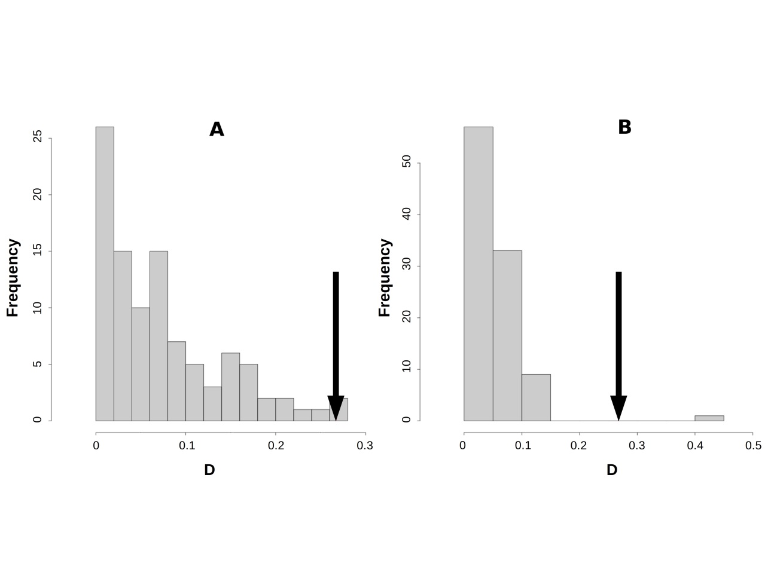Figure S1
Histograms of the similarity test (D metric). A) D values based on 100 null models using the introduced records and random background native points, and B) D values for 100 null models using the native records and random background introduced points. The arrows denote the observed D metric value between introduced and native records.

Table S1
Maximum Entropy models results for the four datasets. Sample sizes and AUC values are given for the training and testing of each model dataset. Percentage contributions of each variable are indicated for the models. The highest percentage contribution is denoted in bold and grey shading and the second highest shaded in grey.

 |  | NATIVE | WARM | COLD | INTRODUCED
Training sample size |  | 902 | 173 | 345 | 61
Training AUC |  | 0.930±0.006 | 0.978±0.080 | 0.973±0.004 | 0.980±0.016
Test sample size |  | 100 | 19 | 38 | 7
Test AUC |  | 0.925 | 0.974 | 0.969 | 0.970
Precipitation | PrecipDry | 0.1 | 0.5 | 51.2 | 0.2
 | PrecipHot | 10.8 | 1.4 | 3.1 | 33.5
 | PrecipCold | 27.4 | 48.4 | 0.5 | 27.9
Temperature | TempDiurn | 11.6 | 8.8 | 4.6 | 0.6
 | TempWet | 24.8 | 24.3 | 10.6 | 16.5
 | TempDry | 25.3 | 16.6 | 30.1 | 21.2

PrecipDry=Bio17 (precipitation of driest quarter), PrecipHot=Bio18 (precipitation of warmest quarter), and PrecipCold=Bio19 (precipitation of coldest quarter), TempDiurn=Bio2 (mean diurnal temperature range), TempWet=Bio8 (mean temperature of wettest quarter), TempDry=Bio9 (mean temperature of driest quarter).

Table S2
Geographic niche overlaps between the introduced and native models. For each comparison the habitat suitability map of the model was contrasted against the projection of the other model. The habitat suitability threshold -- applying the maximum training sensitivity plus specificity logistic threshold -- is given in brackets for each model and for the corresponding projection. Stability represents the proportion of the niche that is shared by the model and the projection. Expansion is the proportion of the model that does not overlap with the projection. Unfilling is the proportion of the projection that does not overlap with the model. Unsuitable is the proportion of the niche predicted as unsuitable by the model and the projection.

model | INTRODUCED |  |  |  | NATIVE
projection | NATIVE  (0.2534) | WARM  (0.1322) | COLD  (0.1811) |  | INTRODUCED  (0.1061)
Stability | 0.019 | 0.007 | 0.004 |  | 0.047
Unfilling | 0.047 | 0.003 | 0.031 |  | 0.053
Expansion | 0.041 | 0.052 | 0.056 |  | 0.041
Unsuitable | 0.894 | 0.938 | 0.909 |  | 0.858

