Supplementary material - Supplemental figures

Oxidative costs of cooperation in cooperatively breeding Damaraland mole-rats
Rute Mendonça, Philippe Vullioud, Nathan Katlein, Armelle Vallat, Gaétan Glauser, Nigel C. Bennett, Fabrice Helfenstein
DOI: 10.1098/rspb.2020.1023
b)
Control
Blood,
ejaculate & body mass
Blood,
ejaculate & body mass

Scan
observation
Scan
observation
Day 2
Sand
Day 7
Day -2
Day 8
a)
Sand
Blood,
ejaculate & body mass
Blood,
ejaculate & body mass

Scan
observation
Scan
observation
Day 2
Control
Day 7
Day -2
Day 8

Figure S1 - Timeline of the experimental design. Three of the colonies used in this study started with the Control treatment (a), while the other three started with the Sand treatment (b). Each treatment (white and yellow rectangles) lasted 8 days and were separated by an 8-day resting period (thin line connecting the rectangles). The thin line before the start of the experiment represents the period of two days between initial sample collection and start of the first treatment. Blood and ejaculate samples and body mass were collected two days before the start and on the last day of each treatment week (red bars). Scan observations were carried out for 12 hours on Day 2 and Day 7 of each treatment week (green bars). Refer to the main text for more details.
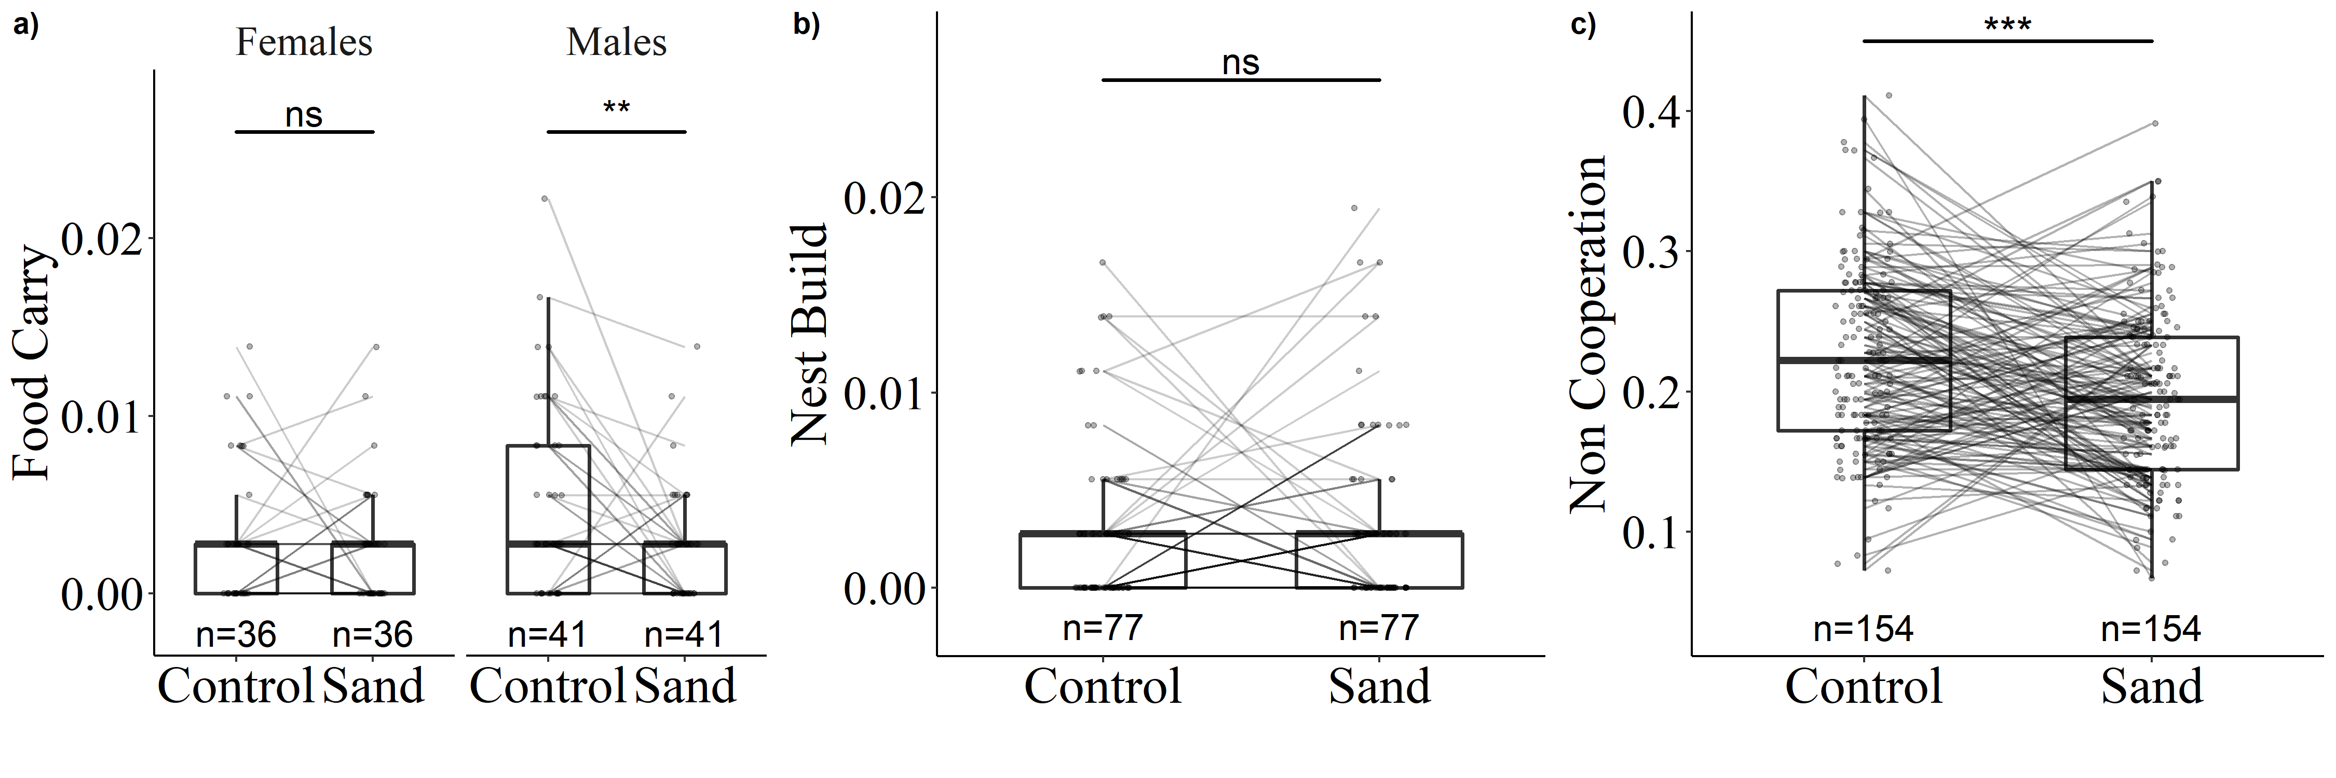
Figure S2 - Effect of treatment on the proportion of time spent (a) nest building, (b) carrying food and (c) carrying out other non-cooperative behaviours, in two sessions of 12h scan observations. Boxplots show median, 1st and 3rd quartiles and whiskers extend no further than 1.5 * interquartile range (IQR). Each individual is represented twice in each treatment, once from scan on day2 and once from scan on day7. Lines between points illustrate the repeated measurements of same individuals. ***, p < 0.001; **, p < 0.01; ns, non-significant.

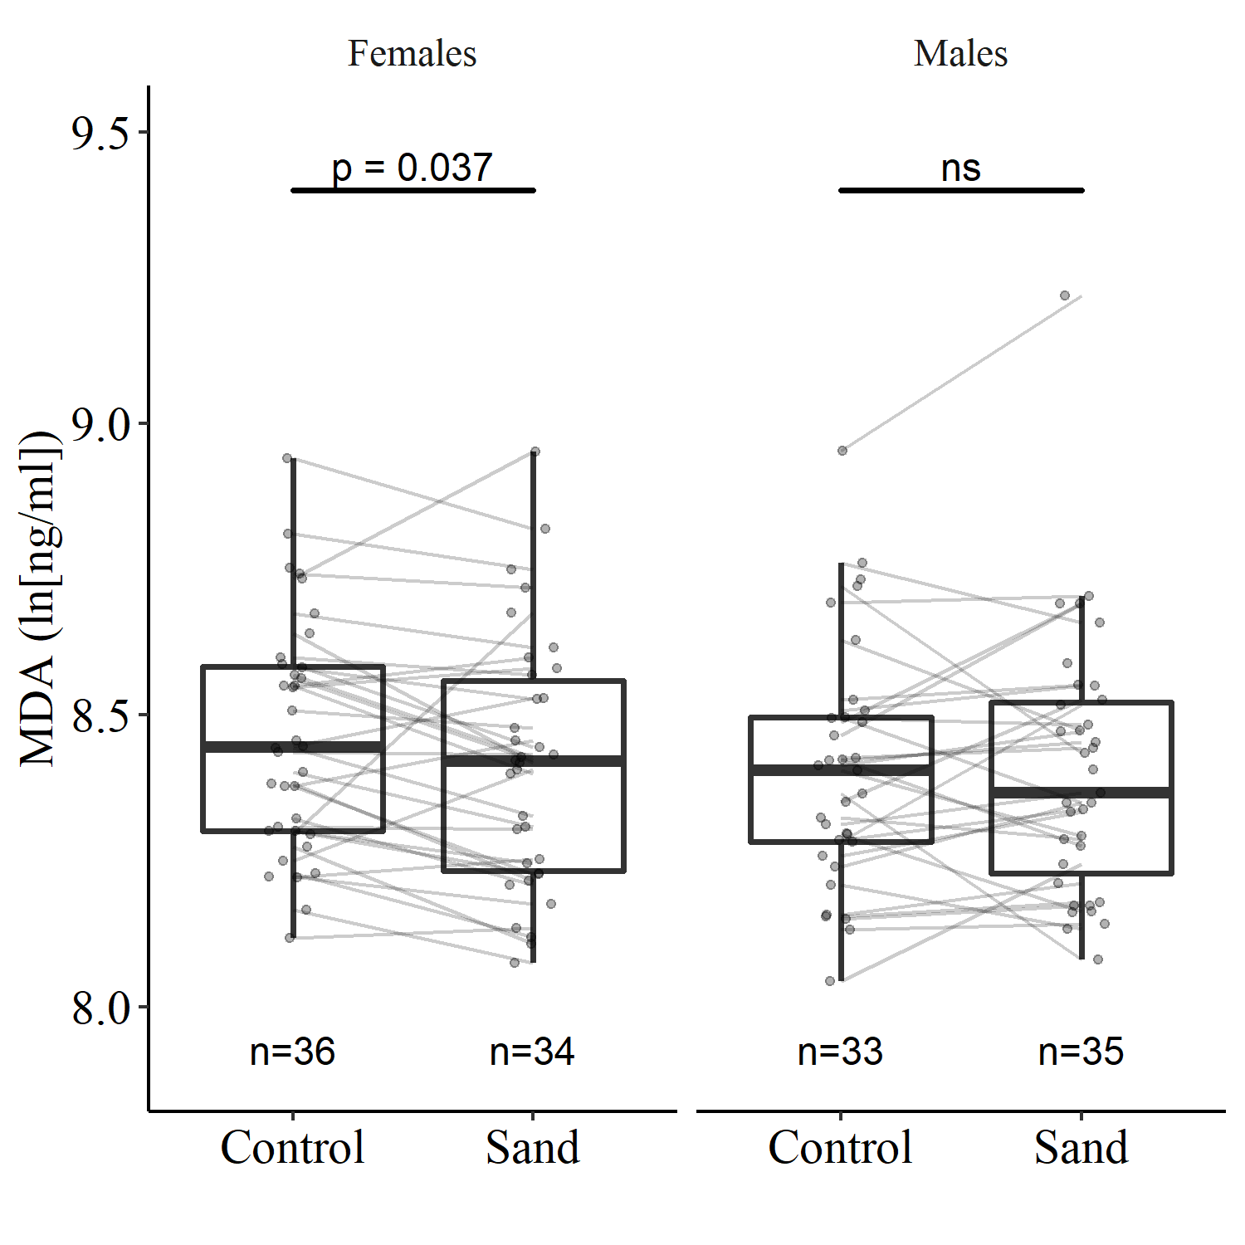

Figure S3 – Effect of treatment on final (Day 8) oxidative damage to lipids (MDA) in erythrocytes dependent on sex. Boxplots show median, 1st and 3rd quartiles and whiskers extend no further than 1.5*IQR. Lines between points illustrate the repeated measurements of same individuals. Significance levels represented refer to least square means comparisons: *, p < 0.05; ns, non-significant.

