Identification of a queen pheromone mediating the rearing of adult sexuals in the pharaoh ant Monomorium pharaonis
Ricardo Caliari Oliveira¹, Jonas Warson¹, David Sillam-Dussès², Beatriz Herrera-Malaver ^{3,4}, Kevin Verstrepen^{3,4}, Jocelyn G. Millar^{5,6} and Tom Wenseleers¹
¹Laboratory of Socioecology and Social Evolution, Department of Biology, KU Leuven, Naamsestraat 59,
3000 Leuven, Belgium
²Laboratory of Experimental and Comparative Ethology UR 4443, University Sorbonne Paris Nord,
93430 Villetaneuse, France
³Laboratory of Systems Biology, VIB-KU Leuven Center for Microbiology, Leuven, Belgium
⁴Laboratory for Genetics and Genomics, Center of Microbial and Plant Genetics, Department M2S, KU Leuven, Gaston Geenslaan 1, 3001, Heverlee, Belgium
⁵Department of Entomology, University of California, Riverside, CA 92521, USA
⁶Department of Chemistry, University of California, Riverside, CA 92521, USA

Full Generalized linear mixed effects models outcome
Table S1. Full outcome binomial generalized linear mixed model for queen pheromone bioassay
Fixed effects | Binomial GLMM  proportion of queens reared |  |  |  | Binomial GLMM  proportion of males reared
Predictors | Log-Odds | std. Error | CI | p | Log-Odds | std. Error | CI | p
(Intercept) | -2.52 | 0.63 | -3.76 – -1.28 | <0.001 | -3.25 | 0.60 | -4.43 – -2.07 | <0.001
group [0.1QE] | -0.56 | 0.77 | -2.07 – 0.95 | 0.466 | -0.27 | 0.69 | -1.62 – 1.09 | 0.699
group [1QE] | -0.78 | 0.81 | -2.37 – 0.80 | 0.332 | -0.51 | 0.72 | -1.92 – 0.89 | 0.472
group [2QE] | -1.22 | 0.84 | -2.87 – 0.44 | 0.149 | -0.42 | 0.74 | -1.87 – 1.04 | 0.575
group [5QE] | -0.99 | 0.98 | -2.91 – 0.93 | 0.310 | -0.51 | 0.86 | -2.20 – 1.17 | 0.549
group [10QE] | -2.26 | 0.65 | -3.52 – -0.99 | <0.001 | -1.62 | 0.57 | -2.73 – -0.51 | 0.004
group [20QE] | -1.70 | 0.82 | -3.30 – -0.09 | 0.038 | -1.43 | 0.71 | -2.83 – -0.04 | 0.044
group [50QE] | -1.76 | 0.82 | -3.36 – -0.16 | 0.031 | -1.56 | 0.71 | -2.96 – -0.17 | 0.028
group [100QE] | -1.58 | 0.80 | -3.15 – -0.00 | 0.049 | -1.48 | 0.72 | -2.89 – -0.06 | 0.041
Colony size | 0.16 | 0.30 | -0.42 – 0.74 | 0.593 | 0.12 | 0.27 | -0.41 – 0.64 | 0.661
Trial | -0.65 | 0.69 | -2.00 – 0.69 | 0.340 | -0.45 | 0.61 | -1.66 – 0.75 | 0.462
Random Effects
σ² | 4.73 |  |  |  | 4.33
τ₀₀ | 1.44 _{obs} |  |  |  | 1.04 _{obs}
 | 0.74 _{colony} |  |  |  | 0.81 _{colony}
ICC | 0.13 |  |  |  | 0.16
N | 6 _{colony} |  |  |  | 6 _{colony}
 | 53 _{obs} |  |  |  | 53 _{obs}
Observations | 53 |  |  |  | 53
AIC | 392.358 |  |  |  | 351.681

Table S2. Full outcome binomial generalized linear mixed model for queen retinue behaviour bioassay
Fixed effects | Poisson GLMM queen retinue behaviour
Predictors | Log-Mean | std. Error | CI | p
(Intercept) | 3.06 | 0.10 | 2.88 – 3.25 | <0.001
QE dose | 0.10 | 0.04 | 0.03 – 0.18 | 0.005
Random Effects
σ² | 0.09
τ₀₀ _{obs} | 0.06
τ₀₀ _{colony} | 0.00
τ₀₀ _{trial} | 0.00
N _{colony} | 4
N _{obs} | 20
N _{trial} | 2
Observations | 20
AIC | 150.509

Quantification of the amount of neocembrene produced by pharaoh ant queens
The diterpene neocembrene, (1E,5E,9E,12R)-1,5,9-trimethyl-12-(1-methylethenyl)-1,5,9-cyclotetradecatriene, is the major component of extracts of the Dufour’s gland of egg-laying queens of Monomorium pharaonis and absent in workers and virgin queens [1]. To determine the absolute quantity of neocembrene present in a single M. pharaonis queen, we dissected the Dufour’s gland of 8 egg-laying queens and prepared two composite samples of four queens each. The dissected glands were extracted in 100 µL of HPLC-grade hexane and the resulting extracts were analyzed with a gas chromatograph (Thermo Fisher Scientific Trace 1300 series) coupled with a mass spectrometer (Thermo Fisher Scientific ISQ series MS). We used an injection volume of 1 µL and splitless injection, with an inlet temperature of 320 °C. The initial temperature of 70 °C was held for 2 min, then increased to 200 °C at a rate of 20 °C min⁻¹, to 250 °C at a rate of 3 °C min⁻¹, and finally to 320 °C at a rate of 5 °C min⁻¹ which was held for 3 minutes. Helium was used as carrier gas at a constant flow rate of 0.9 mL min⁻¹. The electron ionization voltage was autotuned to enhance the acquisition performance according to the molecular weight of the compounds and the ion source temperature and MS transfer line temperature were both set to 300 °C. A Restek RXi-5sil MS 20 m column with an internal diameter of 0.18 mm and a film thickness of 0.18 µm was used. Peaks in the total ion chromatogram were aligned and integrated using a custom R script (available on request). External linear alkane ladders containing n-octane (n-C₈) up to n-tetracontane (n-C₄₀) injected at two different concentrations (0.1 µg/µL and 0.01 µg/µL) were used to quantify neocembrene. We used the nearest eluting linear alkane (nonadecane) to construct a calibration curve using a linear regression on a log(concentration) vs. log(peak area) scale. In our samples, neocembrene accounted on average for 49 % of the relative peak area of the total ion chromatogram and the absolute amount per queen was calculated to be 370 ng per queen.

Extraction and isolation of neocembrene from cultures of Saccharomyces cerevisiae yeast strain EPY300
We used the transgenically modified Saccharomyces cerevisiae strain EPY300 [2] to produce neocembrene. First, strain EPY300 was propagated by inoculation in 5ml SC-HIS-LEU-MET-URA synthetic complete medium containing 2% glucose at 30°C. After overnight incubation, 1 mL of culture was transferred once more to 50 ml SC-HIS-LEU-MET-URA medium containing 2% glucose and incubated at 30°C and 200 rpm for 24 hrs. Finally, the preculture was transferred to 2 L of SC-HIS-LEU-MET-URA medium containing 2% galactose and incubated at 30⁰C and 200 rpm for 2 days. At this point, the yeast culture reached an optical density of 4.40, which was sufficient for neocembrene to be extracted. Subsequently, the yeast cultures were centrifuged for 5 min at 3000 rpm and the supernatants were collected and frozen at -20 ⁰C.
To verify that neocembrene was present in a crude organic phase extract of the EPY300 yeast culture and that its retention index and spectrum matched with that present in M. pharaonis, we used gas chromatography–mass spectrometry (GC–MS). This was done by extracting yeast culture with an equal volume of EtOAc by vortexing for 5 min followed by centrifugation for 1 min at 17000 g [2]. The organic phase was then transferred to a 2 ml glass vial and 1 µl was injected into a gas chromatograph-mass spectrometer (Shimadzu QP2010 Ultra Plus). The GC-MS was equipped with a HP-5ms low-bleed non-polar capillary column (Agilent, 30 m × m x 0.25 mm i.d, 0.25 µm thin layer). Helium was used as carrier gas with a flow rate of 1.3 mL/min. Injection was done in split/splitless mode. The temperature program used was held at 50 °C for 2 min and then ramped to 150 °C at 10 °C/min, held at 150 °C for 2 min. A second ramp was at 5 °C/min and allowed to rise to 320 °C, held for 5 min. The mass detector was operated in scan mode with a mass range of 35–700 amu, using electronic impact ionization at 70 eV. The interface and detector temperatures were kept at 250 °C. A series of linear n-alkanes (C₈ to C₁₉) were injected into the GC-MS under identical conditions to serve as external retention index markers. Subsequently, accurate retention indices of all compounds were calculated using cubic spline interpolation [3]. Compounds were identified using Automated Mass Spectral Deconvolution and Identification System (AMDIS), version 2.71, followed by matching deconvoluted spectra to commercial GC/MS libraries such as FFNSC version 1.3, the Adams 4th edition essential oil library and NIST/EPA/NIH Mass Spectral library version 2011. These analyses demonstrated that the spectrum of the major compound present in this organic phase extract was indeed neocembrene ((1E,5E,9E,12R)-1,5,9-trimethyl-12-(1-methylethenyl)-1,5,9-cyclotetradecatriene), having a mass spectrum that matched with the one in the Adams mass spectral library and also having a measured retention index (1960) that matched the reported one in the NIST Chemistry Webbook (https://webbook.nist.gov/cgi/cbook.cgi?ID=C31570395&Units=SI&Mask=2000#Gas-Chrom).

Purification of neocembrene via preparative liquid chromatography
To isolate the neocembrene present in two batches of 2L of yeast culture we first performed liquid-liquid extractions by adding a 1:1 mix of ethyl acetate and chloroform. Subsequently, the crude solvent extract was separated from the watery phase using a separation funnel and dried in a rotary evaporator. Hexane (1 mL) was then added to this concentrated crude extract and the mixture was sonicated for 5 min. The residue was purified by vacuum flash chromatography on silica gel (230-400 mesh; Thermo Fisher Scientific, Waltham MA, USA) in a 15 mL sintered glass funnel. The silica gel was prewetted with hexane, then the hexane soluble portion of the crude extract was loaded onto the silica gel bed, and rinsed into the bed with hexane. The column was then eluted with 8 x 8 mL hexane. Pure neocembrene was recovered in fractions 3-5, which were combined and concentrated to ~1 mL, then sealed in a glass ampoule for shipment to Belgium for bioassays. Per batch of 2 L of yeast culture, this provided us with an average of 1.825 mg of neocembrene (quantified against an n-eicosane standard), with a purity measured by GC of ~98%.
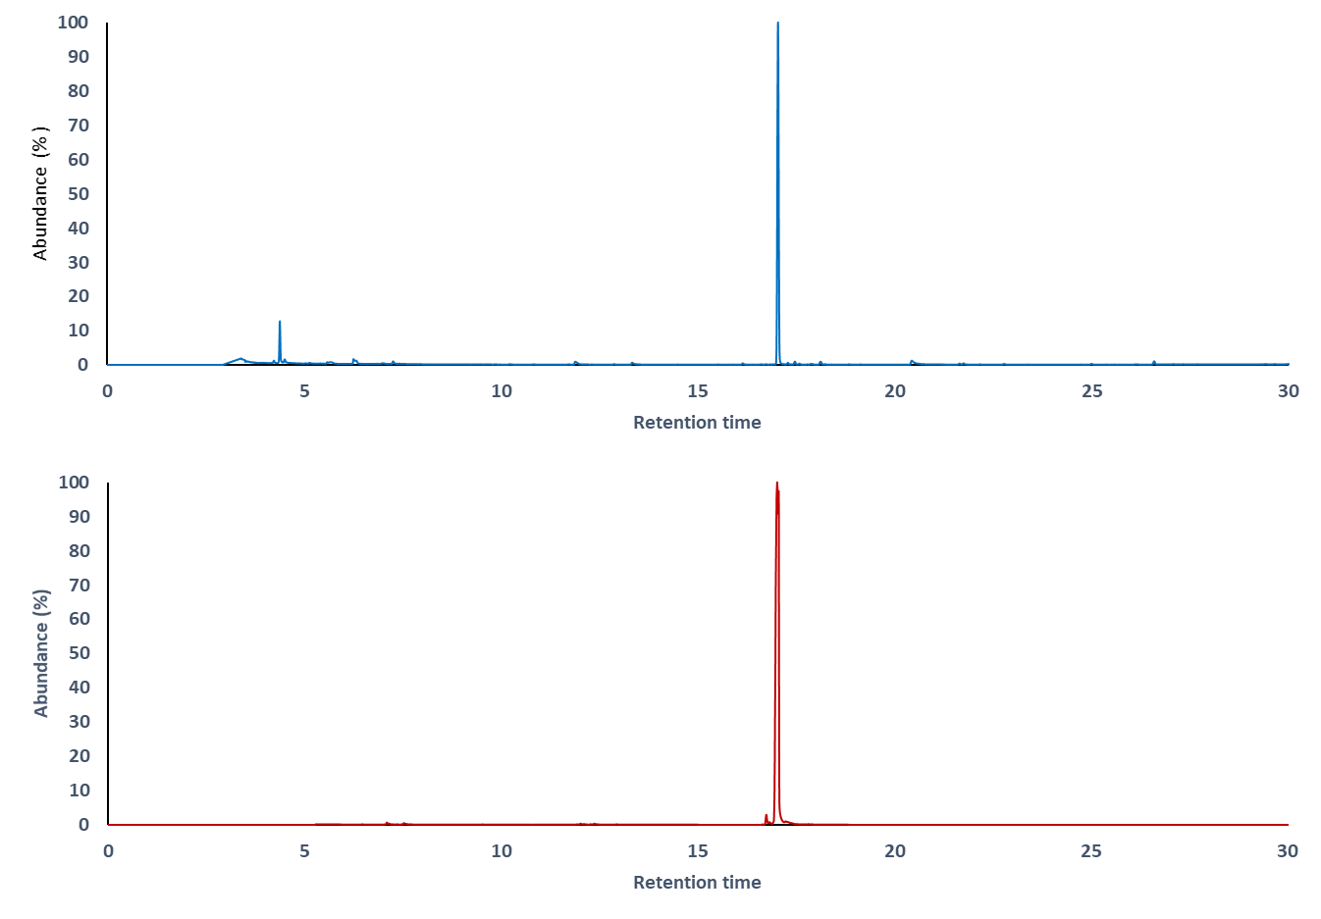
Figure S1. Neocembrene is the major component in extracts of the Dufour’s gland of egg-laying queens of M. pharaonis. Above, the total ion chromatogram of a Dufour’s gland extract from four egg-laying queens of the pharaoh ant shows that neocembrene accounts for nearly half of the extract (49 % of the total peak area). Below, chromatogram of the neocembrene used in our treatments after purification (purity > 98 %).

References
[1] Edwards, J. & Chambers, J. 1984 Identification and source of a queen-specific chemical in the Pharaoh's ant, Monomorium pharaonis (L.). J Chem Ecol 10, 1731-1747.
[2] Kirby, J., Nishimoto, M., Park, J.G., Withers, S.T., Nowroozi, F., Behrendt, D., Rutledge, E.J., Fortman, J.L., Johnson, H.E., Anderson, J.V., et al. 2010 Cloning of casbene and neocembrene synthases from Euphorbiaceae plants and expression in Saccharomyces cerevisiae. Phytochemistry 71, 1466-1473. (doi:10.1016/j.phytochem.2010.06.001).
[3] Halang, W.A., Langlais, R. & Kugler, E. 1978 Cubic spline interpolation for the calculation of retention indices in temperature-programmed gas-liquid chromatography. Anal Chem 50, 1829-1832. (doi:10.1021/ac50035a026).

