Supplementary Material for:
No, you go first: context-dependent social adjustment of neophobia in an invasive species
Kelly, T. R.¹, Kimball, M. G.¹, Stansberry, K. R.¹, and Lattin, C. R.¹
¹ Biological Sciences Department, Louisiana State University, Baton Rouge, Louisiana, USA.
Author for correspondence: christinelattin@lsu.edu
Material Included:
Novel object images
Datapoint losses
Table S1 – partner time differences
Table S2 – contrast object effects
Figure S1 – contrast object effects
Figure S2 – control trials (no object presented) week contrasts by pairing
Guide to datafiles (R Code & csv files)
Novel object images:
Datapoint Losses:
Control Pairs: One individual escaped during object exposure during week 3 paired trials. We removed these datapoints for both birds (control pairing; week 3 object trials n = 28). Week 5 (unpaired) novel object videos were lost (three trials) for one control bird (control pairing; week 5 object trials n = 27, week 5 control trials n = 18).
Mixed Pairs: Due to a camera failure, one trial was lost during week 3 (paired trials; n = 20).

Table S1. House sparrow average time to approach a novel object (seconds; s), organized by the pairings that took place during the third week of the experiment. Average approach difference for each pair is reported. Overall average pair difference and standard deviation is reported for control and mixed phenotype pairs.
More neophobic partner  average approach time (s) | Less neophobic partner  average approach time (s) | Pair average approach difference (s)
Control pairs
174 | 173 | 1
1287 | 1277 | 10
51 | 47 | 4
543 | 542 | 1
33 | 25 | 8
 | Average pair difference: | 4.8
 | Standard deviation: | 3.6
Mixed phenotype pairs
2400 | 318 | 2082
1645 | 132 | 1513
1625 | 273 | 1352
756 | 103 | 653
410 | 116 | 294
374 | 72 | 302
348 | 14 | 334
 | Average pair difference: | 932.8
 | Standard deviation: | 662.8

Table S2: Results for a Cox mixed-effects model of house sparrow feeding probability. Subject ID was included as a random effect and object as a fixed effect. Contrasts are with respect to control conditions (no object in the dish).
Object | β coefficient | Hazard ratio (95% confidence interval) | Z-score | P value
plastic purple egg | -1.94 | 0.14 (0.08 – 0.25) | -7.25 | <0.001
white cover | -0.86 | 0.42 (0.26 – 0.68) | -3.57 | <0.001
dish painted red | -1.35 | 0.26 (0.16 – 0.41) | -5.61 | <0.001
yellow pipe cleaners | -1.05 | 0.35 (0.22 – 0.55) | -4.63 | <0.001
white blinking light | -1.45 | 0.23 (0.14 – 0.38) | -5.79 | <0.001
gold bells | -1.20 | 0.30 (0.19 - 0.48) | -4.99 | <0.001
tinfoil hood | -0.99 | 0.37 (0.24 – 0.58) | -4.27 | <0.001
pink puffs | -1.71 | 0.18 (0.11 – 0.29) | -7.01 | <0.001
blue cocktail umbrella | -1.53 | 0.21 (0.13 – 0.35) | -6.49 | <0.001

Figure S1: Kaplan-Meier survival curve contrasting house sparrow feeding probability among different novel objects. Feeding probability was significantly decreased in the presence of a novel object (all p < 0.001). The number of trials for each object type is provided in the table below as is the number yet to feed at 300 s intervals.
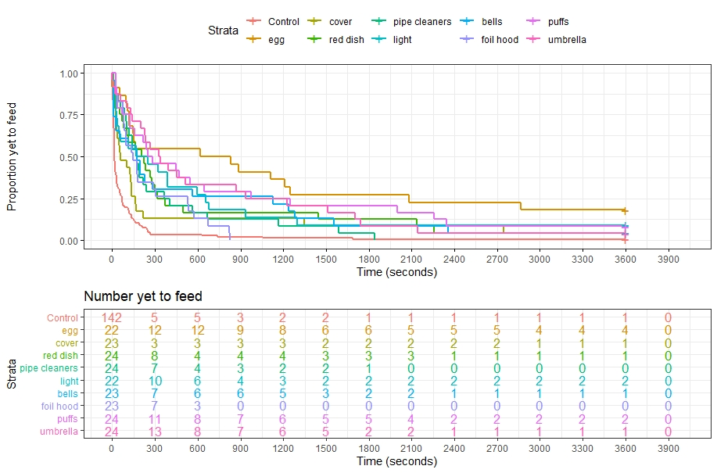

Figure S2: Kaplan-Meier survival curve of house sparrow feeding likelihood when no novel object was presented. Regardless of pairing type, feeding likelihood was not affected by the presence of a cage mate.
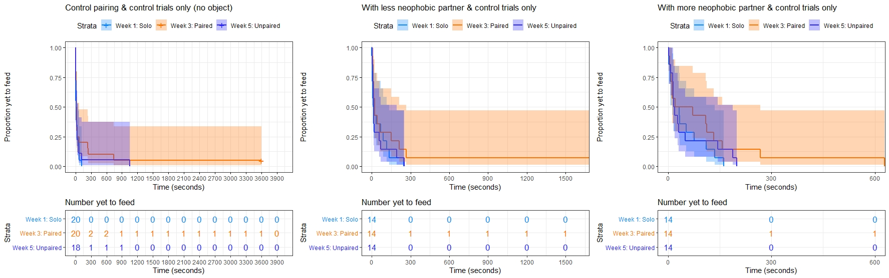

Guide to datafiles:
Files are split by pairing type and by control or object trials.
Pairing Effects:
Control Trials (no object presented)
R Code: “R Code week comparisons by pairing_control trials only.R”
Data: [control pair] “Approach times_controls all weeks_control trials only.csv”
[more neo] “Approach times_more neophobic all weeks_control trials only.csv”
[less neo] “Approach times_less neophobic all weeks_control trials only.csv”
Object Trials
R Code: “R Code week comparisons by pairing_no control trials.R”
Data: [control pair] “Approach times_controls all weeks_no control trials.csv”
[more neo] “Approach times_more neophobic all weeks_no control trials.csv”
[less neo] “Approach times_less neophobic all weeks_no control trials.csv”

Object Effects (seventh model):
R Code: “R Code all weeks all phenotypes for object effects.R”
Data: “Approach times_all phenotypes all weeks.csv”

