Supplementary information to Article:
Albatrosses can memorize locations of predictable fishing boats but favor natural foraging
submitted to Proceedings of the Royal Society of London Series B: Biological Sciences
Authors: Julien Collet & Henri Weimerskirch
Doi: 10.1098/rspb.2020.0958

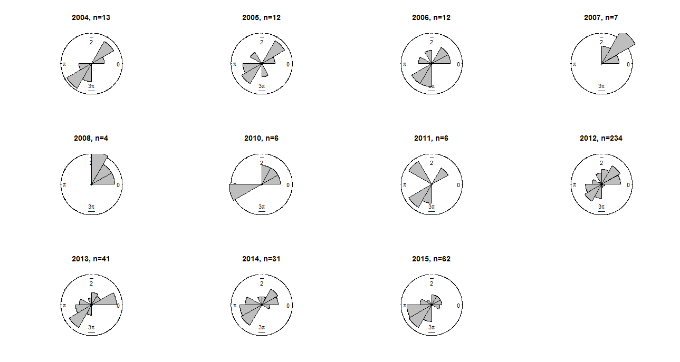
S 1: Circular distributions of directions at maximum range for BBA tracked over different years in Canon des Sourcils Noirs, Kerguelen (year refers to January, e.g. 2012 corresponds to December 2011-January 2012).

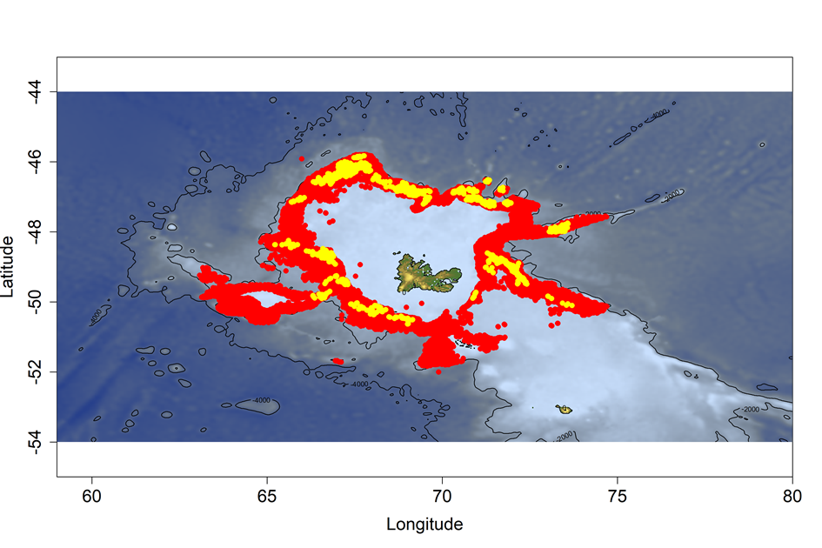

S 2: Map of all fishing events: in red, all fishing events between 2002 and January 2012, in yellow, fishing events during the BBA tracking study period (Dec 2011 – Jan 2012)

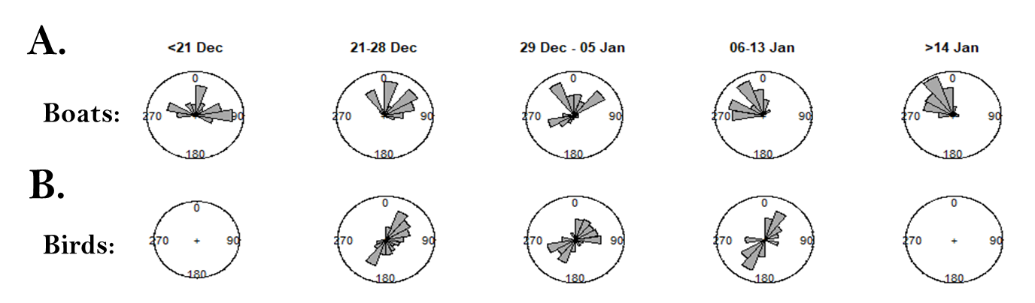
S 3: A. Dynamics of boats fishing operations around the BBA colony in Dec-Jan 2011-2012 and B. dynamics of foraging directions of BBA tracked in Dec-Jan 2011-2012, by 7-day periods.

S 4: Dynamics of boat angular distribution around the colony, in December-January every year (rows) since 2002 up to 201-2012 (colons show same 7-day periods as in S3). The study year (2011-2012) is highlighted in red.

S5: Sensitivity of our analyses to the removal of trips < 24h
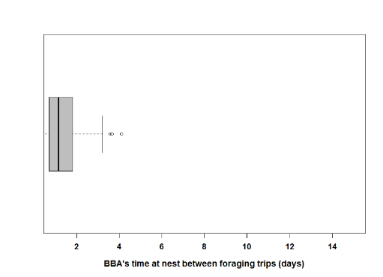
In the main section, we present results after having removed from analyses all foraging trips < 24h (n=68, against n=166 trips > 24h). Among all trips < 24h, only two ever passed <30km from a boat, and only one showed “attendance behaviour” (bird < 3km from boat with apparent speed < 10km/h). Indeed, as already shown in Collet et al 2017, these trips are generally too short to reach the shelf break and therefore have extremely low chance to encounter and attend boats. Here we present the same figures as in the main text but run with all trips retained. Our conclusions remain unchanged.
Compared to Fig.2A, retaining short trips < 24h result in slightly shorter time intervals between what we consider as “successive trips”, but biologically speaking the difference is negligible. Note that the duration in between two consecutive trips has no effect on the probability to switch sector or not (p = 0.21), nor does it interact with previous boat attendance on the probability to switch sector or not (p = 0.63).
Figure S5.1 : Time elapsed between two successive trips by the same individual. This figure is equivalent to the lower inset in Fig. 2A.

When looking at the encounter rate of boats during a second trip, we find a stronger signal than in Fig.2B for birds that previously attended a boat and returned there having a higher chance to find a boat again than birds that previously attended a boat and switched sector. This confirms that birds returning to the same sector where they previously found boats nearly doubled their chance to find boats again.
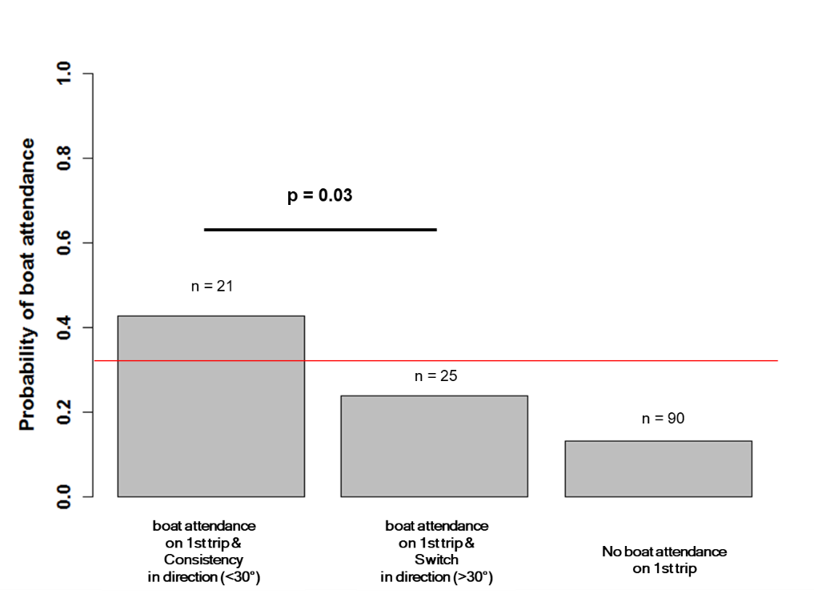
Figure S5.2: Observed probability of encountering boats on a second trip depending on adopted consistency strategy (red line: unconditional probability of boat presence in a 30° sector not knowing about past boat presence/absence). This figure is equivalent to Fig.2B.
When looking at the angle between two consecutive trips by a same individual, the probability to switch sector is not dependent on whether a boat was attended or not during the first trip of the pair (chronological sequence prediction, p>0.05 for an angle < 30°). Depending on the angular threshold we use (especially with sharper angles), we may actually see that the probability of consistency is lower when a boat was attended during the first trip of the pair, against the chronological sequence prediction. We can also note that compared to results presented in the main section, here adding the trips < 24h increased sample size mainly in the category of trips where no boats were attended during the previous trip: birds rarely made a short trip after a long trip where they attended a boat, but we are not sure how to interpret this result.
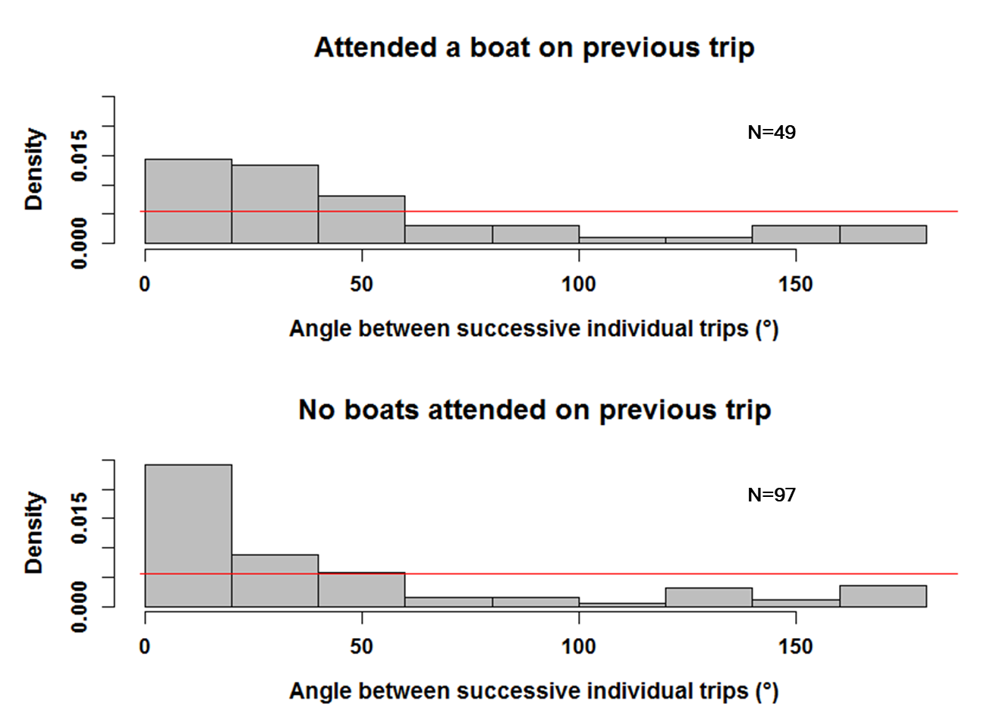
Figure S5.3 : Chronological sequence prediction: Bird consistency in direction at maximum range across pairs of successive trips, depending on whether (A) or not (B) a boat was attended during the first foraging trip of the pair. The probability density functions are used in y-axis to adopt a common scale relative to sample sizes. Red lines show expectations in the absence of individual consistency in direction (uniform distribution: no privileged direction). This figure is equivalent to Fig.3
When looking at the distance birds ever passed to where they attended boats during their previous trip, we found only 13 instead of 14 cases where they approached < 1km. This suggests that in one case of such a close approach, the bird had been performing a short trip < 24h before returning where it previously attended a boat. In all cases, we still find that there are closer approach than expected by chance alone, since distance to where birds will later attend boats is still significantly larger and especially for pairs of trips with large-scale angular consistency (trips with angle < 30°: p < 0.01; trips > 30°, p = 0.10).
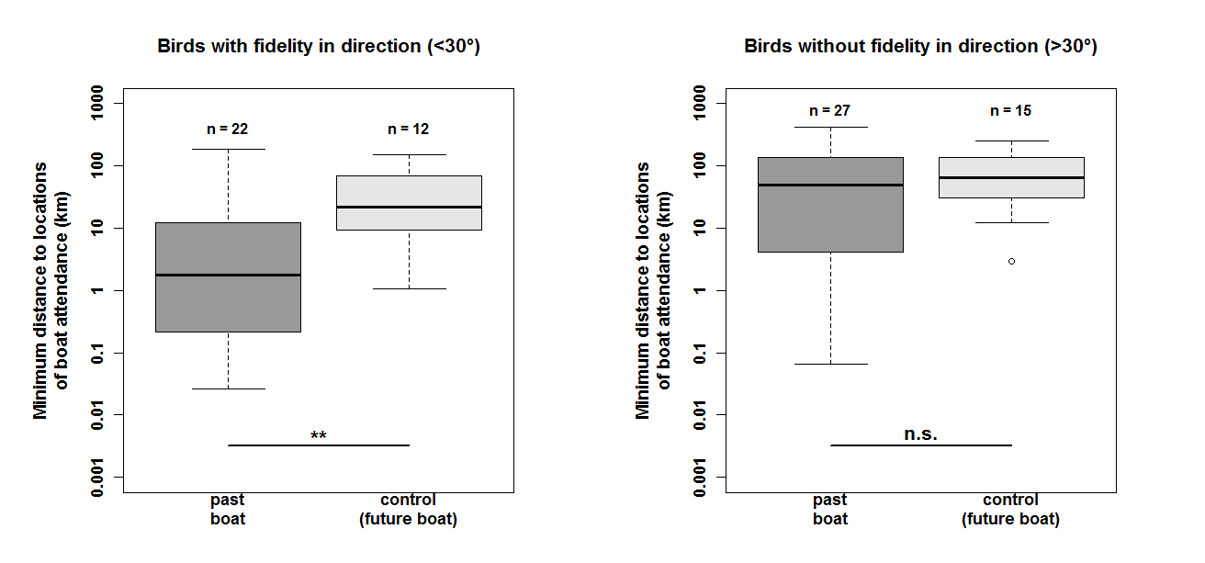
Figure S5.4: Mistake prediction. This figure is equivalent to figure 4A and 4B.
Finally, we still find support for the personal-information prediction, whether or not we keep all individuals simultaneously tracked with a trip < 30° from the focal trip (p < 0.001), or if we retain only individuals that we know can be attracted to boats (p = 0.06).
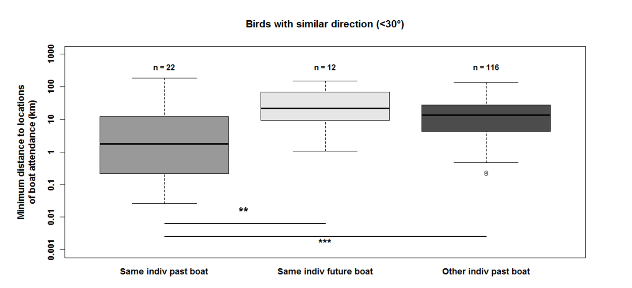
Figure S5.5 : Mistake and personal information predictions. This figure is equivalent to Fig4A.

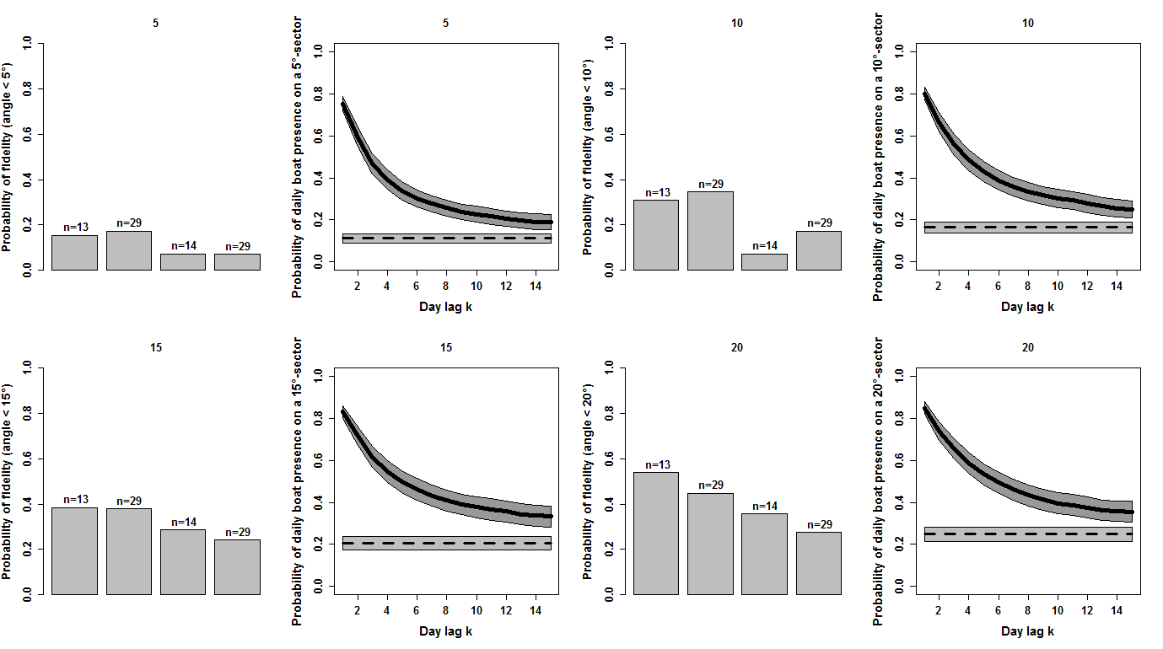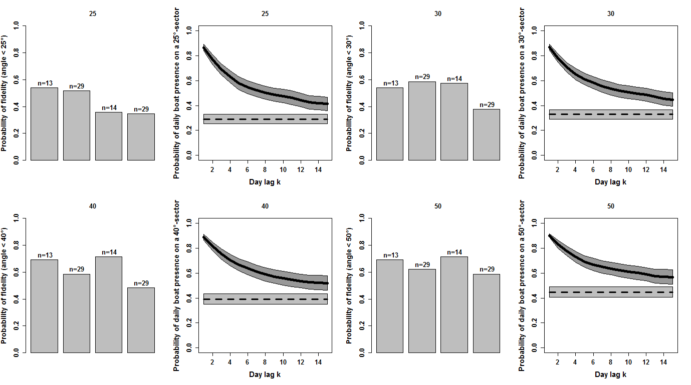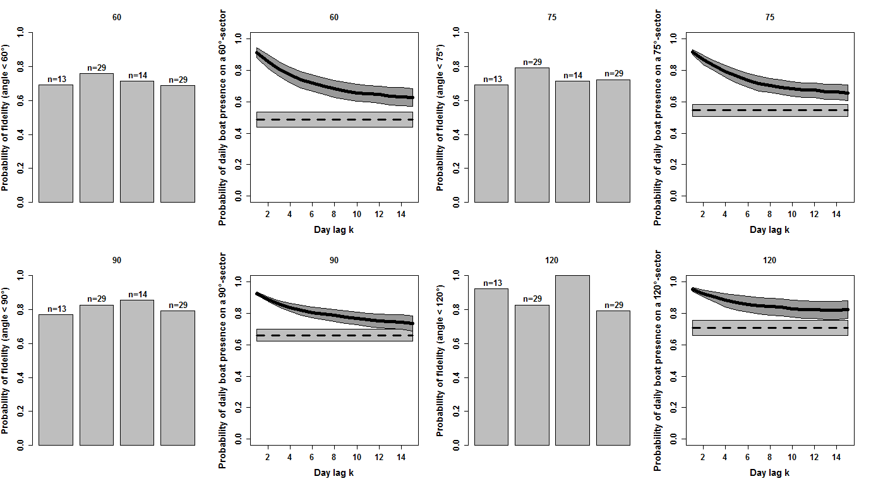
S 6: Sensitivity analyses for different angular threshold (from 5° to 120° instead of 30°): left panels in each dyad indicate bird probability of angular fidelity for birds that did not attend boats in their previous trip (females then males) or that did attend boat in their previous trip (females then males), respectively. Right panels indicate boat predictability (see Fig.2). The probability of angular fidelity is never higher when birds had attended boats than when they had not, but for all thresholds there is a predictability signal detectable in fishing operations.
S7. Trip commutingness analyses
In most populations and species of seabirds, most trips seem to display a “commuting shape” (Weimerskirch 2007), where the bird leaves relatively straight in one direction, then intensify search at a local scale for a long time, before returning back home again relatively straight to the colony, from a direction similar to the outgoing direction. There are no standardized metric to measure or define commutingness, but for our purposes, we aim to demonstrate that the direction at maximum range is a representative measure of the areas explored and exploited by the bird during its foraging trip.
In our population, 76.5 ± 23.0% of GPS locations (median 84.7%) have a direction from colony <30° from the direction measured at maximum range, and on average 49.9 ± 23.1% of the trip duration (median 51.5%) is spent within the distal part of the trip (i.e. at a distance from colony >75% of its maximum range).
This indicates that each trip has a certain angular width, and it is probably not sensible to use much smaller angular thresholds than 30° for inter-trip consistency analyses. It also indicates that only a narrow range of directions are explored by a bird in any given trip. As such, our measure truly reflects a decision by highlighting all the directions that were not chosen during this trip. In addition, it confirms that a large part of the foraging trip duration is spent in the distal part of the trip, which supports the choice of using the point at maximum range rather than, say, a direction at departure.

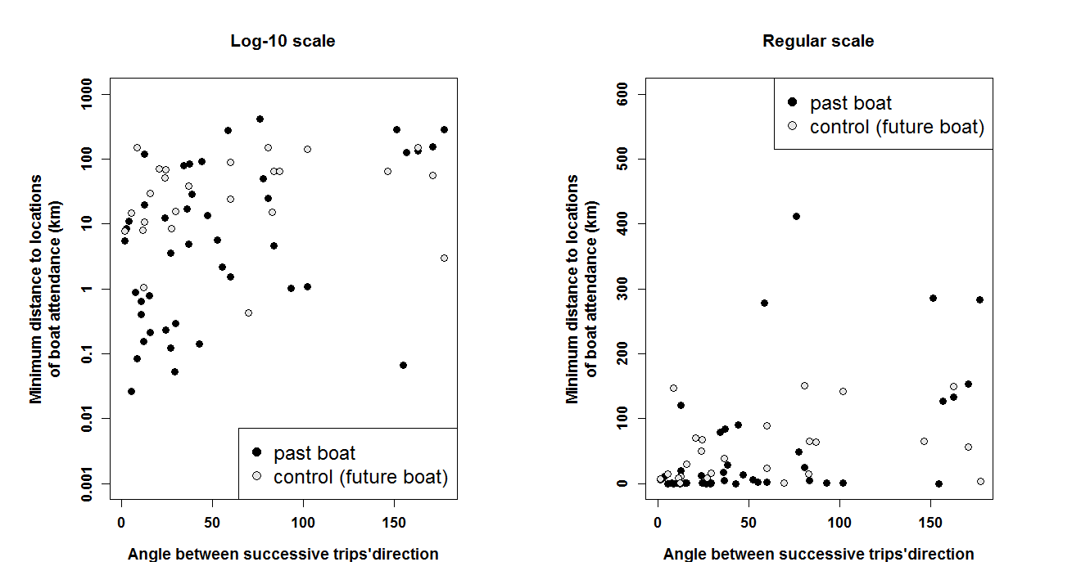
S 8: Minimum distance (left: log-scaled, right: naturally scaled) to either past (black) or future (grey) locations of boat attendance by the same individual, in relation to the angle between the directions at maximum range within the pair of consecutive trips.

