Physiological response of Swiss ecosystems to 2018 drought across plant types and elevation
Mana Gharun, Lukas Hörtnagl, Eugénie Paul-Limoges, Shiva Ghiasi, Iris Feigenwinter, Susanne Burri, Kristiina Marquardt, Sophia Etzold, Roman Zweifel, Werner Eugster, Nina Buchmann

Supplementary Figure 1 Monthly GPP (gross primary productivity), RECO (ecosystem respiration), LE (latent heat flux), and H (sensible heat flux) during 2018 compared to the long-term median. Vertical lines mark the start and end of the average growing period (average 2016–2018) (see details in Table 3). Shaded area shows the long-term monthly standard deviation. Note that the monthly medians presented here were computed from gap-filled half-hourly fluxes.
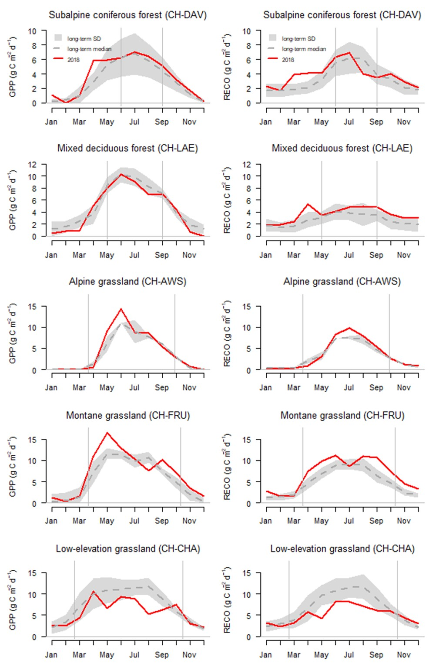
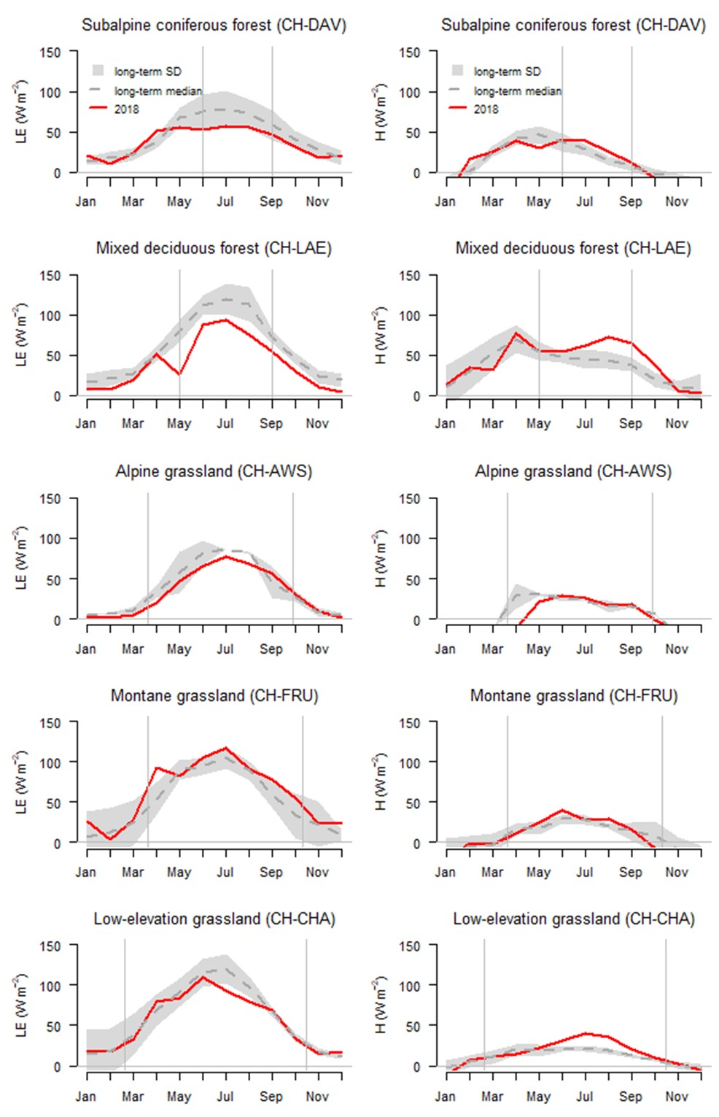

Supplementary Figure 2 Net ecosystem exchange (NEE) in response to photosynthetically active radiation (PPFD) under high (lowest 25% quantile of SWDI) and low (highest 25% quantile of SWDI) soil dryness, and under high (highest 25% quantile of VPD) and low (lowest 25% quantile of VPD) atmospheric dryness. Data were binned by PPFD with equal number of observations in each bin. Symbols mark the median values for each PPFD bin and error bars show the 5% to 95% percentile range of the data in each bin. Data was pooled for 2016-2018, during growing period only, measured only, and daytime only (global radiation > 0 W m⁻²). Parameters related to these response curves are reported in Supplementary Table 1.
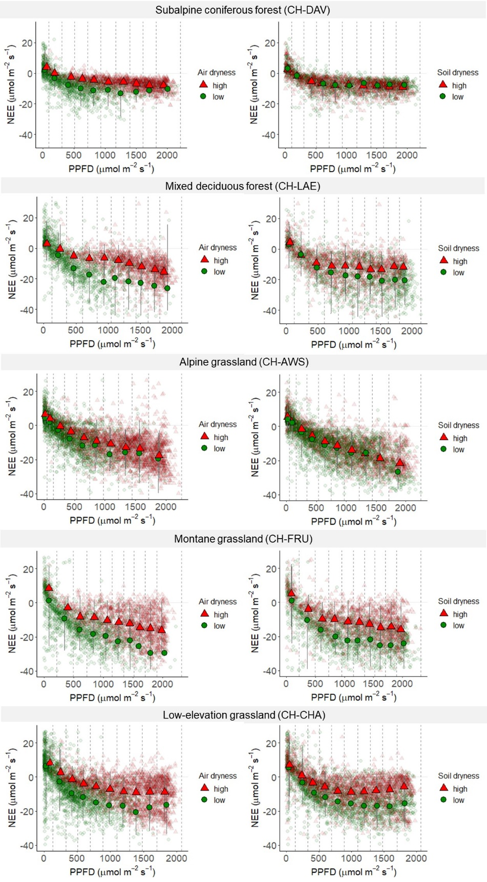
Supplementary Figure 3 Net ecosystem exchange (NEE, μmol CO₂ m⁻² s⁻¹), root zone volumetric soil water content (SWC, %), vapor pressure deficit (VPD, hPa), and air temperature (Tair, °C) over three years (2016–2018). Soil water content at the grassland sites is from the top 5 cm and for the forest sites depth-integrated over the top 30 cm. Grey areas mark periods of missing data.
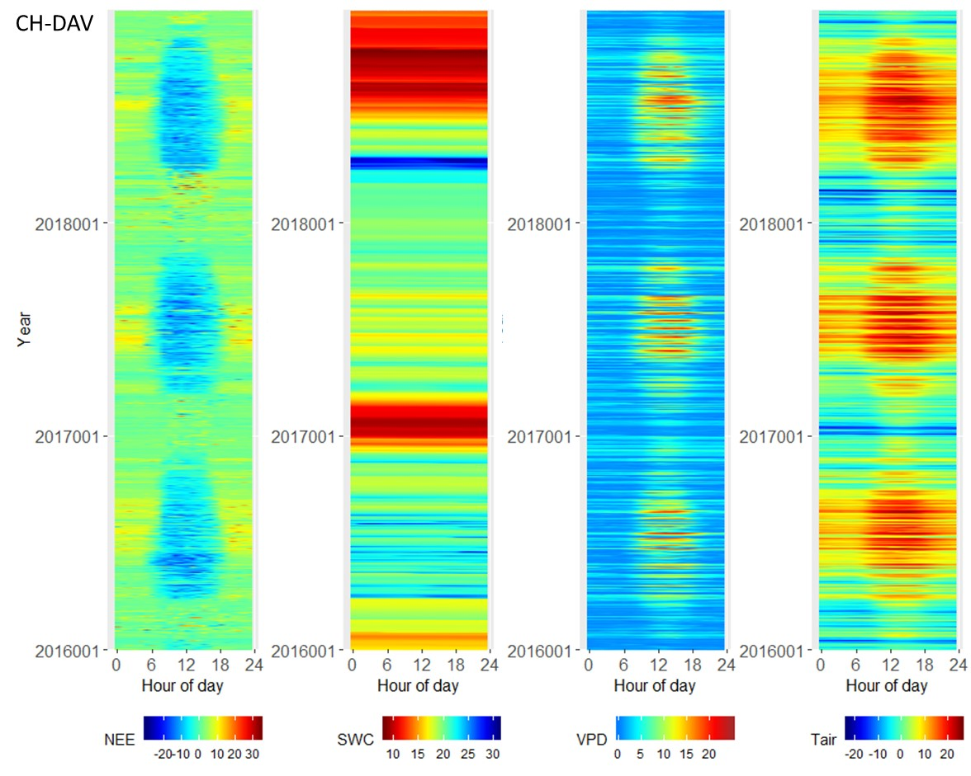

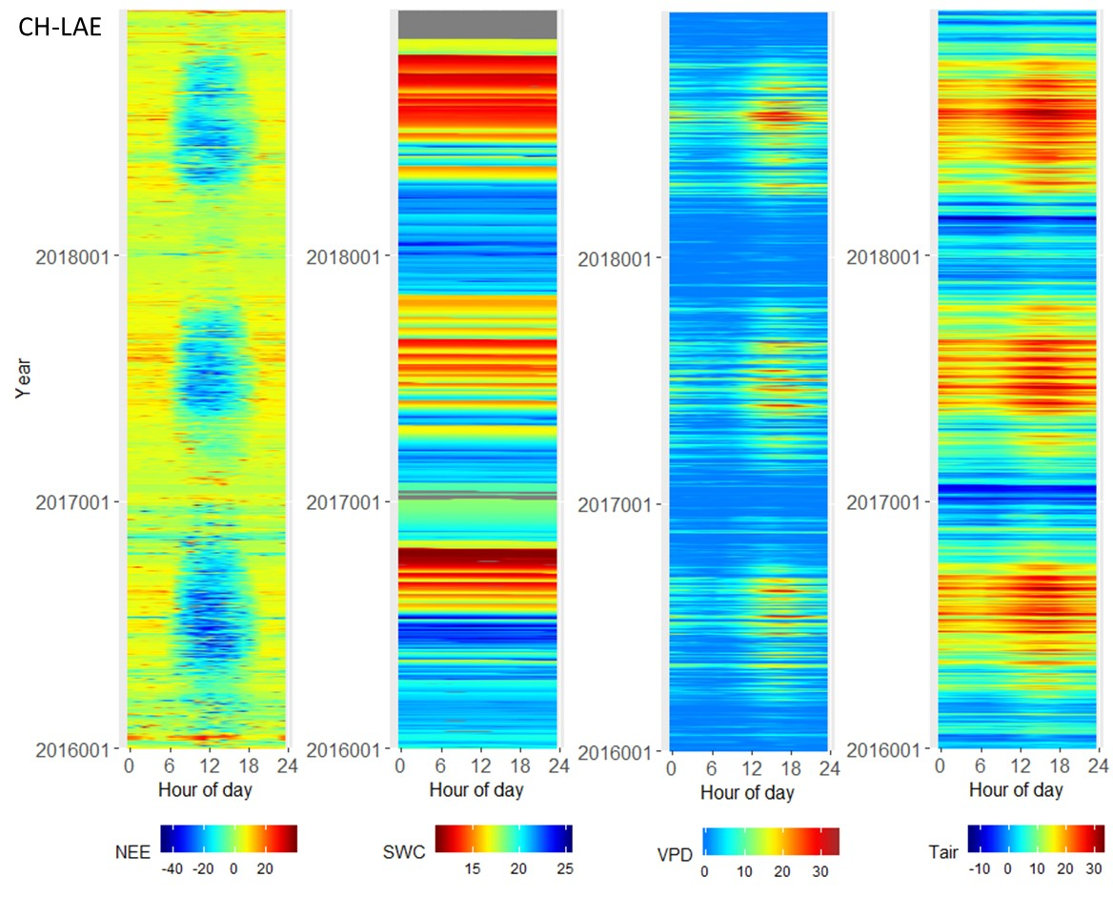

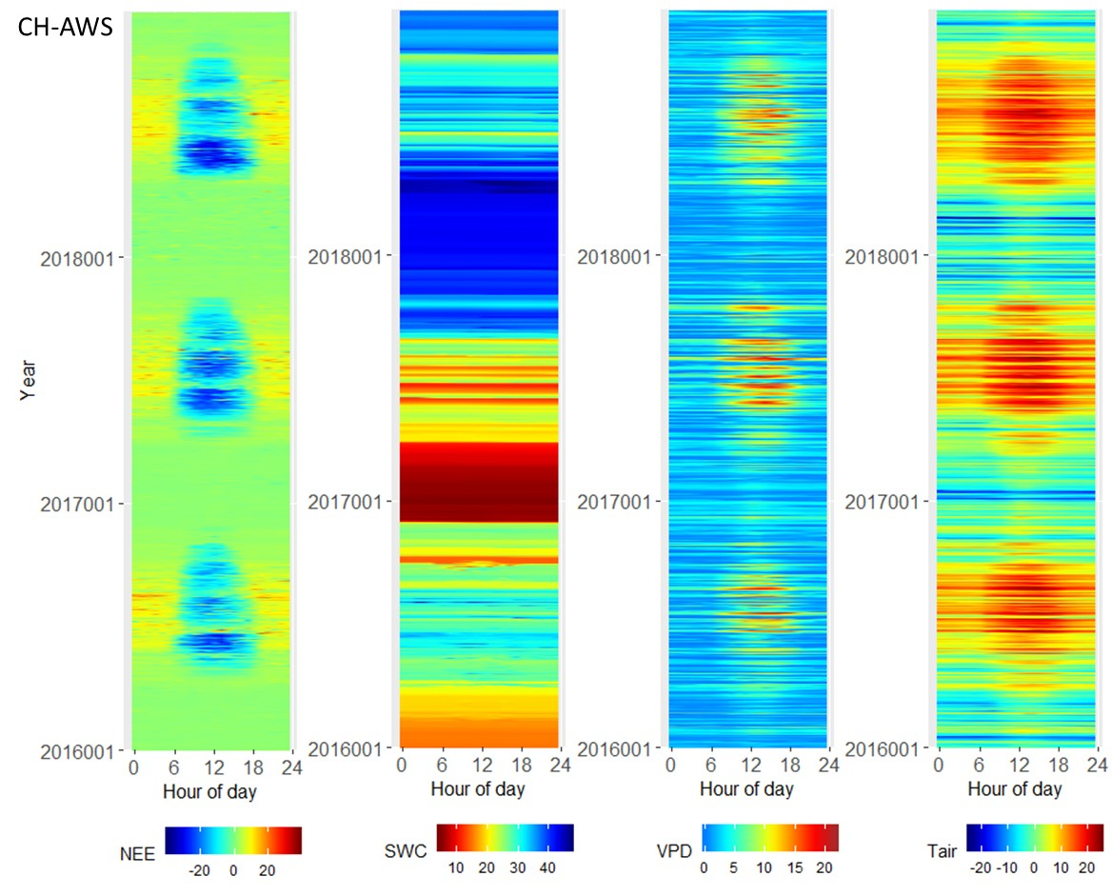

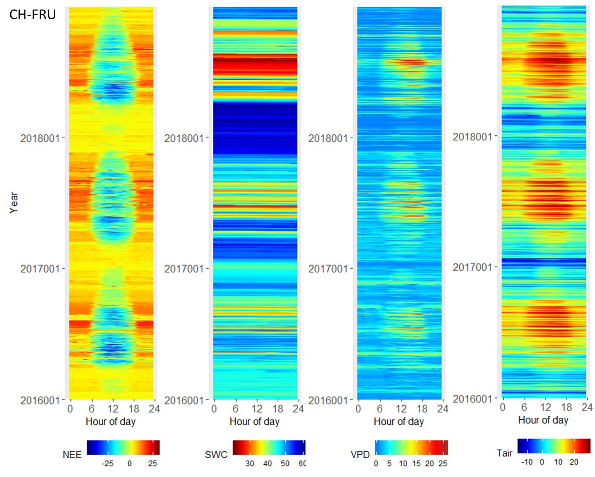

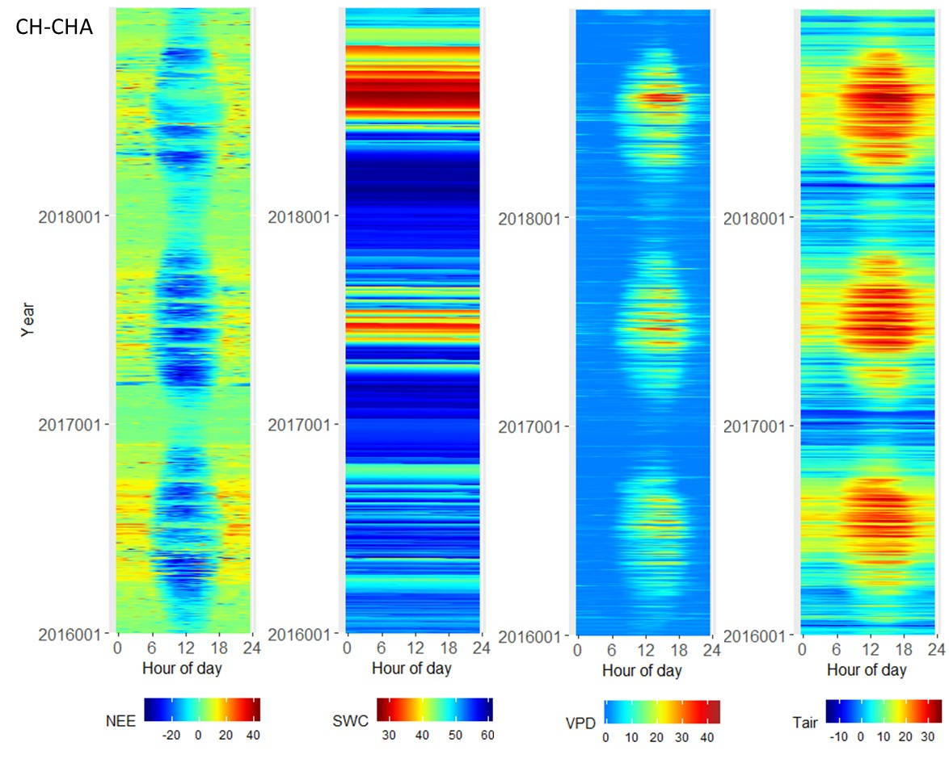

Supplementary Table 1 Light response parameters (± standard error of the mean) for different levels of atmospheric and soil dryness. Soil dryness groups are the 25% lowest and the highest SWDI quantiles. Atmospheric dryness are the 25% lowest and highest VPD quantiles. The bigleaf R package (Knauer et al. 2018) was used to fit a rectangular light response curve (NEE versus PPFD) following the method of Falge et al. (2001), and derive estimates of light use efficiency (α) and reference GPP (GPP_{ref}), which is GPP at saturating light.

 | Light use efficiency (α) |  |  |  | Reference GPP (GPP_{ref})
 | Atmospheric dryness |  | Soil  dryness |  | Atmospheric dryness |  | Soil  dryness
Site | low | high | low | high | low | high | low | high
Subalpine coniferous forest (CH-DAV) | 0.08 (±0.005) | 0.04 (±0.003) | 0.08 (±0.005) | 0.06 (±0.004) | 19.0 (±0.37) | 16.7 (±0.15) | 17.2 (±0.19) | 15.7 (±0.19)
Mixed deciduous forest (CH-LAE) | 0.05 (±0.003) | 0.02 (±0.002) | 0.06 (±0.006) | 0.06 (±0.006) | 32.7 (±1.2) | 22.3 (±0.42) | 27.6 (±0.54) | 20.4 (±0.45)
Alpine grassland  (CH-AWS) | 0.04 (±0.002) | 0.04 (±0.002) | 0.04 (±0.002) | 0.04 (±0.002) | 25.0 (±0.61) | 25.2 (±0.29) | 29.0 (±0.39 | 26.9 (±0.29)
Montane grassland  (CH-FRU) | 0.10 (±0.006) | 0.07 (±0.006) | 0.10 (±0.006) | 0.10 (±0.009) | 34.1 (±0.65) | 28.1 (±0.38) | 34.3 (±0.44) | 26.7 (±0.35)
Low-elevation grassland (CH-CHA) | 0.06 (±0.004) | 0.04 (±0.004) | 0.09 (±0.005) | 0.05 (±0.006) | 32.2 (±1.09) | 22.8 (±0.44) | 30.8 (±0.47) | 18.6 (±0.38)

References
Knauer, J., et al., Bigleaf-An R package for the calculation of physical and physiological ecosystem properties from eddy covariance data. PLoS One, 2018. 13(8): p. e0201114.
Falge, E., et al., Gap filling strategies for defensible annual sums of net ecosystem exchange. Agricultural and Forest Meteorology, 2001. 107(1): p. 43-69.

