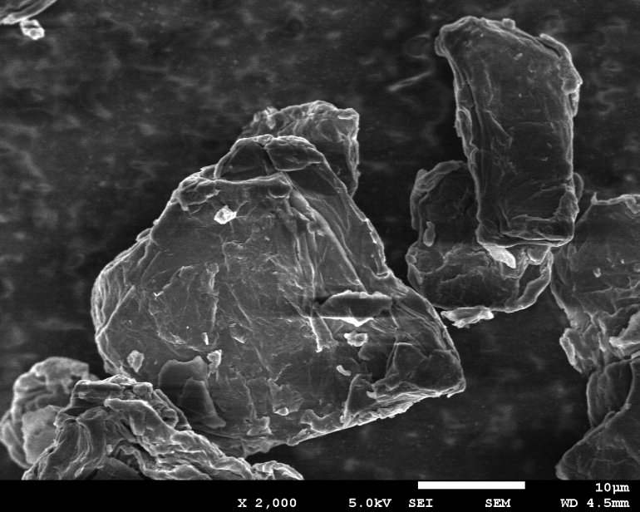
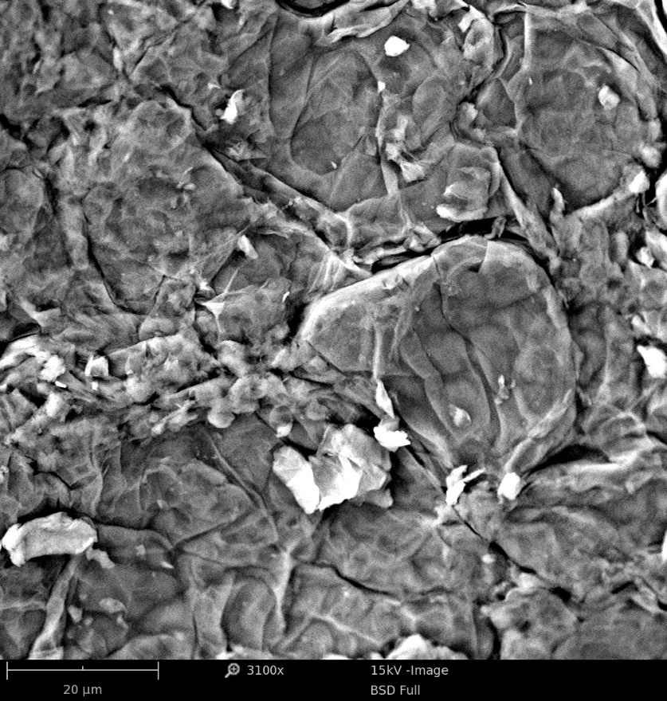
(a)
(b)
10 µm
20 µm

Supplementary Figure S2

