Supplementary Material For:

Endocrine regulation of egg rejection in a brood parasite host

Mikus Abolins-Abols^{1,2,}* and Mark E. Hauber²

¹Department of Biology, University of Louisville, Louisville, KY 40292, USA
²Department of Evolution, Ecology, and Behavior, School of Integrative Biology, University of Illinois at Urbana-Champaign, IL 61801, USA

*Corresponding author email: m.abolins-abols@louisville.edu

Table S1: The distribution of life history and morphological variables across randomized treatments (excluding nests that were abandoned or depredated).
Variable | Treatment average |  | Test (2-tailed) | Test statistic | P value
 | Mitotane | Sham
Age (#second year adult: #after second year) | 11:9 | 5:12 | Fishers exact | NA | 0.18
Clutch size (mean) | 3.3 | 3.0 | t-test | t=0.22 | 0.83
Days since clutch completion (mean) | 3.5 | 3.0 | t-test | t=-0.86 | 0.40
Date (days after Jan 1; mean) | 166.9 | 166.3 | t-test | t=-0.15 | 0.88
Mass (g; mean) | 84.4 | 84.1 | t-test | t=-0.88 | 0.39
Tarsus (mm; mean) | 32.6 | 32.5 | t-test | t=-0.12 | 0.90

Table S2: General Linearized Model showing that clutch size, negatively associated with egg rejection in [1], did not explain significant variation in egg rejection behavior in this data set.
Factor | Estimate | SE | z value | p-value
Intercept | 2.15 | 1.9 | 1.15 | 0.25
Mitotane treatment | -1.53 | 0.73 | -2.08 | 0.04
Clutch size | -0.53 | 0.52 | -1.01 | 0.31

Figure S1. Comparison of flight-initiation distances (FID) between mitotane- and sham-treatments in free-living American robin females. Mitotane-treated birds (orange triangles) and sham-treated birds (grey circles) showed no statistical difference in FIDs either before or 24hrs after treatment (see main text). Boxes with whiskers represent the median and the 10th, 25th, 75th, and 90th percentiles.

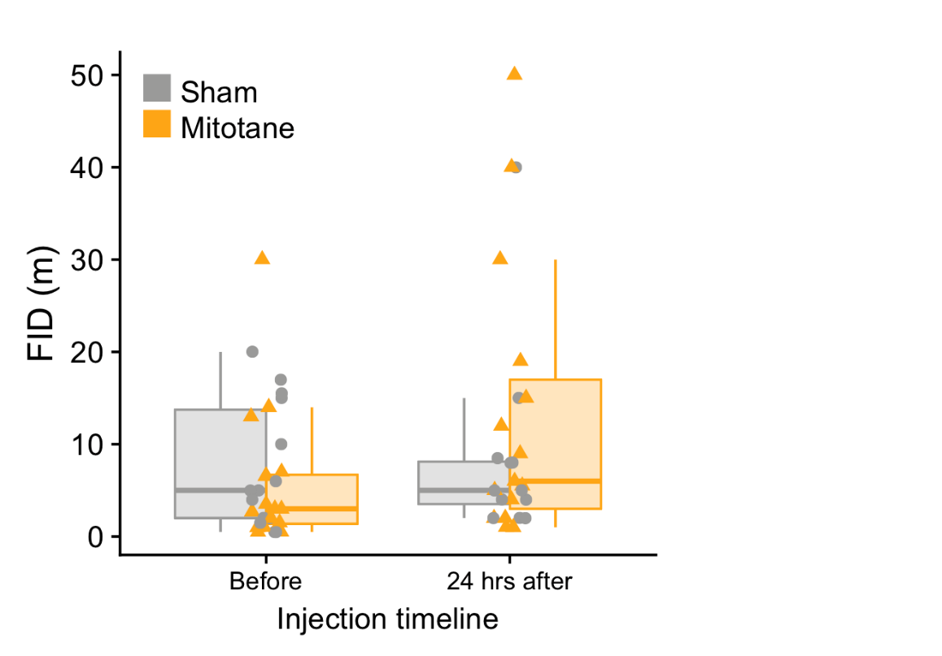

References
- Abolins-Abols M, Hauber ME. 2020. Proximate predictors of variation in egg rejection behavior by hosts of avian brood parasites. J. Comp. Psych. Advance online publication (https://doi.org/10.1037/com0000225)

