**Supplementary material**

**Article title**

Author 1,a Author 2,b Author 3,b and Author 4b

Donghao Hua, Kazuyoshi Ogawab, Mikio Kajiyamab and Toshiharu Enomaeb

aGraduate School of Life and Environmental Sciences, and bFaculty of Life and Environmental Sciences, University of Tsukuba, 1-1-1 Tennodai, Tsukuba, Ibaraki 305-8572, Japan

*a.*

*b.*

Table S1 Diameter of synthesised AgNPs with different [AgNO3] measured with Zetasizer

|  |  |  |
| --- | --- | --- |
| [AgNO3] (g/mL) | AgNP diameter (nm) | SD (nm) |
| 0.10 | 16.9 | 5.3 |
| 0.20 | 18.4 | 4.8 |
| 0.30 | 20.4 | 4.4 |
| 0.50 | 24.2 | 6.5 |

Table S2 Zeta potential of synthesised AgNPs with different [AgNO3]

|  |  |  |  |
| --- | --- | --- | --- |
| [AgNO3] (g/mL) | Zeta Potential (mV) | SD (mV) | Number of samples measured |
| 0.10 | −48.1 | 1.1 | 9 |
| 0.20 | −6.1 | 3.3 | 13 |
| 0.30 | −45.8 | 1.2 | 15 |
| 0.50 | −50.6 | 2.2 | 6 |



Figure S1 DTG curve of solid AgNPs (inner figure is the DTG curve from 40-900 oC).

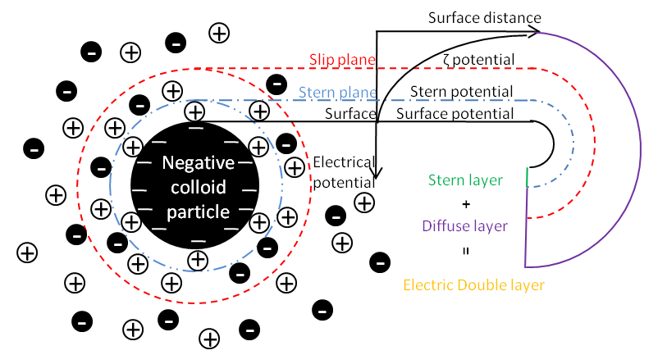

Figure S2 Schematic diagram of (a) electric double layer and (b) *dH* measured by DLS and *dS* measured by TEM for the AgNPs.

