Table S1: The strain selected for investigation of FA δ¹³C values in different algae groups and the media they were cultured in.
 | Species | Salinity | medium
Chlorophyceae | Chlamydomonas reinhardtii (SCC K-1016) | freshw. | MWC
 | Chlorella emersonii (ACOI 516 Vienna) | freshw. | MWC
 | Chlorella vulgaris (SAG 211-11b Vienna) | freshw. | MWC
 | Choricystis minor (Vienna, SAG 17.98) | freshw. | MWC
 | Dunaliella tertiolecta (Kiel) | 16 | Mod. F
 | Dunaliella salina (Kiel) | 16 | Mod. F
 | Haematococcus pluvialis (SAG 192.80 Vienna) | freshw. | MWC
 | Monoraphidium (ITM, no strain no.) | freshw. | MWC
 | Pseudokirchneriella subcapitata (ITM, no strain no.) | freshw. | MWC
 | Scenedemus sp. (Uppsala) | freshw. | MWC
 | Selenastrum capricornutum (ASW 05 231, Vienna) | freshw. | MWC
 | Tetraselmis suecica (Scientio A324) | 30 | Mod. F
Diatoms | Achnantes sp. (Kiel) | 18 | Mod. F
 | Chaetoceros peruvianus (SCCAP K-1679) | 30 | Mod. F
 | Navicula pelliculosa (CCAP 1050/9) | 10 | Mod. F
 | Thalassiosira weissflogii (SAB 2135) | 18 | Mod. F
 | Phaeodactylum tricornutum (SCC, K-1280) | 30 | Mod. F
Cyanbacteria | Anabaena variabilis (Botan; ATCC 29413) | 10 | Mod. F
 | Anabaena sp. (Kiel) | 18 | Mod. F
 | Anabanopsis elenkinii (ASW 01 027 Vienna) | freshw. | Jüttner
 | Leptolyngbya (Botan; PCC73110) | 10 | Mod. F
 | Nodularia balthica (Botan; KAC17) | 10 | Mod. F
 | Spirulina major (ASW 01 026 Vienna) | freshw. | Jüttner
 | Synechococcus sp. (Botan; S7942) | 10 | Mod. F
 | Synechocystis sp. (Isolate from Lake Nakuru) | 23 | Mod. F
 | Synechocystis sp. (Botan; PCC6803) | 10 | Mod. F
Hapto-phytes | Emiliania huxleyi calcifying (Kiel) | 30 | Mod. F
 | Emiliania huxleyi naked (Kiel) | 30 | Mod. F
 | Gephyrocapsa oceanica (Kiel) | 30 | Mod. F
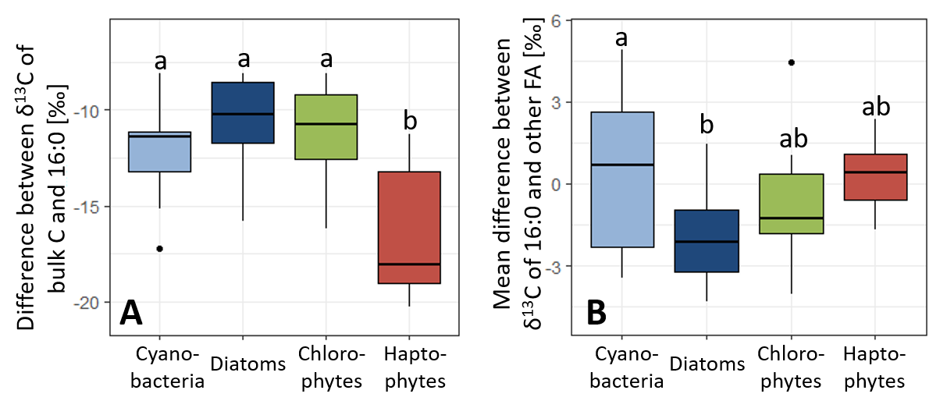
Fig. S1 Boxplots of the differences in δ¹³C values between C16:0 and bulk C (A), and between C16:0 and other FA (B) in polar lipids of four major algae groups. Bulk C represents an integrated isotope value of all C-compounds. In total, 29 species (51 samples) were analysed. Lowercase letters denote significant differences between different algae groups.

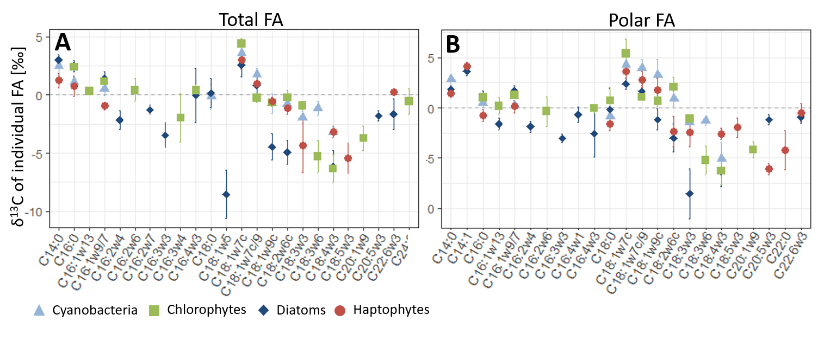
Fig. S2: δ¹³C fingerprints of four major algae groups calculated based on the difference in δ¹³C values of individual FA relative to an unweighted mean of all δ¹³C FA isotope values. Displayed are the δ¹³C values of individual FA in total (A) and polar FAs (B) of all FA that were recorded in at least 15% of samples of a specific algae group. Error bars represent standard errors of the mean. 16:1w7 and 16:1w9 co-eluted and are hence displayed together. Individual values of these FA are restricted to samples were peaks could be separated. 18:1w7 and 18:1w9 co-eluted in some samples18:1w7c/9 represents the merged measurements in all samples.
In the main manuscript, we chose 16:0 standardisation over standardisation by total FA δ¹³C. While the results were similar, we chose 16:0 standardisation because total FA standardisation might lead to the creation of artificial differences between groups. For example, if a cyanobacterium is especially poor of unsaturated FA, which are generally depleted in δ¹³C, total FA standardisation might lead to an apparent enrichment of e.g. 16:1 compared to 16:1 of a diatom species, which was standardised by a mean of FA that includes also depleted polyunsaturated FA.
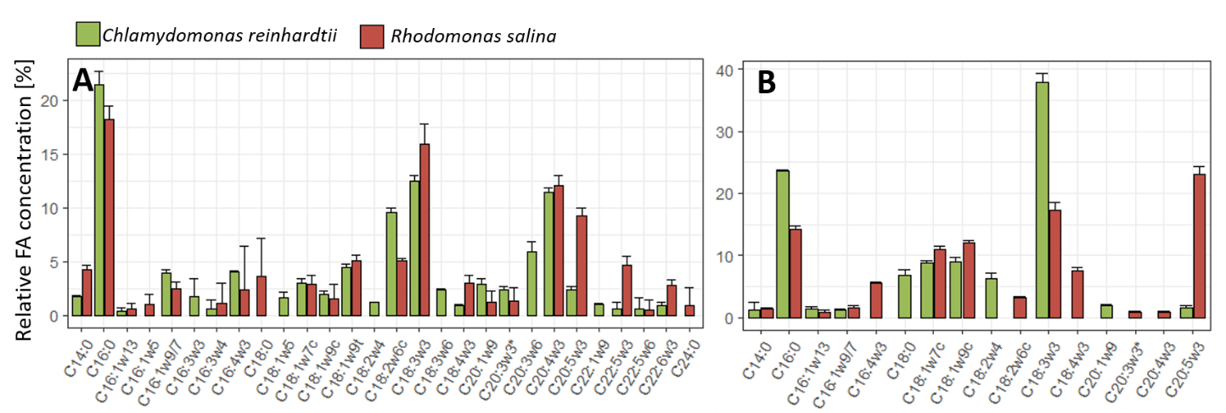
Fig. S3: Relative FA concentrations in diet and consumers of controlled feeding experiments. Presented are relative contribution to polar FA in (A) Brachionus plicatilis (B) and Daphnia magna fed with two different food algae. 16:1ω7 and 16:1ω9 as well as 20:3ω3, 20:4ω6 and 22:0 co-eluted and joint quantifications for these FA are provided. Error bars represent standard deviations.

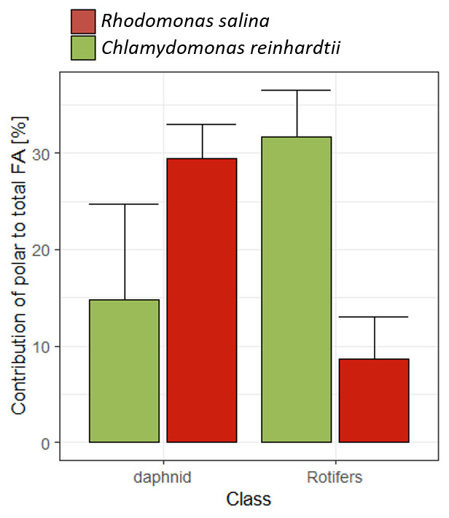
Fig S4: Contribution of polar lipids to the total lipid pool for daphnids (Daphnia magna) and rotifers (Brachionus plicatilis) fed Chlamydomonas reinhardtii (black) or Rhodomonas salina (red). Error bars denote standard deviations.

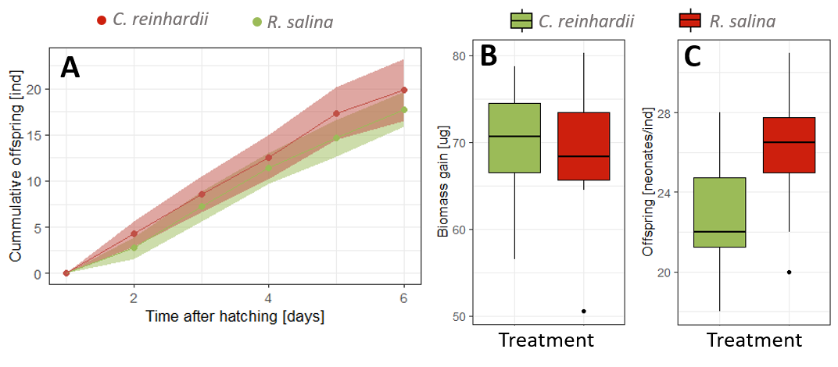
Fig. S5: Zooplankton growth and egg production when fed either Chlamydomonas reihardii (blue-grey) or Rhodomonas salina (red). Presented are the cumulative offspring of the parthenogenetic rotifer Brachionus plicatilis within the first 6 days after hatching (A), biomass gain of Daphnia magna neonates within 12 days (B) and neonate production of Daphnia magna during their first spawning event (C). Coloured ranges in A represent standard deviations of measurements.
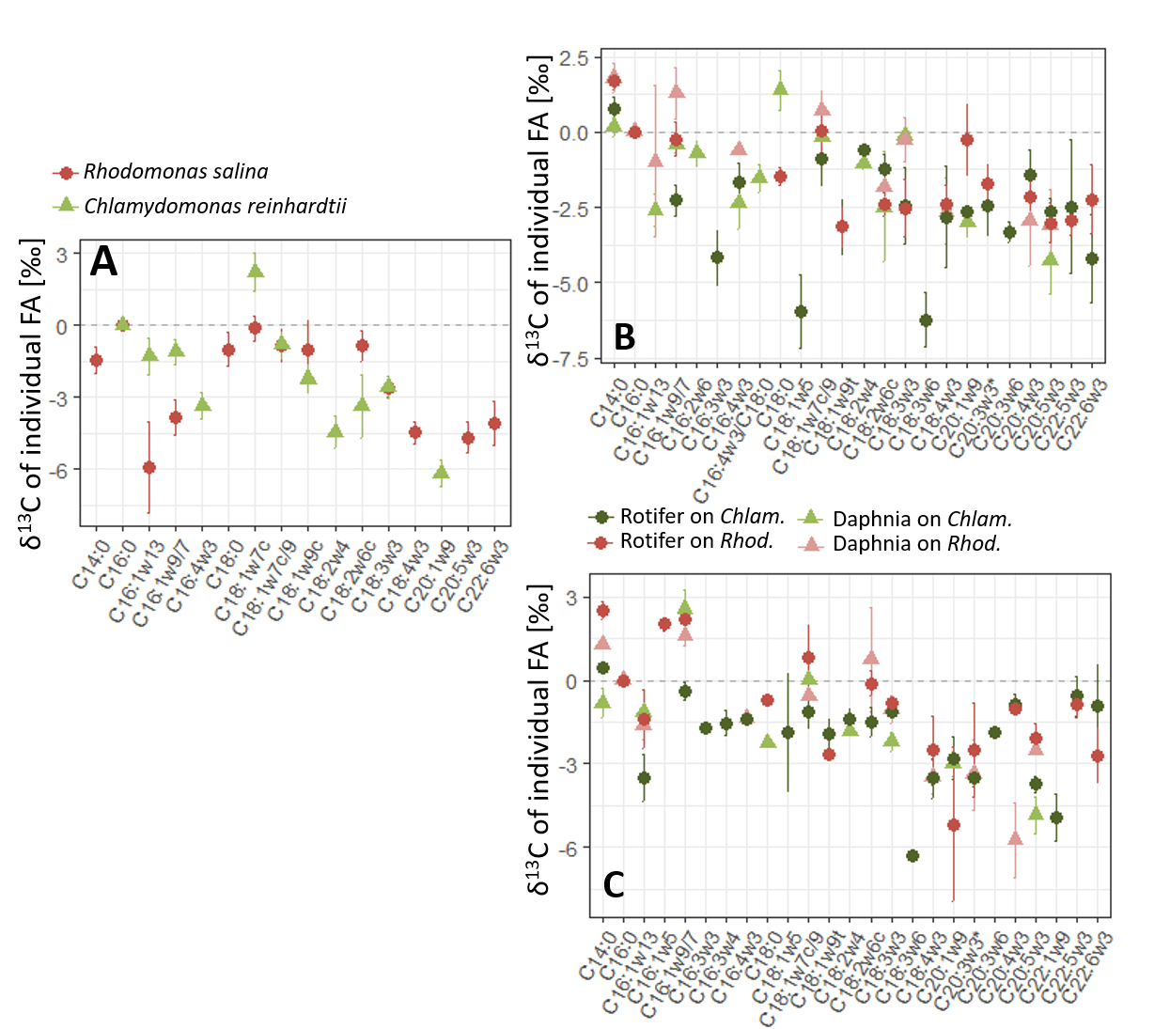
Fig S6: Patterns in isotopic values of individual FA (A) in green algae (C. reinhardtii, green) and cryptophytes (R. Salina, red) and (B) total and (C) polar lipids in the zooplankton consumers Daphnia (D. magna, triangles) or rotifers (B. plicatilis, circles) fed with either C. reinhardtii (green colours) or R. Salina (red colours). δ¹³C FA values were standardized by the C isotope composition of 16:0. Note: 16:1w7 and 16:1w9 as well as 18:1w7 and 18:1w9 co-eluted and hence integrated values are presented.

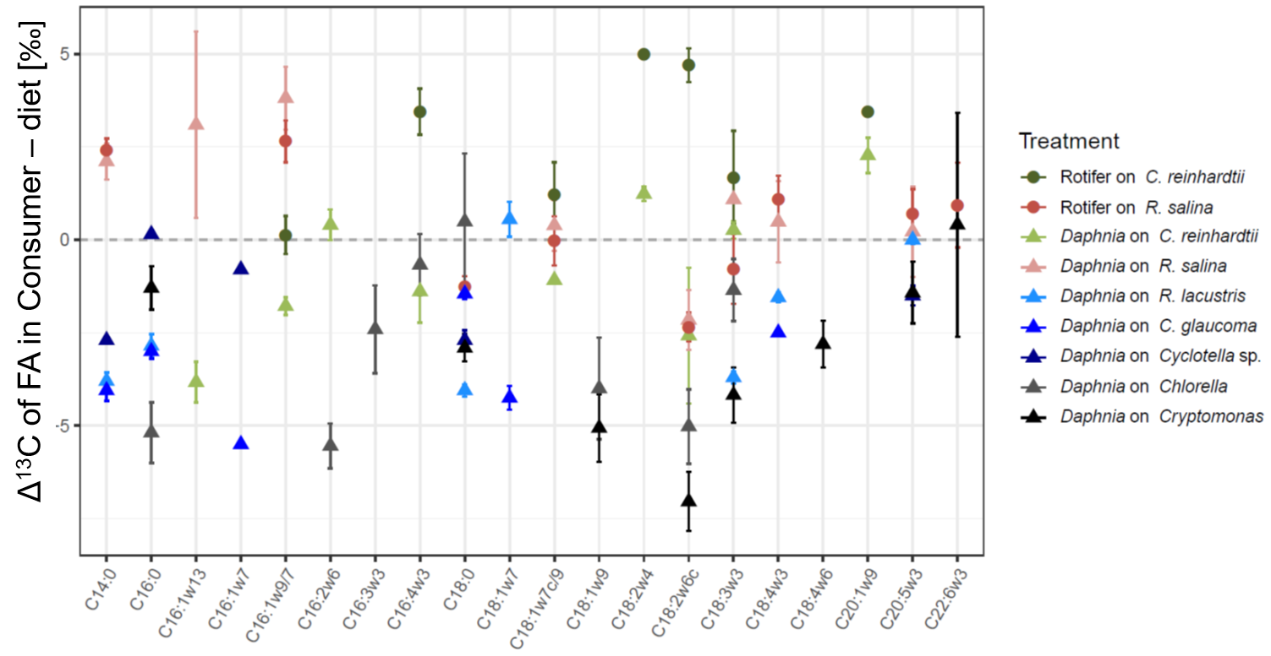
Fig. S7: Trophic fractionation of consumer versus diet ¹³C values in individual FA for feeding experiments for rotifers (circles) and daphnids (triangles) fed either R. Salina (red) or C. reinhardtii in the current study, compared to previously published data for Daphnia fed R. lacustris (light blue triangle), C. Glaucoma ( blue triangles) or Cyclotella sp. (dark blue triangles) from Bec et al. (2011) and Daphnia fed Chlorella (grey triangles) or Cryptomonas (black triangles) from Gladyshev et al. 2016. Error bars denote standard errors of the mean.

