Supplemental Material for:
Stressed Connections: Glucocorticoid Levels Following Acute Psychosocial Stress Disrupt Affiliative Mimicry

Jonas P. Nitschke^{a,b}, Cecile S. Sunaharaª, Evan W. Carr^{c}, Piotr Winkielman^{d,e}, Jens C. Pruessner^{b,f}, Jennifer A. Bartz^{a*}

ª Department of Psychology, McGill University, Montreal, Canada
^{b} Faculty of Medicine, McGill Centre for Studies in Aging, McGill University, Montreal, Canada
^{c} Columbia Business School, New York, USA
^{d} Department of Psychology, University of California, San Diego, USA
^{e} SWPS University of Social Sciences and Humanities, Warsaw, Poland
^{f} Department of Psychology, University of Konstanz, Konstanz, Germany

This document includes:
Supplemental Methods
- Menstrual Cycle Screening Procedure
Supplemental Results
- Three- & Four-way interaction rMEM
- Additional Corrugator Supercilii Analyses
- Trait Empathy and Mimicry
Additional Information
Information regarding this dataset
Supplemental Figures
- Figure S1: Zygomaticus Major time-course activation to frowning faces
- Figure S2: Time-course data of mimicry response (i.e., zygomaticus major activation to smiles and corrugator supercilii activation to frowns)

Supplemental Methods
Menstrual Cycle Screening Procedure:
Prior work has suggested that hormonal status, in particular the female menstrual cycle, can impact the biological stress response (for a review: Kudielka et al., 2009). For this reason we wanted to keep our sample as homogenous as possible and recruited regularly menstruating women in either their late-follicular and mid-luteal phase of their menstrual cycle. During recruitment, female participants were asked to self-report hormonal contraceptive use. Only regularly menstruating females, with cycle lengths of 21- 35 days were recruited. For each female participant, following recruitment, and prior to scheduling the first laboratory session, we tracked the two full menstrual cycles in order to confirm their self-reported cycle length. For visit-1, half of the female participants were scheduled during the late follicular phase of their menstrual cycle, and the other half during their mid-luteal phase. Then, participants were scheduled for visit-2 during the same menstrual cycle phase of the following month, according to the previously tracked cycle. Half the female participants were scheduled to participate during the late follicular phase of the menstrual cycle, while the other half was scheduled during the mid-luteal phase. It is important to note that, adding cycle phase as predictors to the models (instead of gender/sex) did not change the results; female participants showed similar behaviours across both menstrual cycle phases.

Supplemental Results
1. Three- & Four-way interaction rMEM
Our overall aim in this research was to investigate the effects of stress on mimicry—that is, smiling to smiling faces and frowning to frowning faces. As we were not interested in directly comparing the timing of zygomatics and corrugator muscle activation, we ran our analyses for these muscles separately, as others have done (Arnold & Winkielman, 2019; Carr et al., 2014; Korb et al., 2016) to keep our statistical model as simple as possible. Indeed, testing a 3- or 4-factor interaction models in the context of a multilevel model is very computationally intense—especially when also adhering to the implementing new recommendations about appropriately controlling for random error in multi-level models (e.g., Barr et al. 2013; 2013).
To simultaneously test the effects of acute stress induction on both muscles (zygomaticus major, corrugator supercilii) we attempted to run a repeated measures mixed-effects model predicting muscle activation with a including a three-way interaction between muscle * Stimulus-Type * Day as fixed effects. We also included gender/sex of participants as a covariat. We initially tried to add a nested random-slope nested within Subject-ID (Barr, 2013; Barr et al., 2013), including all within-subject factors subsumed in the interaction, however models could not be estimated. This was either due to a lack of computational power (we ran this model on a 32-core cluster with 1510 GB of RAM), or issues with the underlying lmer code. Following recommendations by Brauer and Curtin (2018) we simplified the model to include a random intercept only, Subject ID. Here, we estimated activation (of either muscle) with the fixed-factors: Day, Time-course, Muscle-type, Stimulus-type, and Gender (covariate). We estimated activation (of either muscle) with the fixed-factors: Day, Time-course, Muscle Type, Stimulus Type, and Gender (covariate). In response to your comments, we included the suggested 3-way interaction Day * Stimulus Type * Muscle Type. (Note: that we also ran a more conservative model that included all possible triple interactions, and the results reported below hold.)
The results revealed a significant Day * Stimulus-Type * Muscle Type interaction (F (4, 25) = 42.92, p < 0.0001). We then conducted post-hoc tests (all uncorrected) using the R-package ‘emmeans’ (Lenth, 2016) to probe the interaction effect. We focused on comparing the results obtained for this model to the results reported in the paper—that is, the two main effects of Day and Stimulus. Of note, the model was too complex to estimate degrees of freedom for the effects (again, RAM buffering errors).
First, in regard to the main effect of stress induction on muscle activation, the post-hoc test revealed a significant effect of day on zygomaticus activation: The average activation of the zygomaticus in response to smiles was higher on Day-1, compared to Day-2 (z= 2.86, p= 0.004). This is in line with the results reported in the manuscript; stress led to a reduction in mean zygomaticus activation in response to smiles. In addition, the average zygomaticus activation in response to frowns was higher on Day-2, compared to Day-1 (z= 2.12, p= 0.034).
Second, we find significant effects for differential muscle activation in response to stimulus presentation. Mean zygomaticus activation was higher for smiles, compared to frowns, on both days (Day-1: z= 11.311, p< 0.0001; Day-2: z= 6.354, p < 0.0001). This is in line with the findings reported in the manuscript, where we find a significant effect of stimulus on zygomaticus reactivity. Conversely, there was no difference in corrugator activation in response to smiles or frowns.

2. Additional Corrugator Supercilii Analyses
Given the repeated measures design of the current study, we followed suggestions by Gueorguieva and Krystal (2004) to run mixed-effects models instead of repeated measures ANOVAs. As described in the manuscript, these analyses, which controlled for error structures that included all within-subject effects, did not reveal any congruent mimicry towards frowning faces (i.e., corrugator supercilii activity towards frowning stimuli). However, we also ran analyses controlling for random error structures resembling that of a repeated measure ANOVA (i.e., the random intercept only) for comparison. These analyses revealed an effect of frowning stimuli on mean-level corrugator activity, F(1, 11204)= 4.07, p=0.04, which may suggest the presence of mimicry towards frowning faces. Of note, however, there was still no effect of stress on corrugator activity.

3. Trait Empathy and Mimicry:
In additional, exploratory analyses, we investigated the relationship between trait empathy and mimicry, using the Interpersonal Reactivity Index (IRI; Davis, n.d.), a questionnaire that assesses self-reported empathy on 4 different dimensions: perspective taking (example: “I sometimes try to understand my friends better by imagining how things look from their perspective”), emotional concern (example:“I am often quite touched by things that I see happen”), personal distress (example: “In emergency situations, I feel apprehensive and ill-at-ease”), and fantasy (example: “I really get involved with the feelings of the characters in a novel”). In order to test the association between IRI and mimicry we ran the same rMEM analyses described in the main manuscript; fEMG activations were entered as dependent variables, with stimulus valence, and testing day as fixed-effects, and stimulus presentation order and participant sex/gender were entered as covariates.Subject-ID was entered as a random-effect. In addition, we added each subscale of the IRI separately in order to investigate the effects of trait empathy on fEMG activation. In a second step we entered the interaction between the IRI and day of testing. The results revealed no significant association between trait measures of perspective taking, emotional concern, and personal distress, and fEMG activation for either of the two muscles (zygomaticus or corrugator), all ps > 0.05. There was however a significant effect of the fantasy subscale on zygomaticus activation F(1, 72.5) = 6.84, p=0.01, indicating that higher scores on this subscale were related to higher affiliative mimicry regardless of the day of testing. It has been suggested that fantasy measures the tendency to transpose oneself imaginatively into the feelings and actions of fictitious characters (Davis, n.d.), however, these theoretical assumptions have not held up in empirical studies, and it remains unclear what the subscale tap-into (Corte et al., 2007; Nomura & Akai, 2012). In the context of the current study it might measure the likelihood to engage with the stimuli presented on the computer screen (i.e., real individuals showing genuine expressions, however, not physically present or interpersonally reactive).

Additional Information
Information regarding this dataset: As noted in the main text, this dataset is part of a larger program of research into the effects of acute stress, as well as other hormones, on affiliative behaviours. In addition to the mimicry data presented here we collected data for assessing cognitive empathic abilities. The cognitive empathy task was conducted prior to the mimicry task.
Published research associated with the current dataset (day-1) can be found here:
- Nitschke, J. P., & Bartz, J. A. (2020). Lower digit ratio and higher endogenous testosterone are associated with lower empathic accuracy. Hormones and behavior, 119, 104648.

Supplemental Figures:
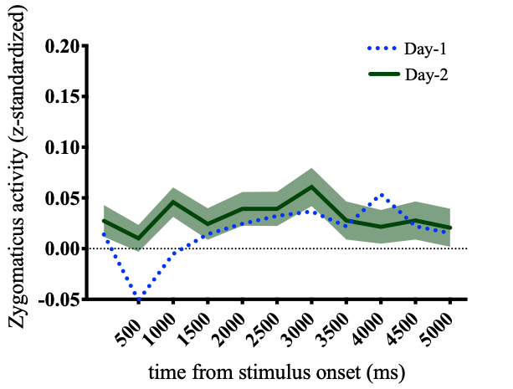
Figure S1: The mean zygomaticus response to frowning faces (incongruent fEMG response); the dotted blue line represents the zygomaticus response to frowning faces on Day-1 (baseline), and the green line represents zygomaticus response to frowning faces on Day-2 (TSST).

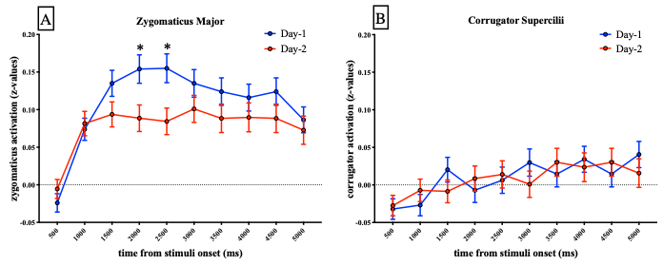
Figure S2: Time-course data of the mimicry response on Day-1 (i.e., the baseline day) and Day-2 (i.e., the TSST day). (A) depicts zygomaticus major activity to smiling faces, while (B) depicts corrugator supercilii activity to frowning faces. The blue lines represent activity during Day-1, whereas the red lines represent activity during Day-2. Stars indicate significant differences between Day-1 and Day-2.
References
Arnold, A. J., & Winkielman, P. (2019). The Mimicry Among Us: Intra- and Inter-Personal Mechanisms of Spontaneous Mimicry. Journal of Nonverbal Behavior. https://doi.org/10.1007/s10919-019-00324-z
Barr, D. J. (2013). Random effects structure for testing interactions in linear mixed-effects models. Frontiers in Psychology, 4, 328.
Barr, D. J., Levy, R., Scheepers, C., & Tily, H. J. (2013). Random effects structure for confirmatory hypothesis testing: Keep it maximal. Journal of Memory and Language, 68(3). https://doi.org/10.1016/j.jml.2012.11.001
Brauer, M., & Curtin, J. J. (2018). Linear mixed-effects models and the analysis of nonindependent data: A unified framework to analyze categorical and continuous independent variables that vary within-subjects and/or within-items. Psychological Methods, 23(3), 389–411.
Carr, E. W., Winkielman, P., & Oveis, C. (2014). Transforming the mirror: power fundamentally changes facial responding to emotional expressions. Journal of Experimental Psychology. General, 143(3), 997–1003.
Corte, K. D., De Corte, K., Buysse, A., Verhofstadt, L. L., Roeyers, H., Ponnet, K., & Davis, M. H. (2007). Measuring Empathic Tendencies: Reliability And Validity of the Dutch Version of the Interpersonal Reactivity Index. In Psychologica Belgica (Vol. 47, Issue 4, p. 235). https://doi.org/10.5334/pb-47-4-235
Davis, M. H. (n.d.). Measuring individual differences in empathy: Evidence for a multidimensional approach. Journal of Personality and Social Psychology, 44(1), 113–126.
Gueorguieva, R., & Krystal, J. H. (2004). Move over ANOVA: progress in analyzing repeated-measures data and its reflection in papers published in the Archives of General Psychiatry. Archives of General Psychiatry, 61(3), 310–317.
Korb, S., Malsert, J., Strathearn, L., Vuilleumier, P., & Niedenthal, P. (2016). Sniff and mimic—intranasal oxytocin increases facial mimicry in a sample of men. Hormones and Behavior, 84, 64–74.
Kudielka, B. M., Hellhammer, D. H., & Wüst, S. (2009). Why do we respond so differently? Reviewing determinants of human salivary cortisol responses to challenge. Psychoneuroendocrinology, 34(1), 2–18.
Lenth, R. V. (2016). Least-Squares Means: TheRPackagelsmeans. In Journal of Statistical Software (Vol. 69, Issue 1). https://doi.org/10.18637/jss.v069.i01
Nitschke, J. P., & Bartz, J. A. (2020). Lower digit ratio and higher endogenous testosterone are associated with lower empathic accuracy. Hormones and Behavior, 119, 104648.
Nomura, K., & Akai, S. (2012). Empathy with fictional stories: reconsideration of the fantasy scale of the interpersonal reactivity index. Psychological Reports, 110(1), 304–314.

