Electronic Supplementary Material
Title: Phylogenetic clustering and rarity imply high risk of local species extinction in prospective deep-sea mining areas of the Clarion-Clipperton Zone
Lara Macheriotou¹, Annelien Rigaux¹, Sofie Derycke^{1, 2}, Ann Vanreusel¹
¹Marine Biology Research Group, Department of Biology, Ghent University, Krijgslaan 281 7 building S8, 9000, Ghent, Belgium
²Aquatic Environment and Quality, Institute for Agricultural and Fisheries Research (ILVO), Ankerstraat 1, 8400 Oostende, Belgium
Table S1: Longitude, latitude average depth and number of respective replicates of the six sampling Areas (BGR.PA, BGR.RA: Bundesanstalt für Geowissenschaften und Rohstoffe Prospective Area and Reference Area respectively, IOM.C: InterOcean Metal-Control, GSR: Global Seabed Resources, IFREMER: Institut Français de Recherche pour l'Exploitation de la Mer, APEI3: Area of Particular Environmental Interest #3). Replicates of each Area were retrieved from separate mutlicorer deployments.
Area | Longitude | Latitude | Depth (m) | Replicates
BGR.PA | 117° 03" W | 11° 50" N | 4132 | 5
BGR.RA | 117° 32" W | 11° 49" N | 4351 | 4
IOM.C | 119° 39" W | 11° 04" N | 4437 | 2
GSR | 123° 15" W | 13° 51" N | 4513 | 4
IFREMER | 130° 08" W | 14° 03" N | 4949 | 5
APEI3 | 128° 21" W | 18° 47" N | 4839 | 3

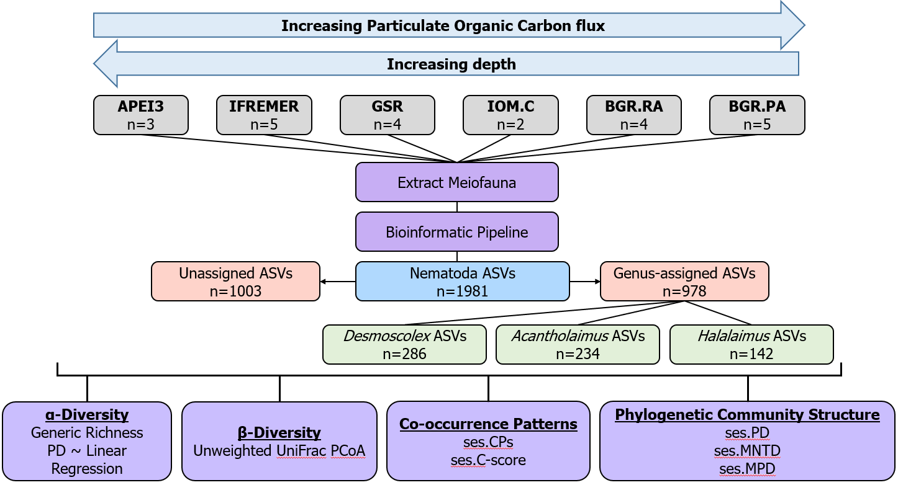
Figure S1: Sampling design: Six Areas were sampled on an East to West transect along a Particulate Organic Carbon and depth gradient (grey boxes with respective replicates). Meiofauna was extracted from each replicate, to which the bioinformatic pipeline was applied, resulting in a total of 1981 Nematoda ASVs. Of these, 1003 were Unassigned at genus-level, 978 were Genus-assigned. From the Genus-assigned ASVs, 286, 234, and 142 were assigned to the genera Desmoscolex, Acantholaimus and Halalaimus, respectively.

DNA extraction, HTS Library Preparation
Genomic DNA was extracted by adding 6 µL proteinase-K [10mg/mL] and centrifuged 5 min at 14000 rpm (Room Temperature, RT). The pellet was ground, bead-beaten for 2 min at 30 cycles/second and incubated at 60°C for 1 hour. Ammoniumacetate (250 µL, 7.5 M) was added and tubes centrifuged for 10 min at 14000 rpm (RT). The supernatant (750 µL) was transferred into a new sterile tube; 750 µL of cold 80% isopropanol was added, mixed, incubated for 30 min at RT, and centrifuged for 15 min at 14000 rpm (4°C). The supernatant was removed, 1 mL washing buffer (76% EtOH 10mM ammonium acetate) was added, tubes were incubated for 30 min on ice (to remove salts) and centrifuged for 5 min at 14000 rpm (4°C). Finally, the supernatant was removed, and 20 µL of sterile water was added.
The 18S (V1-V2 region) ribosomal locus was amplified using the primers SSU_F_04-SSU/22_R (GCTTGTCTCAAAGATTAAGCC, TCCAAGGAAGGCAGCAGGC respectively) which were constructed with Illumina overhang adapters as described in “16S Metagenomic Sequencing Library Preparation”. Each sample was amplified in triplicate with the following PCR conditions: 95°C 2 min, 30x(95 °C 1 min, 57 °C 45 sec, 72 °C 1 min), 72 °C 10 min. The mix consisted of 8.4 μL PCR-grade H₂O, 4 µL Phusion Buffer, 4 µL Dye, 0.4 µL dNTP [10 mM], 1 µL forward and reverse primer [10 μM], 0.2 µL Phusion Hot Start II High Fidelity Polymerase (New England BioLabs, U.S.A.) and 1 µL DNA template (diluted 1/10). In the event of failed amplification, DNA templates were diluted 1/50 in PCR-grade H₂O and/or 2 µL template were used. PCR products were run on a 1% agarose electrophoresis gel, triplicates were pooled, purified using Agencourt AMPure XP beads and run on Bioanalyzer 2100 High Sensitivity to confirm length and size distribution of the PCR fragments. Library indexing was completed using the FC131-1002 NexteraXT Index Kit (Illumina, U.S.A.) and Kapa High Fidelity PCR kit (Kapa Biosystems, U.S.A.). The mix consisted of 11.25 μL PCR-grade H₂O, 5 µL Buffer, 0.75 µL dNTP [10 mM], 2.5 µL Index1 and Index2, 0.5 µL Kapa Hot Start High Fidelity Polymerase and 2.5 µL PCR product. These were then purified using Agencourt AMPure XP beads and 11 randomly chosen samples were run on Bioanalyzer 2100 High Sensitivity to confirm successful indexing. DNA was quantified using Qubit® dsDNA High Sensitivity Assay Kit in all samples for pooling. Finally, biological replicates were distributed over three pooled libraries and sequenced at Edinburgh Genomics on three Illumina MiSeq-v3 2x300bp paired-end read runs (https://genomics.ed.ac.uk/).
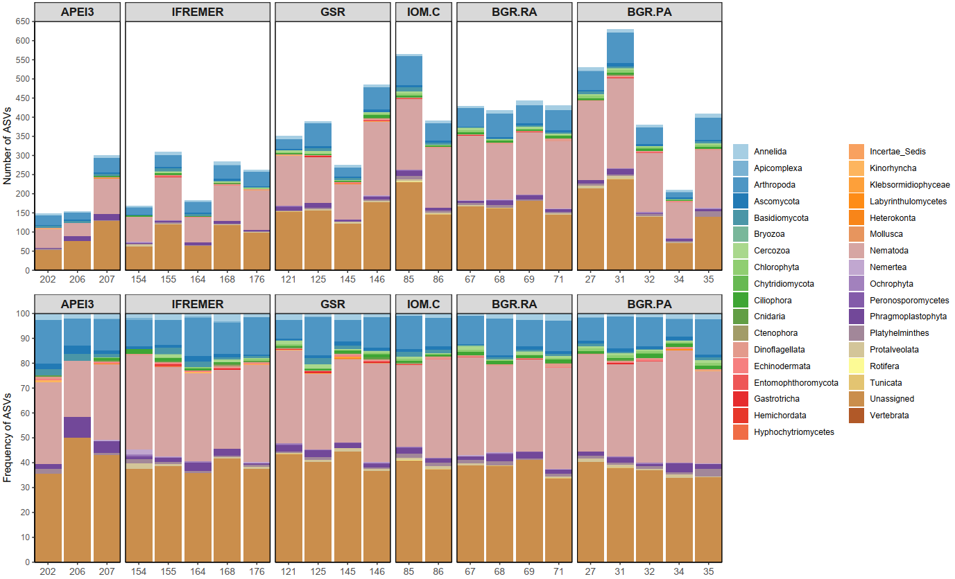
Figure S2: Phylum-level taxonomic assignments of rarefied ASVs in the BGR.PA, BGR.RA, IOM.C, GSR, IFREMER and APEI areas.

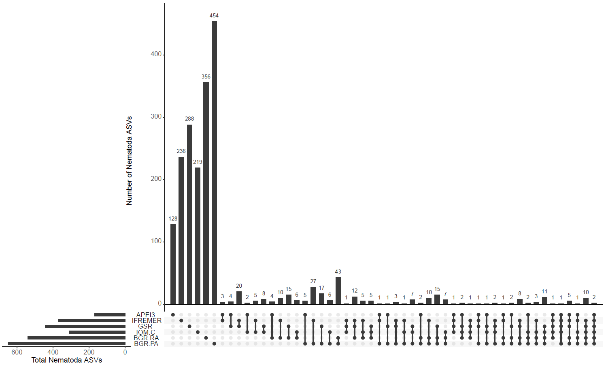
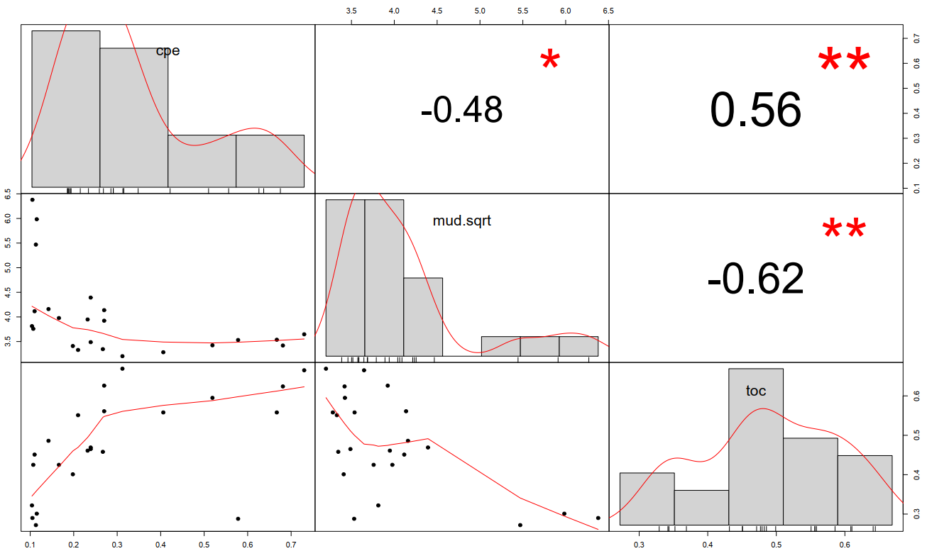
Figure S3: Unique and shared Nematoda ASVs. Main panel: number above bars indicate number of Nematoda ASVs found in areas marked by filled circles; bottom left graph: total number of Nematoda ASVs in the BGR.PA, BGR.RA, IOM.C, GSR, IFREMER and APEI3 areas.
Figure S4: Correlation chart for environmental variables %Total Organic Carbon (toc), square-root %Mud (mud.sqrt, <4 µm) and Chloroplastic Pigment Equivalent (CPE, Σ chlorophyll-a + phaeopigments). The distribution of each variable is shown on the diagonal; bivariate scatter plots with a fitted line are displayed on the bottom of the diagonal; the value of the (Pearson) correlation plus the significance level as stars are displayed on top of the diagonal [p-values (0, 0.001, 0.01, 0.05, 0.1, 1) <=> symbols (“***”, “**”, “*”, “.”, " “)].
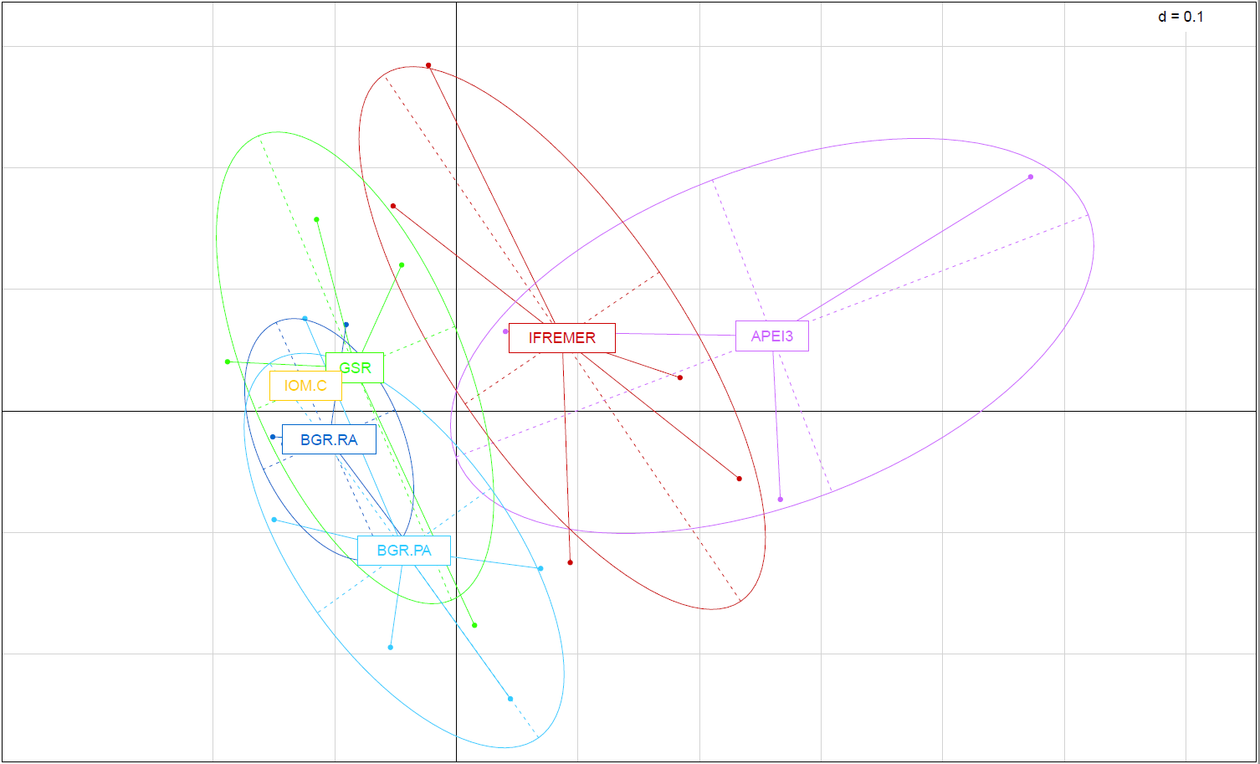
Figure S5: Principal Coordinates Analysis (PCoA) of unweighted UniFrac distance of Nematoda ASVs in the BGR.PA (light blue), BGR.RA (dark blue), IOM.C (yellow), GSR (green), IFREMER (red) and APEI3 (purple) areas.

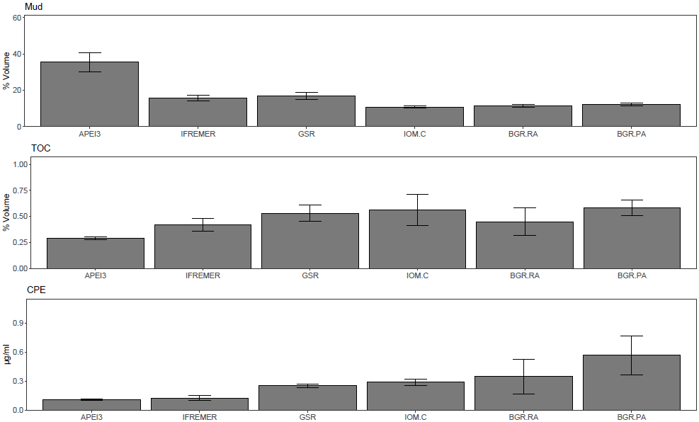 Figure S6: Environmental variables %Total Organic Carbon (%TOC), %Mud () and Chloroplastic Pigments Equivalent (CPE, μg/mL) in the BGR.PA, BGR.RA, IOM.C, GSR, IFREMER and APEI3 areas. Error bars represent standard deviation.
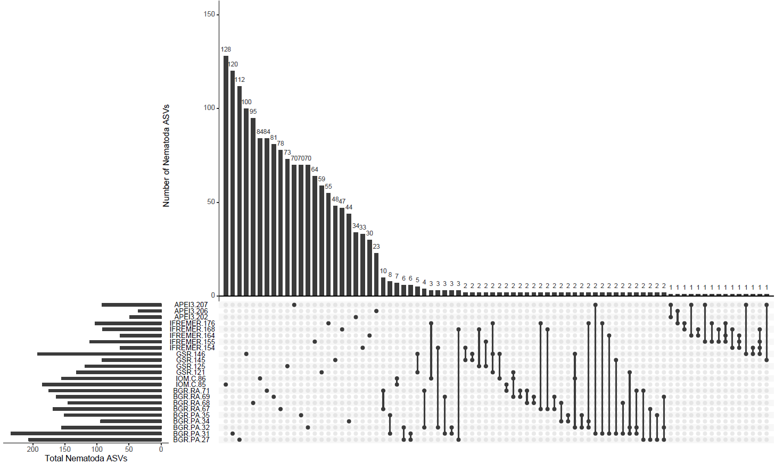
Figure S7: Unique and shared Nematoda ASVs by replicate core. Main panel: number above bars indicate number of Nematoda ASVs found in Areas marked by filled circles; a single filled circle/column signifies unique ASVs (i.e. not shared with another sampling location). Bottom left graph: total number of Nematoda ASVs in the BGR.PA, BGR.RA, IOM.C, GSR, IFREMER and APEI3 areas.
Table S2: Average (Avg.) and standard deviation (St. dev.) for generic richness of Nematoda ASVs the BGR.PA, BGR.RA, IOM.C, GSR, IFREMER and APEI3 areas.
Area | Avg. | St. dev.
APEI3 | 9.000 | 3.606
IFREMER | 12.800 | 3.834
GSR | 15.750 | 3.304
IOM.C | 19.500 | 0.707
BGR.RA | 20.250 | 1.500
BGR.PA | 20.600 | 2.074

Table S3: Results of statistical testing (p-value) for data normality (Shapiro-Wilk, S-W), homoscedasticity (Levene) and Analysis of Variance (ANOVA) for generic richness of Nematoda ASVs in the BGR.PA, BGR.RA, IOM.C, GSR, IFREMER and APEI3 areas. Significant values indicated in grey (α=0.05). Note: Normality assumption could not be tested in IOM.C data due to insufficient replication (n=2).
Area | S-W | Levene | ANOVA
APEI3 | 0.537 | 0.415 | 0.000
IFREMER | 0.961
GSR | 0.513
IOM.C | ---
BGR.RA | 0.224
BGR.PA | 0.023

Groups | p-Tukey
IFREMER-APEI3 | 0.491
GSR-APEI3 | 0.066
IOM.C-APEI3 | 0.010
BGR.RA-APEI3 | 0.001
BGR.PA-APEI3 | 0.000
GSR-IFREMER | 0.656
IOM.C-IFREMER | 0.111
BGR.RA-IFREMER | 0.014
BGR.PA-IFREMER | 0.006
IOM.C-GSR | 0.670
BGR.RA-GSR | 0.287
BGR.PA-GSR | 0.178
BGR.RA-IOM.C | 1.000
BGR.PA-IOM.C | 0.997
BGR.PA-BGR.RA | 1.000
Table S4: Tukey's HSD (Honestly Significant Difference) test results (p-value) for pairwise comparisons for generic richness of Nematoda ASVS in the BGR.PA, BGR.RA, IOM.C, GSR, IFREMER and APEI3 areas. Significant values indicated in grey (α=0.05).

Table S5: Average (Avg.) and standard deviation (St. Dev.) for Phylogenetic Diversity (PD) in the BGR.PA, BGR.RA, IOM.C, GSR, IFREMER and APEI3 areas.
Level | Area | PD
 |  | Avg. | St. dev.
Nematoda | APEI3 | 3.746 | 1.539
 | IFREMER | 5.395 | 1.041
 | GSR | 7.187 | 1.271
 | IOM.C | 8.481 | 0.898
 | BGR.RA | 7.813 | 0.241
 | BGR.PA | 7.953 | 1.671
Genus-assigned | APEI3 | 1.824 | 0.442
 | IFREMER | 2.562 | 0.503
 | GSR | 3.241 | 0.471
 | IOM.C | 4.130 | 0.167
 | BGR.RA | 4.069 | 0.394
 | BGR.PA | 4.054 | 0.732
Unassigned | APEI3 | 2.759 | 1.206
 | IFREMER | 4.059 | 0.856
 | GSR | 5.527 | 1.035
 | IOM.C | 5.997 | 0.732
 | BGR.RA | 5.381 | 0.335
 | BGR.PA | 5.669 | 1.243
Acantholaimus | APEI3 | 0.210 | 0.056
 | IFREMER | 0.216 | 0.053
 | GSR | 0.251 | 0.052
 | IOM.C | 0.403 | 0.214
 | BGR.RA | 0.298 | 0.082
 | BGR.PA | 0.305 | 0.105
Desmoscolex | APEI3 | 0.439 | 0.083
 | IFREMER | 0.517 | 0.137
 | GSR | 0.661 | 0.135
 | IOM.C | 1.021 | 0.125
 | BGR.RA | 0.859 | 0.178
 | BGR.PA | 0.902 | 0.298
Halalaimus | APEI3 | 0.250 | 0.055
 | IFREMER | 0.331 | 0.062
 | GSR | 0.333 | 0.028
 | IOM.C | 0.527 | 0.065
 | BGR.RA | 0.429 | 0.043
 | BGR.PA | 0.392 | 0.163

Table S6: Results of statistical testing (p-value) for data normality (Shapiro-Wilk, S-W), homoscedasticity (Levene) and Analysis of Variance (ANOVA) for Phylogenetic Diversity (PD) within Nematoda, Genus-assigned, Unassigned, Acantholaimus, Desmoscolex and Halalaimus ASVs in each area. Non-parametric equivalents (PERMDISP, PERMANOVA) where used when necessary (i.e. Shapiro-Wilk/Levenes p<0.05, n<3). Significant values indicated in grey (α=0.05).
Level | Area | PD
 |  | Shapiro-Wilk | Levene | p-ANOVA
All Nematoda | APEI3 | 0.4877 | 0.5467 | 0.0039
 | IFREMER | 0.0576
 | GSR | 0.2651
 | IOM.C | ---
 | BGR.RA | 0.1883
 | BGR.PA | 0.3947
Genus-assigned | APEI3 | 0.9863 | 0.5861 | 0.0003
 | IFREMER | 0.9400
 | GSR | 0.4886
 | IOM.C | ---
 | BGR.RA | 0.2669
 | BGR.PA | 0.5535
Unassigned | APEI3 | 0.3687 | 0.6745 | 0.0145
 | IFREMER | 0.6335
 | GSR | 0.2112
 | IOM.C | ---
 | BGR.RA | 0.3154
 | BGR.PA | 0.1910
Acantholaimus | APEI3 | 0.7264 | 0.0386 | PERMDISP
 | IFREMER | 0.1392 |  | 0.5386
 | GSR | 0.4743 |  | PERMANOVA
 | IOM.C | --- |  | 0.579
 | BGR.RA | 0.6639
 | BGR.PA | 0.0738
Desmoscolex | APEI3 | --- | 0.7190 | 0.0320
 | IFREMER | 0.6702
 | GSR | 0.6354
 | IOM.C | ---
 | BGR.RA | 0.5322
 | BGR.PA | 0.6122
Halalaimus | APEI3 | 0.7055 | 0.0585 | 0.0911
 | IFREMER | 0.8784
 | GSR | 0.4371
 | IOM.C | ---
 | BGR.RA | 0.5431
 | BGR.PA | 0.4102

Table S7: Tukey's HSD (Honestly Significant Difference) test results (adjusted p-value) for pairwise comparisons of Phylogenetic Diversity (PD) for Nematoda, Genus-assigned, Unassigned and Desmoscolex ASVs in the BGR.PA, BGR.RA, IOM.C, GSR, IFREMER and APEI3 areas. Significant values indicated in grey (α=0.05).
Groups | Nematoda | Genus-assigned | Unassigned | Desmoscolex
IFREMER-APEI3 | 0.623 | 0.557 | 0.621 | 0.998
GSR-APEI3 | 0.055 | 0.061 | 0.048 | 0.848
IOM.C-APEI3 | 0.021 | 0.006 | 0.055 | 0.146
BGR.RA-APEI3 | 0.018 | 0.002 | 0.067 | 0.293
BGR.PA-APEI3 | 0.010 | 0.001 | 0.026 | 0.181
GSR-IFREMER | 0.453 | 0.555 | 0.412 | 0.920
IOM.C-IFREMER | 0.156 | 0.057 | 0.353 | 0.124
BGR.RA-IFREMER | 0.173 | 0.017 | 0.520 | 0.248
BGR.PA-IFREMER | 0.101 | 0.011 | 0.263 | 0.118
IOM.C-GSR | 0.896 | 0.541 | 0.996 | 0.449
BGR.RA-GSR | 0.988 | 0.404 | 1.000 | 0.800
BGR.PA-GSR | 0.964 | 0.369 | 1.000 | 0.597
BGR.RA-IOM.C | 0.994 | 1.000 | 0.987 | 0.954
BGR.PA-IOM.C | 0.998 | 1.000 | 0.999 | 0.986
BGR.PA-BGR.RA | 1.000 | 1.000 | 0.999 | 1.000

Table S8: Partial and global p-values and adjusted R-squared values for linear regression analyses of PD for Nematoda, Unassigned, Genus-assigned, Acantholaimus, Desmoscolex, Halalaimus ASVs and environmental variables %Total Organic Carbon (TOC), square-root %Mud (Mud.sqrt, <4 µm) and Chloroplastic Pigment Equivalent (CPE, Σ chlorophyll-a + phaeopigments).
PD | CPE | TOC | Mud.sqrt | CPE:TOC | Global p-value | Adj. R²
 | p-value
Nematoda | 0.0090 | 0.0040 | - | 0.0207 | 0.0015 | 0.4764
Unassigned | - | 0.0020 | - | - | 0.0025 | 0.3293
Genus-assigned | 0.0210 | - | 0.0045 | - | 0.0001 | 0.5720
Acantholaimus | - | - | - | - | - | -
Desmoscolex | - | - | - | - | - | -
Halalaimus | - | - | 0.0038 | - | 0.0038 | 0.3030

Table S9: Observed, simulated (mean), lower/upper-tail p-values (2-tailed t-test) and standardized effect size (SES) for checkerboard pairs (CPs) and C-score of Nematoda, Acantholaimus, Desmoscolex and Halalaimus ASVs within CCFZ (pooled/unpooled) and BGR.PA, BGR.RA, IOM.C, GSR, IFREMER and APEI3. Significant values indicated in grey (α=0.05).
Checkerboard pairs | Nematoda
 | Regional |  | Local
CPs | CCFZ.Replicates | CCFZ.Areas | APEI3 | IFREMER | GSR | IOM.C | BGR.RA | BGR.PA
Observed | 1755971 | 1399727 | 8413 | 49488 | 61554 | 19375 | 93978 | 138078
Simulated_mean | 1780635.000 | 1465388.000 | 9239.700 | 50288.000 | 63823.000 | 19531.000 | 93722.000 | 143483.000
Lower-tail P | 0.000 | 0.000 | 0.000 | 0.000 | 0.000 | 0.084 | 0.999 | 0.000
Upper-tail P | 1.000 | 1.000 | 1.000 | 1.000 | 1.000 | 0.935 | 0.001 | 1.000
SES | -65.544 | -119.180 | -14.818 | -7.391 | -16.543 | -1.588 | 1.541 | -28.777
%CPs_obs | 89.536 | 71.371 | 58.566 | 72.103 | 62.589 | 40.453 | 64.816 | 65.665
%CPs_sim | 90.794 | 74.719 | 64.321 | 73.269 | 64.896 | 40.779 | 64.640 | 68.236
C-score
Observed | 1.698 | 1399727.000 | 0.600 | 0.856 | 0.749 | 0.405 | 0.789 | 0.853
Simulated_mean | 1.762 | 1465387.000 | 0.659 | 0.870 | 0.789 | 0.408 | 0.789 | 0.892
Lower-tail P | 0.000 | 0.000 | 0.000 | 0.001 | 0.000 | 0.080 | 0.413 | 0.000
Upper-tail P | 1.000 | 1.000 | 1.000 | 0.999 | 1.000 | 0.936 | 0.587 | 1.000
SES | -65.471 | -119.700 | -14.475 | -5.798 | -18.345 | -1.585 | 0.024 | -24.550
 | Acantholaimus
 | Regional |  | Local
CPs | CCFZ.Replicates | CCFZ.Areas | APEI3 | IFREMER | GSR | IOM.C | BGR.RA | BGR.PA
Observed | 23293 | 18631 | 248 | 886 | 749 | 286 | 1267 | 1622
Simulated_mean | 23655.000 | 19151.000 | 270.630 | 912.620 | 785.960 | 332.840 | 1261.400 | 1769.500
Lower-tail P | 0.000 | 0.000 | 0.038 | 0.070 | 0.037 | 0.023 | 0.531 | 0.000
Upper-tail P | 1.000 | 1.000 | 0.968 | 0.935 | 0.966 | 0.992 | 0.493 | 1.000
SES | -7.658 | -7.996 | -2.327 | -1.665 | -2.253 | -3.526 | 0.287 | -6.575
%CPs_obs | 85.444 | 68.343 | 53.333 | 61.915 | 50.438 | 33.217 | 60.913 | 52.645
%CPs_sim | 86.772 | 70.251 | 58.200 | 63.775 | 52.927 | 38.657 | 60.644 | 57.433
C-score
Observed | 2.198 | 0.933 | 0.581 | 0.864 | 0.735 | 0.332 | 0.788 | 0.809
Simulated_mean | 2.280 | 0.985 | 0.623 | 0.906 | 0.777 | 0.387 | 0.773 | 0.882
Lower-tail P | 0.000 | 0.000 | 0.070 | 0.044 | 0.044 | 0.020 | 0.887 | 0.001
Upper-tail P | 1.000 | 1.000 | 0.942 | 0.958 | 0.958 | 0.992 | 0.130 | 0.999
SES | -6.407 | -9.505 | -1.727 | -2.047 | -2.088 | -3.529 | 0.955 | -4.811
 | Desmoscolex
 | Regional |  | Local
CPs | CCFZ.Replicates | CCFZ.Areas | APEI3 | IFREMER | GSR | IOM.C | BGR.RA | BGR.PA
Observed | 36936 | 29721 | 60 | 844 | 1070 | 513 | 1803 | 3099
Simulated_mean | 37584.000 | 31319.000 | 80.075 | 836.860 | 1126.800 | 517.230 | 1786.000 | 3220.700
Lower-tail P | 0.000 | 0.000 | 0.008 | 0.660 | 0.013 | 0.308 | 0.773 | 0.002
Upper-tail P | 1.000 | 1.000 | 0.994 | 0.378 | 0.988 | 0.814 | 0.250 | 0.998
SES | -12.524 | -19.536 | -3.947 | 0.518 | -3.234 | -0.255 | 0.754 | -4.251
%CPs_obs | 90.629 | 72.926 | 50.000 | 78.076 | 67.043 | 41.878 | 66.753 | 67.961
%CPs_sim | 92.219 | 76.847 | 66.729 | 77.415 | 70.602 | 42.223 | 66.124 | 70.629
C-score
Observed | 1.526 | 0.911 | 0.500 | 0.841 | 0.719 | 0.419 | 0.816 | 0.880
Simulated_mean | 1.587 | 0.986 | 0.666 | 0.834 | 0.776 | 0.422 | 0.812 | 0.930
Lower-tail P | 0.000 | 0.000 | 0.007 | 0.597 | 0.004 | 0.306 | 0.530 | 0.001
Upper-tail P | 1.000 | 1.000 | 0.994 | 0.424 | 0.996 | 0.815 | 0.483 | 0.999
SES | -13.717 | -21.331 | -3.811 | 0.420 | -4.011 | -0.271 | 0.283 | -4.552
 | Halalaimus
 | Regional |  | Local
CPs | CCFZ.Replicates | CCFZ.Areas | APEI3 | IFREMER | GSR | IOM.C | BGR.RA | BGR.PA
Observed | 8823 | 6823 | 157 | 396 | 337 | 130 | 533 | 657
Simulated_mean | 8838.300 | 6917.000 | 154.090 | 394.640 | 325.950 | 126.420 | 511.350 | 680.900
Lower-tail P | 0.287 | 0.031 | 0.637 | 0.480 | 0.986 | 0.682 | 0.999 | 0.066
Upper-tail P | 0.724 | 0.970 | 0.485 | 0.560 | 0.048 | 0.592 | 0.001 | 0.939
SES | -0.515 | -2.280 | 0.409 | 0.134 | 1.145 | 0.453 | 1.680 | -1.739
%CPs_obs | 88.133 | 68.155 | 67.965 | 70.588 | 67.944 | 37.037 | 65.000 | 66.364
%CPs_sim | 88.286 | 69.094 | 66.706 | 70.346 | 65.716 | 36.017 | 62.360 | 68.778
C-score
Observed | 2.307 | 1.059 | 0.680 | 0.948 | 0.776 | 0.370 | 0.916 | 0.971
Simulated_mean | 2.321 | 1.092 | 0.667 | 0.947 | 0.749 | 0.360 | 0.877 | 1.007
Lower-tail P | 0.165 | 0.005 | 0.636 | 0.443 | 0.951 | 0.680 | 0.993 | 0.091
Upper-tail P | 0.836 | 0.995 | 0.488 | 0.582 | 0.090 | 0.591 | 0.009 | 0.913
SES | -0.955 | -3.462 | 0.411 | 0.052 | 1.073 | 0.444 | 1.473 | -1.457
Table S10: Average (Avg.) and standard deviation (St. Dev.) for standardized effect size of PD (ses.PD), unweighted Mean Pairwise Distance (ses.MPD) and unweighted Mean Nearest Taxon Distance (ses.MNTD) for Nematoda, Genus-assigned, Unassigned, Acantholaimus, Desmoscolex and Halalaimus ASVs in the BGR.PA, BGR.RA, IOM.C, GSR, IFREMER and APEI3 areas.
Level | Area | ses.PD |  | ses.MPD |  | ses.MNTD
 |  | Avg. | St. dev. | Avg. | St. dev. | Avg. | St. dev.
Nematoda | APEI3 | -1.934 | 0.858 | -0.553 | 0.091 | -2.140 | 0.784
 | IFREMER | -1.170 | 0.652 | -0.891 | 0.347 | -1.104 | 0.720
 | GSR | -1.327 | 0.950 | -0.903 | 0.476 | -1.602 | 1.303
 | IOM.C | -1.498 | 0.646 | -1.731 | 0.952 | -1.718 | 0.662
 | BGR.RA | -2.241 | 0.462 | -1.831 | 0.634 | -2.377 | 0.552
 | BGR.PA | -2.149 | 1.170 | -2.283 | 1.588 | -2.368 | 1.214
Genus-assigned | APEI3 | -2.419 | 0.491 | -0.607 | 1.072 | -2.297 | 0.688
 | IFREMER | -1.700 | 0.817 | -0.654 | 0.679 | -1.516 | 1.002
 | GSR | -1.439 | 0.448 | -0.841 | 1.228 | -1.015 | 0.478
 | IOM.C | -1.448 | 0.065 | -0.364 | 0.940 | -1.641 | 0.277
 | BGR.RA | -1.083 | 1.360 | -0.457 | 1.106 | -1.531 | 1.114
 | BGR.PA | -1.248 | 1.372 | -0.987 | 1.104 | -1.437 | 1.221
Unassigned | APEI3 | -0.335 | 0.194 | -0.457 | 0.294 | -1.106 | 0.409
 | IFREMER | 0.111 | 1.407 | -0.237 | 0.883 | -0.025 | 1.495
 | GSR | -0.480 | 0.882 | -0.379 | 0.718 | -0.799 | 1.426
 | IOM.C | -0.710 | 0.425 | -1.863 | 0.451 | -0.267 | 0.561
 | BGR.RA | -1.805 | 0.159 | -1.630 | 0.808 | -1.834 | 0.198
 | BGR.PA | -1.217 | 0.760 | -1.586 | 1.550 | -1.517 | 0.928
Acantholaimus | APEI3 | -0.244 | 0.191 | -0.442 | 0.052 | -0.949 | 0.124
 | IFREMER | -0.999 | 0.359 | -1.366 | 0.338 | -1.412 | 0.316
 | GSR | -1.305 | 0.518 | -1.618 | 0.518 | -1.656 | 0.404
 | IOM.C | 0.085 | 1.695 | -0.275 | 1.771 | -0.042 | 1.874
 | BGR.RA | -0.911 | 0.824 | -1.036 | 0.581 | -1.283 | 0.808
 | BGR.PA | -1.324 | 1.083 | -1.350 | 0.889 | -2.074 | 0.998
Desmoscolex | APEI3 | 0.029 | 0.042 | -0.286 | 0.195 | -0.035 | 0.076
 | IFREMER | -0.068 | 0.607 | -0.344 | 0.796 | -0.108 | 0.524
 | GSR | -0.261 | 0.809 | -0.519 | 0.936 | -0.095 | 0.690
 | IOM.C | -0.464 | 0.113 | -0.119 | 0.388 | -0.970 | 0.111
 | BGR.RA | -0.523 | 0.990 | -0.871 | 1.029 | -0.340 | 1.063
 | BGR.PA | -0.469 | 1.164 | -0.351 | 0.950 | -0.826 | 1.061
Halalaimus | APEI3 | -0.892 | 0.560 | -1.034 | 0.304 | -0.918 | 0.421
 | IFREMER | -0.227 | 0.702 | -0.330 | 0.742 | -0.213 | 0.713
 | GSR | -0.640 | 0.454 | -0.657 | 0.686 | -0.568 | 0.575
 | IOM.C | -0.003 | 0.392 | 0.152 | 0.422 | -0.318 | 0.450
 | BGR.RA | -0.439 | 0.423 | -0.603 | 0.494 | -0.237 | 0.520
 | BGR.PA | -0.432 | 0.829 | -0.223 | 0.869 | -0.476 | 0.870

Table S11: Statistical testing of normality (Shapiro-Wilk, S-W) and non-zero means (t-test) for standardised effect size of Phylogenetic Diversity (ses.PD), unweighted Mean Pairwise Distance (ses.MPD) and unweighted Mean Nearest Taxon Distance (ses.MNTD) for Nematoda, Genus-assigned, Unassigned, Acantholaimus, Desmoscolex and Halalaimus ASVs in the BGR.PA, BGR.RA, IOM.C, GSR, IFREMER and APEI3 areas. Significant values indicated in grey (α=0.05).
Level | Area | ses.PD |  |  | ses.MNTD |  |  | ses.MPD
 |  | S-W | t.test | W | S-W | t.test | W | S-W | t.test | W
Nematoda | APEI3 | 0.592 | 0.086 |  | 0.922 | 0.061 |  | 0.531 | 0.013
 | IFREMER | 0.064 | 0.023 |  | 0.065 | 0.037 |  | 0.263 | 0.007
 | GSR | 0.686 | 0.094 |  | 0.712 | 0.123 |  | 0.492 | 0.046
 | IOM.C |  |  | 0.500 |  |  | 0.500 |  |  | 0.500
 | BGR.RA | 0.268 | 0.004 |  | 0.890 | 0.005 |  | 0.077 | 0.015
 | BGR.PA | 0.647 | 0.021 |  | 0.875 | 0.018 |  | 0.747 | 0.045
Genus-assigned | APEI3 | 0.508 | 0.020 |  | 0.974 | 0.042 |  | 0.714 | 0.507
 | IFREMER | 0.125 | 0.014 |  | 0.425 | 0.039 |  | 0.064 | 0.126
 | GSR | 0.280 | 0.011 |  | 0.825 | 0.035 |  | 0.725 | 0.321
 | IOM.C |  |  | 0.500 |  |  | 0.500 |  |  | 1.000
 | BGR.RA | 0.897 | 0.262 |  | 0.516 | 0.098 |  | 0.998 | 0.526
 | BGR.PA | 0.770 | 0.143 |  | 0.868 | 0.078 |  | 0.015 |  | 0.063
Unassigned | APEI3 | 0.999 | 0.135 |  | 0.332 | 0.062 |  | 0.584 | 0.159
 | IFREMER | 0.447 | 0.882 |  | 0.354 | 0.975 |  | 0.730 | 0.620
 | GSR | 0.554 | 0.416 |  | 0.930 | 0.404 |  | 0.696 | 0.428
 | IOM.C |  |  | 0.500 |  |  | 1.000 |  |  | 0.500
 | BGR.RA | 0.272 | 0.000 |  | 0.816 | 0.001 |  | 0.579 | 0.040
 | BGR.PA | 0.455 | 0.033 |  | 0.506 | 0.031 |  | 0.545 | 0.110
Acantholaimus | APEI3 | 0.365 | 0.212 |  | 0.913 | 0.008 |  | 0.753 | 0.007
 | IFREMER | 0.235 | 0.005 |  | 0.020 |  | 0.063 | 0.115 | 0.001
 | GSR | 0.489 | 0.022 |  | 0.794 | 0.006 |  | 0.412 | 0.012
 | IOM.C |  |  | 1.000 |  |  | 1.000 |  |  | 1.000
 | BGR.RA | 0.085 | 0.152 |  | 0.332 | 0.071 |  | 0.182 | 0.054
 | BGR.PA | 0.365 | 0.071 |  | 0.244 | 0.014 |  | 0.134 | 0.038
Desmoscolex | APEI3 |  |  | 0.500 |  |  | 1.000 |  |  | 0.500
 | IFREMER | 0.364 | 0.833 |  | 0.107 | 0.701 |  | 0.959 | 0.436
 | GSR | 0.215 | 0.616 |  | 0.862 | 0.827 |  | 0.245 | 0.408
 | IOM.C |  |  | 0.500 |  |  | 0.500 |  |  | 1.000
 | BGR.RA | 0.849 | 0.427 |  | 0.824 | 0.618 |  | 0.595 | 0.239
 | BGR.PA | 0.536 | 0.466 |  | 0.494 | 0.194 |  | 0.471 | 0.501
Halalaimus | APEI3 | 0.762 | 0.153 |  | 0.500 | 0.091 |  | 0.716 | 0.041
 | IFREMER | 0.216 | 0.554 |  | 0.597 | 0.583 |  | 0.995 | 0.425
 | GSR | 0.705 | 0.092 |  | 0.408 | 0.185 |  | 0.206 | 0.196
 | IOM.C |  |  | 1.000 |  |  | 1.000 |  |  | 1.000
 | BGR.RA | 0.866 | 0.170 |  | 0.729 | 0.488 |  | 0.356 | 0.125
 | BGR.PA | 0.469 | 0.356 |  | 0.500 | 0.335 |  | 0.546 | 0.634

Table S12: Description of null models applied in the calculation of standard effect size (ses) of Phylogenetic Diversity (ses.PD), unweighted Mean Pairwise Distance (ses.MPD) and unweighted Mean Nearest Taxon Distance (ses.MNTD) for Nematoda, Genus-assigned, Unassigned, Desmoscolex, Acantholaimus, and Halalaimus ASVs in the BGR.PA, BGR.RA, IOM.C, GSR, IFREMER and APEI3 areas. Source: R Package “picante” vignette.
Null Model | Randomization
taxa.labels | Shuffle distance matrix labels (across all taxa included in distance matrix)
richness | Randomize community data matrix abundances within samples (maintains sample species richness)
frequency | Randomize community data matrix abundances within species (maintains species occurrence frequency)
sample.pool | Randomize community data matrix by drawing species from pool of species occurring  in at least one community (sample pool) with equal probability
phylogeny.pool | Randomize community data matrix by drawing species from pool of species occurring  in the distance matrix (phylogeny pool) with equal probability
independentswap | Randomize community data matrix with the independent swap algorithm¹  maintaining species occurrence frequency and sample species richness
trialswap | Randomize community data matrix with the trial-swap algorithm²  maintaining species occurrence frequency and sample species richness

R scripts
DADA2
https://docs.google.com/document/d/11Mv0mmlyh-UNCwU8En5ceYC7RgoTPiqJh2tv2byadOs/edit?usp=sharing
Downstream analysis
https://docs.google.com/document/d/1iZB8hF4jfOzTuuBLWDB_qeZBPcNhhkvJMQ6KI1R7-nM/edit?usp=sharing
Cutadapt output
https://docs.google.com/document/d/1u63B_CG6IK26GtulgaNHgTE784dzMkWOc85FtE9uaYA/edit?usp=sharing
DADA2 output
https://docs.google.com/spreadsheets/d/1fQ023DApDg_9nKFYZnHHtx3llcqF2TBw0L5ivOcIbiE/edit?usp=sharing
References

1. Gotelli, N. J. Null model analysis of species co-occurrence patterns. Ecology 81, 2606–2621 (2000).
2. Miklós, I. & Podani, J. Randomization of presence-absence matrices: Comments and new algorithms. Ecology 85, 86–92 (2004).

