Acoustic coordination by allied male dolphins in a cooperative context
Bronte L. Moore¹, Richard C. Connor ², Simon J. Allen^{1,3,4}, Michael Krützen⁴ and Stephanie L. King ^{1, 3 *}

ª School of Biological Sciences, University of Western Australia, Crawley, WA, Australia
^{b} Biology Department, University of Massachusetts Dartmouth, North Dartmouth, MA, USA
^{c} School of Biological Sciences, University of Bristol, Bristol BS8 1TQ, UK
^{d} Department of Anthropology, University of Zurich, Zurich, Switzerland

* Corresponding author: Stephanie King, School of Biological Sciences, University of Bristol, Bristol BS8 1TQ, UK. Email: stephanie.king@bristol.ac.uk

Supplementary Information

The following datasets and code are available from the Dryad Digital Repository: Moore BL, Connor RC, Allen SJ, Krützen M, King SL. 2020 Data from: Acoustic coordination by allied male dolphins in a cooperative context. Dryad Digital Repository. (https://doi.org/10.5061/dryad.r2280gb9h)

ESM 1: Data file ‘Moore et al localised pop data for Proc B.xlsx’ containing bearings and intervals for pop trains used in the localisation analysis.

ESM 2: Data file ‘full dataset for linear regression.csv’ containing all the raw data on individual male pop trains and multi-male pop trains.

ESM 3: Data file ‘Individual male pop analysis.csv’ containing IPI information from individual male pop trains produced by six different males from four different second-order alliances.

ESM 4: Data file ‘Multi male pop analysis.csv’ containing IPI information of pops in localised multi-male pop trains. Same data as presented in ESM 1 (worksheet 'multi interval') but saved in this format so it can be read directly by R code (ESM 6).

ESM 5: R code for IPI linear regression and Figure S1.

ESM 6: R code for individual and multi male pop analysis (Figures 3 and 4).

ESM 7: Moore et al pops sound file figure 1A.

ESM 8: Moore et al pops sound file figure 1B.

Table S1. List of second-order alliances, and the number of males in each alliance, from both the eastern and western gulf of Shark Bay that have been observed engaging in coordinated pop production.
Second-order alliance | Alliance size | Gulf | Sync pops
AC | 10 | East | yes
AM | 9 | East | ‡
BB | 14 | East | yes
EC | 7 | East | yes
HG | 9 | East | yes
HH | 3 | East | ‡
KS | 14 | East | yes
LL | 6 | East | †
PB | 10 | East | yes
PD | 6 | East | yes
RR | 6 | East | yes
SB | 5 | East | yes
SC | 6 | East | †
SJ | 9 | East | yes
SW | 4 | East | ‡
TF | > 14 * | East | yes
US | 6 | East | yes
WC | 14 | East | yes
BW | 7 | West | yes
FF | 3 | West | yes
CS | 6 | West | ‡
SP | 6 | West | ‡
LB | 3 | West | yes
† multi-male pops recorded in mixed-group of LL and SC but could not localise to the specific alliance.
* “The Federation” (TF) are a group of ~ 18 males found on the edge of our study area that herd females in large groups. More sightings data needed to establish alliance membership.

‡ Limited acoustic recordings collected for these alliances.

Figure S1. Distribution of inter-pop-intervals (IPIs) for individual male and multi-male pop trains. Distribution of IPIs of consecutive pops in individual male pop trains (red) and multi-male pop trains (blue). The mean (solid line) and median (dashed line) are shown for each distribution.
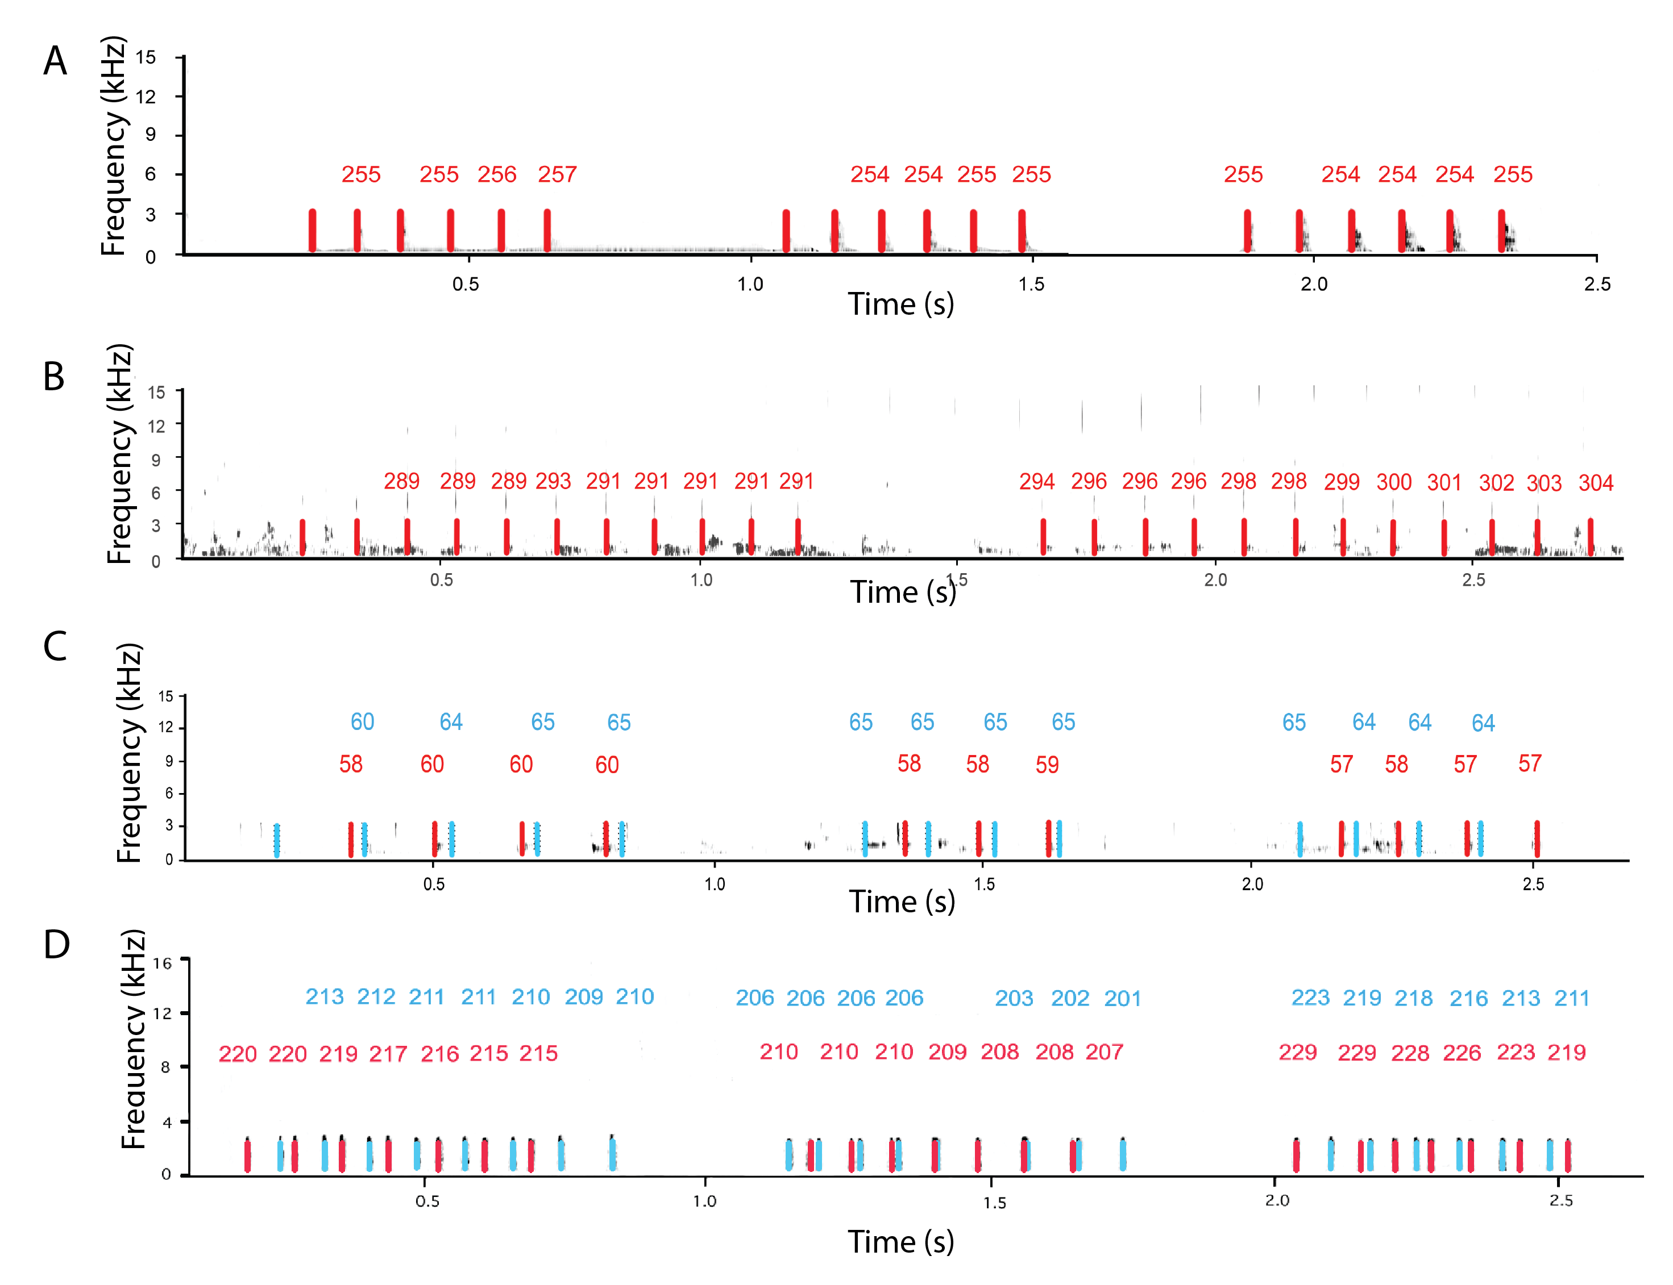

Figure S2. Individual and multi-male pop trains from different second-order alliances. Pop trains produced by an individual male from two different second-order alliances (2A and 2B), with each pop marked in red, and the localised bearing in relation to the research vessel (0° is the research vessel’s bow). Multi-male pop trains produced by males from two different second-order alliances (2C and 2D) with pops produced by two different males (red and blue), and the localised bearing of each pop in relation to the research vessel.

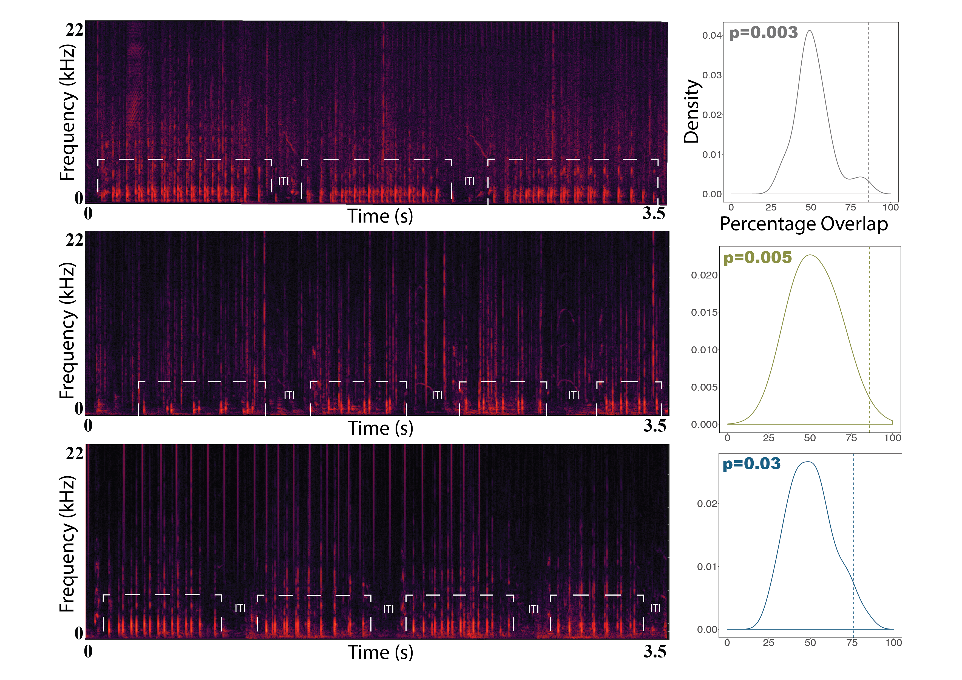
Figure S3. Analysis of inter-train-interval (ITI) in localised multi-male pop trains. Each pop train is denoted by a white box with pops localised to two different males; top panel is KS alliance (n = 3 pop trains shown, 4 in total), middle panel is RR alliance (n=4 pop trains shown, 7 in total) and bottom panel is SB alliance (n = 4 pop trains shown, 7 in total). On the right are corresponding null models of the expected percentage overlap based on 1000 randomised time shifts. The dotted line indicates the observed percentage overlap, with plots colour-coded by second-order alliance membership.

Model Selection Table

Model selection for the linear mixed-effect model results for IPI and pop train type with second-order alliance membership included as a random effect. To account for the violation of the homoscedasticity assumption, we explicitly modelled the differences in variance between pop train type using the ‘varIdent’ function. Support to reject the null model using log-likelihood (logLik), Akaike's Information Criterion (AIC), and Δ AIC.
 | Model | logLik | AIC | Δ AIC
Full | lme (IPIs ~ pop train type, random = ~ 1| factor(alliance), weights = varFunc *) | 10512.89 | -21015.79
Null | lme (IPIs ~ 1, random = ~ 1| factor(alliance), weights = varFunc *) | 9731.645 | -19455.29 | 1560.5

* VarFunc = varIdent(form ~1 | factor(alliance))

Output for influence diagnostics for linear mixed-effects models: random effect
influence(fullmod, "alliance")
$fixed.effects
(Intercept) factor(pop train type)Multi-Male pop trains
0.1447592 -0.0483271

fixed.effects[-alliance]
(Intercept) factor(pop train type)Multi-Male pop trains
[1,] 0.1483192 -0.04882693
[2,] 0.1554276 -0.05111998
[3,] 0.1462296 -0.04386048
[4,] 0.1375143 -0.04843295
[5,] 0.1524502 -0.05025203
[6,] 0.1518558 -0.04899754
[7,] 0.1215366 -0.04679033

$groups
[1] "alliance"

$deleted
[1] "AC" "RR" "KS" "BB" "FF" "SB" "PB"

Shark Bay Ethogram – Behavioural states

Recorded as the predominant activity that is common to ≥50% of the group for ≥50% of the 5 min. interval.

Resting: Dolphins are in a tight group, moving slowly with regular, peduncle or tail-out dives. The group may be moving in a straight line or meandering. During rest there is no evidence of foraging or socializing. Snagging is often observed during resting and resting groups regularly snag en masse. Snagging is when a dolphin floats at the surface and is still or slowly moving. When still the dolphin’s flukes drop to the degree that only the rostral edge of the dorsal fin may show at the surface and the rostrum may be exposed to the top of the mandible. Snagging may last from a few seconds to several minutes.

Travelling: Individuals are in parallel orientation (abreast) moving in one general direction (i.e. not varying more than 45 degrees and no rapid changes in direction) for a period of several minutes or during consecutive surfacing bouts.

Socialising: Social behaviour is characterised by body contact, rubbing and petting, often accompanied by splashing, surface activity and acoustic behaviour. Bottlenose dolphins also perform a variety of synchronous behaviours.

Forage: Foraging often involving lone dolphins or widely dispersed groups. An exception to this occurs when one or more dolphins remain in close proximity to a foraging dolphin for social reasons (i.e., when males are herding a female). Both inter-individual geometry (iig) and dive type are important in determining whether or not dolphins are foraging, independent of observations of feeding. Movement and iig are usually characterised by milling (individuals changing orientation with respect to each other) or meandering (individuals are in parallel orientation repeatedly changing direction) during foraging. In deeper water, foraging usually involves multiple breath surfacing bouts, culminating in a tail-out or peduncle dive. In shallower water, regular bottom grubbing, rapid surfaces and (fish) chases are often observed.

Shark Bay Ethogram – Consortship Criteria

Consortships are coercively maintained associations between 2-3 males and one female. Consortships are scored as YES (Y), NO (N), or PROBABLE (P) for both the male subgroup and suspected female consort. Scoring the consortship as a YES for both males & female consort requires satisfaction of the following criteria:
- The subgroup of 2-3 males + 1 female is observed with >10m separation between any other individual or group, AND
- ONE or more of the following 6 events are observed:
  - 1hr: Consortship subgroup is observed for at least 1 hour. At least one male from the consortship subgroup is within 10m of the suspected female throughout the 1-hr observation period.
  - Capture: The female is captured by an alliance of males.
  - Bolt: Female attempting to escape by rapidly swimming ('bolting') from an alliance of males
  - Pops: At least one of the males producing a vocal threat called 'pops' that induces the female to remain close (Connor& Smolker, 1996)
  - Directed Aggression: At least one of the males directing physical threats or aggression toward the female. Aggressive behaviour described in the Shark Bay Dolphin Research Ethogram.
  - Theft: teams of two alliances attempting to take a female from another alliance (a'theft'; Connor et al., 1992a,b) ** In this case, the consortship is scored as a “Y” for loosing males, winning males, and female.

If A observed but B is not observed, the consortship should be scored as a “P” if:
- > 10m separation, one female, > 30 min but < 1hr observation (“P” for males & female)

