To ensure that the parameter space was sampled sufficiently, we examined the standard deviation of each outcome measure as a function of the number of LHS iterations. The standard deviations converged after 24 LHS iterations and 1188 model simulations (Figure S1), indicating that the outcome measures had stabilized. We note that 12 model variants failed to solve due to FEBio crashes of unknown origin, but this is not expected to affect the results since the number of failed models was very small compared to the total number of simulations in the study.
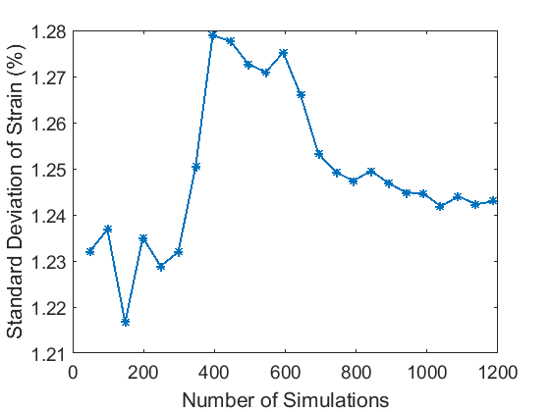
Figure S1. Standard deviation of 05_PS3 strain showing convergence after 1188 model simulations. 95_PS1 strain converged similarly.

