SUPPLEMENTARY MATERIAL
S1. Conceptual diagram depicting the hypothesized associations among network structure, ecological mechanisms, and environmental factors. (a) A specialized and modular network structure may derive from interaction frequencies increasing between partners with matching morphologies and overlapping phenologies. In contrast, a generalized network structure could develop when species interact randomly according to their relative abundances. (b) Depictions of how morphological matching, phenological overlap, and abundance are expected to influence the pairwise interaction frequencies between species. Orange represents plant species, and blue represents hummingbird species. Our model for morphological matching assumes that hummingbirds with the longest bill have the highest probability of interacting with flowers that have the longest corollas and vice versa. The model for phenological overlap assumes that interaction frequencies increase proportionally to the temporal overlap of mutualistic partners. Finally, the abundance model assumes abundant partners (large circles) to interact more frequently than rare partners. The β-coefficients parameterize the degree to which each ecological mechanism explains the pairwise interaction frequencies between species. (c) These coefficients are expected to vary across environmental gradients. As an example, the warm, humid, and non-seasonal climates of the tropics have been suggested to increase the influence of biotic interactions on natural selection. In turn, this could lead to a greater variety of morphological (co)adaptations and greater resource specialization in the tropics than in temperate regions [1-5].
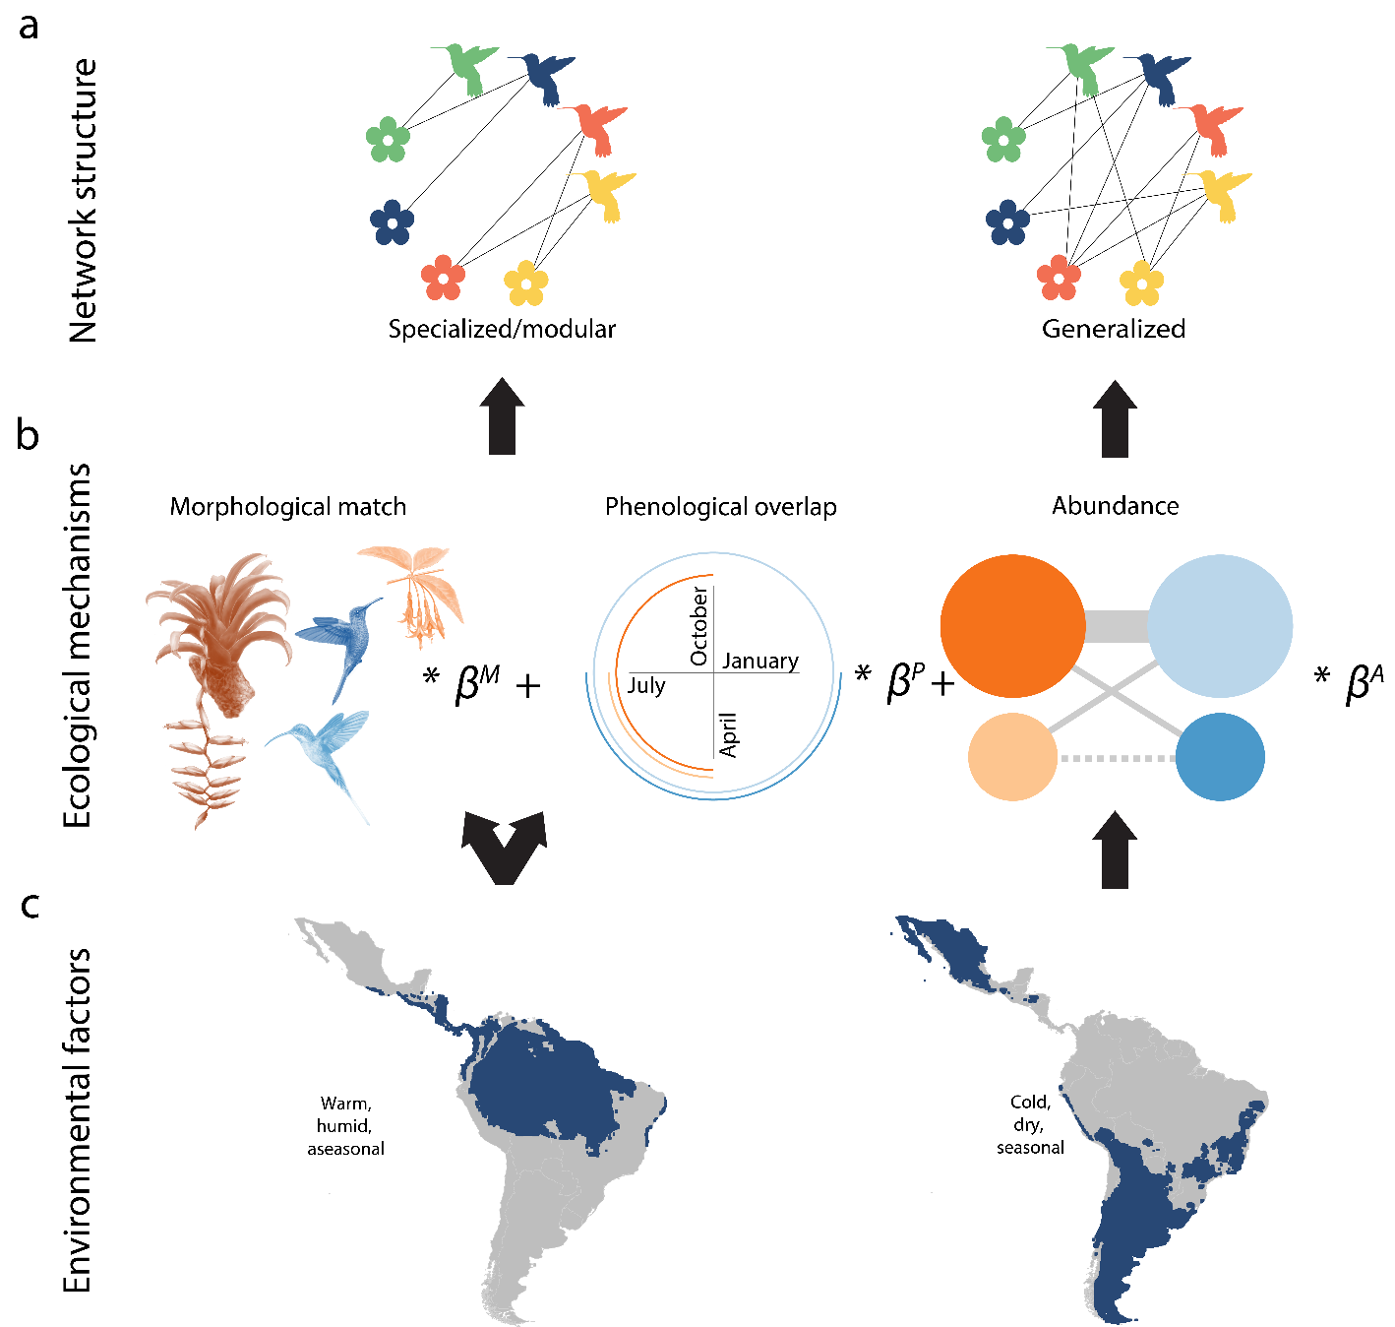
S2. Coordinates, description and data source for the 24 plant-hummingbird networks across the Americas. Ecoregion names are based on Olson et al. [6].
Network ID | Lat | Long | Ecoregion/ Site description and location | Source
1 | 20.48 | -100.32 | Deserts and xeric shrublands/ Tropical deciduous forest | Patiño González, B. I. (2017) Efecto de la morfología, fenología y abundancia en las redes mutualistas colibrí-planta del Parque Nacional El Cimatario, Querétaro, México. PhD Thesis, Universidad Autónoma de Querétaro.
2 | 20.13 | -98.71 | Tropical and subtropical moist broadleaf forests/ Temperate highlands, central Mexico | Román Díaz-Valenzuela & Ortiz-Pulido, R. unpublished data.
3 | 19.23 | -98.97 | Tropical and subtropical moist broadleaf forests/ Highland temperate forest, Mexico | Lara C. (2006) Temporal dynamics of flower use by hummingbirds in a highland temperate forest in Mexico. Ecoscience, 13, 23-29.
4 | 10.44 | -84.01 | Tropical and subtropical moist broadleaf forests/ Tropical rainforest, Costa Rica | Maglianesi M.A., Blüthgen N., Böhning-Gaese K., & Schleuning, M. (2014) Morphological traits determine specialization and resource use in plant-hummingbird networks in the neotropics. Ecology, 95, 3325-3334.
5 | 10.27 | -84.08 | Tropical and subtropical moist broadleaf forests/ Tropical rainforest, Costa Rica | Maglianesi M.A., Blüthgen N., Böhning-Gaese K., & Schleuning, M. (2014) Morphological traits determine specialization and resource use in plant-hummingbird networks in the neotropics. Ecology, 95, 3325-3334.
6 | 10.18 | -84.11 | Tropical and subtropical moist broadleaf forests/ Tropical rainforest, Costa Rica | Maglianesi M.A., Blüthgen N., Böhning-Gaese K., & Schleuning, M. (2014) Morphological traits determine specialization and resource use in plant-hummingbird networks in the neotropics. Ecology, 95, 3325-3334.
7 | 4.5 | -75.6 | Tropical and subtropical moist broadleaf forests/ Secondary Andean forest, Colombia | Marín-Gómez, O.H. unpublished data.
8 | 0.07 | -72.45 | Tropical lowland forest, Colombia | Rosero-Lasprilla L. (2003) Interações planta/beija-flor em três comunidades vegetais da parte sul do Parque Nacional Natural Chiribiquete, Amazonas (Colombia). PhD Thesis. Universidade Estadual de Campinas, Brasil.
9 | -2.84 | -79.16 | Tropical and subtropical moist broadleaf forests/ Shrubland, Ecuador | Tinoco, B. A., Graham, C. H., Aguilar, J. M. & Schleuning, M. (2017), Effects of hummingbird morphology on specialization in pollination networks vary with resource availability. Oikos, 126, 52-60.
10 | -2.87 | -79.12 | Tropical and subtropical moist broadleaf forests/ Highland Andean forest, Ecuador | Tinoco, B. A., Graham, C. H., Aguilar, J. M. & Schleuning, M. (2017), Effects of hummingbird morphology on specialization in pollination networks vary with resource availability. Oikos, 126, 52-60.
11 | -2.96 | -79.1 | Tropical and subtropical moist broadleaf forests/ Cattle ranching (former Andean forest), Ecuador | Tinoco, B. A., Graham, C. H., Aguilar, J. M. & Schleuning, M. (2017), Effects of hummingbird morphology on specialization in pollination networks vary with resource availability. Oikos, 126, 52-60.
12 | -3.82 | -70.27 | Tropical and subtropical moist broadleaf forests/ Amazonian rainforest, SE Colombia | Cotton P.A. (1998) The hummingbird community of a lowland Amazonian rainforest. Ibis, 140, 512-521.
13 | -3.97 | -79.07 | Tropical and subtropical moist broadleaf forests/ Midelevation cloud forest, Ecuador | Sonne, J., Zanata, T.B., Martín González, A.M., Cumbicus Torres, N.L., Fjeldså, J., Colwell, R.K., Tinoco, B.A., Rahbek, C. & Dalsgaard, B. (2019) The distributions of morphologically specialized hummingbirds coincide with floral trait matching across an Andean elevational gradient. Biotropica, 51, 205-218.
14 | -4.11 | -78.97 | Tropical and subtropical moist broadleaf forests/ Tierra firme forest, Ecuador | Sonne, J., Zanata, T.B., Martín González, A.M., Cumbicus Torres, N.L., Fjeldså, J., Colwell, R.K., Tinoco, B.A., Rahbek, C. & Dalsgaard, B. (2019) The distributions of morphologically specialized hummingbirds coincide with floral trait matching across an Andean elevational gradient. Biotropica, 51, 205-218.
15 | -4.11 | -79.18 | Tropical and subtropical moist broadleaf forests/ Temperate cloud forest, Ecuador | Sonne, J., Zanata, T.B., Martín González, A.M., Cumbicus Torres, N.L., Fjeldså, J., Colwell, R.K., Tinoco, B.A., Rahbek, C. & Dalsgaard, B. (2019) The distributions of morphologically specialized hummingbirds coincide with floral trait matching across an Andean elevational gradient. Biotropica, 51, 205-218.
16 | -19.16 | -48.39 | Tropical and subtropical grasslands, savannas and shrublands/ Cerrado, central Brazil | Maruyama P.K., Vizentin-Bugoni J., Oliveira G.M., Oliveira P.E., & Dalsgaard B. (2014) Morphological and spatio-temporal mismatches shape a Neotropical savanna plant-hummingbird network. Biotropica, 46, 740–747.
17 | -19.25 | -43.52 | Tropical and subtropical grasslands, savannas and shrublands/ Rocky outcrops, central Brazil | Rodrigues L.C. & Rodrigues M. (2014) Flowers visited by hummingbirds in the open habitats of the southeastern Brazilian mountaintops: species composition and seasonality. Brazilian Journal of Biology, 74, 659-676.
18 | -19.95 | -43.9 | Tropical and subtropical grasslands, savannas and shrublands/ Rocky outcrops, central Brazil | Vasconcelos M.F. & Lombardi J.A. (1999) Padrão sazonal na ocorrência de seis espécies de beija-flores (Apodiformes: Trochilidae) em uma localidade de campo rupestre na Serra do Curral, Minas Gerais. Ararajuba, 7, 71-79.
19 | -23.28 | -45.05 | Tropical and subtropical moist broadleaf forests/ Montane Atlantic forest, SE Brazil | Vizentin-Bugoni, J., Maruyama, P.K., Debastiani, V.J., Duarte, L.D.S., Dalsgaard, B. & Sazima, M. (2016). Influences of sampling effort on detected patterns and structuring processes of a Neotropical plant-hummingbird network. J. Anim. Ecol., 85, 262–272.
20 | -23.32 | -44.94 | Tropical and subtropical moist broadleaf forests/ Restinga, Atlantic forest, SE Brazil | Maruyama P.K, Vizentin-Bugoni J., Dalsgaard B., Sazima I. & Sazima. M. (2015) Nectar robbery by a hermit hummingbird: association to floral phenotype and its influence on flowers and network structure. Oecologia: 178, 783-793.
21 | -23.35 | -44.83 | Tropical and subtropical moist broadleaf forests/ Secondary Atlantic forest, SE Brazil | Maruyama P.K, Vizentin-Bugoni J., Dalsgaard B., Sazima I. & Sazima. M. (2015) Nectar robbery by a hermit hummingbird: association to floral phenotype and its influence on flowers and network structure. Oecologia: 178, 783-793.
22 | -23.36 | -44.85 | Tropical and subtropical moist broadleaf forests/ Coastal Atlantic forest, SE Brazil | Maruyama P.K, Vizentin-Bugoni J., Dalsgaard B., Sazima I. & Sazima. M. (2015) Nectar robbery by a hermit hummingbird: association to floral phenotype and its influence on flowers and network structure. Oecologia: 178, 783-793.
23 | -24.18 | -47.93 | Tropical and subtropical moist broadleaf forests/ Atlantic forest, SE Brazil | Rocca-de-Andrade M.A. (2006) Recurso floral para aves em uma comunidade de Mata Atlântica de encosta: sazonalidade e distribuição vertical. PhD Thesis. Universidade Estadual de Campinas, Brasil.
24 | -31.8 | -52.42 | Subtropical grasslands, savannas and shrublands/ Pampas, S Brazil | Jeferson Vizentin-Bugoni & Ana M. Rui, unpublished data.

S3. Hummingbird species in each of the 24 networks across the Americas.
Species | Network ID
Amazilia fimbriata | 12, 16, 20, 21, 22
Adelomyia melanogenys | 7, 13
Aglaeactis cupripennis | 11
Aglaiocercus kingii | 7
Amazilia beryllina | 3
Amazilia franciae | 7
Amazilia lactea | 18
Amazilia saucerottei | 7
Amazilia tzacatl | 4, 7
Amazilia versicolor | 8, 19, 20, 21, 22, 23
Amazilia violiceps | 1
Anopetia gounellei | 23
Anthracothorax nigricollis | 7, 12, 23, 24
Aphantochroa cirrochloris | 23
Archilochus alexandri | 1
Archilochus colubris | 1, 2, 3
Atthis heloisa | 1, 3
Augastes scutatus | 17
Boissonneaua flavescens | 7
Boissonneaua matthewsii | 15
Calliphlox amethystina | 20
Calothorax lucifer | 1, 2, 3
Campylopterus hemileucurus | 6
Campylopterus largipennis | 12, 17
Chaetocercus mulsant | 9
Chlorestes notata | 12
Chlorostilbon lucidus | 16, 17, 18, 23, 24
Chlorostilbon mellisugus | 12
Chlorostilbon olivaresi | 8
Chrysuronia oenone | 12
Clytolaema rubricauda | 19, 20, 23
Coeligena coeligena | 7, 13
Coeligena iris | 9, 10, 11
Coeligena lutetiae | 15
Coeligena torquata | 13, 15
Colibri coruscans | 7, 9, 10, 11
Colibri serrirostris | 16, 17, 18
Colibri thalassinus | 2, 3, 13
Cynanthus latirostris | 1, 2
Doryfera ludovicae | 5, 6, 7, 13, 14, 15
Ensifera ensifera | 9, 10
Eriocnemis luciani | 9, 10, 11
Eriocnemis vestita | 15
Eugenes fulgens | 1, 2, 3, 6
Eupetomena macroura | 16, 17, 18, 19, 22
Eupherusa nigriventris | 5
Eutoxeres aquila | 5, 14
Florisuga fusca | 18, 19, 22, 23, 24
Florisuga mellivora | 4, 7, 8, 12
Glaucis hirsutus | 12, 20, 22
Haplophaedia aureliae | 13
Heliangelus amethysticollis | 13
Heliangelus exortis | 7
Heliangelus viola | 9, 10, 11
Heliodoxa jacula | 5, 6
Heliodoxa leadbeateri | 14
Heliomaster squamosus | 20
Hylocharis chrysura | 24
Hylocharis cyanus | 20, 22
Hylocharis leucotis | 1, 2, 3
Heliangelus micraster | 15
Klais guimeti | 4
Lafresnaya lafresnayi | 9, 10, 11, 15
Lampornis amethystinus | 3
Lampornis calolaemus | 5, 6
Lampornis clemenciae | 1, 2, 3
Lampornis hemileucus | 5
Lesbia nuna | 11
Lesbia victoriae | 9
Leucochloris albicollis | 19, 20, 23, 24
Lophornis chalybeus | 19, 22, 23
Metallura baroni | 9
Metallura tyrianthina | 9, 10, 11, 15
Ocreatus underwoodii | 7, 13, 14
Panterpe insignis | 6
Phaeochroa cuvierii | 4
Phaethornis bourcieri | 8, 12
Phaethornis eurynome | 19, 23
Phaethornis guy | 5, 6, 7, 14
Phaethornis hispidus | 12
Phaethornis longirostris | 4
Phaethornis malaris | 8
Phaethornis pretrei | 16, 17, 18
Phaethornis ruber | 8, 12, , 20, 22
Phaethornis squalidus | 20, 21, 22, 23
Phaethornis striigularis | 4, 5
Phaethornis superciliosus | 12
Phaethornis syrmatophorus | 13
Phlogophilus hemileucurus | 14
Pterophanes cyanopterus | 9, 10, 11
Ramphodon naevius | 20, 21, 22, 23
Ramphomicron microrhynchum | 9
Selasphorus calliope | 1
Selasphorus flammula | 6
Selasphorus platycercus | 1, 2, 3
Selasphorus rufus | 1, 2, 3
Selasphorus sasin | 1, 3
Selasphorus scintilla | 6
Stephanoxis lalandi | 19
Stephanoxis loddigesii | 24
Thalurania colombica | 4
Thalurania furcata | 8, 12, 16, 14
Thalurania glaucopis | 19, 20, 21, 22, 23, 24
Threnetes leucurus | 12
Threnetes ruckeri | 4
Topaza pyra | 8

S4. Plant species in each of the 24 networks across the Americas.
Family | Species | Network ID
Acanthaceae | Aphelandra colorata | 19
Acanthaceae | Aphelandra longiflora | 16, 19
Acanthaceae | Aphelandra macrostachya | 8
Acanthaceae | Aphelandra storkii | 4
Acanthaceae | Dianthera candicans | 1
Acanthaceae | Dicliptera pohliana | 24
Acanthaceae | Dicliptera squarrosa | 16
Acanthaceae | Justicia brasiliana | 24
Acanthaceae | Justicia carnea | 21
Acanthaceae | Justicia cuatrecasasii | 8
Acanthaceae | Justicia parabolica | 19
Acanthaceae | Justicia sp. | 23
Acanthaceae | Justicia sp2 | 19
Acanthaceae | Mendoncia velloziana | 20, 23
Acanthaceae | Mendoncia sp. | 19
Acanthaceae | Ruellia brevifolia | 16
Acanthaceae | Ruellia elegans | 20
Acanthaceae | Sanchezia munita | 12
Acanthaceae | Sanchezia oblonga | 21
Acanthaceae | Sanchezia cf. putumayensis | 12
Acanthaceae | Trichanthera gigantea | 7
Alstroemeriaceae | Alstroemeria inodora | 19
Alstroemeriaceae | Alstroemeria plantaginea | 18
Alstroemeriaceae | Bomarea carderi | 7
Alstroemeriaceae | Bomarea distichifolia | 15
Alstroemeriaceae | Bomarea edulis | 20, 22
Alstroemeriaceae | Bomarea glaucescens | 9, 10
Alstroemeriaceae | Bomarea multiflora | 9
Alstroemeriaceae | Bomarea hirsuta | 6
Alstroemeriaceae | Bomarea pardina | 13, 14
Alstroemeriaceae | Bomarea sp. | 7
Amaryllidaceae | Hippeastrum cipoana | 17
Apocynaceae | Rauvolfia sp. | 12
Apocynaceae | Tabernaemontana macrocalyx | 8
Asparagaceae | Agave salmiana | 1
Asparagaceae | Agave sp. | 2
Asteraceae | Acritopappus longifolius | 17
Asteraceae | Chuquiraga jussieui | 11
Asteraceae | Cirsium nivale | 3
Asteraceae | Chronopappus bifrons | 17
Asteraceae | Eremanthus crotonoides | 17
Asteraceae | Eremanthus erythropappus | 17, 18
Asteraceae | Hololepis pedunculata | 17
Asteraceae | Lepidaploa sp1 | 17
Asteraceae | Lessingianthus roseus | 17
Asteraceae | Mutisia lemanni | 9, 10
Asteraceae | Mutisia speciosa | 19, 22
Asteraceae | Neomirandea eximia | 6
Asteraceae | Piptolepis leptosmermoides | 17
Asteraceae | Trixis vauthieri | 17
Asteraceae | Verbesina latisquama | 9
Asteraceae | Vernonanthura phosphorica | 17
Balsaminaceae | Impatiens walleriana | 20, 22
Berberidaceae | Berberis lutea | 9, 11
Bignoniaceae | Campsis grandiflora | 24
Bignoniaceae | Jacaranda mimosifolia | 24
Bromeliaceae | Aechmea bromeliifolia | 17
Bromeliaceae | Aechmea gamosepala | 19
Bromeliaceae | Aechmea organensis | 19
Bromeliaceae | Aechmea chantinii | 8
Bromeliaceae | Aechmea coelestis | 22, 23
Bromeliaceae | Aechmea contracta | 8, 12
Bromeliaceae | Aechmea corymbosa | 8
Bromeliaceae | Aechmea distichantha | 19, 22
Bromeliaceae | Aechmea mariae-reginae | 4
Bromeliaceae | Aechmea nudicaulis | 19, 22, 23, 24
Bromeliaceae | Aechmea ornata | 23
Bromeliaceae | Aechmea pectinata | 22, 23
Bromeliaceae | Aechmea recurvata | 24
Bromeliaceae | Aechmea rubiginosa | 8
Bromeliaceae | Aechmea vanhoutteana | 19
Bromeliaceae | Aechmea williamsii | 12
Bromeliaceae | Aechmea sp. | 13
Bromeliaceae | Billbergia amoena | 17, 19
Bromeliaceae | Billbergia decora | 8
Bromeliaceae | Billbergia pyramidalis | 21, 22
Bromeliaceae | Billbergia vittata | 17
Bromeliaceae | Bromelia antiacantha | 22, 24
Bromeliaceae | Bromelia sp1 | 8
Bromeliaceae | Bromelia sp1a | 10
Bromeliaceae | Bromelia sp2 | 9, 11
Bromeliaceae | Bromelia sp4 | 11
Bromeliaceae | Canistrum fragrans | 19
Bromeliaceae | Canistrum cyathiforme | 23
Bromeliaceae | Canistrum perplexum | 19
Bromeliaceae | Canistrum superbum | 19
Bromeliaceae | Dyckia sp. | 17
Bromeliaceae | Edmundoa lindenii | 23
Bromeliaceae | Guzmania gloriosa | 15
Bromeliaceae | Goudaea chrysostachys | 8
Bromeliaceae | Guzmania monostachia | 4
Bromeliaceae | Guzmania nicaraguenses | 5
Bromeliaceae | Guzmania squarrosa | 13
Bromeliaceae | Guzmania sp. | 7
Bromeliaceae | Hohenbergia augusta | 17
Bromeliaceae | Mezobromelia sp. | 7
Bromeliaceae | Neoregelia bahiana | 17
Bromeliaceae | Neoregelia fluminensis | 21
Bromeliaceae | Neoregelia johannis | 20, 21
Bromeliaceae | Nidularium angustifolium | 21, 22
Bromeliaceae | Nidularium billbergioides | 23
Bromeliaceae | Nidularium innocentii | 19, 21, 22
Bromeliaceae | Nidularium krisgreeniae | 23
Bromeliaceae | Nidularium longiflorum | 19
Bromeliaceae | Nidularium procerum | 19
Bromeliaceae | Nidularium rutilans | 19
Bromeliaceae | Nidularium seidelii | 21, 22
Bromeliaceae | Pepinia caricifolia | 8
Bromeliaceae | Pitcairnia brittoniana | 5
Bromeliaceae | Tillandsia aeranthos | 24
Bromeliaceae | Tillandsia complanata | 9, 10, 11
Bromeliaceae | Tillandsia dura | 19
Bromeliaceae | Tillandsia gardneri | 17
Bromeliaceae | Tillandsia geminiflora | 19, 20, 22
Bromeliaceae | Tillandsia stricta | 19, 23
Bromeliaceae | Tillandsia sp. | 19
Bromeliaceae | Vriesea carinata | 19
Bromeliaceae | Vriesea ensiformis | 21, 22, 23
Bromeliaceae | Vriesea erythrodactylon | 19
Bromeliaceae | Vriesea incurvata | 19
Bromeliaceae | Vriesea inflata | 19
Bromeliaceae | Vriesea medusa | 17
Bromeliaceae | Vriesea philippocoburgi | 23
Bromeliaceae | Vriesea platynema | 23
Bromeliaceae | Vriesea procera | 17, 20, 22
Bromeliaceae | Vriesea procera tenuis | 17
Bromeliaceae | Vriesea rodigasiana | 20, 21, 23
Bromeliaceae | Vriesea simplex | 19
Bromeliaceae | Vriesea sp. | 19
Bromeliaceae | Vriesea vagans | 23
Bromeliaceae | Werauhia ororiensis | 6
Burseraceae | Protium sp. | 17
Cactaceae | Cipocereus minensis | 17
Cactaceae | Opuntia imbricata | 2
Cactaceae | Opuntia tomentosa | 1
Cactaceae | Opuntia sp1 'amarilla' | 2
Cactaceae | Opuntia sp2 'morada' | 2
Cactaceae | Pilosocereus aurisetus | 17
Campanulaceae | Burmeistera parviflora | 6
Campanulaceae | Centropogon comosus | 15
Campanulaceae | Centropogon cornutus | 7, 19, 20, 22
Campanulaceae | Centropogon erythraeus | 15
Campanulaceae | Centropogon granulosus | 5
Campanulaceae | Centropogon latisepalus | 7
Campanulaceae | Centropogon solanifolius | 6, 14
Campanulaceae | Centropogon sp. | 10
Campanulaceae | Lobelia fistulosa | 17
Campanulaceae | Siphocampylus convolvulaceus | 19
Campanulaceae | Siphocampylus fimbriatus | 17
Campanulaceae | Siphocampylus longipediunculatus | 19
Campanulaceae | Siphocampylus scandens | 13
Campanulaceae | Siphocampylus sp. | 19
Cannaceae | Canna paniculata | 19, 20
Caprifoliaceae | Valeriana sp. | 11
Caryocaraceae | Caryocar brasiliense | 16
Caryophyllaceae | Silene laciniata | 2
Clusiaceae | Symphonia globulifera | 8
Combretaceae | Combretum llewelynii | 12
Convolvulaceae | Ipomoea murucoides | 1
Costaceae | Costus curvibracteatus | 5
Costaceae | Costus pulverulentus | 4, 5
Costaceae | Costus scaber | 4, 8, 12
Costaceae | Costus spiralis | 12, 23
Costaceae | Costus sp. | 7
Crassulaceae | Echeveria gibbiflora | 3
Curcubitaceae | Gurania bignoniacea | 5
Curcubitaceae | Gurania lobata | 12
Curcubitaceae | Gurania rhizantha | 12
Curcubitaceae | Gurania rufipila | 8
Eleocarpaceae | Vallea stipularis | 10, 11
Ericaceae | Agarista coriifolia | 17, 18
Ericaceae | Cavendishia bracteata | 6, 7, 10, 13, 14, 15
Ericaceae | Cavendishia callista | 5
Ericaceae | Cavendishia complectens | 5
Ericaceae | Cavendishia quereme | 5
Ericaceae | Ceratostema loranthiflorum | 15
Ericaceae | Disterigma humboldtii | 6
Ericaceae | Disterigma pentandrum | 15
Ericaceae | Gaultheria erecta | 11
Ericaceae | Gaultheria gracilis | 6
Ericaceae | Gaultheria tomentosa | 11
Ericaceae | Gaylussacia brasiliensis | 17
Ericaceae | Gaylussacia montana | 17
Ericaceae | Gaylussacia oleifolia | 17
Ericaceae | Gonocalyx pterocarpus | 6
Ericaceae | Macleania floribunda | 13
Ericaceae | Macleania rupestris | 9, 10, 11
Ericaceae | Orthaea abbreviata | 13
Ericaceae | Psammisia ramiflora | 5
Ericaceae | Psammisia sp. | 13, 14
Ericaceae | Satyria meiantha | 5
Ericaceae | Satyria panurensis | 8
Ericaceae | Thibaudia costaricensi | 5
Ericaceae | Vaccinium poasanum | 6
Fabaceae | Bauhinia brevipes | 16
Fabaceae | Bauhinia ungulata | 16
Fabaceae | Calliandra selloi | 24
Fabaceae | Calliandra tweediei | 24
Fabaceae | Camptosema coriaceum | 16
Fabaceae | Centrosema coriaceum | 18
Fabaceae | Dahlstedtia pentaphylla | 23
Fabaceae | Dahlstedtia pinnata | 20, 21, 22, 23
Fabaceae | Erythrina americana | 1
Fabaceae | Erythrina crista-galli | 24
Fabaceae | Erythrina fusca | 12
Fabaceae | Erythrina rubrinervia | 7
Fabaceae | Erythrina speciosa | 19, 22, 24
Fabaceae | Inga stenoptera | 12
Fabaceae | Inga edulis | 23
Fabaceae | Inga marginata | 20, 21
Fabaceae | Inga ornata | 7
Fabaceae | Inga sessilis | 19
Fabaceae | Inga subnuda | 22
Fabaceae | Inga vera | 16
Fabaceae | Tachigali paniculata | 12
Fabaceae | Zygia lathetica | 8
Gentianaceae | Calolisianthus pendulus | 17
Gesneriaceae | Columnea peruviana | 10
Gentianaceae | Macrocarpaea macrophylla | 6
Gentianaceae | Macrocarpaea rubra | 19
Gentianaceae | Macrocarpaea sp. | 14
Gentianaceae | Tachia occidentalis | 8
Gesneriaceae | Unknown genus 'PAC016' | 12
Gesneriaceae | Alloplectus hispidus | 15
Gesneriaceae | Besleria aggregata | 14
Gesneriaceae | Besleria columneoides | 4
Gesneriaceae | Besleria formosa | 14
Gesneriaceae | Besleria longimucronata | 19, 20, 21
Gesneriaceae | Besleria notabilis | 5
Gesneriaceae | Besleria solanoides | 6, 7
Gesneriaceae | Columnea dimidiata | 7
Gesneriaceae | Columnea ericae | 8
Gesneriaceae | Columnea magnifica | 6
Gesneriaceae | Columnea microcalyx | 6
Gesneriaceae | Columnea purpurata | 5
Gesneriaceae | Columnea querceti | 5
Gesneriaceae | Columnea strigosa | 15
Gesneriaceae | Columnea sp. | 14
Gesneriaceae | Drymonia conchocalyx | 5
Gesneriaceae | Drymonia semicordata | 8
Gesneriaceae | Drymonia urceolata | 13
Gesneriaceae | Drymonia sp. | 14
Gesneriaceae | Kohleria affinis | 7
Gesneriaceae | Kohleria inaequalis | 7
Gesneriaceae | Kohleria tigridia | 6
Gesneriaceae | Lesia savannarum | 8
Gesneriaceae | Nematanthus fissus | 22
Gesneriaceae | Nematanthus fluminensis | 19, 22
Gesneriaceae | Nematanthus gregarius | 19, 23
Gesneriaceae | Nematanthus maculatus | 19
Gesneriaceae | Nematanthus sericeus | 19
Gesneriaceae | Nematanthus striatus | 23
Gesneriaceae | Nematanthus strigillosus | 17
Gesneriaceae | Nematanthus fritschii | 19
Gesneriaceae | Paliavana sericifolia | 17, 18
Gesneriaceae | Sinningia cooperi | 19
Gesneriaceae | Sinningia elatior | 19
Gesneriaceae | Sinningia glazioviana | 19
Gesneriaceae | Sinningia rupicola | 18
Gesneriaceae | Sinningia sp. | 23
Heliconiaceae | Heliconia acuminata | 8
Heliconiaceae | Heliconia acuminata occidentalis | 8
Heliconiaceae | Heliconia angusta | 21, 22
Heliconiaceae | Heliconia atropurpurea | 5
Heliconiaceae | Heliconia farinosa | 20, 21
Heliconiaceae | Heliconia griggsiana | 7
Heliconiaceae | Heliconia imbricata | 4
Heliconiaceae | Heliconia juruana | 12
Heliconiaceae | Heliconia lankesteri | 6
Heliconiaceae | Heliconia latispatha | 4, 7
Heliconiaceae | Heliconia mariae | 4
Heliconiaceae | Heliconia mathiasiae | 4
Heliconiaceae | Heliconia orthotricha | 14
Heliconiaceae | Heliconia pogonantha | 4
Heliconiaceae | Heliconia psittacorum | 16
Heliconiaceae | Heliconia schumanniana | 12
Heliconiaceae | Heliconia spathocircinata | 20
Heliconiaceae | Heliconia stricta | 12
Heliconiaceae | Heliconia vaginalis | 5
Heliconiaceae | Heliconia venusta | 7
Heliconiaceae | Heliconia wagneriana | 4
Heliconiaceae | Heliconia sp. | 23
Lamiaceae | Amasonia arborea | 8
Lamiaceae | Hyptis sp. | 17
Lamiaceae | Leonotis nepetifolia | 1
Lamiaceae | Prunella vulgaris | 3
Lamiaceae | Salvia circinnata | 2
Lamiaceae | Salvia chamaedryoides | 2
Lamiaceae | Salvia corrugata | 9, 10, 11
Lamiaceae | Salvia elegans | 3
Lamiaceae | Salvia hirta | 9, 10
Lamiaceae | Salvia melissodora | 1
Lamiaceae | Salvia microphylla | 2
Lamiaceae | Salvia mocinoi | 3
Lamiaceae | Salvia xalapensis | 2
Lamiaceae | Salvia prunelloides | 2
Lamiaceae | Salvia sp1 | 2
Lamiaceae | Salvia sp2 | 2
Lamiaceae | Scutellaria caerulea | 2
Lamiaceae | Stachys coccinea | 2
Loranthaceae | Aetanthus nodosus | 15
Loranthaceae | Psittacanthus calyculatus | 1
Loranthaceae | Psittacanthus cucullaris | 12
Loranthaceae | Psittacanthus dichrous | 19, 22, 23
Loranthaceae | Psittacanthus lasianthus | 8
Loranthaceae | Tristerix longibracteatus | 11
Lythraceae | Cuphea aequipetala | 2
Lythraceae | Cuphea ericoides | 17
Lythraceae | Cuphea melvilla | 12
Lythraceae | Cuphea procumbens | 2
Lythraceae | Lafoensia pacari | 18
Malvaceae | Callianthe rufinerva | 19
Malvaceae | Eriotheca pentaphylla | 22
Malvaceae | Erythroxylum vaccinifolium | 17
Malvaceae | Helicteres brevispira | 16
Malvaceae | Helicteres sacarolha | 16
Malvaceae | Luehea divaricata | 24
Malvaceae | Malvaviscus palmanus | 6
Malvaceae | Pavonia viscosa | 18
Malvaceae | Spirotheca rivieri | 19, 23
Malvaceae | Malvaceae sp1 | 17
Marantaceae | Calathea capitata | 12
Marantaceae | Calathea lasiostachya | 5
Marantaceae | Calathea lutea | 4
Marantaceae | Goeppertia comunis | 23
Marantaceae | Goeppertia gymnocarpa | 4
Marantaceae | Goeppertia inocephala | 4
Marantaceae | Goeppertia standleyi | 14
Marantaceae | Calathea zingiberina | 8
Marantaceae | Ischnosiphon lasiocoleus | 8
Marantaceae | Monotagma secundum | 8
Marcgraviaceae | Schwartzia brasiliensis | 22, 23
Melastomataceae | Axinaea sp. | 15
Melastomataceae | Brachyotum andreanum | 15
Melastomataceae | Brachyotum sp. | 9, 11
Melastomataceae | Miconia denticulata | 10
Musaceae | Musa ornata | 20, 23
Musaceae | Musa velutina | 7
Myrtaceae | Melaleuca glauca | 24
Myrtaceae | Eucalyptus globulus | 7
Myrtaceae | Melaleuca leucadendra | 24
Myrtaceae | Myrcia lasiantha | 17
Myrtaceae | Myrcianthes sp. | 10
Myrtaceae | Syzygium malaccense | 12
Onagraceae | Fuchsia microphylla | 3
Onagraceae | Fuchsia regia | 19, 23
Onagraceae | Fuchsia vulcanica | 9, 10, 11
Onagraceae | Oenothera sp. | 2
Orchidaceae | Elleanthus aurantiacus | 6, 7
Orchidaceae | Elleanthus brasiliensis | 23
Orchidaceae | Maxillaria sp. | 13
Orobanchaceae | Agalinis angustifolia | 17
Orobanchaceae | Castilleja scorzonerifolia | 3
Orobanchaceae | Castilleja tenuiflora | 1, 2, 3
Orobanchaceae | Esterhazya splendida | 17
Orobanchaceae | Lamourouxia dasyantha | 2
Passifloraceae | Passiflora aff. involucrata | 12
Passifloraceae | Passiflora quadriglandulosa | 12
Passifloraceae | Passiflora skiantha | 8
Passifloraceae | Passiflora spinosa | 12
Passifloraceae | Passiflora vitifolia | 8
Passifloraceae | Passiflora sp. | 9
Plantaginaceae | Penstemon barbatus | 2
Plantaginaceae | Penstemon gentianoides | 3
Plantaginaceae | Penstemon roseus | 3
Polemoniaceae | Loeselia mexicana | 2
Proteaceae | Oreocallis grandiflora | 9, 10, 11
Rosaceae | Rubus floribundus | 9, 11
Rubiaceae | Bouvardia ternifolia | 2, 3
Rubiaceae | Coussarea hydrangeifolia | 16
Rubiaceae | Decagonocarpus cornutus | 8
Rubiaceae | Faramea eurycarpa | 5
Rubiaceae | Ferdinandusa sprucei | 8
Rubiaceae | Genipa americana | 12
Rubiaceae | Hamelia patens | 4, 7
Rubiaceae | Hillia ilustris | 23
Rubiaceae | Hillia parasitica | 17
Rubiaceae | Hillia triflora | 5
Rubiaceae | Hippotis brevipes | 6
Rubiaceae | Hippotis scarlatina | 14
Rubiaceae | Isertia hypoleuca | 8
Rubiaceae | Isertia rosea | 8
Rubiaceae | Manettia cordifolia | 16, 19
Rubiaceae | Palicourea acetosoides | 7
Rubiaceae | Palicourea angustifolia | 14
Rubiaceae | Palicourea azurea | 15
Rubiaceae | Palicourea canarina | 13
Rubiaceae | Palicourea crocea | 12
Rubiaceae | Palicourea dichotoma | 8
Rubiaceae | Palicourea elata | 4, 5
Rubiaceae | Palicourea fastigiata | 12
Rubiaceae | Palicourea gomezii | 5
Rubiaceae | Palicourea guianensis | 14
Rubiaceae | Palicourea aff. lasiantha | 12
Rubiaceae | Palicourea lasiorrhachis | 6, 15
Rubiaceae | Palicourea cf. luteonivea | 13
Rubiaceae | Palicourea lyristipula | 15
Rubiaceae | Palicourea marcgravii | 16
Rubiaceae | Palicourea nigricans | 8
Rubiaceae | Palicourea quadrifolia | 8
Rubiaceae | Palicourea rigida | 16
Rubiaceae | Palicourea sessilis | 17
Rubiaceae | Palicourea tomentosa | 4, 8, 14
Rubiaceae | Palicourea stenosepala | 13
Rubiaceae | Palicourea subspicata | 8
Rubiaceae | Palicourea weberbaueri | 15
Rubiaceae | Palicourea sp1 | 12
Rubiaceae | Palicourea sp2 | 5
Rubiaceae | Palicourea sp3 | 10
Rubiaceae | Pentagonia donnell-smithii | 4
Rubiaceae | Psychotria bahiensis | 8
Rubiaceae | Psychotria leiocarpa | 19
Rubiaceae | Psychotria nuda | 20, 21, 22
Rubiaceae | Pyrostegia venusta | 19
Rubiaceae | Retiniphyllum speciosum | 8
Rubiaceae | Sabicea grisea | 20, 22
Rubiaceae | Warszewiczia coccinea | 4, 14
Salicaceae | Ryania pyrifera | 8
Schlegeliaceae | Schlegelia fastigiata | 4
Solanaceae | Brugmansia sanguinea | 9, 10
Solanaceae | Dyssochroma viridiflorum | 23
Solanaceae | Iochroma arborescens | 20
Solanaceae | Markea coccinea | 8
Solanaceae | Markea cf. longiflora | 15
Solanaceae | Nicotiana glauca | 1, 2
Solanaceae | Saracha quitensis | 9, 10, 11
Theaceae | Gordonia fruticosa | 17
Tropaeolaceae | Tropaeolum pentaphyllum | 24
Velloziaceae | Aylthonia luzulifolia | 17
Velloziaceae | Barbacenia flava | 17
Velloziaceae | Barbacenia gentianoides | 17
Velloziaceae | Barbacenia williamsii | 18
Velloziaceae | Barnadesia arborea | 9, 10, 11
Velloziaceae | Vellozia cf. epidendroides | 17
Verbenaceae | Citharexylum myrianthum | 23
Verbenaceae | Lantana camara | 19, 20
Verbenaceae | Stachytarpheta cayennensis | 20, 22
Verbenaceae | Stachytarpheta gesnerioides | 16
Verbenaceae | Stachytarpheta glabra | 17, 18
Verbenaceae | Stachytarpheta mexiae | 17
Violaceae | Paypayrola hulkiana | 8
Violaceae | Viola arguta | 9, 10, 11
Vochysiaceae | Qualea multiflora | 16
Vochysiaceae | Vochysia emarginata | 17
Vochysiaceae | Vochysia microphylla | 17
Vochysiaceae | Vochysia tucanorum | 16
Zingiberaceae | Hedychium coronarium | 20
Zingiberaceae | Renealmia cernua | 4, 5
Zingiberaceae | Renealmia sp. | 8

S5.
5a) Series of summary statistics calculated for each network: Complementary specialization (H₂’); weighted modularity (Q); Connectance (C; proportion of realized links in relation to all links possible). ∆-values are the metric values corrected by randomization of the Patefield null model, i.e. ∆ = observed value – mean values of 1000 randomizations. ‘n. int.’: the number of interactions observed. n plant & n hum: number of species sampled in the network.
ID | H₂’ | Q | ∆Q | C | n. int. | n. plants | n.  hum. | n. sampling slices | Sampling period | hum. abund. estimation meth. | plant. abund. estimation meth.
1 | 0.06 | 0.26 | -0.02 | 0.40 | 774 | 10 | 13 | 12 | Jul 15-Jun 16 | Transect | Transect
2 | 0.19 | 0.24 | 0.14 | 0.43 | 110 | 23 | 9 | 8 | April-May | Point counts | Point counts
3 | 0.53 | 0.47 | 0.35 | 0.42 | 417 | 11 | 12 | 12 | Jan-Dec 03 | Transect | Transect
4 | 0.64 | 0.51 | 0.34 | 0.23 | 309 | 22 | 8 | 10 | May-Sep 11 & Dec11-Apr 12 | Mist netting | Transect
5 | 0.51 | 0.36 | 0.25 | 0.24 | 226 | 25 | 8 | 10 | May-Sep 11 & Dec 11-Apr 12 | Mist netting | Transect
6 | 0.32 | 0.25 | 0.21 | 0.21 | 287 | 20 | 9 | 10 | May-Sep 11 & Dec 11-Apr 12 | Mist netting | Transect
7 | 0.6 | 0.46 | 0.35 | 0.31 | 2957 | 23 | 14 | 12 | Jan to Dec 11 | Mist netting | Transect
8 | 0.37 | 0.33 | 0.27 | 0.25 | 890 | 44 | 8 | 15 | Aug 99-Oct 00 | Mist netting | Transect
9 | 0.44 | 0.39 | 0.27 | 0.23 | 812 | 19 | 12 | 11 | Febr-Aug 11 & 12, Dec 12 | Point counts | Transect
10 | 0.45 | 0.39 | 0.32 | 0.33 | 334 | 20 | 8 | 11 | Febr-Aug 11 & 12, Dec 12 | Point counts | Transect
11 | 0.54 | 0.48 | 0.4 | 0.30 | 596 | 19 | 9 | 11 | Febr-Aug 11 & 12, Dec 12 | Point counts | Transect
12 | 0.42 | 0.36 | 0.32 | 0.21 | 1203 | 29 | 14 | 12 | Oct 87- Sep 89 | Mist netting | Transect
13 | 0.63 | 0.46 | 0.41 | 0.30 | 209 | 13 | 9 | 8 | Feb–May 17 & Oct 17–Jan 18 | Transect | Transect
14 | 0.55 | 0.48 | 0.47 | 0.32 | 288 | 17 | 8 | 8 | Feb–May 17 & Oct 17–Jan 18 | Transect | Transect
15 | 0.6 | 0.44 | 0.36 | 0.32 | 326 | 15 | 7 | 8 | Feb–May 17 & Oct 17–Jan 18 | Transect | Transect
16 | 0.48 | 0.41 | 0.35 | 0.33 | 1240 | 18 | 6 | 13 | Nov 96-Nov 97 | Transect | Transect
17 | 0.6 | 0.56 | 0.4 | 0.26 | 2236 | 51 | 6 | 24 | Aug 07-Jul 09 | Mist netting | Transect
18 | 0.46 | 0.44 | 0.34 | 0.27 | 775 | 10 | 6 | 12 | Apr 95-Apr 99 | Transect | Transect
19 | 0.57 | 0.47 | 0.34 | 0.25 | 2804 | 55 | 9 | 24 | Sep 11-Aug 13 | Transect | Transect
20 | 0.47 | 0.36 | 0.25 | 0.21 | 330 | 22 | 13 | 18 | Jan 12-Jun 13 | Transect | Transect
21 | 0.36 | 0.18 | 0.13 | 0.26 | 173 | 16 | 5 | 18 | Jan 12-Jun 13 | Transect | Transect
22 | 0.45 | 0.37 | 0.23 | 0.26 | 721 | 28 | 11 | 18 | Jan 12-Jun 13 | Transect | Transect
23 | 0.59 | 0.52 | 0.42 | 0.20 | 519 | 34 | 12 | 24 | Mar 03-Feb 05 | Transect | Transect
24 | 0.31 | 0.32 | 0.25 | 0.30 | 481 | 16 | 7 | 12 | May 07-Apr 09 | Transect | Transect
mean |  |  |  |  | 792 | 23 | 9 | 13

5b) Additional network details
The networks used in this study were sampled over a minimum period of 8 months (‘Network ID13-15’; Table S2) to a maximum of 24 months (‘Network ID17, 19 & 23’; Table S2). The networks included only legitimate interactions, i.e. when the hummingbirds used the corolla opening to extract nectar and touched anthers and/or stigmas. Interaction frequencies were quantified as the number of flower visits per species of hummingbird on each plant species. Most studies used direct observation and/or video cameras to quantify visits on focal flowering plants. The only exception was one network collected by following hummingbirds in the field for up to ten minutes to identify the visited plants and count visits (‘Network ID18’; Table S2).
Measurements on flower morphology were mostly taken in the field from an average of 11 flowers per species (coef. var. = 0.83; doubletons = 30; singletons = 44; n=522; NA = 29). For nine out of 560 records of plant species, we were unable to measure the flowers in the field. For those species, we estimated the effective corolla length on local herbarium vouchers or from photographs with scales.
Bill morphology was measured mainly as the length of the exposed culmen from captured hummingbird individuals. The average number of individuals measured in the field was 19 (coef. variance = 1.04; singletons = 4; doubletons = 2; n = 204). In the remaining cases, we supplemented data with data from the literature (n= 19), from local museum specimens (n=45), and international collections [n=25; 7].

S6a: Details on models for morphological matching
We used the model for morphological matching presented by Sonne et al. [8], which assumes that pairwise interaction frequencies decrease proportionally to the standardized difference in length between the hummingbird’s bill and the plant’s corolla. In this framework, a hummingbird with the longest bill has the highest probability of interacting with the longest flowers, while the shortest-billed hummingbirds have the highest probability of interacting with the shortest flowers. We calculated pairwise morphological matching for each hummingbird i and plant j within each network k. We first standardized the hummingbird’s bill length and the plant’s corolla length to zero mean and unit variance within networks and calculated the Euclidean distance between species pairs (M_{ijk}). The standardized approach to trait matching has two benefits relevant to this study. First, it minimizes assumptions regarding how far hummingbirds can extend their tongue to reach nectar in the bottom of the flowers [9]. Second, the standardized approach to trait matching incorporates assumptions about interspecific competition for shared resources. As all species within a network are represented with interactions, we would expect the longest-billed hummingbirds to experience the least competition by interacting with the longest flowers – and vice versa for the smallest-billed hummingbirds, which experience the least competition by interacting with the shortest flowers [8].

S6b: Details on Bayesian models used to estimate the ability of morphological matching, phenological overlap and abundances to describe pairwise interactions.
For each network, we used morphological matching (M), phenological overlap (P) and species’ abundances (A) to model interaction frequencies individually for each hummingbird and plant species. While the following model is described for hummingbirds, the same method was applied to the plants.
The model describes the pairwise interaction frequencies (N) for each hummingbird species i in the network k. N_{ik} is assumed to follow a Poisson distribution with mean λ_{ik}, and the log link function of λ_{ik} is predicted by the covariates (A,P,M)_{ijk}. The model’s parameters were estimated using a Markov chain Monte Carlo method (MCMC). We extracted posterior distributions of the standardized coefficients (β^{A}_{ik,} β^{P}_{ik} and β^{M}_{ik}). A more negative β^{M}_{ik} indicates greater ability of morphological trait matching to describe pairwise interactions, whereas more positive β^{A}_{ik} and β^{P}_{ik} indicate greater ability of abundances and phenological overlap to describe interactions. These covariates were considered to be significant if 95% of their posterior parameter distribution did not overlap with zero. All parameters are specified with non-informative priors specified by precision rather than standard deviation (precision = 1/variance). The MCMC chains were run using the JAGS software [10, 11]. Posterior distributions of parameters constitute 100,000 of three independent runs (300,000 draws in total). We kept every 10th draw to reduce autocorrelation. For each network, we determined the proportion of species with interaction frequencies significantly described by morphological matching (Imp.M), phenological overlap (Imp.P) and abundance (Imp.A). We used these proportions as measures of the ability of a certain model to statistically describe the hummingbirds’ interaction frequencies. The full Bayesian model is written below. Here, we parameterized variances using precision, instead of standard deviation (e.g. precision of 0.001 is equal to a standard deviation of 31.6).
Model of observed interaction frequencies
N_{ijk} ~Poisson(λ_{ik})
Log(λ_{ik}) = α_{ik} + β^{A}_{ik} × A_{i,j} +β^{P}_{ik} ×P_{i,j} +β^{M}_{ik} ×M_{i,j}

Priors
α_{i} ~ Normal(µ_{α},τ_{ω})
β^{A}_{ik} ~ Normal(µ_{βiA} ,τ_{βiA})
β^{P}_{ik} ~ Normal(µ_{βiP} ,τ_{βiP})
β^{M}_{ik} ~ Normal(µ_{βiM},τ_{βiM})

µ_{α} ~Normal(0,0.01)
µ_{βiA} ~Normal(0,0.01)
µ_{βiP} ~Normal(0,0.01)
µ_{βiM} ~Normal(0,0.01)

τ_{ω} ~half-caunchy(0,1)
τ_{βiA} ~half-caunchy(0,1)
τ_{βiP} ~half-caunchy(0,1)
τ_{βiM} ~half-caunchy(0,1)

S7: The performance of different null models in detecting network structure
As the empirical networks vary in species richness and sampling intensity, the observed values of specialization and modularity may not be directly comparable [12-15]. One common approach to dealing with these confounding factors is the use of null models, which randomize interactions between species while constraining parameters that could be influenced by sampling [13-15]. Many such null models exist in the literature, and there remains no consensus on which one to choose [14, 16]. A highly constraining null model makes randomizations very conservative, thereby imposing type II error (i.e., incorrectly accepting a false null hypothesis). Conversely, a null model with few constraints may suffer from high type I error (i.e. incorrectly rejecting a true null hypothesis). We evaluated the performance of three different null models that constrain: (i) network marginal sums [17], (ii) network connectance [18] and (iii) both connectance and marginal sums: the 'swap.web' function in the R-package 'bipartite' [19].

Sensitivity to type II error: Do the null model corrections identify network structure in the presence of an ecological mechanism that drives resource partitioning?
We evaluated the performance of the null models in detecting complementary specialization and modularity by simulating an ecological mechanism that contributes to the partitioning of interactions within a network, i.e. morphological matching. A well-performing null model should generate networks that are less specialized and modular than those simulated by the morphological matching. In each simulated network, the number of plants and pollinators in the k^{th} simulated network was sampled from Poisson distributions with parameter λ given by the mean number of plants and pollinators in the empirical networks (λ_{plants} =23, λ_{pollinators} = 9; S5a). The total number of interactions in the networks (I_{k}) was sampled from Poisson distributions with parameter λ given by the mean number of interactions in the empirical networks (λ_{interactions} =792; S5a). All species in the network were represented by at least one interaction. We assumed that the pairwise interaction probabilities between plants and pollinators decrease in proportion to the standardized difference in partner traits. Traits were assumed to be univariate and to follow a normal distribution with zero mean and unit variance. Our algorithm uses stepwise removal of interactions from an initial network state where all pairwise interaction frequencies equal 50, meaning a total of 5000 interactions. The probability of removing an interaction between species i and j is given by:
(1) $P_{ij}=\frac{{{abs(trait}_{i}-{trait}_{j})}^{α}}{\sum_{i=1}^{10}{\sum_{j=1}^{10}{{{abs(trait}_{i}-{trait}_{j})}^{α}}}}$
The scale parameter α defines the importance of morphological matching for the differences in relative interaction probabilities. α is sampled from a continuous uniform distribution between 0.01 and 1. Higher values of α mean that species have an increased probability of interacting with their closest matching partners. Following the pairwise probabilities P_{ij}, the algorithm removes interactions until the network has a total sum of I_{i} interactions. The resulting network is then used to calculate complementary specialization and modularity. The figure below shows how higher values of α translate into higher complementary specialization and modularity over 1000 random iterations.
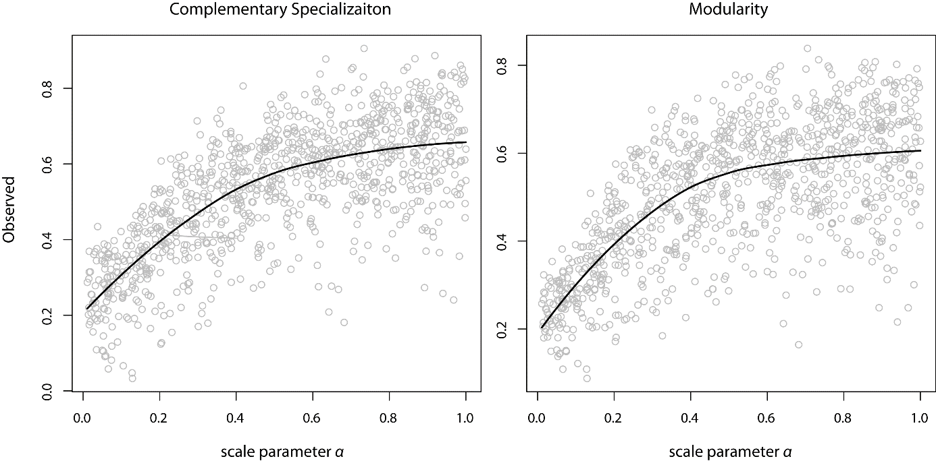
We then applied each of the three null models to randomize the interactions of the simulated network, and thereafter recalculated complementary specialization and modularity. The entire procedure was repeated for 1000 iterations. The results are presented in the figure below.
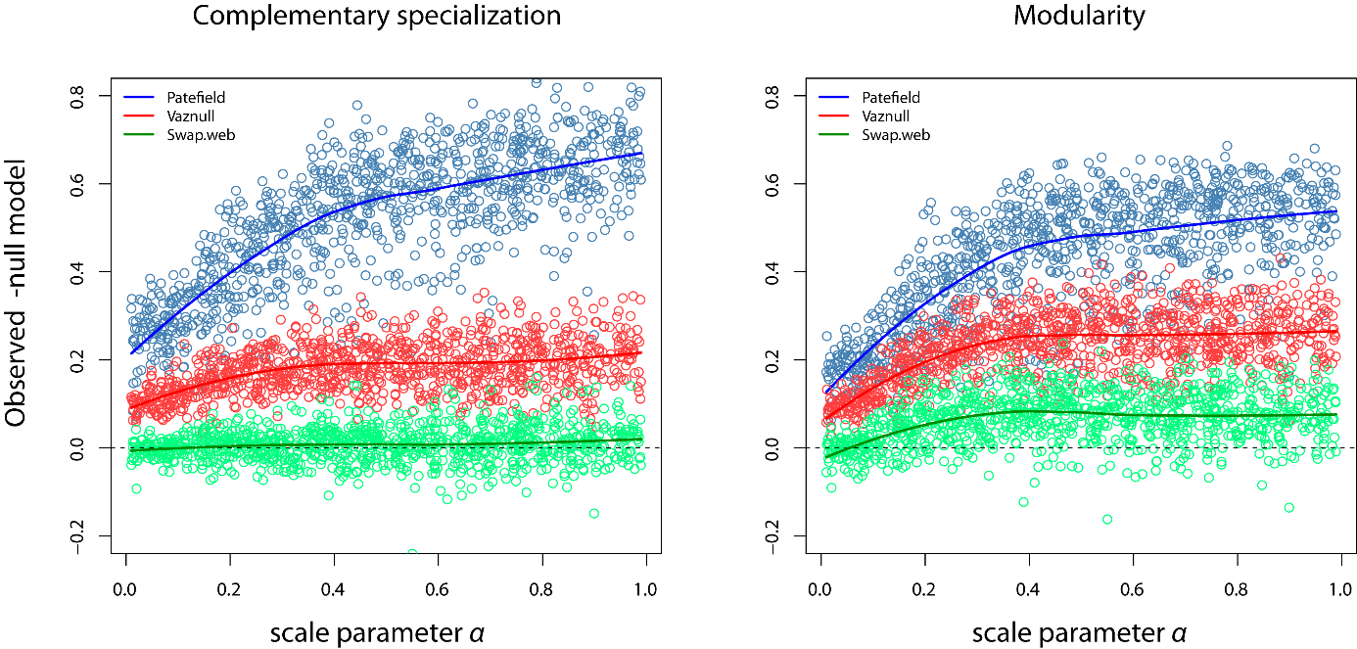
The figure shows that swap.web performs poorly in distinguishing true specialized and modular networks, while the vaznull algorithm performs poorly in distinguishing networks with high specialization and modularity from networks with a medium degree of specialization and modularity. The r2dtable (Patefield) null model performs the best of the three in distinguishing networks with varying degrees of specialization and modularity.
Sensitivity to type I error: Do null model corrections incorrectly identify network structure in the absence of niche differences?
If species interact randomly according to their abundances, the network should not be more specialized or modular than the null model predicts. To simulate interactions in the absence of niche differences, we assumed pairwise interactions to increase proportionally with the product of species abundances. Following the observation that the majority of species in ecological communities are rare, and few are abundant, we simulated the abundance of hummingbirds and plants as following a log-normal distribution [20-23]. Since species abundance is determined from different sampling schemes, the data is not comparable between networks. For this reason, we are unable to parametrize our simulations of abundance by using empirical information. For simulating hummingbird and plant abundances, we instead used a log-normal distribution with the parameters: mean = 0 and log standard deviation =1. The number of plants and pollinators in the k^{th} simulated network was sampled from Poisson distributions with parameter λ given by the mean number of plants and pollinators in the empirical networks (λ_{plants} =23, λ_{pollinators} = 9). The total number of interactions in the networks (I_{k}) was sampled from a uniform distribution between 50 and 1000. Each species is constrained to be represented by at least one interaction. The probability of assigning an interaction between a plant i and hummingbird j is given by:
(2) $P_{ij}=\frac{{abund}_{i}*{abund}_{j}}{\sum_{i=1}^{10}{\sum_{j=1}^{10}{{abund}_{i}*{abund}_{j}}}}$
The resulting network was then used to calculate complementary specialization and modularity. The figure below shows that variation in the number of interactions alone (variation in sampling) affects the degree of complementary specialization and modularity.
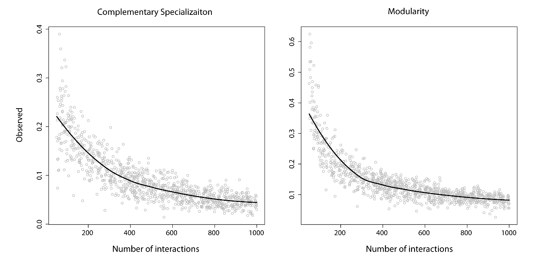
We then applied each of the three null models to randomize the interactions of the simulated network, and thereafter recalculated complementary specialization and modularity. The entire procedure was repeated for 1000 iterations, and the results are presented in the figure below.

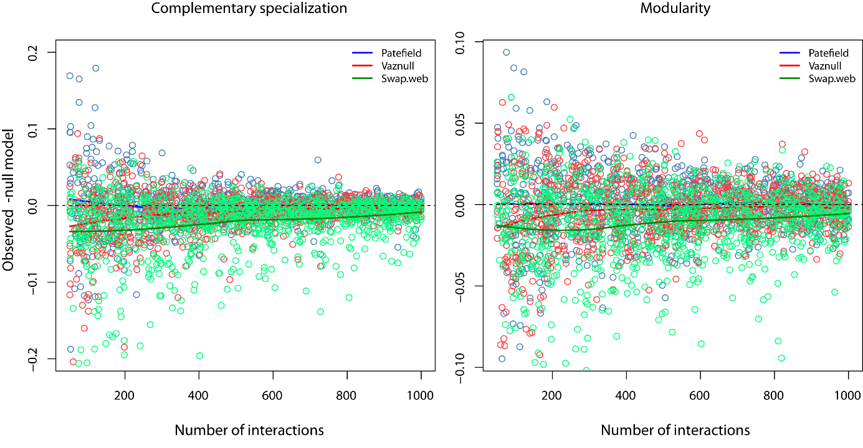All three null models performed equally well in not falsely identifying complementary specialization and modularity in the absence of niche differences. Taken together, we consider the Patefield null model to represent the best compromise in minimizing type I and type II error; hence, we used the Patefield null model to correct for specialization and modularity in our statistical analyses.

S8: Moran’s I correlograms testing for spatial autocorrelation (SAC) in residuals of linear models that predict complementary specialization (H₂') and Δmodularity (∆Q), by the proportion of species within networks that have interaction frequencies significantly explained by morphological matching (Imp.M), phenological overlap (Imp.P) and abundance (Imp.A). ∆ indicates a correction by the Patefield null model. As predictors, we additionally included the network size, defined as the total richness of hummingbirds and plants, and a measure of sampling intensity. Sampling intensity was calculated as the square root number of interaction events divided by the total richness of hummingbirds and plants [12]. The analyses were repeated for both hummingbirds and plants. Open circles indicate statistical non-significance at a (two-sided) 5% level. The correlograms show no sign of significant positive SAC in the model residuals. Hence, we assess that spatial autocorrelation is negligible for our models’ results.
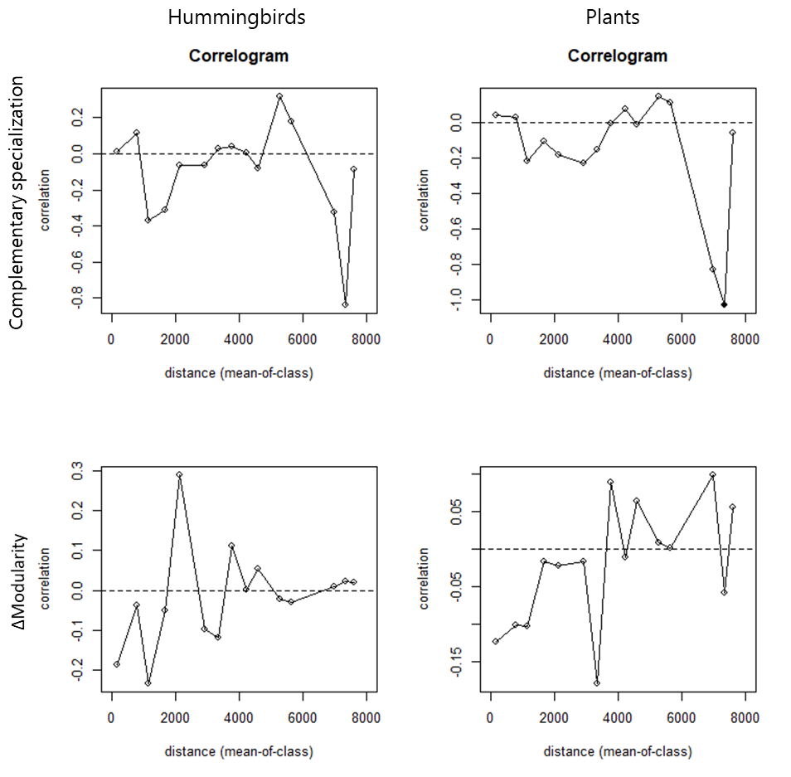

S9.
a) Map showing how the sampling of networks is clustered into two regions separated roughly at -60º longitude (ellipses).
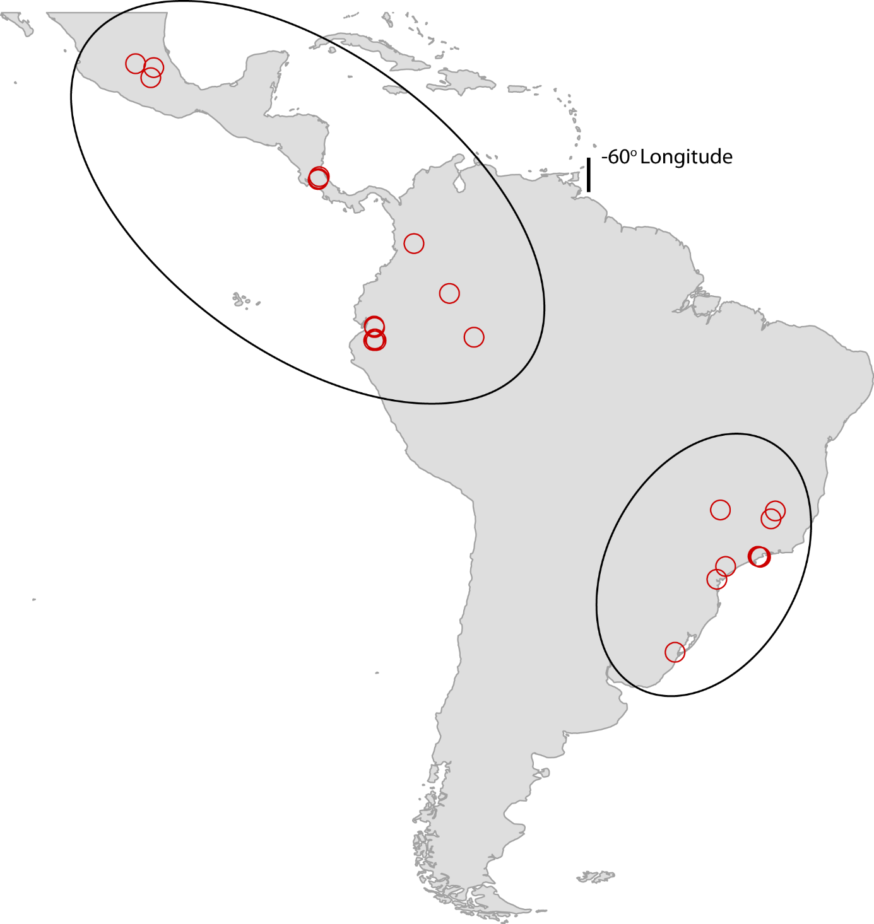

b) Models fitted on the ability of different ecological mechanisms to describe interaction frequencies within networks (n = 24). The analyses were repeated individually for hummingbirds and plants. The response variables comprise the proportion of species within networks that have interaction frequencies significantly described by morphological matching (Imp.M), phenological overlap (Imp.P), and abundance (Imp.A). The explanatory variables include ‘sampling intensity’, ‘network size’ and a binary dummy variable stating whether networks are located east or west of 60º longitude. The goodness of fit was assessed by McFadden's R². ***p<0.001, **p<0.01, *p<0.05.

 | Imp.M  Standardized coefficients |  | Imp.P  Standardized coefficients |  | Imp.A  Standardized coefficients
 | Hummingbirds | Plants | Hummingbirds | Plants | Hummingbirds | Plants
Absolute latitude | -1.43*** | -0.71*** | -1.05*** | -0.06 | 0.49 | -0.22
East/west (60ºW) | -1.57* | -0.93* | -0.50 | -1.05* | 1.14 | 0.60
Network size | -0.17 | -0.04 | -0.25 | -0.41*** | 0.16 | 0.14
Sampling intensity | 0.14 | 0.06 | 0.24 | 0.33** | 0.93*** | 0.26*
McFadden R² | 0.57 | 0.29 | 0.52 | 0.18 | 0.33 | 0.24
Adj. McFadden R² | 0.39 | 0.14 | 0.35 | 0.12 | 0.22 | 0.16

S10. Multiple linear models fitted on measurements of network structure, i.e. complementary specialization (H₂') and modularity (Q). ∆ indicates a correction by the Patefield null model. Explanatory variables include the proportion of species within networks that have interactions frequencies significantly explained by morphological matching (Imp.M), sampling intensity, and network size. ***p<0.001, **p<0.01, *p<0.05.
 | Hummingbirds |  |  |  | Plants
n = 24 | H₂' | ∆H₂' | ∆Q |  | H₂' | ∆H₂' | ∆Q
 | Standardized coefficients |  |  |  | Standardized coefficients
Imp.M | 0.46** | 0.50** | 0.45* |  | 0.51** | 0.56*** | 0.52***
SI | -0.25 | -0.08 | -0.52 |  | -0.21 | -0.04 | -1.13
network size | 0.53** | 0.51 | 0.59*** |  | 0.49** | 0.47** | 0.54**
R2 | 0.53 | 0.55 | 0.57 |  | 0.58 | 0.63 | 0.64
R2_{adj} | 0.45 | 0.48 | 0.51 |  | 0.52 | 0.57 | 0.59

References
[1] Dobzhansky, T. 1950 Evolution in the tropics. American Scientist 38, 209-221.
[2] Fischer, A.G. 1960 Latitudinal variations in organic diversity. Evolution 14, 64-81. (doi:10.1111/j.1558-5646.1960.tb03057.x).
[3] Schemske, D.W. 2002 Ecological and evolutionary perspectives on the origins of tropical diversity. Foundations of tropical forest biology, 163-173.
[4] MacArthur, R.H. 1969 Patterns of communities in the tropics. Biological Journal of the Linnean Society 1, 19-30.
[5] Dalsgaard, B., Magård, E., Fjeldså, J., González, A.M.M., Rahbek, C., Olesen, J.M., Ollerton, J., Alarcón, R., Araujo, A.C., Cotton, P.A., et al. 2011 Specialization in plant-hummingbird networks is associated with species richness, contemporary precipitation and quaternary climate-change velocity. PloS one 6, e25891. (doi:10.1371/journal.pone.0025891).
[6] Olson, D.M., Dinerstein, E., Wikramanayake, E.D., Burgess, N.D., Powell, G.V.N., Underwood, E.C., D'Amico, J.A., Itoua, I., Strand, H.E., Morrison, J.C., et al. 2001 Terrestrial ecoregions of the World: A new map of life on Earth. BioScience 51, 933-938. (doi:10.1641/0006-3568(2001)051[0933:TEOTWA]2.0.CO;2).
[7] Zanata, T.B., Dalsgaard, B., Rahbek, C. & Varassin, I.G. 2018 Bill measurements of hummingbirds in the network database. (doi:10.6084/m9.figshare. 6151196.v2).
[8] Sonne, J., Zanata, T.B., Martín González, A.M., Cumbicus Torres, N.L., Fjeldså, J., Colwell, R.K., Tinoco, B.A., Rahbek, C. & Dalsgaard, B. 2019 The distributions of morphologically specialized hummingbirds coincide with floral trait matching across an Andean elevational gradient. Biotropica 51, 205-218. (doi:10.1111/btp.12637).
[9] Rico-Guevara, A. 2014 Morphology and Function of the Drinking Apparatus in Hummingbirds. In Doctoral Dissertations 490 (University of Connecticut - Storrs.
[10] Plummer, M. 2003 JAGS: A program for analysis of Bayesian graphical models using Gibbs sampling. Proceedings of the 3rd international workshop on distributed statistical computing.
[11] Plummer, M. 2012 JAGS Version 3.3. 0 user manual. International Agency for Research on Cancer, Lyon, France.
[12] Schleuning, M., Fründ, J., Klein, A.M., Abrahamczyk, S., Alarcón, R., Albrecht, M., Andersson, G.K.S., Bazarian, S., Böhning-Gaese, K., Bommarco, R., et al. 2012 Specialization of mutualistic interaction networks decreases toward tropical latitudes. Current Biology 22, 1925-1931. (doi:10.1016/j.cub.2012.08.015).
[13] Schleuning, M., Ingmann, L., Strauß, R., Fritz, S.A., Dalsgaard, B., Matthias Dehling, D., Plein, M., Saavedra, F., Sandel, B., Svenning, J.C., et al. 2014 Ecological, historical and evolutionary determinants of modularity in weighted seed-dispersal networks. Ecology Letters 17, 454-463. (doi:10.1111/ele.12245).
[14] Dalsgaard, B., Schleuning, M., Maruyama, P.K., Dehling, D.M., Sonne, J., Vizentin-Bugoni, J., Zanata, T.B., Fjeldså, J., Böhning-Gaese, K. & Rahbek, C. 2017 Opposed latitudinal patterns of network-derived and dietary specialization in avian plant-frugivore interaction systems. Ecography, 1-7. (doi:10.1111/ecog.02604).
[15] Martín-González, A.M., Dalsgaard, B., Nogués-Bravo, D., Graham, C.H., Schleuning, M., Maruyama, P.K., Abrahamczyk, S., Alarcón, R., Araujo, A.C., Araújo, F.P., et al. 2015 The macroecology of phylogenetically structured hummingbird–plant networks. Global Ecology and Biogeography 24, 1212-1224. (doi:10.1111/geb.12355).
[16] Dormann, C.F., Fründ, J., Blüthgen, N. & Gruber, B. 2009 Indices, graphs and null models: analyzing bipartite ecological networks. The Open Ecology Journal 2. (doi: 10.2174/1874213000902010007).
[17] Patefield, W.M. 1981 Algorithm AS 159: An efficient method of generating random R × C tables with given row and column totals. Journal of the Royal Statistical Society. Series C (Applied Statistics) 30, 91-97. (doi:10.2307/2346669).
[18] Vázquez, D.P., Melian, C.J., Williams, N.M., Blüthgen, N., Krasnov, B.R. & Poulin, R. 2007 Species abundance and asymmetric interaction strength in ecological networks. Oikos 116, 1120-1127.
[19] Dormann, C., Gruber, B. & Fründ, J. 2008 Introducing the bipartite package: analysing ecological networks. R news 8, 8-11.
[20] Fisher, R.A., Corbet, A.S. & Williams, C.B. 1943 The relation between the number of species and the number of individuals in a random sample of an animal population. The Journal of Animal Ecology, 42-58.
[21] Preston, F.W. 1948 The commonness, and rarity, of species. Ecology 29, 254-283.
[22] Magurran, A.E. & Henderson, P.A. 2003 Explaining the excess of rare species in natural species abundance distributions. Nature 422, 714.
[23] Canard, E.F., Mouquet, N., Mouillot, D., Stanko, M., Miklisova, D. & Gravel, D. 2014 Empirical evaluation of neutral interactions in host-parasite networks. The American Naturalist 183, 468-479. (doi:10.1086/675363).

