Electronic Supplementary Material

This file contains:
Supplementary Methods………………………………………………………………………………………………………...…1
Supplementary Tables………………………………………………………………………………………………….…………...5
Supplementary Figures………………………………………………………………………………………………….…..…….16

Supplementary Methods

Estimation of covariance
To estimate covariance between sardine and anchovy, we fit a MARSS model the dominant sardine and anchovy stock in each region r (dominance was assessed based on which stock had the highest median biomass), using the MARSS package in R (Holmes et al., 2012; R Core Team, 2019). The model consists of a state equation and an observation equation.

The state equation is:

$x_{t}={\left[\begin{matrix}B & … & 0 \\ ⋮ & ⋱ & ⋮ \\ 0 & … & B\end{matrix}\right]x}_{t-1}+w_{t}$ ${ w}_{t}\sim MVN\left(0,\left[\begin{matrix}Q_{r=1} & … & 0 \\ ⋮ & ⋱ & ⋮ \\ 0 & … & Q_{r=5}\end{matrix}\right]\right)$ (Eq. S1)

Where $B=\left[\begin{matrix}b_{s} & b_{a,s} \\ b_{s,a} & b_{a}\end{matrix}\right]$ and $Q_{r}=\left[\begin{matrix}q_{s,r} & q_{,r} \\ q_{,r} & q_{a,r}\end{matrix}\right]$. This structure means that species interactions are consistent across ecosystems but covariance between sardine and anchovy varies by ecosystem. Estimating B as the same across ecosystems allows us to characterize species interaction effects independently from ecosystem-specific environmental effects. It also provides a way to calculate the proportion of total variance in x_{t} owing to species interactions, which is useful in this circumstance. Estimating a “global” B but allowing Q to vary by ecosystem was also the best fit model when we compared the fit of these different model structures to the data.

and an observation equation,

$y_{t}=x_{t}+v_{t}$ ${ v}_{t}\sim MVN(0,R)$ (Eq. S2)

which describes observations of the process. In the process model (Eq. S1), x_{t} is an m × 1 vector of the natural log of biomass for sardine and anchovy at time t. B is an m × m matrix containing the effects of each species on itself along the diagonal and the effect of one species on the other on the off-diagonal. Elements of Q are estimated so that the process variances for sardine and anchovy are species-specific (q_{s} and q_{a}) and covariance between sardine and anchovy is region-specific (q_{s,a}). The observation errors in the R matrix are drawn from the same distribution for sardine and anchovy globally.
Both the Q and B matrices contribute to the covariance between sardine and anchovy in each system; we encourage interested readers to explore this relationship using the “QB Comparison” code in the project GitHub repository (https://github.com/mcsiple/sardine-anchovy).
Other state-space approaches to this question have treated landings as observations of the underlying abundance (e.g., (Hosack et al., 2013)), and this is a suitable approach as well. Since one of our main questions was whether signals of covariance are shared across these metrics, we wanted to analyze them independently. We also acknowledge that the biomass and recruitment time series were estimated in stock assessments, each of which likely estimates their own degree of process error.

Spectral analysis
For spectral analysis, data are required for every year in the time series; to achieve this we used the states estimated from the model described above. Missing values predominantly occurred during periods of very low biomass and estimates during these periods were low and consistent (figures S10-S14).

For each sardine-anchovy pair, we calculated the continuous wavelet transform:

$w_{k}\left(t,s\right)=s^{-1}\int_{-∞}^{∞}{ψ\left(\frac{t-τ}{s}\right)}x_{k}(τ)dτ$ (Eq. S3)

where s is the scale of the analysis (the scale at which the wavelet transform is sampled, or “scale localization”), $ψ_{τ}$ is the wavelet function and $x_{k}(τ)$ is the biomass of the kth species at time $τ$ (Keitt, 2008) (figure S2).
We then calculated the localized wavelet modulus ratio (WMR) as described in Keitt (2008):

$WMR=\frac{Λ_{t,s}(\left|\sum_{k}{w_{k}\left(τ,s\right)}\right|)}{Λ_{t,s}(\sum_{k}{\left|w_{k}\left(τ,s\right)\right|})}$ (Eq. S4)

where$Λ_{t,s}\left(∙\right)=\int_{-∞}^{∞}{e^{-\frac{1}{2}{\left(\frac{t-τ}{s}\right)}^{2}}}\left(∙\right)dτ$ (a Gaussian localization function in time t) and $\left|∙\right|$ is the complex modulus. The numerator is the modulus of the sum of the wavelet transform and is lower when species have compensatory or asynchronous dynamics. The denominator, the sum of the moduli of sardine and anchovy, is the maximum possible amplitude if the phases of both species were perfectly aligned. Thus, the WMR is bounded between 0 and 1, where lower values are characteristic of asynchronous or compensatory dynamics, higher values are characteristic of synchronous dynamics, and intermediate values are characteristic of independent dynamics.

Why use wavelets?
There are several ways to analyze the relationship between two time series, wavelets being only one. Another way to analyze their relationship is to use cross-correlation, which identifies relationships between two time series at different temporal lags. While this would be an acceptable way to analyze cleaner time series, we did not use the cross-correlation function (CCF) here, because it requires pre-whitening the data, and would lead to issues with interpretability.
Another approach would be to use cross-spectral density, which analyzes the relationship between two time series in the frequency domain (as opposed to in the time domain, as cross-correlation does). This approach would identify modes at certain frequencies that were similar between the two time series. This would be another acceptable approach for analyzing sardine and anchovy dynamics.
Finally, one could also use mutual cross-information, which gives you the amount of information about one time series that is contained in the other. This would also be an acceptable way to analyze the data, but was not as amenable to testing against a null condition.
We used wavelet analysis because it can produce a distribution of wavelet modulus ratios at specific frequencies, allowing us to perform statistical tests comparing the two distributions. Wavelet analysis has been used in the past to analyze sardine and anchovy data (see (Lindegren et al., 2013)), but it is just one of many approaches that could be suitable for data like these. An issue with many of the approaches mentioned here is that they are generally designed to work with long time series without missing values, and these are rare in ecology. The code to look at mutual information and partial autocorrelation functions, as well as the wavelet methods we used in the final analysis, are in the GitHub repository for this project.
In the results, asynchrony is presented in the form of raw distributions of the wavelet modulus ratio (WMR), and in the d parameter from Mann-Whitney Wilcoxon tests, which describes the estimated difference between the observed WMR and the null WMR distribution. We find it more helpful to look at the raw values of WMR, as the Mann-Whitney Wilcoxon tests are much less sensitive.

Power Analysis
Because a separate Q matrix was estimated for each region in the covariance analysis, we used the median estimate of sardine variance $q_{s}$, anchovy variance $q_{a}$, and sardine-anchovy covariance $q$for the simulations. In the simulations, the covariance between sardine and anchovy in the simulation is driven by each species’ different response to the environmental driver. We also incorporated some autocorrelation in sardine and anchovy in the power analysis. Because regional values for B were not estimable from the data (see the “Evaluating asynchrony” section above), we estimated a global B matrix and use these values in the power analysis.

$x_{t}=\left[\begin{matrix}b_{s} & b_{s,a} \\ b_{a,s} & b_{a}\end{matrix}\right]x_{t-1}+Cc_{t}+ε_{t}; ε\sim MVN\left(0,\left[\begin{matrix}q_{s} & q \\ q & q_{a}\end{matrix}\right]\right)$ (Eq. S5)

$x_{t}=\left[\begin{matrix}0.98 & 0.03 \\ -0.10 & 0.67\end{matrix}\right]x_{t-1}+Cc_{t}+ε_{t}; ε\sim MVN\left(0,\left[\begin{matrix}0.12 & 0.12 \\ 0.12 & 0.19\end{matrix}\right]\right)$ (Eq. S6)

Time series were initiated as follows:
$$x_{1}\sim MVN(0,\left[\begin{matrix}q_{s} & q \\ q & q_{a}\end{matrix}\right])$$

Baumgartner et al. (1992) data
The Baumgartner et al. (1992) scale deposition data from the Santa Barbara Basin contain information about much lower-frequency signals of synchrony/asynchrony in sardine and anchovy in the California Current. Because these data are sampled at frequencies lower than all the other datasets we used, we did not compare them directly with the time series presented here. However, we have included a csv of the Baumgartner et al. data (scraped from the paper) on the GitHub repository for this project, so that interested parties can analyze it with the methods we use here.

References

Baumgartner, T.R., Soutar, A., Ferreira-Bartrina, V., 1992. Reconstruction of the history of Pacific sardine and northern anchovy populations over the past two millennia from sediments of the Santa Barbara Basin, California. CalCOFI Rep 33, 24–40.
Holmes, E.E., Ward, E.J., Wills, K., 2012. MARSS: Multivariate autoregressive state-space models for analyzing time-series data. R J. 4, 11–19.
Hosack, G.R., Trenkel, V.M., Dambacher, J.M., 2013. The relative importance of environmental stochasticity, interspecific interactions, and observation error: Insights from sardine and anchovy landings. J. Mar. Syst., Advances in Marine Ecosystem Modelling Research III 125, 77–89. https://doi.org/10.1016/j.jmarsys.2012.09.003
Keitt, T.H., 2008. Coherent ecological dynamics induced by large-scale disturbance. Nature 454, 331–334. https://doi.org/10.1038/nature06935
Lindegren, M., Checkley, D.M., Rouyer, T., MacCall, A.D., Stenseth, N.C., 2013. Climate, fishing, and fluctuations of sardine and anchovy in the California Current. Proc. Natl. Acad. Sci. U. S. A. 110, 13672–13677. https://doi.org/10.1073/pnas.1305733110
R Core Team, 2019. R: A language and environment for statistical computing. R Foundation for Statistical Computing, Vienna, Austria.
Torrence, C., Compo, G.P., 1998. A practical guide to wavelet analysis. Bull. Am. Meteorol. Soc. 61–78.

Supplementary Tables

Table S1. Data collected for this study from the RAM legacy database and Barange et al. 2009.
Region | Data source | Dominant anchovy stock* | Dominant sardine stock*
NE Atlantic | Barange | Bay of Biscay anchovy | European sardine
California Current | Barange | California anchovy | California sardine
Humboldt Current | Barange | Humboldt anchovy – Central Peru | Humboldt sardine – S Peru N Chile
Kuroshio-Oyashio Current | Barange | Japanese anchovy | Japanese sardine
Benguela Current | Barange | Southern Benguela anchovy | Northern Benguela sardine
NE Atlantic | RAM | Anchovy ICES VIII | European pilchard ICES VIIIc-Ixa
California Current | RAM | N Anchovy E Pacific | Pacific sardine Pacific Coast
Humboldt Current | RAM | Peruvian anchoveta | No sardine biomass data from this source/location
Kuroshio-Oyashio Current | RAM | Japanese anchovy Tsushima Strait | No sardine biomass data from this source/location
Benguela Current | RAM | Anchovy South Africa | No sardine biomass data from this source/location
*Dominant stocks are defined by the sardine or anchovy stock with the highest median spawning stock biomass for that region and data source.

Table S2. Data included in this study. Bold stock names indicate species identified as the “dominant species” based on long-term median biomass.

Data source | Region | Stock | Type | Biomass | Recruitment | Landings | Total catch
Barange | Benguela | Northern Benguela sardine | S | 1 | 0 | 1 | 0
 | Benguela | Southern Benguela anchovy | A | 1 | 1 | 1 | 0
 | Benguela | Southern Benguela sardine | S | 1 | 1 | 1 | 0
 | California | California anchovy | A | 1 | 1 | 1 | 0
 | California | California sardine | S | 1 | 1 | 1 | 0
 | Humboldt | Chilean common sardine | S | 1 | 1 | 1 | 0
 | Humboldt | Humboldt anchovy - Central Peru | A | 1 | 1 | 1 | 0
 | Humboldt | Humboldt anchovy - South Peru N Chile | A | 1 | 1 | 1 | 0
 | Humboldt | Humboldt sardine - N Central Peru | S | 1 | 1 | 1 | 0
 | Humboldt | Humboldt sardine - South Peru N Chile | S | 1 | 1 | 1 | 0
 | Kuroshio-Oyashio | Japanese anchovy | A | 1 | 1 | 1 | 0
 | Kuroshio-Oyashio | Japanese sardine | S | 1 | 1 | 1 | 0
 | NE Atlantic | Bay of Biscay anchovy | A | 1 | 1 | 1 | 0
 | NE Atlantic | European sardine | S | 1 | 1 | 1 | 0
FAO | Benguela | Engraulidae - Atlantic, Southeast | A | 0 | 0 | 1 | 0
 | Benguela | Round sardinella - Atlantic, Southeast | S | 0 | 0 | 1 | 0
 | Benguela | Sardinella spp - Atlantic, Southeast | S | 0 | 0 | 1 | 0
 | Benguela | Southern African anchovy - Atlantic, Southeast | A | 0 | 0 | 1 | 0
 | Benguela | Southern African pilchard - Atlantic, Southeast | S | 0 | 0 | 1 | 0
 | California | California anchovy - Pacific, Eastern Central | A | 0 | 0 | 1 | 0
 | California | California anchovy - Pacific, Northeast | A | 0 | 0 | 1 | 0
 | California | California pilchard - Pacific, Eastern Central | S | 0 | 0 | 1 | 0
 | California | California pilchard - Pacific, Northeast | S | 0 | 0 | 1 | 0
 | California | Pacific anchoveta - Pacific, Eastern Central | A | 0 | 0 | 1 | 0
 | Humboldt | Longnose anchovy - Pacific, Southeast | A | 0 | 0 | 1 | 0
 | Humboldt | Pacific anchoveta - Pacific, Southeast | A | 0 | 0 | 1 | 0
 | Humboldt | Peruvian anchoveta - Pacific, Southeast | A | 0 | 0 | 1 | 0
 | Humboldt | South American pilchard - Pacific, Southeast | S | 0 | 0 | 1 | 0
 | Kuroshio-Oyashio | Engraulidae - Pacific, Northwest | A | 0 | 0 | 1 | 0
 | Kuroshio-Oyashio | Japanese anchovy - Pacific, Northwest | A | 0 | 0 | 1 | 0
 | Kuroshio-Oyashio | Japanese pilchard - Pacific, Northwest | S | 0 | 0 | 1 | 0
 | Kuroshio-Oyashio | Japanese sardinella - Pacific, Northwest | S | 0 | 0 | 1 | 0
 | Kuroshio-Oyashio | Sardinella spp - Pacific, Northwest | S | 0 | 0 | 1 | 0
 | Kuroshio-Oyashio | Slender raindbow sardine - Pacific, Northwest | S | 0 | 0 | 1 | 0
 | Kuroshio-Oyashio | Stolephorus spp - Pacific, Northwest | A | 0 | 0 | 1 | 0
 | NE Atlantic | European anchovy - Atlantic, Northeast | A | 0 | 0 | 1 | 0
 | NE Atlantic | European pilchard - Atlantic, Northeast | S | 0 | 0 | 1 | 0
 | NE Atlantic | Sardinella spp - Atlantic, Northeast | S | 0 | 0 | 1 | 0
RAM | Benguela | Anchovy South Africa | A | 1 | 1 | 0 | 1
 | Benguela | Sardine South Africa | S | 0 | 1 | 0 | 1
 | California | N Anchovy E Pacific | A | 1 | 0 | 0 | 0
 | California | Pacific sardine Pacific Coast | S | 1 | 1 | 0 | 1
 | Humboldt | Peruvian anchoveta | A | 1 | 1 | 0 | 1
 | Kuroshio-Oyashio | Japanese anchovy Inland Sea of Japan | A | 1 | 0 | 0 | 1
 | Kuroshio-Oyashio | Japanese anchovy Pacific Coast of Japan | A | 1 | 1 | 0 | 1
 | Kuroshio-Oyashio | Japanese anchovy Tsushima Strait | A | 1 | 0 | 0 | 1
 | NE Atlantic | Anchovy ICES VIII | A | 1 | 1 | 0 | 1
 | NE Atlantic | European pilchard ICES VIIIc-IXa | S | 1 | 1 | 0 | 0

Table S3. Results of Mann–Whitney–Wilcoxon tests comparing WMR values from the observed sardine/anchovy time series and the null distribution of WMR values derived from 50 sets of surrogate time series, where the null hypothesis is that the distributions differ by a location parameter of 0 (alternative is two-sided). U is the Mann-Whitney test statistic (equivalent here to Wilcoxon’s W in this case), which is the number of all comparisons where the observed WMR was higher than the WMR of the null; N is the combined sample size; p is the p-value; d is an estimate of the difference in location parameters between the two distributions (observed - null; median of the difference between a sample from the observed distribution and a sample from the null distribution), where CI.L and CI.U are the lower and upper 95% confidence limits of d; r is an effect size measure indicating the proportion of comparisons in which the WMR of the null was lower than that of the observed WMR (i.e., the observed dynamics were more synchronous than expected). P-values are shown here but we offer the caveat that they are exaggerated by the pseudoreplication caused by combining WMRs from multiple time and frequencies, and the ability to arbitrarily increase the amount of data in the null distribution through the generation of additional surrogate time series. Bold rows indicate cases where asynchrony was stronger than expected by chance.

region | variable | data source | period | U | N | p | d | CI.L | CI.U | r
Benguela | rec | Barange | < 5 yr | 47746274 | 58140 | < 0.001 | 0.224 | 0.214 | 0.234 | 0.73
Benguela | rec | Barange | 5-10 yr | 19212832 | 43605 | < 0.001 | 0.238 | 0.225 | 0.251 | 0.53
Benguela | rec | Barange | 10+ yr | 10063096 | 63954 | < 0.001 | 0.243 | 0.223 | 0.263 | 0.13
Benguela | ssb | Barange | < 5 yr | 32498484 | 57120 | < 0.001 | 0.087 | 0.078 | 0.096 | 0.52
Benguela | ssb | Barange | 5-10 yr | 11608153 | 39984 | < 0.001 | 0.107 | 0.095 | 0.120 | 0.38
Benguela | ssb | Barange | 10+ yr | 6838044 | 62832 | < 0.001 | 0.086 | 0.070 | 0.103 | 0.09
Benguela | landings | Barange | < 5 yr | 28128214 | 57120 | < 0.001 | 0.051 | 0.041 | 0.060 | 0.45
Benguela | landings | Barange | 5-10 yr | 10999787 | 39984 | < 0.001 | 0.098 | 0.084 | 0.112 | 0.36
Benguela | landings | Barange | 10+ yr | 6757495 | 62832 | < 0.001 | 0.090 | 0.073 | 0.107 | 0.09
California | rec | Barange | < 5 yr | 27905829 | 57120 | < 0.001 | 0.052 | 0.042 | 0.062 | 0.44
California | rec | Barange | 5-10 yr | 12603525 | 39984 | < 0.001 | 0.149 | 0.135 | 0.163 | 0.41
California | rec | Barange | 10+ yr | 7325380 | 62832 | < 0.001 | 0.104 | 0.090 | 0.119 | 0.10
California | ssb | Barange | < 5 yr | 29589084 | 57120 | < 0.001 | 0.049 | 0.042 | 0.056 | 0.47
California | ssb | Barange | 5-10 yr | 11832309 | 39984 | < 0.001 | 0.112 | 0.100 | 0.125 | 0.39
California | ssb | Barange | 10+ yr | 7143654 | 62832 | < 0.001 | 0.071 | 0.060 | 0.082 | 0.09
California | landings | Barange | < 5 yr | 30284177 | 57120 | < 0.001 | 0.061 | 0.053 | 0.069 | 0.48
California | landings | Barange | 5-10 yr | 8119880 | 39984 | 0.783 | 0.002 | -0.011 | 0.015 | 0.26
California | landings | Barange | 10+ yr | 4812351 | 62832 | 0.007 | -0.021 | -0.035 | -0.006 | 0.06
Humboldt | rec | Barange | < 5 yr | 18646658 | 39015 | < 0.001 | 0.184 | 0.173 | 0.195 | 0.64
Humboldt | rec | Barange | 5-10 yr | 6033361 | 29835 | < 0.001 | 0.144 | 0.129 | 0.159 | 0.35
Humboldt | rec | Barange | 10+ yr | 1418043 | 34425 | < 0.001 | 0.074 | 0.053 | 0.095 | 0.06
Humboldt | ssb | Barange | < 5 yr | 16908461 | 39882 | < 0.001 | 0.146 | 0.133 | 0.159 | 0.55
Humboldt | ssb | Barange | 5-10 yr | 7378466 | 32844 | < 0.001 | 0.156 | 0.141 | 0.172 | 0.36
Humboldt | ssb | Barange | 10+ yr | 865239 | 35190 | < 0.001 | -0.056 | -0.079 | -0.033 | 0.04
Humboldt | landings | Barange | < 5 yr | 9749854 | 39882 | < 0.001 | -0.026 | -0.040 | -0.013 | 0.32
Humboldt | landings | Barange | 5-10 yr | 2926495 | 32844 | < 0.001 | -0.106 | -0.122 | -0.090 | 0.14
Humboldt | landings | Barange | 10+ yr | 889268 | 35190 | < 0.001 | -0.065 | -0.099 | -0.034 | 0.04
Kuroshio-Oyashio | rec | Barange | < 5 yr | 37363843 | 53295 | < 0.001 | 0.215 | 0.204 | 0.225 | 0.68
Kuroshio-Oyashio | rec | Barange | 5-10 yr | 15710599 | 42075 | < 0.001 | 0.198 | 0.186 | 0.211 | 0.46
Kuroshio-Oyashio | rec | Barange | 10+ yr | 6594608 | 58905 | < 0.001 | 0.130 | 0.114 | 0.147 | 0.10
Kuroshio-Oyashio | ssb | Barange | < 5 yr | 35144538 | 53295 | < 0.001 | 0.134 | 0.127 | 0.142 | 0.64
Kuroshio-Oyashio | ssb | Barange | 5-10 yr | 15677495 | 42075 | < 0.001 | 0.205 | 0.192 | 0.218 | 0.46
Kuroshio-Oyashio | ssb | Barange | 10+ yr | 7407364 | 58905 | < 0.001 | 0.205 | 0.188 | 0.222 | 0.11
Kuroshio-Oyashio | landings | Barange | < 5 yr | 17508822 | 53295 | < 0.001 | -0.034 | -0.043 | -0.025 | 0.32
Kuroshio-Oyashio | landings | Barange | 5-10 yr | 11053715 | 42075 | < 0.001 | 0.050 | 0.041 | 0.060 | 0.32
Kuroshio-Oyashio | landings | Barange | 10+ yr | 7286913 | 58905 | < 0.001 | 0.137 | 0.123 | 0.150 | 0.11
NE Atlantic | rec | Barange | < 5 yr | 6494282 | 57120 | < 0.001 | -0.323 | -0.338 | -0.308 | 0.10
NE Atlantic | rec | Barange | 5-10 yr | 5603065 | 39984 | < 0.001 | -0.108 | -0.124 | -0.091 | 0.18
NE Atlantic | rec | Barange | 10+ yr | 4273318 | 62832 | < 0.001 | -0.053 | -0.069 | -0.038 | 0.06
NE Atlantic | ssb | Barange | < 5 yr | 33797799 | 57120 | < 0.001 | 0.123 | 0.112 | 0.133 | 0.54
NE Atlantic | ssb | Barange | 5-10 yr | 10533487 | 39984 | < 0.001 | 0.090 | 0.075 | 0.105 | 0.34
NE Atlantic | ssb | Barange | 10+ yr | 5239465 | 62832 | 0.772 | 0.003 | -0.014 | 0.020 | 0.07
NE Atlantic | landings | Barange | < 5 yr | 24730367 | 57120 | 0.003 | 0.015 | 0.005 | 0.025 | 0.39
NE Atlantic | landings | Barange | 5-10 yr | 8847944 | 39984 | < 0.001 | 0.029 | 0.015 | 0.043 | 0.29
NE Atlantic | landings | Barange | 10+ yr | 5931849 | 62832 | < 0.001 | 0.052 | 0.032 | 0.072 | 0.08
NE Atlantic | rec | RAM | < 5 yr | 5917293 | 26010 | < 0.001 | 0.123 | 0.107 | 0.139 | 0.46
NE Atlantic | rec | RAM | 5-10 yr | 1232905 | 19074 | < 0.001 | 0.062 | 0.038 | 0.087 | 0.18
NE Atlantic | rec | RAM | 10+ yr | 72863 | 13872 | 0.081 | -0.040 | -0.083 | 0.005 | 0.02
NE Atlantic | ssb | RAM | < 5 yr | 3714520 | 26010 | 0.050 | -0.018 | -0.036 | 0.000 | 0.29
NE Atlantic | ssb | RAM | 5-10 yr | 1301104 | 19074 | < 0.001 | 0.090 | 0.064 | 0.117 | 0.19
NE Atlantic | ssb | RAM | 10+ yr | 19806 | 13872 | < 0.001 | -0.323 | -0.361 | -0.276 | 0.01
Table S4. Parameter estimates from the state-space model used to estimate covariance between sardine and anchovy.
Variable | Region | Parameter | Description | Median | loCI | hiCI | diag or offdiag
Biomass | All | bs | Sardine density-dependence (1 = independent) | 0.98 | 0.93 | 1.00 | diag
Biomass | All | bsa | Effect of sardine on anchovy | -0.10 | -0.19 | -0.02 | offdiag
Biomass | All | bas | Effect of anchovy on sardine | 0.03 | -0.05 | 0.10 | offdiag
Biomass | All | ba | Anchovy density dependence | 0.67 | 0.55 | 0.78 | diag
Biomass | All | R | Observation error | 0.00 | -0.02 | 0.02 | var
Biomass | Benguela | q1s | Sardine variance | 0.08 | 0.03 | 0.13 | var
Biomass | Benguela | q1 | Sardine-anchovy covariance | 0.06 | -0.01 | 0.12 | covar
Biomass | Benguela | q1a | Anchovy variance | 0.37 | 0.21 | 0.53 | var
Biomass | California | q2s | Sardine variance | 0.12 | 0.05 | 0.19 | var
Biomass | California | q2 | Sardine-anchovy covariance | -0.11 | -0.23 | 0.01 | covar
Biomass | California | q2a | Anchovy variance | 0.48 | 0.24 | 0.72 | var
Biomass | Humboldt | q3s | Sardine variance | 0.19 | 0.07 | 0.32 | var
Biomass | Humboldt | q3 | Sardine-anchovy covariance | -0.03 | -0.15 | 0.09 | covar
Biomass | Humboldt | q3a | Anchovy variance | 0.37 | 0.20 | 0.53 | var
Biomass | Kuroshio-Oyashio | q4s | Sardine variance | 0.11 | 0.04 | 0.18 | var
Biomass | Kuroshio-Oyashio | q4 | Sardine-anchovy covariance | 0.10 | -0.03 | 0.24 | covar
Biomass | Kuroshio-Oyashio | q4a | Anchovy variance | 0.49 | 0.13 | 0.85 | var
Biomass | NE Atlantic | q5s | Sardine variance | 0.46 | 0.21 | 0.71 | var
Biomass | NE Atlantic | q5 | Sardine-anchovy covariance | -0.15 | -0.42 | 0.13 | covar
Biomass | NE Atlantic | q5a | Anchovy variance | 0.74 | 0.27 | 1.22 | var
Landings | All | bs | Sardine density-dependence | 0.93 | 0.87 | 1.00 | diag
Landings | All | bsa | Effect of sardine on anchovy | -0.06 | -0.14 | 0.01 | offdiag
Landings | All | bas | Effect of anchovy on sardine | 0.01 | -0.06 | 0.08 | offdiag
Landings | All | ba | Anchovy density dependence | 0.73 | 0.63 | 0.82 | diag
Landings | All | R | Observation error | 0.03 | -0.01 | 0.06 | var
Landings | Benguela | q1s | Sardine variance | 0.18 | 0.08 | 0.28 | diag
Landings | Benguela | q1 | Sardine-anchovy covariance | 0.05 | -0.06 | 0.16 | offdiag
Landings | Benguela | q1a | Anchovy variance | 0.53 | 0.28 | 0.78 | var
Landings | California | q2s | Sardine variance | 0.45 | 0.20 | 0.69 | var
Landings | California | q2 | Sardine-anchovy covariance | -0.08 | -0.23 | 0.08 | offdiag
Landings | California | q2a | Anchovy variance | 0.22 | 0.10 | 0.35 | var
Landings | Humboldt | q3s | Sardine variance | 0.33 | 0.12 | 0.54 | var
Landings | Humboldt | q3 | Sardine-anchovy covariance | -0.10 | -0.26 | 0.06 | offdiag
Landings | Humboldt | q3a | Anchovy variance | 0.43 | 0.23 | 0.63 | var
Landings | Kuroshio-Oyashio | q4s | Sardine variance | 0.21 | 0.08 | 0.34 | var
Landings | Kuroshio-Oyashio | q4 | Sardine-anchovy covariance | -0.08 | -0.19 | 0.03 | offdiag
Landings | Kuroshio-Oyashio | q4a | Anchovy variance | 0.41 | 0.23 | 0.59 | var
Landings | NE Atlantic | q5s | Sardine variance | 0.17 | 0.08 | 0.27 | var
Landings | NE Atlantic | q5 | Sardine-anchovy covariance | 0.04 | -0.05 | 0.13 | offdiag
Landings | NE Atlantic | q5a | Anchovy variance | 0.50 | 0.29 | 0.70 | var
Recruitment | All | bs | Sardine density-dependence | 0.80 | 0.70 | 0.91 | diag
Recruitment | All | bsa | Effect of sardine on anchovy | 0.02 | -0.12 | 0.16 | offdiag
Recruitment | All | bas | Effect of anchovy on sardine | -0.21 | -0.33 | -0.10 | offdiag
Recruitment | All | ba | Anchovy density dependence | 0.62 | 0.47 | 0.78 | diag
Recruitment | All | R | Observation error | 0.06 | 0.00 | 0.12 | var
Recruitment | Benguela | q1s | Sardine variance | 0.55 | 0.16 | 0.94 | var
Recruitment | Benguela | q1 | Sardine-anchovy covariance | 0.43 | 0.11 | 0.76 | offdiag
Recruitment | Benguela | q1a | Anchovy variance | 0.57 | 0.18 | 0.96 | var
Recruitment | California | q2s | Sardine variance | 0.16 | 0.02 | 0.31 | var
Recruitment | California | q2 | Sardine-anchovy covariance | -0.28 | -0.49 | -0.08 | offdiag
Recruitment | California | q2a | Anchovy variance | 0.84 | 0.41 | 1.27 | var
Recruitment | Humboldt | q3s | Sardine variance | 0.22 | 0.04 | 0.40 | var
Recruitment | Humboldt | q3 | Sardine-anchovy covariance | -0.08 | -0.30 | 0.13 | offdiag
Recruitment | Humboldt | q3a | Anchovy variance | 0.62 | 0.19 | 1.05 | var
Recruitment | Kuroshio-Oyashio | q4s | Sardine variance | 0.13 | 0.00 | 0.26 | var
Recruitment | Kuroshio-Oyashio | q4 | Sardine-anchovy covariance | -0.07 | -0.26 | 0.11 | offdiag
Recruitment | Kuroshio-Oyashio | q4a | Anchovy variance | 0.53 | 0.10 | 0.96 | var
Recruitment | NE Atlantic | q5s | Sardine variance | 0.95 | 0.37 | 1.52 | var
Recruitment | NE Atlantic | q5 | Sardine-anchovy covariance | -0.01 | -0.41 | 0.39 | offdiag
Recruitment | NE Atlantic | q5a | Anchovy variance | 0.61 | 0.14 | 1.07 | var

Table S5. Power analysis results based on 100 simulations. This gives the number of times the estimate of d from a given observation length fell within the confidence interval for the complete time series. Prob.higher and Prob.lower refer to whether the estimated value of d is higher than the true value (i.e., the observation detects more synchrony than is actually present at that timescale) or lower than the true value (an estimate of d from the observation time series indicates more asynchrony than the true amount).
Timescale | Obs length | prob.higher | prob.lower | prob.in.CI
<5 yr | 30 | 0.8 | 0.04 | 0.04
<5 yr | 40 | 0.12 | 0.74 | 0.06
<5 yr | 50 | 0.48 | 0.26 | 0.12
<5 yr | 60 | 0.08 | 0.7 | 0.06
<5 yr | 70 | 0.64 | 0.12 | 0.06
<5 yr | 80 | 0.48 | 0.32 | 0.04
<5 yr | 90 | 0.12 | 0.74 | 0.08
<5 yr | 100 | 0.52 | 0.28 | 0.08
<5 yr | 110 | 0.02 | 0.9 | 0.04
<5 yr | 120 | 0.44 | 0.36 | 0.08
<5 yr | 130 | 0.2 | 0.62 | 0.08
<5 yr | 140 | 0.02 | 0.94 | 0.0
<5 yr | 150 | 0.14 | 0.14 | 0.34
5-10 yr | 30 | 0.72 | 0.04 | 0.04
5-10 yr | 40 | 0.08 | 0.78 | 0.04
5-10 yr | 50 | 0.4 | 0.46 | 0.02
5-10 yr | 60 | 0.18 | 0.66 | 0.08
5-10 yr | 70 | 0.5 | 0.26 | 0.1
5-10 yr | 80 | 0.4 | 0.4 | 0.02
5-10 yr | 90 | 0.14 | 0.8 | 0.02
5-10 yr | 100 | 0.38 | 0.44 | 0.04
5-10 yr | 110 | 0.04 | 0.92 | 0.04
5-10 yr | 120 | 0.36 | 0.44 | 0.12
5-10 yr | 130 | 0.24 | 0.58 | 0.08
5-10 yr | 140 | 0.04 | 0.86 | 0.06
5-10 yr | 150 | 0.26 | 0.08 | 0.36
>10 yr | 30 | 0.68 | 0.08 | 0.02
>10 yr | 40 | 0.18 | 0.58 | 0.1
>10 yr | 50 | 0.58 | 0.26 | 0.02
>10 yr | 60 | 0.5 | 0.3 | 0.1
>10 yr | 70 | 0.48 | 0.32 | 0.02
>10 yr | 80 | 0.68 | 0.14 | 0.06
>10 yr | 90 | 0.28 | 0.64 | 0.02
>10 yr | 100 | 0.56 | 0.24 | 0.04
>10 yr | 110 | 0.26 | 0.58 | 0.08
>10 yr | 120 | 0.4 | 0.44 | 0.02
>10 yr | 130 | 0.44 | 0.34 | 0.04
>10 yr | 140 | 0.08 | 0.68 | 0.12
>10 yr | 150 | 0.24 | 0.32 | 0.1

Supplementary Figures

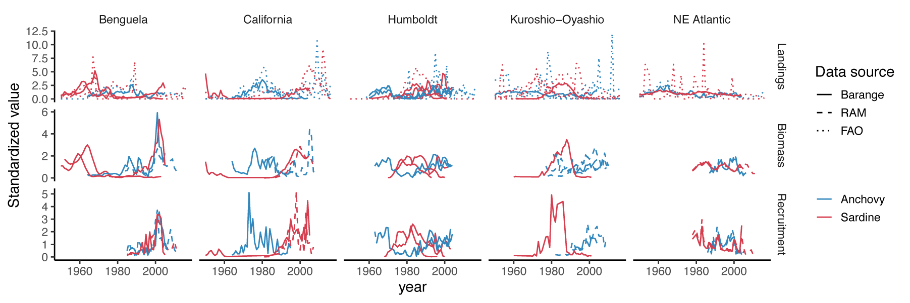
Figure S1. Time series of sardine and anchovy landings, biomass, and recruitment in each ecosystem considered in this study. Values are standardized by dividing by the long-term mean.

Figure S2. Method for quantifying asynchrony at each time scale. (A) Time series of sardine and anchovy biomass (shown here as an example; the same method was applied to surrogate sardine-anchovy time series and observed sardine-anchovy time series) (B) Wavelet analysis gives the wavelet modulus ratio (WMR) at all time scales. Warmer colors represent stronger synchrony at time scale y in year x. Only values within the “cone of influence” are included in the analysis [values outside the cone of influence are subject to edge effects; 64]. The cone of influence is shown as a dotted line. (C) The density of wavelet modulus ratio values at each time scale is used to quantify the degree of asynchrony and compare across ecosystems and variables.

Figure S3. Median landings, biomass, and recruitment for sardine and anchovy in each LME, based on data from Barange et al. (2009).

Figure S4. Median landings for sardine and anchovy in each LME, based on data from FAO.

Figure S5. Median biomass for sardine and anchovy in each LME, based on data from the RAM legacy database.

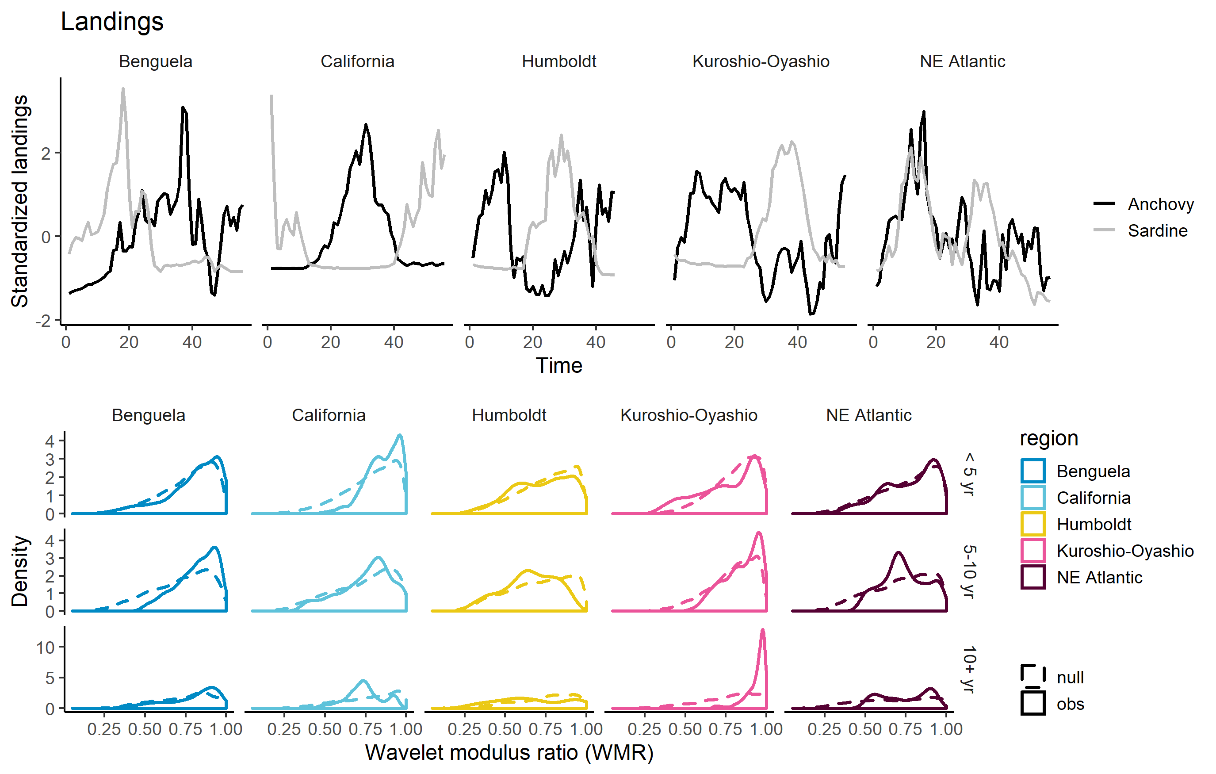
Figure S6. Wavelet modulus ratios observed from observed time series and null WMR distributions for landings, from Barange et al. 2009.

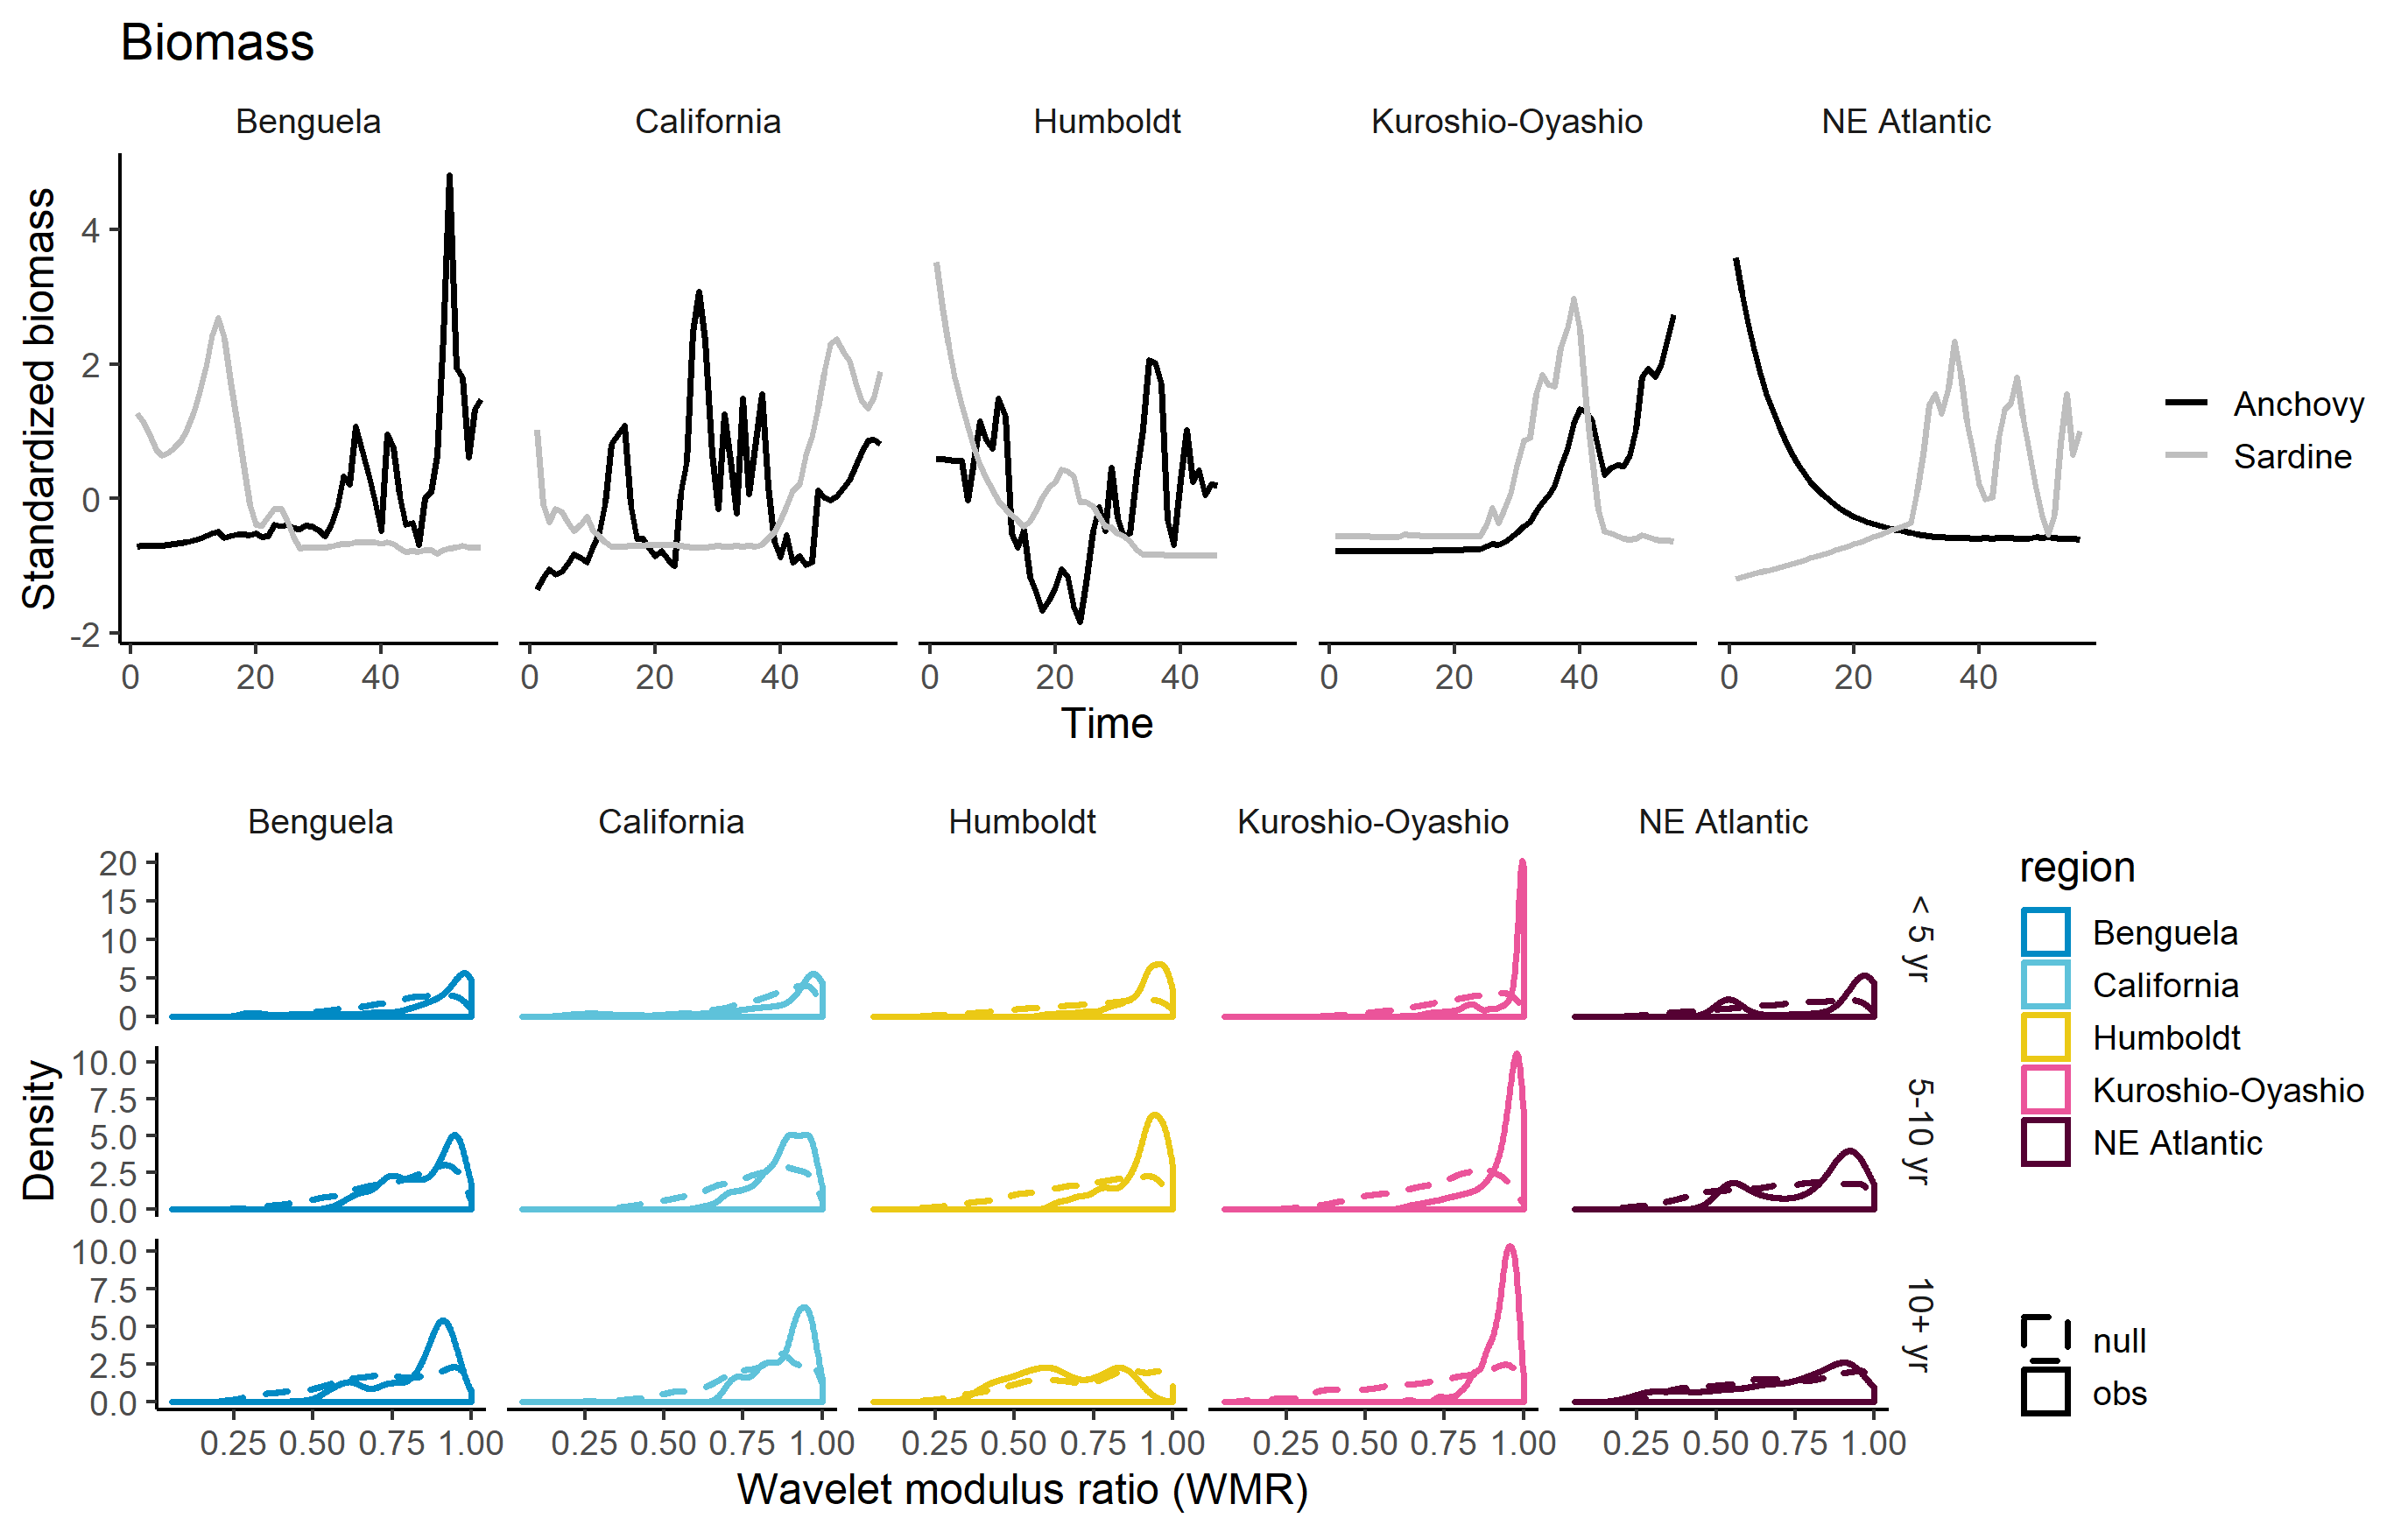
Figure S7. Wavelet modulus ratios observed from observed time series and null WMR distributions for biomass, from Barange et al. 2009.
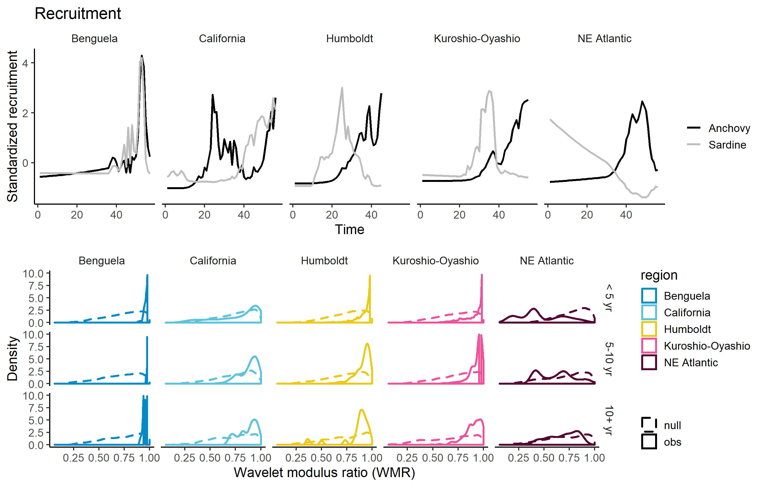
Figure S8. Wavelet modulus ratios observed from observed time series and null WMR distributions for recruitment estimates, from Barange et al. 2009.

Figure S9. Top: Sardine and anchovy time series that are asynchronous at a time scale of 60 years, simulated using time series parameters estimated from real time series (Equations S1-S2). (B) the WMR distribution at each timescale for that time series. In general, using wavelet methods with Mann-Whitney-Wilcoxon tests resulted in overestimates of synchrony when the time series was not long enough for the frequency of the asynchronous dynamics.
California current
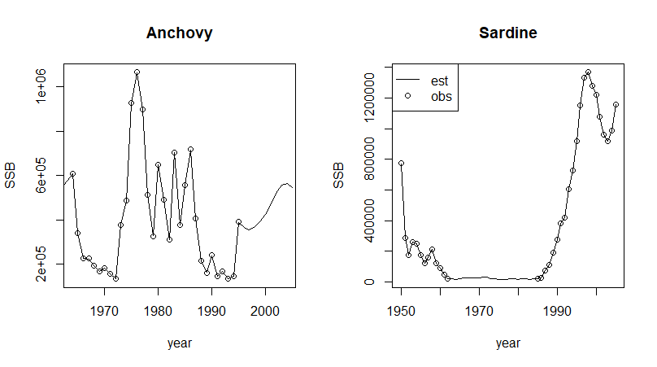
Humboldt Current
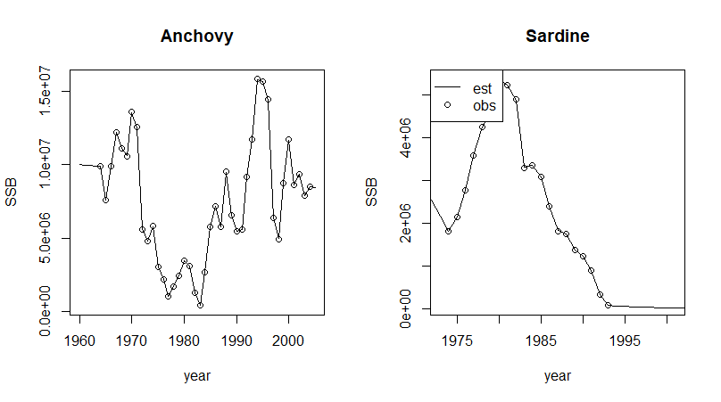

NE Atlantic
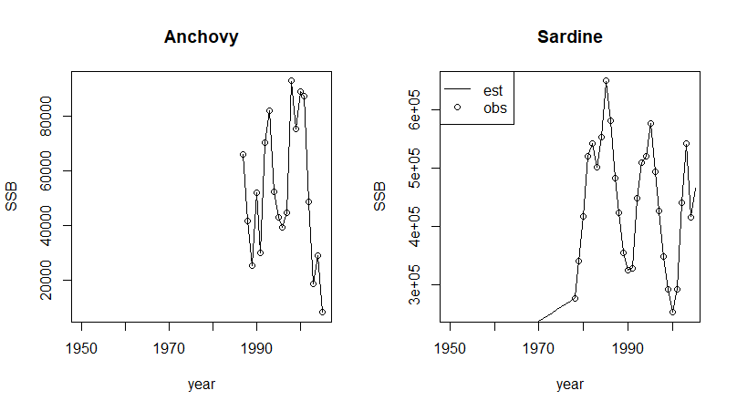
Kuroshio-Oyashio
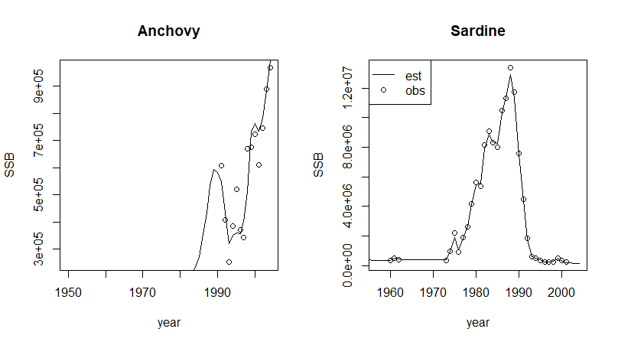

Benguela Current
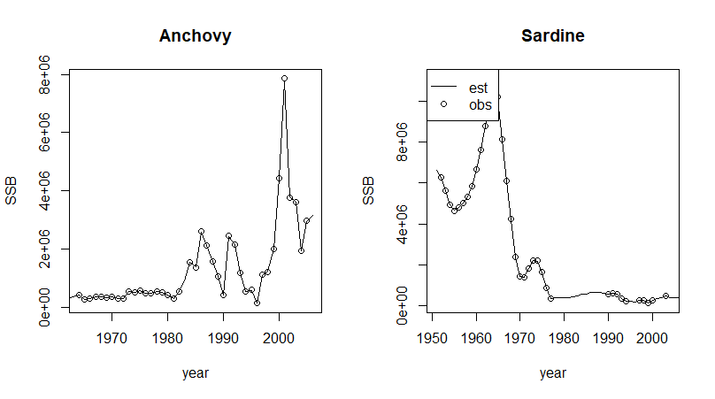
Figures S10-S14. States estimated by the MARSS model, used to do the wavelet analysis.

