Analysis of data from the Metacyc database : methodological details

Data was downloaded from the MetaCyc website (https://metacyc.org/ [1]), by extracting all pathways from the Degradation/Utilisation/Assimilation class, for all organisms which contained the term soil in the field environment of the database. This yielded 487 pathways for 852 different organisms. The MetaCyc database also provided additional data such as genome size, total number of pathways, number of identified enzymes and number of identified transporters.
Pathways : Among the 487 identified pathways, some were duplicated (due to typos for example) and some were described only for other organisms kingdoms. The consolidated data for pathways was thus reduced to 439 distinct pathways. Then, distinct pathways having similar roles (e.g. urea degradation I and II) were grouped together, yielding 313 distinct pathways.
Organisms : Taxonomic data, as well as genome sequence information, was obtained for each record in the database from the NCBI (R package taxize [2]), using the full organism name with strain number. Up-to-date taxonomic information was also obtained by checking the species name in the Prokaryotic Nomenclature Up-to-date [3]. For the purpose of this analysis, the database was reduced to only bacteria, thus keeping 849 organism records. Because the Metacyc database aggregates data from published genomes, some organisms are represented as multiple records (e.g. E. coli). Overall, 27 bacterial species were present as multiple records (73) in the database. We kept only one record for these organisms to limit overrepresentation, so that the final database has 803 records. Note however that 134 other records had no species information and were only associated to 29 different genus. These records could be duplicates –or not– of other species in the database. These records were kept.
MetaCyc data was joined to the rrnDB database [4] using the genome accession number of the record as a key. 229 records in our database also had 16S rRNA gene count records.

1. Caspi R et al. 2018 The MetaCyc database of metabolic pathways and enzymes. Nucleic Acids Res 46, D633–D639. (doi:10/ggbrws)
2. Chamberlain S et al. 2019 taxize: Taxonomic information from around the web. See https://github.com/ropensci/taxize.
3. Leibniz Institute DSMZ - German Collection of Microorganisms and Cell Cultures. 2019 Prokaryotic Nomenclature Up-to-Date.
4. Stoddard SF, Smith BJ, Hein R, Roller BRK, Schmidt TM. 2015 rrnDB: improved tools for interpreting rRNA gene abundance in bacteria and archaea and a new foundation for future development. Nucleic Acids Res 43, D593–D598. (doi:10/gf33tx)

Supplementary Figures

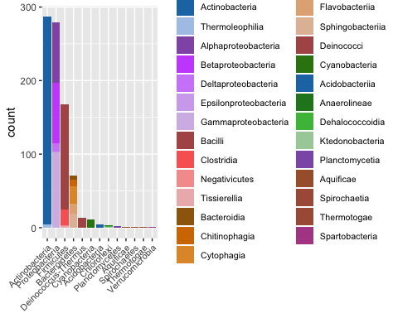Fig S1 Distribution of bacterial phyla and classes in the database. Colours corresponds to different phyla and shades to different classes within the phyla.

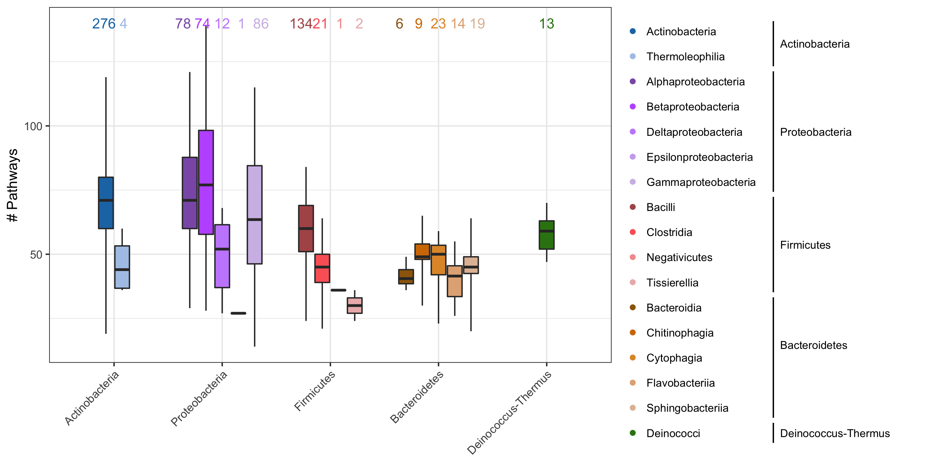

Fig. S2 The number of pathways per strain, as a function of class. The numbers above each class box indicate the number of strains in that class.

Fig S3 Illustration of the effect of resource patch size on the variability of resource use by decomposers. The resources patches are in black and the red discs are the area from which decomposers acquire resources. The amount of resource available to decomposers varies little when resource patches are smaller than the red discs (left panel), but can vary greatly when resources patches are larger than red discs.

