Supplementary information

Climate warming and trophic mismatches in terrestrial ecosystems: the green-brown imbalance hypothesis

Madhav P. Thakur^{1,*}

¹Department of Terrestrial Ecology, Netherlands Institute of Ecology (NIOO- KNAW), Wageningen, The Netherlands

*corresponding author (m.thakur@nioo.knaw.nl)

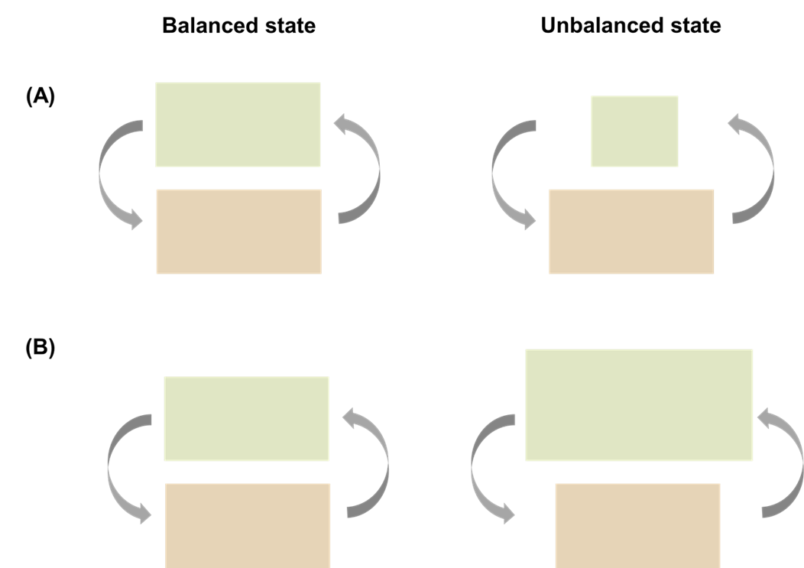

Supplementary figure 1: Two scenarios of green-brown imbalances. In scenario A, climate warming (via trophic mismatches) reduce the biomass that enters from green food webs to brown food webs. In scenario B, the opposite is the case. As the input to brown food webs differ in the two scenarios, the input from brown food webs to green food webs will also change. For simplicity, the balanced state is shown with equal size of green and brown boxes, which is mainly to indicate that mass and energy flow is close to a steady state.

