Supplementary Information for

Substrate use drives the macroevolution of mammalian tail morphological diversity
Sarah T. Mincer¹ and Gabrielle A. Russo²
¹Interdepartmental Doctoral Program in Anthropological Sciences, Stony Brook University, Stony Brook, NY 11794, USA
²Department of Anthropology, Stony Brook University, Stony Brook, NY 11794, USA

*Address correspondence to:

Sarah T. Mincer
Interdepartmental Program in the Anthropological Sciences
Stony Brook University
Stony Brook, NY 11794 USA
sarah.mincer@stonybrook.edu
570-406-4040

Gabrielle A. Russo
Department of Anthropology
Stony Brook University
Stony Brook, NY 11794 USA
gabrielle.russo@stonybrook.edu
631-632-7619

S1. Data collection methods and analyses used in this study
pGLS
For this study, pGLS was used to account for the fact that more closely-related species are expected to have more similar tail lengths than species that are more distantly-related. A variance-covariance matrix is created to estimate the amount of covariation that occurs because of phylogenetic similarity. This estimate is then used as an error term to account for interspecific trait covariance due to shared ancestry [1]. A pGLS then returns a measure of phylogenetic signal as Pagel’s λ, which is 0 if there is no phylogenetic signal and approaches 1 when tail length evolution occurs at a constant rate throughout the tree (Brownian-motion model) [2]. If λ=0, the PGLS will produce results similar to a typical least squares regression analysis.
pANCOVA
A pANCOVA combines the information generated from the pGLS with maximum likelihood estimates of unequal evolutionary rates. Group membership is defined based off the variables of interest, and a group indicator variable is included in the matrix for a typical ANCOVA. Indicating group membership allows us to calculate differences among groups and see if a full model pANCOVA with more than one slope and/or intercept provides a better fit for the data than a simple ANCOVA with one slope and one intercept.
Evolutionary Modelling
In order to look at the interactions between possible variables, we obtained a best-fit evolutionary model using multi-optima Ornstein Uhlenbeck (OU) models in the R package “bayou” [3]. This procedure used a reversible-jump Markov chain Monte Carlo (MCMC) on the data for TL~BL, and then highlighted the locations of highly supported regime shifts based off the posterior probability value (pp). The analysis specified a chain of four million iterations, and the procedure was repeated with ten chains to ensure chain convergence. Large sample sizes such as the one used in this study (OTU = 1139 species) requires more chains and iterations to ensure convergence onto a best fit model. We also provided the program with intercepts and slopes that resulted from the PGLS of groups based on the variables tested. This creates bounds in space for the Bayesian analysis, and can help ensure that the algorithm converges on the correct best-fit model. In addition to analyzing regime shifts, bayou v2.0 allow for additional predictors to be included in order to test for shifts in the scaling between a trait and its predictors, in this case TL~BL. This method uses the shift locations identified in the MCMC and adds in the covariate of BL that varies in different branches of the phylogeny. All regime shifts are assessed using pANCOVA to confirm that each regime provides a statistically significantly better fit to the data than a model with less groups.
Rate Analyses
We compared net rates of tail length evolution for the groups defined by our best-fit evolutionary model using the R program “geomorph” [4]. Evolutionary rate is often analyzed using the rate of phenotypic variation accumulation, which is assumed to be proportional to time [5, 6]. Less trait variance corresponds with a lower rate of tail length evolution, while increased trait variance indicates a higher rate of evolution and selection on tail length. We first phylogenetically transformed the data for each species, then obtained residuals from the best fit line for TL~BL. These values were used to calculate the amount of tail length variation present in each group designated by the best fit model, designated as PD_{U,0} [6]. These values are rank ordered, then ratios are obtained to determine the relative differences in rate between groups which can be used to look for statistically significant differences in evolutionary rates.

Tables

Tail Length~Body Length
Groups compared |  | pANCOVA |  | pGLS
 |  | F- value | p-value | r² | Intercepts | Slopes
Substrate Use | Arboreal vs all other mammals | 52.0 | <0.001 | Arboreal: 0.165  Non-arboreal: 0.277 | Arboreal:  2.24  Non-arboreal: 0.149 | Arboreal:  0.573  Non-arboreal: 0.805
 | Arboreal + semi-arboreal vs all other mammals | 62.7 | <0.001 | 0.201 | Arboreal +  Semi-arboreal: 1.49 | Arboreal + Semi-arboreal: 0.673
 | Aquatic+semi-aquatic vs other non-arboreal | 19.6 | <0.001 | 0.563 | Aquatic + Semi-aquatic: 0.823 | Aquatic + Semi-aquatic: 0.705
 | Subterranean vs other non-arboreal | 50.0 | <0.001 | 0.128 | Subterranean: 0.760 | Subterranean: 0.529
Locomotion | Bipedal hoppers vs other non-arboreal | 18.35 | <0.001 | 0.834 | Bipedal hoppers: 0.915 | Bipedal hoppers: 0.820
 | Quadrupedal hoppers vs non-arboreal | 15.2 | <0.001 | 0.035 | Quadrupedal hoppers: -3.36 | Quadrupedal hoppers: 1.163
 | Gliders vs other arboreal+semi-arboreal | 5.95 | <0.05 | 0.569 | Gliders:  0.478 | Gliders:  0.894
 | Prehensile vs other arboreal+semi-arboreal | 20.4 | <0.001 | 0.277 | Prehensile: 0.501 | Prehensile: 0.911
Diet | Carnivore vs all other mammals | 4.49 | <0.05 | 0.333 | Carnivore: 1.31 | Carnivore: 0.648
 | Herbivore vs all other mammals | 22.0 | <0.001 | 0.285 | Herbivore: 0.0324 | Herbivore: 0.844
 | Insectivore vs all other mammals | 15.7 | <0.001 | 0.357 | Insectivore: 0.0336 | Insectivore: 0.819
 | Omnivore vs all other mammals | 7.27 | <0.001 | 0.165 | Omnivore: 2.236 | Omnivore: 0.573
Table S1. Tail length~body length pANCOVA and pGLS results for a priori behavioral and categorical variables. Data and lines of best fit plotted in Figures 1 of main text+S1.

Tail Length~Body Mass
Groups compared |  | pANCOVA |  | pGLS
 |  | F- value | p-value | r² | Intercepts | Slopes
Substrate Use | Arboreal vs all other mammals | 76.8 | <0.001 | Arboreal: 0.132  Non-arboreal: 0.244 | Arboreal: 5.59  Non-arboreal: 4.75 | Arboreal:  0.208  Non-arboreal: 0.240
 | Arboreal + semi-arboreal vs all other mammals | 103 | <0.001 | 0.133 | Arboreal + Semi-arboreal: 5.33 | Arboreal + Semi-arboreal: 0.204
 | Aquatic+semi-aquatic vs other non-arboreal | 9.86 | <0.001 | 0.342 | Aquatic + Semi-aquatic: 5.06 | Aquatic + Semi-aquatic: 0.141
 | Subterranean vs other non-arboreal | 42.7 | <0.001 | 0.108 | Subterranean: 3.33 | Subterranean: 0.100
Locomotion | Bipedal hoppers vs other non-arboreal | 8.23 | <0.001 | 0.846 | Bipedal hoppers: 5.67 | Bipedal hoppers: 0.239
 | Quadrupedal hoppers vs non-arboreal | 9.62 | <0.001 | 0.075 | Quadrupedal hoppers: 3.53 | Quadrupedal hoppers: 0.390
 | Gliders vs other arboreal+semi-arboreal | 3.95 | <0.05 | 0.435 | Gliders:  5.70 | Gliders:  0.226
 | Prehensile vs other arboreal+semi-arboreal | 3.46 | <0.001 | 0.866 | Prehensile: 5.77 | Prehensile: 0.327
Diet | Carnivore vs all other mammals | 13.0 | <0.001 | 0.287 | Carnivore: 5.40 | Carnivore: 0.204
 | Herbivore vs all other mammals | 23.5 | <0.001 | 0.233 | Herbivore: 4.85 | Herbivore: 0.264
 | Insectivore vs all other mammals | 23.4 | <0.001 | 0.256 | Insectivore: 4.58 | Insectivore: 0.219
 | Omnivore vs all other mammals | 25.3 | <0.001 | 0.170 | Omnivore: 5.28 | Omnivore: 0.166
Table S2. Tail length~body mass pANCOVA and pGLS results for a priori behavioral and categorical variables. Data and lines of best fit plotted in Figures S2+S3.

 | pGLS
Evolutionary Model Regime | Slope | Intercept | Evolutionary Rate
Ancestral | 0.75 | 0.53 | 0.01
Sigmodontinae | 0.49 | 1.52 | 0.04
Arvicolinae | 0.59 | 0.63 | 0.03
Cricetinae | -0.23 | 4.05 | 0.15
Primates | 0.20 | 4.70 | 0.02
Macaca | -4.40 | 32.43 | 0.89
Tayassuidae | 0.69 | -0.94 | 0.04
Capreolinae | 0.87 | -2.03 | 0.04
Bovinae | 1.64 | -6.37 | 0.04
Caprinae | 0.24 | 2.82 | 0.06
Lynx | 3.33 | -17.73 | 0.19
Mustelidae | 0.05 | 4.22 | 0.23
Table S3. Tail length~Body length pGLS and evolutionary rate results for the evolutionary best-fit model shown in Figure 1 of main text.

Figures
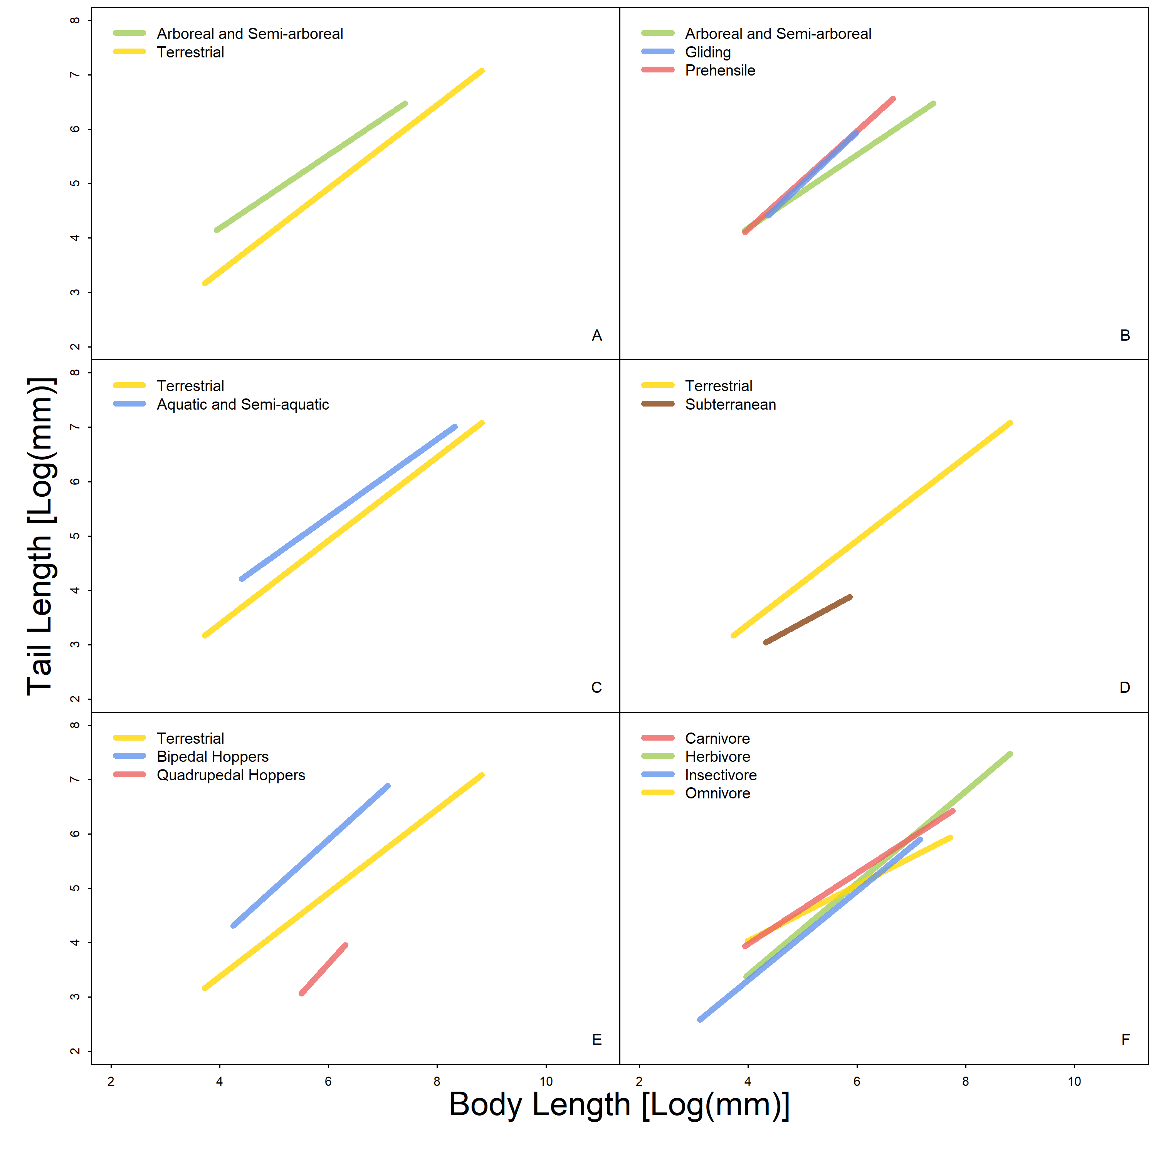
Figure S1. Tail length~body length for the behavioral and categorial variables tested. Results listed in Table S1. Only lines of best fit are shown here to highlight shifts in slope and intercept for substrate (A, C), locomotor (B, D, E), and dietary (F) groups. Lines of best fit as well as data points shown in figure 1 of main text. Arboreal and semi-arboreal mammals have significantly longer tails than other mammals (S1A), and gliding and prehensile-tailed mammals have the longest tails of all arboreal and semi-arboreal mammals (S1B). Among non-arboreal mammals, aquatic and semi-aquatic species have some of the longest tails (S1C), while subterranean have the shortest (S1D). Grouped by locomotor mode, bipedal hoppers have the longest tails and quadrupedal hoppers have the shortest tails (S1E). Tail length differs by diet, with separation among herbivores, carnivores, omnivores, and insectivores S(1F).

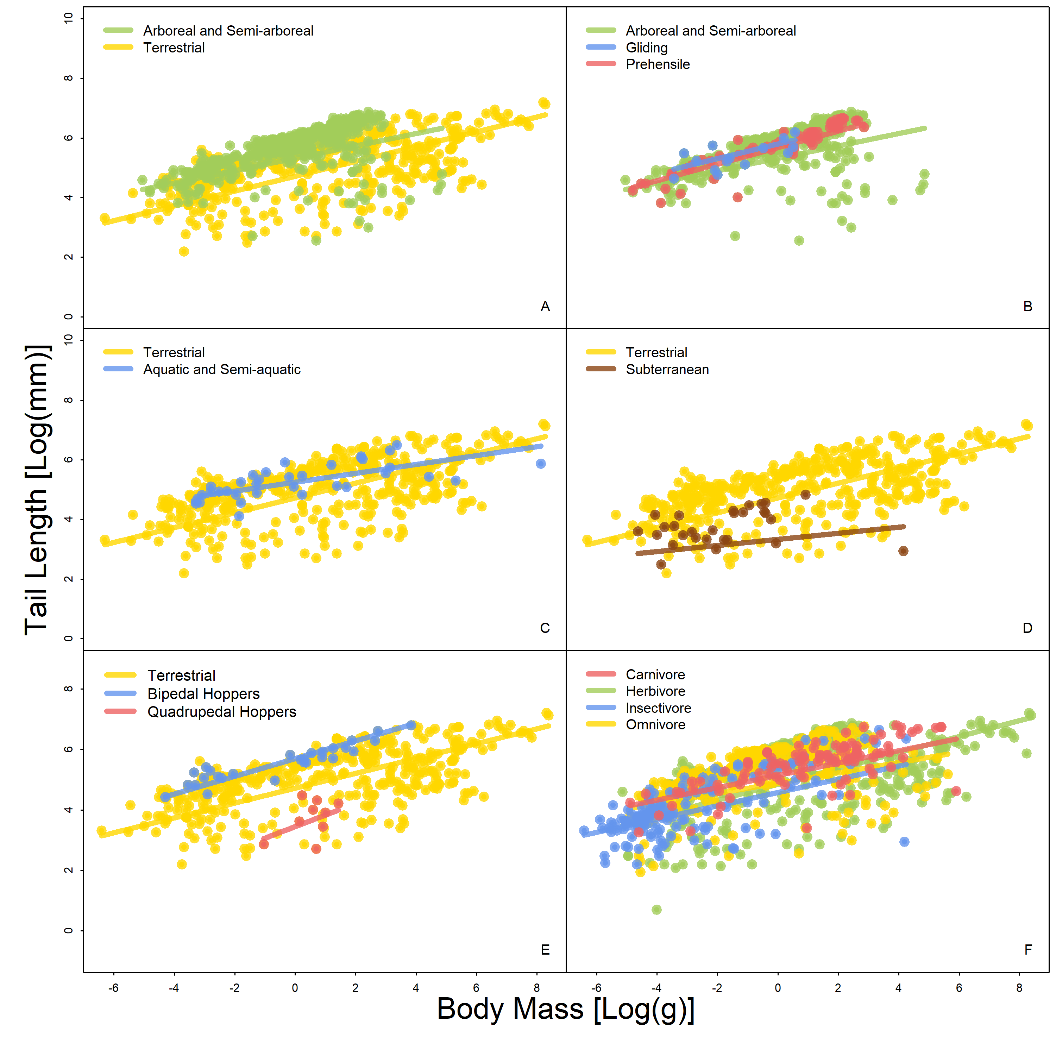
Figure S2. Tail length~body mass for the behavioral and categorial variables tested. Data points and lines of best fit shown for statistically significant differences (p < 0.05) in lines of best fit for substrate (A, C), locomotor (B, D, E), and dietary (F) groups. Results listed in Table S2. Arboreal and semi-arboreal mammals have significantly longer tails than other mammals (S2A), and gliding and prehensile-tailed mammals have the longest tails of all arboreal and semi-arboreal mammals (S2B). Among non-arboreal mammals, aquatic and semi-aquatic species have some of the longest tails (S2C), while subterranean have the shortest (S2D). Grouped by locomotor mode, bipedal hoppers have the longest tails and quadrupedal hoppers have the shortest tails (S2E). Tail length differs by diet, with separation among herbivores, carnivores, omnivores, and insectivores (S2F).
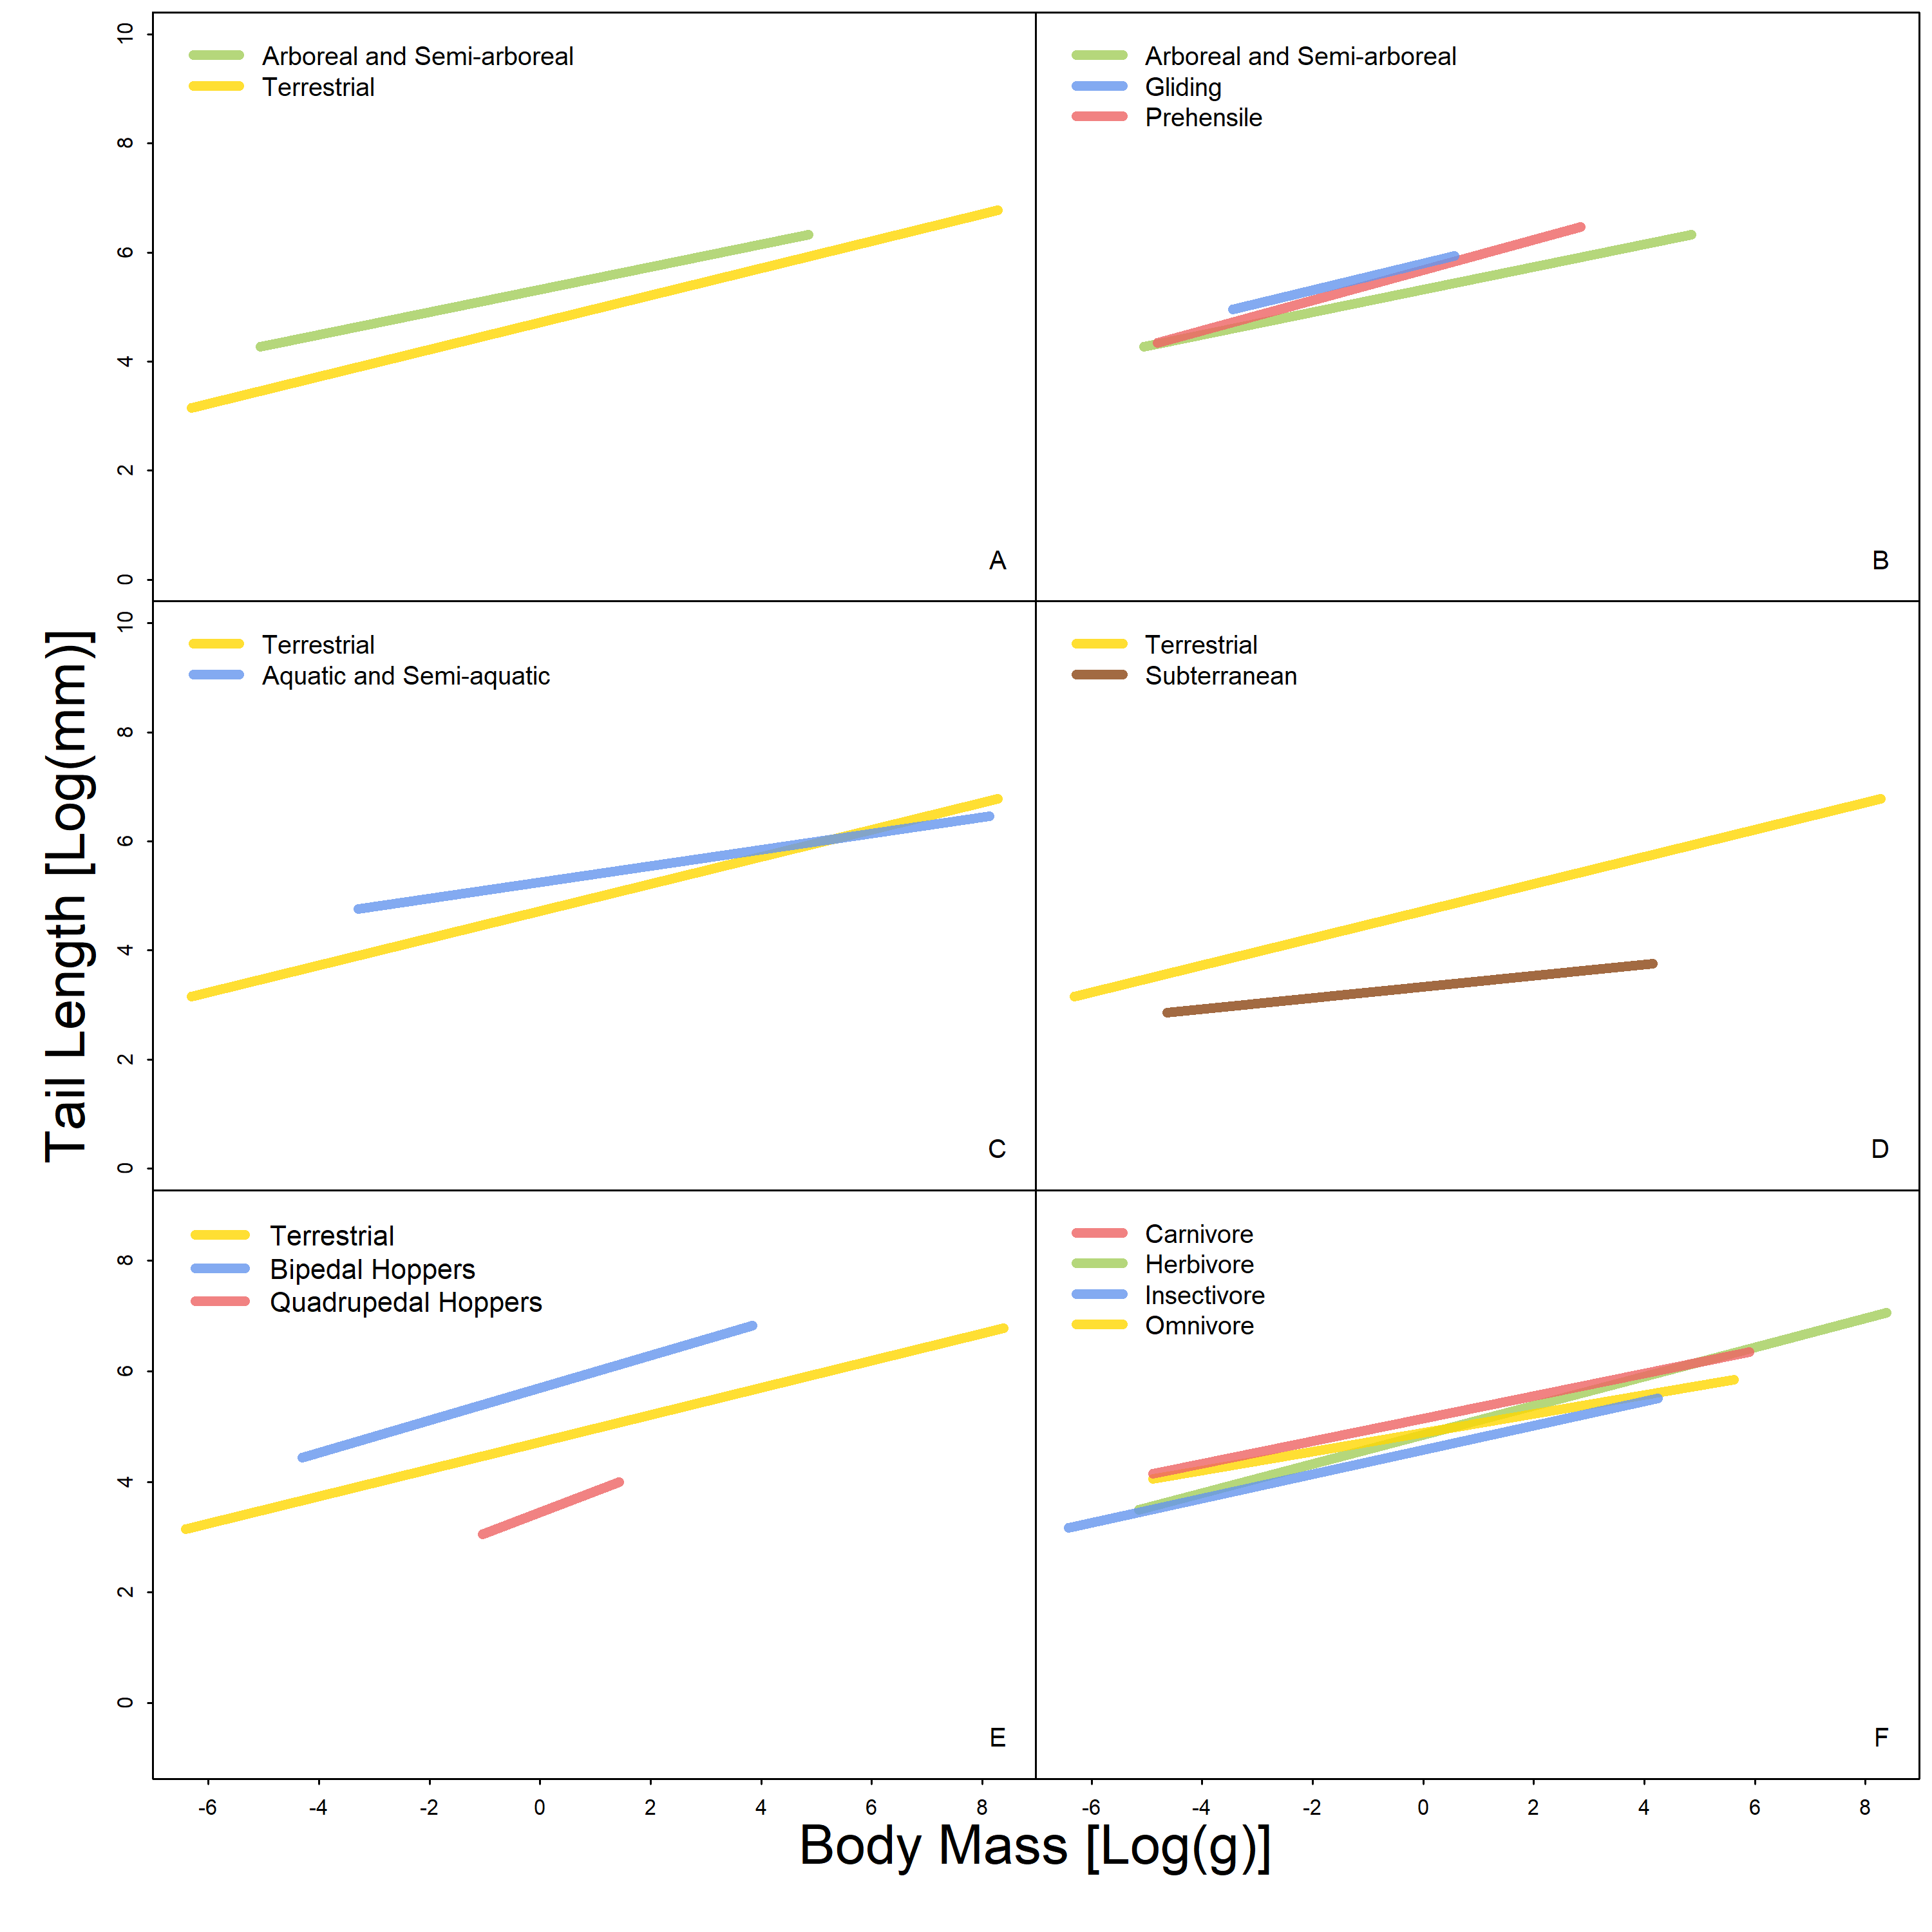
Figure S3. Tail length~body mass for the behavioral and categorial variables tested. Only lines of best fit are shown here to highlight shifts in slope and intercept for substrate (A, C), locomotor (B, D, E), and dietary (F) groups. Lines of best fit as well as data points shown in figure S2. Results listed in Table S2. Arboreal and semi-arboreal mammals have significantly longer tails than other mammals (S3A), and gliding and prehensile-tailed mammals have the longest tails of all arboreal and semi-arboreal mammals (S3B). Among non-arboreal mammals, aquatic and semi-aquatic species have some of the longest tails (S3C), while subterranean have the shortest (S3D). Grouped by locomotor mode, bipedal hoppers have the longest tails and quadrupedal hoppers have the shortest tails (S3E). Tail length differs by diet, with separation among herbivores, carnivores, omnivores, and insectivores (S3F).

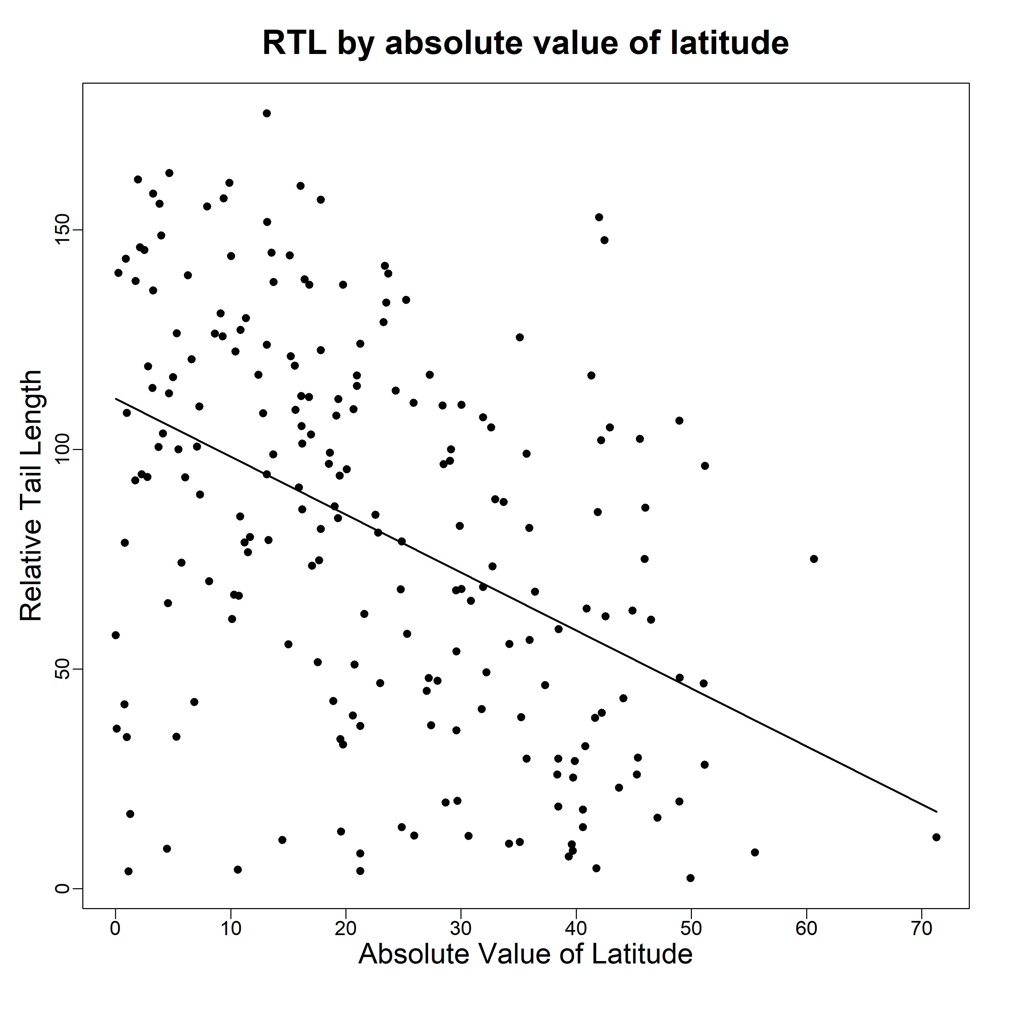
Figure S4. Relative tail length by latitude (used as a proxy for climate) R²= 0.19, p < 0.001, slope = -1.32, intercept = 111.56. Mammals living near the equator (absolute value of latitude 0) exhibit greater tail length diversity compared to mammals living further from the equator, which are instead restricted to shorter tail lengths.

References
[1] Smaers, J.B. & Rohlf, F.J. 2016 Testing species’ deviation from allometric predictions using the phylogenetic regression. Evolution 70, 1145-1149. (doi:10.1111/evo.12910).
[2] Pagel, M. 1997 Inferring evolutionary processes from phylogenies. Zoologica Scripta 26, 331-348. (doi:10.1111/j.1463-6409.1997.tb00423.x).
[3] Uyeda, J.C., Eastman, J. & Harmon, L. 2013 bayou: Bayesian fitting of Ornstein-Uhlenbeck models to phylogenies. R package version 2.0. (
[4] Adams, D., Collyer, M., Kaliontzopoulou, A. & Sherratt, E. 2016 Geomorph: Software for geometric morphometric analyses. R package version 3.0. Available at http://cran.r-project.org/web/packages/geomorph/index.html.
[5] Adams, D.C. 2012 Comparing evolutionary rates for different phenotypic traits on a phylogeny using likelihood. Systematic biology 62, 181-192.
[6] Adams, D.C. 2014 Quantifying and comparing phylogenetic evolutionary rates for shape and other high-dimensional phenotypic data. Systematic Biology 63, 166-177. (doi:10.1093/sysbio/syt105).

