SUPPORTING INFORMATION to:
Structure-behaviour correlations between two genetically closely related snail species
H. Le Ferrand^{1,*}, Y. Morii^{2,3}
¹ School of Mechanical and Aerospace Engineering, School of Materials Science and Engineering, Nanyang Technological University, Singapore
² Phenix Group, School of Agriculture and Environment, Massey University, Private Bag 11-222, Palmerston North 4410, New Zealand
³ Department of Forest Science, Research Faculty of Agriculture, Hokkaido University, Sapporo, Hokkaido 0608589, Japan
* To whom correspondence should be addressed : hortense@ntu.edu.sg

Figure S1. Angle of the snail shell with respect to the snail body (angle θ_{swing}) as a function of the time t and for 7 consecutive swings, for K. gainesi.

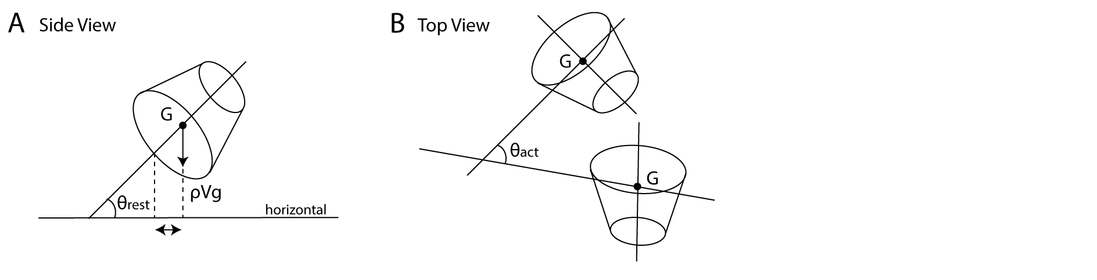
Figure S2. Schematics for the determination of the shell’s moment when the snail is at rest on a horizontal surface (A) and when the snail is swinging its shell (B).
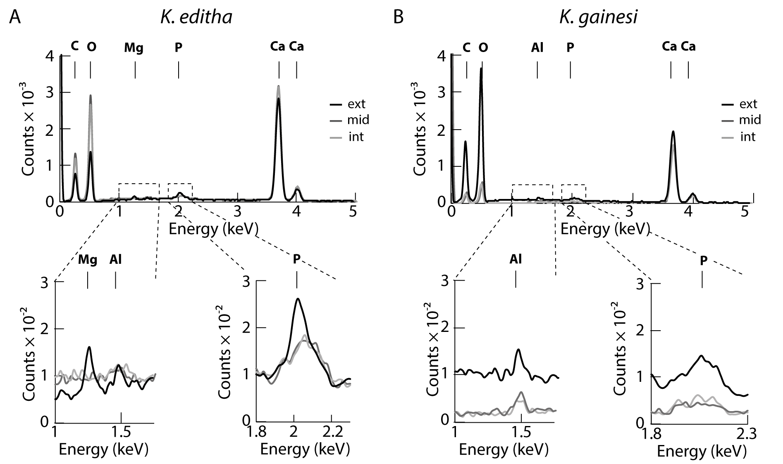
Figure S3. Energy dispersive X-Ray spectra up to 5 keV obtained for K. editha (A) and K. gainesi (B), respectively.

Table S1. Collection details of the snails.
