Supplementary Material for Wainwright et al. Overcoming the detectability cost of symmetrical colouration
Methods
Preparing the stimuli for Experiments 1 and 2
Nine images of Melanolophia specimens at rest were obtained using Google Images, from which the outline was obtained by using the “lasso” tool on Paint.net.4.0.16. A perfectly symmetrical outline was created by mirroring each half of each moth specimen, giving a total of 18 shapes which acted as replicates for the different experimental treatments. The target dimensions were approximately 55 mm wide by 20 mm high with small deviations depending on the particular moth outline.
Photographs of the bark of 180 oak trees (Quercus robor), were taken with a calibrated Nikon D80 (Nikon Corporation, Tokyo, Japan) at Leigh Woods National Nature Reserve (North Somerset, UK, 2°38.6’W, 51°27.8’N) to provide the surface patterning of the artificial prey and the backgrounds against which they would ‘rest’. That is, the prey were background-matching in the sense of being random samples from their backgrounds [1]. Each target was sampled from a different tree photo, from a randomly chosen location (selecting x and y coordinates using Matlab’s random number generator for a uniform distribution). This was in order to avoid the possibility of search image formation by the human participants and, in Experiment 2, wild avian predators (e.g. [2]).
Photographing museum specimens
Dead British moth specimens were acquired from collections at the Bristol City Museum and Art Gallery (Bristol, UK, 51°45.7’N, 2°20.6’W) in May 2018. Whole drawers of the specimens were photographed using a Nikon D80 with a Nikkor 35 mm lens under controlled lighting conditions after calibration with a Colorchecker chart (X-Rite, Tacoma Falls, USA). Using this, camera RGB values were converted to linearized and device-independent sRGB.
Editing moth images
Moth images were modified using the image editing software GIMP 2 (www.gmp.org). The entire body of each specimen was cropped and saved as a PNG image file. The left and right forewings were then individually cropped and, in the case of the museum specimens, rotated so that they were in the typical resting position of the species (this was judged by comparison with multiple photographs of the animal in Google Images). These were also saved as PNG image files.
Moth categorisation
In order to assign species for the analysis whilst also avoiding experimenter bias, the right forewings of the 152 cryptically coloured species photographed/scanned from the museum specimens and field guide were printed on to paper and cut out. Indicators of the presence of eyespots (concentric rings of contrasting colours) were not observed in any of the 152 species. Moths which did have eyespot characteristics on their forewings were discounted even before the human categorization task, as moths with these patterns would not have been classed as being camouflaged.
The cut-outs were shuffled and shown to 20 naïve human participants, individually, under controlled conditions in November 2018. Participants were asked to place each forewing in one of two categories: one for wings with discrete, high contrast markings (Category A) and another for wings with either homogenous patterns or horizontal markings that crossed the entire wing (Category B). Participants were informed that if some of the criteria for Category A were met on any area of the wing, the wing should be placed in Category A. If no criteria for Category A were met, the wing should be placed in Category B. There was no time limit for this task to be completed but participants took approximately 15-20 min. Of the 152 species used during the categorisation task, 95% of the test participants put 36 of those species into category A. It was the left and right forewings of these 36 species that were then selected to enter the image analysis (figure S1). Replicates were possible for all the moths from the museum collections. For moths obtained from the field guide, multiple images were only available for polymorphically coloured species.
Image analysis program
The PNG files of the left and right moth forewings were read into the MATLAB program, from which species and side (left or right) information was extracted. Image size was determined, and the alpha transparency channel of the PNG file ensured that only the area occupied by the wing was selected. In order to reduce the saliency of wing edges, wings were placed on a background equivalent to the mean colour (RGB) of the moth. From this, saliency maps were generated by applying an avian-vision adaptation [3] of a model created by Rosenholtz et al. [4,5]. The separate saliency maps are, in Rosenholtz et al.’s terminology, for ‘contrast’ (luminance contrast), colour and orientation. The edges (3 pixels) were removed from each of the saliency maps using the Matlab function ‘imerode’ with a disk-shaped ‘morphological structuring element’ (‘strel’ function) of radius 3 applied to the moth-wing mask by which the moth image was then multiplied. This was to further reduce any effect of contrast at the edge of each wing.
The Rosenholtz et al. model uses a transformation of a calibrated RGB image to L*a*b* colour space. An avian equivalent was created based on the colour space of a generalised passerine bird (the main avian predators of cryptic moths) by using a method previously applied by Stevens & Cuthill [7] and Xiao & Cuthill [3]. Photon catches of blue tit UV, S, M and L single cones, and double cones were created from sRGB data using a standard D65 illuminant. Double cone photon catches were used instead of luminance (the L in L*a*b*), the ratio of (L – M) to (M + L) photon catch as a red-green opponent channel, and the ratio of (M + L – 2*S) to (S + M + L) photon catch as a yellow-blue opponent channel. The scale of each channel/dimension was between 0 and 1 (for L, black = 0 and 1 = white; for a, 0 = green, 1 = red; for b, 0 = blue, 1 = yellow). The distance in the surrogate L dimension was used to calculate luminance contrast whilst chromatic contrast was calculated using the Euclidean distance in the surrogate 2D L*a*b* chromatic space.
Differences in the three salience measures (luminance, colour, and orientation) were highly correlated across images (figure S2). Luminance, colour, and orientation saliency maps were used to create a combined salience map by summing values of each column of pixels from left to right (for a right forewing) or right to left (for a left forewing) using empirically derived human weightings. The total salience transect was then smoothed using the “shape-preserving piecewise cubic interpolation” (option ‘pchip’ in Matlab’s interp1 function) over a 100-point line to generate the total salience in steps of 1% of the wing transect. Relative salience was then calculated by dividing the total salience at a particular transect point by the number of pixels used to calculate it, controlling for the width of the wing at that point. Species, side, absolute salience, and relative salience information was recorded to be used in the statistical analysis.
During the statistical analysis, the transect order for left forewings was reversed so that the salience of both left and right sides could be analysed by moving from the proximal (midline) to the distal end of the wing.

Supplementary statistical analyses
The museum specimens were photographed with a calibrated camera, so the mapping to avian colour space is reliable, but the same cannot be said for the images of species taken from the guidebook. We therefore performed two checks for the robustness of our results: an analysis to test for a difference in outcome between museum-photographed and book-scanned species, and an analysis using only avian-double-cone-based salience maps. The former was achieved by incorporating ‘source’ (museum vs book) in the models presented in the main text. There was no effect of image source on the difference in absolute salience between the middle third and inner third (t = 0.161, d.f. = 31.94, p = 0.873). There was a significantly higher difference for museum than book-derived images, when comparing the inner third and outer thirds (t = 2.190, d.f. = 32.1, p = 0.036), but the inner and outer thirds differed for both book (t = 6.849, d.f. = 5.89, p < 0.001) and museum photos (t = 6.293, d.f. = 8.19, p < 0.001). Relative salience comparisons did not differ with respect to image source (inner vs middle: t = 0.651, d.f. = 30.10, p = 0.520; inner vs outer: t = 1.449, d.f. = 32.66, p = 0.157). Therefore, the estimated differences between wing regions are similar, or weaker, for images derived from the guidebook than the properly calibrated museum images; they do not bias the results in favour of the predicted effects.
Repeating the analyses in the main text using only avian-double-cone-based salience maps is a sensible precaution for two reasons. First, the book-derived images are not even calibrated for human vision, far less avian, so the colour salience maps for this subset of the data may not be reliable. Second, evidence suggests that perception of pattern, which is the focus of our study, is dominated by achromatic cues in birds just as it is in humans [8]. Just as in the analyses presented in the main text, the absolute salience of the middle third was significantly greater than that of the inner third (t = 8.262, d.f. = 20.89, p < 0.001) and the inner third was significantly more salient than the outer third (t = 8.243, d.f. = 35.26, p < 0.001). For relative salience, just as in the main analysis, both the middle third and the outer third had a significantly greater relative salience than the inner third (t = 4.448, d.f. = 32.65, p < 0.001; t = 3.749, d.f. = 25.30, p < 0.001). This similarity of results between an analysis based on only achromatic information and the full luminance-colour-orientation salience maps is not surprising because the three salience maps of luminance, colour and orientation are highly correlated (Figure S2). That is, if there are coloured patches on the wings, they create contrast in luminance, hue and the orientation of edges.
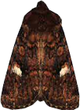
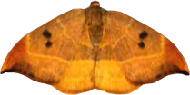
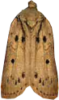
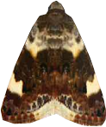
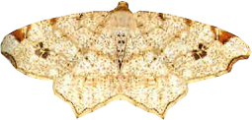
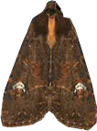
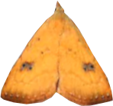
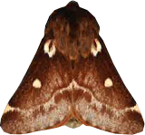
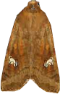
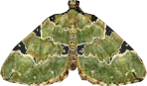
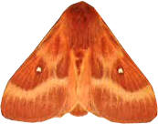
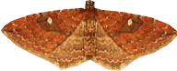
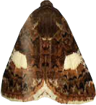
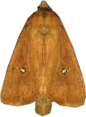
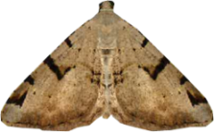
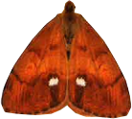
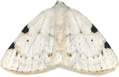
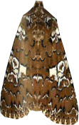
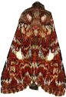
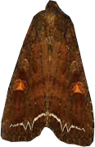
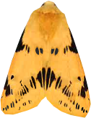
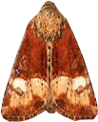
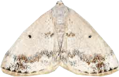
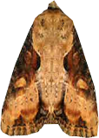
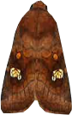
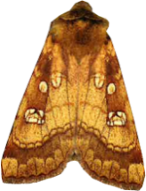
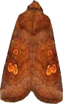
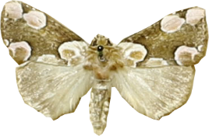
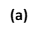
Figure S1 Photographic images of the 36 moth species which were taken at Bristol City Museum and Art Gallery’s collections (a) using a Nikon D80 DSLR (Nikkor 35 mm lens) and from the photographic field guide by Sterry et al. []6]. (b). After the human categorisation task, only these species were selected to enter the image analysis. Left and right forewings were cropped and rotated using GIMP2 editing software so that they were in the typical resting position of the species. From left to right: Beautiful golden Y (Autographa pulchrina), brimstone moth (Opisthograptis luteolata), buff tip (Phalera bucephala), dot moth (Melanchra persicariae), gold spangle (Autographa bractea), heart (Dicycla oo), peach blossom (Thyatira batis), small dark yellow underwing (Coranarta cardigera), white-spotted pinion (Cosmia diffinis), beautiful yellow underwing (Anarta myrtilli), bright-line brown eye (Lacanobia oleracea), buff ermine (Spilarctia luteum), cloaked minor (Mesoligia furunculi), clouded silver (Lomographa temerata), crinan ear (Amphipoea crinanensis), double lobed (Apamea ophiogramma), ear moth (Amphipoea oculea), fisher’s estuarine moth (Gortyna borelii), four-spotted (Tyta luctuosa), gem (Nycterosea obstipata), grass eggar (Lasiocampa trifolli), green carpet (Colostygia pectinaria), large ear (Amphipoea lucens), lesser common rustic (Mesapamea didyma), oak hook-tip (Watsonalla binaria), oak nycteoline (Nycteola revayana), oak rustic (Dryobota labecula), pale shoulder (Acontia lucida), peacock moth (Macaria notata), small eggar (Eriogaster lanestris), straw dot (Rivula sericealis), twin-spotted wainscot (Lenisa geminipuncta), v-moth (Macaria wauaria), vapourer (Orgyia antiqua), white pinion spotted (Lomographa bimaculate), white spot (Hadena albimacula). Moths are not shown to scale. Reprinted by permission of HarperCollins Publishers Ltd. © Sterry et al. (2016).
(b)

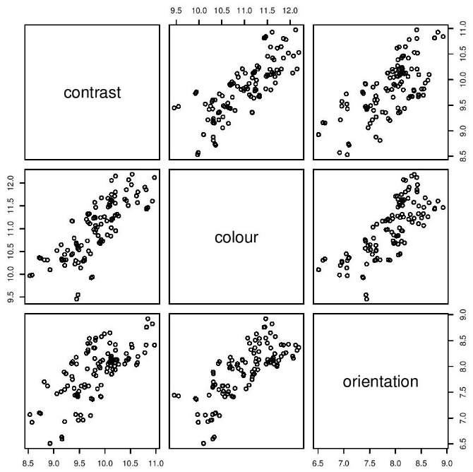

Figure S2 How the three salience measures (luminance contrast, colour contrast, orientation contrast; all log-transformed) correlate across images in the natural pattern analysis. The Pearson correlation between luminance salience and colour salience was 0.79, between luminance and orientation salience 0.70, and between colour and orientation salience 0.76 (all variables log-transformed to account for heteroscedasticity).

Supplementary references
- Endler, J. A. 1981 An overview of the relationships between mimicry and crypsis, Biological Journal of the Linnean Society, 16, 25-31.
- Pietrewicz, A. T. & Kamil, A. C. 1979 Search image formation in the blue jay (Cyanocitta cristata), Science, 204, 1332-1333.
- Xiao, F. & Cuthill, I. C. 2016 Background complexity and the detectability of camouflaged targets by birds and humans. Proc. R. Soc. B, 283, 20161527.
- Rosenholtz, R., Li, Y., Mansfield, J. & Jin, Z. 2005 Feature congestion: a measure of display clutter, In Proceedings of the SIGCHI Conference on Human Factors in Computing Systems, ACM, 761-770.
- Rosenholtz, R., Li, Y. & Nakano, L. 2007 Measuring visual clutter, Journal of Vision, 7, 1-22.
- Sterry, P., Cleave, A. & Read, R. 2016 British Butterflies & Moths (Collins Complete Guides). London, William Collins.
- Stevens, M. & Cuthill, I. C. 2006 Disruptive coloration, crypsis and edge detection in early visual processing, Proc. R. Soc. Lond. B, 273, 2141-2147.
- Jones, C.D. & Osorio, D. 2004 Discrimination of orientated visual textures by poultry chicks. Vision Res. 44, 83-89.

