Supplementary Materials S1
Corticosterone (CORT) Measurement
We validated the Corticosterone High Sensitivity EIA Kit (Immunodiagnostic Systems Ltd., Fountain Hills, AZ, USA) for use in Anolis sagrei by assessing both parallelism and quantitative recovery of a known CORT addition (spike).
Parallelism
To assess parallelism we generated a pooled plasma sample by combining plasma from both male and female A. sagrei (n=15). We serially diluted the pooled sample from 1:1 to 1:128 in assay buffer and assessed samples in duplicate. We compared the slope of the dilution curve to the standard curve, and the curves were not different (t₁₀=-0.368, p=0.720; Zar 1996). This indicates the kit measures CORT in A. sagrei in a fashion indistinguishable from the standards provided with the kit. The dilution curve was used to determine that a 1:10 dilution for samples was ideal as average samples would fall close to 50% binding values for the assay kit.
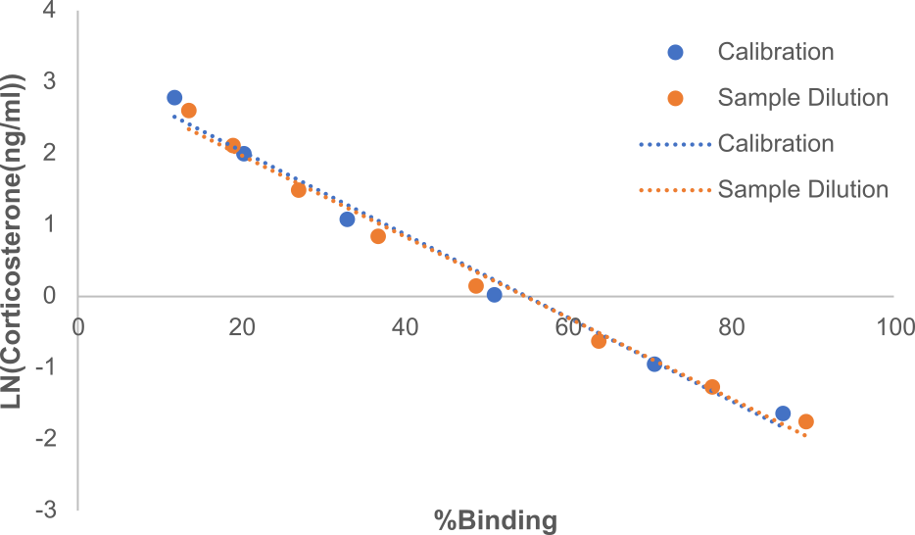
Figure S1. Comparison of slopes produced from serial dilution of control solution provided with kit (Calibration, blue) and from serial dilution of pooled sample (Sample Dilution, orange). Corticosterone concentrations were calculated by fitting absorbance values to a four point logistic curve. Equation for linear fit to calibration values: y = -0.0583x + 3.2043; R² = 0.9869. Equation for linear fit to pooled sample dilution values: y = -0.0567x + 3.1105; R² = 0.9882. Slopes were not significantly different indicating parallel responses were achieved.
Recovery
To assess recovery we generated a pooled plasma sample by combining plasma from both male and female A. sagrei (n=7) which was spiked with known concentrations of CORT from control standard provided with the kit. We created three dilutions of control solution from the kit (1:1, 1:5, and 1:10) to make a high, middle, and low spike. We split the pooled sample evenly into micro-centrifuge tubes and mixed with equal volumes of the diluted control standard to add known spikes of CORT to each sample as well as assaying a non-spiked sample of the pooled plasma. Each sample was assessed in duplicate. CORT measured in the unspiked pooled sample was 15.01 ng/ml, and made up 8 ul (2.4016 ng) of each 50 ul spiked sample. Average recovery across the three spikes was 110.3% (range: 92.7-135%). The coefficient of variation in measured and calculated CORT for the three spiked samples was 4.55%.
Spike | Measured CORT (ng/ml) | Calculated CORT (ng/ml) | % Recovery
High | 15.711 | 16.766 | 0.927
Medium | 5.368 | 5.274 | 1.033
Low | 4.341 | 3.838 | 1.350
Table S1. Values of CORT concentration measured from samples with high, medium, and low spikes of CORT added along with calculated concentrations and estimates of percent recovery.
References:
Zar JH. Biostatistical analysis. Englewood Cliffs: Prentice-Hall; c1996.

