Supplementary Materials S4:
Levels of ALAN intensity at perches of sleeping anoles at study site:
From 6/12/16 to 6/20/16 we measured light intensities at sleeping perches of anoles at our collection site using a TES 1332A Digital Lux Meter. Anoles commonly perched on branches, leaves, and fronds of vegetation including shrubs, cycads, and bushes. The habitat had a mostly closed canopy and no direct sources of ALAN. Light levels ranged from 0.0-0.1 lux (n = 104). Readings for only two anoles indicated a light level of 0.1 lux, with all other measurements indicating light levels below the detection limit of the meter (0.0).
Levels of ALAN intensity at perches of sleeping anoles at an urban park in Miami:
On 9/17/2016, we measured light intensities at sleeping perches of anoles in a park in the Miami metropolitan area (25.7460°, -80.2585°, WGS84) using a TES 1332A Digital Lux Meter. Habitats in the park included shrubs and small plants commonly used in landscaping, and, while multiple trees were present, the canopy was largely open. The park was illuminated by several streetlights which were not accessible to anoles for foraging on insects attracted to ALAN due to their height and distance from accessible perches. All measurements were taken at sites of anoles that were inactive and sleeping when encountered. Light levels (0.68 ± 0.23 lux; mean ± SE; n = 18) ranged from 0.1-3.8 lux with the lowest levels occurring at perches shaded from light by vegetation. All sleeping perches registered at least 0.1 lux whereas only 2% of sleeping perches at our natural collection site had light levels of ≥ 0.1 lux. We compared light levels at these sites using a Mann-Whitney U test, and light levels at the urban park were significantly higher than those at our collection site (W = 1, p < 0.0001).
Levels of ALAN intensity at perches exposed to landscape lighting in Miami:
In summer 2018, we measured light levels associated with a series of standard 150 W landscaping lights (GE floodlight 150W PAR38 halogen bulbs; n=8). These bulbs are commonly stocked at hardware and home improvement stores in the Miami area (where they were purchased) for landscape lighting applications and were mounted in weatherproof landscape light sockets. Light levels were measured using a TES 1332A Digital Lux Meter at distances of 2.5, 5, and 7.5 m from each light source at heights randomly assigned between 0.2 and 2 m. If a potential anole perch was within 0.25 m of the assigned location, we took data from the closest such perch. Many locations at which light levels were measured were blocked from direct exposure to the light source by intervening foliage, reducing light levels below maximal potential exposure levels. At each location, we measured light levels with the light meter perpendicular to the light source (representing maximal exposure) or at a 45° angle to the light source (representing a moderate level of exposure). Based on our experience, anoles using artificial lights to actively forage for insects attracted to lights generally do so no farther then 3-4 m from the light source, likely due to the lack of insects attracted to lights at distances >3-4 m from the source (see Fig. S4). Light levels varied due to the presence of foliage, but show that anoles close enough to landscape lights to benefit from foraging on insects attracted to the lights (<4 m), are likely to experience light levels comparable to or greater than levels to which anoles were exposed in our lab treatment (Fig. S3). Anoles are exposed to these levels of ALAN while foraging on insects attracted to lights in urban areas, including on walls of structures (Fig. S4A) and on natural perches and the ground near landscape lights (Fig. S4B and C) which are common in urban Miami (Fig. S4D). Measurements on landscape lights of the same type (n=10) in 2014 yielded similar results, with a mean light level of 92 lux at a distance of 3 m from light sources (H. Moniz, unpubl. data).

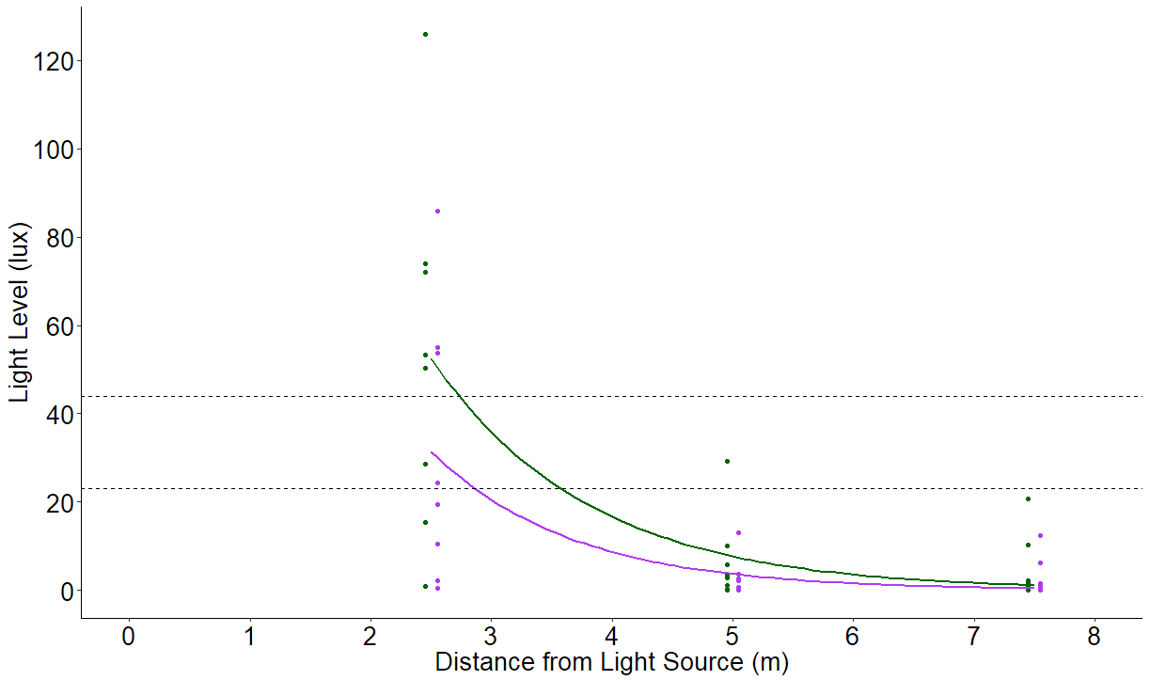
Figure S3. Light levels from perches in front of landscape lights at distances of 2.5, 5, and 7.5 m from light source with light meter held perpendicular to light source (maximal exposure, dark green) and at a 45° angle to light source (moderate exposure, purple). Light levels are offset on x-axis to improve readability. Dotted lines represent range of light levels in ALAN treatment in our lab experiment.

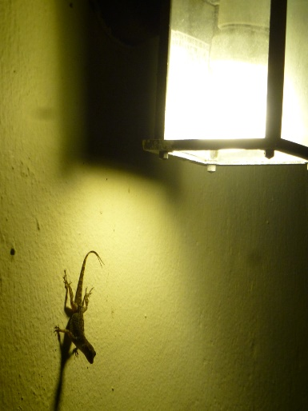
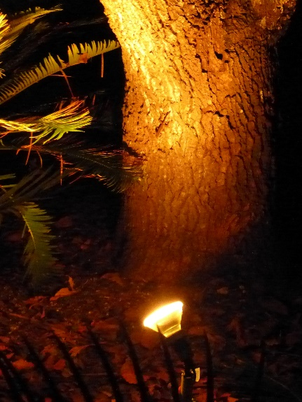
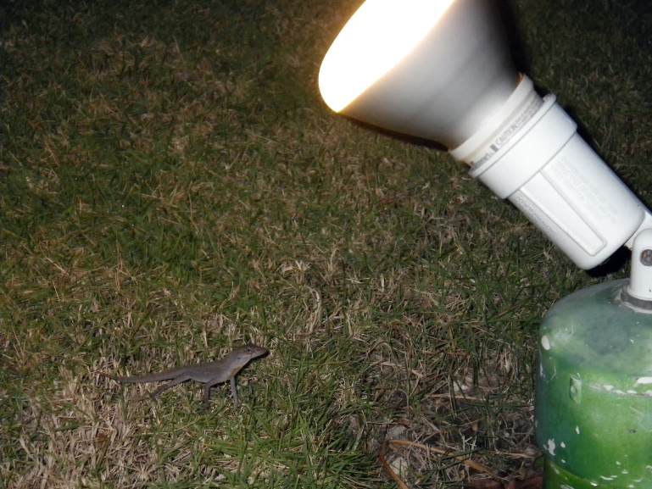
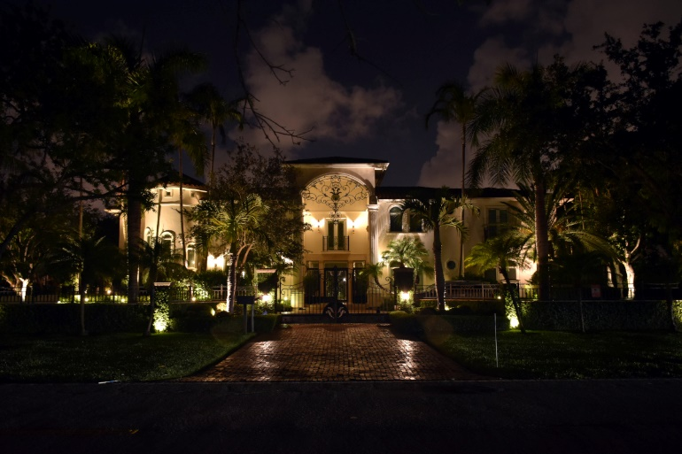
A
B
C
D

Figure S4. Anoles actively forage in close proximity to street, house, and landscape lights (0.25 m from light [A]; 1.25m from light [B]; 0.25 m from light [C]). Such lighting is common in residential areas near the collection site (<1 km) for anoles used in this experiment (D).

