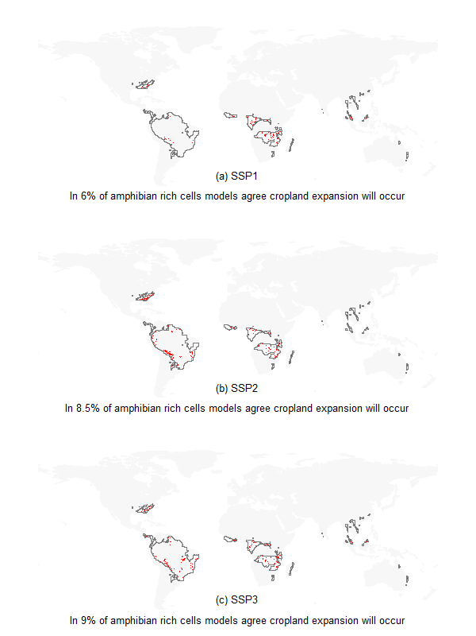
Figure S1: Spatial distribution of agreement across models on where cropland will occur from 2010-2050 within amphibian species rich hotspots across SSP scenarios
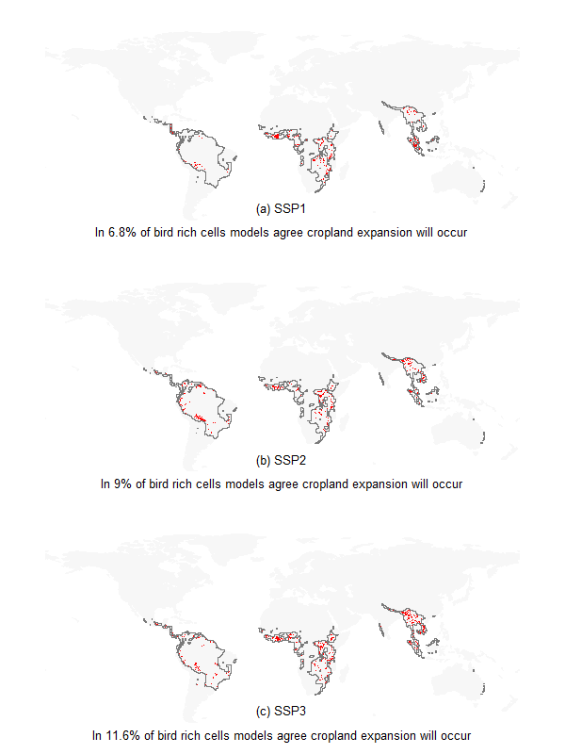
Figure S2: Spatial distribution of agreement across models on where cropland will occur from 2010-2050 within bird species rich hotspots across SSP scenarios
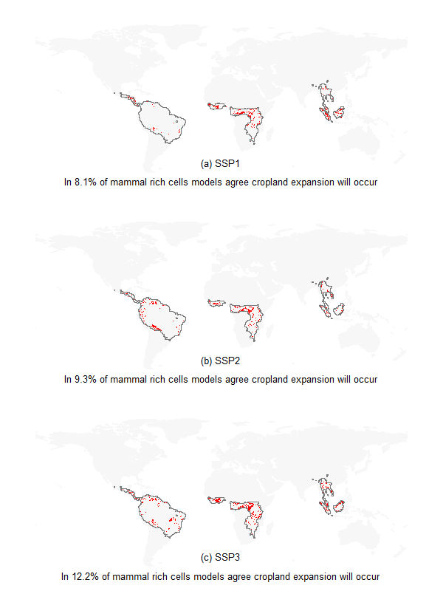

Figure S3: Spatial distribution of agreement across models on where cropland will occur from 2010-2050 within mammal-species-rich hotspots across SSP scenarios

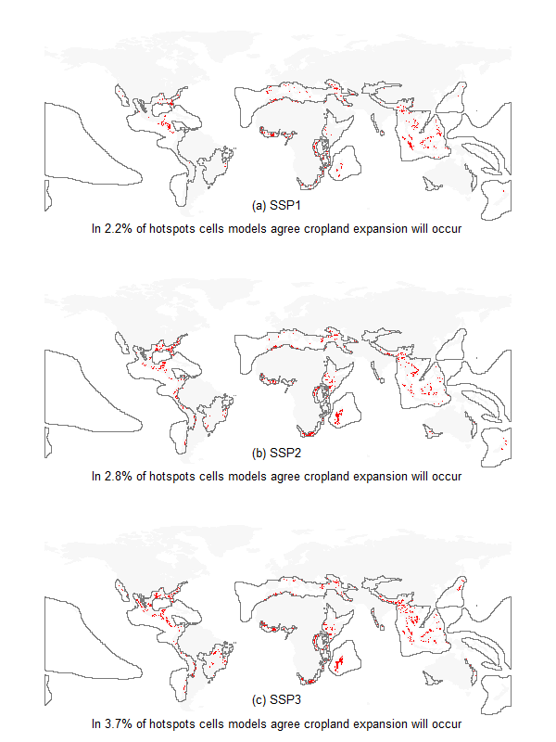

Figure S4: Spatial distribution of agreement across models on where cropland will occur from 2010-2050 within CI biodiversity hotspots across SSP scenarios

Appendix A: Count of AZE sites per country impacted by cropland expansion from 2010-2050 across all models and SSP scenarios. Rows with more than one country indicate AZE sites overlapping multiple countries.

 | SSP1 |  |  |  |  | Total | SSP2 |  |  |  | ssp3 |  |  | Total | Grand total
 | GloBIOM |  | IMAGE | PLUM |  |  | GloBIOM | IMAGE | PLUM Total |  | GloBIOM | IMAGE | PLUM
Africa | 37 |  | 50 |  | 22 57 |  | 39 | 56 | 18 63 |  | 41 | 56 | 27 | 62 | 66
Angola | 2 |  | 1 |  | 2 | 2 | 2 | 2 | 2 | 2 | 2 | 2 | 2 | 2 | 2
Cameroon | 3 |  | 4 |  | 1 | 6 | 3 | 9 |  | 9 | 6 | 9 | 1 | 9 | 9
Congo, The Democratic Republic Of | 1 |  | 3 |  | 2 | 3 | 1 | 3 | 1 | 3 | 2 | 3 | 2 | 3 | 3
Cote D'ivoire | 1 |  | 1 |  |  | 1 | 1 | 1 |  | 1 | 1 | 1 |  | 1 | 1
Cote D'ivoire, Guinea, Liberia | 1 |  | 1 |  | 1 | 1 | 1 | 1 | 1 | 1 | 1 | 1 |  | 1 | 1
Ethiopia | 4 |  | 4 |  |  | 4 | 5 | 5 |  | 6 | 4 | 4 |  | 5 | 6
Etiopia |  |  |  |  |  |  | 1 |  |  | 1 |  |  |  |  | 1
Gabon |  |  |  |  | 1 | 1 |  |  | 1 | 1 |  |  | 1 | 1 | 1
Kenya | 3 |  | 4 |  | 2 | 4 | 3 | 3 | 2 | 4 | 3 | 3 | 2 | 4 | 4
Liberia | 1 |  | 1 |  |  | 1 | 1 |  |  | 1 | 1 | 1 |  | 1 | 1
Madagascar | 10 |  | 17 |  | 5 | 18 | 10 | 18 | 2 | 19 | 10 | 20 | 9 | 20 | 20
Malawi | 1 |  |  |  |  | 1 | 1 | 1 |  | 1 | 1 |  |  | 1 | 1
Mozambique | 1 |  |  |  |  | 1 |  |  |  |  |  |  |  |  | 1
Reunion |  |  |  |  |  |  |  | 1 |  | 1 |  |  |  |  | 1
Réunion (to France) |  |  |  |  |  |  |  | 1 |  | 1 |  | 1 |  | 1 | 1
Rwanda | 1 |  | 1 |  |  | 1 | 1 | 1 |  | 1 | 1 | 1 |  | 1 | 1
Somalia | 1 |  |  |  |  | 1 | 1 | 1 |  | 1 | 1 | 1 | 1 | 1 | 1
South Africa | 1 |  | 1 |  | 1 | 1 | 1 | 1 | 1 | 1 | 1 | 1 | 1 | 1 | 1
Tanzania, United Republic Of | 3 |  | 7 |  | 6 | 7 | 4 | 6 | 6 | 6 | 3 | 6 | 6 | 6 | 7
Uganda | 2 |  | 2 |  |  | 2 | 2 | 2 | 1 | 2 | 2 | 2 | 1 | 2 | 2
Zimbabwe | 2 |  | 2 |  | 1 | 2 | 2 |  | 1 | 2 | 2 |  | 1 | 2 | 2
ASIA | 40 |  | 47 |  | 27 | 72 | 49 | 40 | 37 | 76 | 54 | 46 | 50 | 78 | 86
Afghanistan |  |  |  |  |  |  | 1 | 1 |  | 1 | 1 |  |  | 1 | 1
China | 8 |  | 13 |  | 13 | 21 | 9 | 8 | 14 | 21 | 10 | 11 | 14 | 21 | 23
India | 5 |  | 7 |  | 2 | 10 | 11 | 11 | 6 | 14 | 12 | 14 | 7 | 15 | 16
Indonesia | 12 |  | 14 |  | 3 | 18 | 13 | 11 | 1 | 18 | 14 | 12 | 12 | 20 | 20
Japan | 4 |  | 1 |  | 1 | 4 | 4 | 3 | 2 | 5 | 3 | 2 | 3 | 3 | 6
Malaysia | 2 |  | 2 |  | 2 | 2 | 2 |  | 2 | 2 | 2 |  | 2 | 2 | 2
Myanmar | 2 |  |  |  | 2 | 3 | 2 | 2 | 2 | 3 | 2 | 2 | 2 | 3 | 3
Philippines | 1 |  | 4 |  | 1 | 4 | 1 | 1 |  | 2 | 3 |  | 1 | 3 | 5
Sri Lanka | 6 |  | 3 |  |  | 6 | 6 | 2 | 6 | 6 | 6 | 3 | 6 | 6 | 6
Vietnam |  |  | 3 |  | 3 | 4 |  | 1 | 4 | 4 | 1 | 2 | 3 | 4 | 4
EUROPE AND THE MIDDLE EAST | 6 |  | 2 |  | 2 | 7 | 7 | 2 | 1 | 7 | 7 | 2 | 3 | 8 | 8
Armenia | 1 |  | 1 |  | 1 | 1 | 1 | 1 |  | 1 | 1 | 1 | 1 | 1 | 1
Austria |  |  |  |  | 1 | 1 | 1 |  | 1 | 1 | 1 |  | 1 | 1 | 1
Italy | 1 |  |  |  |  | 1 | 1 |  |  | 1 | 1 |  |  | 1 | 1
Portugal | 1 |  |  |  |  | 1 | 1 |  |  | 1 | 1 |  |  | 1 | 1
Spain | 1 |  |  |  |  | 1 | 1 |  |  | 1 | 1 |  | 1 | 1 | 1
Turkey | 2 |  | 1 |  |  | 2 | 2 | 1 |  | 2 | 2 |  |  | 2 | 2
Ukraine |  |  |  |  |  |  |  |  |  |  |  | 1 |  | 1 | 1
NORTH AMERICA | 55 |  | 73 |  | 46 | 103 | 68 | 68 | 55 | 113 | 75 | 72 | 67 | 113 | 128
America | 1 |  | 2 |  | 1 | 2 | 1 | 2 | 1 | 2 | 1 | 2 | 1 | 2 | 3
Canada | 2 |  | 1 |  |  | 2 | 1 |  | 1 | 1 | 1 | 1 | 1 | 1 | 2
Costa Rica | 3 |  | 2 |  | 2 | 3 | 3 | 1 | 2 | 3 | 3 | 2 | 2 | 3 | 3
Costa Rica, Panama | 1 |  | 1 |  | 1 | 1 | 1 |  | 1 | 1 | 1 | 1 | 1 | 1 | 1
Cuba | 2 |  | 5 |  | 3 | 6 | 3 | 5 | 3 | 10 | 3 | 12 | 6 | 14 | 14
Dominican Republic | 2 | 2 |  |  |  | 2 |  |  | 2 | 2 |  | 1 | 2 | 2 | 2
El Salvador, Honduras | 1 |  |  |  |  | 1 | 1 |  |  | 1 | 1 |  |  | 1 | 1
Guadeloupe | 1 |  |  |  |  | 1 |  |  |  |  |  |  |  |  | 1
Guatemala | 8 |  | 6 |  | 6 | 8 | 8 | 5 | 6 | 8 | 8 | 6 | 6 | 8 | 8
Haiti | 5 |  |  |  | 2 | 5 | 5 |  | 4 | 6 | 6 |  | 4 | 6 | 6
Honduras | 10 |  | 6 |  | 6 | 12 | 11 | 4 | 4 | 12 | 11 | 9 | 9 | 12 | 13
Jamaica | 2 |  | 2 |  |  | 3 | 5 |  |  | 5 | 5 |  |  | 5 | 5
Mexico | 14 |  | 44 |  | 21 | 49 | 23 | 45 | 28 | 51 | 28 | 36 | 33 | 50 | 57
Panama | 1 |  |  |  | 1 | 1 | 1 | 1 | 1 | 1 | 1 | 1 | 1 | 1 | 1
Puerto Rico | 3 |  |  |  |  | 3 | 3 |  |  | 3 | 3 |  |  | 3 | 3
St Lucia |  |  | 1 |  |  | 1 |  |  |  |  |  |  |  |  | 1
Trinidad and Tobago |  |  |  |  |  |  |  | 1 |  | 1 | 1 |  |  | 1 | 1
United States Of America | 2 |  |  |  | 1 | 3 | 2 | 4 | 2 | 6 | 2 | 1 | 1 | 3 | 6
PACIFIC | 10 |  | 18 |  |  | 23 | 11 | 15 | 1 | 23 | 13 | 18 | 5 | 25 | 31
Australia | 4 |  | 9 |  |  | 12 | 5 | 7 | 1 | 12 | 6 | 8 | 4 | 13 | 14
Fiji |  |  | 2 |  |  | 2 |  | 1 |  | 1 |  |  |  |  | 2
New Caledonia | 1 |  |  |  |  | 1 |  | 3 |  | 3 |  | 3 | 1 | 3 | 3
New Zealand | 2 |  | 2 |  |  | 2 | 2 | 2 |  | 2 | 2 | 3 |  | 3 | 3
Papua New Guinea | 4 |  | 2 |  |  | 4 | 4 | 1 |  | 4 | 5 | 4 |  | 6 | 6
Samoa |  |  |  |  |  |  |  | 1 |  | 1 |  |  |  |  | 1
Solomon Islands | 1 |  |  |  |  | 1 |  |  |  |  |  |  |  |  | 1
Vanuatu |  |  | 1 |  |  | 1 |  |  |  |  |  |  |  |  | 1
SOUTH AMERICA | 58 |  | 51 |  | 51 | 103 | 102 | 92 | 51 | 138 | 98 | 48 | 64 | 124 | 153
Argentina | 4 |  | 2 |  | 2 | 5 | 5 | 5 | 4 | 8 | 5 | 4 | 5 | 9 | 9
Bolivia | 8 |  | 4 |  | 2 | 8 | 9 | 6 | 2 | 9 | 9 | 4 | 2 | 9 | 9
Brazil | 6 |  | 17 |  | 8 | 22 | 12 | 8 | 6 | 14 | 12 | 3 | 8 | 15 | 24
Chile | 1 |  | 1 |  |  | 1 | 1 | 3 |  | 3 | 3 | 1 | 1 | 3 | 3
Colombia | 9 |  | 10 |  | 7 | 17 | 24 | 21 | 13 | 33 | 24 | 6 | 16 | 29 | 35
Colombia, Venezuela | 1 | 1 |  |  |  | 1 |  | 2 |  | 2 |  | 2 | 1 | 2 | 2
Ecuador | 6 |  | 7 |  | 8 | 11 | 12 | 16 | 8 | 23 | 10 | 3 | 5 | 13 | 23
Paraguay |  |  |  |  | 1 | 1 |  |  | 1 | 1 |  |  | 1 | 1 | 1
Peru | 19 |  | 6 |  | 18 | 29 | 30 | 22 | 14 | 34 | 27 | 18 | 20 | 32 | 35
Venezuela | 5 |  | 3 |  | 4 | 8 | 9 | 9 | 3 | 11 | 8 | 7 | 5 | 11 | 12
Grand Total | 206 |  | 241 |  | 148 | 365 | 276 | 273 | 163 | 420 | 288 | 242 | 216 | 410 | 472

