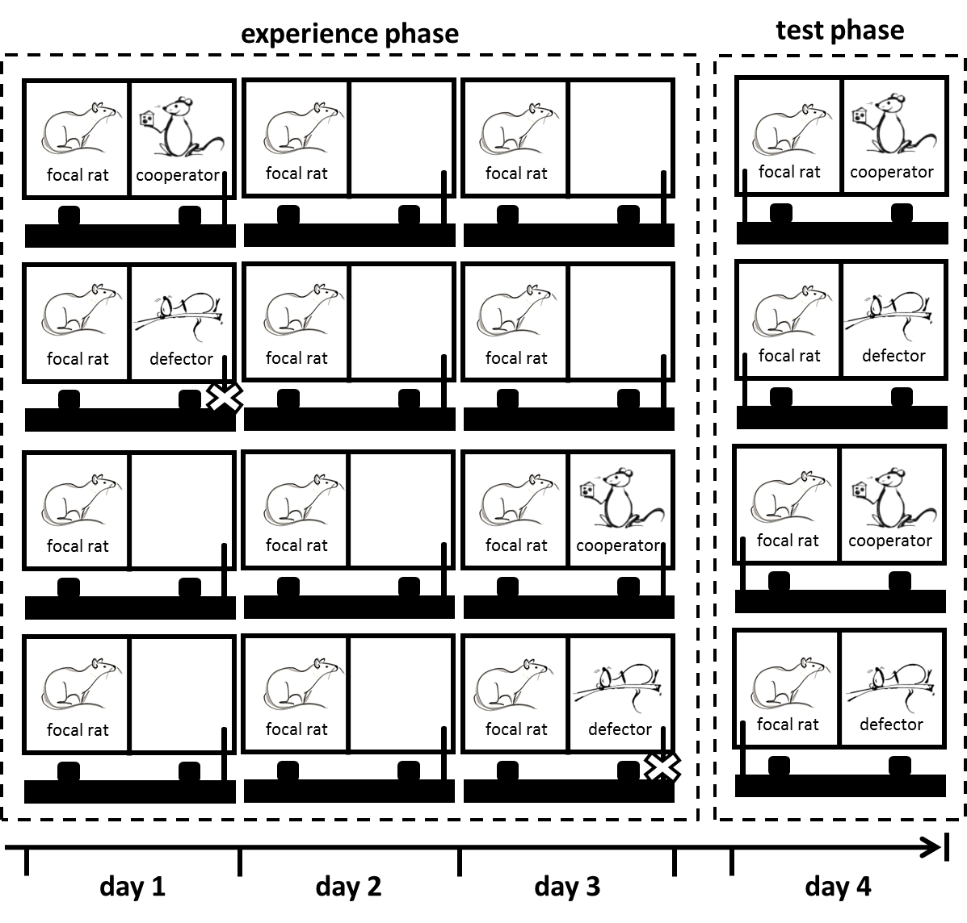
Fig. S1: Experimental setup of the memory capacity test
Focal rats experienced either cooperating (provided food) or defecting (did not provide food, indicated by a cross across the pulling stick) social partners one or three days prior to the test phase. In the test phase (day 4), focal rats were enabled to provide food to their partners.

