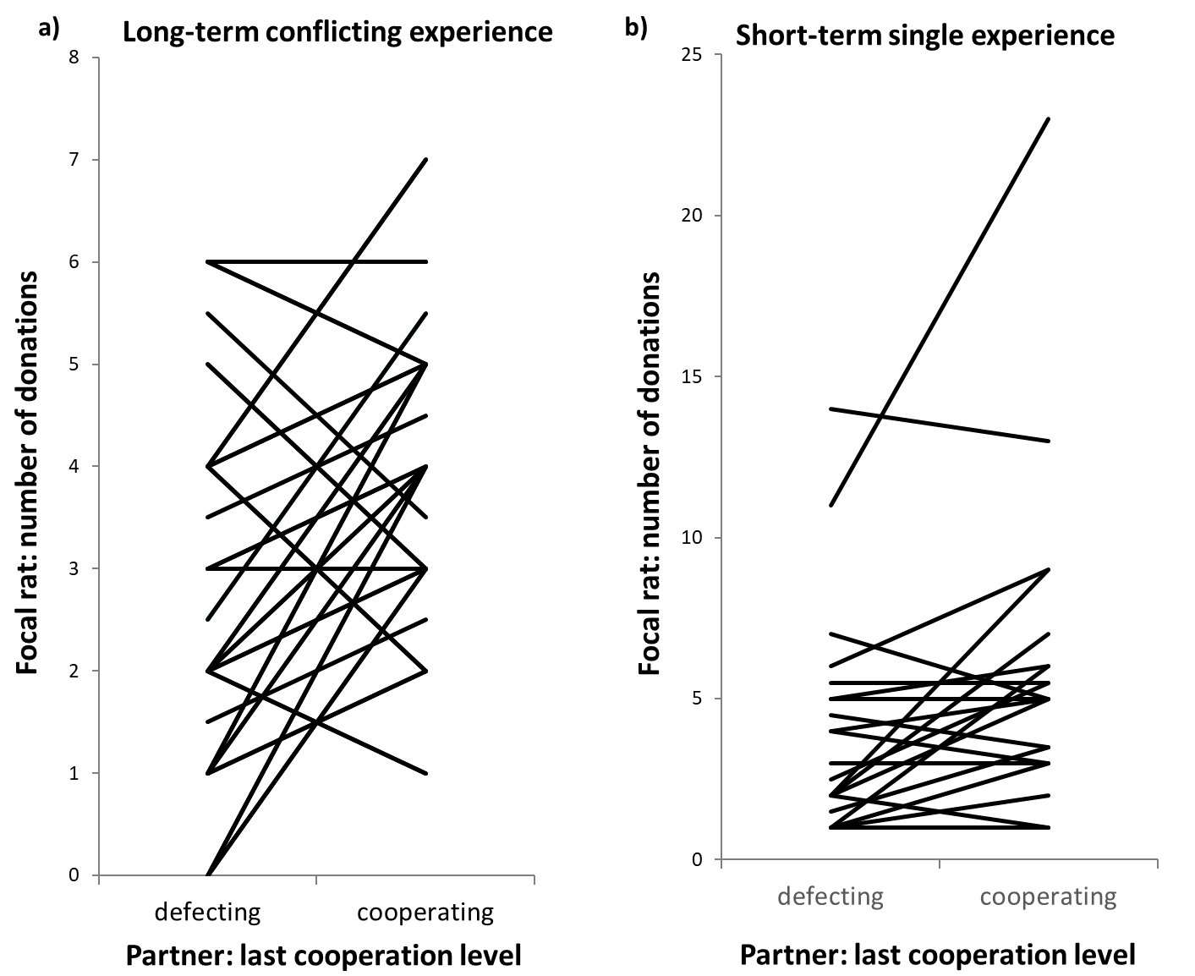
Fig. S2: Food donations of focal rats to their social partners depending on the latter’s previous long-term or short-term cooperation propensity.
Focal rats pulled more often for partners (DDDC) that had defected for three days but cooperated on the last day prior the test phase, compared to partners (CCCD) that had cooperated for three days but defected on the last day (panel a, long-term conflicting experience). Likewise, rats provided more food to cooperating (C) than to defecting partners (D) that had been encountered only once, i.e. on the day before they could provide them with food (panel b, short-term consistent experience). Every line represents the raw data for a single focal rat towards its partner. To avoid overlap of data, we raised the respective lines of 4 individuals in (a) and in (b) by 0.5 units on the ordinate for better visibility. The slopes of lines were not affected by this measure.

