Supplementary Tables & Figures

Supplementary Table S1. Data summarizing the rocks used to impact trees during field experiments where impact sounds were suitable for acoustic and statistical analyses. Three standardized rocks were used during the course of the experiment (SI1, SI2, SI3) supplemented by other rocks assumed to be chimpanzee tools based on impact signs at AST sites.
rock ID | type | weight (kg) | length (cm) | width (cm) | height (cm)
SI1 | igneous | 3.00 | 16 | 15 | 8
SI2 | laterite | 3.00 | 16 | 16 | 7
SI3 | igneous | 3.00 | 16 | 14 | 8
rock A | laterite | 8.50 | 22 | 17 | 15
rock B | laterite | 6.00 | 18 | 15 | 12
rock C | laterite | 3.50 | 18 | 12 | 11
rock D | laterite | 2.25 | 14 | 13 | 8
rock E | laterite | 3.25 | 19 | 13 | 9
rock F | laterite | 3.75 | 17 | 15 | 8
rock G | laterite | 3.25 | 16 | 13 | 8

Supplementary Table S2. LMM results for attack time (ms*1000) as the response variable.
 | estimate ± SE | T | Chisq | df | P | CI 2.5% | CI 97.5%
Intercept | 4.22 ± 0.75 | 5.65 | - | - | - | 2.70 | 5.69
throw.target.hollow | -1.40 ± 0.67 | -2.10 | 10.86 | 2 | 0.004 | -2.83 | 0.04
throw.target.trunk | -2.07 ± 0.55 | -3.73 |  |  |  | -3.92 | -0.94
ASTspecies.yes | 0.97 ± 0.61 | 1.60 | 2.86 | 1 | 0.09 | -0.25 | 2.24
z.tree.dbh | 0.42 ± 0.26 | 1.60 | 2.28 | 1 | 0.13 | -0.17 | 1.47
z.stoneweight | -0.04 ± 0.17 | -0.25 | 0.06 | 1 | 0.80 | -0.63 | 0.52
stone.type.laterite | -0.10 ± 0.32 | -0.32 | 0.10 | 1 | 0.75 | -0.78 | 0.68
recording.level.3 | 0.24 ± 0.48 | 0.50 | 0.21 | 1 | 0.65 | -0.95 | 1.34
Full versus null model comparison χ²=18.84, df=4, P<0.001, N=125

Supplementary Table S3. LMM results for spectral centroid (Hz) as the response variable.
 | estimate ± SE | T | Chisq | Df | P | CI 2.5% | CI 97.5%
Intercept | 3910 ± 559 | 7.00 | - | - | - | 2731 | 5086
throw.target.hollow | 2840± 638 | 4.45 | 9.13 | 2 | 0.010 | 937 | 4352
throw.target.trunk | 2073 ± 347 | 5.97 |  |  |  | 1114 | 2798
ASTspecies.yes | -1590 ± 643 | -2.47 | 5.85 | 1 | 0.016 | -2932 | -181
z.tree.dbh | 491 ± 289 | 1.70 | 0.63 | 1 | 0.43 | -1057 | 1176
z.stoneweight | -93 ± 91 | -1.02 | 0.99 | 1 | 0.32 | -419 | 369
stone.type.laterite | -284 ± 165 | -1.73 | 2.14 | 1 | 0.14 | -776 | 121
recording.level.3 | -15 ± 169 | -0.09 | 0.007 | 1 | 0.93 | -469 | 350
Full versus null model comparison χ²=23.33, df=4, P<0.001, N=125

Supplementary Table S4. LMM results for the absolute damping coefficient as the response.
 | estimate ± SE | T | Chisq | Df | P | CI 2.5% | CI 97.5%
Intercept | 126 ± 17 | 7.50 | - | - | - | 92.5 | 163
throw.target.hollow | 22.5 ± 15 | 1.46 | 2.94 | 2 | 0.23 | -15.3 | 61.8
throw.target.trunk | 24.2 ± 13 | 1.88 |  |  |  | -13.7 | 51.2
ASTspecies.yes | -59.5 ± 14 | -4.23 | 13.27 | 1 | 0.0003 | -104.4 | -29.5
z.tree.dbh | -0.23 ± 5.6 | -0.04 | 0.002 | 1 | 0.97 | -15.2 | 28.3
z.stoneweight | 12.69 ± 6.1 | 2.07 | 2.82 | 1 | 0.09 | -3.58 | 35.5
stone.type.laterite | -11.0 ± 7.4 | -1.50 | 2.04 | 1 | 0.15 | -40.4 | 5.43
recording.level.3 | 15.8 ± 6.9 | 2.31 | 5.11 | 1 | 0.024 | 2.30 | 37.6
Full versus null model comparison χ²=15.62, df=4, P<0.01, N=125

Supplementary Table S5. Summary of the sound field experiment. Throws were repeated with each rock thrown at a tree for a total of 172 impact sound recordings (see also Table S1).
tree.no | date | time* | AST or non-AST species | rocks used | throw targets | total no. of throws
1 | March 2, 2017 | 9:13 | AST species | SI1, SI2, rockH | buttress, trunk, hollow | 14
2 | March 2, 2017 | 9:45 | AST species | SI1, SI2 | buttress | 4
3 | March 2, 2017 | 10:14 | AST species | SI1, SI2 | buttress | 4
4 | March 2, 2017 | 10:52 | AST species | SI1, SI2 | buttress | 4
5 | March 2, 2017 | 11:15 | non-AST species | SI1, SI2 | trunk | 4
6 | March 2, 2017 | 11:48 | AST species | SI1, SI2 | trunk | 4
7 | March 2, 2017 | 12:00 | non-AST species | SI1, SI2 | trunk | 5
8 | March 3, 2017 | 8:34 | AST species | SI1, SI2, rockA | hollow | 6
9 | March 3, 2017 | 9:05 | non-AST species | SI1, SI2 | trunk | 4
10 | March 3, 2017 | 9:18 | non-AST species | SI1, SI2 | trunk | 4
11 | March 3, 2017 | 10:37 | non-AST species | SI1, SI2 | trunk | 4
12 | March 3, 2017 | 11:22 | AST species | SI1, SI2, rockB, rockC | trunk, hollow | 24
13 | March 4, 2017 | 8:07 | AST species | SI3, SI2, rockJ | buttress | 6
14 | March 4, 2017 | 8:37 | AST species | SI3, SI2, rockD | buttress | 6
15 | March 4, 2017 | 9:15 | non-AST species | SI3, SI2 | trunk | 4
16 | March 4, 2017 | 9:48 | non-AST species | SI3, SI2 | trunk | 4
17 | March 4, 2017 | 10:24 | non-AST species | SI3, SI2 | trunk | 4
18 | March 4, 2017 | 11:20 | non-AST species | SI3, SI2 | trunk | 4
19 | March 4, 2017 | 11:45 | non-AST species | SI3, SI2 | trunk | 4
20 | March 6, 2017 | 8:42 | AST species | SI3, SI2, rockE | trunk, buttress | 12
21 | March 6, 2017 | 10:00 | AST species | SI3, SI2, rockF | trunk, buttress | 13
22 | March 6, 2017 | 10:54 | non-AST species | SI3, SI2, rockG* | trunk | 6
23 | March 6, 2017 | 11:33 | non-AST species | SI3, SI2 | trunk | 4
24 | March 6, 2017 | 11:46 | non-AST species | SI3, SI2 | trunk | 4
25 | March 11, 2017 | 8:15 | AST species | SI3, SI2 | trunk, buttress | 8
26 | March 11, 2017 | 8:54 | AST species | SI3, SI2 | buttress | 4
27 | March 11, 2017 | 10:18 | AST species | SI3, SI2 | hollow | 8
*We found a site with no impact marks on the tree but rocks accumulated at the base, few with slight impact signs. One of these rocks was used as an additional impactor during the experiment. However, camera-trap data failed to confirm any AST behaviour by chimpanzees here. Instead observations over the course of the study suggest the rocks may have been used to aid food processing by primates which is why they had marks but not the tree.

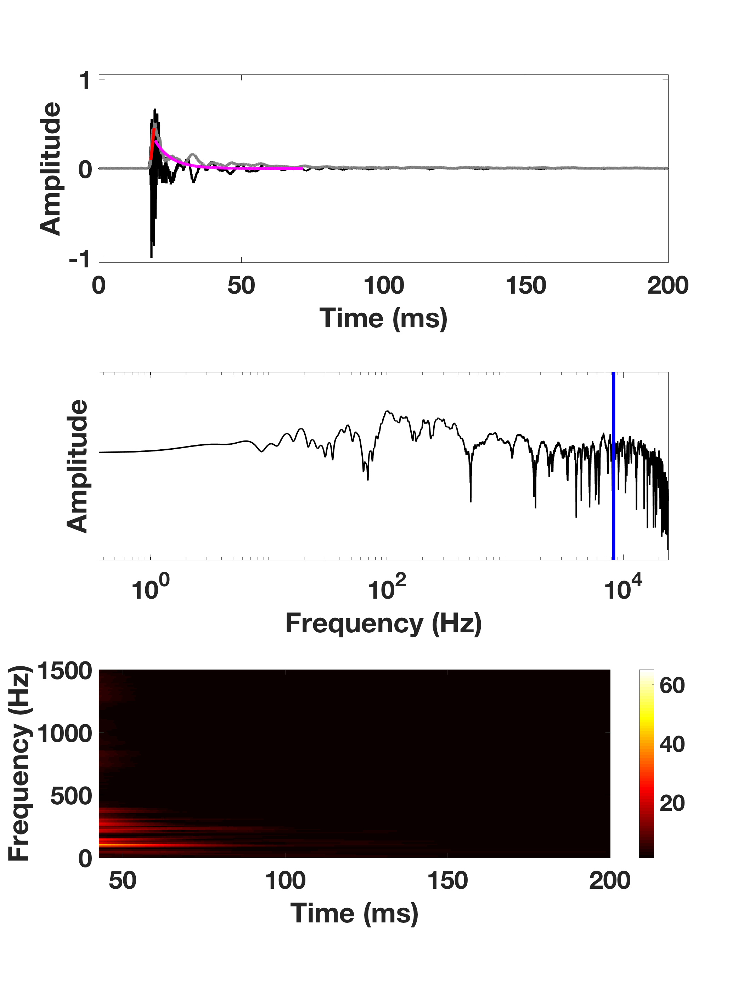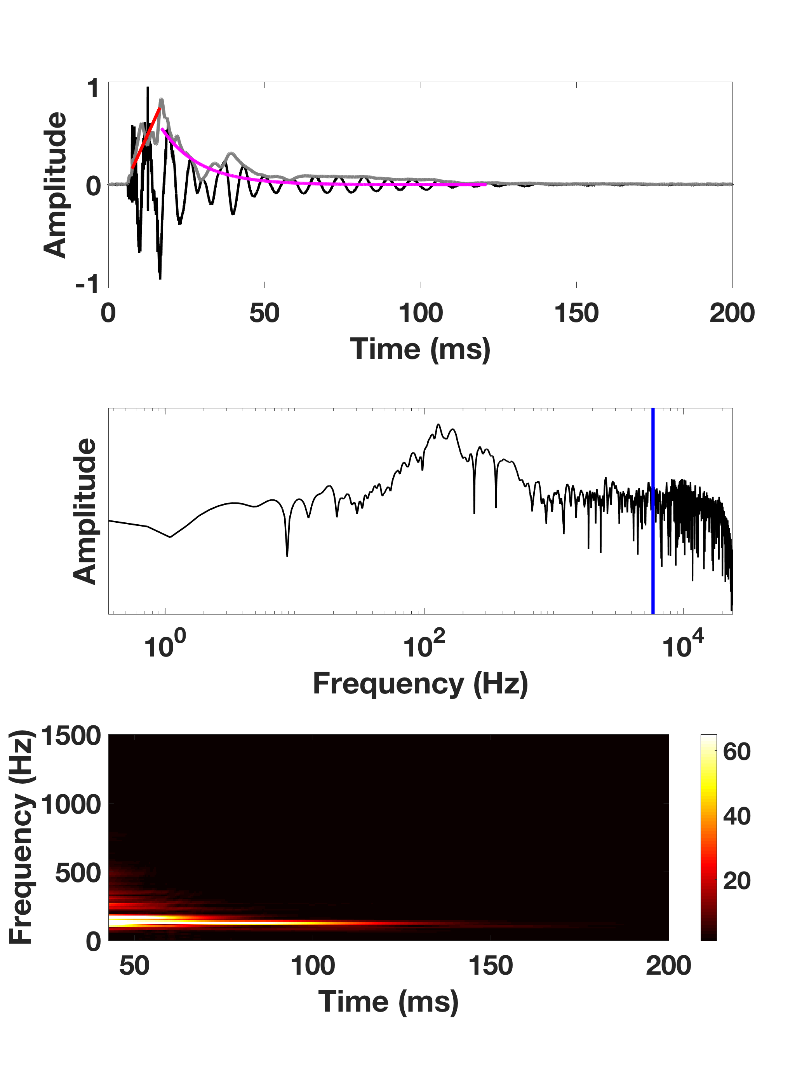
(b)
(a)
Figure S1. Signal representations of an impact sound recorded on a a) non-AST tree, Erythrophleum guineense, and an b) AST tree Ceiba pentandra using the same impactor and recording level. The upper part of the figure corresponds to the sound pressure signal with respect to time (black). The temporal envelope (gray line), the attack time (red) and the exponential function (magenta) on which the damping coefficient is estimated are also represented. This signal clearly lasts longer for the AST tree (i.e., a weaker damped exponential function and consequently a lower damping coefficient). The middle part corresponds to the frequency spectrum of the sound pressure signal, showing emergent resonances around 100Hz for the AST tree. The spectral centroids are indicated at blue line positions. The lower part corresponds to the modulus of the time-frequency representation of the sound pressure signal obtained by Short-Time Fourier Transform. This illustrates the genuine acoustic signature of the two impact sounds by highlighting both the time and the frequency behaviour of the sounds generated. Again, the lower damping of the emergent resonances in the AST tree is visible.

