Fungicide suppression of flight performance in the honey bee (Apis mellifera) and its amelioration by quercetin
Ling-Hsiu Liao, Wen-Yen Wu, Azra Dad and May R. Berenbaum
Proceeding of the Royal Society B., doi: 10.1098/rspb.2019.2041
Supplementary Methods

The honey bee preparation and procedure of the flight characteristics
Each forager for the flight treadmill experiment was caught when it was feeding at a syrup feeder, placed in a vial and chilled down on ice for 15 minutes until it was incapable of moving and anesthetized. Hairs on the dorsal thorax of the bee were shaved using a razor blade, and a piece of carbon steel plate (2 × 2 × 0.127 mm³ or 2 mm diameter × 0.2 mm iron plate) was glued on the middle of the notum of the bee using a cyanoacrylate adhesive (Loctite® Super Glue Gel, Henkel Corporation, Westlake, OH). Then the bee was set in a quiet humidified box for at least 30 minutes, considered as a restoration time-out, for recovery from stress before the first flight in the flight treadmill.
Without supplemental feeding, after a restoration time-out, the unstressed bee was placed on the flight treadmill for a depletion flight to exhaust her energy and stored sugar fuel. The “start” of a flight was designated as when continuous wing-flapping (> one minute) was triggered through a tarsal reflex. The “end” of a flight was designated as when the tested bee stopped flapping wings and could not resume flight spontaneously and/or be triggered again in five successive attempts through triggering the tarsal reflex. Generally, a depletion flight required at least 20 minutes and could take as long as four hours. The experiments were conducted only on the individuals that could perform depletion flights lasting more than 5 minutes, in order to ensure that the tethering process and treatment did not harm the bee. The flights were monitored with a webcam (Webcam C905, Logitech International S.A., Swiss), and the sound signal of wing-flapping was also monitored with the DL4YHF's Spectrum Lab (Audio Signal Analyzer, http://dl4yhf.darc.de/spectra1.html) or a custom-written LabVIEW program in real-time.
After the depletion flight, the tested bee was fed 10 µL of 25% sucrose syrup with the treatment chemical for its particular group. The bee was then positioned in the flight treadmill and allowed to hold on a stick to take a five-minute restoration rest. The stimulus of optic flow was turned off and the screens of the monitors were set to all-white during the resting period. After the five-minute restoration period, the stick was removed to trigger a tarsal reflex and the optic flow was started as well to induce another trial of flight of the bee. Three to five trials were conducted per honey bee to reduce inter-animal variability. Between each trial, the tested bee was also fed 10 µL of 25% sucrose syrup with the treatment chemical and then held a five-minute restoration period.
In the flight treadmill assays, typically, the wing flapping frequency of a forager speeds up from 0 Hz to her stable frequency (Fig. S2 and S3A). After reaching stable wing flapping, the tested forager generally excreted within 1 to 3 minutes during flight. This could be due to her gut working on digesting the sugar water to fuel her flight or due to an effort to reduce her weight prior to taking flight. Foragers then remained in their stable wing flapping frequency (Fig. S3B) until they had exhausted their energy and stored sugar fuel. In the “end” of a flight, the tested bee stopped flapping wings and could not resume flight. The sound of wing flapping was not continuous (Fig. S3C).
Fig. S1. Flight treadmill for testing the flight characteristics of foragers. A schematic diagram(A); a prototype photo of the flight treadmill(B); a rear view during a flight test(C).

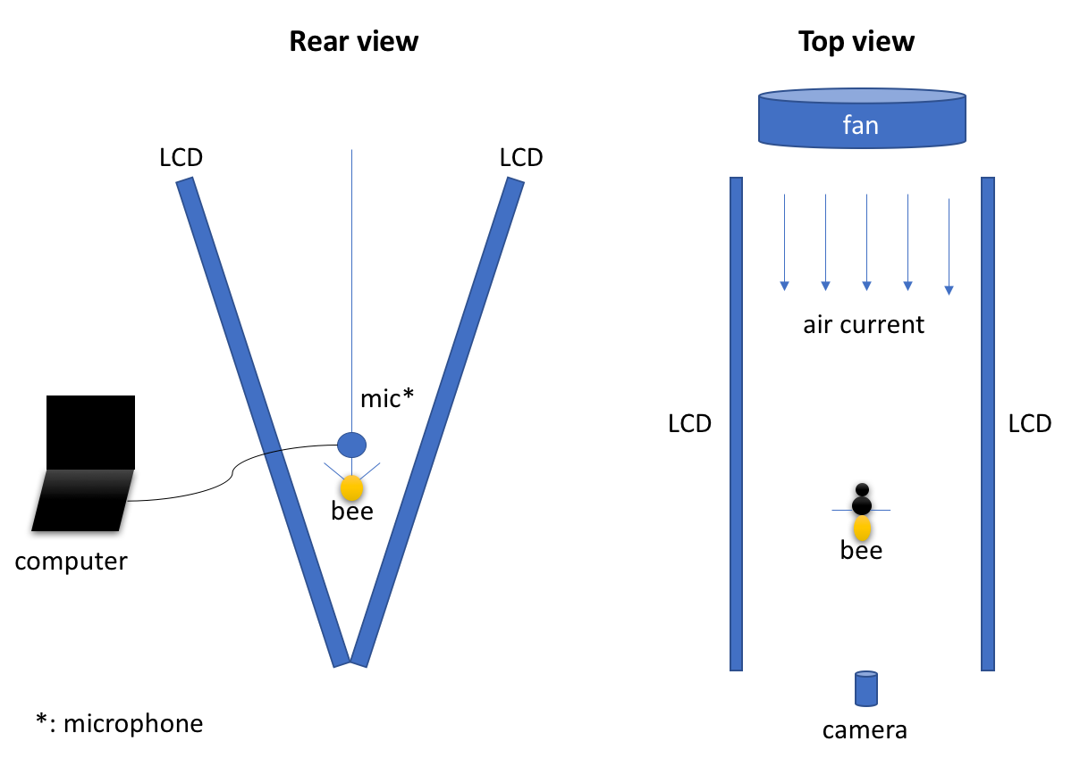
A
B
C
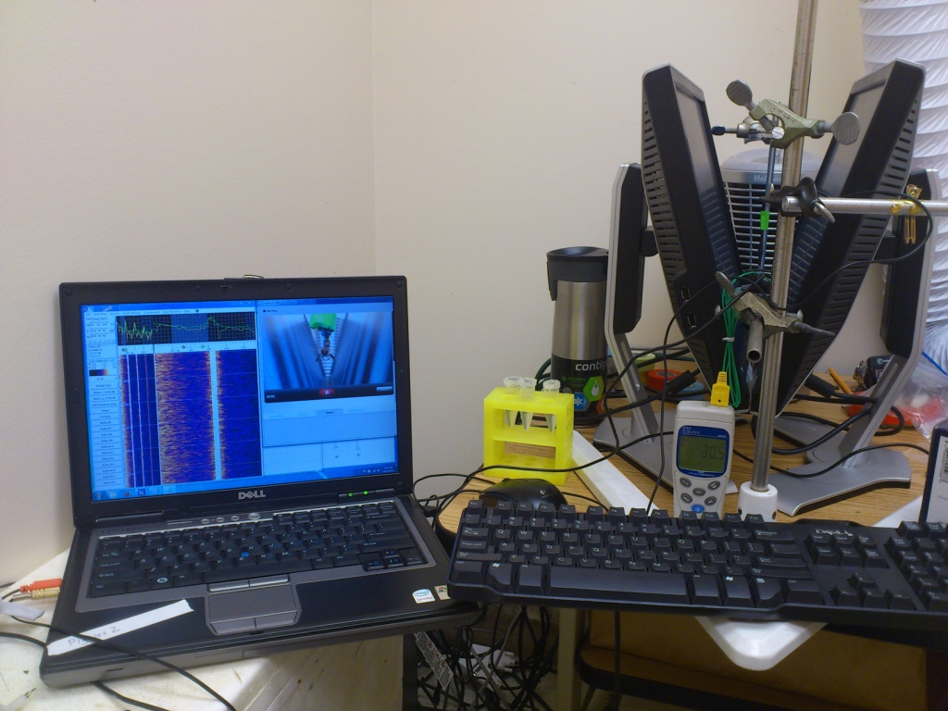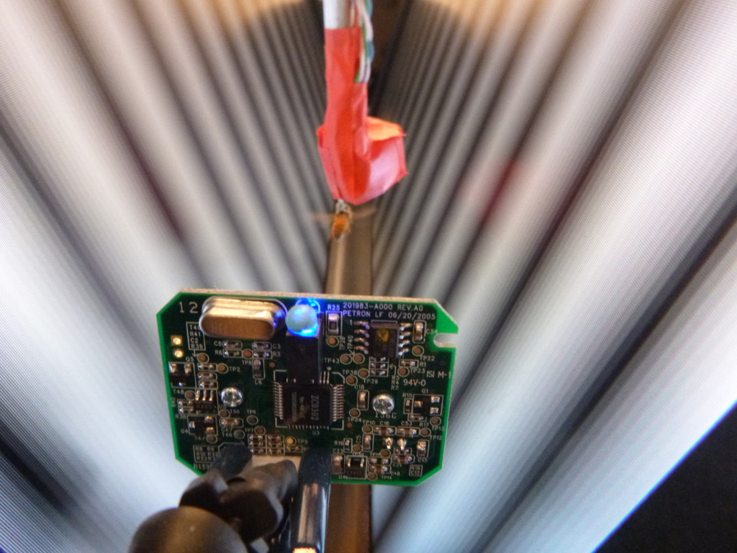

Fig. S2. An analysis process of wingbeat frequency signals in a typical flight bout. Sound signals of each flight trial were transformed into a spectrogram (A); harmonics and background noise (lower than 75Hz) were removed and only the fundamental frequency was exacted every 0.1 second (B).
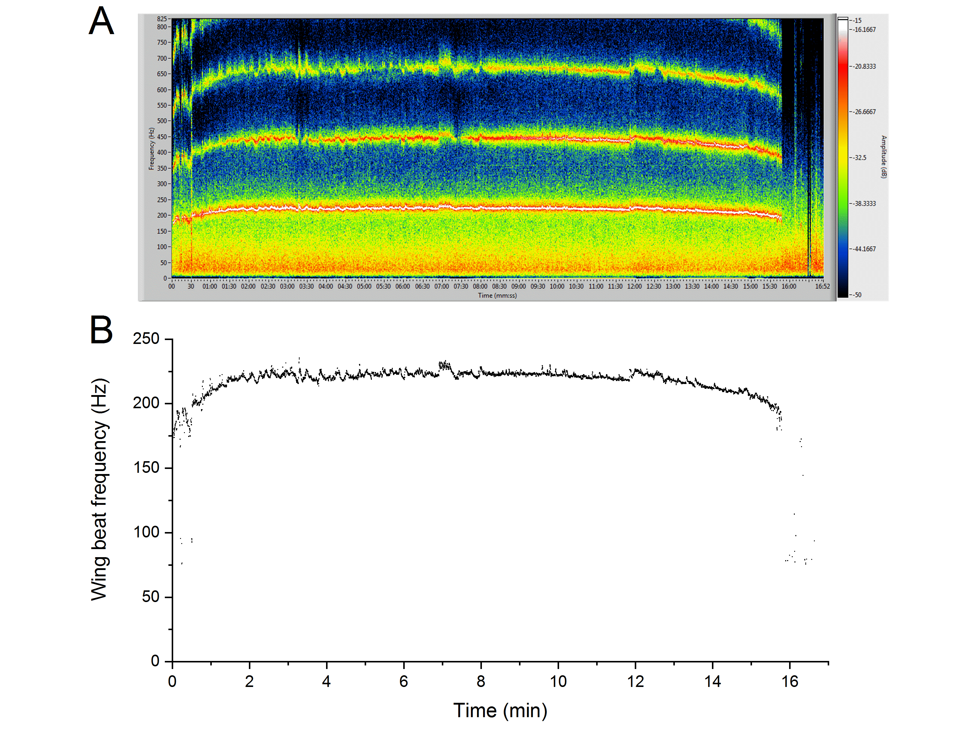
Fig. S3. A typical flight treadmill assay in different flight stages. The left column represents wing- flapping frequency signal pattern in real time. The right column shows monitored image of bees on the flight treadmill arena. A) the beginning of flight stage. B) the stable flight stage. C) the end of flight stage.
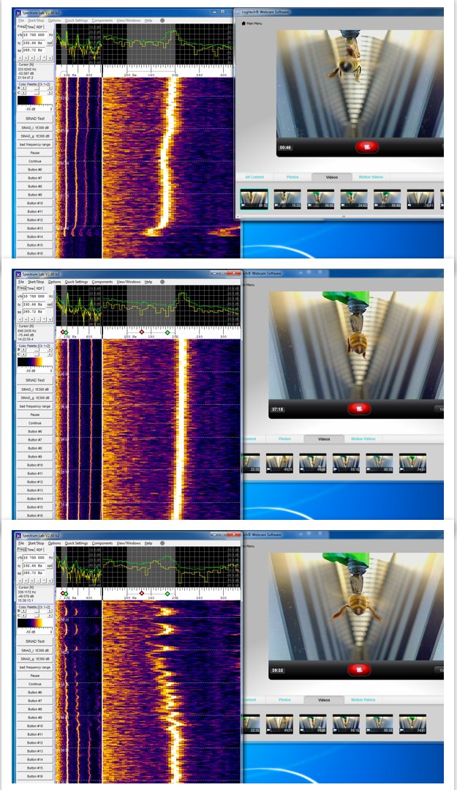
A
B
C
Table S1. Numbers of tested bees and flights in each set and treatment
Treatments⁺ | Bees | ad libitum intake flight-0 | 10-ul syrup feeding flight
CD vs Qc set
CD | 15 | 15 | 96
Qc | 12 | 12 | 72
CD vs Bs set 1
CD | 20 | 20 | 105
Bs | 17 | 17 | 90
CD vs Bs set 2
CD | 18 | 18 | 96
Bs | 17 | 16 | 90
CD vs Bs vs QB set
CD | 17 | 17 | 42
Bs | 18 | 18 | 54
QB | 17 | 17 | 48
⁺CD, control sugar water diet; Qc, sugar water diet containing 0.25 mM quercetin; Bs, sugar water diet containing 10 ppm boscalid; QB, sugar water diet containing 0.25 mM quercetin and 10 ppm boscalid.

