# Online Appendix A: Temporally varying disruptive selection in the medium ground finch (*Geospiza fortis*)

Marc-Olivier Beausoleil, Luke O. Frishkoff, Leithen K. M'Gonigle, Joost A.M. Raeymaekers, Sarah A. Knutie, Luis Fernando De León, Sarah K. Huber, Jaime A. Chaves, Dale H. Clayton, Jennifer A. H. Koop, Jeffrey Podos, Diana M. T. Sharpe, Andrew P. Hendry, and Rowan D. H. Barrett

Doi: 10.1098/rspb.2019.2290

## Methodological details

In our long-term study of Darwin’s finches, we captured individual birds of four ground finch species (*Geospiza magnirostris*, *G. fortis*, *G. fuliginosa*, and *G. scandens*) annually between 2003 and 2011 at El Garrapatero, an arid zone site on Santa Cruz Island in Galápagos, Ecuador (figure SA1). Table SI shows additional information about the number of individuals captured in the years the study was conducted. Although the analysis in the paper concerns *G. fortis*, we provide some capture information about the other ground finch species. We also conducted a supplementary principal component analysis of four ground finch species present in the area in order to characterize the major component axes with respect to known relationships between interspecific trait variation and diet. We first pooled all individuals of all species (*G. fuliginosa, G. fortis, G. magnirostris,* and *G. scandens*) across all years (table SI) for principal component analysis (PCA) of the three beak traits (length, depth, and width; figure SA1). Beak morphologies all loaded positively on the first principal component (figure SA1). The beak trait that has the highest loading on PC1 is beak depth (with a score of 7.7), while beak width and length have similar loadings (5.7 for both). We then performed a similar analysis for *G. fortis* only (shown in the article)—the species on which subsequent analyses were focused. We compared the interpretation of the axes of the PCA with all the species of ground finches versus the PCA of only *G. fortis* to ensure they retained similar biological interpretation. Consistent with previous work on Darwin’s finches, the covariance matrix principal component analyses were calculated because all beak traits were on the same scale (mm) [1-3]. Both PCAs were visualized with a correlation biplot (scaling 2), preserving the Mahalanobis distances among the objects in the matrix and taking into account collinearity of the traits [4,5]. The three granivorous *Geospiza* species (i.e., excluding *G. scandens*) separated clearly along PC1, apart from a few intermediate individuals—again as in previous analyses [6]. The primary axis of morphological variation was similar (i.e., beak size) when restricting the analysis to *G. fortis* only (figure 2, in the article)—echoing previous work in finding that the primary axis of variation in *G. fortis* parallels the primary axis of variation for *Geospiza* as a group.

We identified and measured finches following previously established methods used in previous studies [2,3]. We measured beak length from the anterior edge of nares to anterior tip of the upper mandible, beak depth at the nares and beak with at the base of the lower mandible. These measurements are plotted in figure SA1. We estimated the sex and age of each bird by examining beak and feather colour [2], as well as the presence of a brood patch or cloacal protuberance characteristic of breeding birds. Additional information on our measurement methods can be found in the main article.

## Generalized linear model selection

A generalized linear model was carried out to find if there is a general pattern throughout the years regarding survival and climatic conditions (table SII and SIII). The most explanatory models, based on AIC in table SII, include a quadratic explanatory variable for beak size. It should be noted that the samples are not totally independent since some birds in multiple years can be found multiple times. Our goal here is not to infer selection in this model, but rather to inform of potential survival effect of beak size depending on climate (correlational selection) and beak size having a nonlinear on survival.

## Generalized additive models: consistent smoothing across years

To standardize for variation in the smoothing across models, we estimated a mean smoothing parameter by calculating all possible GAMs without constraint regarding their smoothing parameter (λ) and then taking the mean of λ across all models. This mean λ (ln(λ) = ‑4.58) was near a local minimum of the validation score in all individual (year-specific) models. We then constrained the thin plate splines in each year to this mean λ to evaluate differences between years for a constant smoothing parameter. We conducted a visual check of the generalized cross-validation (GCV; figure SA2) across multiple λ values to ensure the model was not overfitting the data. The model fit of the splines can be found in the appendix (table SIV).

1. Number of birds captured and capture effort per year at El Garrapatero. These birds were used for the principal component analysis to compute the phenotypic space across all species and within *G. fortis* (figure SA1).

|  |  |  |  |  |  |  |  |  |  |  |
| --- | --- | --- | --- | --- | --- | --- | --- | --- | --- | --- |
|  | 2003 | 2004 | 2005 | 2006 | 2007 | 2008 | 2009 | 2010 | 2011 | Total |
| *G. fortis* | 45 | 92 | 148 | 185 | 36 | 76 | 149 | 147 | 195 | 1073 |
| *G.  fuliginosa* | 5 | 6 | 9 | 1 | 1 | 0 | 57 | 136 | 189 | 404 |
| *G. magnirostris* | 1 | 0 | 8 | 8 | 4 | 0 | 2 | 4 | 10 | 37 |
| *G. scandens* | 5 | 3 | 0 | 7 | 1 | 0 | 8 | 21 | 35 | 80 |
| Capture effort (hours) | 36 | 140 | 212 | 120 | 52 | 56 | 132 | 300 | 128 | 1176 |
| Bird per hour | 1.6 | 0.7 | 0.8 | 1.7 | 0.8 | 1.4 | 1.6 | 1.0 | 3.4 | 1.44* |

*This value is the mean across all years.

1. Model ranking of all GLMs using the mark-recapture data across all year. All the models that have a delta Akaike information criterion corrected for small sample size (AICc) less than 2 contain the nonlinear coefficient. *Prc.brf* is the total precipitation in the previous year, x and x2 are the raw and squared beak size PCA scores respectively.

|  |  |  |  |  |  |  |  |  |  |  |  |
| --- | --- | --- | --- | --- | --- | --- | --- | --- | --- | --- | --- |
| **Models** | **Intercept** | **Rainfall the year before** | **PC1** | **PC12** | **Prec:PC1** | **Prec:PC12** | **Degrees of freedom** | **logLik** | **AICc** | **delta** | **Weight** |
| y ~ prc.bfr + x2 + prc.bfr:x2 + 1 | -1.21 | -0.0013 |  | 0.77 |  | 0.02 | 4.00 | -226.75 | 461.58 | 0.00 | 0.19 |
| y ~ prc.bfr + x + x2 + prc.bfr:x2 + 1 | -1.29 | -0.0012 | -1.67 | 6.07 |  | 0.02 | 5.00 | -225.93 | 461.99 | 0.41 | 0.16 |
| y ~ prc.bfr + x + x2 + prc.bfr:x + prc.bfr:x2 + 1 | -1.23 | -0.0014 | 1.17 | -3.22 | -0.01 | 0.06 | 6.00 | -224.93 | 462.03 | 0.46 | 0.15 |
| y ~ prc.bfr + x2 + 1 | -1.40 | -0.0007 |  | 8.66 |  |  | 3.00 | -228.36 | 462.77 | 1.19 | 0.11 |
| y ~ x + x2 + 1 | -1.70 |  | -1.91 | 14.67 |  |  | 3.00 | -228.36 | 462.78 | 1.20 | 0.11 |
| y ~ x2 + 1 | -1.64 |  |  | 8.58 |  |  | 2.00 | -229.45 | 462.92 | 1.35 | 0.10 |
| y ~ prc.bfr + x + x2 + 1 | -1.48 | -0.0006 | -1.69 | 14.05 |  |  | 4.00 | -227.51 | 463.11 | 1.53 | 0.09 |
| y ~ prc.bfr + x + x2 + prc.bfr:x + 1 | -1.40 | -0.0009 | -2.53 | 13.04 | 0.00 |  | 5.00 | -227.07 | 464.27 | 2.69 | 0.05 |
| y ~ prc.bfr + 1 | -1.22 | -0.0007 |  |  |  |  | 2.00 | -231.83 | 467.68 | 6.10 | 0.01 |
| y ~ 1 | -1.45 |  |  |  |  |  | 1.00 | -232.89 | 467.78 | 6.20 | 0.01 |
| y ~ prc.bfr + x + prc.bfr:x + 1 | -1.15 | -0.0011 | -0.57 |  | 0.01 |  | 4.00 | -230.02 | 468.13 | 6.55 | 0.01 |
| y ~ prc.bfr + x + 1 | -1.25 | -0.0007 | 1.06 |  |  |  | 3.00 | -231.06 | 468.16 | 6.59 | 0.01 |
| y ~ x + 1 | -1.49 |  | 0.97 |  |  |  | 2.00 | -232.24 | 468.51 | 6.93 | 0.01 |

1. Estimates of the various models in table SI for the years 2005, 2006, 2008, 2009, 2010, and 2011. *Prc.brf* is the raw precipitation (mm) in the previous year, x and x2 are the raw and squared beak size PCA scores respectively.

|  |  |  |  |  |  |  |
| --- | --- | --- | --- | --- | --- | --- |
| Model |  | **Estimate** | **Standard Error** | **Z value** | ***p*-value** | **Variable** |
| y ~ prc.bfr + x + x2 + prc.bfr:x2 + 1 |  | -1.288 | 0.243 | -5.30 | **<0.05\*** | Intercept |
|  | -1.668 | 1.296 | -1.29 | 0.20 | PC1 |
|  | 6.074 | 6.905 | 0.88 | 0.38 | PC12 |
|  | -0.001 | 0.001 | -1.97 | **0.049\*** | prc.bfr |
|  | 0.022 | 0.013 | 1.74 | 0.08 | PC12:prc.bfr |

1. Output of the generalized additive model (GAM) for each pair of years. Each spline is calculated over a pair of years. The Chi square statistics are calculated to assess significance of model smooth terms, N is the sample size of each pair of years.

|  |  |  |  |  |  |  |  |
| --- | --- | --- | --- | --- | --- | --- | --- |
| **Years** | **Intercept  +/- SE** | ***p*-value intercept** | **Effective degrees of freedom** | **χ2** | **Approximate *p*-value smoothing** | **Adjusted R2** | **N** |
| 2004-2005 | -1.03 ± 0.22 | < 0.001 | 5.49 | 4.16 | 0.72 | 0 | 110 |
| 2005-2006 | -1.40 ± 0.19 | < 0.001 | 4.25 | 4.06 | 0.60 | 0.01 | 185 |
| 2006-2007 | -2.40 ± 0.24 | < 0.001 | 3.89 | 2.10 | 0.81 | 0 | 233 |
| 2007-2008 | -1.15 ± 0.32 | < 0.001 | 3.69 | 3.98 | 0.51 | 0.02 | 61 |
| 2008-2009 | -1.46 ± 0.24 | < 0.001 | 3.96 | 4.17 | 0.52 | 0.02 | 127 |
| 2009-2010 | -1.82 ± 0.21 | < 0.001 | 4.83 | 12.23 | 0.05 | 0.07 | 196 |
| 2010-2011 | -2.13 ± 0.27 | < 0.001 | 4.58 | 5.87 | 0.44 | 0.02 | 175 |

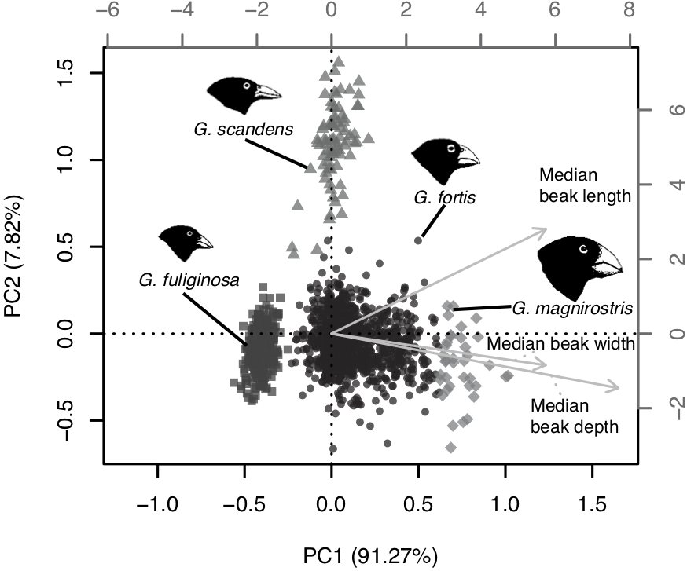

1. Correlation biplot of the principal component analysis based on three beak dimensions (length, width, and depth) for all ground. The first axis of variation (PC1) represents variation in beak size (bigger beaks have higher scores) and PC2 represents variation in beak shape (pointer beaks have higher scores). The grey axes (top and right) are scaled for the trait vectors (in light grey), whereas the black axes (bottom and left) are scaled for the points.



1. Minimization of the generalized cross-validation (GCV) score of the generalized additive model (GAM) in pairs of years. The x-axis shows different values of smoothing parameter (λ) that were tested and the corresponding GCV score (y-axis). Although, the λ is common to all the GAM (vertical dashed line), the GCV is generally minimized.

# Online Appendix References

1. Grant, P. R. & Schluter, D. 1984 Interspecific competition inferred from patterns of guild structure. In *Ecological Communities: Conceptual issues and the evidence* (eds D. R. Strong D. Simberloff L. G. Abele & A. B. Thistle), pp. 201–233. Princeton, New Jersey: Princeton University Press. (doi:10.1515/9781400857081.201)

2. Grant, P. R. 1999 *Ecology and evolution of Darwin's finches*. Princeton, New Jersey: Princeton University Press.

3. De León, L. F., Rolshausen, G., Bermingham, E., Podos, J. & Hendry, A. P. 2012 Individual specialization and the seeds of adaptive radiation in Darwin's finches. *Evol. Ecol. Res.* **14**, 365–380.

4. Mahalanobis, P. C. 1936 On the generalized distance in statistics. *Proc. Natl. Acad. Sci. U.S.A.* **2**, 49–55.

5. Legendre, P. & Legendre, L. 2012 *Numerical ecology*. 3rd English edition. Elsevier Science BV, Amsterdam, The Netherlands.

6. Hendry, A. P., Huber, S. K., De León, L. F., Herrel, A. & Podos, J. 2009 Disruptive selection in a bimodal population of Darwin's finches. *Proc. R. Soc. Lond. B* **276**, 753–759. (doi:10.1098/rspb.2008.1321)