Table 1S: Mean density (± SE) of proliferating cells (PCNA+ cell/mm3) in four brain regions in wild-caught male Rivulus exposed to differing predation pressure.
 |  |  | forebrain |  |  | midbrain
stream | predation | N | DL | DM | V | PVZ
Arima | RO | 8 | 18113 ± 2107 | 14793 ± 2878 | 23725 ± 5490 | 9400 ± 1024
 | HP | 8 | 36918 ± 3553 | 40261 ± 6810 | 39128 ± 4581 | 22133 ± 3501
Aripo | RO | 8 | 13947 ± 2521 | 16167 ± 2382 | 19260 ± 5417 | 10087 ± 1956
 | HP | 7 | 37512 ± 3510 | 31338 ± 3322 | 45123 ± 4431 | 18504 ±2315
Yarra | LP | 9 | 21464 ± 825 | 21177 ± 1412 | 22962 ± 2438 | 14531 ± 2015
 | HP | 9 | 32819 ± 2724 | 36005 ± 4735 | 38164 ± 3489 | 26058 ± 2848

In all streams and brain regions, the HP populations had significantly greater cell proliferation densities than the respective RO/LP population. For statistical analysis, see Results; RO = Rivulus only (no predators) ; HP = High predator density; LP = low predator density, DL= dorsolateral telencephalon, DM= dorsomedial telencephalon, V = ventral telencephalon, PVZ = periventricular zone

Table 2S: Mean density (± SE) of proliferating cells (PCNA+ cell/mm3) in four brain regions in lab-reared male Rivulus derived from populations with differing predation pressure.

 |  |  | forebrain |  |  | midbrain
stream | predation | N | DL | DM | V | PVZ
Arima | RO | 9 | 9365 ± 2874 | 12204 ± 2556 | 15818 ± 3999 | 10211 ± 1638
 | HP | 8 | 31540 ± 6251 | 29926 ± 5283 | 30239 ± 7411 | 21864 ± 2488
Aripo | RO | 5 | 13529 ± 3294 | 15302 ± 3280 | 13033 ± 5801 | 8195 ± 1015
 | HP | 9 | 26961 ± 2558 | 25876 ± 3044 | 38763 ± 4951 | 17079 ± 2979

In both streams and all brain regions, HP populations had significantly greater cell proliferation densities than the respective RO population. For statistical analysis, see Results; RO = Rivulus only (no predators), HP = High predator density; DL= dorsolateral telencephalon, DM= dorsomedial telencephalon, V = ventral telencephalon, PVZ = periventricular zone

Table 3S: Brain mass allometry in populations of adult male wild-caught Rivulus.

stream | predation | N | r² | slope (95% CI) | p-value | y-intercept (95% CI) | p-value | mean brain mass (mg) | p-value
Arima | RO | 24 | 0.83 | 0.409 (0.327 to 0.492) | <0.0001 | -0.47 (-1.06 to 0.11) | <0.0001 | 11.6 ± 0.7 | 0.0041
 | HP | 23 | 0.91 | 0.739 (0.635 to 0.843) |  | -2.70 (-3.47 to -2.13) |  | 8.0 ± 1.2
Aripo | RO | 18 | 0.91 | 0.549 (0.459 to 0.639) | 0.0083 | -1.44 (-2.04 to -0.85) | 0.0091 | 9.3 ± 0.9 | 0.044
 | HP | 30 | 0.85 | 0.671 (0.562 to 0.779) |  | -2.40 (-3.06 to -1.73) |  | 7.5 ± 1.6
Guanapo | RO | 23 | 0.92 | 0.461 (0.401 to 0.521) | 0.0020 | -1.01 (-1.41 to -0.60) | 0.0322 | 9.9 ± 0.7 | 0.0261
 | HP | 18 | 0.98 | 0.680 (0.623 to 0.734) |  | -2.36 (-2.27 to -1.99) |  | 7.6 ± 0.9
El Cedro | RO | 22 | 0.83 | 0.508 (0.402 to 0.615) | <0.0001 | -1.10 (-1.86 to -0.34) | <0.0001 | 12.9 ± 0.9 | 0.0062
 | HP | 13 | 0.91 | 0.715 (0.563 to 0.867) |  | -2.87 (-3.93 to -1.80) |  | 9.4 ± 1.5

RO = Rivulus only (no predation), HP = High Predation. P-values indicate significant differences between RO and HP populations within a stream. P-values refer to significant differences between RO and HP populations within a stream.

Table 4S: Brain mass allometry in lab-reared adult male Rivulusª.

predation | N | r² | slope (95% CI) | p- value | y- intercept (95% CI) | p-value | mean brain mass (mg) | p-value
RO | 19 | 0.41 | 0.348 (0.147 to 0.548) | 0.0007 | -0.56 (-1.62 to 0.73) | 0.0092 | 5.0 ± 0.2 | 0.00068
HP | 21 | 0.46 | 1.047 (0.490 to 1.604) |  | -4.40 (-7.85 to -1.74) |  | 2.8 ± 0.2

ª data are combined from Arima and Guanapo streams. RO = Rivulus only (no predation), HP = High Predation. Asterisks indicate significant difference between RO and HP populations within a stream. P-values refer to significant differences between RO and HP populations.

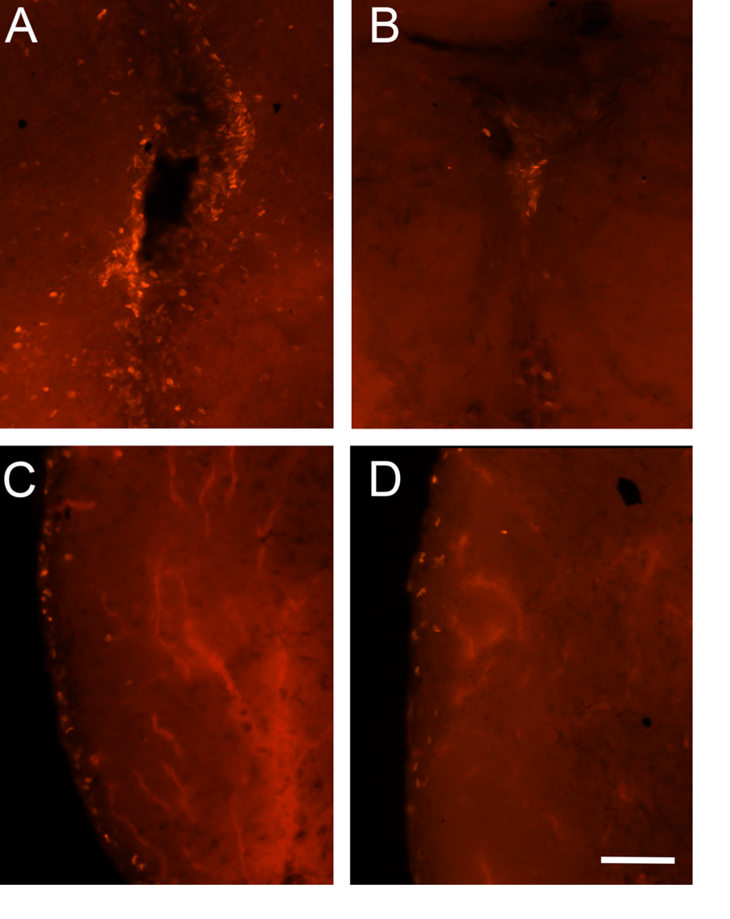

Figure 1S. Immunohistochemical labeling of proliferating cells (PCNA+) in the brain of wild-caught Rivulus. A) Midbrain periventricular zone (PVZ) in fish from high predation (HP) population. B) Midbrain periventricular zone in fish from no predation (RO) population. C) Forebrain dorsolateral telenecephalon in fish from HP population. D) Forebrain dorsolateral telencephalon in fish from RO population. Scale bar = 50µm.

