Supplementary material for “Does urbanization favor exotic bee species? Implications for the conservation of native bees in cities”

Authors: Gordon Fitch^{1*}, Caleb J. Wilson^{2,3*}, Paul Glaum¹, Chatura Vaidya¹, Maria-Carolina Simao⁴, and Mary A. Jamieson²

¹Department of Ecology and Evolutionary Biology, University of Michigan, Ann Arbor, MI 48109
²Department of Biological Sciences, Oakland University, Rochester, MI 48309
³Department of Entomology and Plant Pathology, North Carolina State University, Raleigh, NC 27695
⁴ ﻿New Jersey Agricultural Experiment Station, Rutgers University, New Brunswick, NJ 08901
*These authors contributed equally to this work

Corresponding Author:
Gordon Fitch
gmfitch@umich.edu

Supplemental methods
Study area and sampling strategy
We sampled bees at 41 sites along an urban gradient in southeast Michigan, USA. At 26 sites bees were collected in June, July, and August of 2014, using both bowl traps and active netting. For trapping, two bowl trap trios (white, blue, yellow) per site were placed in the field for 24h once per month. Netting also occurred monthly at each site, with one 30-minute netting bout from 0800-1200h and another from 1400-1700h. A. mellifera were not systematically caught or counted during netting at these sites. Floral surveys were conducted at the same time as bowl trapping. At these sites, all floral resources within a 20m radius of the center of the bowl trap placement area were surveyed. Flowering plants were identified to species or morphospecies, and the number of blooms of each species was estimated. We took measurements of the bloom area of each species as described in Glaum et al. [1], and used these measurements, along with abundance counts, to estimate coverage of each species.
At the remaining 15 sites, bees were collected once during the months of June, July and August of 2017 using a combination of bowl traps and active netting techniques. During each sampling period, four 25 m transects were haphazardly placed to cover a representative amount of blooming plant cover and species richness at each field site. All blooming plants within one meter of either side of the centerline of each transect were identified to species and a bloom cover estimate was generated for each species. One m² and 0.5 m² quadrats were used to aid in visual estimation of bloom cover provided by flower patches along each transect. Surveyors would place either the 1 m2 quadrat or 0.5m2 quadrat around patches of flowers (depending on the size of the patch) and estimate the percent cover of one target species within the quadrat. This estimate was multiplied by the total area of the quadrat used to produce a square meter estimate of area provided by the target species. This process was repeated as needed to encompass all patches in which the target species was present. These estimates were summed up for each species across the entire transect. This process was repeated for all other blooming species located in the transect. The total bloom cover provided by each species across all transects was summed within each sampling period. Surveyors walked along each transect at a pace of 3.3 m/min to reach the end of each transect in 7.5 minutes, collecting all bees observed (30 mins of collection per site). In August, honeybees were visually counted. In June, 4 bowl trap trios (red, blue, yellow) were placed at each field site; this was increased to 6 trios for July and August. All traps were collected within 48 hours of being placed out.
Across both datasets bee abundance and richness were pooled across sampling months and treated as a site level variable for analyses of the effects of urbanization and proximity to ports of entry on bee abundance and richness. Bee abundance was pooled at the site level for these analyses because urbanization and proximity to ports of entry are site-level variables and would therefore affect the total bee community at each site. For analyses of the effects of floral resources on bee abundance and richness, and the effect of exotic bee abundance on native bee abundance, data from each month were considered separately.
All flowering plants identified to species at all sites were classified as exotic, native, or of uncertain origin, based on information in the United States Department of Agriculture (USDA) plants database [plants.sc.egov.usda.gov].

Geographic analysis
To measure urbanization at each field site, we used the methods described in detail in Glaum et al. [1]. Briefly, we constructed four concentric buffers (500 m - 2000 m) around each field site using ArcMap 10.6.1 [2]. Within each one of these radii data we used the National Land Cover Database (NLCD) 2011 [3] to quantify the proportion of impervious surface surrounding each field site. The NLCD classifies land cover at a resolution of 30m×30m pixels. Within each radius we summed all pixels corresponding to the medium development (50-70% impervious surface area) and high intensity development (80-100% impervious surface area) land cover classes. These sums were then divided by the total number of pixels within each radius to produce a measurement of urbanization. At a 500m radius sites ranged from 0-99% (mean 35%, SE: +-4%) surrounding impervious surface area.

Data Analysis
Bee native status was classified using [4]. To determine the radius at which urbanization had the greatest impact on exotic bees, we regressed exotic bee abundance against proportion of developed land within buffers of four radii (500m, 1km, 1.5km, 2km). We then compared model fit of these four candidate models using AICc. The same analysis was repeated for exotic bee richness, as well as for native bee abundance and richness. While in all cases the magnitude of the effect of urbanization was qualitatively consistent for all radii, 500m was supported as the most predictive buffer for both abundance (exotics: AICc weight = 1, ∆AICc = 38.5 for next-best model; natives: AICc weight = 0.99, ∆AICc = 10.2) and richness (exotics: AICc weight = 0.52, ∆AICc = 0.94; natives: AICc weight = 0.31, ∆AICc = 0.19), and so was used in all subsequent analyses.
To account for differences in bee abundance across sites, we used rarefaction to estimate species richness based on the number of bees collected at the lowest-abundance site. The results of all analyses were qualitatively similar whether raw or rarefied richness were used (Table S7); results for raw richness are reported. Rarefaction was conducted using the function `rarefy()` in R package `vegan` [5]. The minimum number of bees caught at a site was 23, so for rarefied total richness we rarefied to this number. We also performed rarefaction for exotic bee richness at the 22 sites where ≥ 5 exotic bees were caught. The 19 sites where < 5 exotic bees were caught were assigned a rarefied exotic richness of 0. Analyses involving species richness at the site (rather than site-month) level were conducted using both raw and rarefied richness. Analyses considering each month separately were conducted with raw richness only, because the small number of specimens precluded meaningful rarefaction.
To evaluate the effect of floral resources on exotic bees, we considered each sampling month separately, since seasonal variation in floral resources was idiosyncratic across sites. We therefore used GLMMs rather than GLMs, since we had 3 observations from each site (one for each month of sampling). Because exotic floral abundance and richness were strongly correlated with native floral abundance and richness (abundance: ß = 0.46±0.10, t = 4.6, p < 0.001; richness: ß = 0.06±0.01, z = 6.2, p < 0.001), we used proportional richness and cover of exotic plants as our measure of exotic floral resource availability. While we were primarily interested in the link between exotic flowering plants and exotic bees, we have previously shown that total floral resource availability is correlated with overall bee abundance and richness in our study area [6]. We therefore included a measure of total floral resource availability as a covariate in all GLMMs. Because floral resource metrics showed collinearity, we first evaluated which metric had the most explanatory power using AICc. The metrics considered were: total richness and percent coverage, exotic richness and percent coverage, and native richness and percent coverage. The floral metric with the most explanatory power was total floral richness (Table S8), so this was the metric incorporated into our models. Total floral richness was not correlated with proportional exotic plant richness (ß=–0.006±0.03, p=0.8).
To evaluate whether proximity to a port of entry was correlated with exotic bee abundance or richness, we determined the Euclidean distance from each site to the nearest registered international port of entry. The two ports of entry in our study area were 1) the Port of Detroit along the Detroit River (Detroit, MI), and 2) the Detroit Metropolitan Airport (Romulus, MI) [7]. The distance from our sites to the nearest port of entry ranged from 1.9km–62km. We did not use other registered POEs for analysis because they are located outside of the counties where we collected data and are likely too far away to influence the exotic bee communities of our sites. Distances to other locations where materials containing exotic bees could be unloaded such as truck stops or warehouses were not evaluated in this study, despite their potential importance as points of introduction, because comprehensive data on the location of such sites were not available.
To evaluate the relationship between temperature and exotic bee abundance or richness, we considered three aspects of temperature: mean daily minimum temperature, mean daily temperature, and mean daily maximum temperature. Mean daily minimum temperature best explained both exotic bee abundance and richness, and so was the temperature metric used in subsequent analyses.
We tested for spatial autocorrelation in the residuals of all models using Moran’s I, as implemented in the R package ‘ape’ [17]; none of the models were significantly autocorrelated.

References:

1. Glaum P, Simao M-C, Vaidya C, Fitch G, Iulinao B. 2017 Big city Bombus : using natural history and land-use history to find significant environmental drivers in bumble-bee declines in urban development. R. Soc. Open Sci. 4, 170156. (doi:10.1098/rsos.170156)
2. ESRI. 2017 ArcGIS Desktop.
3. Homer CG et al. 2015 Completion of the 2011 National Land Cover Database for the conterminous United States-Representing a decade of land cover change information. Photogramm. Eng. Remote Sensing 81, 345–354.
4. Cane J. 2003 Exotic non-social bees (Hymenoptera: Apoidea) in North America: Ecological implications. In For Nonnative Crops, Whence Pollinators of the Future? (eds K Strickler, JH Cane), pp. 113–126. Lanham, MD: Entomological Society of America.
5. Okansen J et al. 2018 Vegan Community Ecology Package Version 2.5-1.
6. Fitch G, Glaum P, Simao M-C, Vaidya C, Matthijs J, Iuliano B, Perfecto I. 2019 Changes in adult sex ratio in wild bee communities are linked to urbanization. Sci. Rep. 9, 3767. (doi:10.1038/s41598-019-39601-8)
7. Protection USC and B. 2018 Locate a Port of Entry in Michigan. See https://www.cbp.gov/contact/ports/mi.
8. Hoiss B, Krauss J, Potts SG, Roberts S, Steffan-Dewenter I. 2012 Altitude acts as an environmental filter on phylogenetic composition, traits and diversity in bee communities. Proc. R. Soc. B Biol. Sci. 279, 4447–4456. (doi:10.1098/rspb.2012.1581)
9. Hulshof CM, Violle C, Spasojevic MJ, McGill B, Damschen E, Harrison S, Enquist BJ. 2013 Intra-specific and inter-specific variation in specific leaf area reveal the importance of abiotic and biotic drivers of species diversity across elevation and latitude. J. Veg. Sci. 24, 921–931. (doi:10.1111/jvs.12041)
10. Sydenham MAK, Moe SR, Totland Ø, Eldegard K. 2015 Does multi-level environmental filtering determine the functional and phylogenetic composition of wild bee species assemblages? Ecography (Cop.). 38, 140–153. (doi:10.1111/ecog.00938)
11. Horne B Van. 1983 Density as a Misleading Indicator of Habitat Quality. J. Wildl. Manage. 47, 893. (doi:10.2307/3808148)
12. Bock CE, Jones ZF. 2004 Avian habitat evaluation: Should counting birds count? Front. Ecol. Environ. 2, 403–410. (doi:10.1890/1540-9295(2004)002[0403:AHESCB]2.0.CO;2)
13. Crone EE, Williams NM. 2016 Bumble bee colony dynamics: quantifying the importance of land use and floral resources for colony growth and queen production. Ecol. Lett. 19, 460–468. (doi:10.1111/ele.12581)
14. Goulson D, Hughes W, Derwent L, Stout J. 2002 Colony growth of the bumblebee, Bombus terrestris, in improved and conventional agricultural and suburban habitats. Oecologia 130, 267–273. (doi:10.1007/s004420100803)
15. Westphal C, Steffan-Dewenter I, Tscharntke T. 2009 Mass flowering oilseed rape improves early colony growth but not sexual reproduction of bumblebees. J. Appl. Ecol. 46, 187–193. (doi:10.1111/j.1365-2664.2008.01580.x)
16. Iles DT, Williams NM, Crone EE. 2018 Source‐sink dynamics of bumblebees in rapidly changing landscapes. J. Appl. Ecol. 55, 2802–2811. (doi:10.1111/1365-2664.13175)
17. Paradis E, Schliep K. 2018 ape 5.0: an environment for modern phylogenetics and evolutionary analyses in R. Bioinformatics

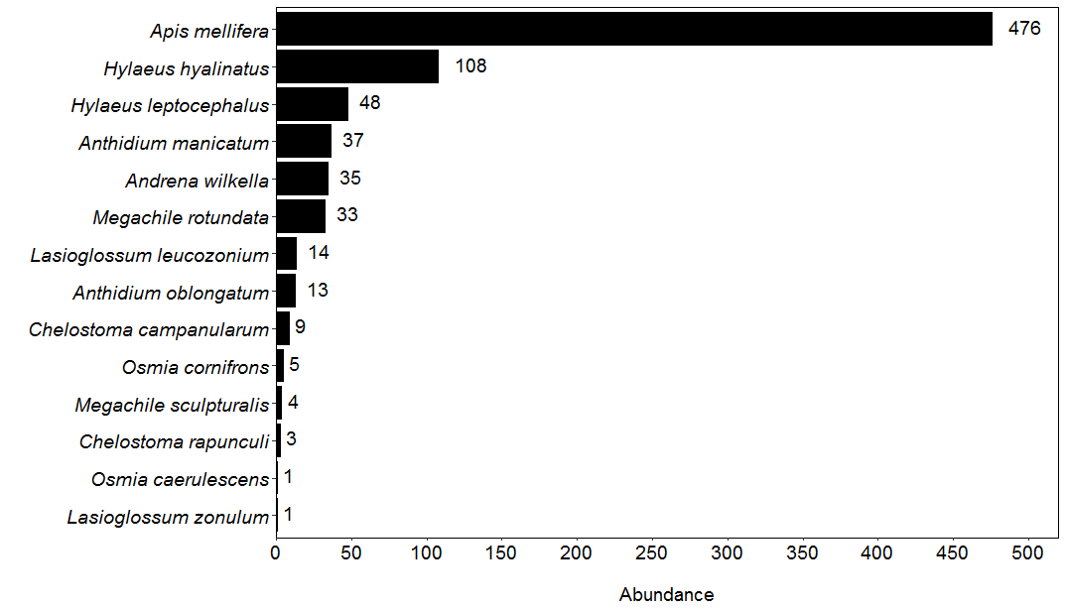

Figure S1. The total abundance of each exotic bee species collected across all field sites.

Figure S2: The abundances of all collected exotic bee species across all field sites ordered by total abundance. Note that there are many sites for each species with zero counts that all overlap at the same value. The total number of field sites that each species was recorded at is listed on the right side of the figure.

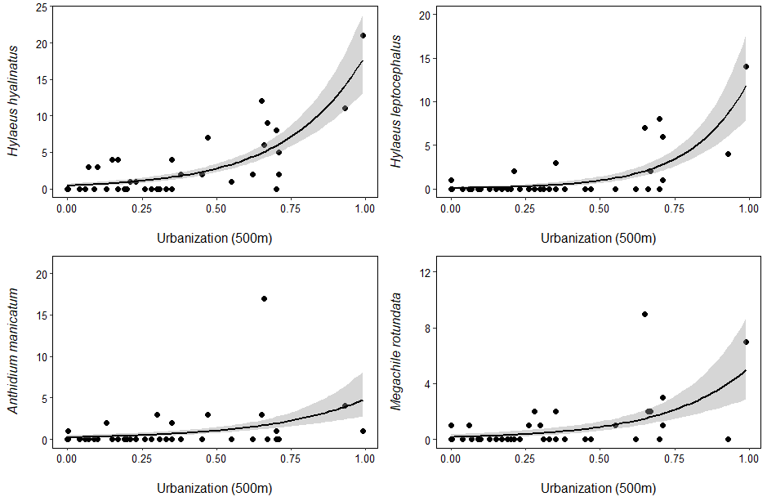

Figure S3.
The abundances of the most common widespread exotic bee species (present at ≥ 10 sites) with respect to increasing urbanization. Raw abundances are plotted on the y axis.

Table S1. Summary statistics for potential predictors of bee abundance and richness. †Values represent per-site metrics. ‡Values represent per-site per-month metrics.

Variable | Mean±SD | Minimum | Maximum
Proportion developed land within 500m (urbanization)† | 0.33±0.27 | 0 | 0.99
Distance to port of entry (km)† | 29.5±14.4 | 1.9 | 61.1
Mean temperature (°C)† | 20.6±2.7 | 16.2 | 24.3
Total flowering plant richness‡ | 20±11 | 3 | 48
Exotic flowering plant richness‡ | 16±9 | 1 | 39
Native flowering plant richness‡ | 5±4 | 0 | 16
Total flowering plant bloom cover (cm2/m2)‡ | 0.7±1.3 | 2.3e-5 | 7.1
Exotic flowering plant bloom cover (cm2/m2)‡ | 0.5±0.8 | 1.1e-5 | 4.5
Native flowering plant bloom cover (cm2/m2)‡ | 0.3±0.7 | 0 | 5.7

Table S2. All study sites with details about exotic bee abundance and urbanization information. Exotic bee abundance and exotic bee species richness does not include honey bees.

Site | County | City | Honey bee abundance | Exotic bee abundance | Exotic bee spp. richness | % Impervious surface at 500 m
Cold Frame Farm | Macomb | Bruce Township | 23 | 2 | 2 | 0 %
Oakland Hills Community Garden | Oakland | Oakland Township | 29 | 2 | 2 | 0 %
Clarkston Community Garden | Oakland | Clarkston | 112 | 14 | 4 | 0 %
Rochester Community Garden | Oakland | Rochester | 9 | 15 | 7 | 35 %
Oakland University Student Organic Farm | Oakland | Auburn Hills | 3 | 3 | 1 | 10 %
Wabash Community Garden | Oakland | Rochester Hills | 0 | 1 | 1 | 20 %
Haven Community Garden | Oakland | Pontiac | 38 | 11 | 5 | 30 %
Hess-Hathaway Community Garden | Oakland | Waterford | 18 | 7 | 4 | 5 %
Everyone’s Garden | Oakland | Berkley | 10 | 15 | 6 | 67 %
Good Neighbor’s Garden | Oakland | Ferndale | 6 | 17 | 3 | 70 %
Grant Park Community Garden | Oakland | Ferndale | 0 | 8 | 2 | 62 %
It Takes a Village Garden | Wayne | Detroit | 1 | 52 | 9 | 65 %
Voices for Earth Justice Community Garden | Wayne | Detroit | 11 | 6 | 3 | 17 %
Brother Nature Farm | Wayne | Detroit | 51 | 8 | 7 | 71 %
Coriander Farm | Wayne | Detroit | 44 | 25 | 4 | 66 %
Boehnke House | Washtenaw | Ann Arbor | 1 | 4 | 2 | 23 %
Buhr Park Community Garden | Washtenaw | Ann Arbor | 2 | 4 | 2 | 7 %
University of Michigan-Ann Arbor Campus Farm | Washtenaw | Ann Arbor Township | 0 | 0 | 0 | 4 %
Catholic Social Services Community Garden | Washtenaw | Pittsfield Township | 0 | 1 | 1 | 33 %
Clague Middle School Community Garden | Washtenaw | Ann Arbor | 0 | 3 | 2 | 21 %
County Farm Park Community Garden | Washtenaw | Ann Arbor | 0 | 0 | 0 | 17 %
Cultivating Community Garden | Washtenaw | Ann Arbor | 0 | 14 | 3 | 71 %
Dexter Community Garden | Washtenaw | Dexter | 2 | 3 | 2 | 28 %
Eastern Michigan University Community Garden | Washtenaw | Ypsilanti | 2 | 0 | 0 | 19 %
E.S. George Reserve | Livingston | Putnam Township | 0 | 0 | 0 | 0 %
Ellsworth Community Garden | Washtenaw | Pittsfield Township | 3 | 0 | 0 | 35 %
Frog Island Community Garden | Washtenaw | Ypsilanti | 8 | 2 | 2 | 55 %
Greenview Community Garden | Washtenaw | Ann Arbor | 0 | 0 | 0 | 17 %
Lafayette Greens | Wayne | Detroit | 1 | 47 | 5 | 99 %
Leslie Science Center | Washtenaw | Ann Arbor | 1 | 2 | 1 | 13 %
M’lis Farm | Washtenaw | Webster Township | 6 | 6 | 3 | 0 %
North Cass Community Garden | Wayne | Detroit | 2 | 19 | 3 | 93 %
Normal Park Community Garden | Washtenaw | Ypsilanti Township | 1 | 4 | 1 | 15 %
Perry Community Garden | Washtenaw | Ypsilanti | 4 | 10 | 2 | 47 %
Platt Community Garden | Washtenaw | Ann Arbor | 2 | 0 | 0 | 31 %
Westminster Presbyterian Church Garden | Washtenaw | Ann Arbor | 0 | 0 | 0 | 19 %
University of Michigan School of Public Health Garden | Washtenaw | Ann Arbor | 0 | 0 | 0 | 70 %
University of Michigan-Dearborn Community Garden | Wayne | Dearborn | 2 | 2 | 1 | 45 %
University of Michigan-Dearborn-ELS | Wayne | Dearborn | 0 | 1 | 1 | 26 %
University of Michigan Nichols Arboretum | Washtenaw | Ann Arbor | 0 | 1 | 1 | 9 %
West Park Community Garden | Washtenaw | Ann Arbor | 3 | 2 | 1 | 38 %

Table S3. Relationship between season-long minimum temperature and exotic bee abundance, richness, and proportional abundance. ∆AICc compared to the best model, which eliminates minimum temperature but includes all other listed variables. Significance codes: * p<0.05; *** p<0.001.
Response variable | Minimum temperature (ß±SE) | Urbanization  (ß±SE) | Year  (ß±SE) | DF | ∆AICc
Non-honey bee exotic abundance | 0.01±0.05 | 0.69±0.19*** | 1.15±0.30*** | 33 | 2.6
Proportional non-honey bee exotic abundance | –0.09±0.09 | 0.82±0.09*** | –– | 34 | 1.4
Non-honey bee exotic richness | 0.01±0.04 | 1.14±0.48* | 1.14±0.48*** | 33 | 2.4

Table S4: Relationships between floral resource metrics and urbanization.
Response variable | Urbanization  (ß±SE) | % Deviance  explained | DF
Total plant species richness | 0.13±0.21 | 0.9 | 39
Exotic plant species richness | 0.21±0.22 | 2.0 | 39
Native plant species richness | –0.08±0.29 | 0.2 | 39
Total bloom cover | –0.73±1.10 | 0.0 | 39

Table S5. Relationship between native and exotic bee abundance at high- and low-abundance sites. Abundance cutoffs as for Figure 2b-c. ¹The best model for this response variable includes floral richness; estimates for the effect of exotic bee abundance are from the model that includes floral richness, while %DE refers to the deviance explained by exotic bee abundance only. ²Significant response is driven entirely by a single point. When that outlier is removed, model estimate becomes: ß = –0.14±0.13, p = 0.3, %DE = 0.2. ³This model includes an observation-level random effect to account for overdispersion. Significance codes: * p<0.05; ** p<0.01.
 | Exotic bee abundance  (excluding A. mellifera) |  |  | A. mellifera abundance
 | ß±SE | %DE | DF | ß±SE | %DE | DF
All observations | 0.01±0.02¹ | 0.0 | 111 | –0.01±0.02¹ | 0.0 | 105
High abundance | –0.03±0.01** | 28.0 | 15 | –0.05±0.02*² | 3.4 | 13
Low abundance | 0.01±0.03¹ | 0.0 | 92 | 0.13±0.15³ | 0.0 | 91

Table S6: Model comparison for the effect of additional predictors on relationship between exotic and native bee abundance. ß estimates are for the effect of exotic bee abundance on native bee abundance in all cases. None = no additional predictors. Urbanization = proportion developed land within 500m. Plant richness = species richness of plants within site. Significance codes: * p<0.05; ** p<0.01; *** p<0.001.
Model | Additional predictors
 | None |  | Urbanization |  | Plant richness |  | Proximity to port of entry |  | Minimum temperature
 | ∆AICc | ß | ∆AICc | ß | ∆AICc | ß | ∆AICc | ß | ∆AICc | ß
Native abundance ~  non-honey bee exotic abundance, High abundance sites | 0.0 | –0.03 ± 0.01** | 33.7 | –0.08 ± 0.02*** | 0.8 | –0.04 ± 0.01*** | 35.9 | –0.06 ± 0.02** | 23.0 | –0.07 ± 0.02***
Native abundance ~  Honey bee abundance,  High abundance sites | 0.0 | –0.05 ± 0.02* | 0.9 | –0.04 ± 0.02* | 3.3 | –0.03 ± 0.02 | 1.7 | –0.05 ± 0.02** | 3.1 | –0.04 ± 0.02*

Table S7: Model parameters comparing raw vs. rarefied exotic bee richness with respect to urbanization and sampling year. Significance codes: **p < 0.01; ***p < 0.001.
Response variable | Urbanization  (ß±SE) | Year  (ß±SE) | % Deviance  explained | DF
Exotic Richness
Raw | 1.21±0.36*** | 0.78±0.21*** | 41.6 | 38
Rarefied | 1.80±0.54*** | 1.41±0.33*** | 38.7 | 38
Proportion exotic species
Raw | 1.26±0.36*** | –– | 27.3 | 39
Rarefied | 1.74±0.54** | 1.29±0.33*** | 35.7 | 38

Table S8: AICc model comparison for the effect of floral resources on bee abundance and richness. Richness – number of species and morphospecies recorded. Cover – proportion of transect area covered by blooms.
Response variable | ∆AICc
 | Floral resource metric
 | Total richness | Exotic richness | Native richness | Total cover | Exotic cover | Native cover
Bee Abundance
Exotic | 0.00 | 0.45 | 13.07 | 7.35 | 16.79 | 6.30
Native | 0.00 | 53.29 | 59.60 | 144.51 | 159.01 | 163.39
Bee Richness
Exotic | 0.00 | 1.19 | 4.79 | 4.49 | 6.43 | 5.39
Native | 0.00 | 6.07 | 13.24 | 22.25 | 25.00 | 24.03

