Supplementary Materials for

Exceptional preservation of comma shrimp from a mid-Cretaceous Lagerstätte of Colombia, and the origins of crown Cumacea

Javier Luque^{1,2,3} and Sarah Gerken⁴

¹Department of Geology and Geophysics, Yale University, New Haven, CT 06520-8109, USA.
²Department of Biological Sciences, University of Alberta, Edmonton, AB T6G 2E9, Canada.
³Smithsonian Tropical Research Institute, Balboa–Ancón 0843–03092, Panamá, Panamá.
⁴University of Alaska Anchorage, Anchorage, AK 99508, USA.

Authors for correspondence:
Javier Luque, e-mails: javier.luque@yale.edu; luque@ualberta.ca. orcid.org/0000-0002-4391-5951
Sarah Gerken, e-mail: sagerken@alaska.edu. orcid.org/0000-0001-7895-8137

Article DOI: 10.1098/rspb.2019.1863

This PDF file includes:
Figure S1. Mass accumulations of Eobodotria muisca gen. et sp. nov. from the mid-Cretaceous (Cenomanian–Turonian, 95–90 Mya) of Colombia, South America.
Figure S2. Palaeocuma hessi Bachmayer, 1960, from the Jurassic (Callovian, 165 Mya) of La Voulte-sur-Rhone, France.
Figure S3 Results of equally-weighted and implied-weights maximum parsimony analyses.
Figure S4 Bayesian majority-rule consensus topology of the post-burnin sample of trees for crown-group cumacean family Bodotriidae, including the extinct Eobodotria muisca gen. et sp. nov.
Table S1 List of known fossil stem- and crown-group cumaceans, arranged chronologically from oldest to youngest.

Supporting Figures

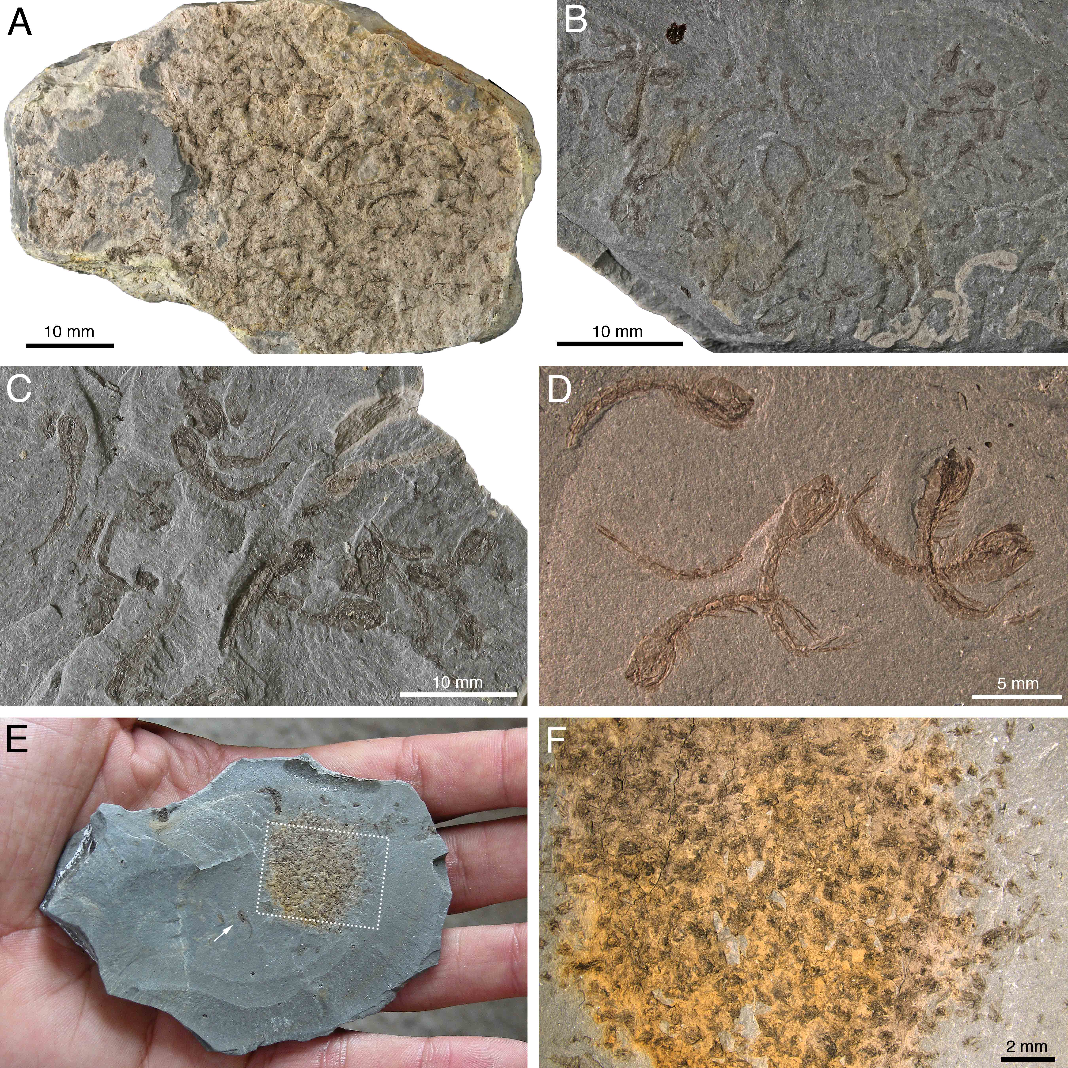
Figure S1. Mass accumulations of Eobodotria muisca gen. et sp. nov. from the mid-Cretaceous (Cenomanian–Turonian, 95–90 Mya) of Colombia, South America. (A) sample MGJRG.2019.I.13; brown, beige, and orange-yellow colours due to weathering. (B) sample IGM p881227, slightly weathered, showing a packing density of about 6 specimens per cm². (C) Sample MGJRG.2019.I.9, showing a fresh, non-weathered hand sample with well-preserved cumaceans. (D) Sample IGM p880694 with holotype and at least 4 other complete specimens. (E) Sample IGM p880691, showing an unusual pile of poorly preserved cumacean remains; white arrow points a well-preserved adult female (see Figure 1D). (F) Close-up of the pile of cumacean remains in sample IGM p880691 (dotted box in E).
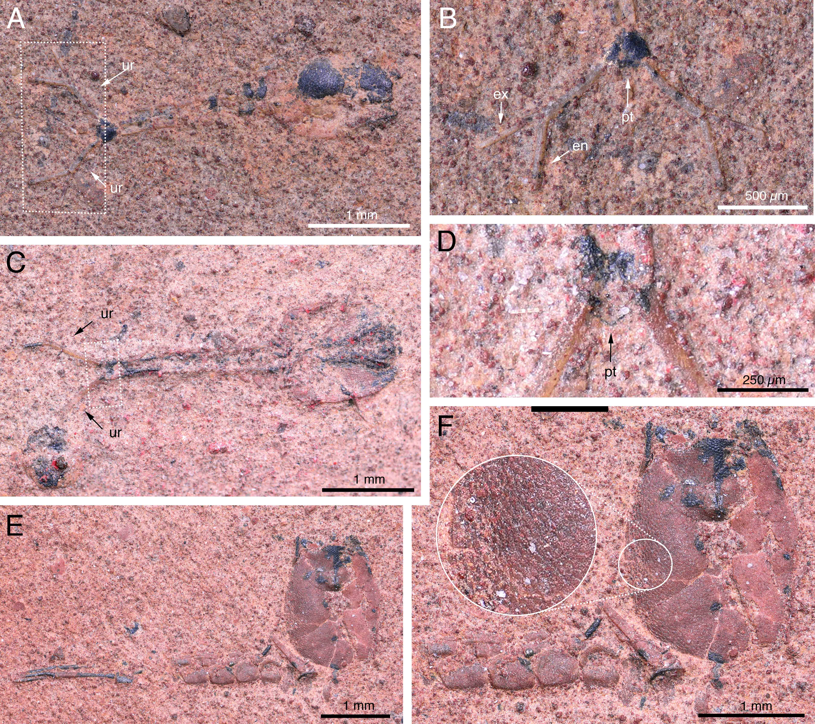

Figure S2. Palaeocuma hessi Bachmayer, 1960, from the Jurassic (Callovian, 165 Mya) of La Voulte-sur-Rhone, France. (A) Holotype F1282; (B) Close-up of holotype biramous uropods with long and slender exopod and endopod. (C) Paratype F2441; (D) Close-up of paratype showing the fused pleotelson. (E) Hypotype F2442; (F) Close-up of hypotype showing details of the pleonites and the ovate carapace with scaly cuticle. Photos courtesy of Loïc Costeur and Walter Etter (Natural History Museum Basel, Switzerland).
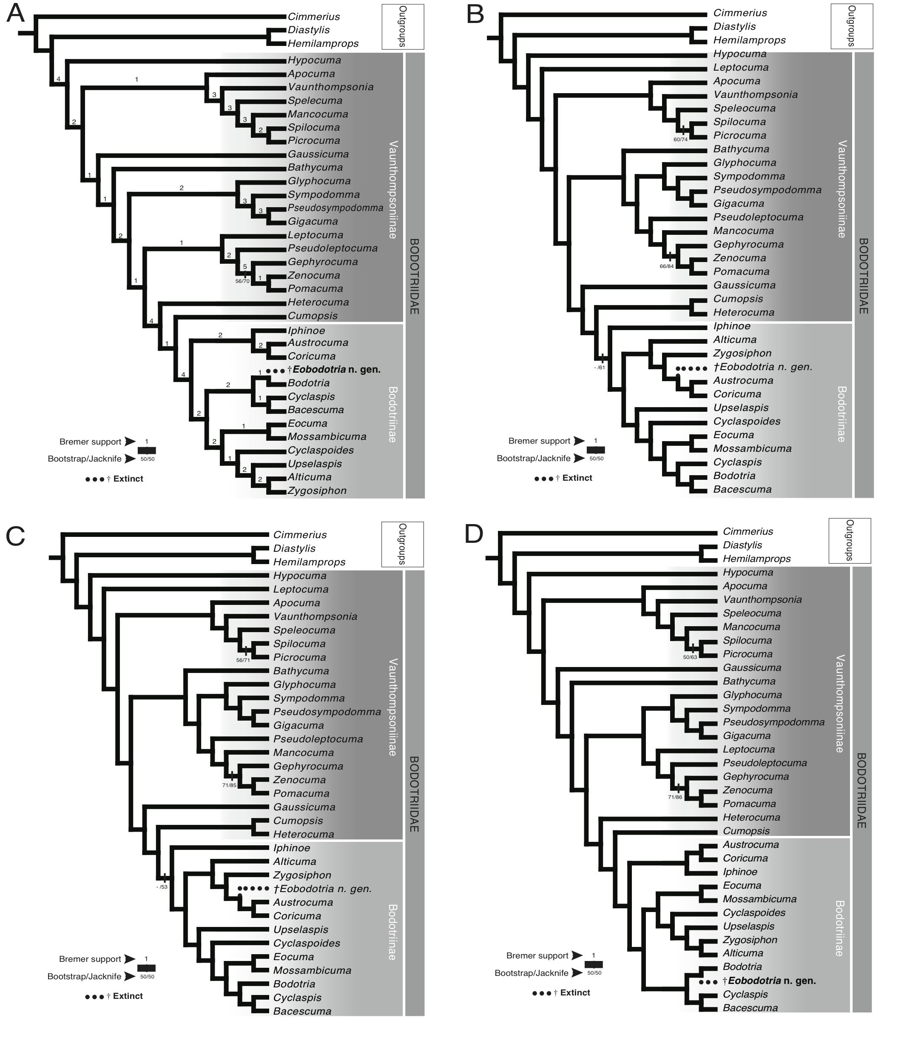
Figure S3. Results of equally-weighted and implied-weights maximum parsimony analyses. A) equally-weighted parsimony: single most parsimonious tree. (B–D) Implied-weights maximum parsimony (IWMP) topologies: (B) concavity value K=3; (C) concavity value K=6; (D) concavity value K=12. Analyses performed in TNT v.1.5.

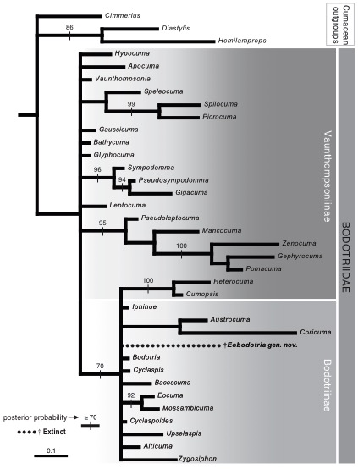
Figure S4. Bayesian majority-rule consensus topology of the post-burnin sample of trees for crown-group cumacean family Bodotriidae, including the extinct Eobodotria muisca gen. et sp. nov. Posterior probability support values indicated above branches. Branches with posterior probability support < 75% are collapsed.

Supporting Tables
Table S1. List of known fossil stem- and crown-group cumaceans, arranged chronologically from oldest to youngest (see also main text, figure 4b–f). Taxa marked with an asterisk (*) are putative stem-group Cumacea.

Taxon | Age | Unit | Locality
*Carbocuma imoensis Schram et al., 2003 | Upper Mississippian and Pennsylvanian | Imo Formation and Eudora Shale | Arkansas and Kansas, U.S.A.
*Ophthalmdiastylis parvulorostrum Schram et al., 2003 | Upper Mississippian and Pennsylvanian | Imo Formation and Eudora Shale | Arkansas and Kansas, U.S.A.
*Securicaris spinosus Schram et al., 2003 | Upper Mississippian | Imo Formation | Arkansas, U.S.A.
*Ophthalmdiastylis inflata Malzahn, 1972 | Permian | Marl Beds of Zechstein 1 | Germany
*Ophthalmdiastylis costata Malzahn, 1972 | Permian | Marl Beds of Zechstein 1 | Germany
Palaeocuma hessi Bachmayer, 1960 | Callovian | La Voulte-sur-Rhône Konservat-Lagerstätte | La Voulte-sur-Rhône, France
Eobodotria muisca Luque & Gerken gen. et sp. nov. | Upper Cenomanian–lower-mid Turonian | Churuvita Group | Boyacá, Colombia

