Biology Letters
Electronic supplementary material

The effects of anthropogenic noise on animals: a meta-analysis

Hansjoerg P. Kunc and Rouven Schmidt
Correspondence to: kunc@gmx.at
Literature Search and Study Selection Criteria

We conducted a systematic literature search in Web of Science (on 13.09.2018) and Scopus (on 14.09.2018), searching for studies that reported effects of noise pollution. Our search was limited to peer-reviewed articles. Our search in Web of Science was conducted on titles, abstracts, author keywords, and keywords plus. In Scopus our search was conducted on titles, abstracts, keywords, and limited to the document type article. The search was conducted using the following keywords: "anthropogenic noise" OR “noise pollution” OR “environmental noise”, returning 5921 records in Web of Science, and 10637 in Scopus respectively (figure S1). Records were downloaded as BibTeX database files (*.bib) and then merged in R using the package REVTOOLS [1], resulting in a data frame with 16558 studies. Using the find_duplicates function in REVTOOLS, we identified and removed 3063 duplicates, and for each of the remaining 13495 studies, we checked the title and abstract to determine whether the research was indeed quantifying the effect of anthropogenic noise pollution (for details see Fig. S1). In cases where we could not clarify this from the title and abstract we read the paper to find the relevant information. Additionally, we found twelve eligible studies by checking bibliographies of reviews. To be included in our analysis the studies had to fulfil the following four criteria:
- The effect sizes must be obtained from experimental studies, because only carefully controlled experimental manipulations allow establishing cause and effect relationships [2]; only this will enable us to quantify the effects of any human induced global change without any ambiguity [3]. In cases where different amplitudes of noise were played back, we chose the values of those exposures with the highest noise amplitude, which reflects the setup of the majority of studies that exposed animals to one loud noise exposure.
- The reported details on sample size, measure of central tendency, and measure of spread had to be accessible in the text or figures. To excerpt data from figures we used the software Web plot digitizer [4]. In 64 cases were not able to extract the data (Figure S1).
- The type of stimuli used in noise exposure experiments had to mimic the characteristics of anthropogenic noise, which is usually low frequency noise [5-7].
- The response to the treatment had to be unambiguously elicited by anthropogenic noise, i.e. we had to exclude seven studies that used boats in most instances to test the effects of noise. However, the response to the treatment could either be explained by noise, or by the visual stimulus – the boat, or a combination of both and thus it does not allow to assess the effect of anthropogenic noise.

Overall we obtained 487 effect sizes from 108 experimental studies and 109 species (Figure S1). Due to the large number of studies included in our analysis. We are not able to cite each study in the main text – all studies included in the analysis can be accessed in the data file. Out of the 487 response variables 296 (60.78%) were only reported once (table S1). Thus single response variables could not be statistically analysed due to the lack of repeats within response variables.

Table S1. Overview about the frequency of single response variable that was included in our various models. Overall we obtained 487 effect sizes. Note: The 487 effect sizes is the sum of effect sizes of each taxonomic group reported in table 1, minus the three of reptilians. The difference between the effect sizes in the overall model (table 1A) and the number of effect sizes reported here is that we could not retrieve phylogenetic information for some species to construct the phylogenetic tree, but these species could be allocated into a taxonomic group (for details see text).

 | amphibians | arthropods | birds | fish | mammals | molluscs | reptiles
50.percent.quartile.energy.distribution | 0 | 0 | 1 | 0 | 0 | 0 | 0
75.percent.quartile. energy.distribution | 0 | 0 | 1 | 0 | 0 | 0 | 0
ACTH | 0 | 0 | 0 | 1 | 0 | 0 | 0
adrenal.weight | 0 | 0 | 0 | 0 | 1 | 0 | 0
alarm.call.duration | 0 | 0 | 1 | 0 | 0 | 0 | 0
alert | 0 | 0 | 0 | 0 | 1 | 0 | 0
alert.distance | 0 | 0 | 0 | 0 | 1 | 0 | 0
amplitude | 4 | 0 | 4 | 0 | 0 | 0 | 0
analgesic.response | 0 | 0 | 0 | 0 | 1 | 0 | 0
antibody.titre | 0 | 0 | 0 | 0 | 1 | 0 | 0
approach.latency | 0 | 0 | 1 | 0 | 0 | 0 | 0
arrival.at.nest.time.to.feed | 0 | 0 | 1 | 0 | 0 | 0 | 0
average.birds.present | 0 | 0 | 12 | 0 | 0 | 0 | 0
average.call.power | 0 | 0 | 1 | 0 | 0 | 0 | 0
average.power | 0 | 0 | 1 | 0 | 0 | 0 | 0
bandwidth | 0 | 0 | 4 | 0 | 0 | 0 | 0
begging.activity | 0 | 0 | 1 | 0 | 0 | 0 | 0
begging.intensity | 0 | 0 | 1 | 0 | 0 | 0 | 0
bill.length.day4 | 0 | 0 | 1 | 0 | 0 | 0 | 0
blood.ALT | 0 | 1 | 0 | 0 | 0 | 0 | 0
blood.AMY | 0 | 1 | 0 | 0 | 0 | 0 | 0
blood.AST | 0 | 1 | 0 | 0 | 0 | 0 | 0
blood.Bicarb | 0 | 1 | 0 | 0 | 0 | 0 | 0
blood.Ca | 0 | 1 | 0 | 0 | 0 | 0 | 0
blood.Chol | 0 | 1 | 0 | 0 | 0 | 0 | 0
blood.Cl | 0 | 1 | 0 | 0 | 0 | 0 | 0
blood.GDH | 0 | 1 | 0 | 0 | 0 | 0 | 0
blood.GGT | 0 | 1 | 0 | 0 | 0 | 0 | 0
blood.Gluc | 0 | 1 | 0 | 0 | 0 | 0 | 0
blood.K | 0 | 1 | 0 | 0 | 0 | 0 | 0
blood.Lactate | 0 | 1 | 0 | 0 | 0 | 0 | 0
blood.LIP | 0 | 1 | 0 | 0 | 0 | 0 | 0
blood.Mg | 0 | 1 | 0 | 0 | 0 | 0 | 0
blood.Na | 0 | 1 | 0 | 0 | 0 | 0 | 0
blood.Na_K | 0 | 1 | 0 | 0 | 0 | 0 | 0
blood.Phos | 0 | 1 | 0 | 0 | 0 | 0 | 0
blood.SDH | 0 | 1 | 0 | 0 | 0 | 0 | 0
blood.THC | 0 | 2 | 0 | 0 | 0 | 0 | 0
blood.TP | 0 | 1 | 0 | 0 | 0 | 0 | 0
blood.Trig | 0 | 1 | 0 | 0 | 0 | 0 | 0
blood.Urea | 0 | 1 | 0 | 0 | 0 | 0 | 0
blood.Uric | 0 | 1 | 0 | 0 | 0 | 0 | 0
blow.rate | 0 | 0 | 0 | 0 | 1 | 0 | 0
body.condition | 0 | 0 | 1 | 0 | 0 | 0 | 0
body.length | 0 | 0 | 0 | 1 | 1 | 0 | 0
body.size | 0 | 0 | 1 | 0 | 0 | 0 | 0
body.weight | 0 | 0 | 0 | 0 | 1 | 0 | 0
body.with.length.ratio | 0 | 0 | 0 | 1 | 0 | 0 | 0
boldness.score | 0 | 0 | 0 | 1 | 0 | 0 | 0
brightness.of.vocal.sac | 1 | 0 | 0 | 0 | 0 | 0 | 0
cadmium.concentration.in.digestive.glands | 0 | 0 | 0 | 0 | 0 | 1 | 0
cadmium.concentration.in.gills | 0 | 0 | 0 | 0 | 0 | 1 | 0
call.length | 4 | 0 | 0 | 0 | 0 | 0 | 0
call.rate | 10 | 0 | 0 | 0 | 0 | 0 | 0
calling.effort..total.calling.time.per.minute | 2 | 0 | 0 | 0 | 0 | 0 | 0
central.frequency | 3 | 0 | 0 | 0 | 0 | 0 | 0
change.in.maximum.skin.temperature | 0 | 0 | 0 | 0 | 1 | 0 | 0
change.in.preference | 0 | 0 | 0 | 1 | 0 | 0 | 0
change.in.ventilation.rate.compared.to.coastal.noise.control | 0 | 0 | 0 | 4 | 0 | 0 | 0
change.prop.time.vigilant | 0 | 0 | 0 | 0 | 1 | 0 | 0
change.ventilation.rate | 0 | 0 | 0 | 1 | 0 | 0 | 0
change.vigilance.scan.rate | 0 | 0 | 0 | 0 | 1 | 0 | 0
cholesterol | 0 | 0 | 0 | 1 | 0 | 0 | 0
closest.approach.m | 0 | 0 | 1 | 0 | 0 | 0 | 0
complexity | 0 | 0 | 5 | 0 | 0 | 0 | 0
cortecosterol | 0 | 0 | 0 | 1 | 0 | 0 | 0
corticosterone | 1 | 0 | 5 | 0 | 1 | 0 | 0
cortisol | 0 | 0 | 1 | 4 | 0 | 0 | 0
cortisol.secretion | 0 | 0 | 0 | 1 | 0 | 0 | 0
count.of.foraging.activity | 0 | 0 | 0 | 1 | 0 | 0 | 0
defensive.acts | 0 | 0 | 0 | 1 | 0 | 0 | 0
diff.in.nr.startles.2min | 0 | 0 | 0 | 1 | 0 | 0 | 0
digging.depth | 0 | 0 | 0 | 0 | 0 | 1 | 0
distance.covered | 1 | 0 | 0 | 0 | 0 | 0 | 0
distance.to.nest.box | 0 | 0 | 1 | 0 | 0 | 0 | 0
distance.to.parent.cm | 0 | 0 | 2 | 0 | 0 | 0 | 0
dominant.frequency | 4 | 0 | 0 | 0 | 0 | 0 | 0
dominant.frequency.of.dee.calls | 0 | 0 | 1 | 0 | 0 | 0 | 0
drd2transcriptional.variations.gene. | 0 | 0 | 0 | 0 | 0 | 1 | 0
duration | 5 | 0 | 12 | 0 | 0 | 0 | 0
duration.of.vigilance.scans | 0 | 0 | 0 | 0 | 1 | 0 | 0
energy | 0 | 0 | 1 | 0 | 0 | 0 | 0
entropy | 0 | 0 | 1 | 0 | 0 | 0 | 0
feeding.perc.trial | 0 | 0 | 1 | 0 | 0 | 0 | 0
feeding.rate | 0 | 0 | 2 | 0 | 0 | 0 | 0
feeds.per.hour | 0 | 0 | 1 | 0 | 0 | 0 | 0
female.choice.latency | 1 | 0 | 0 | 0 | 0 | 0 | 0
female.emergence.in.response.to.male.song | 0 | 0 | 2 | 0 | 0 | 0 | 0
female.time.at.nest | 0 | 0 | 1 | 0 | 0 | 0 | 0
first.reaction.distance | 0 | 1 | 0 | 0 | 0 | 0 | 0
fledling.probability | 0 | 0 | 1 | 0 | 0 | 0 | 0
flight.distance | 0 | 0 | 0 | 0 | 1 | 0 | 0
flight.distance.after.detection | 0 | 0 | 0 | 0 | 1 | 0 | 0
flightzone.cm | 0 | 0 | 0 | 1 | 0 | 0 | 0
flushing.distance | 0 | 0 | 3 | 0 | 0 | 0 | 0
food-handling.error | 0 | 0 | 0 | 1 | 0 | 0 | 0
footdrum | 0 | 0 | 0 | 0 | 1 | 0 | 0
foraging.bout.duration | 0 | 0 | 1 | 0 | 0 | 0 | 0
foraging.efficiency | 0 | 0 | 0 | 1 | 0 | 0 | 0
frequency.of.colour.changes | 0 | 0 | 0 | 0 | 0 | 1 | 0
frequency.of.raised.arms | 0 | 0 | 0 | 0 | 0 | 1 | 0
frequency.range | 0 | 0 | 1 | 0 | 0 | 0 | 0
glances.per.min.nest | 0 | 0 | 0 | 1 | 0 | 0 | 0
glucose | 0 | 0 | 0 | 3 | 0 | 0 | 0
granulocytes | 0 | 2 | 0 | 0 | 0 | 0 | 0
group.deviation.from.south | 0 | 0 | 0 | 0 | 1 | 0 | 0
group.dive.time | 0 | 0 | 0 | 0 | 1 | 0 | 0
growth | 0 | 0 | 1 | 0 | 0 | 0 | 0
growth.hormone.level | 0 | 0 | 0 | 0 | 1 | 0 | 0
haematocrit | 0 | 0 | 1 | 1 | 0 | 0 | 0
haemocyte.expression | 0 | 1 | 0 | 0 | 0 | 0 | 0
haemolymph.ph | 0 | 2 | 0 | 0 | 0 | 0 | 0
haemolymph.refractive.index | 0 | 2 | 0 | 0 | 0 | 0 | 0
head.down | 0 | 0 | 0 | 0 | 0 | 0 | 1
head.down.duration | 0 | 0 | 1 | 0 | 0 | 0 | 0
head.down.period | 0 | 0 | 1 | 0 | 0 | 0 | 0
head.movment.rate.nr.hour | 0 | 0 | 1 | 0 | 0 | 0 | 0
head.turned | 0 | 0 | 0 | 0 | 0 | 0 | 1
head.up.rate | 0 | 0 | 1 | 0 | 0 | 0 | 0
heads.up.period | 0 | 0 | 1 | 0 | 0 | 0 | 0
hearing.threshold.to.100Hz | 0 | 0 | 0 | 1 | 0 | 0 | 0
hearing.threshold.to.200Hz | 0 | 0 | 0 | 1 | 0 | 0 | 0
hearing.threshold.to.50Hz | 0 | 0 | 0 | 1 | 0 | 0 | 0
hearing.thresholds.to.conspecific.sound | 0 | 0 | 0 | 2 | 0 | 0 | 0
heart.rate.after.12days.noise.exposure | 0 | 1 | 0 | 0 | 0 | 0 | 0
heart.rate.after.2hrs.noise.exposure | 0 | 2 | 0 | 0 | 0 | 0 | 0
heart.rate.after.7days.noise.exposure | 0 | 1 | 0 | 0 | 0 | 0 | 0
hepatopancreas.index | 0 | 2 | 0 | 0 | 0 | 0 | 0
hiding.initiation.distance | 0 | 2 | 0 | 0 | 0 | 0 | 0
hyalinocytes | 0 | 2 | 0 | 0 | 0 | 0 | 0
increase.in.soundpressure.db | 0 | 0 | 1 | 0 | 0 | 0 | 0
interval.length | 2 | 0 | 0 | 0 | 0 | 0 | 0
lactate | 0 | 0 | 0 | 1 | 0 | 0 | 0
latency.to.courtship.signalling | 0 | 1 | 0 | 0 | 0 | 0 | 0
latency.to.enter.openspace.sec | 0 | 0 | 0 | 2 | 0 | 0 | 0
latency.to.final.decision | 0 | 1 | 0 | 0 | 0 | 0 | 0
latency.to.mating | 0 | 1 | 0 | 0 | 0 | 0 | 0
latency.to.nestlings.crouching | 0 | 0 | 1 | 0 | 0 | 0 | 0
latency.to.orientation.towards.female | 0 | 1 | 0 | 0 | 0 | 0 | 0
latency.to.receptive.behaviour | 0 | 1 | 0 | 0 | 0 | 0 | 0
latency.to.touch.shell | 0 | 1 | 0 | 0 | 0 | 0 | 0
leucozyte.migration.inhibition | 0 | 0 | 0 | 0 | 1 | 0 | 0
lymphnode.weight | 0 | 0 | 0 | 0 | 1 | 0 | 0
male.time.at.nest | 0 | 0 | 1 | 0 | 0 | 0 | 0
mass.index.day4 | 0 | 0 | 1 | 0 | 0 | 0 | 0
maximum.distance | 0 | 0 | 0 | 1 | 0 | 0 | 0
maximum.frequency | 0 | 0 | 5 | 0 | 0 | 0 | 0
maximum.power | 0 | 0 | 1 | 0 | 0 | 0 | 0
mean.number.of.plattform.approaches | 0 | 0 | 3 | 0 | 0 | 0 | 0
minimum.frequency | 0 | 0 | 15 | 0 | 0 | 0 | 0
missed.detections | 0 | 0 | 1 | 0 | 0 | 0 | 0
nest.digging.frequency | 0 | 0 | 0 | 1 | 0 | 0 | 0
nest.digging.latency | 0 | 0 | 0 | 1 | 0 | 0 | 0
no.feeding.attemps | 0 | 0 | 0 | 1 | 0 | 0 | 0
note.length | 10 | 0 | 0 | 0 | 0 | 0 | 0
nr.fish.predated | 0 | 0 | 0 | 2 | 0 | 0 | 0
nr.indiviudals.showed.startle.response | 0 | 0 | 0 | 1 | 0 | 0 | 0
nr.intact.haircells | 0 | 0 | 0 | 0 | 0 | 1 | 0
nr.nestlings.begging | 0 | 0 | 1 | 0 | 0 | 0 | 0
nr.of.indiviudals.above.ground | 0 | 0 | 0 | 0 | 1 | 0 | 0
nr.of.startle.responses | 0 | 0 | 0 | 2 | 0 | 0 | 0
nr.of.unsuccessful.strikes | 0 | 0 | 0 | 2 | 0 | 0 | 0
nr.social.interactions | 0 | 0 | 0 | 1 | 0 | 0 | 0
nr.startles.in.2min | 0 | 0 | 0 | 1 | 0 | 0 | 0
nr.strikes.per.prey.capture | 0 | 0 | 0 | 1 | 0 | 0 | 0
nr.strikes.to.capture.first.prey | 0 | 0 | 0 | 1 | 0 | 0 | 0
number.death.embryos | 0 | 0 | 1 | 0 | 0 | 0 | 0
number.of.climbs | 1 | 0 | 0 | 0 | 0 | 0 | 0
number.of.crossed.lines.in.open.field.task | 0 | 0 | 0 | 0 | 1 | 0 | 0
number.of.female.copulation.soliciation.display | 0 | 0 | 1 | 0 | 0 | 0 | 0
number.of.fish.surviving | 0 | 0 | 0 | 1 | 0 | 0 | 0
number.of.food.item.consumed | 0 | 0 | 0 | 1 | 0 | 0 | 0
number.of.individuals | 0 | 1 | 0 | 0 | 0 | 0 | 0
number.of.jumps | 1 | 0 | 0 | 0 | 0 | 0 | 0
number.of.movements | 0 | 1 | 0 | 0 | 0 | 0 | 0
number.of.nestling.attemps | 0 | 0 | 1 | 0 | 0 | 0 | 0
number.of.parasite.attracted | 0 | 1 | 0 | 0 | 0 | 0 | 0
number.of.pecks | 0 | 0 | 1 | 0 | 0 | 0 | 0
number.of.pyknotic.cells.in.CA1.hippocampal.area | 0 | 0 | 0 | 0 | 1 | 0 | 0
number.of.pyknotic.cells.in.CA3.hippocampal.area | 0 | 0 | 0 | 0 | 1 | 0 | 0
number.of.pyknotic.cells.in.DG.hippocampal.area | 0 | 0 | 0 | 0 | 1 | 0 | 0
number.of.startle.response | 0 | 0 | 0 | 1 | 0 | 0 | 0
number.of.vigilance.scans | 0 | 0 | 0 | 0 | 1 | 0 | 0
number.of.walls | 1 | 0 | 0 | 0 | 0 | 0 | 0
onset | 0 | 0 | 6 | 0 | 0 | 0 | 0
opercular.beat.rate | 0 | 0 | 0 | 2 | 0 | 0 | 0
organ.weight.body | 0 | 0 | 0 | 0 | 1 | 0 | 0
osmolarity | 0 | 0 | 0 | 1 | 0 | 0 | 0
oxygen.consumption | 0 | 1 | 0 | 3 | 0 | 0 | 0
parent.present.in.nestbox | 0 | 0 | 1 | 0 | 0 | 0 | 0
pause | 0 | 0 | 1 | 0 | 0 | 0 | 0
pause.length | 2 | 0 | 0 | 0 | 0 | 0 | 0
peak.frequency | 10 | 0 | 3 | 0 | 0 | 0 | 0
per.of.verligers.that.died | 0 | 0 | 0 | 0 | 0 | 1 | 0
perc.advanced.larval.stage | 0 | 0 | 0 | 0 | 0 | 1 | 0
perc.of.eggs.that.failes.to.develop | 0 | 0 | 0 | 0 | 0 | 1 | 0
perc.of.unhatched.eggs | 0 | 0 | 0 | 0 | 0 | 1 | 0
percent.exploration.time.with.novel.object | 0 | 0 | 0 | 0 | 1 | 0 | 0
percentage.of.first.25.capture.events | 0 | 0 | 0 | 0 | 1 | 0 | 0
percentage.of.flights.into.stimulus.compartment | 0 | 0 | 0 | 0 | 1 | 0 | 0
percentage.of.the.flight.time.in.stimulus.compartment | 0 | 0 | 0 | 0 | 1 | 0 | 0
percentage.of.total.capture.events | 0 | 0 | 0 | 0 | 1 | 0 | 0
percentage.two-syllable.calls | 0 | 0 | 1 | 0 | 0 | 0 | 0
phenoloxidase.concentration | 0 | 1 | 0 | 0 | 0 | 0 | 0
phenoloxidase.expression | 0 | 1 | 0 | 0 | 0 | 0 | 0
postural.score.fed | 0 | 0 | 1 | 0 | 0 | 0 | 0
postural.score.unfed | 0 | 0 | 1 | 0 | 0 | 0 | 0
predator.attack.frequency.with.eggs.present | 0 | 0 | 0 | 1 | 0 | 0 | 0
predator.attack.frequency.without.eggs.present | 0 | 0 | 0 | 1 | 0 | 0 | 0
prolonged.swimming.speed.cm.sec | 0 | 0 | 0 | 2 | 0 | 0 | 0
prop.of.Daphnia.eaten | 0 | 0 | 0 | 2 | 0 | 0 | 0
proportion.of.attacks.toward.non-food | 0 | 0 | 0 | 1 | 0 | 0 | 0
proportion.of.nights.with.females.attracted | 6 | 0 | 0 | 0 | 0 | 0 | 0
proportion.of.successful.foraging.trials | 0 | 0 | 0 | 0 | 1 | 0 | 0
proportion.of.time | 0 | 1 | 0 | 0 | 0 | 0 | 0
protein.concentration | 0 | 1 | 0 | 0 | 0 | 0 | 0
protein.concentration.brain | 0 | 1 | 0 | 0 | 0 | 0 | 0
protein.concentration.haemolymph | 0 | 1 | 0 | 0 | 0 | 0 | 0
protein.synthesis.perc.hsp27 | 0 | 1 | 0 | 0 | 0 | 0 | 0
protein.synthesis.perc.hsp60 | 0 | 1 | 0 | 0 | 0 | 0 | 0
protein.synthesis.perc.hsp70 | 0 | 1 | 0 | 1 | 0 | 0 | 0
protein.synthesis.perc.hsp90 | 0 | 1 | 0 | 0 | 0 | 0 | 0
provisioning.calls | 0 | 0 | 1 | 0 | 0 | 0 | 0
provisioning.frequency | 0 | 0 | 1 | 0 | 0 | 0 | 0
rate | 15 | 0 | 6 | 0 | 0 | 0 | 0
reaction.time.sec | 0 | 0 | 1 | 0 | 0 | 0 | 0
relative.synatophysin.expression | 0 | 0 | 0 | 0 | 1 | 0 | 0
response.latency.sec | 0 | 0 | 0 | 2 | 0 | 0 | 0
s2r.high.note | 0 | 0 | 1 | 0 | 0 | 0 | 0
s2r.low.note | 0 | 0 | 1 | 0 | 0 | 0 | 0
search.time | 0 | 0 | 0 | 0 | 1 | 0 | 0
search.time.sec | 0 | 0 | 0 | 0 | 4 | 0 | 0
semigranulocytes | 0 | 2 | 0 | 0 | 0 | 0 | 0
sheltering | 0 | 0 | 0 | 1 | 0 | 0 | 0
song.duration | 0 | 0 | 1 | 0 | 0 | 0 | 0
song.entropy | 0 | 0 | 1 | 0 | 0 | 0 | 0
speed.of.southwards.movement | 0 | 0 | 0 | 0 | 1 | 0 | 0
sperm.count | 1 | 0 | 0 | 0 | 0 | 0 | 0
sperm.viability.[%] | 1 | 0 | 0 | 0 | 0 | 0 | 0
spleen.cell.count | 0 | 0 | 0 | 0 | 1 | 0 | 0
stand.look | 0 | 0 | 0 | 0 | 1 | 0 | 0
standing | 0 | 0 | 0 | 0 | 0 | 0 | 1
sum.of.changes.in.skin.temperature | 0 | 0 | 0 | 0 | 1 | 0 | 0
survival.rate | 0 | 0 | 1 | 1 | 0 | 0 | 0
swimming.distance | 0 | 0 | 0 | 0 | 1 | 0 | 0
swimming.speed | 0 | 0 | 0 | 0 | 1 | 0 | 0
swimming.speed.cm.sec | 0 | 0 | 0 | 2 | 0 | 0 | 0
synatophysin.expression.in.CA1 | 0 | 0 | 0 | 0 | 1 | 0 | 0
synatophysion.mRNA.expression | 0 | 0 | 0 | 0 | 1 | 0 | 0
tarsus.length.day4 | 0 | 0 | 1 | 0 | 0 | 0 | 0
telomere.length | 0 | 0 | 2 | 0 | 0 | 0 | 0
thymus.cell.count | 0 | 0 | 0 | 0 | 1 | 0 | 0
thymus.weight | 0 | 0 | 0 | 0 | 1 | 0 | 0
time.entered.shell | 0 | 1 | 0 | 0 | 0 | 0 | 0
time.open.area | 0 | 0 | 0 | 1 | 0 | 0 | 0
time.spent.bottom.layer | 0 | 0 | 0 | 2 | 0 | 0 | 0
time.spent.caring.nest | 0 | 0 | 0 | 2 | 0 | 0 | 0
time.spent.feeding.perc | 0 | 0 | 0 | 1 | 0 | 0 | 0
time.spent.in.shelter | 0 | 0 | 0 | 2 | 0 | 0 | 0
time.spent.investigating | 0 | 1 | 0 | 0 | 0 | 0 | 0
time.spent.stationary | 0 | 0 | 0 | 2 | 0 | 0 | 0
time.swimming | 0 | 0 | 0 | 0 | 0 | 1 | 0
time.taken.to.find.food.source.sec | 0 | 1 | 0 | 0 | 0 | 0 | 0
time.to.capture | 0 | 0 | 0 | 1 | 0 | 0 | 0
time.to.contact.speaker | 0 | 1 | 0 | 0 | 0 | 0 | 0
time.to.first.movement | 0 | 1 | 0 | 0 | 0 | 0 | 0
time.to.return.to.shelter.sec | 0 | 1 | 0 | 0 | 0 | 0 | 0
time.to.show.startle.response | 0 | 0 | 0 | 1 | 0 | 0 | 0
time.to.startle | 0 | 0 | 0 | 1 | 0 | 0 | 0
total.haemocyte.count | 0 | 3 | 0 | 0 | 0 | 0 | 0
total.number.of.strikes | 0 | 0 | 0 | 2 | 0 | 0 | 0
total.proteins | 0 | 0 | 0 | 1 | 0 | 0 | 0
transcriptional.variations.gene.acac | 0 | 0 | 0 | 0 | 0 | 1 | 0
transcriptional.variations.gene.bax | 0 | 0 | 0 | 0 | 0 | 1 | 0
transcriptional.variations.gene.cat | 0 | 0 | 0 | 0 | 0 | 1 | 0
transcriptional.variations.gene.clec1 | 0 | 0 | 0 | 0 | 0 | 1 | 0
transcriptional.variations.gene.cox1 | 0 | 0 | 0 | 0 | 0 | 1 | 0
transcriptional.variations.gene.cs | 0 | 0 | 0 | 0 | 0 | 1 | 0
transcriptional.variations.gene.dld | 0 | 0 | 0 | 0 | 0 | 1 | 0
transcriptional.variations.gene.gpx | 0 | 0 | 0 | 0 | 0 | 1 | 0
transcriptional.variations.gene.idh2 | 0 | 0 | 0 | 0 | 0 | 1 | 0
transcriptional.variations.gene.idh3a | 0 | 0 | 0 | 0 | 0 | 1 | 0
transcriptional.variations.gene.mdh | 0 | 0 | 0 | 0 | 0 | 1 | 0
transcriptional.variations.gene.mt2 | 0 | 0 | 0 | 0 | 0 | 1 | 0
transcriptional.variations.gene.p53 | 0 | 0 | 0 | 0 | 0 | 1 | 0
transcriptional.variations.gene.sod1 | 0 | 0 | 0 | 0 | 0 | 1 | 0
transcriptional.variations.gene.sod2 | 0 | 0 | 0 | 0 | 0 | 1 | 0
transcriptional.variations.gene.tgl | 0 | 0 | 0 | 0 | 0 | 1 | 0
transcriptional.variations.gene.tnt | 0 | 0 | 0 | 0 | 0 | 1 | 0
transcriptional.variations.gene.twt | 0 | 0 | 0 | 0 | 0 | 1 | 0
triglycerides | 0 | 0 | 0 | 1 | 0 | 0 | 0
turned.over.righting.sec | 0 | 1 | 0 | 0 | 0 | 0 | 0
ventilation.rate.min | 0 | 0 | 0 | 3 | 0 | 0 | 0
vigilant | 0 | 0 | 1 | 0 | 0 | 0 | 0
wing.length.day4 | 0 | 0 | 1 | 0 | 0 | 0 | 0
yolk.sac.centroid.size | 0 | 0 | 0 | 1 | 0 | 0 | 0
number of responses within taxonomic groups | 86 | 74 | 149 | 95 | 50 | 30 | 3
number of responses overall | 487
without reptiles (as in analysis) | 484

To test whether aquatic or terrestrial species differ in their response to noise, we would have to rule out the influence of phylogeny, i.e. that taxonomic groups differ from each other. Thus, a comparison could only be done in arthropods and mammals, because we only have effect sizes of both aquatic and terrestrial species in these two groups. However, the effect sizes in these two taxonomic groups are not even roughly evenly distributed among the two ecosystems (table S2). Therefore, we did not analyse difference between aquatic and terrestrial species.

Table S2. Taxonomic origin of the 487 effect sizes in relation to the ecosystem (aquatic or terrestrial) a species is living in.
Taxonomic group | Number of effect sizes
 | aquatic | terrestrial
amphibia | 0 | 86
arthropoda | 60 | 14
aves | 0 | 149
fish | 95 | 0
mammalia | 4 | 46
mollusca | 30 | 0
reptilia | 0 | 3

Choice of Effect Size

There are three groups of effect size statistics (i) the difference between the means of two groups (e.g. control versus treatment), (ii) the relationship or correlation between two variables, and (iii) the incidence of two outcomes [8]. We used the standardized mean effect difference as it is considered a good fit for experimental studies [8]. Specifically, we used the option “standardized mean effect difference with heteroscedastic population variances in two groups (SMDH)” in METAFOR, [9, 11, 12].

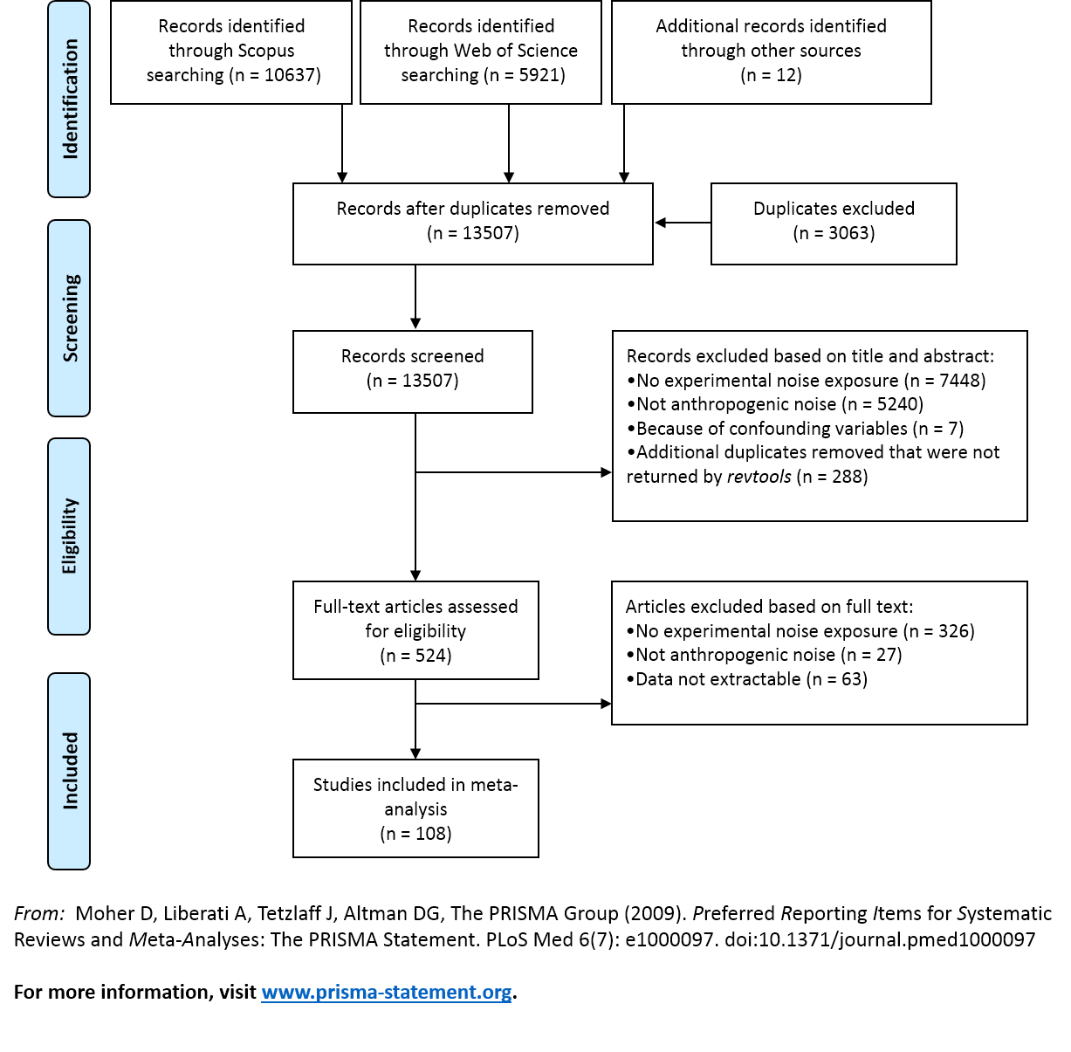
Figure S1. PRISMA flow diagram of the different steps involved in data collection and data selection (following [13]).
Phylogeny

To control for phylogeny, we created a phylogenetic matrix of species in the dataset using the Open Tree of Life [14]. We used the ROTL package [15] to access the Open Tree of Life in R. ROTL does not calculate branch lengths for trees and thus we calculated these using the compute.brlen function in the APE package [16]. A correlation matrix of phylogenetic relatedness among species was then build using APE’s vcv function. This correlation matrix was incorporated in all models, within METAFOR, so that phylogenetic relatedness among effect sizes could be accounted for as a random effect [17].

Heterogeneity

Meta-analysis allows to quantify heterogeneity I²_{total} which is the variance that is not due to sampling error or, in other words, it is the variance in true effects in contrast to the sampling variance [18]. To test whether there was more heterogeneity in effect sizes among studies than could be explained by sampling error alone we used Cochran’s Q statistic. This formally tests whether variation in effect sizes is greater among studies than expected if the true effect is identical for all studies [19]. However, the ratio assumes a constant within-study variance, which is not the case as sampling error varies due to studies having different sample sizes [18]; thus heterogeneity I² should be treated as a measure of “inconsistency” in effect sizes among studies [18]. Therefore, total heterogeneity I² indicates how much of the total variance can be attributed to the total amount of heterogeneity, which is the sum of between- and within cluster heterogeneity [9, 20].

To quantify heterogeneity I² for the multilevel meta-analytic models, we calculated heterogeneity following [21]. These modified heterogeneity I² partitions the proportion of unknown variance not attributable to sampling variance into the contribution of random factors. In our analyses, these are the variance in effect sizes due to phylogenetic relatedness, differences among studies, and differences in within-study variation. In this study, I²_{efffect size} reflects inconsistencies within studies, I²_{study} reflects inconsistencies among studies, I²_{phylogeny} are inconsistencies due to phylogenetic relatedness, I²_{species} are inconsistencies among species, and I² _{total} is the sum of all these values combined. The sum of the percentages of total variation due to these sources equals the traditional I² [22]. High heterogeneity suggests that there may be differences in responses between groups of studies, which can have ecologically important implications [19, 23].

Statistical analysis

All statistical analyses were performed in R version 3.45.2 [24] and R studio 1.1.463. Some studies included multiple effect size estimates due to measurement of several different response variables. To account for the non-independence of effect sizes we used phylogenetically controlled meta-analytical multi-level random-effects models [9, 21]. However, these random effects do not account for non-independence arising from different measurements taken in the same experiment [25]. For meta-analysis in ecology and evolution, the effect size estimates are often correlated at various hierarchical levels and there are different approaches to deal with non-independence, all with their strengths and limitations [25]. Often practical considerations limit the ability to deal with non-independence [25]. However, if the effect is strong, then inferences from the analysis will be likely robust, whether or not all sources of non-independence have been controlled for [25]. Thus, we modelled this correlated structure (cf. [25]) as a covariance matrix that also included sampling error variance (i.e. Vz); we set the correlation among response measurements as 0.5 (following [26]). Meta-models were built using the rma.mv function in the package METAFOR [9].

To test whether noise elicit a significant response we first ran an overall model on 464 effect sizes, including taxonomic group as a moderator and study, effect size, phylogeny and as random factors, and the sampling error variance (Vz) to control for the non-independence of effect sizes. As the standardized mean difference approach does not correct for differences in the direction of response variables [27], we used the absolute values of the effect sizes [27]. Unfortunately, there is little agreement in the literature what represents the best way to deal with these kind of data [28]. However, this model allows us to test whether noise has an effect across taxonomic groups and at the same time to quantify how much the phylogenetic information contributes to the variance in our data (see below). Secondly, for the analysis of each taxonomic group, we included again study and effect size, but also species as a random factor to account for the repeated sampling of species; again, we included the sampling error variance (Vz) to control for the non-independence of effect sizes. We did not include phylogeny because the number of species within some taxonomic groups was too small. Consequently, we were able to include more effect sizes in this analysis as we did not need the phylogenetic matrix, for which the Open Tree of Life database did not return a phylogenetic information for the first model; thus, the sample size for the overall model (n = 464) and the sum of all effect sizes for the different taxonomic groups (n = 483) differ. Moreover, for the reptilians we were only able to obtain three effect sizes from one study and thus we did not conduct an analysis on the taxonomic group level for reptilians.

Some of the correlations among effect sizes may be substantially higher. Therefore, in addition to run the models with the correlation among response measurements set at 0.5 we also ran all models as well with 0.9 assuming very strong correlations among effect sizes. The change in the strength of correlation among response measurements did not change the outcome of our results reported in table S3.

Table S3. Effect of anthropogenic noise on wildlife. (a) Effect of noise on taxonomic groups. (b) Effect of noise on species of a taxonomic group. Estimates and 95% confidence intervals (CI) calculated from a phylogenetically controlled meta-analysis. All effect sizes (ES) are derived from experimental noise exposure studies. Some of the correlations among effect sizes may be substantially higher than 0.5 thus we ran the models also with 0.9. The change in the strength of correlation among response measurements did not change the outcome of our results reported in table 1.
 |  | Number of |  |  |  | estimate | se |  | z |  | CI |  |  |  |  | p | Heterogeneity I² [%]
 |  | ES |  | studies | species |  |  |  |  |  | lower |  | upper |  |  |  | ES |  | study |  | phylogeny/species |  | total |  | Q |  | df |  | p
(a) | overall | 464 | 102 |  | 101 | 0.61 |  | 0.15 |  | 3.95 |  | 0.30 |  | 0.91 | <0.001 |  |  | 66.26 |  | 10.56 |  | 1.65 |  | 78.47 |  | 5119.6 |  | 462 |  | <0.001
 | taxonomic group |  |  |  |  | 0.02 |  | 0.04 |  | 0.35 |  | -0.07 |  | 0.10 | 0.72 |  |  |  |  |  |  |  |  |  |  | 0.12 |  | 1 |  | 0.72
(b) | amphibians | 86 | 13 |  | 21 | 0.47 |  | 0.10 |  | 4.65 |  | 0.27 |  | 0.67 | <0.001 |  |  | 38.95 |  | 0 |  | 19.68 |  | 58.64 |  | 537.72 |  | 85 |  | <0.001
 | arthropods | 74 | 13 |  | 11 | 0.89 |  | 0.15 |  | 5.83 |  | 0.59 |  | 1.20 | <0.001 |  |  | 72.05 |  | 0 |  | 7.17 |  | 79.21 |  | 979.55 |  | 73 |  | <0.001
 | birds | 149 | 36 |  | 38 | 0.52 |  | 0.10 |  | 5.08 |  | 0.32 |  | 0.72 | <0.001 |  |  | 60.24 |  | 17.95 |  | 0 |  | 78.19 |  | 1546.2 |  | 148 |  | <0.001
 | fish | 94 | 25 |  | 26 | 0.74 |  | 0.12 |  | 6.19 |  | 0.51 |  | 0.98 | <0.001 |  |  | 35.07 |  | 41.14 |  | 0 |  | 76.2 |  | 766.07 |  | 93 |  | <0.001
 | mammals | 50 | 14 |  | 7 | 1.32 |  | 0.24 |  | 5.58 |  | 0.86 |  | 1.79 | <0.001 |  |  | 85.42 |  | 0 |  | 0 |  | 85.42 |  | 713.49 |  | 49 |  | <0.001
 | molluscs | 30 | 6 |  | 5 | 0.79 |  | 0.28 |  | 2.84 |  | 0.24 |  | 1.33 | 0.0045 |  |  | 68.79 |  | 0 |  | 16.4 |  | 85.2 |  | 535.15 |  | 29 |  | <0.001

Meta-analysis is vulnerable to outliers and other potentially influential data points. However, diagnostics tests for identifying, and rules for excluding these data points are still evolving, particularly for multi-level models [29]. We evaluated the sensitivity of our analyses by comparing fitted models with and without effect sizes that we defined as potentially influential from inspecting graphs. Including or excluding these values did not change the overall outcome of the results. Circle plots were created with the package CIRCLIZE [30]. Animal drawings are from phylopic.org.
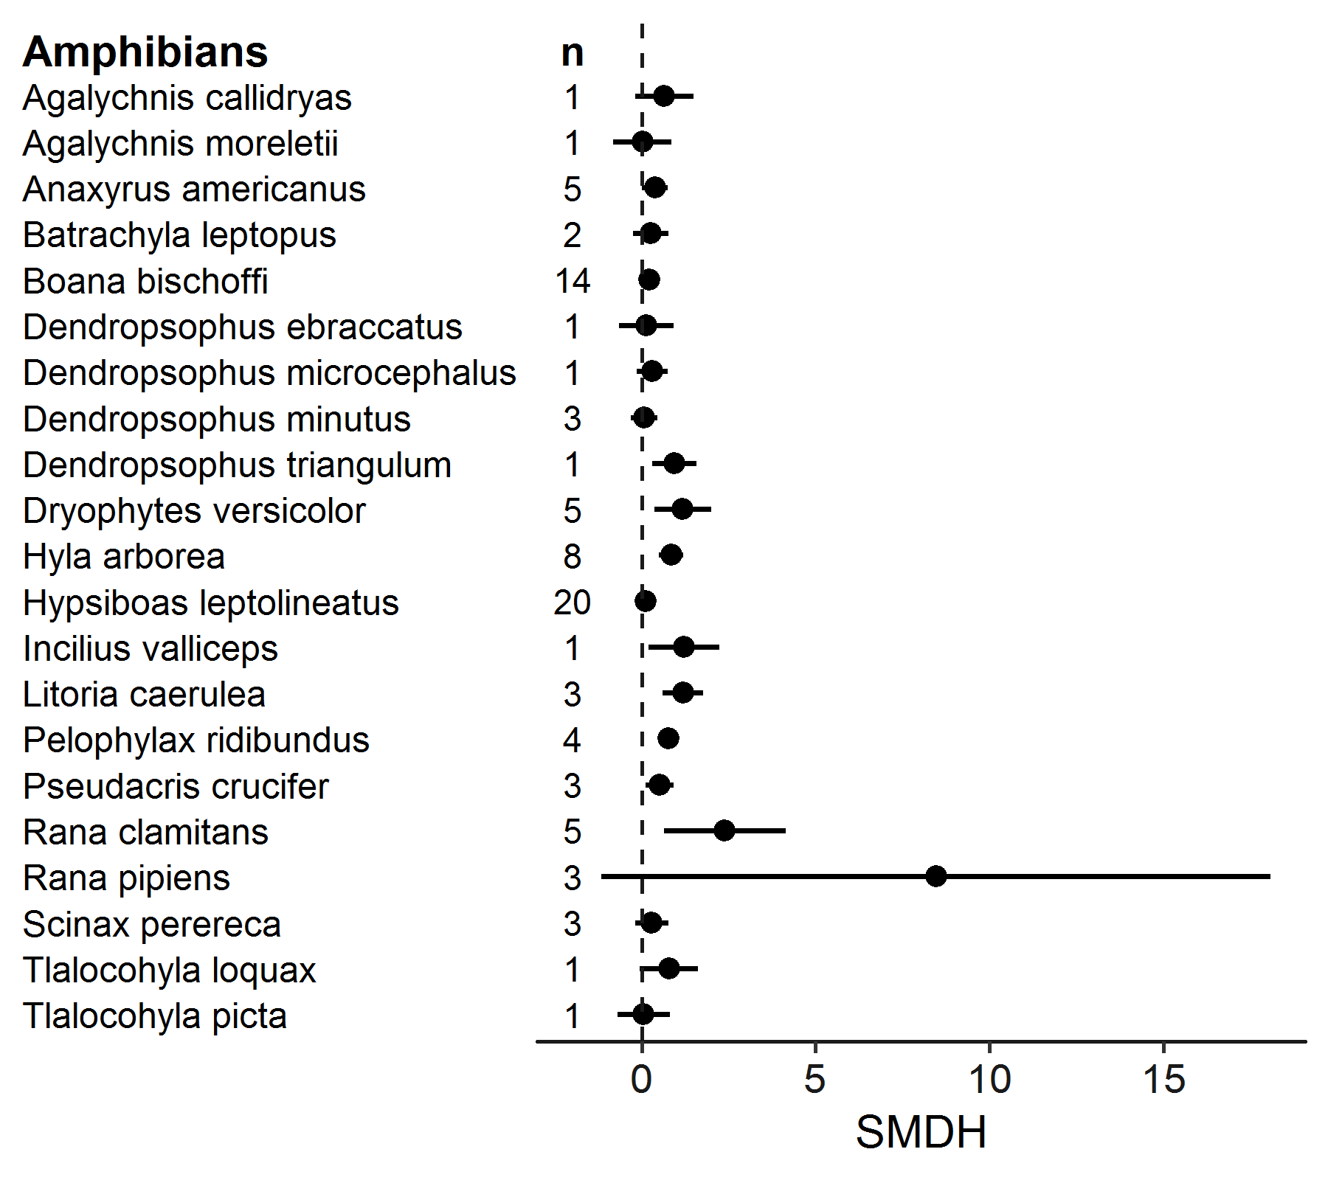
Figure S2. (A) Standardized absolute mean differences (SMDH) for each species of amphibians (n = the number of effect sizes per species).

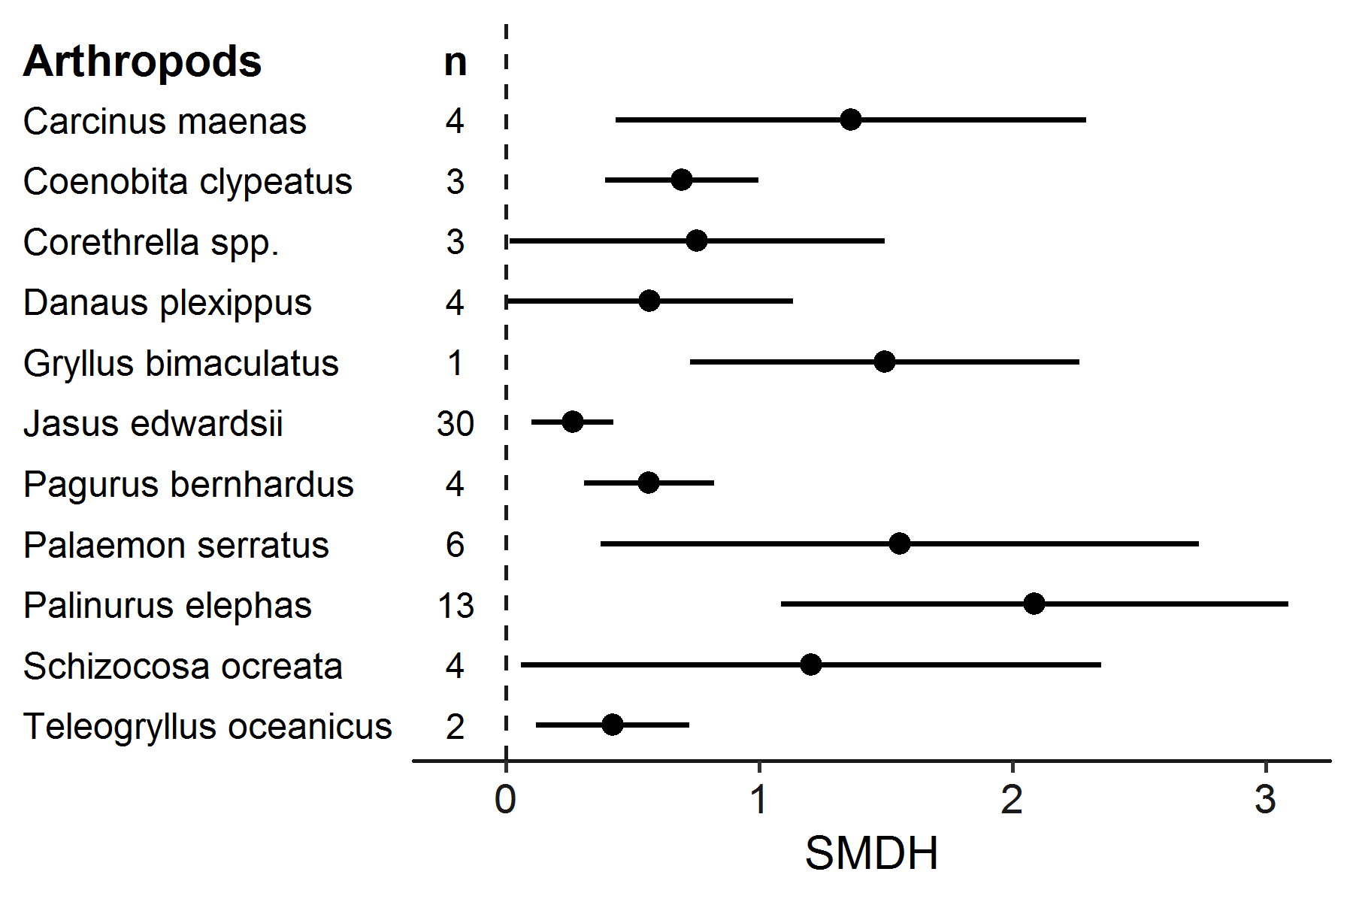
Figure S2. (B) Standardized absolute mean differences (SMDH) for each species of arthropods (n = the number of effect sizes per species).
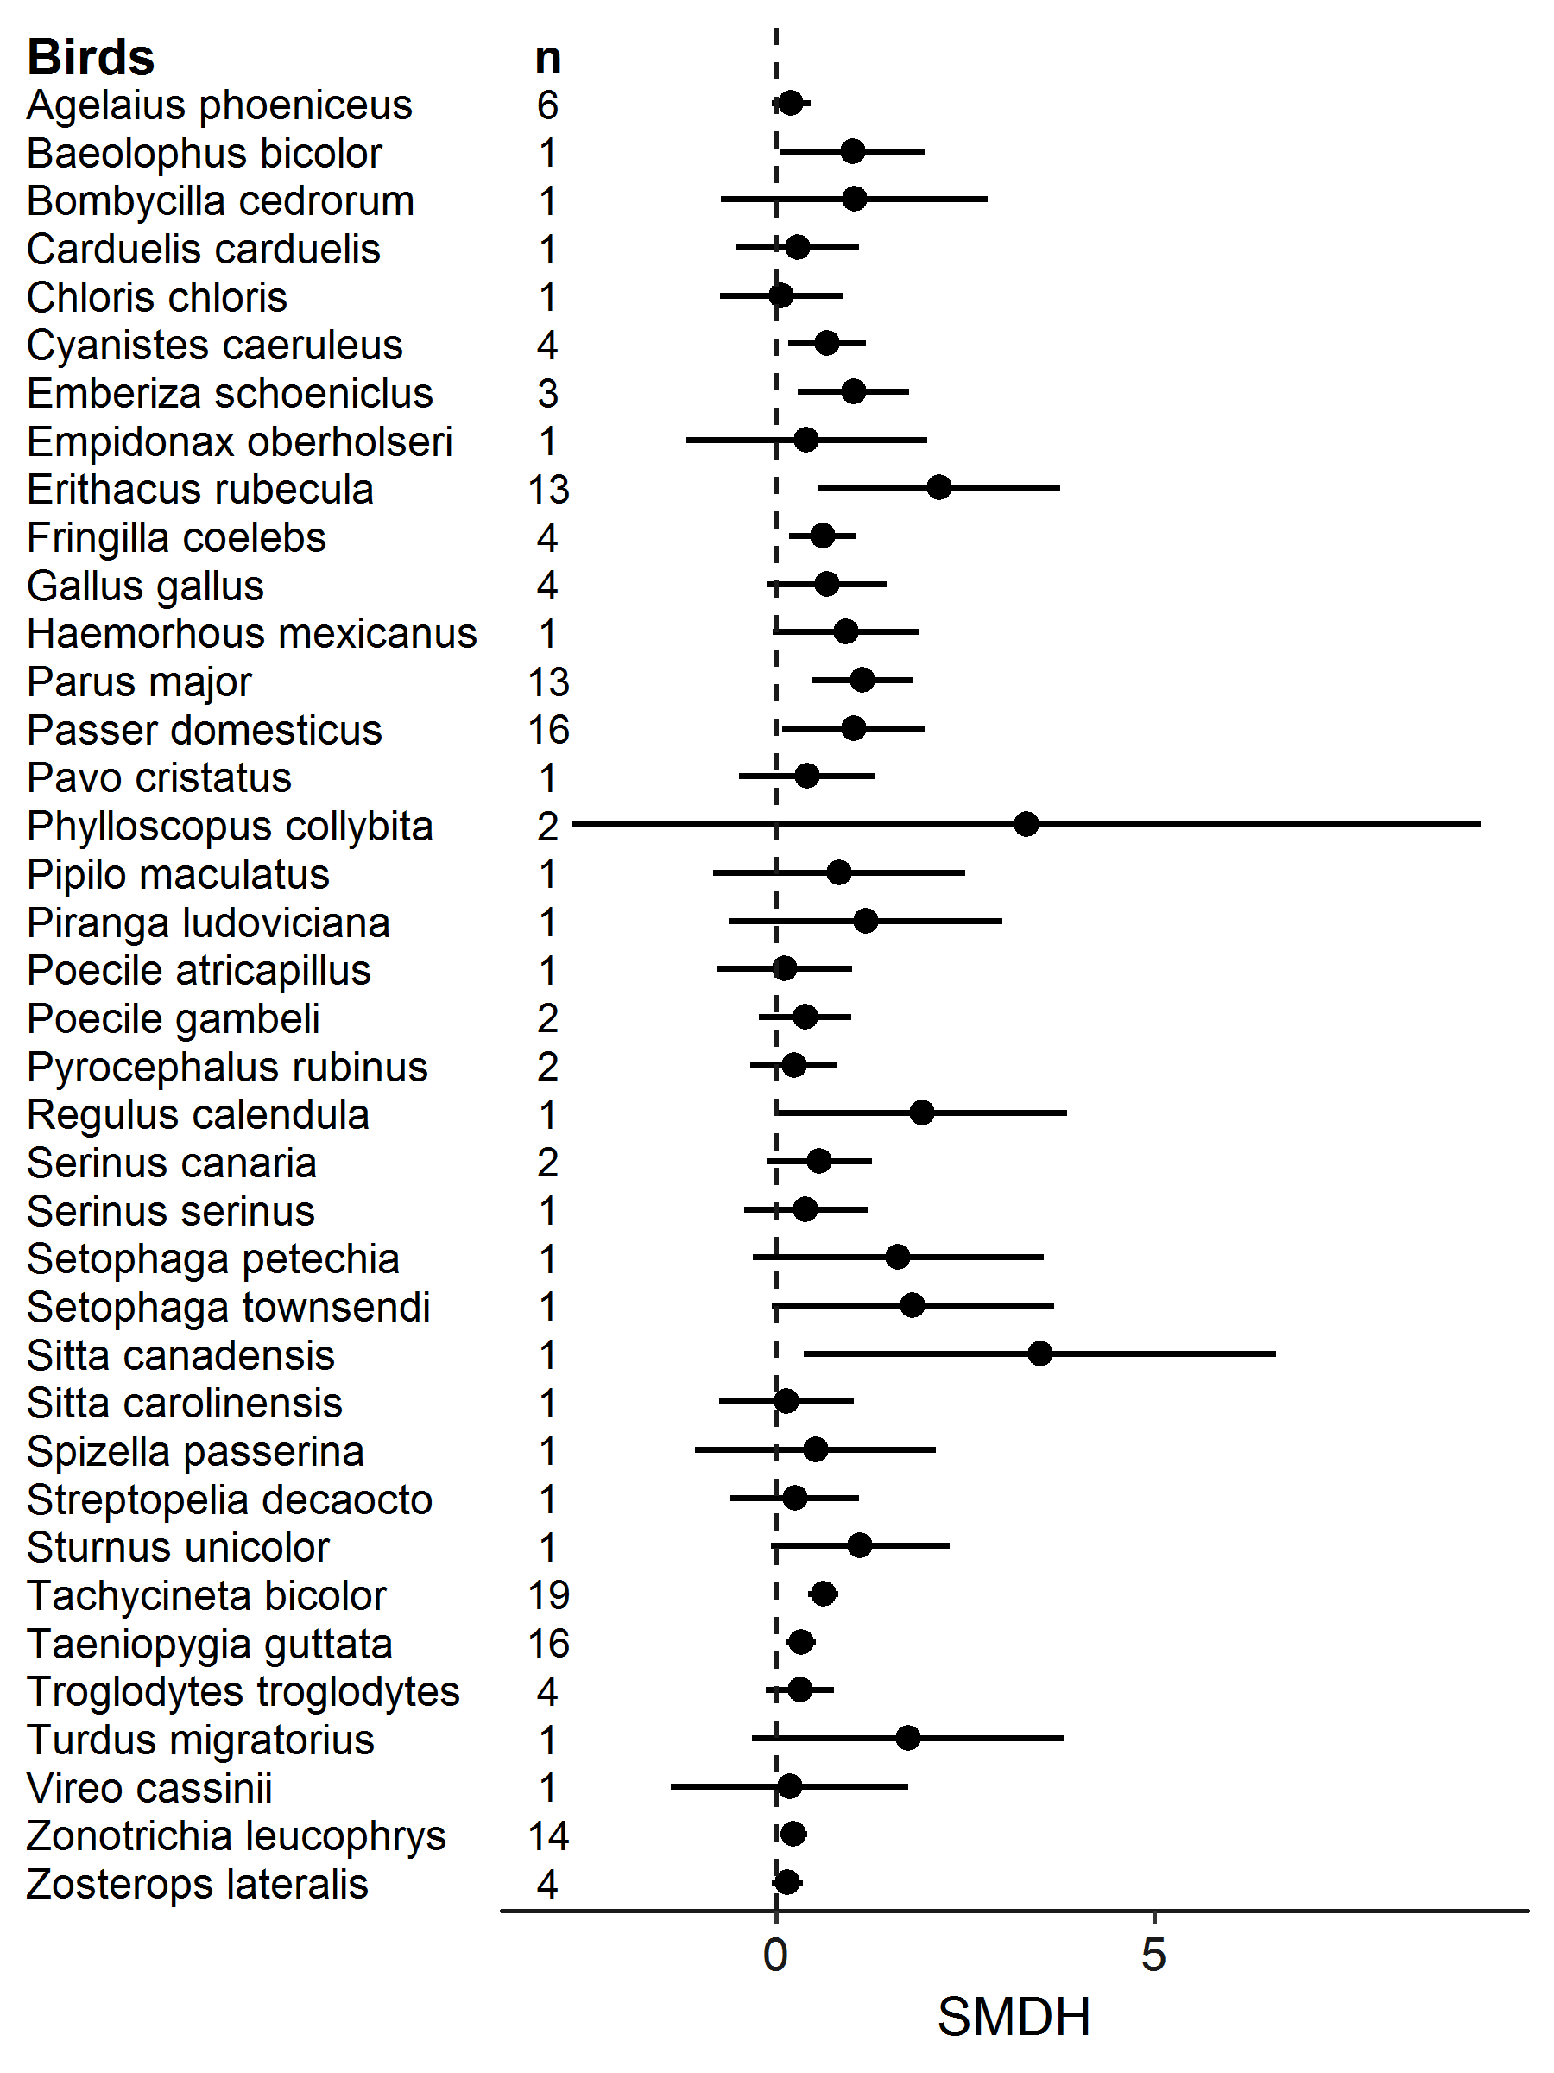
Figure S2. (C) Standardized absolute mean differences (SMDH) for each species of birds (n = the number of effect sizes per species).

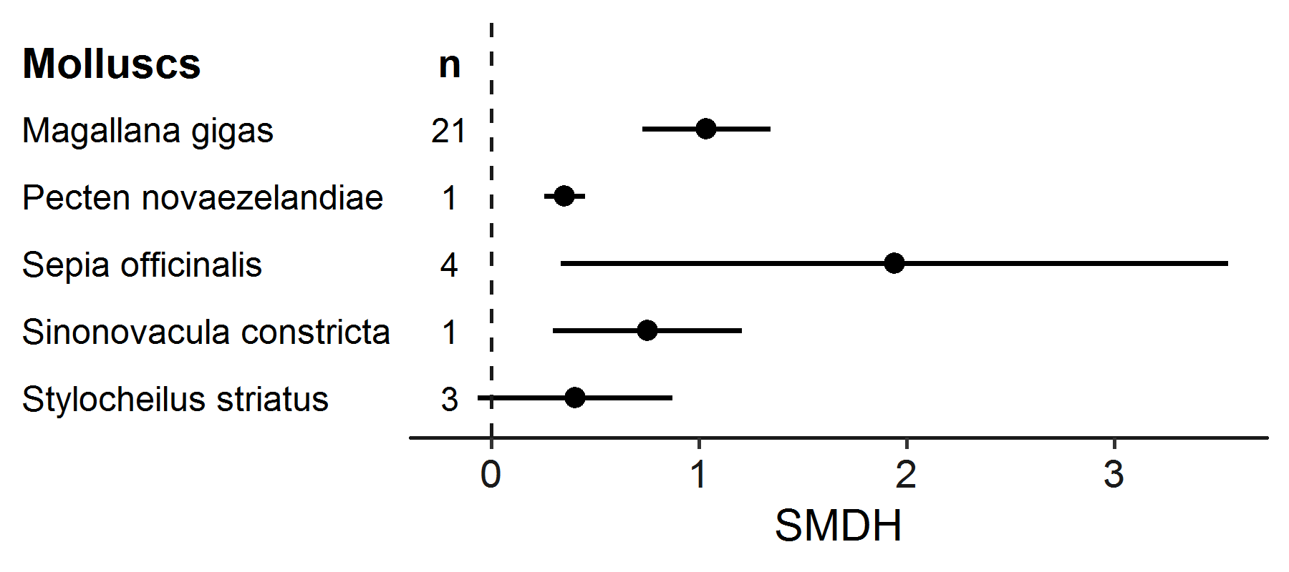
Figure S2. (D) Standardized absolute mean differences (SMDH) for each species of molluscs (n = the number of effect sizes per species).

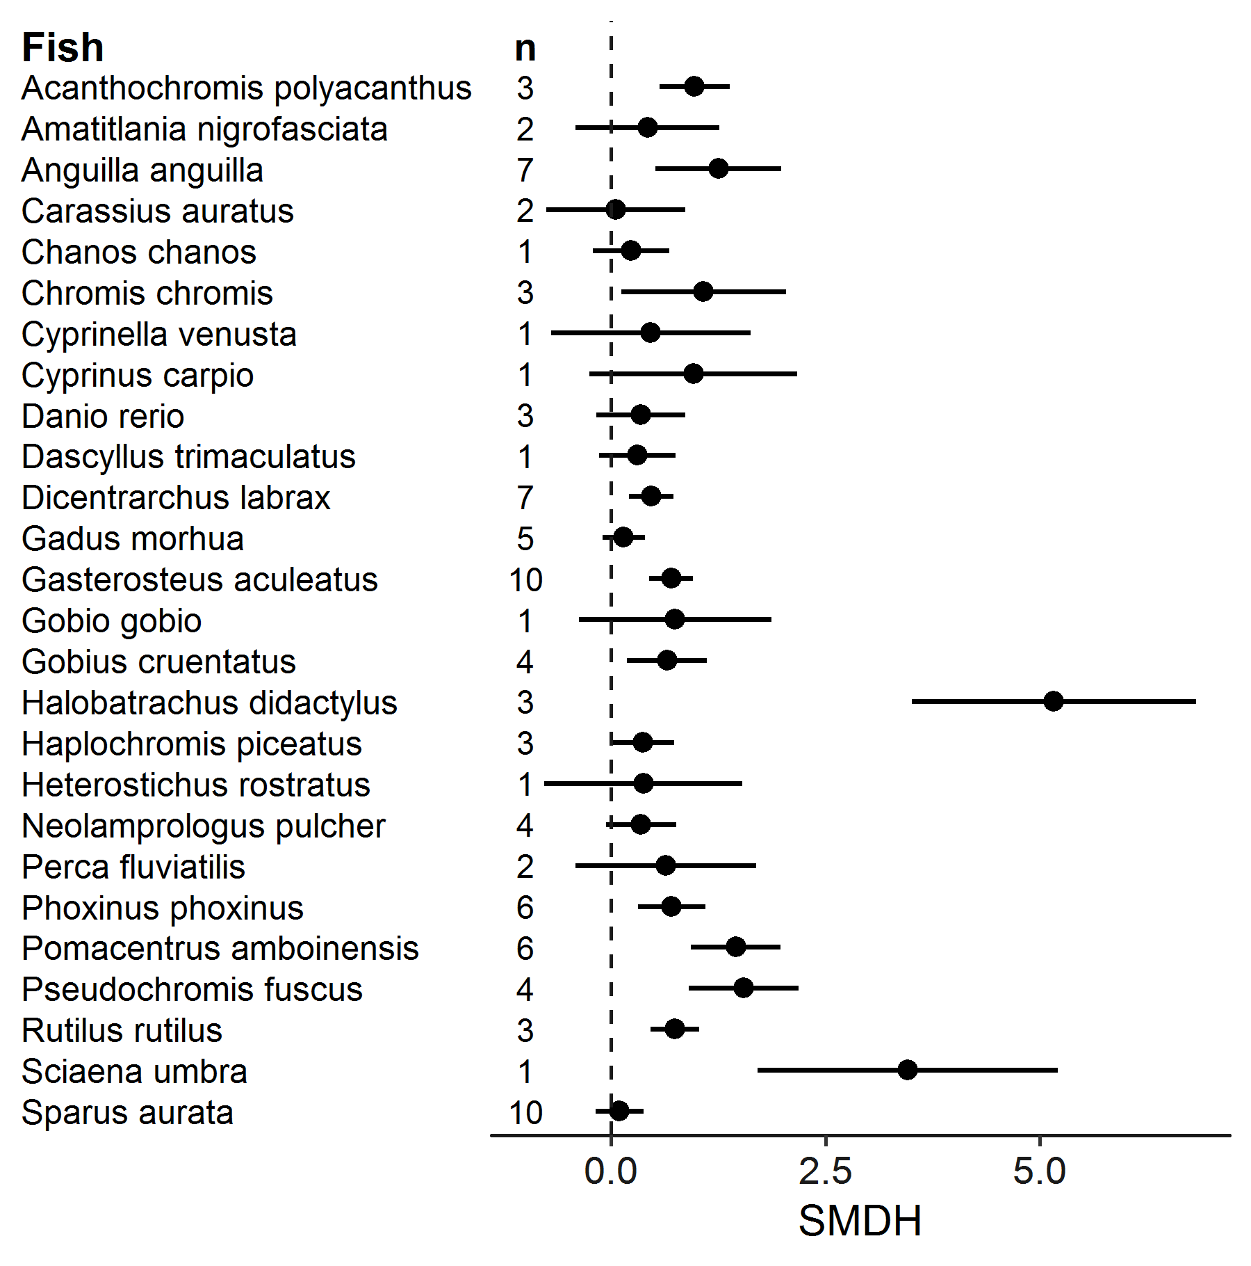
Figure S2. (E) Standardized absolute mean differences (SMDH) for each species of fish (n = the number of effect sizes per species).
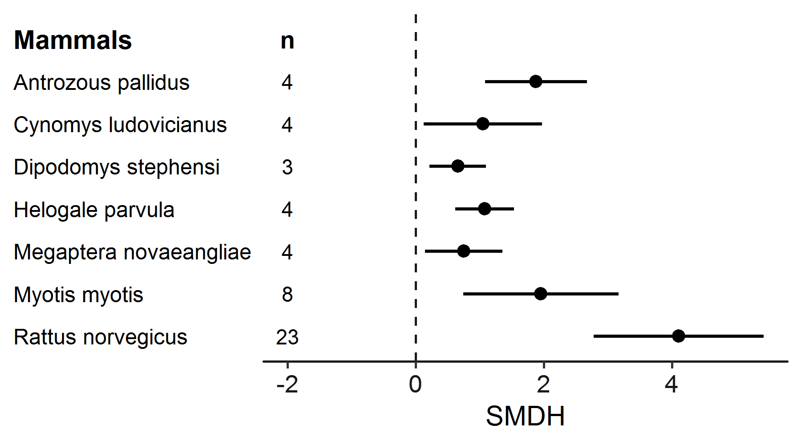
Figure S2. (E) Standardized absolute mean differences (SMDH) for each species of mammals (n = the number of effect sizes per species).

Types of noise

One of our criteria to be included in our analysis was that the type of stimuli used in noise exposure experiments had to mimic the characteristics of anthropogenic noise, which is usually low frequency noise (see above). Thus, we expect that the different types of noise contribute only little to the variation of effect sizes in our sample. To test this formally, we included type of noise as an additional moderator in an initial analysis and found no effect of type of noise (table S4). Therefore, this moderator was excluded from all further analyses.
Table S4. Initial overall model to test the effect of type of noise. Estimates and 95% confidence intervals (CI) calculated from a phylogenetically controlled meta-analysis. All effect sizes (ES) are derived from experimental noise exposure studies. Effect size, study, and species were included as random factors.
 | Number of |  |  |  | estimate |  | se |  | z |  | CI |  |  |  | p
 | ES |  | studies | species |  |  |  |  |  |  | lower |  | upper
overall | 464 | 102 |  | 101 |  | 0.66 |  | 0.28 |  | 2.31 |  | 0.1 | 1.21 | 0.02
taxonomic group |  |  |  |  |  | -0.08 |  | 0.06 |  | 1.3 |  | -0.04 | 0.02 | 0.19
type of noise |  |  |  |  |  | -0.007 |  | 0.02 |  | -0.44 |  | -0.04 | 0.02 | 0.66
Origin of noise: air gun (n = 34), artificial low frequency (n = 12), artificial traffic noise (n = 6), boat (n = 109), compressor (n = 2), generator (n = 1), pile-driving ship (n = 4), low frequency white noise (n = 5), mining (n = 3), pile driving (n = 5), road (n = 3), seismic pulses (n = 1), traffic (n = 182), traffic underwater (n = 1), urban (n = 1), white noise (n = 94), windfarm (n = 1).

Publication bias

Publication bias may arise as statistically significant results are more likely to be published than statistically non-significant results [31]. The resulting bias may lead to erroneous conclusions that could seriously impact the assessment of the factor under investigation [32-34]. There are several different approaches to quantify the potential influence of publication bias either visually or statistically [35]. We checked for publication bias using two widely used approaches: funnel plots [36] and Egger’s regression [37]. We tested for publication bias using Egger’s regression test [37, 38] by modifying the multi-level random-effects models in two ways: first, we used the raw values of effect sizes and second, we included precision of the effect sizes as a moderator (cf. [39]). When the intercept of this regression test significantly deviates from zero, the overall relationship between the precision and size of studies included in the data set is considered asymmetrical, and therefore, biased [38]. We considered data sets to be biased if the intercept differed from zero at p=0.1 (cf. [37]). To evaluate publication bias we used the raw SMDH. We found no evidence for publication bias both graphically and statistically. There was no clear asymmetry in the funnel plot (figure S3). Also Egger’s regression tests did not show evidence of a publication bias (k = 464, z = -1.34, p = 0.18); removing the outlier did not change the outcome. Thus, the results from both visual and statistical inspections suggest that publication bias has little effect and that our results are robust with the data set used.

Time-lag bias

We also tested for a time-lag bias, i.e. that the magnitudes of an effect diminish over time [40-42], which has been reported in different areas of ecology and evolution [41]. To quantify whether significant temporal changes (time-lag bias) in the magnitude of effects sizes occur in our data set we used graphical inspection and a regression [41]. We did not find evidence for a time-lag bias in the published literature as effect sizes did not decrease over time (figure S4, k = 464, z = -0.16, p = 0.87). Thus, the results from both visual and statistical inspections suggest that a time-lag bias has little effect and that our results are robust with the data set used.
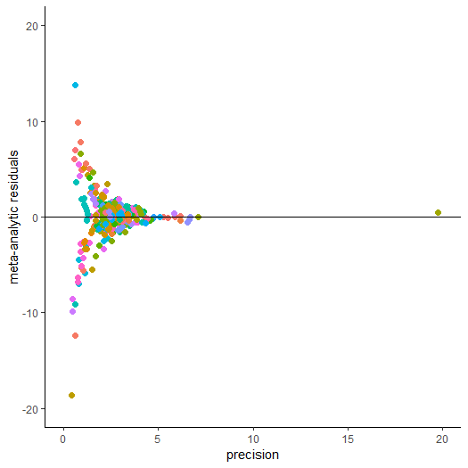
Figure S3. Funnel plot of the meta-analytic residuals against their precision for the meta-analysis. There is neither a clear asymmetry detectable by visual inspection nor Egger’s regression. Each point represents an effect size (n = 464) and each colour represents a study (n = 102). Removing the outlier did not change the outcome of the analysis (see text for details).

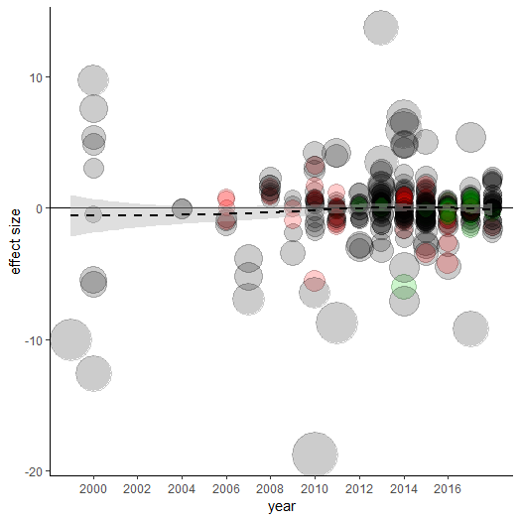
Figure S4. The published effect sizes for noise pollution has not changed over time since the first experimental study was published in our sample (464 effect sizes from 102 studies on 101 species). The dashed black line represents the model estimate, and the shading grey shows the 95% confidence intervals of a multilevel meta-regression based (see text for details). Estimates are shown as the standardized mean differences. The size of the circle represents the sample variance. The colour represents the sample size for each effect size (colours are grouped into following categories: grey: < 10, blue: 10 -20, green: 20 -30, red: > 40 studies).
1. Westgate, M. 2018 revtools: Tools for Evidence Synthesis. R package version 0.3.0, https://CRAN.R-project.org/package=revtools.
2. Milinski, M. 1997 How to avoid seven deadly sins in the study. Advances in the Study of Behavior. 26, 159-180.
3. Whitham, T. G., Bailey, J. K., Schweitzer, J. A., Shuster, S. M., Bangert, R. K., LeRoy, C. J., Lonsdorf, E. V., Allan, G. J., DiFazio, S. P., Potts, B. M. 2006 A framework for community and ecosystem genetics: from genes to ecosystems. Nature Reviews Genetics. 7, 510.
4. Rohatgi, A. 2017 . WebPlotDigitizer-web based plot digitizer version 3.11.
5. Slabbekoorn, H., Bouton, N., van Opzeeland, I., Coers, A., ten Cate, C., Popper, A. N. 2010 A noisy spring: the impact of globally rising underwater sound levels on fish. Trends in ecology & evolution. 25, 419-427.
6. Hildebrand, J. A. 2009 Anthropogenic and natural sources of ambient noise in the ocean. Mar. Ecol. Prog. Ser. 395, 5-20.
7. Kunc, H. P., McLaughlin, K. E., Schmidt, R. 2016 Aquatic noise pollution: implications for individuals, populations, and ecosystems. Proceedings of the Royal Society B: Biological Sciences. 283, 20160839.
8. Nakagawa, S., Noble, D. W., Senior, A. M., Lagisz, M. 2017 Meta-evaluation of meta-analysis: ten appraisal questions for biologists. BMC biology. 15, 18.
9. Viechtbauer, W. 2010 Conducting meta-analyses in R with the metafor package. Journal of statistical software. 36.
10. Hedges, L. V. 1981 Distribution theory for Glass's estimator of effect size and related estimators. journal of Educational Statistics. 6, 107-128.
11. Bonett, D. G. 2009 Meta-analytic interval estimation for standardized and unstandardized mean differences. Psychol. Methods. 14, 225.
12. Bonett, D. G. 2008 Confidence intervals for standardized linear contrasts of means. Psychol. Methods. 13, 99.
13. Moher, D., Liberati, A., Tetzlaff, J., Altman, D. G., PRISMA Grp. 2009 Preferred Reporting Items for Systematic Reviews and Meta-Analyses: The PRISMA Statement. J. Clin. Epidemiol. 62, 1006-1012. (DOI 10.1016/j.jclinepi.2009.06.005).
14. Hinchliff, C. E., Smith, S. A., Allman, J. F. et al. 2015 Synthesis of phylogeny and taxonomy into a comprehensive tree of life. Proc. Natl. Acad. Sci. U. S. A. 112, 12764-12769. (DOI 10.1073/pnas.1423041112 [doi]).
15. Michonneau, F., Brown, J. W., Winter, D. J. 2016 rotl: an R package to interact with the Open Tree of Life data. Methods in Ecology and Evolution. 7, 1476-1481.
16. Paradis, E., Claude, J., Strimmer, K. 2004 APE: Analyses of Phylogenetics and Evolution in R language. Bioinformatics. 20, 289-290. (DOI 10.1093/bioinformatics/btg412).
17. Risely, A., Klaassen, M., Hoye, B. J. 2018 Migratory animals feel the cost of getting sick: A meta-analysis across species. J. Anim. Ecol. 87, 301-314. (DOI 10.1111/1365-2656.12766).
18. Borenstein, M., Higgins, J. P., Hedges, L. V., Rothstein, H. R. 2017 Basics of meta‐analysis: I2 is not an absolute measure of heterogeneity. Research synthesis methods. 8, 5-18.
19. Hedges, L., Olkin, I. 1985 Statistical methods for meta-analysis. New York: Academic Press.
20. Konstantopoulos, S. 2011 Fixed effects and variance components estimation in three-level meta-analysis. Research Synthesis Methods. 2, 61-76. (DOI 10.1002/jrsm.35).
21. Nakagawa, S., Santos, E. S. A. 2012 Methodological issues and advances in biological meta-analysis. Evol. Ecol. 26, 1253-1274. (DOI 10.1007/s10682-012-9555-5).
22. Higgins, J. P., Thompson, S. G., Deeks, J. J., Altman, D. G. 2003 Measuring inconsistency in meta-analyses. BMJ. 327, 557-560. (DOI 10.1136/bmj.327.7414.557 [doi]).
23. Gurevitch, J., Hedges, L. V. 1999 Statistical issues in ecological meta‐analyses. Ecology. 80, 1142-1149.
24. Team, R. C. 2011 R: a language and environment for statistical computing. R Foundation for Statistical Computing, Vienna, Austria; 2016. R Foundation for Statistical Computing. Computing, Vienna, Austria.
25. Noble, D. W. A., Lagisz, M., O'dea, R. E., Nakagawa, S. 2017 Nonindependence and sensitivity analyses in ecological and evolutionary meta-analyses. Mol. Ecol. 26, 2410-2425. (DOI 10.1111/mec.14031).
26. Parker, T. H., Greig, E., I., Nakagawa, S., Parra, M., Dalisio, A. C. 2018 Subspecies status and methods explain strength of response to local versus foreign song by oscine birds in meta-analysis. Anim. Behav. 142, 1-17. (DOI 10.1016/j.anbehav.2018.05.023).
27. Green, S., Higgins, J. 2005 Cochrane handbook for systematic reviews of interventions.
28. Morrissey, M. B. 2016 Meta‐analysis of magnitudes, differences and variation in evolutionary parameters. J. Evol. Biol. 29, 1882-1904.
29. Viechtbauer, W., Cheung, M. W. -. 2010 Outlier and influence diagnostics for meta-analysis. Research Synthesis Methods. 1, 112-125. (DOI 10.1002/jrsm.11).
30. Gu, Z., Gu, L., Eils, R., Schlesner, M., Brors, B. 2014 circlize implements and enhances circular visualization in R. Bioinformatics. 30, 2811-2812. (DOI 10.1093/bioinformatics/btu393).
31. Borenstein, M., Hedges, L. V., Higgins, J. P. T., Rothstein, H. R. 2009 Introduction to Meta-Analysis. Sussex: Wiley.
32. Stern, J., Simes, R. 1997 Publication bias: evidence of delayed publication in a cohort study of clinical research projects. Bmj-British Medical Journal. 315, 640-645. (DOI 10.1136/bmj.315.7109.640).
33. Ioannidis, J. 1998 Effect of the statistical significance of results on the time to completion and publication of randomized efficacy trials. Jama-Journal of the American Medical Association. 279, 281-286. (DOI 10.1001/jama.279.4.281).
34. SIMES, R. 1987 Confronting Publication Bias - a Cohort Design for Metaanalysis. Stat. Med. 6, 11-29. (DOI 10.1002/sim.4780060104).
35. Jennions, M. D., Lortie, C., Rosenberg, M.S., Rothstein, H.R. 2013 Publication and related biases. In Handbook of meta-analysis in ecology and evolution (eds J. Koricheva, J. Gurevitch, M. Mengersen), pp. 207-236. Princeton: Princeton University Press.
36. Rothstein, H. R., Sutton, A. J., Borenstein, M. 2005 Publication bias in meta-analysis. Chichester: Wiley.
37. Egger, M., Smith, G., Schneider, M., Minder, C. 1997 Bias in meta-analysis detected by a simple, graphical test. Bmj-British Medical Journal. 315, 629-634. (DOI 10.1136/bmj.315.7109.629).
38. Sterne, J.A., Egger, M. 2005 Regression methods to detect publication and other bias in meta-analysis. In Publication bias in meta-analysis: prevention, assessment and adjustments (eds H. R. Rothstein, A. J. Sutton, M. Borenstein), pp. 99-110. Chichester: Wiley & Sons, Ltd.
39. Habeck, C. W., Schultz, A. K. 2015 Community-level impacts of white-tailed deer on understorey plants in North American forests: a meta-analysis. Aob Plants. 7, plv119. (DOI 10.1093/aobpla/plv119).
40. Jennions, M., Moller, A. 2002 Relationships fade with time: a meta-analysis of temporal trends in publication in ecology and evolution. Proceedings of the Royal Society B-Biological Sciences. 269, 43-48. (DOI 10.1098/rspb.2001.1832).
41. Koricheva, J., Jennions, M. D., Lau, J. 2013 Temporal trends in effect sizes: causes, detection, and implications. In Handbook of meta-analysis in ecology and evolution (eds J. Koricheva, J. Gurevitch, M. Mengersen), pp. 237-254. Princeton: Princeton University Press.
42. Trikalinos, T. A., Ioannidis, J. P. 2005 Assessing the evolution of effect sizes over time. In Publication bias in meta-analysis (eds H. R. Rothstein, A. J. Sutton, M. Borenstein), pp. 241-259. Chichester: Wiley & sons.

