Field-realistic antidepressant exposure disrupts group foraging dynamics in mosquitofish

Jake M. Martin ^{a,}*, Minna Saaristo ª, Hung Tan ª, Michael G. Bertram ^{a,b}, Venkatesh Nagarajan-Radha ª, Damian K. Dowling ª, Bob B.M. Wong ª

ª School of Biological Sciences, Monash University, Australia

^{b} Department of Wildlife, Fish, and Environmental Studies, Swedish University of Agricultural Sciences, Sweden

* Author for correspondence:
School of Biological Sciences, Monash University,
Melbourne, Victoria 3800, Australia.
E-mail address: jake.martin@monash.edu (J.M. Martin).

Abstract
Psychoactive pollutants, such as antidepressants, are increasingly detected in the environment. Mounting evidence suggests that such pollutants can disrupt the behaviour of non-target species. Despite this, few studies have considered how the response of exposed organisms might be mediated by social context. To redress this, we investigated impacts of two environmentally realistic concentrations of a pervasive antidepressant pollutant, fluoxetine, on foraging behaviour in fish (Gambusia holbrooki), tested individually or in a group. Fluoxetine did not alter behaviour of solitary fish. However, in a group setting, fluoxetine exposure disrupted the frequency of aggressive interactions and food consumption, with observed effects being contingent on both the mean weight of group members and the level of within-group variation in weight. Our results suggest that behavioural tests in social isolation may not accurately predict the environmental risk of chemical pollutants for group-living species, and highlight the potential for social context to mediate the effects of psychoactive pollutants in exposed wildlife.

Keywords
Animal behaviour; Feeding; Fluoxetine; Mosquitofish; Pharmaceutical pollution; Shoal
1. Introduction
Pharmaceutical pollution is widely recognised as an emerging environmental problem [1–3], with over 600 different pharmaceuticals having now been detected in ecosystems globally [2]. Disturbingly, among these pharmaceutical pollutants are large quantities of psychoactive compounds [4]. Given that these drugs are specifically designed to alter mood and behaviour in humans, they also have the potential to do so in exposed wildlife [4,5]. The antidepressant fluoxetine (Prozac®) is one such compound. Fluoxetine is frequently detected in ecosystems globally, at concentrations ranging between <0.1–351 ng/L [6]. The primary target molecule of fluoxetine (the serotonin transport molecule) is conserved across all vertebrate taxa [7], and, thus, fluoxetine has the potential to affect a diverse array of ecologically important behaviours in wildlife [8,9]. Indeed, there is growing evidence that antidepressants, such as fluoxetine, can disrupt a range of behaviours in non-target species at environmentally relevant concentrations, such as activity [10–13], anxiety [14–16], predator avoidance and escape [17–20], and foraging [21–22]. However, to date, few studies have considered how impacts of psychoactive pollutants might be affected by social context [23,24], and fewer still have directly asked whether impacts seen in social isolation are reflective of those in a social context [25]. This is surprising given that social interactions can play an important role in mediating individual behaviour [26, 27]. As a result, for group-living species, behavioural tests performed in social isolation may not accurately predict the environmental risk posed by chemical pollution. Hence, studies of behaviour need to be sensitive to social contexts if we are to fully understand the ecological impacts of chemical exposure on social species.
Here, we tested effects of fluoxetine exposure on foraging behaviour in wild-caught female mosquitofish (Gambusia holbrooki), both individually and when part of a small group (3 fish). The nominal (i.e. desired) concentrations for the low- and high-fluoxetine treatments were 30 and 300 ng/L, respectively. The lower fluoxetine concentration represents a level commonly detected in aquatic ecosystems, while the high concentration represents more heavily polluted ecosystems [6].

2. Materials and methods
Female mosquitofish used in this study (n = 445) were collected from a wild population (37° 54' 28" S, 145° 08' 16" E) and transported to Monash University, where they were acclimated to laboratory conditions for one month. ﻿Water samples previously taken from this site revealed no fluoxetine contamination (analysis performed using liquid chromatography–mass spectrometry; unpublished data). Here, we used only one sex to control for any effects of sexual behaviour that may have confounded the results [28,29]. Female mosquitofish were used as they show a stronger tendency to form shoals than males [28, 30]. After acclimation to laboratory conditions, fish were randomly allocated to one of three treatments for 28 days (unexposed, low-fluoxetine or high-fluoxetine). A 28-day exposure was selected as the effects of fluoxetine can be time dependent, taking ﻿2–4 weeks to manifest in humans [31,32]. For all three treatments, fish were held in flow-through systems (24 h cycling), with 8 tanks per treatment (24 tanks total; housing ~20 fish per tank) over the 28 days. Exposure was performed following previously established protocols (see Supplementary material S1.1; [33–36]). During the exposure, Gas Chromatography coupled to Tandem Mass Spectrometry was used for analytical verification of fluoxetine concentrations (described in [36]). During both the laboratory acclimation and exposure period, fish were maintained in aged carbon-filtered fresh water (pH: 6.9–7.9) under a 24 h light:dark cycle (7:00–18:00 light), and fed ad libitum once daily with commercial fish food (Otohime Hirame larval diet). To standardise hunger levels, fish were not fed for 24 h prior to the start of each trial.
After the 28-day exposure protocol, fish performed a novel foraging trial either individually or as part of a group of three [37]. All foraging trials, regardless of treatment, were performed in aged carbon-filtered fresh water from the same source that supplied the flow-through exposure systems (aerated and heated in large reservoirs). Trial arenas (121.5 L; 60 × 45 × 45 cm; length × width × height; Fig 1) were filled to a depth of 10 cm with water (i.e. 27 L), had a sand substrate, and four foraging plates (12.3 × 8 × 2 cm), each of which contained 48 wells. Foraging plates were positioned in each corner of the arena, 10 cm from the edge. Before mosquitofish were introduced, chironomid larvae (i.e. prey items), were distributed equally across each of the foraging plates in shallow wells. Shallow wells were used to ensure that fish were actively engaging in food discovery and foraging behaviour [37]. Twelve and 36 chironomid larvae were placed in the arena of individual and group foraging trials, respectively. This was done to balance the ratio of prey items to fish across individual and group trials. To ensure that prey items were recognised as a food source, chironomid larvae were introduced into fish diets over the week prior to the behavioural experiments. Prior to the start of each trial, fish were acclimated inside the foraging arena within an opaque cylinder (one fish per cylinder; 7.5 cm diameter) for 5 min. After acclimation, the cylinders were remotely removed, and the individual or group was left to explore the foraging arena for 20 min. Upon completion of each trial, the foraging arenas were emptied and refilled with aged carbon-filtered fresh water. Fish behaviour was video-recorded from above and later scored blind to experimental treatment (i.e. video identification tags did not contain experimental treatment information) using open-source event-logging software (BORIS ﻿v. 7.4.7; [38]). Specifically, for each fish, the time taken to first consume a prey item, and the total number of prey items consumed, was recorded. In addition, for group trials, the total number of aggressive feeding interactions was recorded as the number of times group members attempted to steal food from one another. For individual trials, a total of 113 fish completed the foraging experiment (n: control = 38, low-fluoxetine = 38 and high-fluoxetine = 37). For group trials, a total of 103 groups of fish (i.e. groups of three) completed the foraging experiment (n: control = 34, low-fluoxetine = 34 and high-fluoxetine = 35). The required sample size per treatment group was estimated based on previous experiments investigating effects of fluoxetine on fish behaviour (Martin et al. 2017; Martin et al. 2019a; Martin et al. 2019b; Fursdon et al. 2019). Following behavioural trials, all fish were measured for weight (±0.0001 g) and standard length (±0.01 mm). These measures were used to calculate a body condition index for each fish by producing a least-squares regression of fish weight against standard length, with condition index being the residual distance from this regression line.

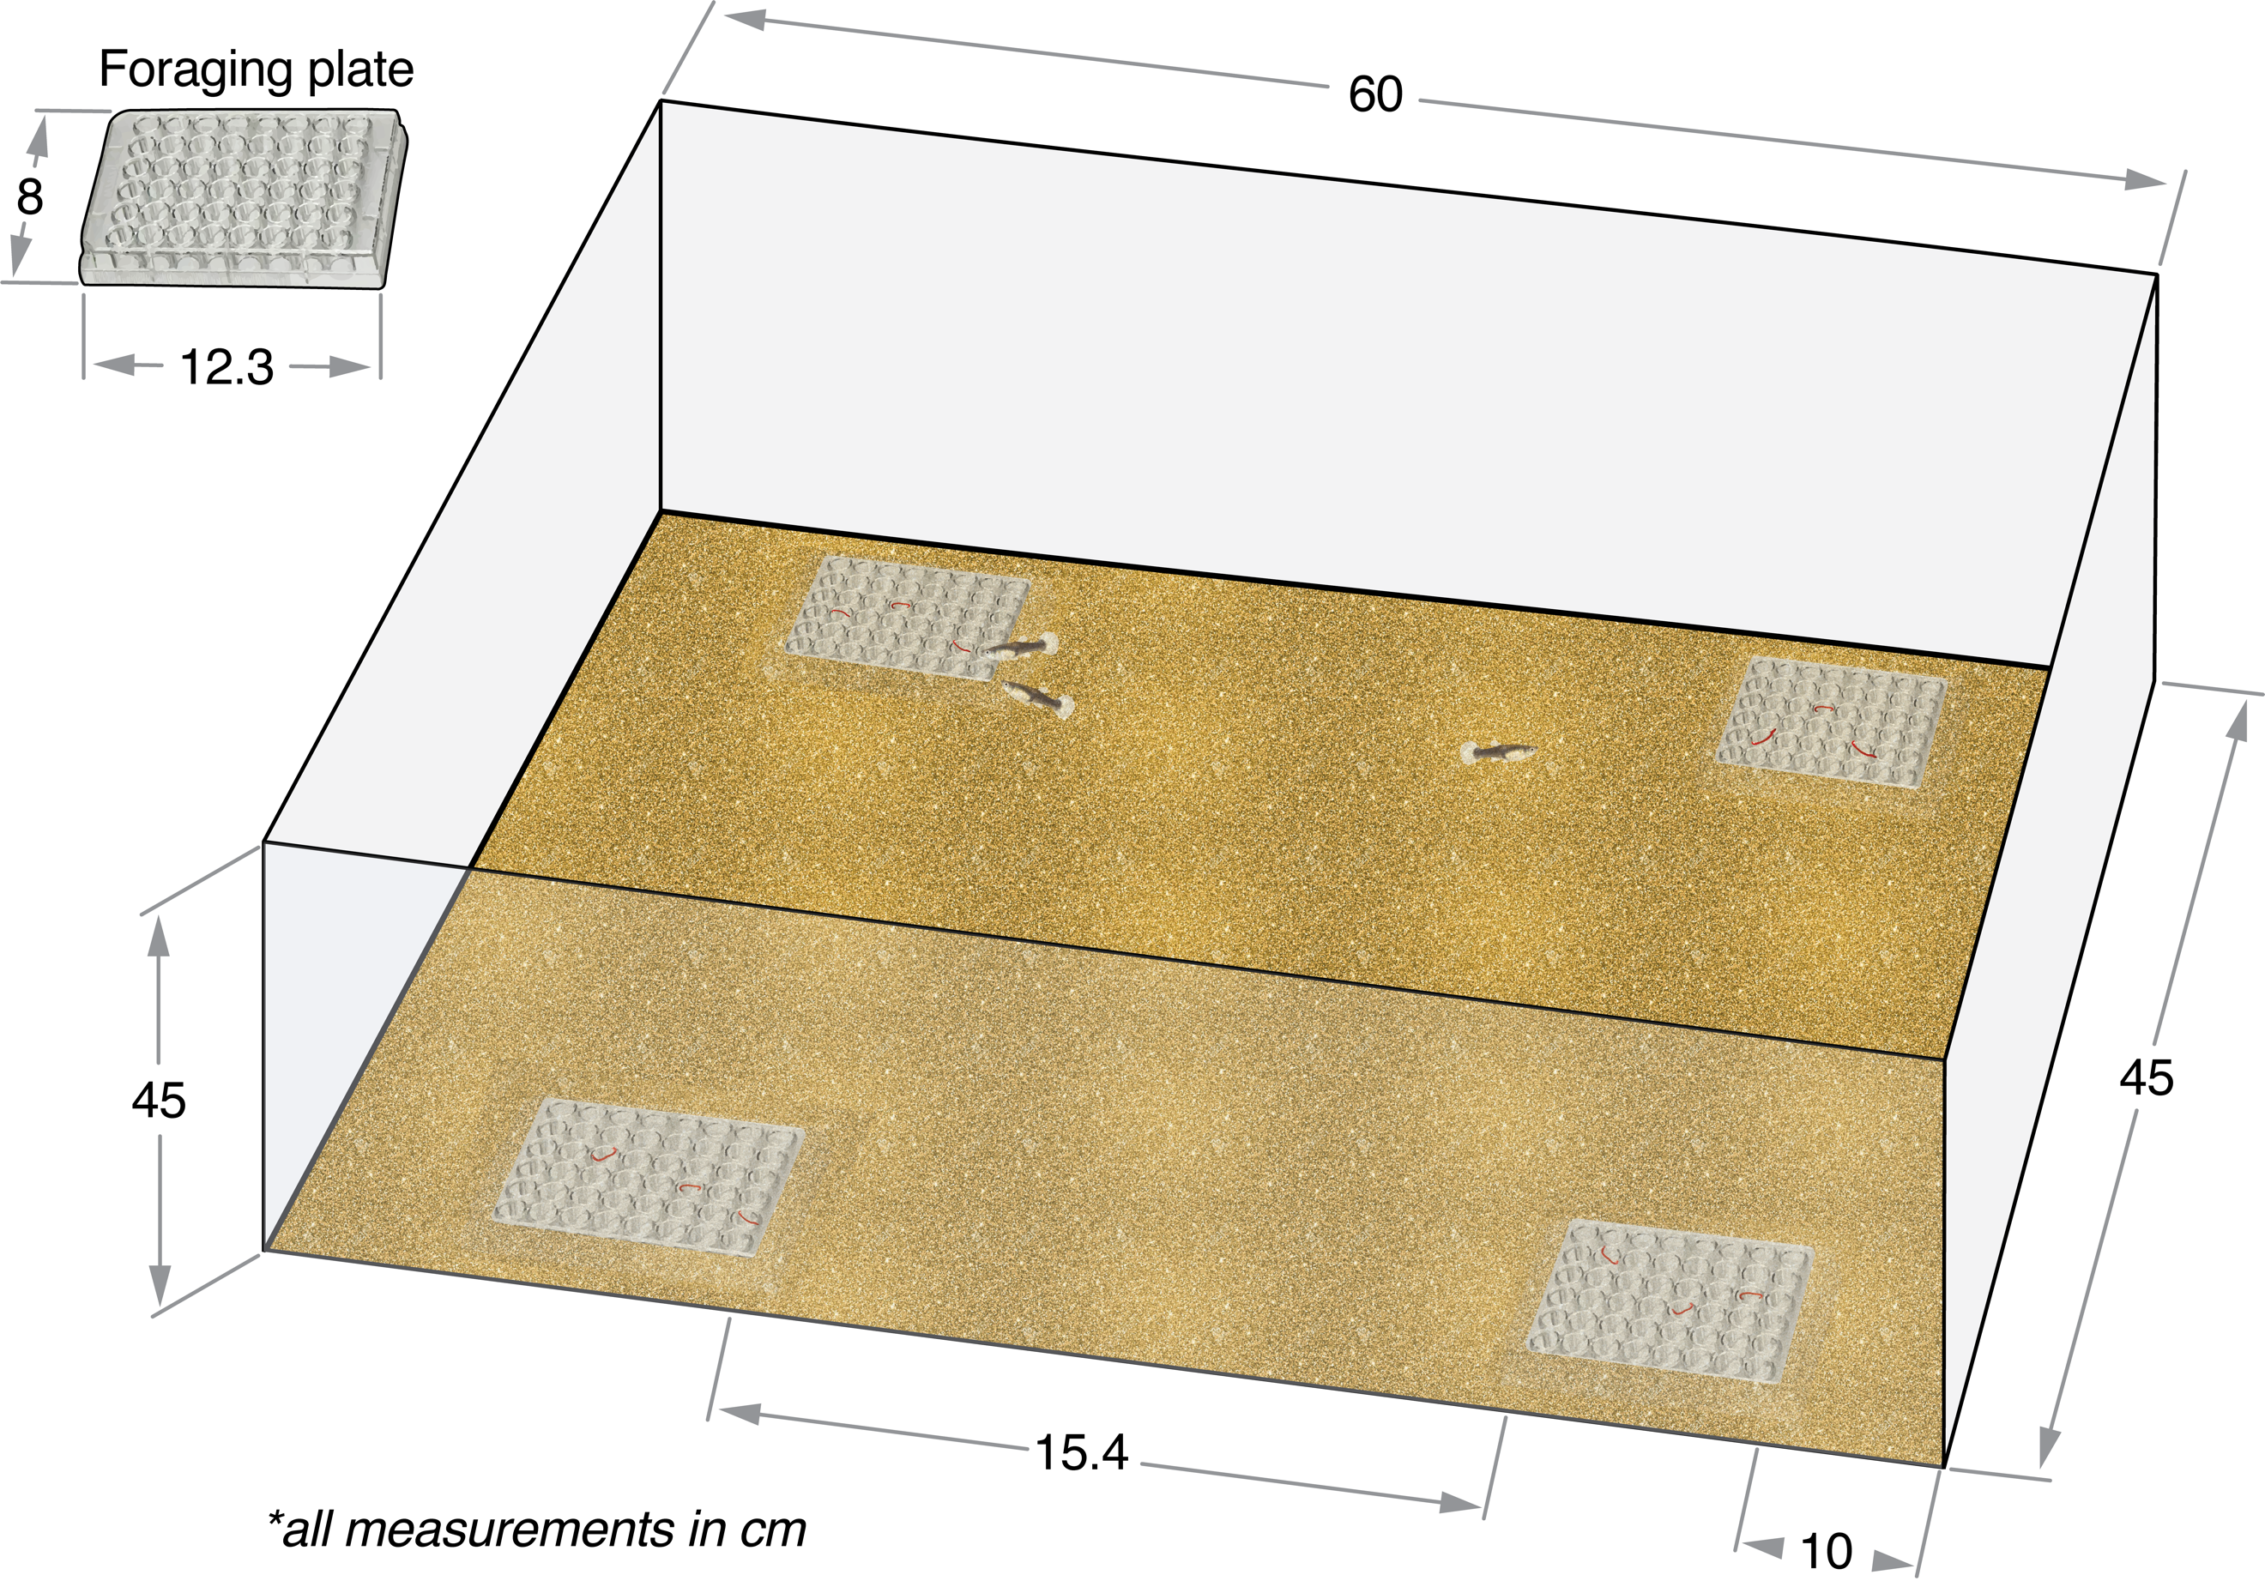
Figure 1. Experimental arena.

Data were analysed using R version 3.5.1 [39]. ﻿For a full description of statistical methods, see ‘Statistical procedures’ (S2) in Supplementary material, as well as Tables S1, S3, and S5 for details of model parameters. Briefly, all models used for individual trials included exposure treatment, fish weight, and their interaction term as fixed effects. Group trial models included exposure treatment, the mean weight of the three group members, the standard deviation of the group members’ weights, and their interaction terms as fixed effects. Weight was selected as a covariate because it is a biologically meaningful predictor of both the effects of fluoxetine exposure and behaviour [16, 34]. To account for possible tank effects, exposure tank ID (i.e. exposure tank number 1–24) was included in all models as a random effect. Fish morphometrics (i.e. weight, length, and condition) were compared across treatment groups using fish from both individual and group trials. Time to event, continuous and count data were tested using Cox Proportional Hazard Mixed Effect models (COXME), Linear Mixed Effect models (LME), and Generalised Linear Mixed Models (GLMM), respectively. Cox proportional hazard models were selected to analyse latency data, because these models are specifically designed to test the effects of a treatment or set of treatments (i.e. fixed factors) on the time a specified event takes to occur (i.e. survival analysis). Furthermore, these models deal with censored data (i.e. instances where fish did not consume a prey item), and can simultaneously assess the effect of several covariates on the dependent variable.

3. Results
3.1 Analytical verification of fluoxetine concentrations
The mean measured concentrations for the low- and high-fluoxetine treatments during the 28-day exposure period were 18.19 ± 4.98 ng/L (n = 32) and 214.69 ± 38.89 ng/L (n = 32). For all control samples, fluoxetine was not detected (i.e. under detection limit; <2 ng/L, n = 16).

3.2 Individual trials
For the time taken to first consume a prey item, there was no significant interaction between exposure treatment and fish weight, nor was there a main effect of exposure treatment or fish weight (COXME; all p >0.05; Tables S1–2 and Fig S1). Similarly, there was no significant interaction between exposure treatment and fish weight, nor was there a main effect of exposure treatment or fish weight on the total number of prey items consumed (nbGLM; all p >0.05; Table S1–2 and Fig S2).

3.3 Group trials
There were no significant interactions or main effects detected on the average time for group members to first consume a prey item (COXME; all p >0.05; Table S3 and Fig. S3). For the total number of prey items consumed, there was a significant interaction between the standard deviation in group weight and exposure treatment (GLMM; F = 6.40, p = 0.041; Fig 2). For unexposed and low-fluoxetine exposed fish, there was a significant positive effect of standard deviation in group weight on the number of prey items consumed (GLMM; unexposed: t = 2.16, p = 0.034, low: t = 2.17, p = 0.034), although no such relationship was detected in high-exposed fish (GLMM; t = –0.93, p = 0.353).

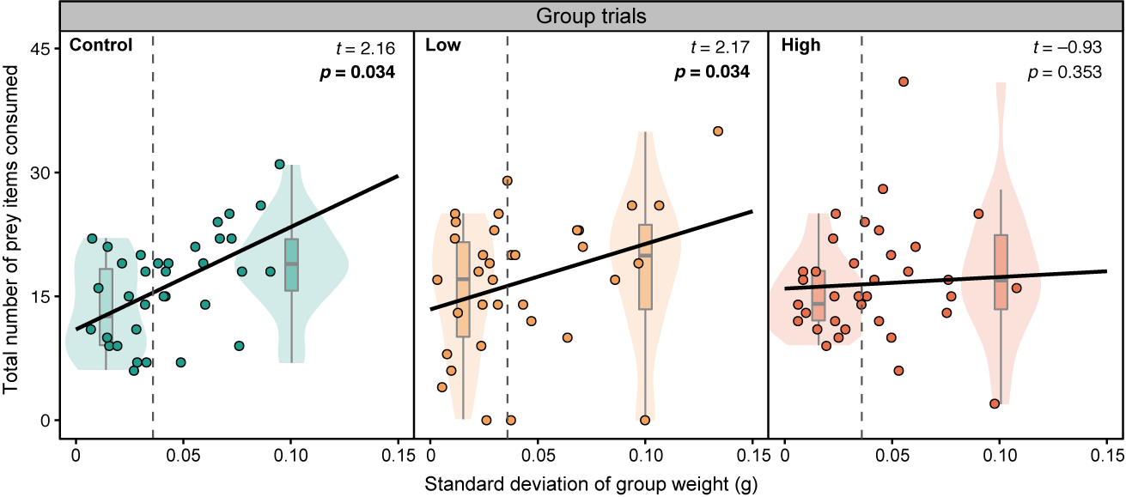
Figure 2. Total number of prey consumed plotted against standard deviation of group weight (g) for control (n = 34), low-fluoxetine (n = 34) and high-fluoxetine groups (n = 35). Dashed grey lines show the median standard deviation of group weight (0.0359 g). To represent the interaction between standard deviation of group weight, within each treatment, violin plots represent groups of small (<0.0359 g; left side of the dashed grey line) and large (>0.0359 g; right side of the dashed grey line) weight variability.

We found a significant interaction between group mean weight and exposure treatment (nbGLMM; F = 3.79, p = 0.026; Fig S4), as well as between standard deviation in group weight and exposure treatment (GLMM; F = 4.39, p = 0.017; Fig S5), on the number of aggressive interactions performed during foraging. Specifically, for unexposed fish, variability in group weight was positively associated with foraging aggression (nbGLMM; z = 2.05, p = 0.040), while mean group weight was negatively associated with aggression (nbGLMM; z = –2.16, p = 0.031), although the latter appears to be driven by a few groups with high aggression and low mean weight (Fig S4). By contrast, for both low- and high-exposed fish, there was no significant effect of either mean group weight (nbGLMM; low: z = 1.09, p = 0.275; high: z = –0.89, p = 0.374) or standard deviation in group weight (nbGLMM; low: z = –1.34, p = 0.180; high: z = 0.08, p = 0.940) on foraging aggression.

3.3 Fish morphology
There was no significant difference between fish weight, standard length or condition index across the exposure treatment groups (LME; all p >0.05; Table S3).

4. Discussion
We found that the effect of fluoxetine exposure on fish foraging behaviour was dependent on social context. For solitary fish, fluoxetine at environmentally relevant concentrations had no significant effect on foraging. This is consistent with previous studies that have similarly employed field-relevant concentrations (i.e. <540 ng/L; [18, 40]), whereas at higher concentrations fluoxetine has been reported to reduce foraging [41–44]. In combination, these findings suggest that fluoxetine exposure at field-detected levels is not sufficient to alter the foraging behaviour of solitary individuals.
In contrast to the results for solitary fish, we found that fluoxetine affected foraging dynamics in social trials. Firstly, fluoxetine exposure disrupted the relationship between the total number of prey consumed and standard deviation in group weight. Specifically, for unexposed and low-fluoxetine exposed fish, standard deviation in fish weight was a positive predictor of the number of prey items consumed (i.e. groups with larger variation in body weight consumed more prey). However, this relationship was not present in high-fluoxetine exposed fish. Importantly, this effect was not generated by differences in the standard deviation of group weight across treatments, as there was no significant difference in weight variability among group members across treatments (LME: F = 0.09, p = 0.912; see Table S7 and Fig S6). Secondly, fluoxetine exposure disrupted body weight-dependent aggressive interactions during feeding. For unexposed fish, mean group weight negatively predicted the number of aggressive interactions during feeding, while standard deviation in group weight positively predicted aggressive interactions. The increase in aggression and competition associated with greater heterogeneity in weight among group members likely led to the increased food consumption observed, as has been shown in Brook trout (Salvelinus fontinalis; [45]) and group-living spiders (Stegodyphus dumicola; [46]). However, these body weight-dependent foraging dynamics were disrupted in fluoxetine-exposed fish. For fish in the low- and high-fluoxetine treatments, neither mean group weight nor standard deviation in group weight significantly predicted the number of aggressive interactions during foraging. Fluoxetine has previously been shown to affect aggressive behaviours, including reduced conspecific chasing behaviour in ﻿Arabian killifish (Aphanius dispar; [23]) and lowered aggression in ﻿Siamese fighting fish (Betta splendens; ﻿[47,48]). It is possible, therefore, that fluoxetine, through its anxiolytic effects, disturbed weight-dependent aggressive interactions during foraging, which, in turn, disrupted the relationship between group weight variability and foraging behaviour.
Following the 28-day exposure, we did not detect an effect of fluoxetine on fish morphology (i.e. length, weight or condition). A fluoxetine-induced decrease in condition index has previously been reported in fish [36, 41, 42, 49] although, typically, such effects are reported at dosages higher than those employed here [36]. Given that the effects of fluoxetine can take 2–3 weeks to manifest [31,32], it is possible that, over a longer duration, shifts in social foraging behaviour could result in shifts in morphology.
In summary, the effects of fluoxetine reported here were dependent on the social context in which fish were tested. We report evidence of a group-specific effect of fluoxetine exposure on foraging behaviour and aggressive interactions during foraging, while no change in behaviour was seen in solitary individuals. Our results suggest that social context may be an important, but underappreciated, factor influencing the ecological impacts of chemical pollutants on wildlife.

Funding
This study was supported by Australian Government Research Training Program Scholarships (to JMM and MGB), and the Australian Research Council (DP130100385 and DP160100372; both to BBMW).

References
﻿
(1) Boxall ABA, Rudd MA, Brooks BW, Caldwell DJ, Choi K, Hickmann S, Innes E, Ostapyk K, Staveley JP, Verslycke T, et al. 2012 Pharmaceuticals and personal care products in the environment: What are the big questions? Environ. Health Perspect. 120, 1221−1229. (doi:10.1289/ehp.1104477)

﻿(2) Küster A, Adler N. 2014 Pharmaceuticals in the environment: scientific evidence of risks and its regulation. Philos. Trans. R. Soc., B, 369, 20130587. (doi:10.1098/rstb.2013.0587)

(3) Bernhardt ES, Rosi EJ, Gessner MO. 2017 Synthetic chemicals
as agents of global change. Front Ecol. Environ. 15, 84−90. (doi:10.1002/fee.1450)

(4) Calisto V, Esteves VI. 2009 Psychiatric pharmaceuticals in the environment. Chemosphere, 77, 1257–1274. (doi:10.1016/j.chemosphere.2009.09.021)

(5) Sehonova P, Svobodova Z, Dolezelova P, Vosmerova P, Faggio C. 2018 Effects of waterborne antidepressants on non-target animals living in the aquatic environment: A review. Sci Total Environ, 631–632, 789–794. (doi:10.1016/j.scitotenv.2018.03.076)

﻿(6) Mole, R. A.; Brooks, B. W. 2019 Global scanning of selective serotonin reuptake inhibitors: occurrence, wastewater treatment and hazards in aquatic systems. Environ. Pollut. 250, 1019–1031. (doi:10.1016/j.envpol.2019.04.118)

﻿(7) Caveney S, Cladman W, Verellen L, Donly C. 2006 Ancestry of neuronal monoamine transporters in the Metazoa. J. Exp. Biol. 209, 4858−4868. (doi:10.1242/jeb.02607)

(8) Fong, PP. 2001 ﻿Antidepressants in Aquatic Organisms: A Wide Range of Effects. 264–281. In Pharmaceuticals and Personal Health Care Productsin the Environment: Scientific and Regulatory Issues; Daughton, CG, Jones-Lepp T L, Eds. ACS Symposium Series 791; American Chemical Society: Washington, DC. (doi:10.1021/bk-2001-0791.ch015)

﻿(9) McDonald DM. 2017 An AOP analysis of selective serotonin reuptake inhibitors (SSRIs) for fish. Comp. Biochem. Physiol., Part C: Toxicol. Pharmacol. 197,19−31 (doi:10.1016/j.cbpc.2017.03.007)

﻿(10) Meijide, FJ.; Da Cuna, R. H.; Prieto, J. P.; Dorelle, L. S.; Babay, P. A.; Lo Nostro, F. L. Effects of waterborne exposure to the ﻿antidepressant fluoxetine on swimming, shoaling and anxiety behaviors of the mosquitofish Gambusia holbrooki. Ecotoxicol. Environ. Saf. 163, 646−655. (doi:10.1016/j.ecoenv.2018.07.085)

(11) Nielsen SV, Kellner M, Henriksen PG. Olsen H, Hansen SH, Baatrup, E. 2018 The psychoactive drug escitalopram affects swimming behaviour and increases boldness in zebrafish (Danio rerio). Ecotoxicology, ﻿27, 485–497 (﻿doi:10.1007/s10646-018-1920-x)

(12) de Farias NO, Oliveira R, Sousa-Moura D, de Oliveira RCS, Rodrigues MAC, Andrade TS, Domingues I, Camargo NS, Muehlmann LA, Grisolia CK. 2019 Exposure to low concentration of fluoxetine affects development, behaviour and acetylcholinesterase activity of zebrafish embryos. Comp Biochem Physiol C. 215, 1–8. (doi:10.1016/j.cbpc.2018.08.009)

(13) Huang IJ, Sirotkin HI, McElroy AE. 2019 Varying the exposure period and duration of neuroactive pharmaceuticals and their metabolites modulates effects on the visual motor response in zebrafish (Danio rerio) larvae. Neurotoxicol Teratol. 72, 39–48. (doi:10.1016/j.ntt.2019.01.006)

﻿(14) Dzieweczynski TL, Kane JL, Campbell BA, Lavin LE. 2016a Fluoxetine exposure impacts boldness in female Siamese fighting fish, Betta splendens. Ecotoxicology, 25, 69−79. ﻿(doi:10.1007/s10646-015-1568-8)

(15) Dzieweczynski TL, Campbell BA, Kane, JL. 2016b Dose-dependent fluoxetine effects on boldness in male Siamese fighting fish. J. Exp. Biol. 219, 797−804. (doi:10.1242/jeb.132761)

(16) Martin JM, Bertram MG, Saaristo M, Fursdon JB, Hannington SL, Brooks BW, Burket SR, Mole RA, Deal NDS, Wong BBM. 2019 Antidepressants in surface waters: fluoxetine influences mosquitofish anxiety-related behavior at environmentally relevant levels. Environ Sci Technol. 53, 6035–6043. (doi:10.1021/acs.est.9b00944)

(17) ﻿Painter MM, Buerkley MA, Julius ML, Vajda AM, Norris DO, Barber LB, Furlong, ET, Schultz MM, Schoenfuss HL. 2009 Antidepressants at environmentally relevant concentrations affect predator avoidance behavior of larval fathead minnows (Pimephales promelas). Environ. Toxicol. Chem. 28, 2677−2684. (doi:10.1897/08-556.1)

﻿(18) Weinberger J, Klaper R. 2014 Environmental concentrations of the selective serotonin reuptake inhibitor fluoxetine impact specific behaviors involved in reproduction, feeding and predator avoidance in the fish Pimephales promelas (fathead minnow). Aquat. Toxicol. 151, 77−83. (doi:10.1016/j.aquatox.2013.10.012)

﻿(19) Martin JM, Saaristo M, Bertram MG, Lewis PJ, Coggan T L, Clarke BO, Wong, BBM. 2017 The psychoactive pollutant fluoxetine compromises antipredator behavior in fish. Environ. Pollut. 222, 592−599. (doi:10.1016/j.envpol.2016.10.010)

﻿(20) Saaristo M, McLennan A, Johnstone CP, Clarke B, Wong BBM. 2017 Impacts of the antidepressant fluoxetine on the anti- predator behavior of wild guppies (Poecilia reticulata). Aquat. Toxicol. 183, 38−45. (doi:10.1016/j.aquatox.2016.12.007)

(21) De Castro-Catala N, Munoz I, Riera JL, Ford AT. 2017 Evidence of low dose effects of the antidepressant fluoxetine and the fungicide prochloraz on the behavior of the keystone freshwater invertebrate Gammarus pulex. Environ. Pollut. 231, 406–414 (doi:10.1016/j.envpol.2017.07.088)

(22) Peters JR, Granek EF, de Rivera CE, Rollins M. 2017 Prozac in the water: Chronic fluoxetine exposure and predation risk interact to shape behaviors in an estuarine crab. Ecol. Evol. 7, 9151–9161. (doi:10.1002/ece3.3453)

(23) Barry MJ. 2013 Effects of fluoxetine on the swimming and behavioral responses of the Arabian killifish. Ecotoxicology, 22, 425−432. (doi:10.1007/s10646-012-1036-7)

﻿(24) Barry MJ. 2014. Fluoxetine inhibits predator avoidance behavior in tadpoles. Toxicol. Environ. Chem. 96, 641–649. (doi:10.1080/02772248.2014.966713)

﻿(25) Pelli M, Connaughton VP. 2015 Chronic exposure to environmentally-relevant concentrations of fluoxetine (Prozac) decreases survival, increases abnormal behaviors, and delays predator escape responses in guppies. Chemosphere, 139, 202−209. (doi:10.1016/j.chemosphere.2015.06.033)

(26) Delgado MD, Miranda M, Alvarez SJ, Gurarie E, Fagan WF, Penteriani V, di Virgilio A, Morales JM. 2018 The importance of individual variation in the dynamics of animal collective movements. Philos. Trans. Royal Soc. B. 373, 20170008 (doi:10.1098/rstb.2017.0008)

(27) Planas-Sitja, I, Nicolis, SC, Sempo, G, Deneubourg, JL. 2018 The interplay between personalities and social interactions affects the cohesion of the group and the speed of aggregation. PLOS ONE, 13, e0201053. (doi:10.1371/journal.pone.0201053)

(28) Pilastro A, Benetton S, Bisazza A. 2003 Female aggregation and male competition reduce costs of sexual harassment in the mosquitofish Gambusia holbrooki. Anim Behav. 65, 1161–1167. (doi:10.1006/anbe.2003.2118)

(29) Arrington JJ, Tharnan KRJ, Rettig JE, Smith GR. 2009 Foraging behavior of male and female mosquitofish (Gambusia affinis) in single- and mixed-sex groups. J Freshw Ecol. 24, 327–329. (doi:10.1080/02705060.2009.9664299)

(30) Martin RG. 1975. Sexual and aggressive behavior, density and social Structure in a natural population of mosquitofish, Gambusia affinis holbrooki. Copeia, 3, 445–454. (doi:10.2307/1443641)

﻿(31) Gardier AM, Malagie I, Trillat AC, Jacquot C, Artigas F. 1996 Role of 5-HT1A autoreceptors in the mechanism of action of serotoninergic antidepressant drugs: recent findings from in vivo microdialysis studies. Fundam. Clin. Pharmacol. 10, 16–27. (doi:10.1111/j.1472-8206.1996.tb00145.x)

﻿(32) Hensler JG. 2003 Regulation of 5-HT1A receptor function in brain following agonist or antidepressant administration. Life Sci. 72, 1665−1682. (doi:10.1016/s0024-3205(02)02482-7)

(33) Saaristo M, Tomkins P, Allinson M, Allinson G, Wong BBM. 2013. An androgenic agricultural contaminant impairs female reproductive behaviour in a freshwater fish PLOS ONE, 8, e62782 (doi:10.1371/journal.pone.0062782)

﻿(34) Martin JM, Bertram MG, Saaristo M, Ecker TE, Hannington SL. Tanner JL, Michelangeli M, O’Bryan MK, Wong BBM. 2019 Impact of the widespread pharmaceutical pollutant fluoxetine on behavior and sperm traits in a freshwater fish. Sci. Total Environ. 2019, 650, 1771−1778. (doi:10.1016/j.scitotenv.2018.09.294)

(35) Fursdon JB, Martin JM, Bertram MG, Lehtonen TK, Wong BBM. 2019 The pharmaceutical pollutant fluoxetine alters reproductive behavior in a fish independent of predation risk. Sci. Total Environ. 650, 642−652. (doi:10.1016/j.scitotenv.2018.09.046)

﻿(36) Bertram MG, Ecker TE, Wong BBM, O’Bryan MK, Baumgartner JB, Martin JM, Saaristo M. 2018 The antidepressant fluoxetine alters mechanisms of pre- and post-copulatory post- copulatory sexual selection in the eastern mosquitofish (Gambusia holbrooki). Environ. Pollut. 238, 238−247. (doi:10.1016/j.envpol.2018.03.006)

(37) Bertram MG, Saaristo M, Martin JM, Ecker TE, Michelangeli M, Johnstone CP, Wong, BBM. 2018 Field-realistic exposure to the androgenic endocrine disruptor 17 beta-trenbolone alters ecologically important behaviours in female fish across multiple contexts. Environ. Pollut., 243, 900–911. (doi:10.1016/j.envpol.2018.09.044)

(38) Friard O, Gamba M. 2016 BORIS: a free, versatile open-source event-logging software for video/audio coding and live observations. Methods Ecol Evol, 7, 1325–1330. (doi:10.1111/2041-210X.12584)

(39) R Development Core Team. 2018 R: A language and environment for statistical computing. R Foundation for Statistical Computing, Vienna, Austria.

(40) Mennigen JA, Sassine J, Trudeau VL, Moon TW. 2010. Waterborne fluoxetine disrupts feeding and energy metabolism in the goldfish Carassius auratus. Aquat Toxicol. 100, 128–137. (doi:10.1016/j.aquatox.2010.07.022)

(41) Stanley JK, Ramirez AJ, Chambliss CK, Brooks BW. 2007 Enantiospecific sublethal effects of the antidepressant fluoxetine to a model aquatic vertebrate and invertebrate. Chemosphere, 69, 9–16 (doi:10.1016/j.chemosphere.2007.04.08)

(42) ﻿Gaworecki KM, Klaine SJ. 2008 Behavioral and biochemical responses of hybrid striped bass during and after fluoxetine exposure. Aquat. Toxicol. 88, 207–213. (doi:10.1016/j.aquatox.2008.04.011)

(43) Mennigen JA, Harris EA, Chang JP, Moon TW, Trudeau VL. 2009 Fluoxetine affects weight gain and expression of feeding peptides in the female goldfish brain. Regul. Pept. 155, 99–104. (doi:10.1016/j.regpep.2009.01.001)

(44) Hedgespeth ML, Nilsson PA, Berglund O. 2014 Ecological implications of altered fish foraging after exposure to an antidepressant pharmaceutical. Aquat. Toxicol. 151, 84–87. (doi:10.1016/j.aquatox.2013.12.011)

(45) Grant JWA. 1990 Aggressiveness and the foraging behavior of young-of-the-year brook charr (Salvelinus fontinalis). Can J Fish Aquat Sci. 47, 915–920 (doi:10.1139/f90-105)

(46) Amir N, Whitehouse MEA, Lubin Y. 2000 Food consumption rates and competition in a communally feeding social spider, Stegodyphus dumicola (Eresidae). J. Arachnol. 28, 195–200. (doi:10.1636/0161-8202(2000)028[0195:FCRACI]2.0.CO;2)

(47) Dzieweczynski TL, Hebert OL. 2012 Fluoxetine alters behavioral consistency of aggression and courtship in male Siamese fighting fish, Betta splendens Physiol. Behav. 107, 92–97. (doi:10.1016/j.physbeh.2012.06.007)

(48) Forsatkar MN, Nematollahi MA, Amiri BM, Huang WB. 2014 Fluoxetine inhibits aggressive behaviour during parental care in male fighting fish (Betta splendens, Regan). Ecotoxicology. 23, 1794–1802. (doi:10.1007/s10646-014-1345-0)

﻿(49) Latifi T, Forsatkar MN, Nematollahi MA. 2015 Reproduction and behavioral responses of convict cichlid, Amatitlania nigrofasciata to fluoxetine. J. Fish. Aquat. Sci. 10, 111–120. (doi:10.3923/jfas.2015.111.120)

(50) Martin JM, Saaristo M, Tan H, Bertram MG, Nagarajan-Radha V, Dowling DK, Bob B.B.M. 2019 Data from: Field realistic antidepressant exposure disrupts group-specific foraging dynamics in fish. Dryad Digital Repository. (doi:10.5061/dryad.ns1rn8pnh)

