**Field-realistic antidepressant exposure disrupts group foraging dynamics in mosquitofish**

Jake M. Martin, Minna Saaristo, Hung Tan, Michael G. Bertram, Venkatesh Nagarajan-Radha, Damian K. Dowling, Bob B.M. Wong

**Supplementary material**

**S1. Methods**

Prior to exposure, fish were kept in holding tanks (54 L; 60 × 30 × 30 cm; length × width × height) containing 30 fish each (23–25 °C; 12:12 h light:dark cycle; in aged carbon-filtered fresh water). Fish were randomly allocated to either a control (i.e. fresh water), low fluoxetine (nominal concentration: 30 ng/L) or high fluoxetine (nominal concentration: 300 ng/L) treatment for 28 days. During the 28-day experiment, fish were exposed to their respective treatments using flow-through systems (24 h cycling rate), with a total of 24 exposure aquaria (60 × 30 × 30 cm) housing ~20 fish each, following previously established protocols (Saaristo et al. 2013; Bertram et al. 2018; Martin et al. 2019a;2018b; Fursdon et al. 2019). Exposure aquaria were supplied with aged carbon-filtered fresh water (pH measured range from 6.9–7.9), with the fluoxetine (low and high) systems also receiving a constant supply of fluoxetine stock solution (low = 6 μg/L and high = 60 μg/L; Sigma Aldrich: F132, CAS: 56296-78-7). Fluoxetine stock solution were prepared as described in Martin et al. (2017). Water temperature was maintained at 23.4 ± 0.9 °C (± SD; *n* = 576) and lighting and feeding conditions were identical to those during laboratory acclimation (see study species collection and housing). To monitor fluoxetine concentrations and to ensure the absence of fluoxetine in the control systems, weekly water samples (80 mL) were drawn from all low- and high-exposed tanks, and bi-weekly from all control tanks. Analytical verification was performed by Envirolab Services (Perth), using Gas Chromatography coupled to Tandem Mass Spectrometry (GC-MS/MS), following previously described protocols (Bertram et al. 2018).

**S2. Statistical procedures**

Collinearity was checked across all variables using correlation matrices. Variables that exceeded a correlation coefficient of 0.70 were considered to be highly correlated and were, therefore, not included in the same model. Where necessary, data were transformed to approximate normality (Tables S1−3 for descriptions). The time to first consume a food item in individual trials and the average time to first consume a food item in the group trials were compared across treatments using Cox proportional hazard mixed effect models (COXME; *coxme* function, *coxme* package; Therneau 2018). The assumption of proportionality was met for both COXME models, as tested by examining the interaction between Schoenfeld residuals and log time (*coxph* and *cox.zph* functions, *survival* package). The number of prey items consumed in individual and group trials were compared across treatments using generalised linear mixed models (GLMM), with Akaike information criterion (AIC) estimates used to select the most appropriate distribution (i.e. Poisson, quasi-Poisson, or negative binomial distribution; see Tables S1–2 for details). For the number of food items consumed in the single trials (but not group trials), a GLMM with a negative binomial distribution was used (nbGLMM; *glmmadmb* function, *glmmADMB* package; Fournier et al. 2012). For group trials, a GLMM with a quasi-Poisson model was used to test the number of prey items consumed (qGLMM; *glmmPQL* function, *MASS* package; Venables and Ripley, 2002). For all models, Wald tests were used to calculate the *p*-values of fixed effects and interaction terms (*Anova* function, *car* package; Fox and Weisberg, 2011).

**S3. Results**

**Table S1.** Results for individual foraging trials generated using Wald tests. For the time taken to first consume a prey item, results are calculated from a Cox proportional hazard mixed effect model (COXME). For the total number of prey items consumed, results are calculated from a generalised linear mixed model (nbGLMM) with a negative binomial distribution. Fixed effects included fish weight (weight) and exposure treatment (exposure). Exposure tank was included as a random effect.

|  |  |  |  |  |
| --- | --- | --- | --- | --- |
| Behavioural response | Model | Predictors |  |  |
| Time to first consume a prey item | COXME | **Fixed effects** | ***F*** | ***p*** |
| Weight | 3.04 | 0.081 |
|  |  | Exposure | 1.96 | 0.375 |
|  |  | Weight:exposure | 1.53 | 0.465 |
|  |  | **Random effect** | ***var*** |  |
|  |  | Exposure tank | 0.089 |  |
| Total number of prey items consumed | nbGLMM | **Fixed effects** | ***F*** | ***p*** |
| Weight | 1.37 | 0.242 |
|  |  | Exposure | 1.20 | 0.548 |
|  |  | Weight:exposure | 0.96 | 0.618 |
|  |  | **Random effect** | ***var*** |  |
|  |  | Exposure tank | <0.001 |  |

**Table S2.** Results for individual foraging trials showing treatment comparisons for the time taken to first consume a prey item and the total number of prey items consumed, calculated from a Cox proportional hazard mixed effect model (COXME) and a generalised linear mixed model (nbGLMM) with a negative binomial distribution, respectively.

|  |  |  |  |  |  |
| --- | --- | --- | --- | --- | --- |
| Behavioural response | Model | Comparison | coef | *z* | *p* |
| Time to first consume a prey item | COXME | Control–Low | -0.587 | -0.80 | 0.420 |
|  |  | Control–High | -0.120 | -0.14 | 0.890 |
|  |  | Low–High | 0.466 | 0.60 | 0.550 |
| Total number of prey items consumed | nbGLMM | Control–Low | 0.246 | 0.71 | 0.480 |
|  |  | Control–High | 0.307 | 0.88 | 0.380 |
|  |  | Low–High | 0.061 | -0.97 | 0.860 |

**Table S3.** Results for group foraging trials generated using Wald tests. For the average time to first consume a prey item, results are calculated from a Cox proportional hazard mixed effect model (COXPH). For the total number of prey items consumed, results are calculated from a generalised linear mixed model with a quasi-Poisson distribution (qGLMM). For aggressive interactions during foraging, results are calculated from a generalised linear mixed model with a negative binomial distribution (nbGLMM). Fixed effects included mean group weight (weight), the standard deviation in group weight (weight.std) and exposure treatment (exposure). Exposure tank was included as a random effect.

|  |  |  |  |  |
| --- | --- | --- | --- | --- |
| Behavioural response | Model | Predictors |  |  |
| Average time to first consume a prey item | COXME | **Fixed effects** | ***F*** | ***p*** |
| Weight | 1.51 | 0.218 |
|  |  | Weight.std | 0.43 | 0.511 |
|  |  | Exposure | 1.25 | 0.535 |
|  |  | Weight:weight.std | 0.44 | 0.509 |
|  |  | Weight:exposure | 0.41 | 0.814 |
|  |  | Weight.std:exposure | 3.27 | 0.195 |
|  |  | Weight:weight.std:exposure | 0.36 | 0.836 |
|  |  | **Random effects** | ***var*** |  |
|  |  | Exposure tank | 0.062 |  |
| Total number of prey items consumed | qGLMM | **Fixed effects** | ***F*** | ***p*** |
|  |  | Weight | 0.37 | 0.542 |
|  |  | Weight.std | 3.91 | **0.048** |
|  |  | Exposure | 0.04 | 0.980 |
|  |  | Weight:weight.std | 0.12 | 0.734 |
|  |  | Weight:exposure | 3.76 | 0.153 |
|  |  | Weight.std:exposure | 6.40 | **0.041** |
|  |  | Weight:weight.std:exposure | 0.16 | 0.924 |
|  |  | **Random effects** | ***var*** |  |
|  |  | Exposure tank | <0.001 |  |
| Aggressive interactions during foraging | nbGLMM | **Fixed effects** | ***F*** | ***p*** |
|  |  | Weight | 4.67 | **0.033** |
|  |  | Weight.std | 3.71 | 0.057 |
|  |  | Exposure | 0.94 | 0.394 |
|  |  | Weight:weight.std | 0.05 | 0.823 |
|  |  | Weight:exposure | 3.79 | **0.026** |
|  |  | Weight.std:exposure | 4.39 | **0.017** |
|  |  | Weight:weight.std:exposure | 0.07 | 0.936 |
|  |  | **Random effects** | ***var*** |  |
|  |  | Exposure tank | 0.177 |  |

**Table S4.** Results for group foraging trials showing treatment comparisons for the average time taken to first consume a prey item, calculated from a Cox proportional hazard mixed effect model (COXME).

|  |  |  |  |  |  |
| --- | --- | --- | --- | --- | --- |
| Behavioural response | Model | Comparison | coef | *z* | *p* |
| Average time to first consume a prey item | COXME | Control–Low | 0.003 | 0.01 | 0.990 |
|  |  | Control–High | 0.191 | 0.56 | 0.580 |
|  |  | Low–High | 0.187 | 0.58 | 0.560 |

**Table S5.** Results from linear mixed effect (LME) models testing morphological endpoints for all control (*n* = 148), low-fluoxetine (*n* = 149) and high-fluoxetine (*n* = 148) fish generated using Wald tests.

|  |  |  |  |  |
| --- | --- | --- | --- | --- |
| Response | Model | Predictors |  |  |
| Length  (log transformed) | LME | **Fixed effects** | ***F*** | ***p*** |
|  | Exposure | 0.59 | 0.564 |
|  |  | **Random effects** | ***var*** |  |
|  |  | Exposure tank | <0.001 |  |
|  |  | Residual | 0.016 |  |
| Weight  (log transformed) | LME | **Fixed effects** | ***F*** | ***p*** |
|  | Exposure | 0.42 | 0.661 |
|  |  | **Random effects** | ***var*** |  |
|  |  | Exposure tank | 0.002 |  |
|  |  | Residual | 0.185 |  |
| Condition index  (rank-based inverse normal transformation) | LME | **Fixed effects** | ***F* (Df,Dfres)** | ***p*** |
|  | Exposure | 0.06 | 0.968 |
|  | **Random effects** | ***var*** |  |
|  |  | Exposure tank | <0.001 |  |
|  |  | Residual | 0.998 |  |

**Table S6.** Results for morphological measurements, showing treatment comparisons for standard length, weight and condition index, generated using linear mixed effect (LME) models.

|  |  |  |  |  |  |
| --- | --- | --- | --- | --- | --- |
| Behavioural response | Model | Comparison | coef | *t* | *p* |
| Standard length | LME | Control–Low | 0.016 | 0.93 | 0.363 |
|  |  | Control–High | –0.001 | ­–0.02 | 0.984 |
|  |  | Low–High | –0.016 | –0.95 | 0.355 |
| Weight | LME | Control–Low | 0.049 | 0.89 | 0.386 |
|  |  | Control–High | 0.013 | 0.23 | 0.817 |
|  |  | Low–High | –0.036 | –0.65 | 0.524 |
| Condition index | LME | Control–Low | –0.023 | –0.20 | 0.844 |
|  |  | Control–High | 0.004 | 0.041 | 0.967 |
|  |  | Low–High | 0.027 | 0.23 | 0.812 |

**Table S7.** Results from linear mixed effect (LME) models testing the standard deviation in group weight across exposure treatment group, generated using Wald tests.

|  |  |  |  |  |
| --- | --- | --- | --- | --- |
| Response | Model | Predictors |  |  |
| Standard deviation in group weight (rank-based inverse normal transformation) | LME | **Fixed effects** | ***F*** | ***p*** |
|  | Exposure | 0.09 | 0.912 |
|  | **Random effects** | ***var*** |  |
|  | Exposure tank | <0.001 |  |
|  |  | Residual | 0.997 |  |

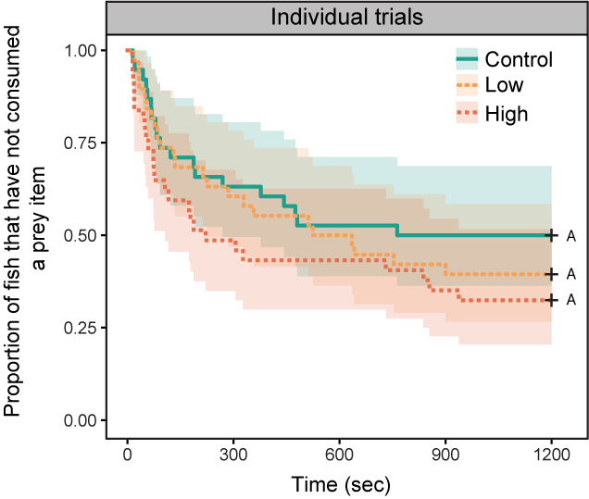

**Figure S1.** Proportion of fish that have not consumed a prey item plotted against time (sec) in individual trials. Control fish shown with a solid green line (*n* = 38), low-fluoxetine shown with a dashed yellow line (*n* = 38), and high-fluoxetine shown with a dotted orange line (*n* = 37). The green, yellow and orange shaded areas around each line represent the 95% confidence interval for control, low- and high-fluoxetine treatments, respectively. Groups that share a capital letter are not significantly different from one another.



**Figure S2.** Violin plot showing the number of prey items consumed plotted by exposure treatment in individual trials, with control fish shown in green (*n* = 38), low-fluoxetine in light orange (*n* = 38) and high-fluoxetine in dark orange (*n* = 37). Boxplots show the 25th, 50th (median) and 75th percentiles. The coloured area surrounding the boxplot shows the probability density at different values smoothed by a kernel density estimator. Groups that share a capital letter are not significantly different from one another.

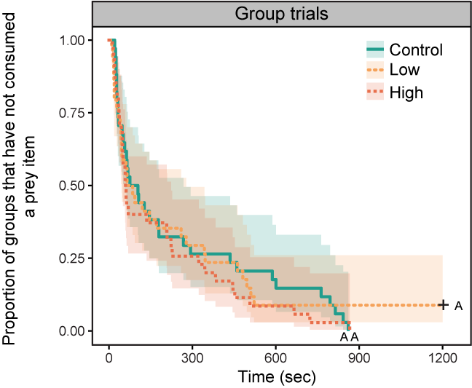

**Figure S3.** Proportion of groups that have consumed a prey item plotted by the average time (sec) taken to do so. Control fish shown with a solid green line (*n* = 38), low-fluoxetine shown with a dashed yellow line (*n* = 38) and high-fluoxetine shown with dotted orange line (*n* = 37). The green, yellow and orange shaded areas around each line represent the 95% confidence interval for control, low- and high-fluoxetine treatments, respectively. Groups that share a capital letter are not significantly different from one another.

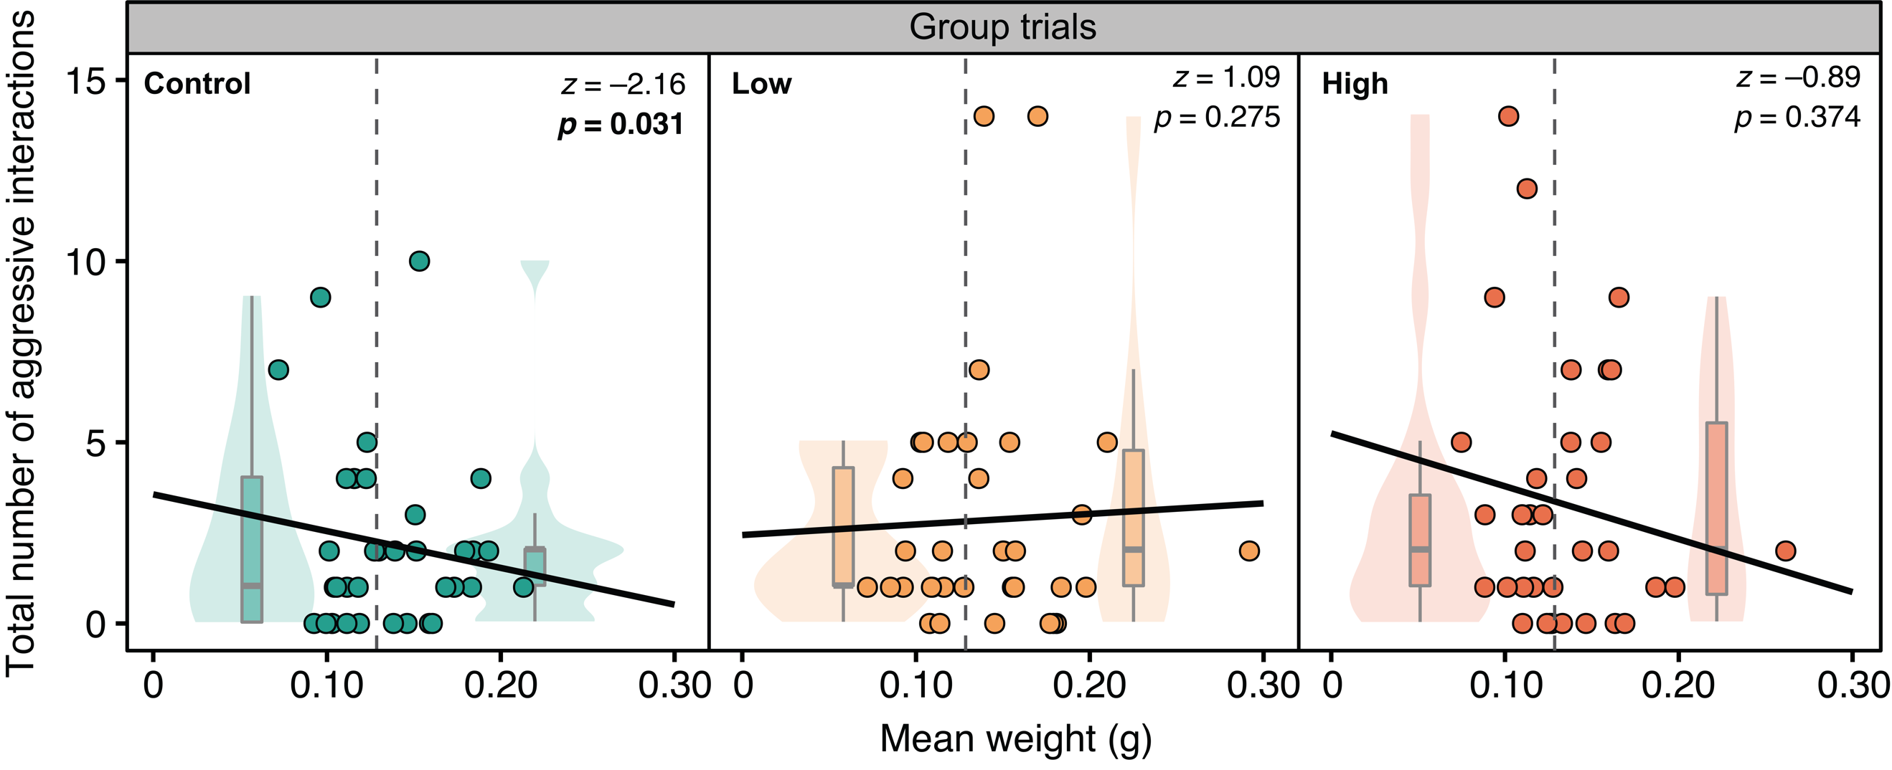

**Figure S4.** Total number of aggressive interactions during foraging plotted against mean group weight (g) for control (*n* = 34), low-fluoxetine (*n* = 34) and high-fluoxetine groups (*n* = 35). The dashed grey lines show median group weight (i.e. 0.1295 g). To represent the interaction between mean group weight, within each treatment, violin plots have been added to the scatter plot which represent groups of small (i.e. <0.1295 g; left side of the dashed grey line) and large (i.e. >0.1295 g; right side of the dashed grey line) mean weight.

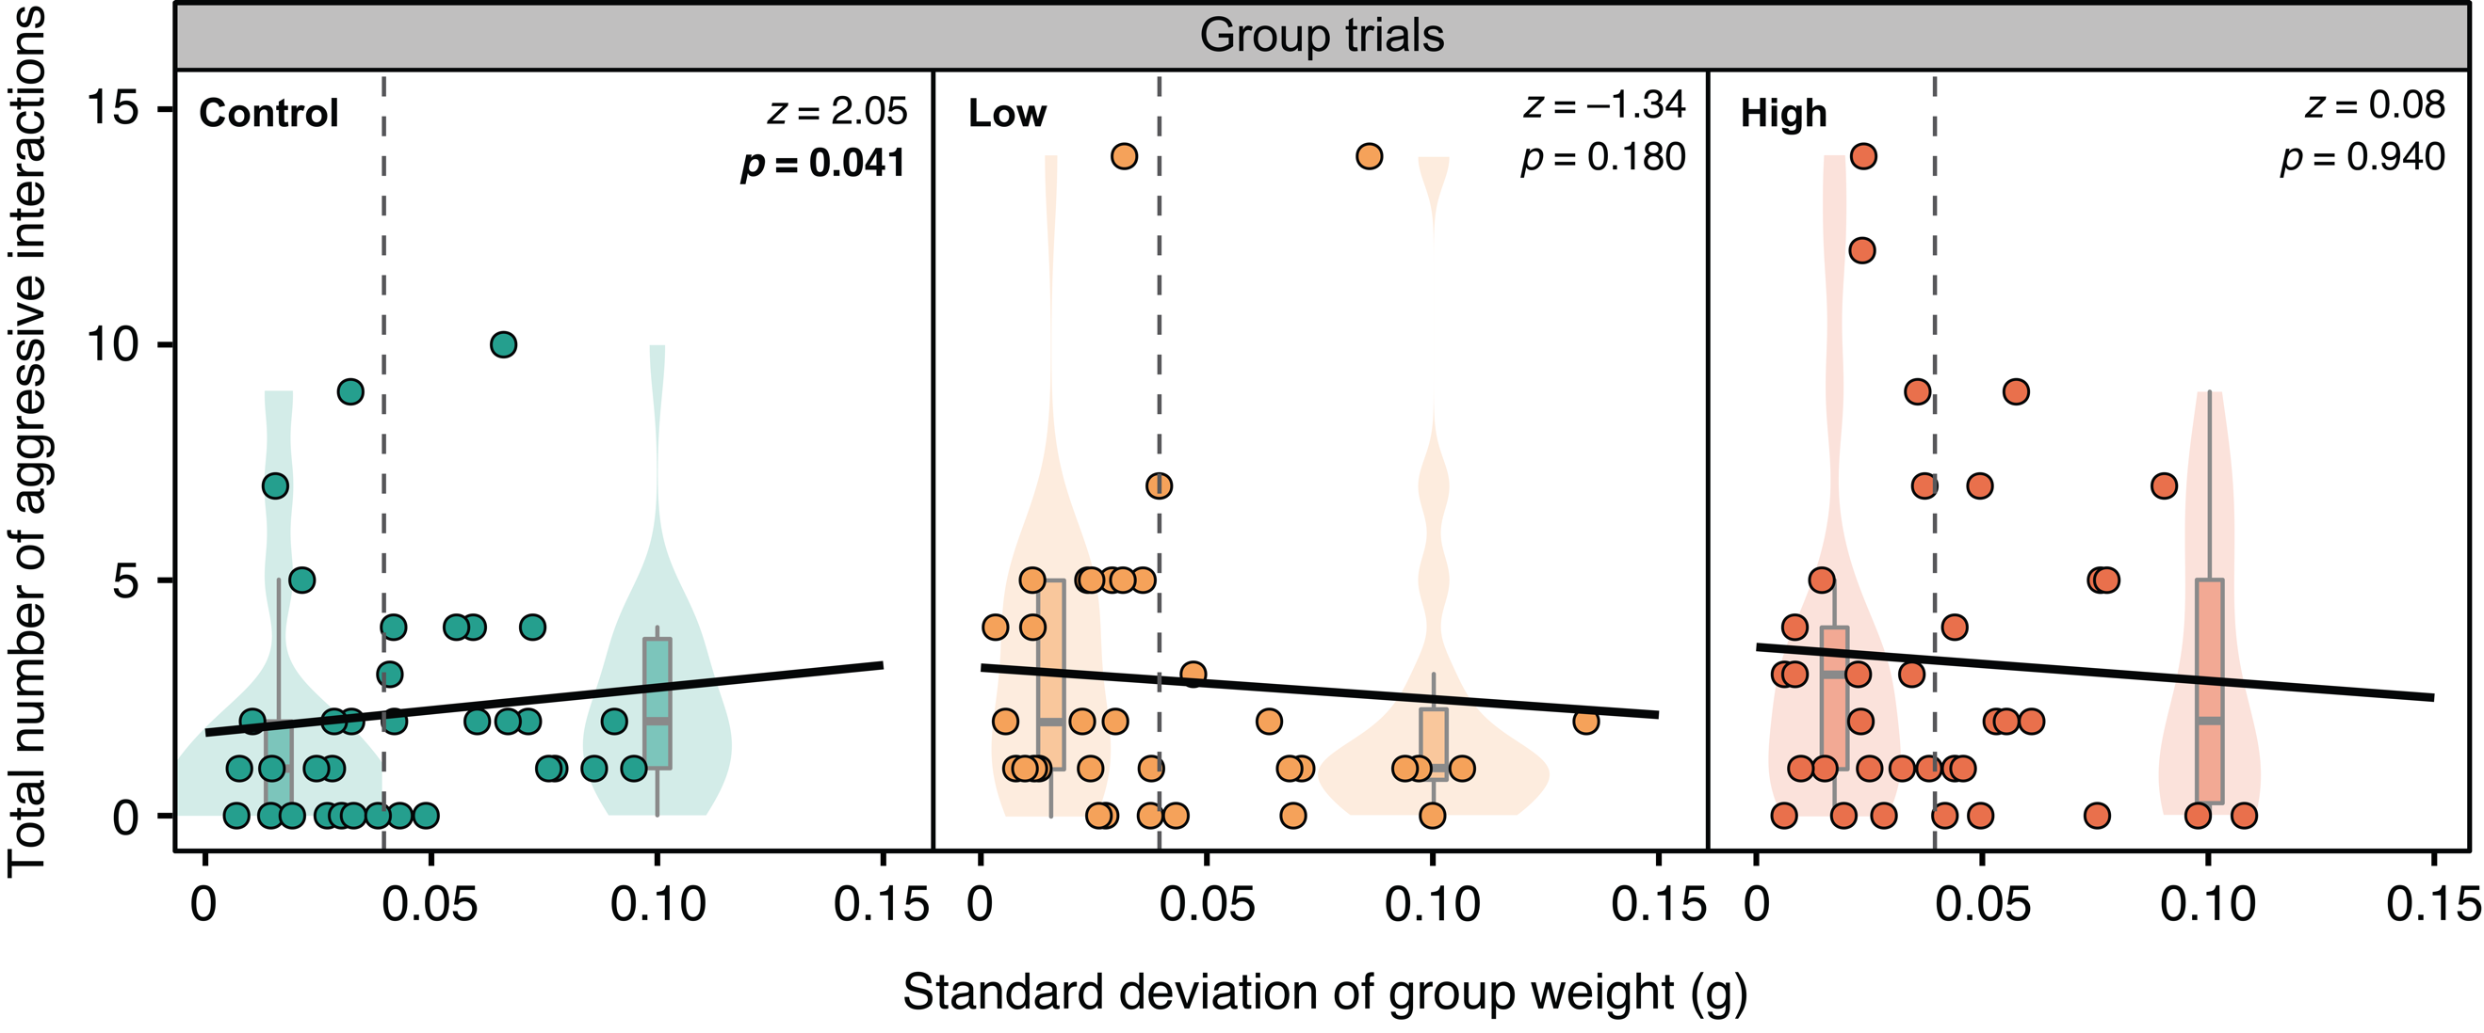

**Figure S5.** Total number of aggressive interactions during foraging plotted against standard deviation of group weight (g) for control (*n* = 34), low-fluoxetine (*n* = 34) and high-fluoxetine groups (*n* = 35). The dashed grey lines show median standard deviation of group weight (i.e. 0.0359 g). To represent the interaction between standard deviation of group weight, within each treatment, violin plots have been added to the scatter plot which represent groups of small (i.e. <0.0359 g; left side of the dashed grey line) and large (i.e. >0.0359 g; right side of the dashed grey line) weight variability.

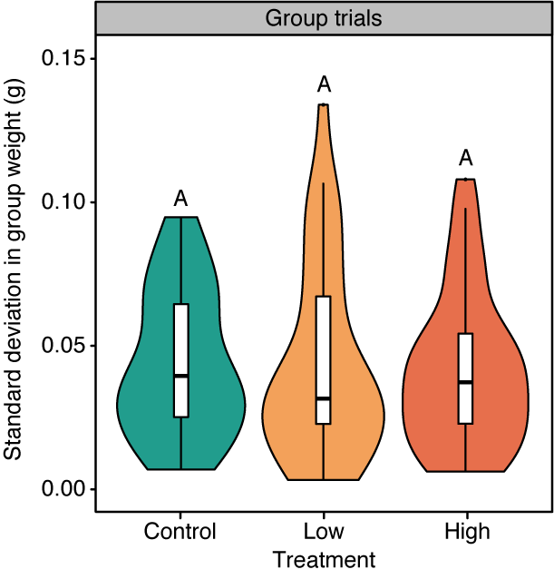

**Figure S5.** The standard deviation in group weights plotted for control (*n* = 34), low-fluoxetine (*n* = 34) and high-fluoxetine groups (*n* = 35). Box plots show the 25th, 50th (median) and 75th percentiles. The coloured area surrounding the boxplot shows the probability density at different values smoothed by a kernel density estimator. Groups that share a capital letter are not significantly different from one another.

**References**

﻿Fournier DA, Skaug HJ, Ancheta J, Ianelli J, Magnusson A, Maunder M, Nielsen A, Sibert J. 2012 AD Model Builder: using automatic differentiation for statistical inference of highly parameterized complex nonlinear models. *Optim. Methods Softw.* **27**, 233–249. (doi:10.1080/10556788.2011.597854).

Fox J, Weisberg S 2011. An R companion to applied regression, Second edition. Thousand Oaks CA: Sage. ISBN:9781412975148

Fursdon JB, Martin JM, Bertram MG, Lehtonen TK, Wong BBM. 2019 The pharmaceutical pollutant fluoxetine alters reproductive behavior in a fish independent of predation risk. *Sci. Total Environ.* **650**, 642−652. (doi:10.1016/j.scitotenv.2018.09.046)

Martin JM, Bertram MG, Saaristo M, Ecker TE, Hannington SL. Tanner JL, Michelangeli M, O’Bryan MK, Wong BBM. 2019a Impact of the widespread pharmaceutical pollutant fluoxetine on behavior and sperm traits in a freshwater fish. *Sci. Total Environ.* 2019, 650, 1771−1778. (doi:10.1016/j.scitotenv.2018.09.294)

Martin JM, Bertram MG, Saaristo M, Fursdon JB, Hannington SL, Brooks BW, Burket SR, Mole RA, Deal NDS, Wong BBM. 2019b Antidepressants in surface waters: fluoxetine influences mosquitofish anxiety-related behavior at environmentally relevant levels. *Environ Sci Technol.* 53, 6035–6043. (doi:10.1021/acs.est.9b00944)

Saaristo M, Tomkins P, Allinson M, Allinson G., Wong BBM. 2013 An androgenic agricultural contaminant impairs female reproductive behaviour in a freshwater fish. *PLoS One*, **8**, e62782. (doi:10.1371/journal.pone.0062782).

Therneau TM. 2018 coxme: Mixed Effects Cox Models. R package version 2.2-10. <https://CRAN.R-project.org/package=coxme>

Venables WN, Ripley BD. 2002 Modern applied statistics with S. Fourth edition. Springer, New York. ISBN:0-387-95457-0