Electronic Supplementary Materials

Authors:
Hangjian Ling^{1,4}, Guillam E. Mclvor², Joseph Westley², Kasper van der Vaart¹, Jennifer Yin¹, Richard T. Vaughan³, Alex Thornton²*, Nicholas T. Ouellette¹*

¹Department of Civil and Environmental Engineering, Stanford University, Stanford, CA USA;
²Center for Ecology and Conservation, University of Exeter, Penryn, UK;

³School of Computing Science, Simon Fraser University, Burnaby, Canada
⁴Department of Mechanical Engineering, University of Massachusetts Dartmouth, North Dartmouth, MA USA;

Correspondence:

Alex Thornton, Email: alex.thornton@exeter.ac.uk

Nicholas T. Ouellette, Email: nto@stanford.edu

Article Title:
Collective turns in jackdaw flocks: kinematics and information transfer

Journal:
Journal of The Royal Society Interface

(a) Three-dimensional imaging system
A three-dimensional (3D) high-speed imaging system, described in detail previously [1], was used to measure the 3D trajectories of individual birds within large flocks. The system included four synchronised high-speed cameras (Basler ace acA2040-90um, pixel size of 5.5 µm, sensor resolution of 2048×2048 pixels, maximum of 90 frames per second). All cameras were seated on the ground and pointed to the sky with an angle to horizontal plane of about 60 degrees. The cameras were arranged in two pairs. Each pair of cameras was separated by about 50 m, which was similar to the distance from the cameras to the birds. At a height of 50 m, the imaging area was 60×60 m² and the imaging resolution was 0.04 m—much smaller than a jackdaw body length (0.3~0.4 m).

Before collecting flocking events, we calibrated the 3D imaging system by recording images of a drone that carried two balls of distinguishably different sizes (10 and 12 cm) and flew through the tracking volume. The two balls were separated by 1.0 m, providing a physical scale for our calibration. The two-dimensional (2D) positions of the balls on the images were used to estimate the fundamental matrix of each camera based on the eight-point algorithm [2]. The camera parameters were refined by sparse bundle adjustment [3,4]. Each calibration involved more than 300 calibration points and the calibration error (defined as the root-mean-square distance between the original 2D coordinates and those generated by re-projecting 3D points onto the 2D image planes of the cameras) was less than 0.5 pixels.

(b) Data collection procedures for mobbing flocks
We recorded the mobbing flocks using the following procedures. To induce collective anti-predator responses, we used a taxidermy fox (Vulpes vulpes) holding a remote-controlled, flapping bird resembling a jackdaw in its mouth. The fox was initially hidden under a sheet in an open field, in the center of the camera array. Once the fox was uncovered and the experimenter had returned to their hide, we broadcast pre-recorded scolding calls through a remote-controlled FoxPro loudspeaker placed in a hidden position on the ground beside the fox. Playback tracks consisted of three bouts of 8 calls, each separated by 10 seconds. This mimicks naturally occurring calling bouts, and the amplitude was normalized across all tracks. As the magnitude of collective responses is influenced by the characteristics of the caller [5], we used only calls produced by colony members, which would be familiar to the birds in the vicinity.

(c) Evidence of discrete pairs in transit flocks
In our previous studies [6,7], we showed that transit flocks without making collective turning contain discrete pairwise structures due to the life-long monogamous pair bonds in jackdaw societies, while mobbing flocks do not. Here, we show that the discrete pairs in transit flocks persist even during collective turns. To do so, we plot the joint probability density functions (PDFs) of the distance to nearest neighbor (D^{n=1}) and the distance to the second nearest neighbor (D^{n=2}) for both transit and mobbing flocks (Fig. S13). Clearly, the PDFs for transit flocks show two distinct regions of high probability, with one region where D^{n=1} is nearly constant regardless of D^{n=2} indicating the presence of paired birds. However, for the mobbing flocks, the PDFs only show one region of high probability where D^{n=1} increases linearly with D^{n=2}. This indicates that the mobbing flocks contain no pairs. The likely explanation for this difference is that the mobbing experiments were conducted during the breeding season, when both members of the pair are foraging independently so as to maximize the rate at which their young are provisioned.

Reference
1. Ling H, Mclvor GE, Nagy G, MohaimenianPour S, Vaughan RT, Thornton A, Ouellette NT. 2018 Simultaneous measurements of three-dimensional trajectories and wingbeat frequencies of birds in the field. J. R. Soc. Interface 15, 20180653. (doi:10.1098/rsif.2018.0653)
2. Hartley R, Zisserman A. 2004 Multiple view geometry in computer vision. (doi:10.1007/s13398-014-0173-7.2)
3. Furukawa Y, Ponce J. 2009 Accurate camera calibration from multi-view stereo and bundle adjustment. Int. J. Comput. Vis. 84, 257–268. (doi:10.1007/s11263-009-0232-2)
4. Theriault DH, Fuller NW, Jackson BE, Bluhm E, Evangelista D, Wu Z, Betke M, Hedrick TL. 2014 A protocol and calibration method for accurate multi-camera field videography. J. Exp. Biol. 217, 1843–1848. (doi:10.1242/jeb.100529)
5. Woods RD, Kings M, McIvor GE, Thornton A. 2018 Caller characteristics influence recruitment to collective anti-predator events in jackdaws. Sci. Rep. 8, 1–8. (doi:10.1038/s41598-018-25793-y)
6. Ling H, Mclvor GE, van der Vaart K, Vaughan RT, Thornton A, Ouellette NT. 2019 Costs and benefits of social relationships in the collective motion of bird flocks. Nat. Ecol. Evol. 3, 943–948. (doi:10.1038/s41559-019-0891-5)
7. Ling H, Mclvor GE, Westley J, van der Vaart K, Vaughan RT, Thornton A, Ouellette NT. 2019 Behavioural plasticity and the transition to order in jackdaw flocks. Nat. Commun. Accept.

Supplementary Figures

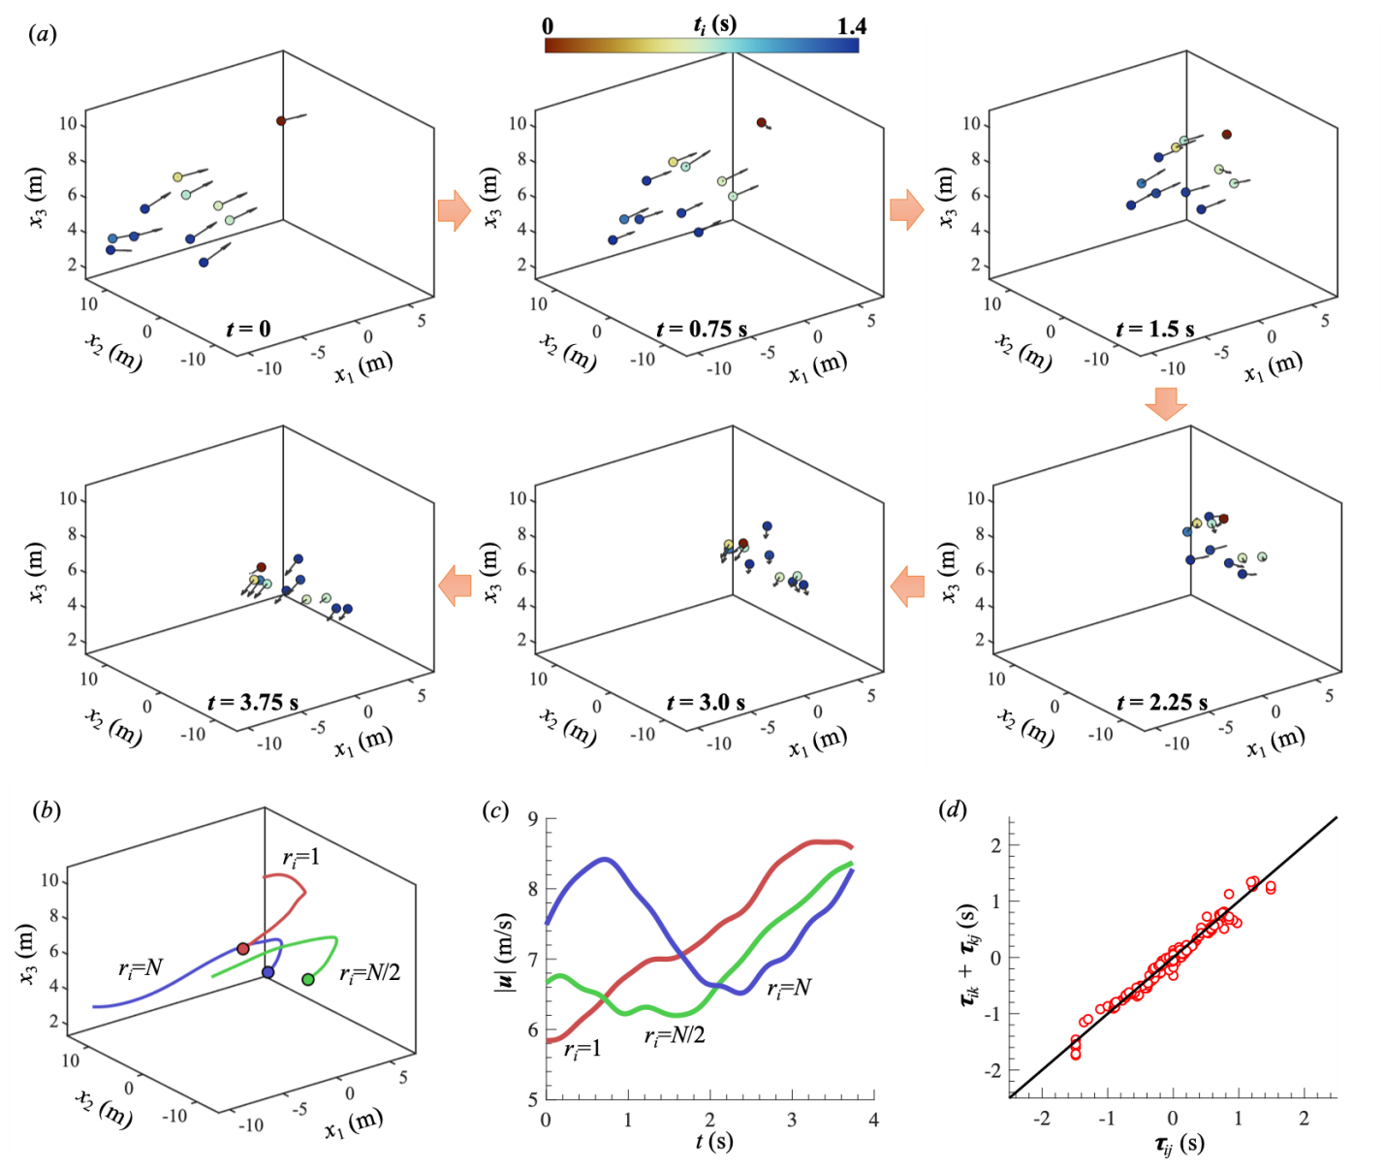

Figure S1. (a) Snapshots of positions (dots) and velocities (arrows) of individual birds in three-dimensional space during a collective turn for flock #T01. Birds are coloured by the turning delay t_{i}. (b-c) Three sample bird trajectories (b) and flight speeds |u| (c) with turn ranks r_{j}=1, N/2 and N taken from the flock shown in (a) (dots are the ends of the trajectories). (d) Relation between τ_{ij} and τ_{ik}+τ_{kj} showing that τ_{ij}≈τ_{ik}+τ_{kj}.

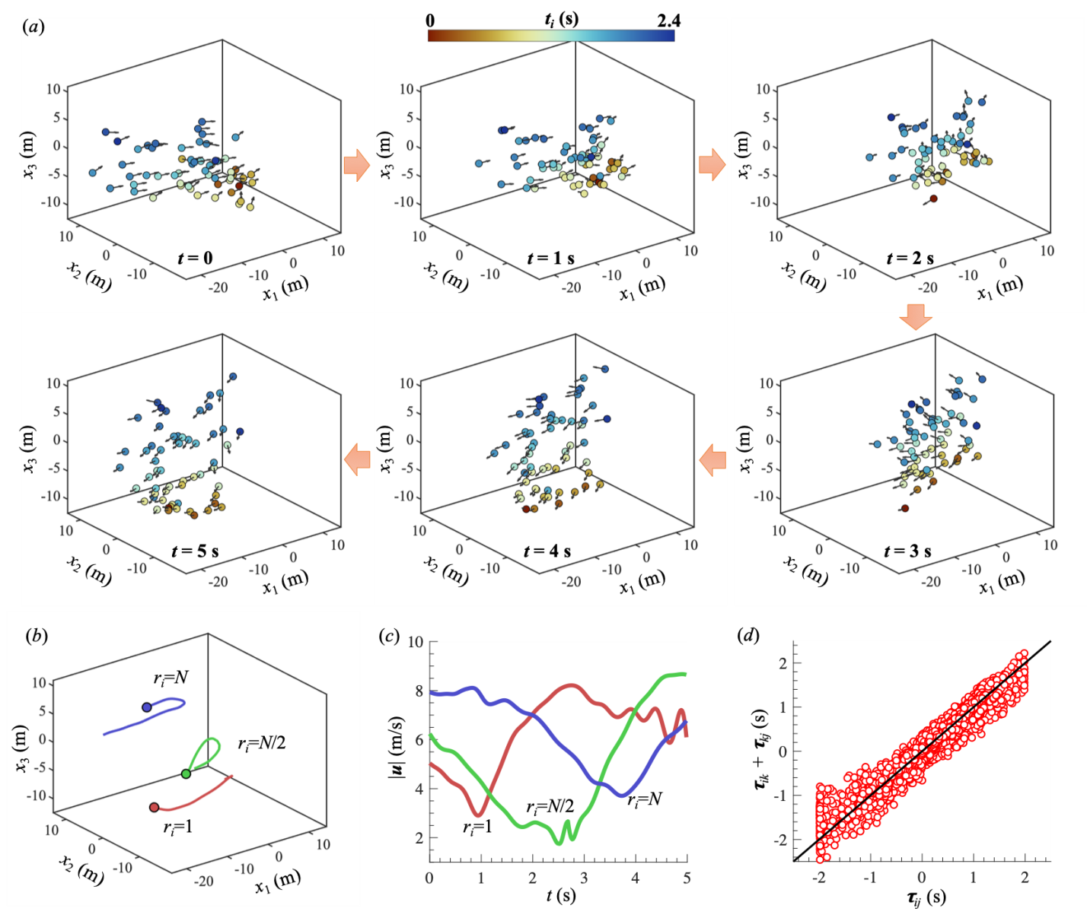

Figure S2. (a) Snapshots of positions (dots) and velocities (arrows) of individual birds in three-dimensional space during a collective turn for flock #M04. Birds are coloured by the turning delay t_{i}. (b-c) Three sample bird trajectories (b) and flight speeds |u| (c) with turning rank r_{j}=1, N/2 and N taken from the flock shown in (a) (dots are the ends of the trajectories). (d) Relation between τ_{ij} and τ_{ik}+τ_{kj} showing that τ_{ij}≈τ_{ik}+τ_{kj}.

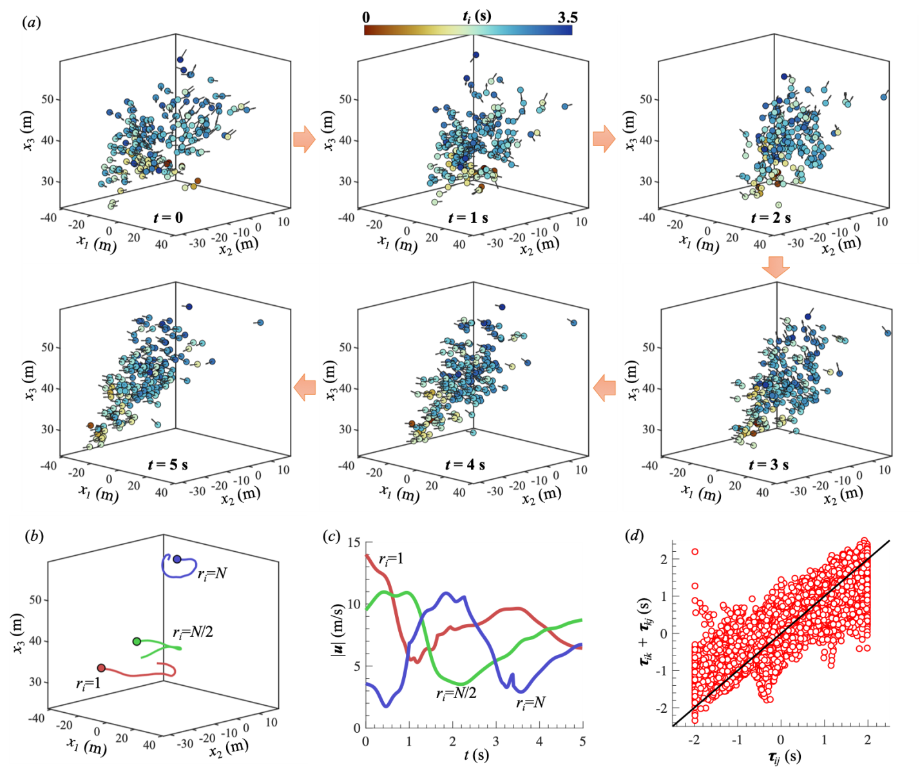

Figure S3. (a) Snapshots of positions (dots) and velocities (arrows) of individual birds in three-dimensional space during a collective turn for flock #T04. Birds are coloured by the turning delay t_{i}. (b-c) Three sample bird trajectories (b) and flight speeds |u| (c) with turn rank r_{j}=1, N/2 and N taken from the flock shown in (a) (dots are the ends of the trajectories). (d) Relation between τ_{ij} and τ_{ik}+τ_{kj}. In this case, τ_{ij} and τ_{ik}+τ_{kj} match less well, likely because the birds that start to turn first are far apart from each other (see Fig. S6).

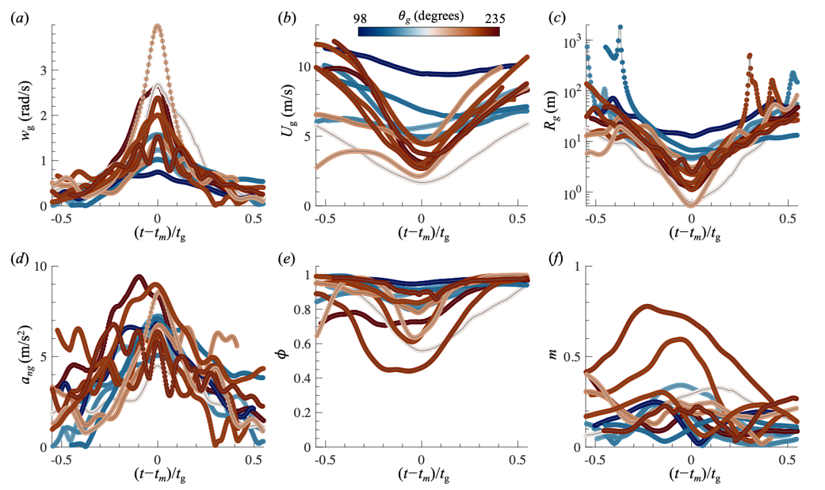
Figure S4. Temporal variations of (a) group turn rate w_{g}, (b) group flight speed U_{g}, (c) group turn radius R_{g}, (d) group radial acceleration a_{ng}, (e) group polarization φ , and (f) angular momentum m during collective turns for 13 transit flocks. Each line is for one flock and coloured by the magnitude of the change of traveling direction θ_{g}.

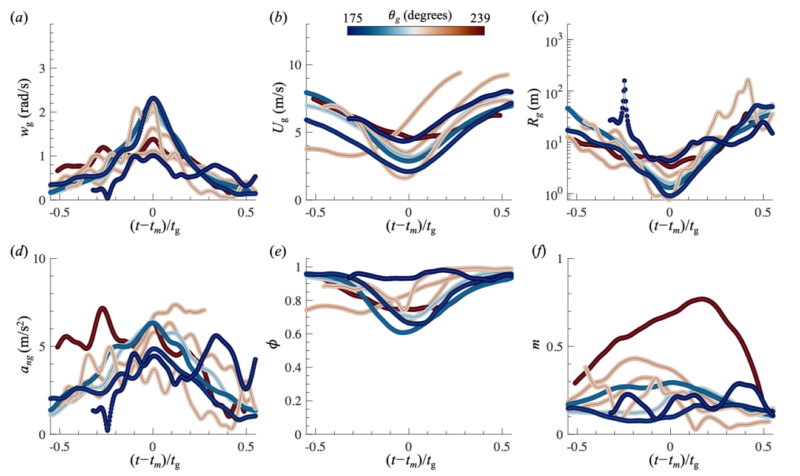
Figure S5. Temporal variations of (a) group turn rate w_{g}, (b) group flight speed U_{g}, (c) group turn radius R_{g}, (d) group radial acceleration a_{ng}, (e) group polarization φ , and (f) angular momentum m during collective turns for 8 mobbing flocks. Each line is for one flock and coloured by the magnitude of the change of traveling direction θ_{g}.

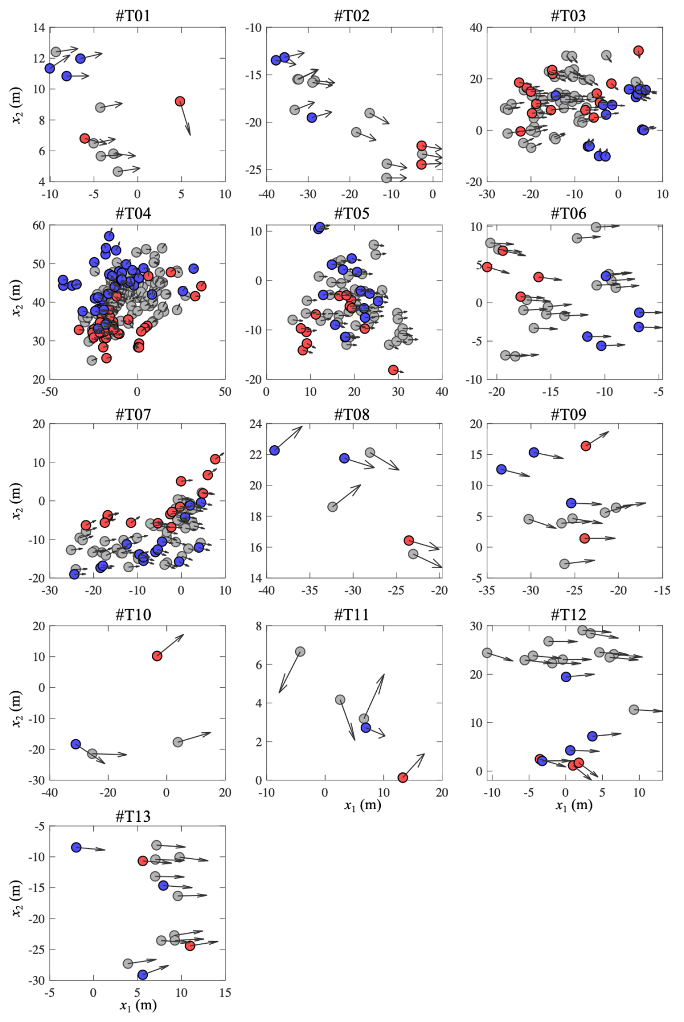
Figure S6. Snapshots of positions (dots) and velocities (arrows) of individual birds at t=t_{s} (time when a turn starts) for 13 transit flocks. Red symbols are the birds that start to turn first (r_{i}<0.2N) and blue symbols are birds that start to turn last (r_{i}>0.8N).

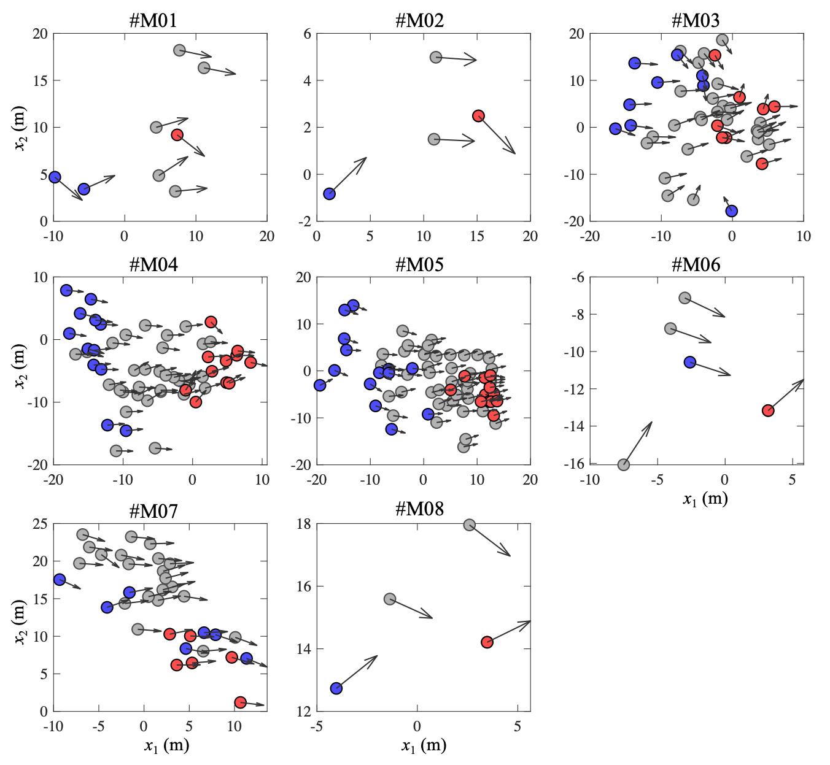

Figure S7. Snapshots of positions (dots) and velocities (arrows) of individual birds at t=t_{s} (time when a turn starts) for 8 mobbing flocks. Red symbols are the birds that start to turn first (r_{i}<0.2N) and blue symbols are birds that start to turn last (r_{i}>0.8N).

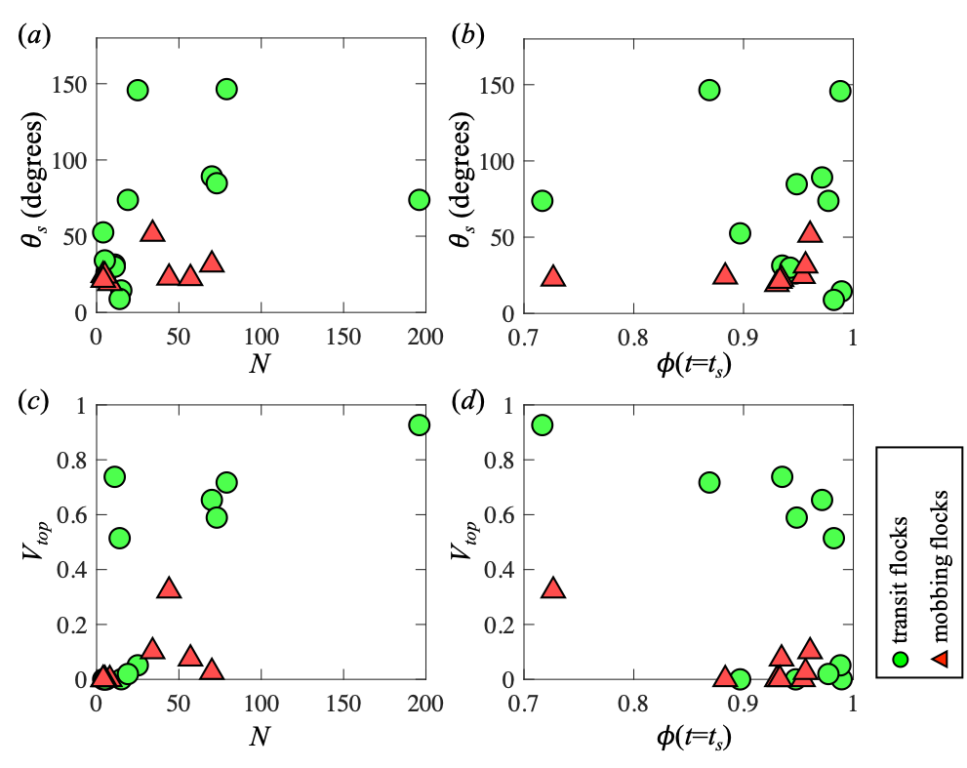
Figure S8. (a) Relationship between group size N and θ_{s} (the angle between group velocity and information propagation direction); (b) Relationship between group polarization at turn begin φ(t=t_{s}) and θ_{s}. (c) Relationship between N and V_{top}. (d) Relationship between φ(t=t_{s}) and V_{top}.

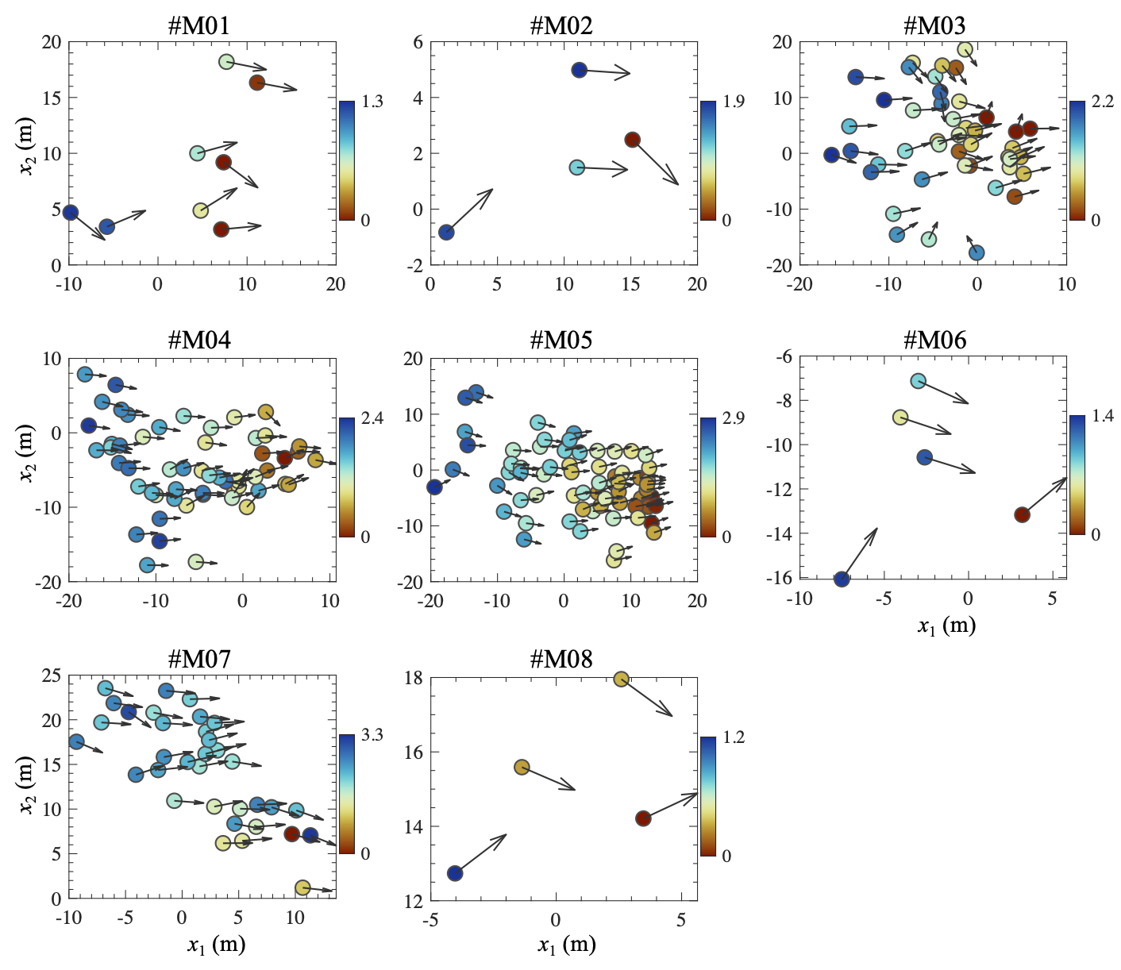

Figure S9. Snapshots of positions (dots) and velocities (arrows) of individual birds projected onto a horizontal plane at t=t_{s} for 8 mobbing flocks. Birds are coloured by t_{i} showing information propagating gradually from front to the back of the flocks.

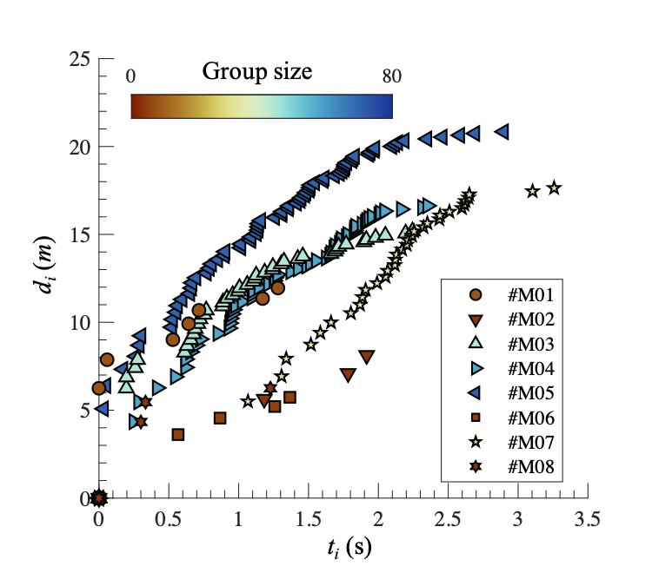
Figure S10. Information propagation distance d_{i} as a function of t_{i} for 8 mobbing flocks.

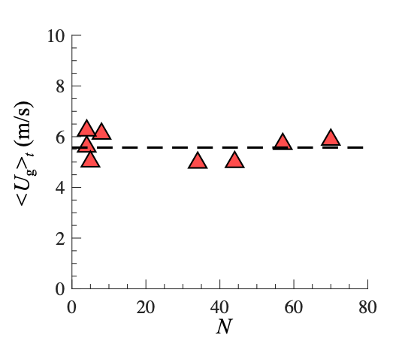
Figure S11. Relationship between group size N and time-averaged group flight speed <U_{g}>_{t} for 8 mobbing flocks showing that bird flight speed is independent of N. Here, the symbol < >_{t} denotes a time average.

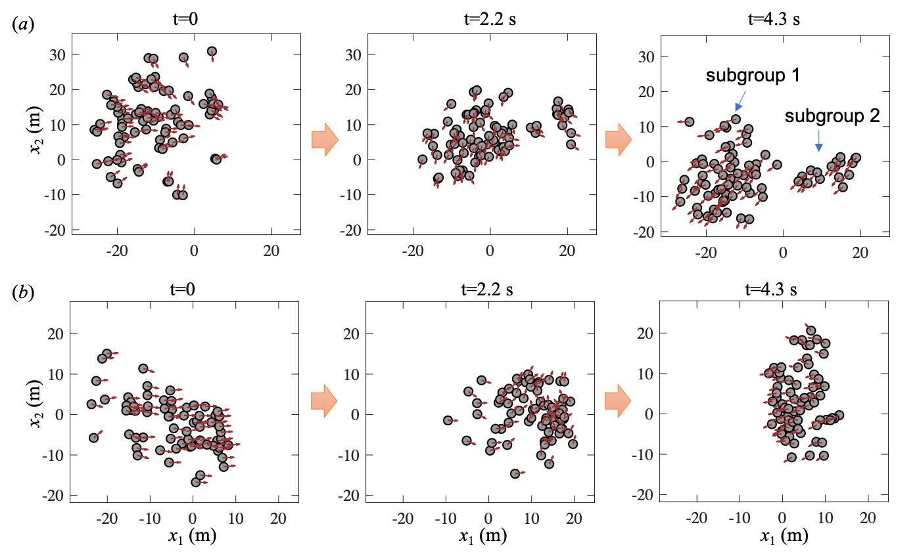
Figure S12. Snapshots of positions (dots) and velocities (arrows) of individual birds projected onto a horizontal plane for (a) transit flock #T03 and (b) mobbing flock #M05. The transit flock shows multiple subgroups during collective turns, while the mobbing flock contains only one large group.

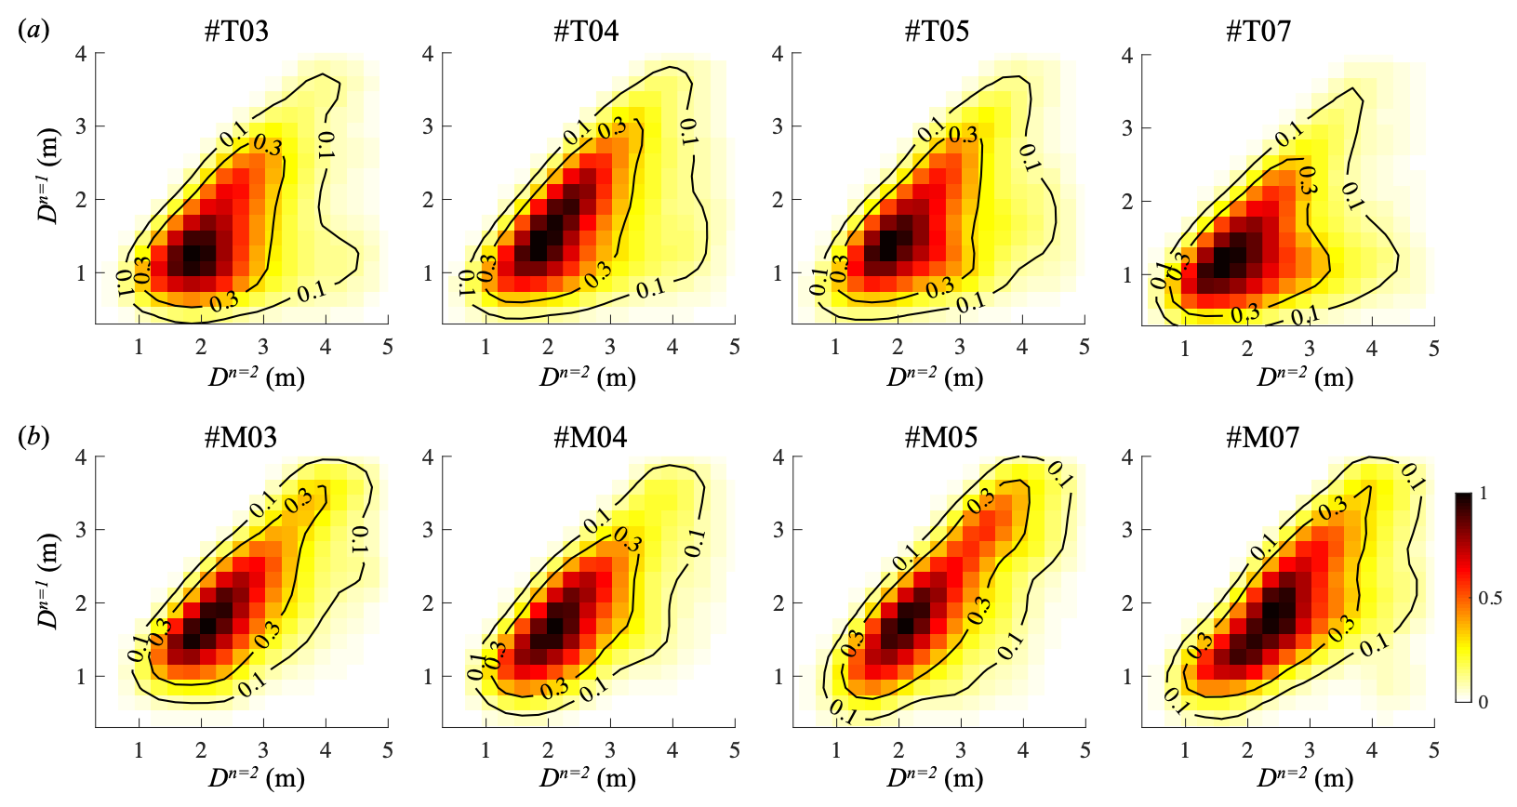
Figure S13. Joint probability density functions (PDFs) of the distance to nearest neighbor (D^{n=1}) and the distance to the second nearest neighbor (D^{n=2}) for (a) transit flocks and (b) mobbing flocks. Only data for flocks with group size larger than 30 are shown. The PDFs of transit flocks show a high probability region where D^{n=1} is nearly a constant regardless of D^{n=2}, indicating the existence of pairwise structures in the transit flocks.

Supplementary Movies
Supplementary Movies S1 to S3 showing the collective turns of bird flocks are available at: https://figshare.com/s/31aaa3454ec7f4b861b8.

