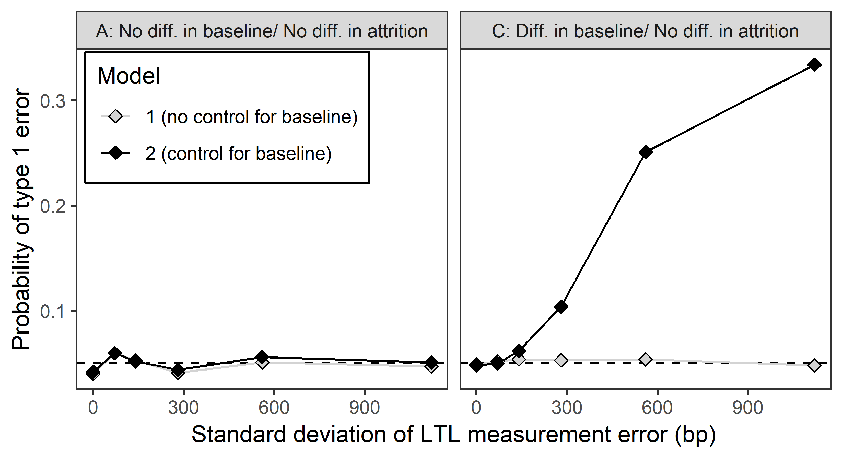

Figure S9. Assuming measurement error to be independent of LTL has no impact on the increased probability of false-positive errors resulting from controlling for LTL_{b} compared to Figure 3. Probability of a type 1 error as a function of measurement error here implemented as a fixed standard deviation (as opposed to as a CV) for models 1 and 2. Data points represent the proportion of simulations yielding a p-value below 0.05 in 1000 replicate simulations. The left and right panels show the probability of type 1 errors in scenarios A and C respectively. The difference in LTL_{b} between smokers and non-smokers in scenario C was LTL_{b} 141 bp shorter in smokers.

