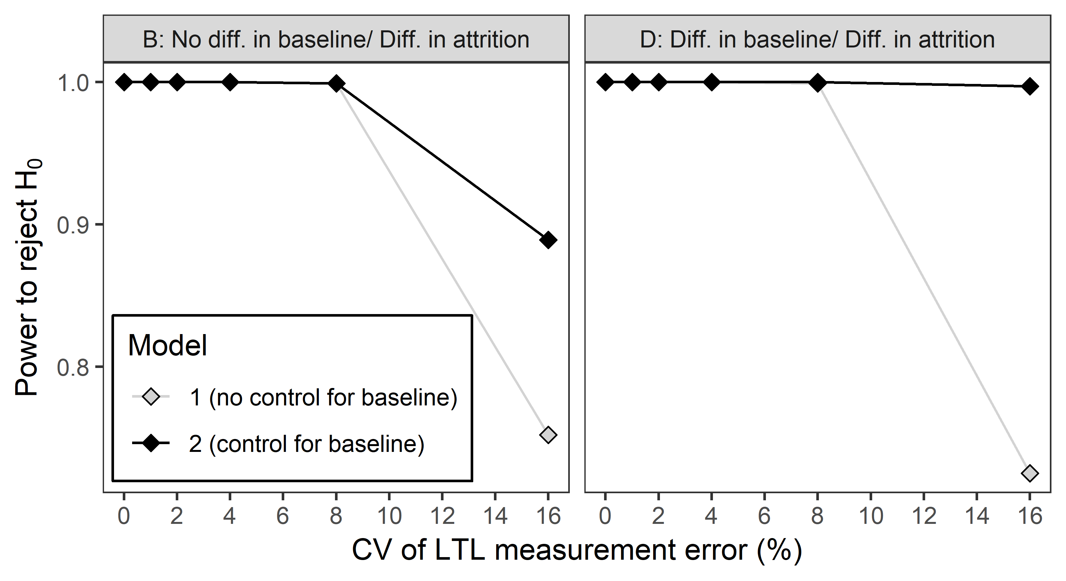

Figure S7. Increasing the true difference in ΔLTL.year⁻¹ between smokers and non-smokers increased power compared to Figure S1. Power as a function of measurement error for models 1 and 2. Data points represent the proportion of simulations yielding a p-value below 0.05 in 1000 replicate simulations. The left and right panels show the power in scenarios B and D respectively. The higher power at a CV of 16% seen with model 2 in scenario D reflects the bias in parameter estimates shown in Figure S5D. Power is generally high because of the large true effect size assumed in this simulation (-20 bp.year⁻¹). The difference in LTL_{b} between smokers and non-smokers in scenario D was LTL_{b} 141 bp shorter in smokers.

