Supplementary Material 2

Assessing the recovery of an Antarctic predator from historical exploitation

Alexandre N. Zerbini, Grant Adams, John Best, Phillip J. Clapham, Jennifer A. Jackson and Andre E. Punt

1) Bayes factor (model likelihood) comparison of scenarios

Scenario | Bayes Factor (weight)
Reference | 0.099
D-1 | 0.101
D-7 | 0.100
C-4 | 0.131
C-5 | 0.102
C-6 | 0.100
C-7 | 0.036
G-1 | 0.149
G- 2 | 0.183
M-1 | 0.099
M-2 | 0.101

2) Estimation of Model Parameters and Quantities of Interest for the Reference Case and Sensitivity Scenarios

2.1) Reference Case
Parameter | Mean |  | Median |  | 2.5% PI |  | 25% PI |  | 75% PI |  | 97.5% PI |  | Unique
r_{max} |  | 0.091 |  | 0.094 |  | 0.054 |  | 0.08 |  | 0.106 |  | 0.117 |  | 10,000
K |  | 28,198 |  | 27,726 |  | 25,296 |  | 26,658 |  | 29,233 |  | 33,606 |  | 10,000
N_{min} |  | 477 |  | 374 |  | 193 |  | 281 |  | 563 |  | 1,312 |  | 10,000
N₂₀₀₆ |  | 13,005 |  | 12,933 |  | 11,169 |  | 12,300 |  | 13,669 |  | 15,141 |  | 10,000
N₂₀₀₈ |  | 15,015 |  | 14,979 |  | 13,284 |  | 14,370 |  | 15,634 |  | 16,925 |  | 10,000
N₂₀₁₂ |  | 19,231 |  | 19,237 |  | 17,371 |  | 18,604 |  | 19,857 |  | 21,037 |  | 10,000
N₂₀₁₉ |  | 24,866 |  | 24,892 |  | 23,088 |  | 24,358 |  | 25,427 |  | 26,367 |  | 10,000
N₂₀₃₀ |  | 27,651 |  | 27,471 |  | 25,259 |  | 26,545 |  | 28,606 |  | 30,823 |  | 10,000
Maximum depletion |  | 0.016 |  | 0.013 |  | 0.007 |  | 0.011 |  | 0.019 |  | 0.04 |  | 10,000
Status in 2006 |  | 0.462 |  | 0.461 |  | 0.396 |  | 0.438 |  | 0.486 |  | 0.537 |  | 10,000
Status in 2008 |  | 0.535 |  | 0.535 |  | 0.449 |  | 0.506 |  | 0.564 |  | 0.621 |  | 10,000
Status in 2012 |  | 0.686 |  | 0.693 |  | 0.546 |  | 0.647 |  | 0.732 |  | 0.794 |  | 10,000
Status in 2019 |  | 0.887 |  | 0.906 |  | 0.713 |  | 0.855 |  | 0.937 |  | 0.964 |  | 10,000
Status in 2030 |  | 0.983 |  | 0.993 |  | 0.903 |  | 0.981 |  | 0.997 |  | 0.999 |  | 10,000

2.2) Scenario D-1
Parameter | Mean |  | Median |  | 2.5% PI |  | 25% PI |  | 75% PI |  | 97.5% PI |  | Unique
r_{max} |  | 0.091 |  | 0.092 |  | 0.054 |  | 0.079 |  | 0.104 |  | 0.116 |  | 10,000
K |  | 28,317 |  | 27,872 |  | 25,300 |  | 26,735 |  | 29,376 |  | 33,931 |  | 10,000
N_{min} |  | 485 |  | 384 |  | 194 |  | 288 |  | 569 |  | 1,310 |  | 10,000
N₂₀₀₆ |  | 12,983 |  | 12,925 |  | 11,156 |  | 12,293 |  | 13,617 |  | 15,134 |  | 10,000
N₂₀₀₈ |  | 14,979 |  | 14,956 |  | 13,262 |  | 14,336 |  | 15,574 |  | 16,862 |  | 10,000
N₂₀₁₂ |  | 19,180 |  | 19,174 |  | 17,394 |  | 18,567 |  | 19,801 |  | 20,974 |  | 10,000
N₂₀₁₉ |  | 24,867 |  | 24,899 |  | 23,149 |  | 24,357 |  | 25,434 |  | 26,332 |  | 10,000
N₂₀₃₀ |  | 27,738 |  | 27,592 |  | 25,254 |  | 26,616 |  | 28,724 |  | 30,903 |  | 10,000
Maximum depletion |  | 0.017 |  | 0.014 |  | 0.007 |  | 0.011 |  | 0.019 |  | 0.04 |  | 10,000
Status in 2006 |  | 0.46 |  | 0.459 |  | 0.395 |  | 0.436 |  | 0.482 |  | 0.53 |  | 10,000
Status in 2008 |  | 0.531 |  | 0.532 |  | 0.447 |  | 0.503 |  | 0.56 |  | 0.616 |  | 10,000
Status in 2012 |  | 0.682 |  | 0.687 |  | 0.543 |  | 0.642 |  | 0.727 |  | 0.79 |  | 10,000
Status in 2019 |  | 0.883 |  | 0.901 |  | 0.708 |  | 0.851 |  | 0.933 |  | 0.963 |  | 10,000
Status in 2030 |  | 0.982 |  | 0.992 |  | 0.899 |  | 0.981 |  | 0.997 |  | 0.999 |  | 10,000

2.3) Scenario D-2
Parameter | Mean | Median | 2.5% PI | 25% PI | 75% PI | 97.5% PI | Unique
r_{max} | 0.087 | 0.092 | 0.033 | 0.073 | 0.106 | 0.117 | 10,000
K | 28,960 | 27,813 | 25,243 | 26,585 | 29,780 | 40,018 | 10,000
N_{min} | 682 | 395 | 194 | 281 | 717 | 2,763 | 10,000
N₂₀₀₆ | 13,387 | 13,282 | 11,331 | 12,511 | 14,129 | 16,043 | 10,000
N₂₀₀₈ | 15,327 | 15,287 | 13,446 | 14,608 | 15,991 | 17,457 | 10,000
N₂₀₁₂ | 19,353 | 19,352 | 17,392 | 18,684 | 20,026 | 21,311 | 10,000
N₂₀₁₉ | 24,688 | 24,812 | 21,712 | 24,249 | 25,384 | 26,367 | 10,000
N₂₀₃₀ | 27,579 | 27,415 | 25,068 | 26,421 | 28,595 | 31,024 | 10,000
Maximum depletion | 0.021 | 0.014 | 0.007 | 0.011 | 0.024 | 0.071 | 10,000
Status in 2006 | 0.467 | 0.468 | 0.375 | 0.44 | 0.495 | 0.551 | 10,000
Status in 2008 | 0.536 | 0.54 | 0.402 | 0.506 | 0.574 | 0.636 | 10,000
Status in 2012 | 0.68 | 0.696 | 0.459 | 0.637 | 0.741 | 0.804 | 10,000
Status in 2019 | 0.868 | 0.905 | 0.557 | 0.835 | 0.941 | 0.967 | 10,000
Status in 2030 | 0.964 | 0.993 | 0.712 | 0.973 | 0.997 | 0.999 | 10,000

2.4) Scenario D-3
Parameter | Mean | Median | 2.5% PI | 25% PI | 75% PI | 97.5% PI | Unique
r_{max} | 0.107 | 0.109 | 0.084 | 0.102 | 0.114 | 0.118 | 10,000
K | 26,728 | 26,621 | 25,040 | 25,928 | 27,331 | 29,322 | 10,000
N_{min} | 275 | 257 | 177 | 216 | 305 | 497 | 10,000
N₂₀₀₆ | 12,404 | 12,363 | 10,807 | 11,797 | 12,971 | 14,245 | 10,000
N₂₀₀₈ | 14,660 | 14,627 | 12,989 | 14,024 | 15,256 | 16,529 | 10,000
N₂₀₁₂ | 19,367 | 19,357 | 17,696 | 18,761 | 19,952 | 21,084 | 10,000
N₂₀₁₉ | 24,922 | 24,913 | 23,759 | 24,445 | 25,379 | 26,148 | 10,000
N₂₀₃₀ | 26,620 | 26,546 | 25,006 | 25,873 | 27,221 | 28,931 | 10,000
Maximum depletion | 0.01 | 0.01 | 0.007 | 0.008 | 0.011 | 0.018 | 10,000
Status in 2006 | 0.465 | 0.462 | 0.403 | 0.44 | 0.487 | 0.538 | 10,000
Status in 2008 | 0.549 | 0.548 | 0.478 | 0.522 | 0.575 | 0.629 | 10,000
Status in 2012 | 0.726 | 0.727 | 0.636 | 0.697 | 0.756 | 0.806 | 10,000
Status in 2019 | 0.933 | 0.94 | 0.859 | 0.921 | 0.952 | 0.968 | 10,000
Status in 2030 | 0.996 | 0.998 | 0.984 | 0.996 | 0.998 | 0.999 | 10,000

2.5) Scenario D-4
Parameter | Mean |  | Median |  | 2.5% PI |  | 25% PI |  | 75% PI |  | 97.5% PI |  | Unique
r_{max} |  | 0.094 |  | 0.097 |  | 0.056 |  | 0.083 |  | 0.108 |  | 0.117 |  | 10,000
K |  | 27,957 |  | 27,492 |  | 25,276 |  | 26,496 |  | 28,896 |  | 33,348 |  | 10,000
N_{min} |  | 440 |  | 342 |  | 190 |  | 268 |  | 504 |  | 1,243 |  | 10,000
N₂₀₀₆ |  | 12,907 |  | 12,846 |  | 11,148 |  | 12,198 |  | 13,552 |  | 15,010 |  | 10,000
N₂₀₀₈ |  | 14,961 |  | 14,941 |  | 13,269 |  | 14,320 |  | 15,569 |  | 16,842 |  | 10,000
N₂₀₁₂ |  | 19,263 |  | 19,266 |  | 17,508 |  | 18,648 |  | 19,882 |  | 21,037 |  | 10,000
N₂₀₁₉ |  | 24,893 |  | 24,915 |  | 23,334 |  | 24,394 |  | 25,431 |  | 26,305 |  | 10,000
N₂₀₃₀ |  | 27,487 |  | 27,304 |  | 25,236 |  | 26,403 |  | 28,393 |  | 30,731 |  | 10,000
Maximum depletion |  | 0.015 |  | 0.013 |  | 0.007 |  | 0.01 |  | 0.018 |  | 0.038 |  | 10,000
Status in 2006 |  | 0.463 |  | 0.462 |  | 0.396 |  | 0.438 |  | 0.486 |  | 0.536 |  | 10,000
Status in 2008 |  | 0.537 |  | 0.538 |  | 0.451 |  | 0.509 |  | 0.566 |  | 0.623 |  | 10,000
Status in 2012 |  | 0.693 |  | 0.7 |  | 0.553 |  | 0.655 |  | 0.737 |  | 0.797 |  | 10,000
Status in 2019 |  | 0.895 |  | 0.914 |  | 0.726 |  | 0.868 |  | 0.941 |  | 0.965 |  | 10,000
Status in 2030 |  | 0.985 |  | 0.994 |  | 0.913 |  | 0.985 |  | 0.997 |  | 0.999 |  | 10,000

2.6) Scenario D-5
Parameter | Mean | Median | 2.5% PI | 25% PI | 75% PI | 97.5% PI | Unique
r_{max} | 0.108 | 0.11 | 0.086 | 0.104 | 0.115 | 0.118 | 10,000
K | 26,637 | 26,534 | 25,049 | 25,885 | 27,200 | 29,046 | 10,000
N_{min} | 264 | 248 | 177 | 211 | 292 | 466 | 10,000
N₂₀₀₆ | 12,378 | 12,343 | 10,782 | 11,772 | 12,943 | 14,185 | 10,000
N₂₀₀₈ | 14,654 | 14,624 | 12,972 | 14,025 | 15,244 | 16,503 | 10,000
N₂₀₁₂ | 19,398 | 19,391 | 17,702 | 18,810 | 19,990 | 21,097 | 10,000
N₂₀₁₉ | 24,924 | 24,924 | 23,769 | 24,450 | 25,378 | 26,157 | 10,000
N₂₀₃₀ | 26,543 | 26,471 | 25,013 | 25,834 | 27,107 | 28,680 | 10,000
Maximum depletion | 0.01 | 0.009 | 0.007 | 0.008 | 0.011 | 0.016 | 10,000
Status in 2006 | 0.465 | 0.464 | 0.403 | 0.441 | 0.487 | 0.537 | 10,000
Status in 2008 | 0.551 | 0.55 | 0.48 | 0.524 | 0.576 | 0.629 | 10,000
Status in 2012 | 0.729 | 0.731 | 0.642 | 0.702 | 0.758 | 0.807 | 10,000
Status in 2019 | 0.936 | 0.942 | 0.87 | 0.926 | 0.954 | 0.969 | 10,000
Status in 2030 | 0.997 | 0.998 | 0.987 | 0.996 | 0.998 | 0.999 | 10,000

2.7) Scenario D-6
Parameter | Mean | Median | 2.5% PI | 25% PI | 75% PI | 97.5% PI | Unique
r_{max} | 0.084 | 0.087 | 0.031 | 0.068 | 0.103 | 0.117 | 10,000
K | 29,382 | 28,161 | 25,275 | 26,814 | 30,436 | 40,897 | 10,000
N_{min} | 762 | 447 | 198 | 301 | 865 | 2,969 | 10,000
N₂₀₀₆ | 13,516 | 13,400 | 11,335 | 12,633 | 14,304 | 16,263 | 10,000
N₂₀₀₈ | 15,390 | 15,329 | 13,447 | 14,650 | 16,085 | 17,599 | 10,000
N₂₀₁₂ | 19,292 | 19,284 | 17,350 | 18,617 | 19,955 | 21,282 | 10,000
N₂₀₁₉ | 24,616 | 24,758 | 21,534 | 24,162 | 25,331 | 26,378 | 10,000
N₂₀₃₀ | 27,767 | 27,622 | 25,128 | 26,611 | 28,834 | 31,218 | 10,000
Maximum depletion | 0.023 | 0.016 | 0.008 | 0.011 | 0.029 | 0.075 | 10,000
Status in 2006 | 0.465 | 0.466 | 0.371 | 0.439 | 0.493 | 0.548 | 10,000
Status in 2008 | 0.531 | 0.535 | 0.396 | 0.5 | 0.568 | 0.631 | 10,000
Status in 2012 | 0.669 | 0.684 | 0.448 | 0.621 | 0.732 | 0.801 | 10,000
Status in 2019 | 0.854 | 0.89 | 0.54 | 0.81 | 0.934 | 0.965 | 10,000
Status in 2030 | 0.958 | 0.989 | 0.687 | 0.961 | 0.997 | 0.999 | 10,000

2.8) Scenario D-7
Parameter | Mean | Median | 2.5% PI | 25% PI | 75% PI | 97.5% PI | Unique
r_{max} | 0.088 | 0.088 | 0.063 | 0.079 | 0.097 | 0.113 | 9,999
K | 28,433 | 28,230 | 25,688 | 27,215 | 29,440 | 32,276 | 10,000
N_{min} | 486 | 441 | 222 | 344 | 579 | 1,001 | 10,000
N₂₀₀₆ | 13,104 | 13,070 | 11,339 | 12,465 | 13,724 | 14,997 | 10,000
N₂₀₀₈ | 15,059 | 15,028 | 13,341 | 14,432 | 15,669 | 16,910 | 10,000
N₂₀₁₂ | 19,178 | 19,173 | 17,376 | 18,558 | 19,794 | 21,029 | 10,000
N₂₀₁₉ | 24,946 | 24,953 | 23,383 | 24,408 | 25,490 | 26,416 | 10,000
N₂₀₃₀ | 27,968 | 27,871 | 25,615 | 27,014 | 28,871 | 30,656 | 10,000
Maximum depletion | 0.017 | 0.016 | 0.008 | 0.013 | 0.02 | 0.032 | 10,000
Status in 2006 | 0.462 | 0.46 | 0.398 | 0.437 | 0.485 | 0.533 | 10,000
Status in 2008 | 0.531 | 0.53 | 0.455 | 0.503 | 0.558 | 0.612 | 10,000
Status in 2012 | 0.677 | 0.678 | 0.571 | 0.641 | 0.715 | 0.777 | 10,000
Status in 2019 | 0.88 | 0.888 | 0.762 | 0.849 | 0.918 | 0.956 | 10,000
Status in 2030 | 0.984 | 0.989 | 0.942 | 0.98 | 0.994 | 0.998 | 10,000

2.9) Scenario C-1
Parameter | Mean | Median | 2.5% PI | 25% PI | 75% PI | 97.5% PI | Unique
r_{max} | 0.093 | 0.096 | 0.055 | 0.082 | 0.107 | 0.117 | 10,000
K | 23,339 | 23,152 | 22,246 | 22,647 | 23,825 | 25,501 | 10,000
N_{min} | 463 | 358 | 200 | 273 | 537 | 1,275 | 10,000
N₂₀₀₆ | 13,194 | 13,125 | 11,286 | 12,442 | 13,873 | 15,449 | 10,000
N₂₀₀₈ | 15,007 | 14,969 | 13,265 | 14,348 | 15,625 | 16,987 | 10,000
N₂₀₁₂ | 18,393 | 18,408 | 16,918 | 17,877 | 18,898 | 19,829 | 10,000
N₂₀₁₉ | 21,897 | 21,898 | 21,140 | 21,713 | 22,109 | 22,555 | 10,000
N₂₀₃₀ | 23,152 | 23,078 | 22,228 | 22,616 | 23,633 | 24,402 | 10,000
Maximum depletion | 0.019 | 0.015 | 0.009 | 0.012 | 0.023 | 0.05 | 10,000
Status in 2006 | 0.565 | 0.564 | 0.496 | 0.538 | 0.59 | 0.645 | 10,000
Status in 2008 | 0.643 | 0.642 | 0.571 | 0.615 | 0.67 | 0.725 | 10,000
Status in 2012 | 0.789 | 0.793 | 0.69 | 0.76 | 0.823 | 0.87 | 10,000
Status in 2019 | 0.94 | 0.951 | 0.838 | 0.923 | 0.967 | 0.98 | 10,000
Status in 2030 | 0.992 | 0.997 | 0.956 | 0.992 | 0.999 | 0.999 | 10,000

2.10) Scenario C-2
Parameter | Mean | Median | 2.5% PI | 25% PI | 75% PI | 97.5% PI | Unique
r_{max} | 0.094 | 0.096 | 0.056 | 0.083 | 0.108 | 0.117 | 10,000
K | 23,745 | 23,556 | 22,653 | 23,059 | 24,225 | 25,858 | 10,000
N_{min} | 454 | 356 | 200 | 274 | 523 | 1,251 | 10,000
N₂₀₀₆ | 13,130 | 13,078 | 11,290 | 12,389 | 13,803 | 15,342 | 10,000
N₂₀₀₈ | 14,982 | 14,958 | 13,270 | 14,327 | 15,608 | 16,886 | 10,000
N₂₀₁₂ | 18,493 | 18,505 | 16,966 | 17,974 | 19,028 | 19,924 | 10,000
N₂₀₁₉ | 22,210 | 22,227 | 21,350 | 22,030 | 22,431 | 22,860 | 10,000
N₂₀₃₀ | 23,552 | 23,480 | 22,635 | 23,024 | 24,022 | 24,780 | 10,000
Maximum depletion | 0.019 | 0.015 | 0.009 | 0.012 | 0.022 | 0.048 | 10,000
Status in 2006 | 0.553 | 0.551 | 0.486 | 0.527 | 0.577 | 0.628 | 10,000
Status in 2008 | 0.631 | 0.63 | 0.559 | 0.604 | 0.657 | 0.71 | 10,000
Status in 2012 | 0.78 | 0.784 | 0.68 | 0.751 | 0.813 | 0.861 | 10,000
Status in 2019 | 0.937 | 0.948 | 0.835 | 0.921 | 0.964 | 0.979 | 10,000
Status in 2030 | 0.992 | 0.997 | 0.957 | 0.992 | 0.998 | 0.999 | 10,000

2.11) Scenario C-3
Parameter | Mean | Median | 2.5% PI | 25% PI | 75% PI | 97.5% PI | Unique
r_{max} | 0.092 | 0.095 | 0.054 | 0.081 | 0.106 | 0.117 | 10,000
K | 25,691 | 25,359 | 23,775 | 24,609 | 26,387 | 29,421 | 10,000
N_{min} | 468 | 361 | 197 | 275 | 537 | 1,290 | 10,000
N₂₀₀₆ | 13,076 | 13,025 | 11,246 | 12,358 | 13,728 | 15,263 | 10,000
N₂₀₀₈ | 15,008 | 14,980 | 13,267 | 14,368 | 15,608 | 16,919 | 10,000
N₂₀₁₂ | 18,861 | 18,869 | 17,196 | 18,309 | 19,422 | 20,475 | 10,000
N₂₀₁₉ | 23,426 | 23,448 | 22,224 | 23,120 | 23,773 | 24,428 | 10,000
N₂₀₃₀ | 25,349 | 25,219 | 23,746 | 24,554 | 26,026 | 27,536 | 10,000
Maximum depletion | 0.018 | 0.014 | 0.008 | 0.011 | 0.02 | 0.044 | 10,000
Status in 2006 | 0.509 | 0.508 | 0.446 | 0.485 | 0.532 | 0.582 | 10,000
Status in 2008 | 0.585 | 0.585 | 0.507 | 0.558 | 0.612 | 0.668 | 10,000
Status in 2012 | 0.737 | 0.742 | 0.614 | 0.703 | 0.778 | 0.831 | 10,000
Status in 2019 | 0.915 | 0.931 | 0.774 | 0.892 | 0.953 | 0.972 | 10,000
Status in 2030 | 0.988 | 0.995 | 0.931 | 0.988 | 0.998 | 0.999 | 10,000

2.12) Scenario C-4
Parameter | Mean | Median | 2.5% PI | 25% PI | 75% PI | 97.5% PI | Unique
r_{max} | 0.091 | 0.093 | 0.055 | 0.08 | 0.105 | 0.117 | 10,000
K | 30,038 | 29,591 | 26,072 | 28,144 | 31,363 | 36,891 | 10,000
N_{min} | 471 | 372 | 192 | 282 | 555 | 1,271 | 10,000
N₂₀₀₆ | 12,925 | 12,863 | 11,132 | 12,231 | 13,559 | 15,072 | 10,000
N₂₀₀₈ | 14,985 | 14,948 | 13,252 | 14,349 | 15,590 | 16,901 | 10,000
N₂₀₁₂ | 19,442 | 19,431 | 17,535 | 18,752 | 20,114 | 21,427 | 10,000
N₂₀₁₉ | 25,879 | 25,854 | 23,555 | 25,079 | 26,616 | 28,495 | 10,000
N₂₀₃₀ | 29,348 | 29,186 | 26,005 | 27,955 | 30,486 | 34,105 | 10,000
Maximum depletion | 0.015 | 0.013 | 0.007 | 0.01 | 0.018 | 0.037 | 10,000
Status in 2006 | 0.433 | 0.432 | 0.353 | 0.407 | 0.458 | 0.513 | 10,000
Status in 2008 | 0.502 | 0.503 | 0.405 | 0.472 | 0.533 | 0.596 | 10,000
Status in 2012 | 0.653 | 0.658 | 0.506 | 0.61 | 0.7 | 0.77 | 10,000
Status in 2019 | 0.867 | 0.886 | 0.68 | 0.831 | 0.922 | 0.956 | 10,000
Status in 2030 | 0.979 | 0.991 | 0.888 | 0.977 | 0.996 | 0.999 | 10,000

2.13) Scenario C-5
Parameter | Mean | Median | 2.5% PI | 25% PI | 75% PI | 97.5% PI | Unique
r_{max} | 0.092 | 0.094 | 0.055 | 0.08 | 0.105 | 0.117 | 10,000
K | 28,312 | 27,873 | 25,460 | 26,807 | 29,358 | 33,768 | 10,000
N_{min} | 502 | 411 | 194 | 300 | 600 | 1,287 | 10,000
N₂₀₀₆ | 12,984 | 12,910 | 11,199 | 12,257 | 13,641 | 15,133 | 10,000
N₂₀₀₈ | 15,001 | 14,968 | 13,276 | 14,333 | 15,618 | 16,930 | 10,000
N₂₀₁₂ | 19,244 | 19,240 | 17,393 | 18,613 | 19,882 | 21,076 | 10,000
N₂₀₁₉ | 24,954 | 24,980 | 23,193 | 24,449 | 25,520 | 26,413 | 10,000
N₂₀₃₀ | 27,773 | 27,606 | 25,420 | 26,692 | 28,718 | 30,958 | 10,000
Maximum depletion | 0.017 | 0.015 | 0.007 | 0.011 | 0.021 | 0.039 | 10,000
Status in 2006 | 0.46 | 0.459 | 0.394 | 0.436 | 0.483 | 0.533 | 10,000
Status in 2008 | 0.532 | 0.532 | 0.447 | 0.504 | 0.561 | 0.618 | 10,000
Status in 2012 | 0.684 | 0.689 | 0.547 | 0.644 | 0.729 | 0.79 | 10,000
Status in 2019 | 0.886 | 0.903 | 0.716 | 0.855 | 0.935 | 0.963 | 10,000
Status in 2030 | 0.983 | 0.993 | 0.905 | 0.982 | 0.997 | 0.999 | 10,000

2.14) Scenario C-6
Parameter | Mean | Median | 2.5% PI | 25% PI | 75% PI | 97.5% PI | Unique
r_{max} | 0.092 | 0.094 | 0.055 | 0.08 | 0.105 | 0.117 | 10,000
K | 28,239 | 27,780 | 25,328 | 26,691 | 29,265 | 33,749 | 10,000
N_{min} | 496 | 393 | 195 | 296 | 577 | 1,439 | 10,000
N₂₀₀₆ | 13,006 | 12,948 | 11,181 | 12,303 | 13,653 | 15,142 | 10,000
N₂₀₀₈ | 15,022 | 14,989 | 13,271 | 14,380 | 15,636 | 16,953 | 10,000
N₂₀₁₂ | 19,251 | 19,257 | 17,441 | 18,626 | 19,877 | 21,066 | 10,000
N₂₀₁₉ | 24,911 | 24,923 | 23,263 | 24,405 | 25,462 | 26,384 | 10,000
N₂₀₃₀ | 27,696 | 27,529 | 25,286 | 26,582 | 28,686 | 30,831 | 10,000
Maximum depletion | 0.017 | 0.014 | 0.007 | 0.011 | 0.02 | 0.044 | 10,000
Status in 2006 | 0.462 | 0.461 | 0.395 | 0.437 | 0.485 | 0.534 | 10,000
Status in 2008 | 0.534 | 0.535 | 0.447 | 0.505 | 0.564 | 0.62 | 10,000
Status in 2012 | 0.686 | 0.692 | 0.546 | 0.647 | 0.731 | 0.792 | 10,000
Status in 2019 | 0.887 | 0.905 | 0.711 | 0.856 | 0.936 | 0.963 | 10,000
Status in 2030 | 0.983 | 0.993 | 0.903 | 0.981 | 0.997 | 0.999 | 10,000

2.15) Scenario C-7
Parameter | Mean | Median | 2.5% PI | 25% PI | 75% PI | 97.5% PI | Unique
r_{max} | 0.089 | 0.091 | 0.05 | 0.076 | 0.103 | 0.116 | 9,999
K | 25,479 | 24,914 | 22,184 | 23,727 | 26,639 | 31,934 | 10,000
N_{min} | 617 | 531 | 204 | 333 | 803 | 1,491 | 10,000
N₂₀₀₆ | 13,250 | 13,193 | 11,379 | 12,507 | 13,933 | 15,457 | 10,000
N₂₀₀₈ | 15,077 | 15,054 | 13,339 | 14,403 | 15,689 | 17,023 | 10,000
N₂₀₁₂ | 18,661 | 18,655 | 17,005 | 18,099 | 19,222 | 20,314 | 10,000
N₂₀₁₉ | 22,937 | 22,927 | 21,356 | 22,325 | 23,516 | 24,647 | 10,000
N₂₀₃₀ | 24,985 | 24,734 | 22,159 | 23,657 | 26,113 | 28,973 | 10,000
Maximum depletion | 0.023 | 0.021 | 0.009 | 0.014 | 0.03 | 0.048 | 10,000
Status in 2006 | 0.523 | 0.522 | 0.434 | 0.493 | 0.553 | 0.616 | 10,000
Status in 2008 | 0.596 | 0.598 | 0.48 | 0.561 | 0.633 | 0.7 | 10,000
Status in 2012 | 0.739 | 0.749 | 0.571 | 0.697 | 0.791 | 0.855 | 10,000
Status in 2019 | 0.907 | 0.927 | 0.724 | 0.879 | 0.955 | 0.977 | 10,000
Status in 2030 | 0.983 | 0.994 | 0.899 | 0.983 | 0.998 | 0.999 | 10,000

2.16) Scenario G-1
Parameter | Mean | Median | 2.5% PI | 25% PI | 75% PI | 97.5% PI | Unique
r_{max} | 0.091 | 0.093 | 0.054 | 0.08 | 0.105 | 0.117 | 10,000
K | 28,204 | 27,739 | 25,329 | 26,685 | 29,256 | 33,693 | 10,000
N_{min} | 476 | 375 | 194 | 282 | 556 | 1,313 | 10,000
N₂₀₀₆ | 13,004 | 12,953 | 11,213 | 12,279 | 13,641 | 15,141 | 10,000
N₂₀₀₈ | 15,015 | 14,976 | 13,306 | 14,365 | 15,610 | 16,940 | 10,000
N₂₀₁₂ | 19,235 | 19,221 | 17,413 | 18,632 | 19,855 | 21,032 | 10,000
N₂₀₁₉ | 24,880 | 24,913 | 23,183 | 24,375 | 25,429 | 26,333 | 10,000
N₂₀₃₀ | 27,662 | 27,488 | 25,284 | 26,572 | 28,651 | 30,842 | 10,000
Maximum depletion | 0.016 | 0.014 | 0.007 | 0.011 | 0.019 | 0.04 | 10,000
Status in 2006 | 0.462 | 0.461 | 0.396 | 0.438 | 0.485 | 0.536 | 10,000
Status in 2008 | 0.535 | 0.535 | 0.447 | 0.506 | 0.563 | 0.621 | 10,000
Status in 2012 | 0.686 | 0.693 | 0.545 | 0.648 | 0.732 | 0.792 | 10,000
Status in 2019 | 0.887 | 0.905 | 0.709 | 0.856 | 0.937 | 0.963 | 10,000
Status in 2030 | 0.983 | 0.993 | 0.898 | 0.982 | 0.997 | 0.999 | 10,000

2.17) Scenario G-2
Parameter | Mean | Median | 2.5% PI | 25% PI | 75% PI | 97.5% PI | Unique
r_{max} | 0.091 | 0.094 | 0.054 | 0.08 | 0.105 | 0.116 | 10,000
K | 28,221 | 27,742 | 25,327 | 26,703 | 29,258 | 33,735 | 10,000
N_{min} | 476 | 372 | 197 | 284 | 560 | 1,308 | 10,000
N₂₀₀₆ | 13,011 | 12,954 | 11,193 | 12,310 | 13,653 | 15,123 | 10,000
N₂₀₀₈ | 15,023 | 14,998 | 13,294 | 14,386 | 15,620 | 16,927 | 10,000
N₂₀₁₂ | 19,243 | 19,250 | 17,437 | 18,610 | 19,866 | 21,045 | 10,000
N₂₀₁₉ | 24,888 | 24,916 | 23,133 | 24,384 | 25,438 | 26,372 | 10,000
N₂₀₃₀ | 27,674 | 27,496 | 25,280 | 26,593 | 28,634 | 30,808 | 10,000
Maximum depletion | 0.016 | 0.013 | 0.008 | 0.011 | 0.019 | 0.04 | 10,000
Status in 2006 | 0.462 | 0.462 | 0.396 | 0.438 | 0.486 | 0.536 | 10,000
Status in 2008 | 0.535 | 0.535 | 0.446 | 0.506 | 0.565 | 0.62 | 10,000
Status in 2012 | 0.686 | 0.693 | 0.543 | 0.647 | 0.733 | 0.792 | 10,000
Status in 2019 | 0.887 | 0.905 | 0.71 | 0.856 | 0.936 | 0.963 | 10,000
Status in 2030 | 0.983 | 0.993 | 0.9 | 0.982 | 0.997 | 0.999 | 10,000

2.18) Scenario M-1
Parameter | Mean | Median | 2.5% PI | 25% PI | 75% PI | 97.5% PI | Unique
r_{max} | 0.083 | 0.083 | 0.049 | 0.071 | 0.096 | 0.114 | 10,000
K | 26,032 | 25,799 | 23,277 | 24,669 | 27,076 | 30,391 | 10,000
N_{min} | 576 | 473 | 187 | 331 | 714 | 1,466 | 10,000
N₂₀₀₆ | 12,720 | 12,653 | 10,815 | 11,988 | 13,413 | 14,946 | 10,000
N₂₀₀₈ | 14,818 | 14,781 | 13,088 | 14,170 | 15,425 | 16,792 | 10,000
N₂₀₁₂ | 19,586 | 19,607 | 17,605 | 18,918 | 20,258 | 21,465 | 10,000
N₂₀₁₉ | 24,909 | 24,958 | 23,169 | 24,326 | 25,533 | 26,516 | 10,000
N₂₀₃₀ | 25,970 | 25,795 | 23,277 | 24,669 | 27,055 | 29,796 | 10,000
Maximum depletion | 0.021 | 0.018 | 0.008 | 0.013 | 0.026 | 0.049 | 10,000
Status in 2006 | 0.489 | 0.488 | 0.431 | 0.468 | 0.509 | 0.554 | 10,000
Status in 2008 | 0.571 | 0.571 | 0.491 | 0.543 | 0.598 | 0.653 | 10,000
Status in 2012 | 0.757 | 0.76 | 0.607 | 0.708 | 0.811 | 0.884 | 10,000
Status in 2019 | 0.96 | 0.979 | 0.814 | 0.946 | 0.994 | 0.999 | 10,000
Status in 2030 | 0.998 | 1 | 0.982 | 0.999 | 1 | 1 | 10,000

2.19) Scenario M-2
Parameter | Mean | Median | 2.5% PI | 25% PI | 75% PI | 97.5% PI | Unique
r_{max} | 0.076 | 0.076 | 0.047 | 0.065 | 0.087 | 0.108 | 9,999
K | 24,682 | 24,521 | 21,933 | 23,540 | 25,653 | 28,267 | 10,000
N_{min} | 690 | 593 | 225 | 419 | 875 | 1,574 | 10,000
N₂₀₀₆ | 12,786 | 12,749 | 10,802 | 12,035 | 13,504 | 14,956 | 10,000
N₂₀₀₈ | 14,778 | 14,751 | 13,015 | 14,128 | 15,401 | 16,693 | 10,000
N₂₀₁₂ | 19,652 | 19,657 | 17,685 | 18,983 | 20,341 | 21,537 | 10,000
N₂₀₁₉ | 24,387 | 24,460 | 21,927 | 23,516 | 25,319 | 26,485 | 10,000
N₂₀₃₀ | 24,677 | 24,521 | 21,933 | 23,540 | 25,653 | 28,256 | 10,000
Maximum depletion | 0.027 | 0.024 | 0.01 | 0.018 | 0.034 | 0.056 | 10,000
Status in 2006 | 0.518 | 0.517 | 0.465 | 0.499 | 0.537 | 0.576 | 10,000
Status in 2008 | 0.6 | 0.6 | 0.529 | 0.576 | 0.624 | 0.671 | 10,000
Status in 2012 | 0.8 | 0.801 | 0.653 | 0.75 | 0.852 | 0.939 | 10,000
Status in 2019 | 0.989 | 1 | 0.896 | 0.996 | 1 | 1 | 9,993
Status in 2030 | 1 | 1 | 1 | 1 | 1 | 1 | 5,659

3) Population Trajectories

3.1) Reference Case

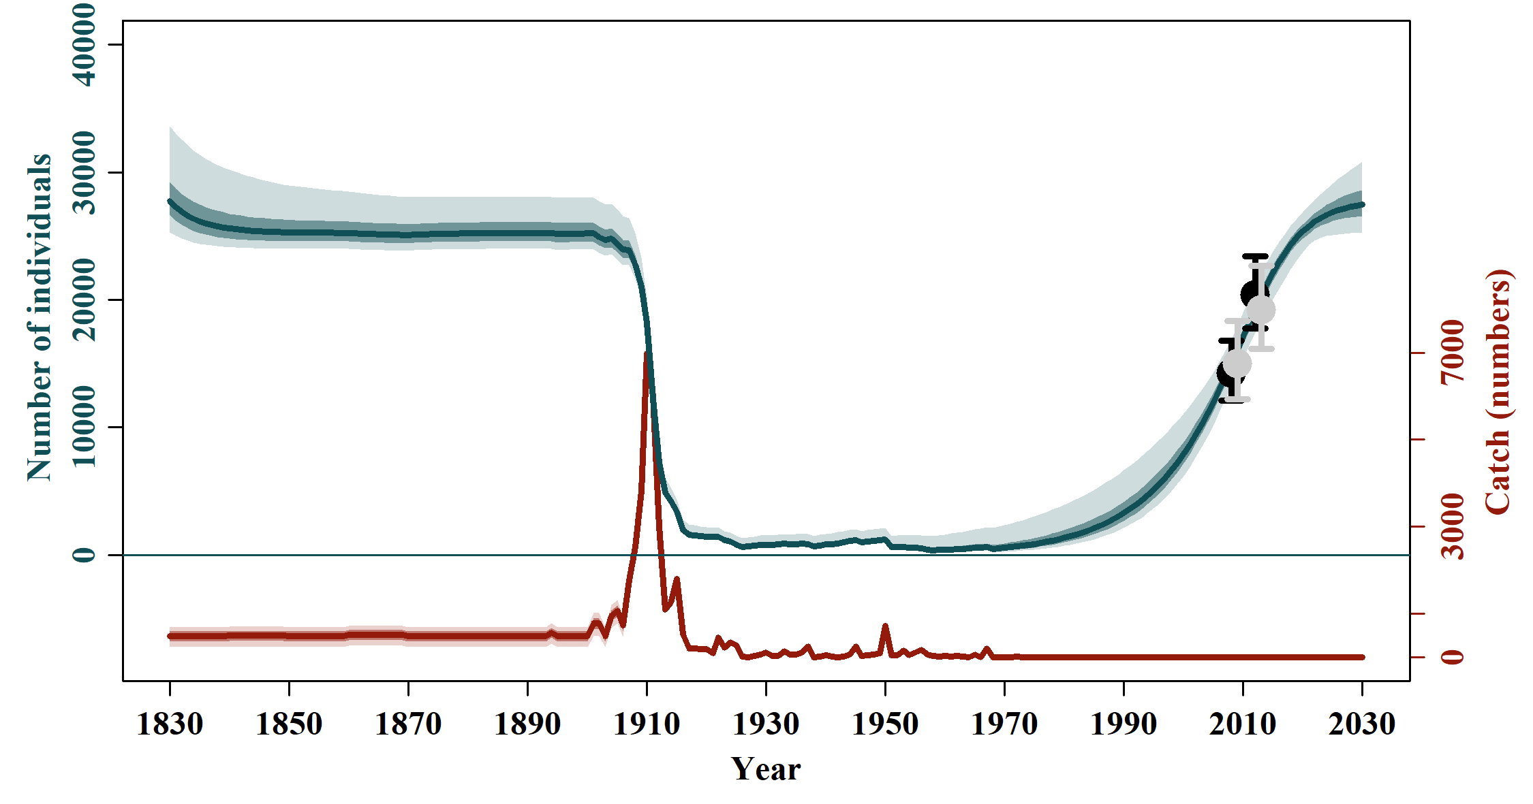

3.2) Sensitivities to Data Inclusion (Scenarios D)

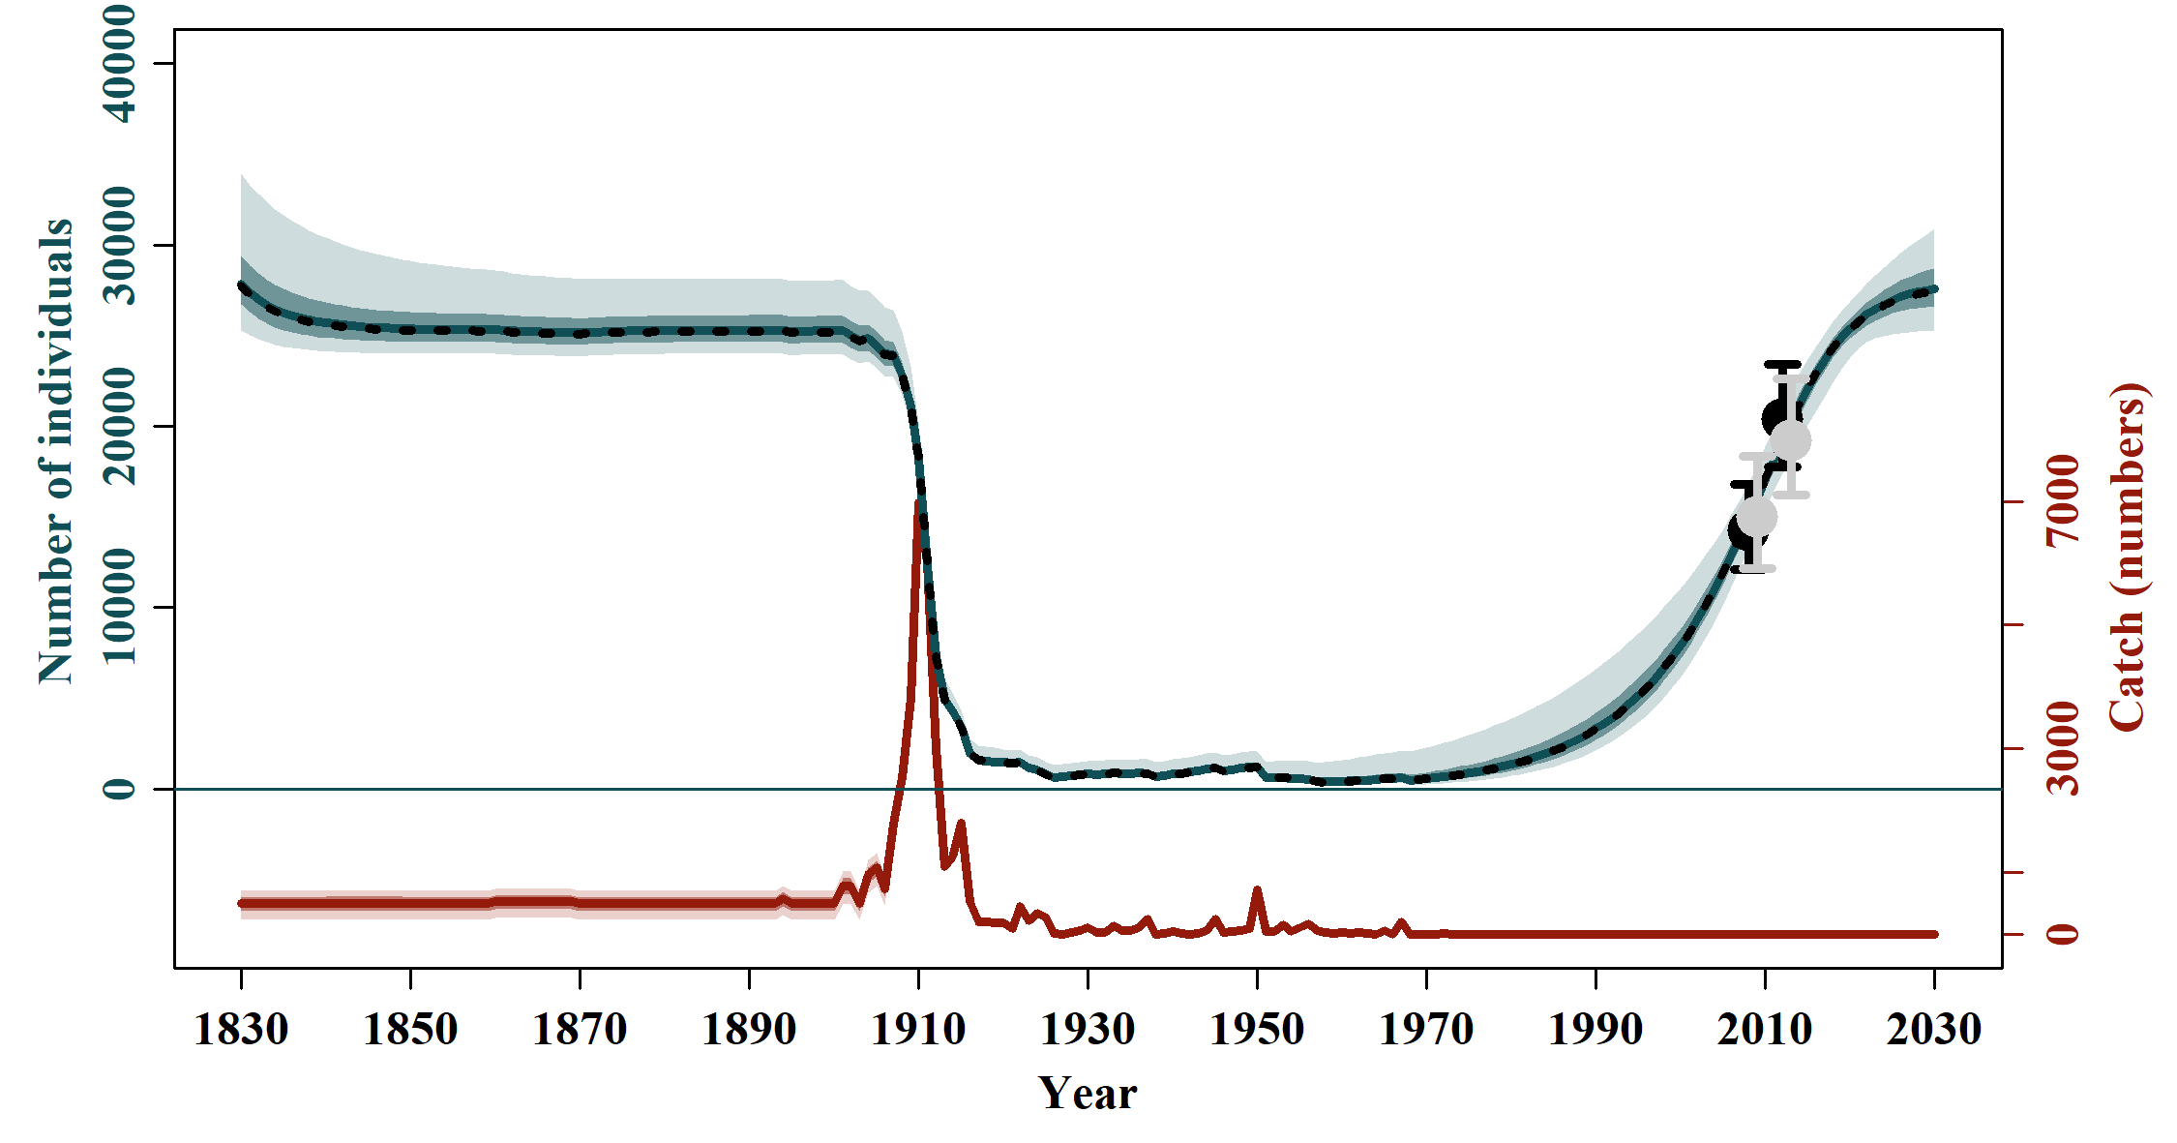 | 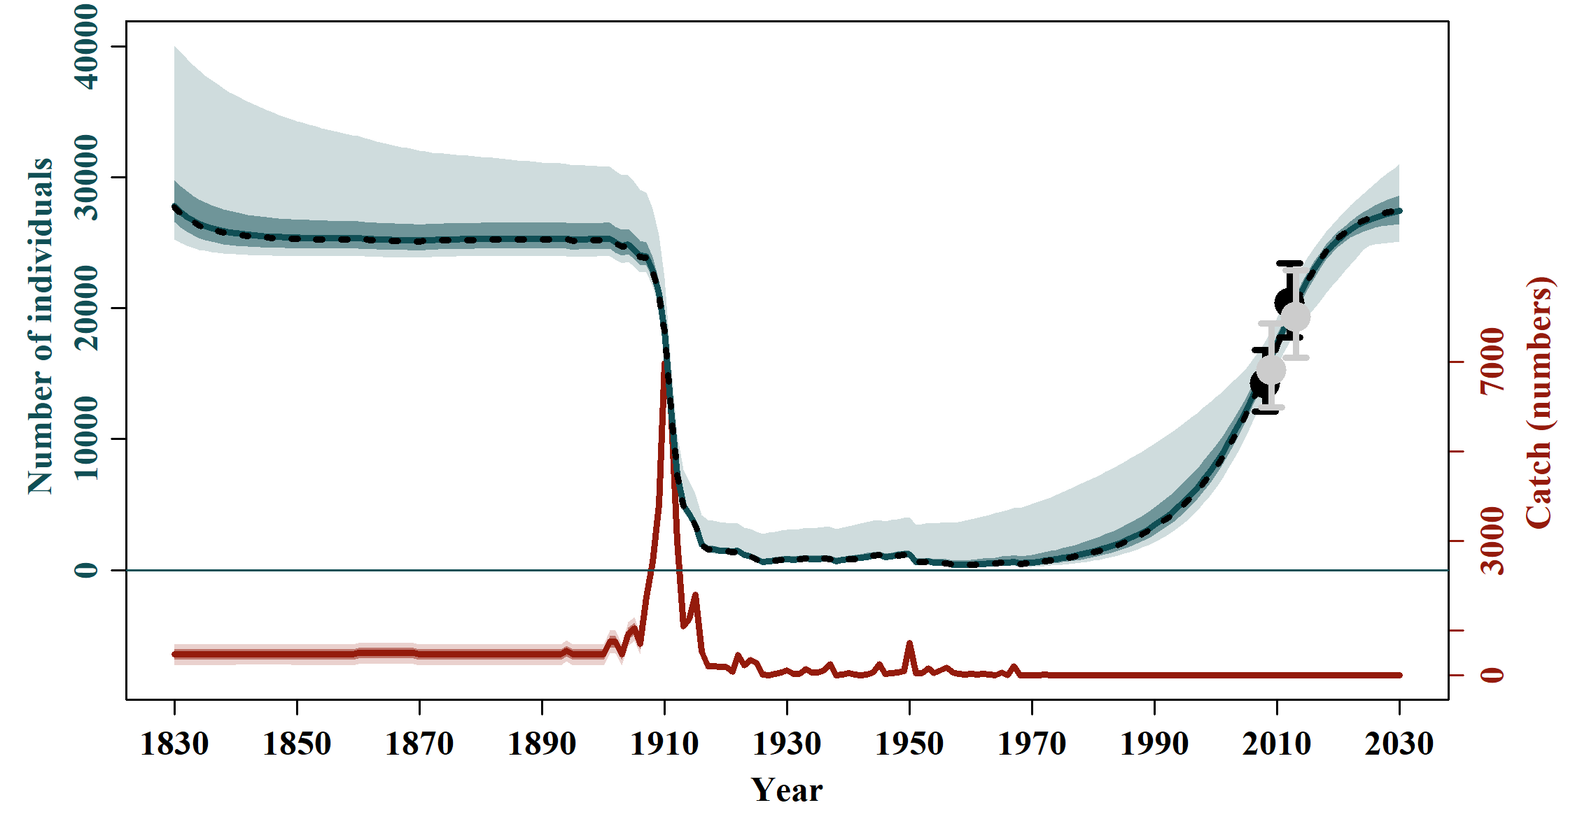
D-1 | D-2
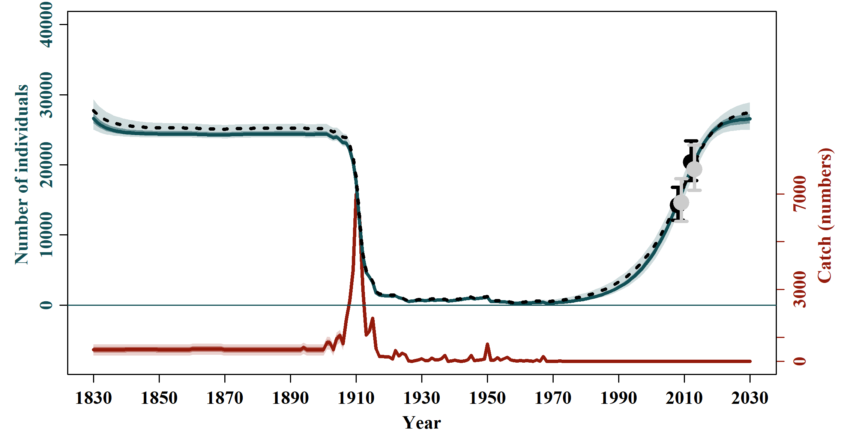 | 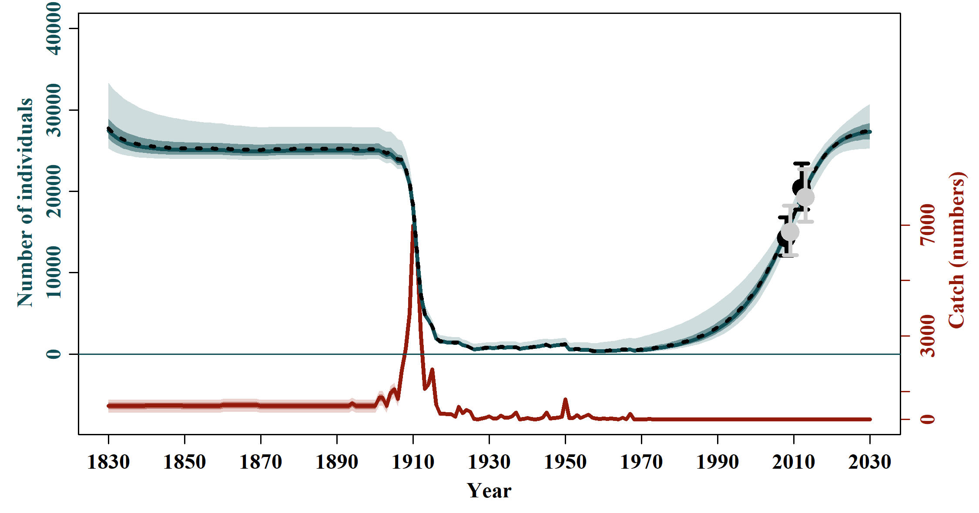
D-3 | D-4
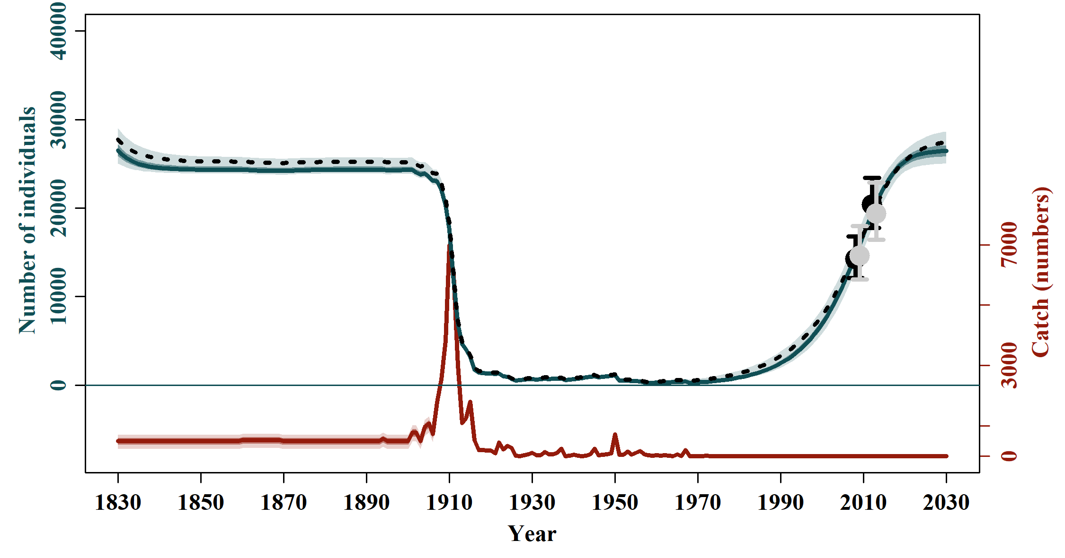 | 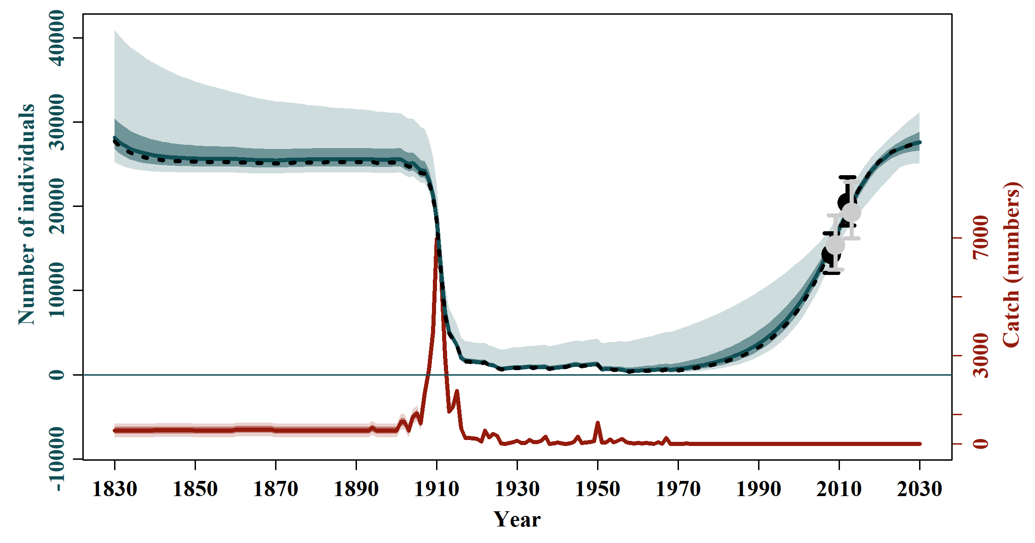
D-5 | D-6
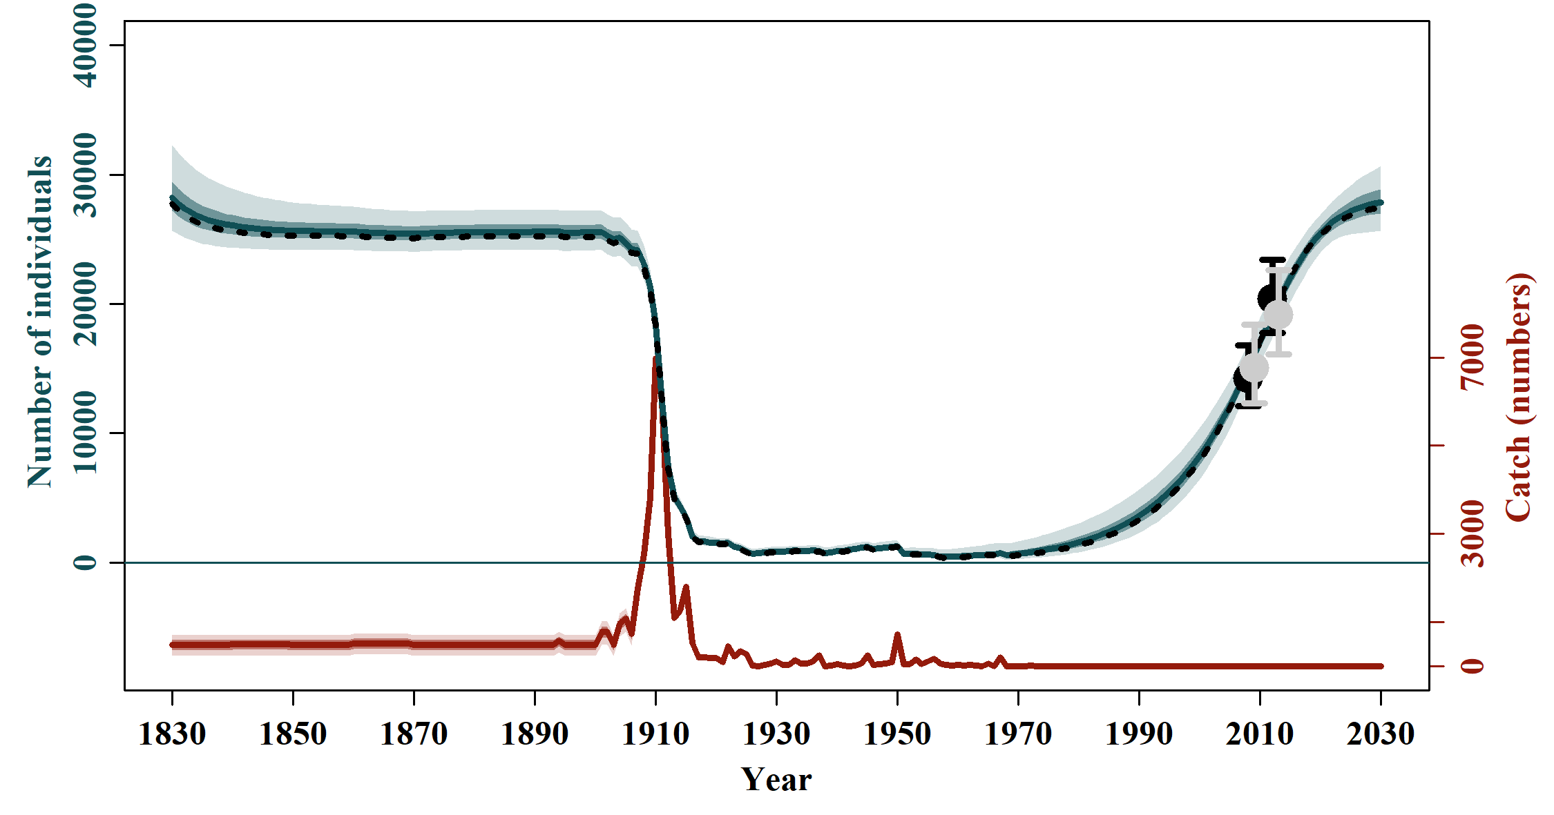
D-7

3.3) Sensitivities to Catch Allocation and Struck and Lost Rates (Scenarios C)

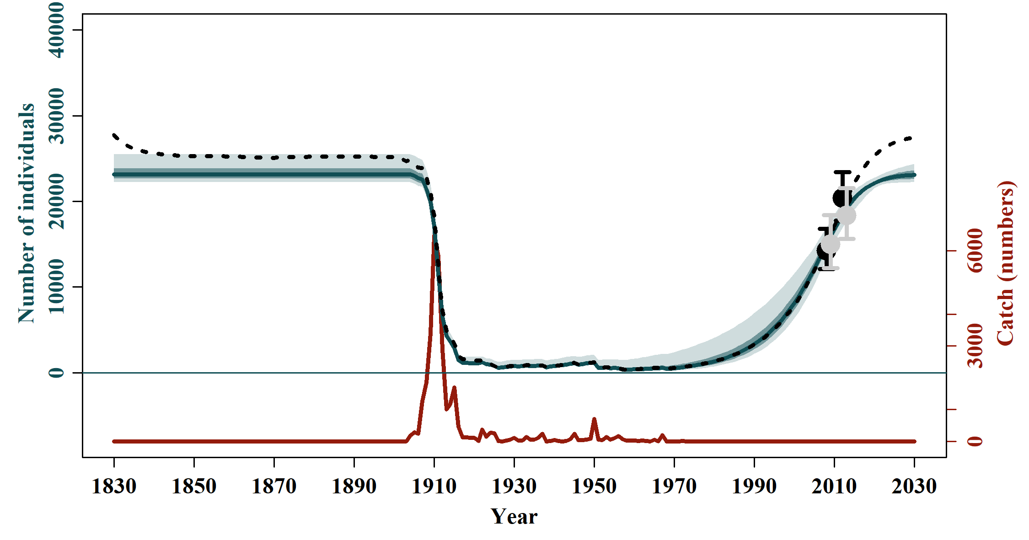 | 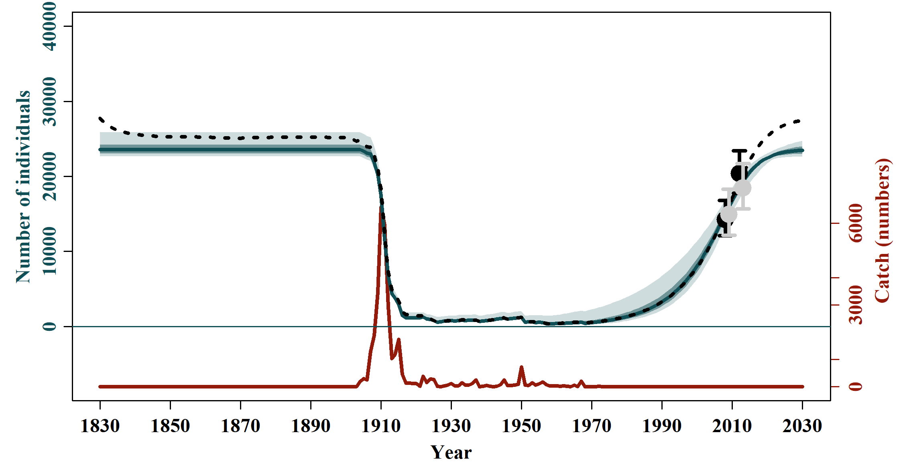
C-1 | C-2
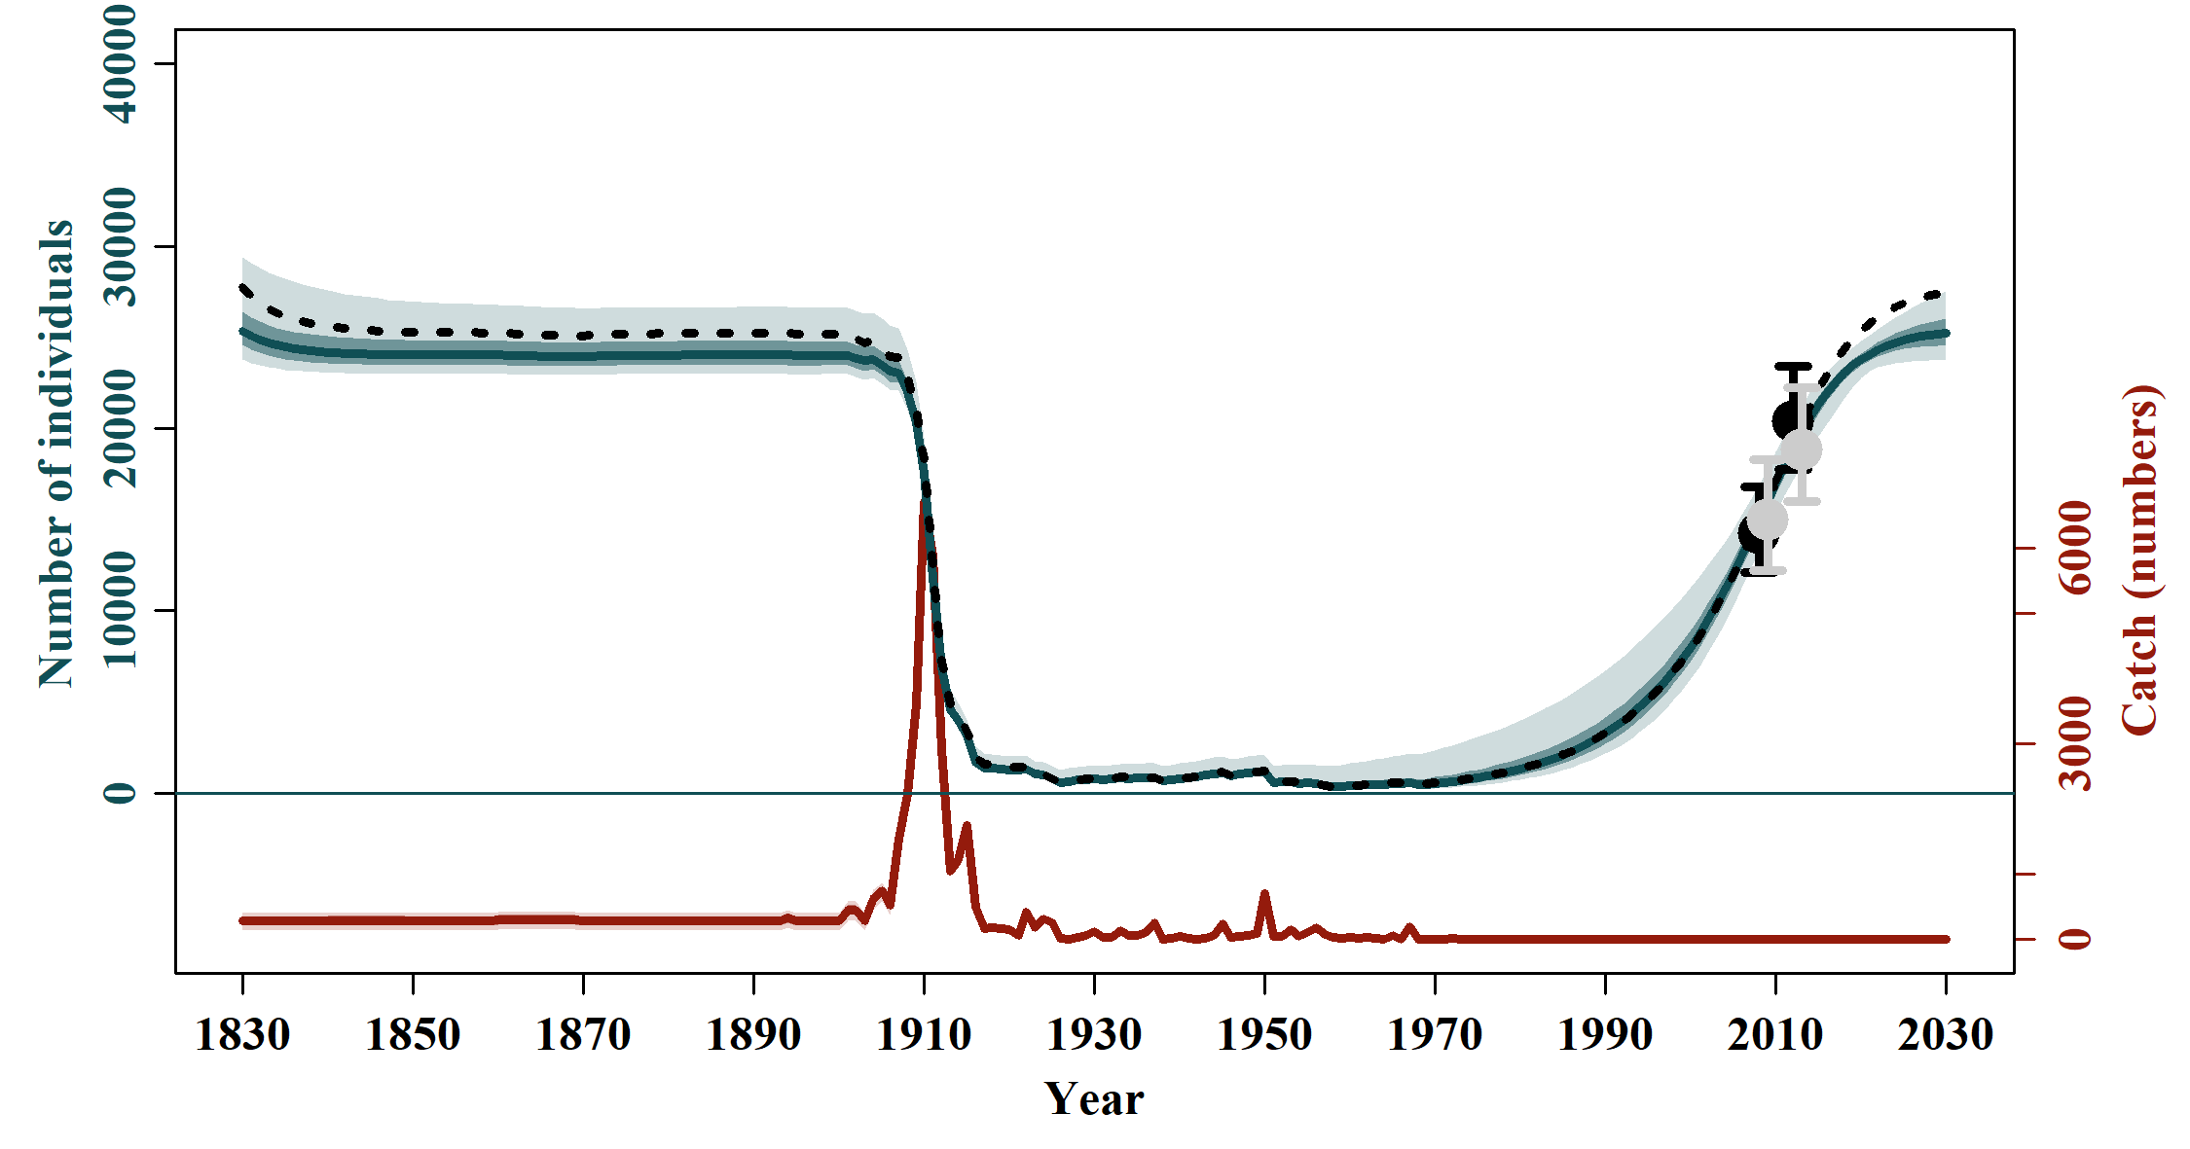 | 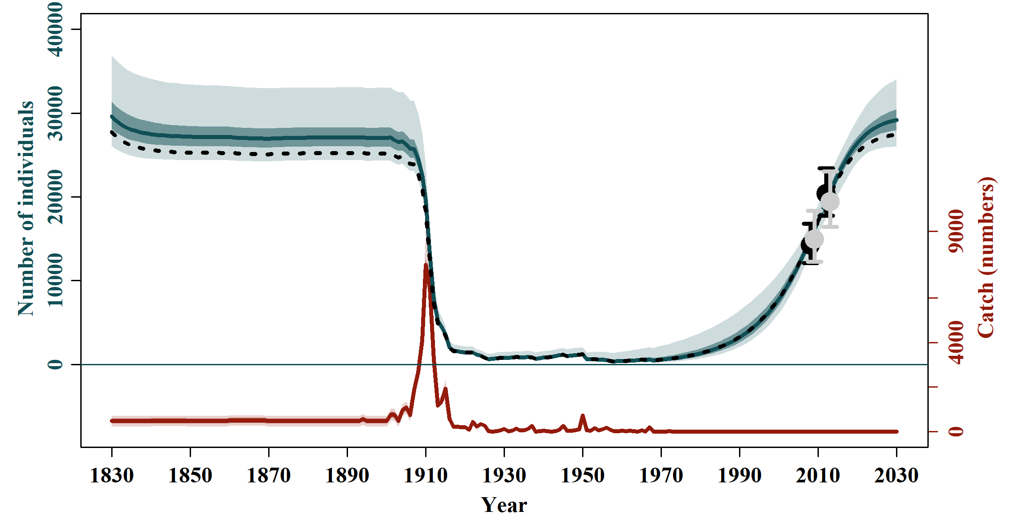
C-3 | C-4
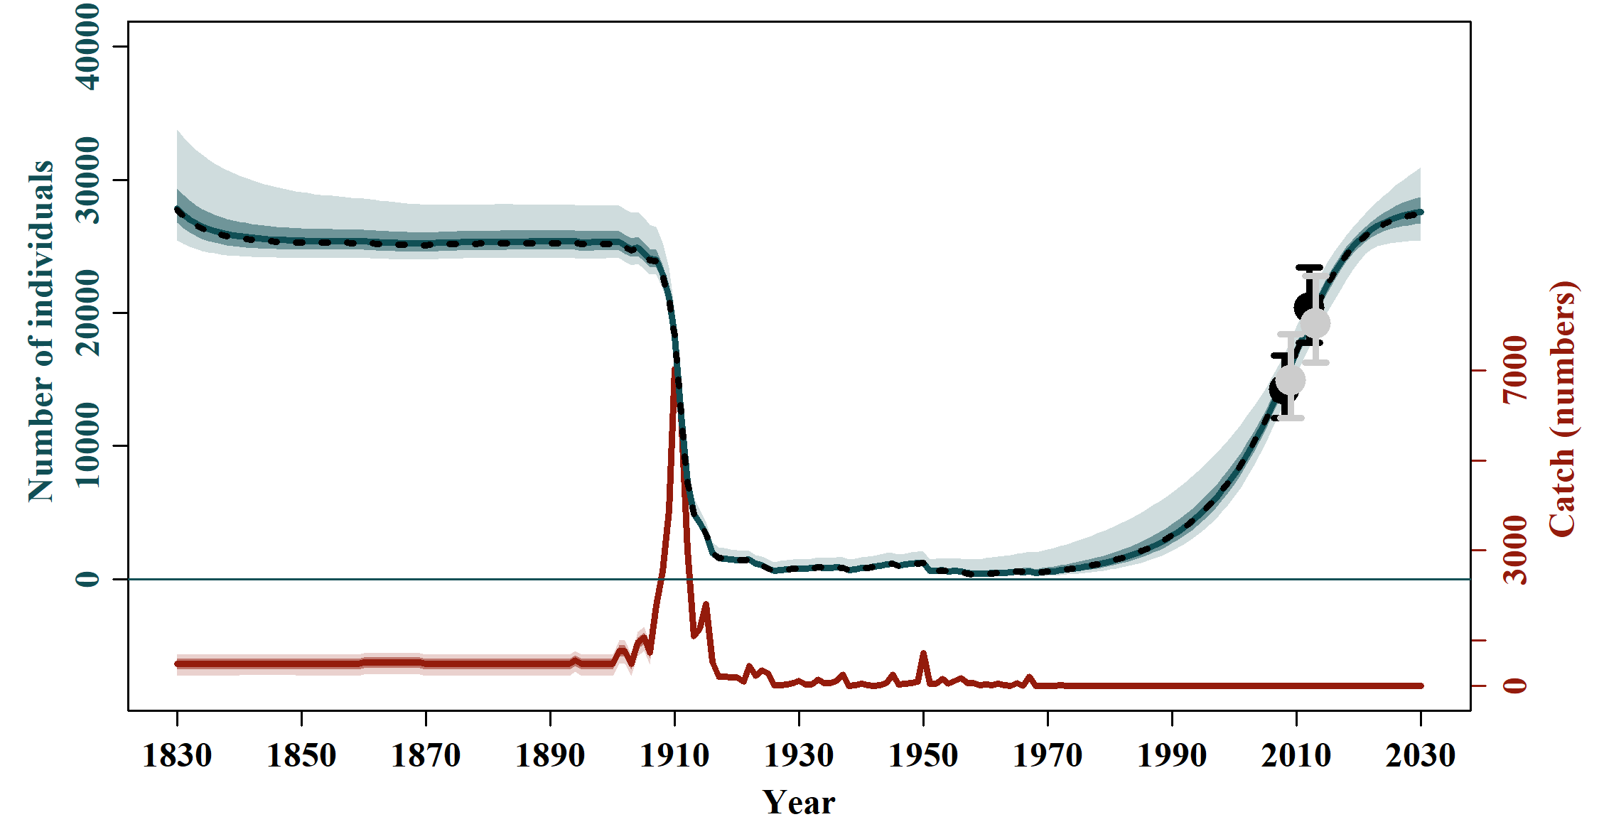 | 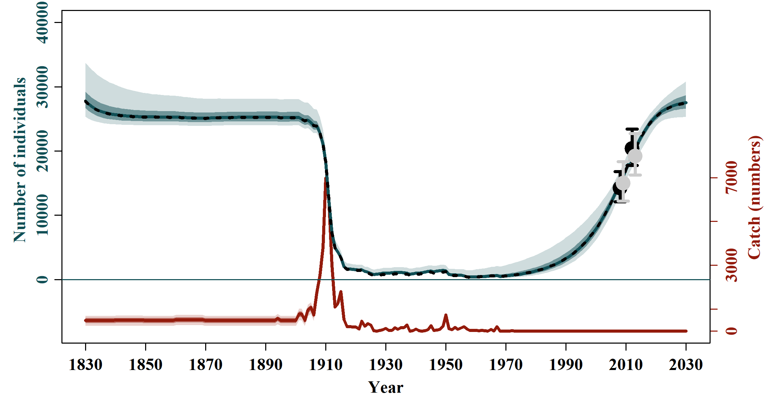
C-5 | C-6
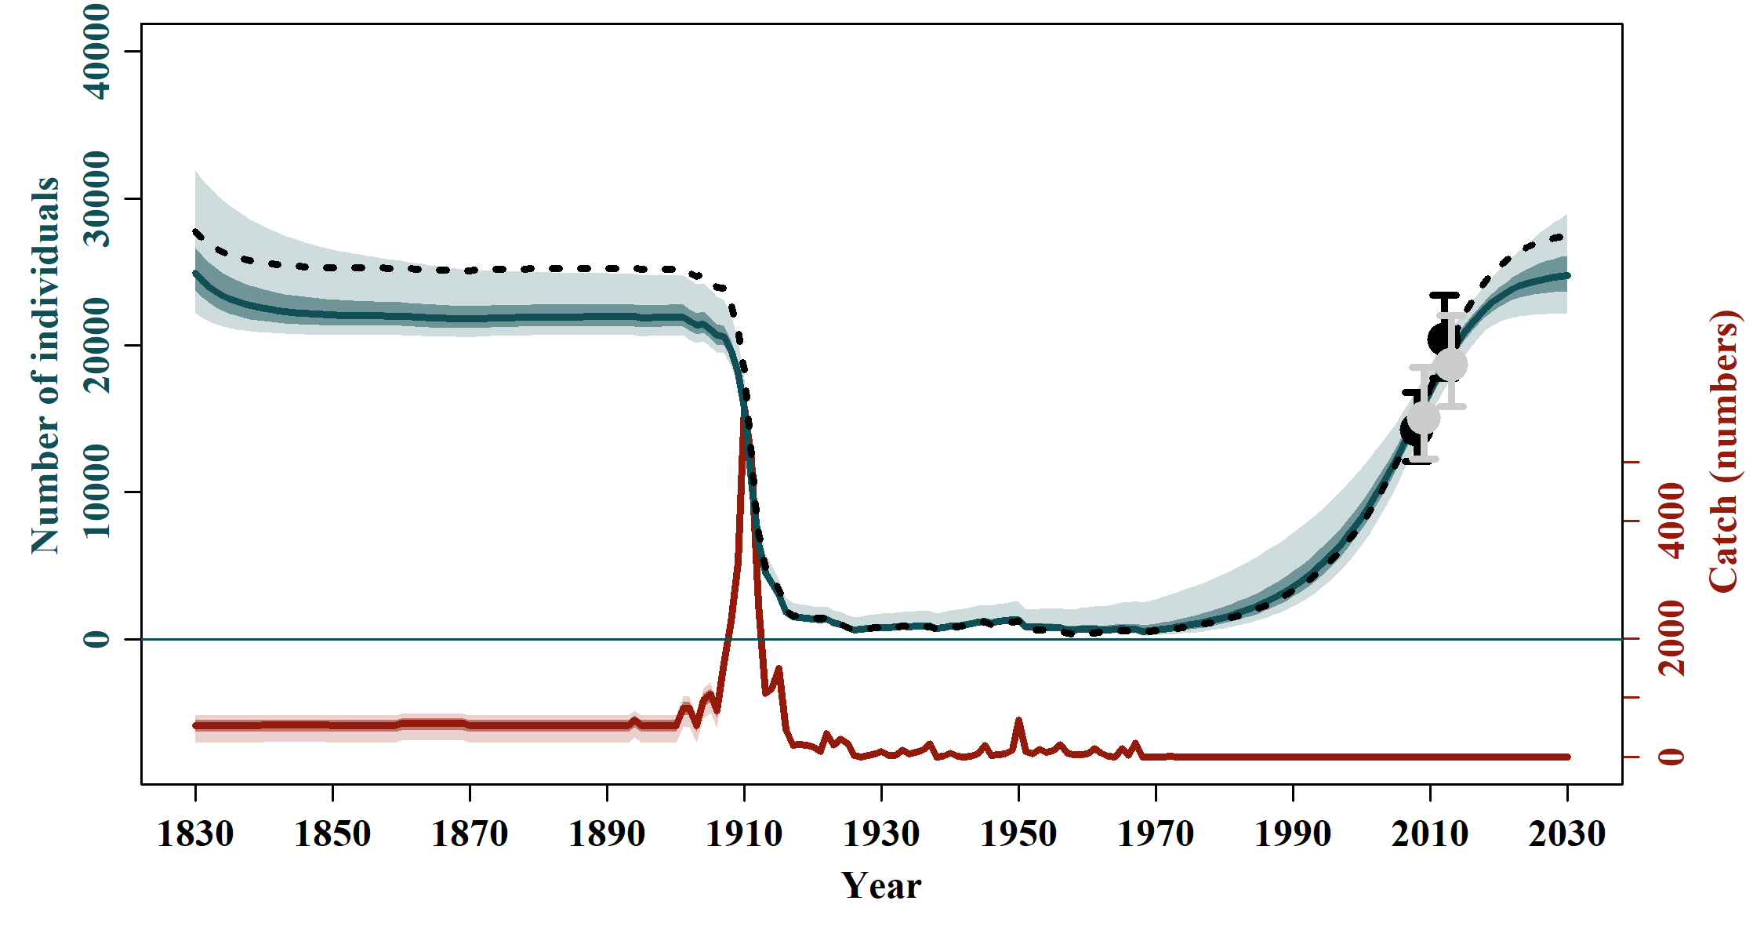
C-7

3.4) Sensitivities to Nmin constraints (Scenarios G) and to maximum productivity level (Scenarios M)

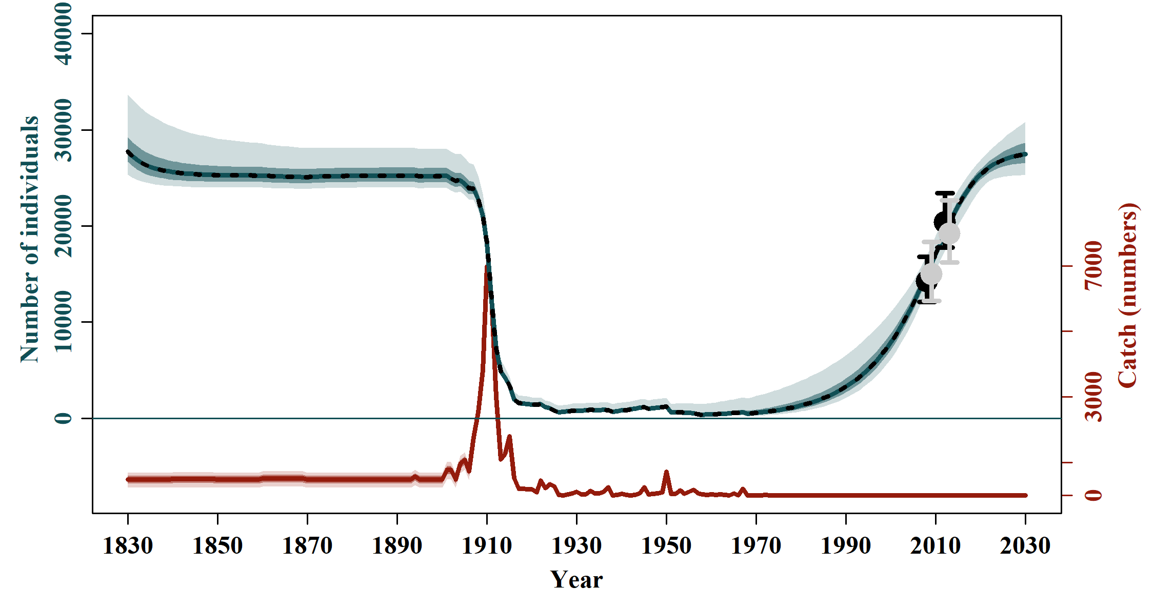 | 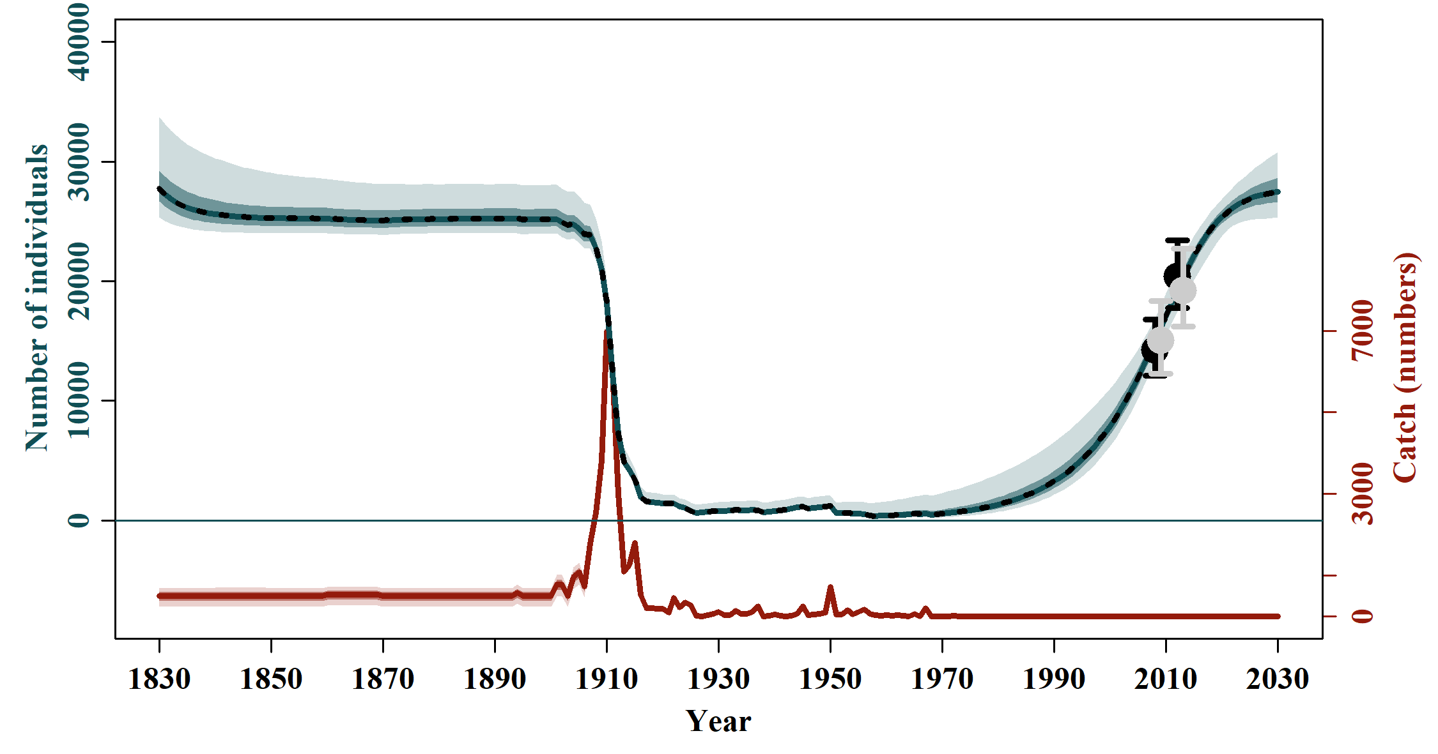
G-1 | G-2
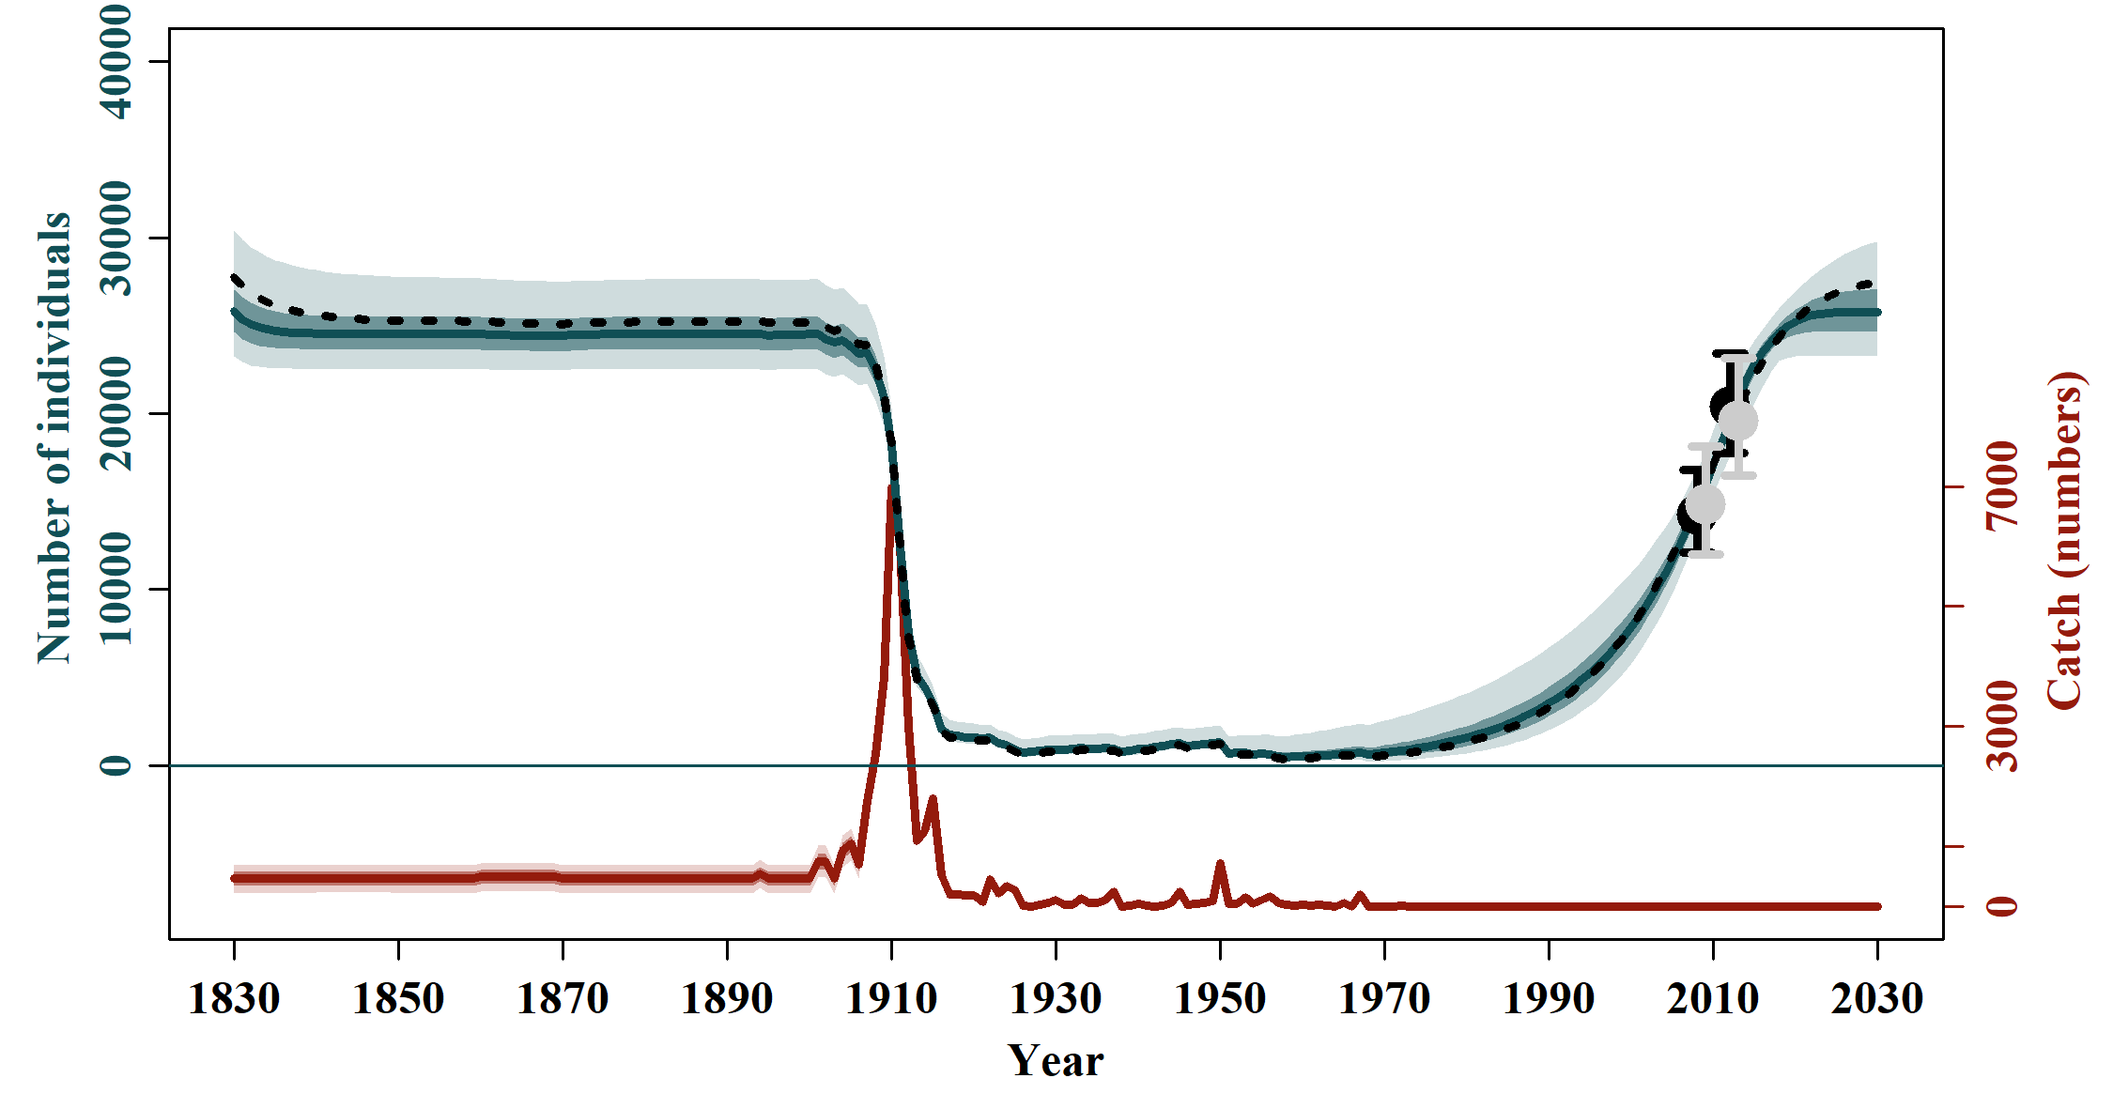 | 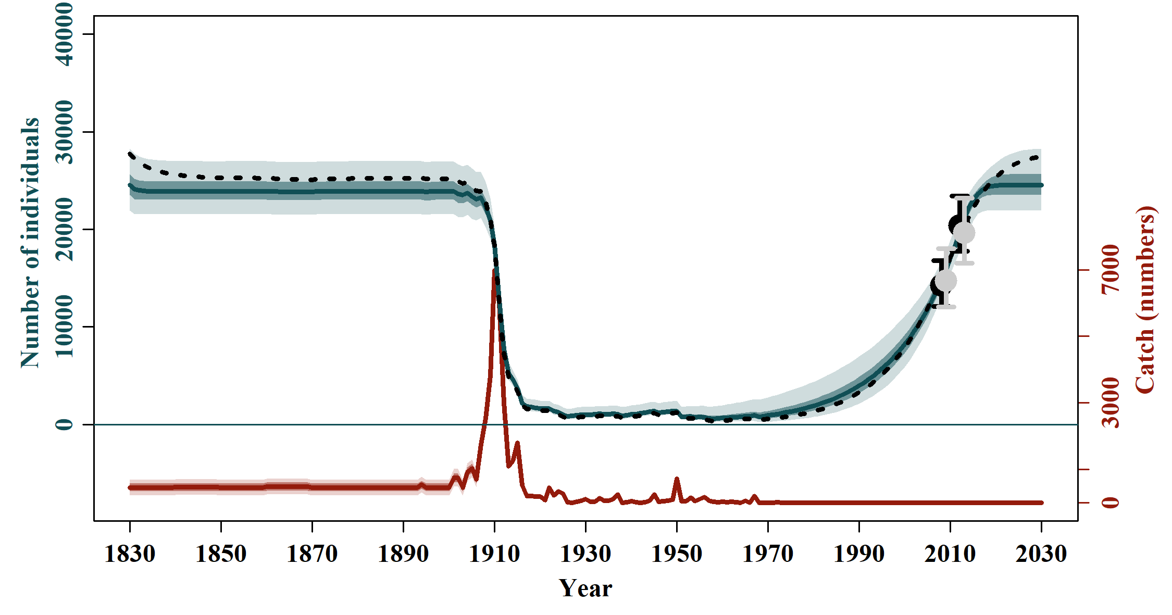
M-1 | M-2

4) Model fit to the Indices of Abundance (FG = feeding grounds, BG = breeding grounds)

4.1) Model Average
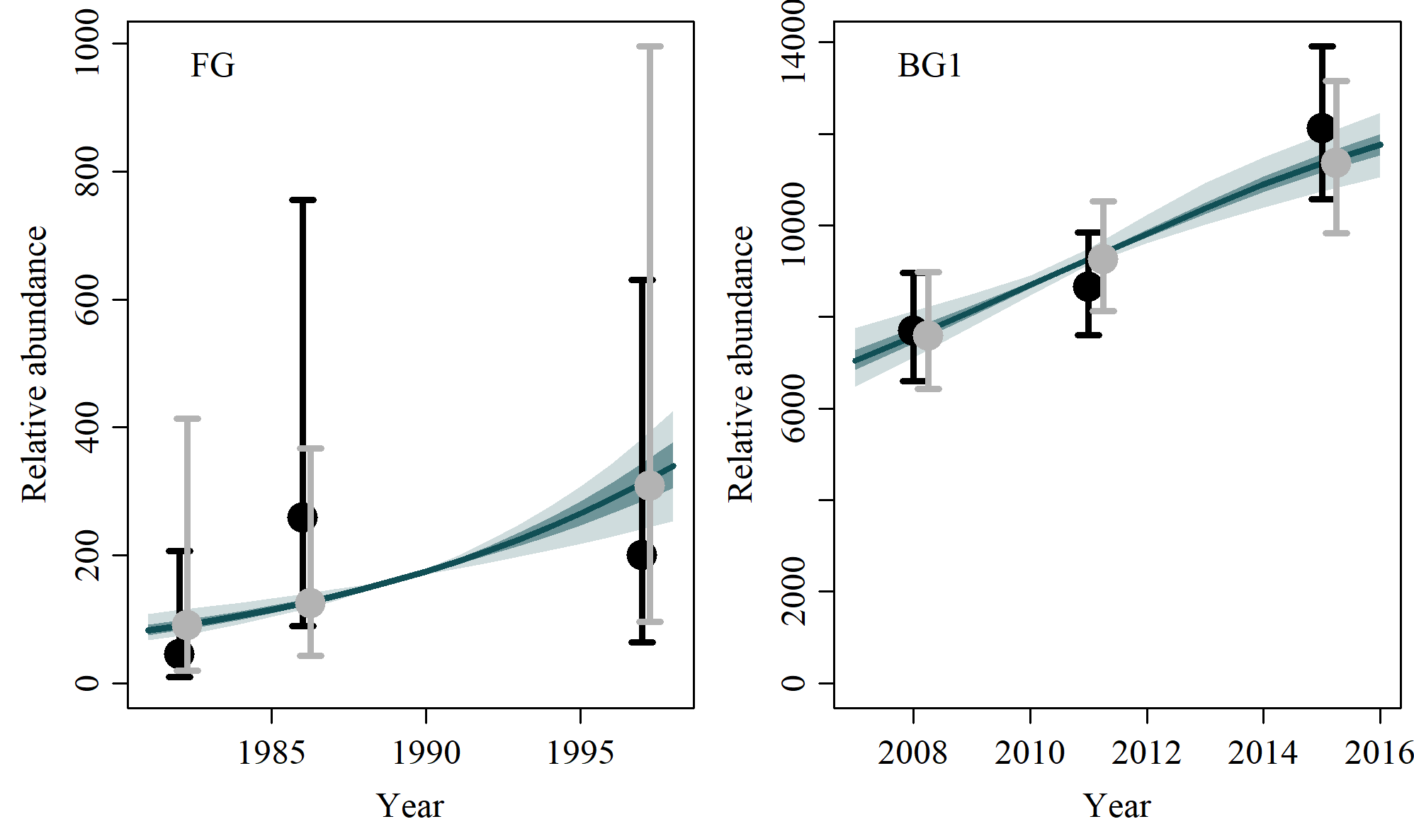

4.2) Reference Case
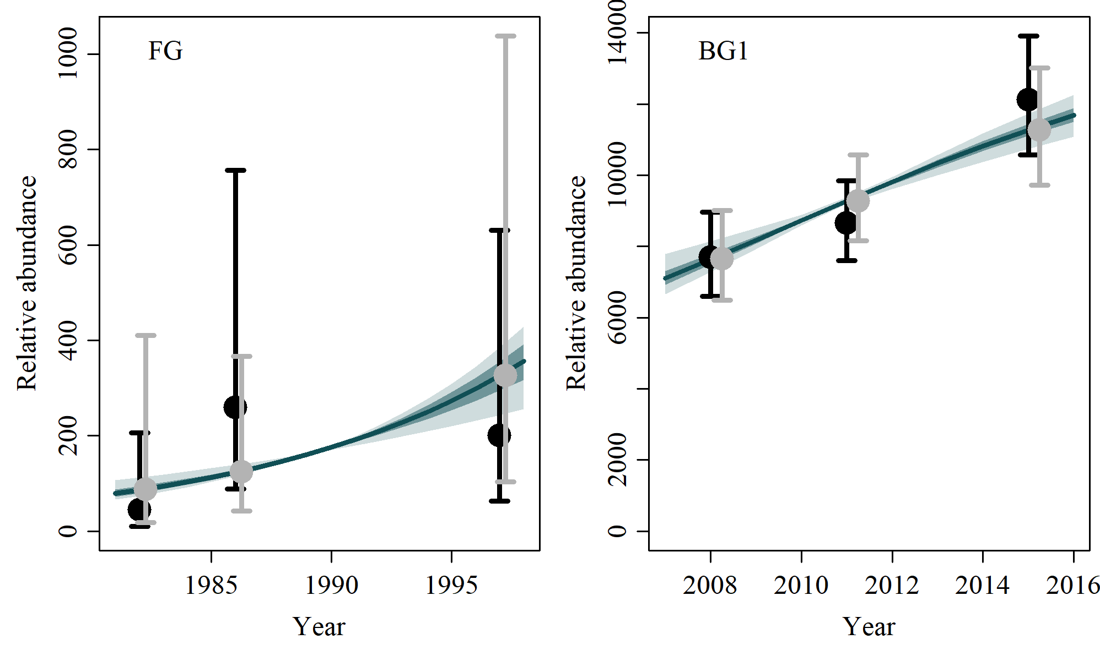

4.3) Scenario D-1
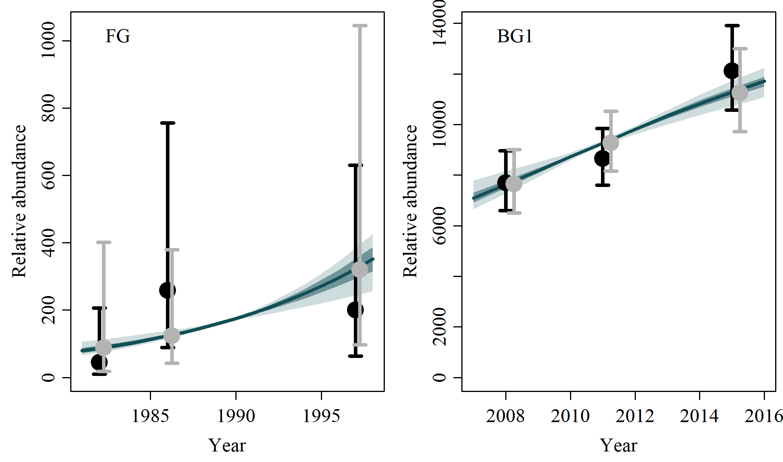

4.4) Scenario D-2
No output because no index of abundance was used.

4.5) Scenario D-3
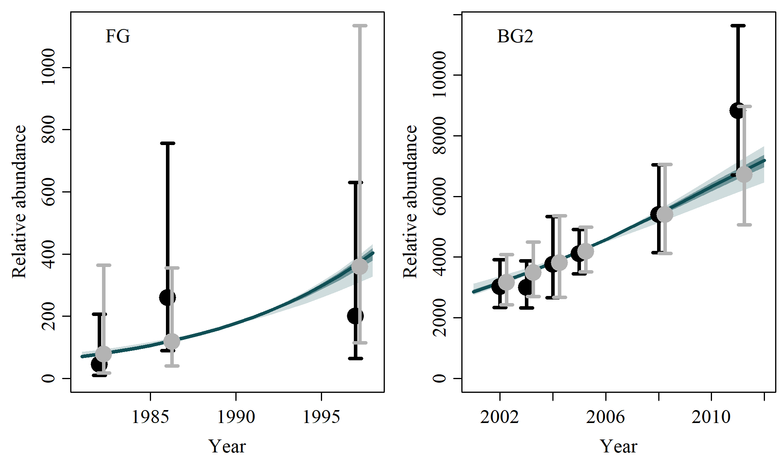

4.6) Scenario D-4

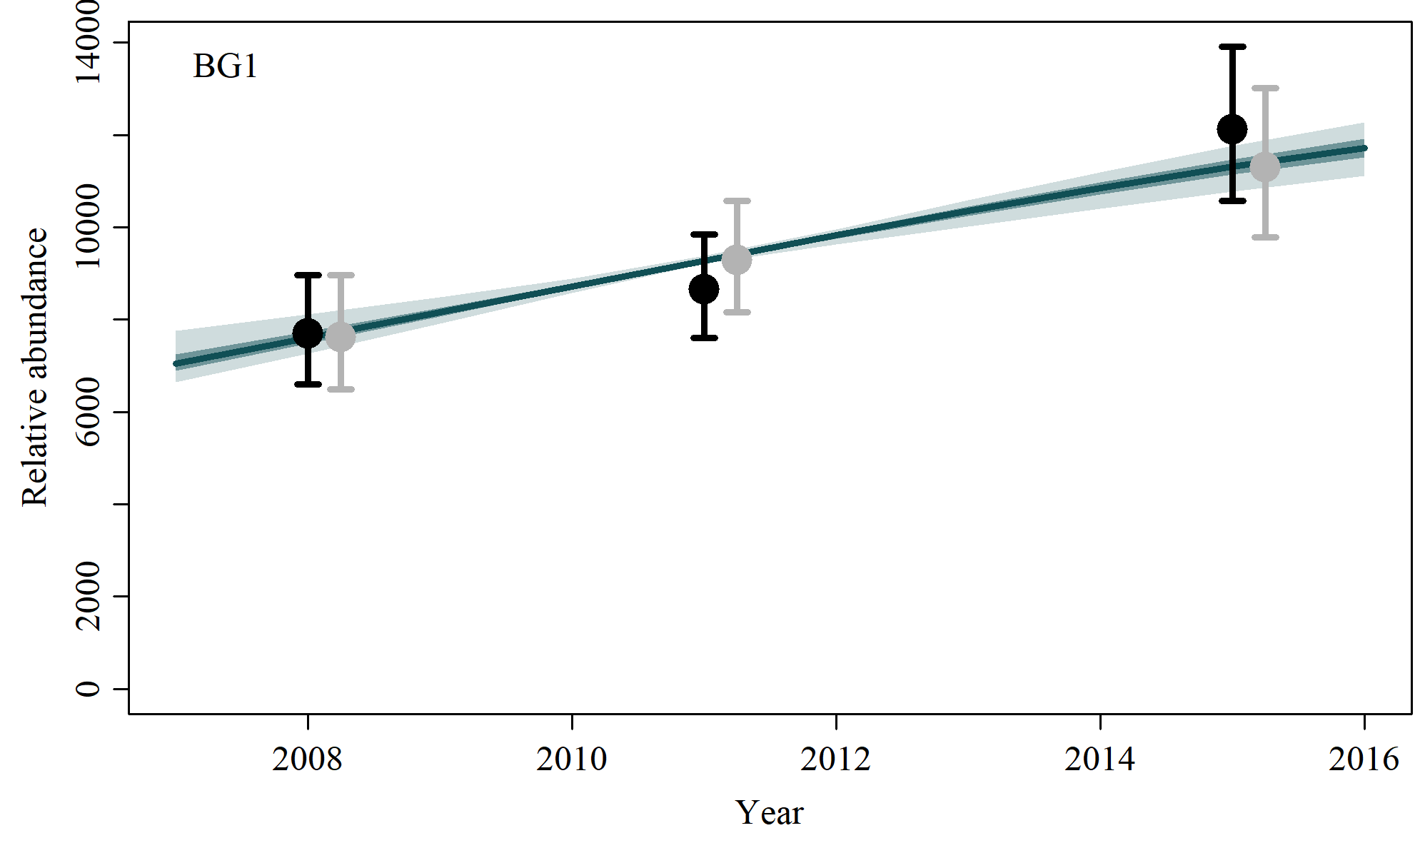

4.7) Scenario D-5
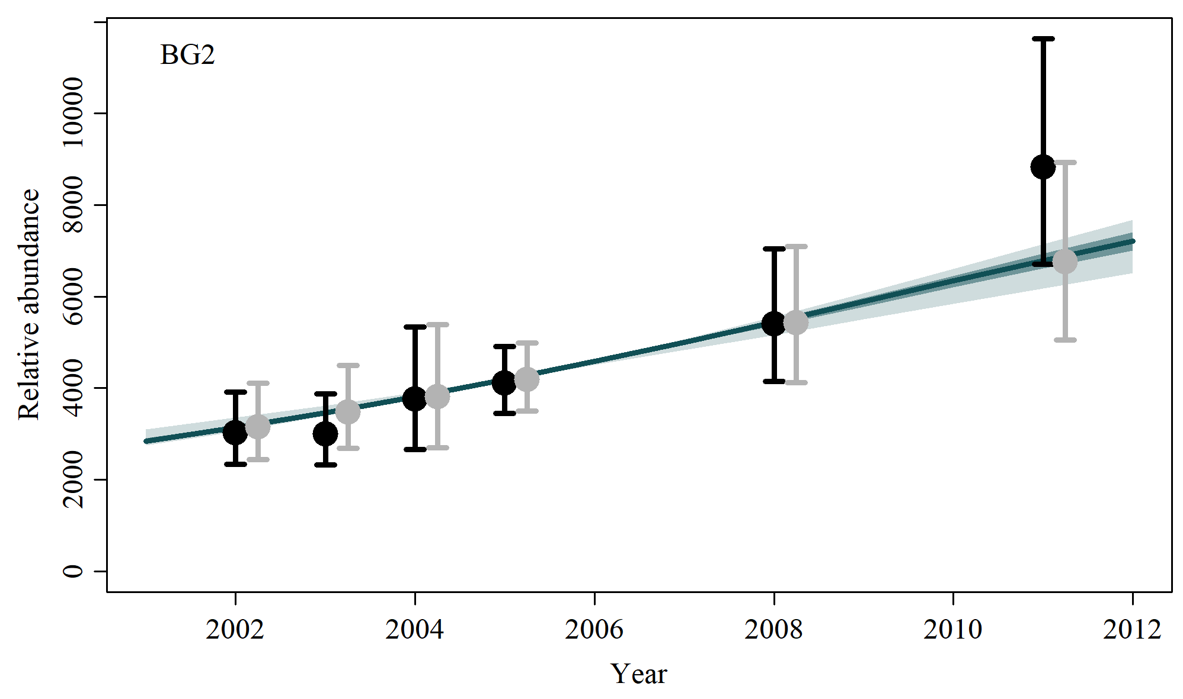
4.8) Scenario D-6

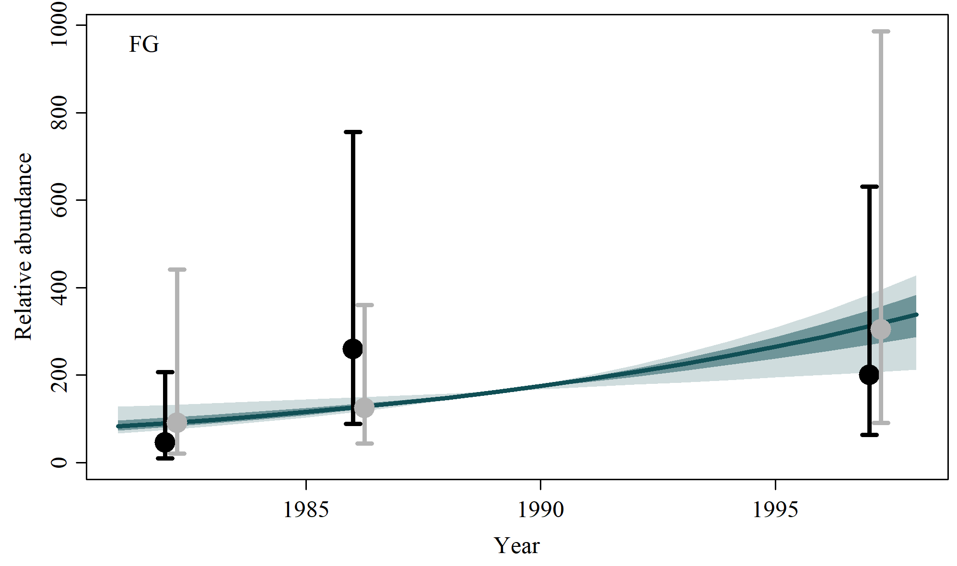

4.9) Scenario D-7
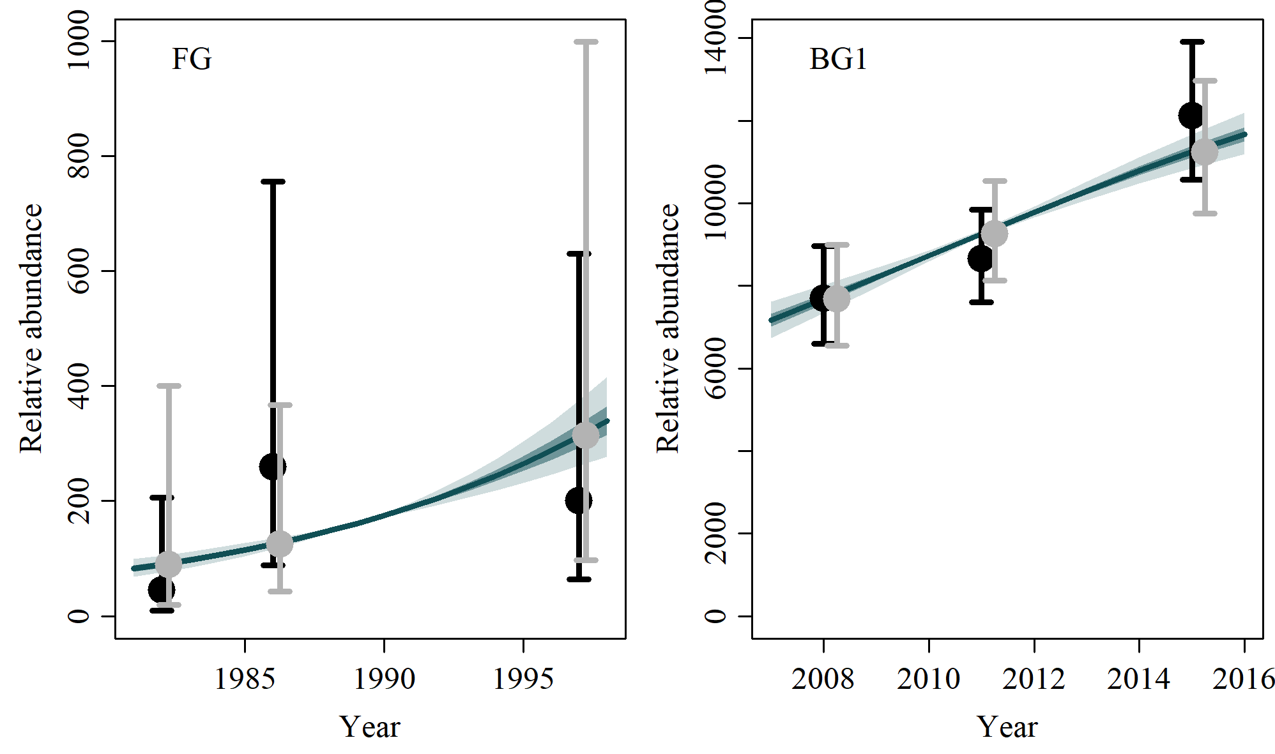

4.10) Scenario C-1 to C-7

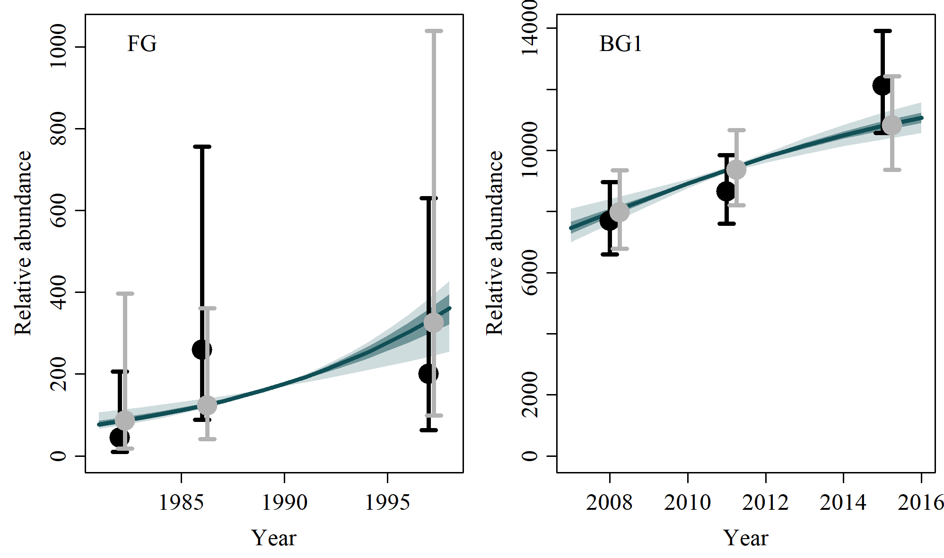 | 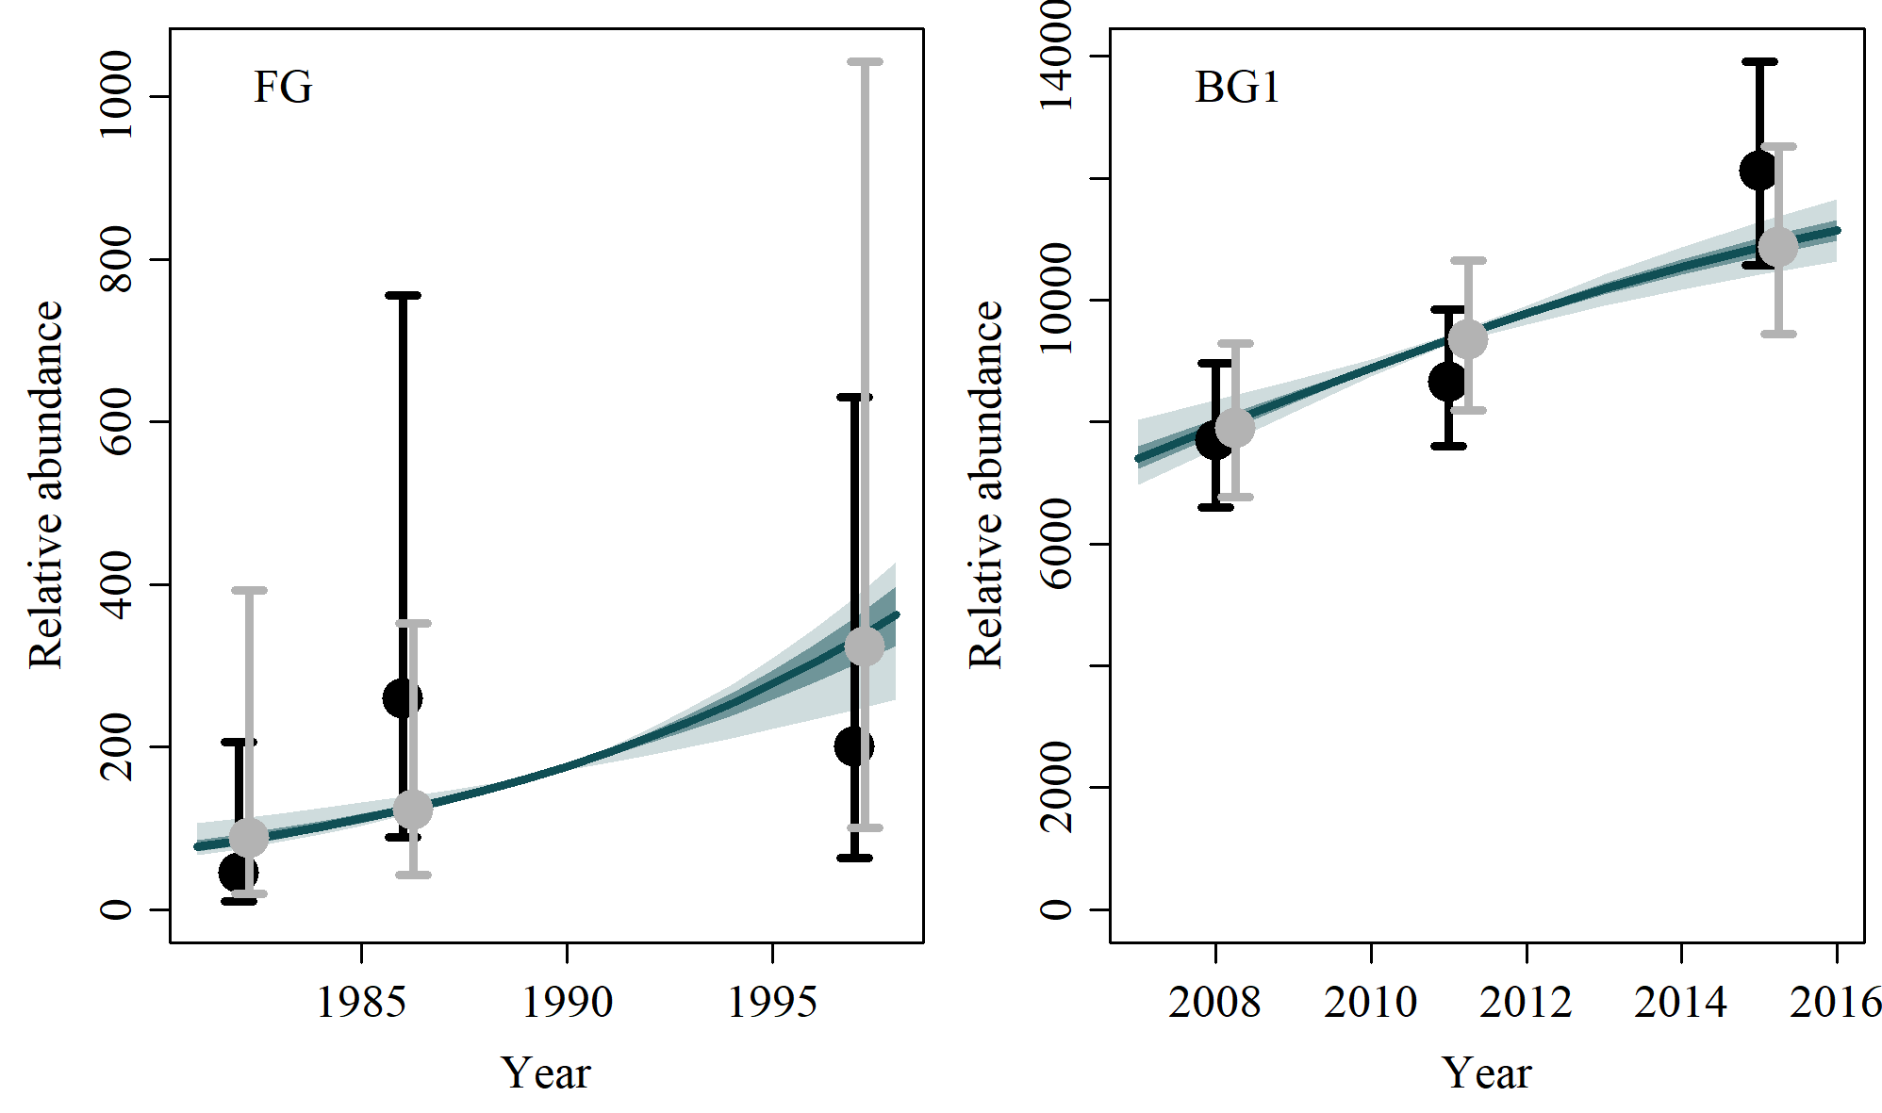
C-1 | C-2
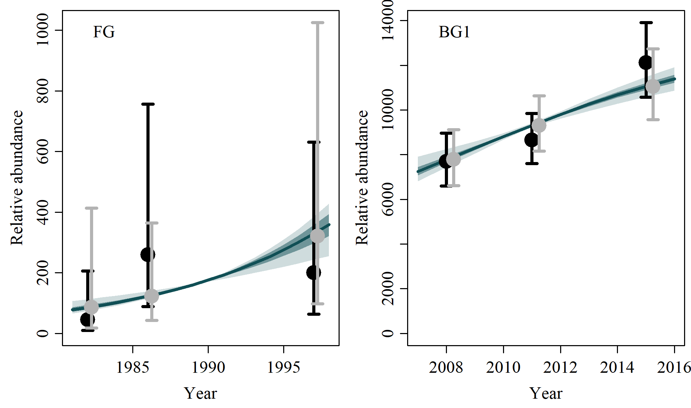 | 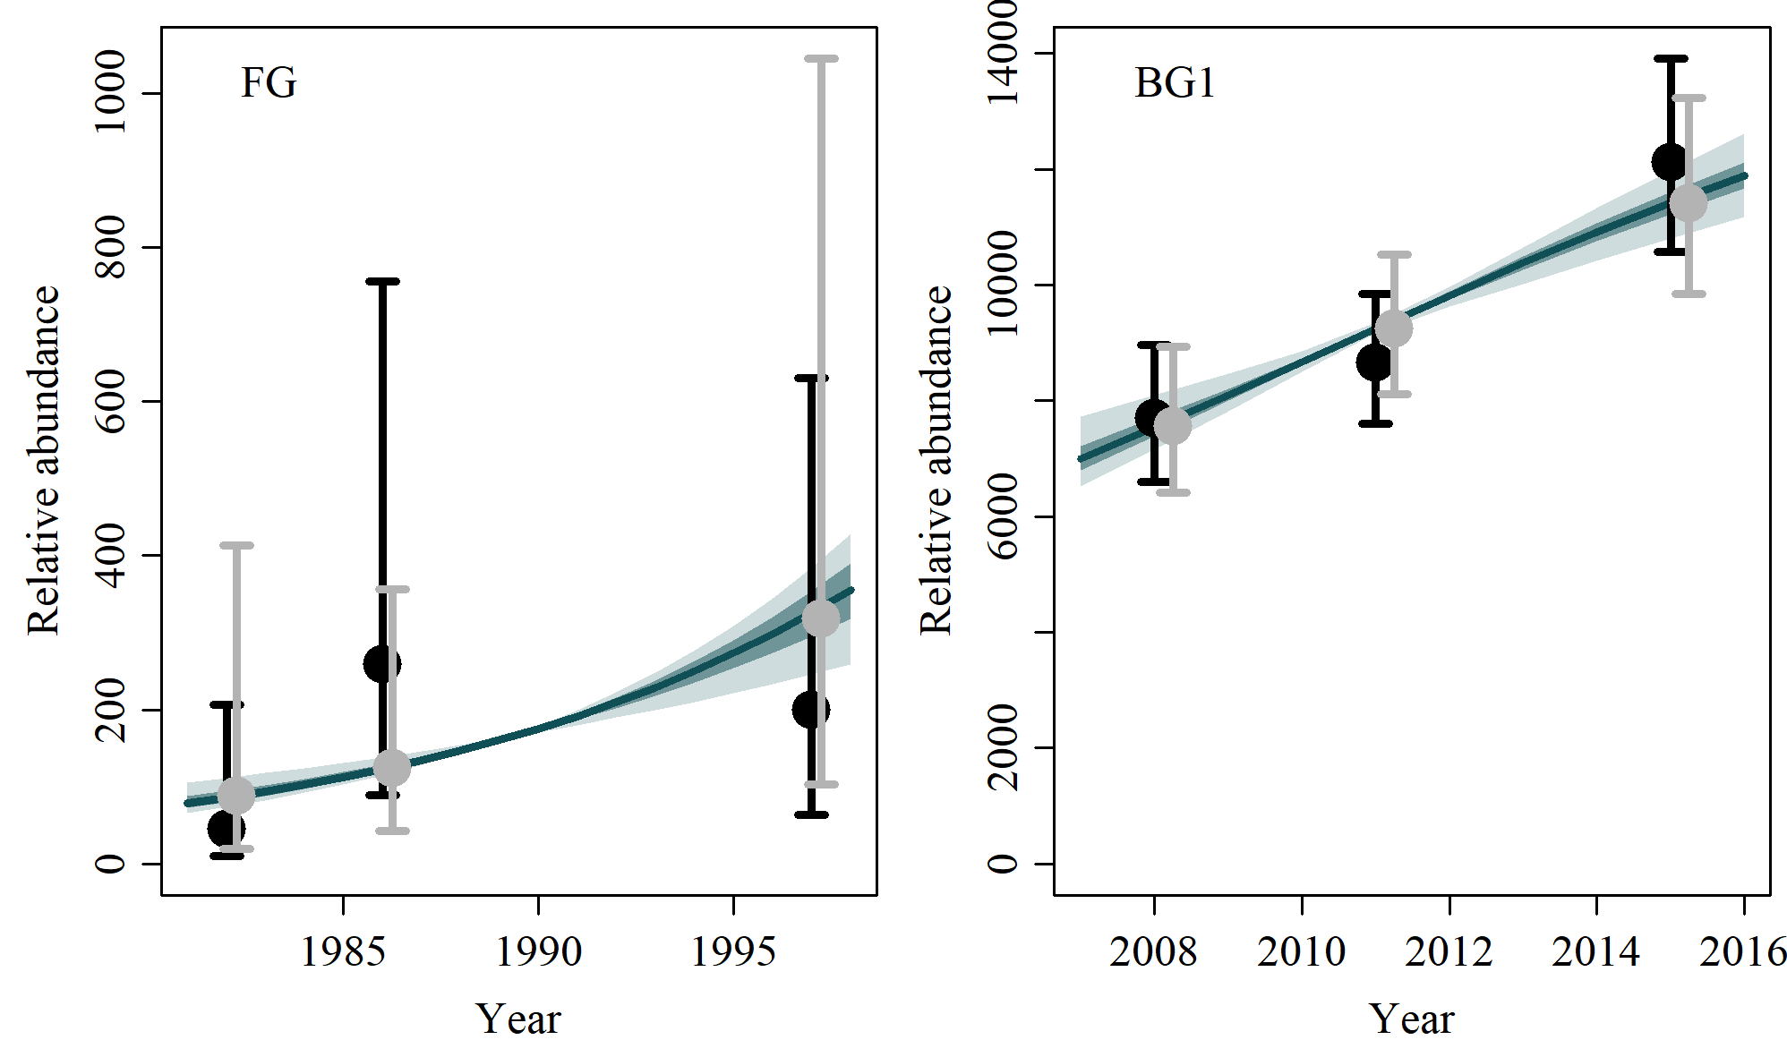
C-3 | C-4
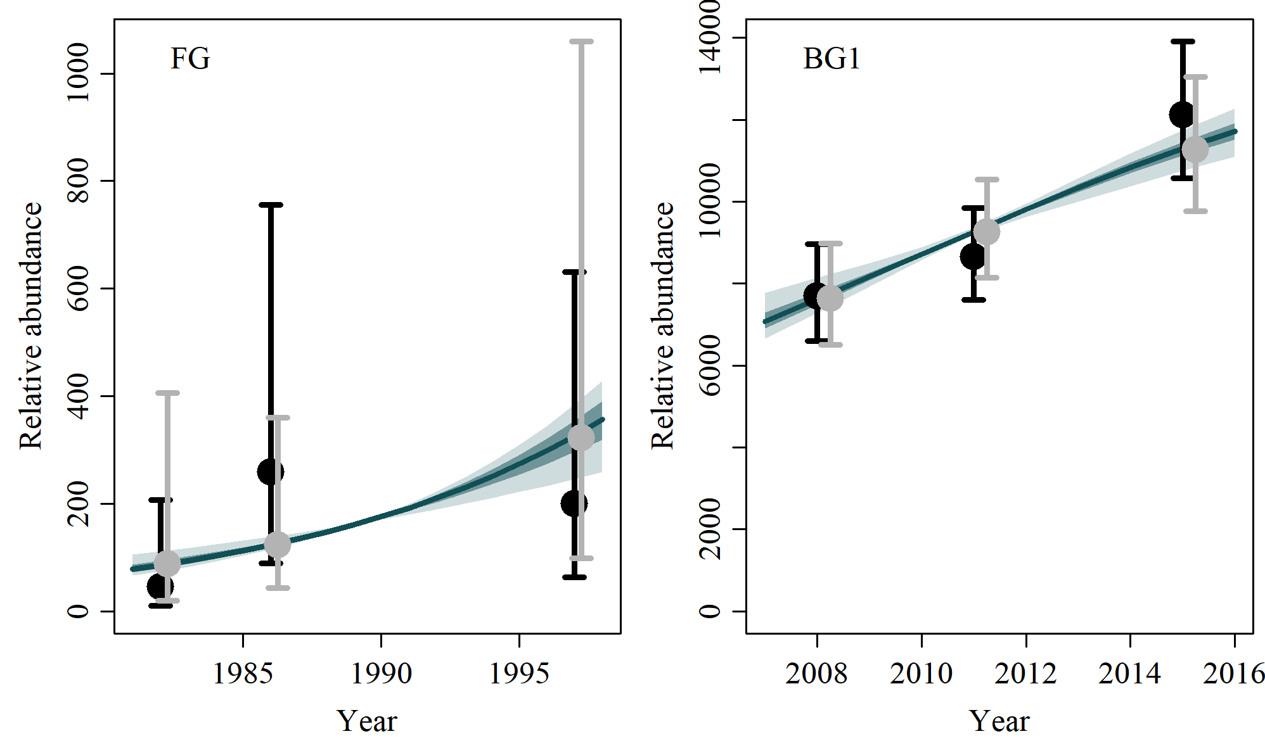 | 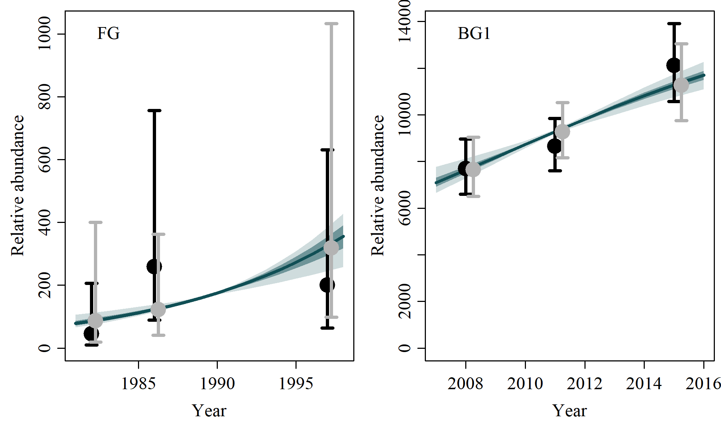
C-5 | C-6
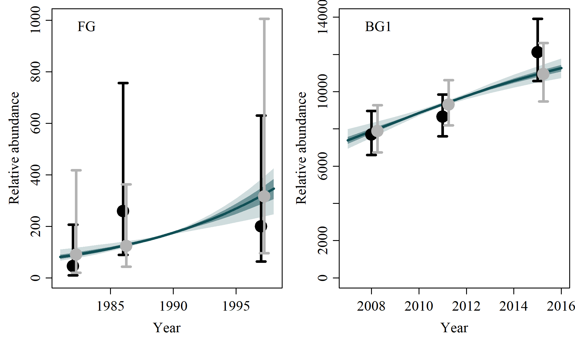
C-7

4.11) Scenario G-1, G2, M-1 and M-2

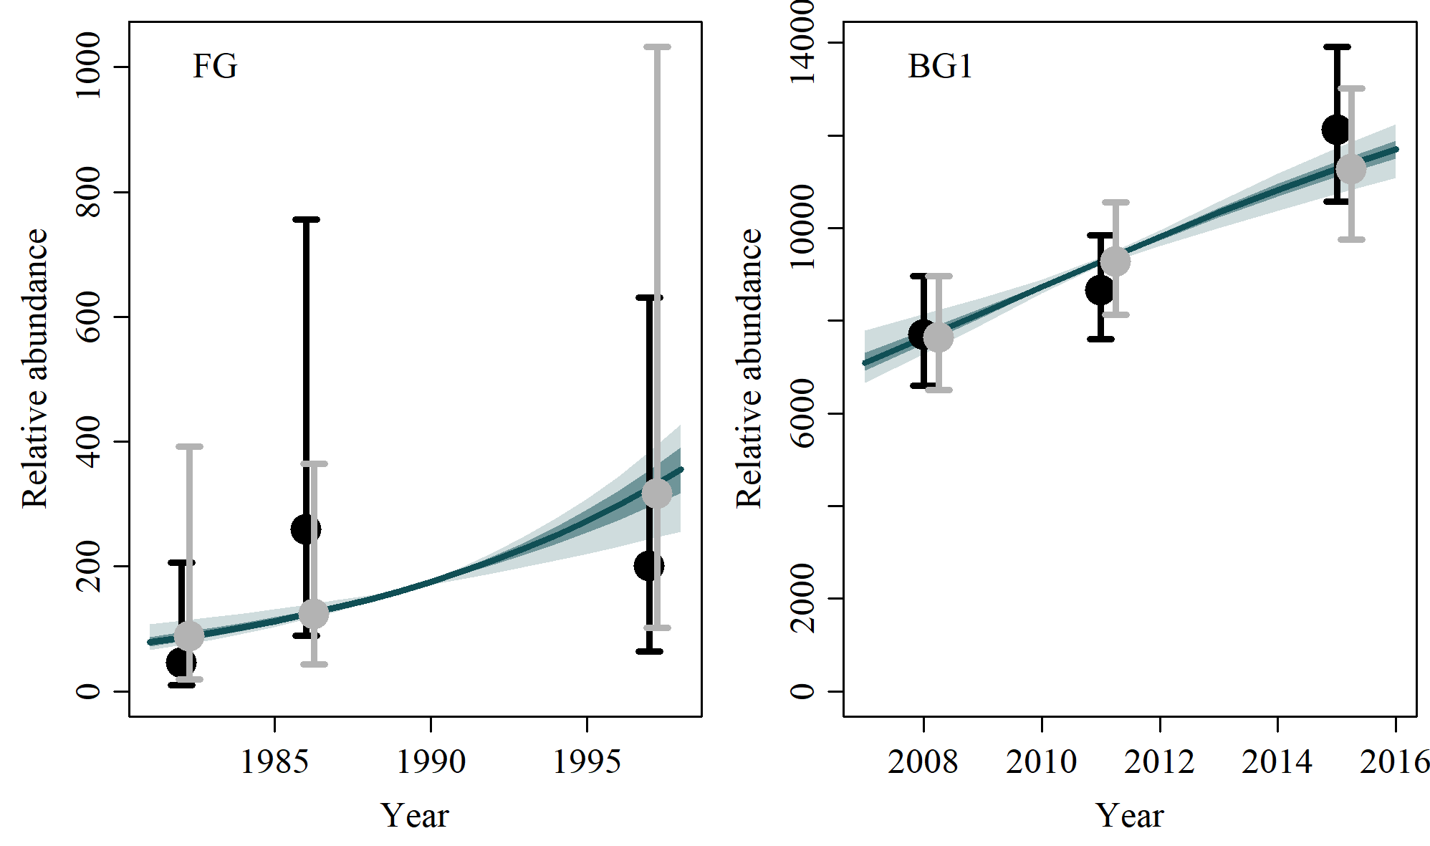 | 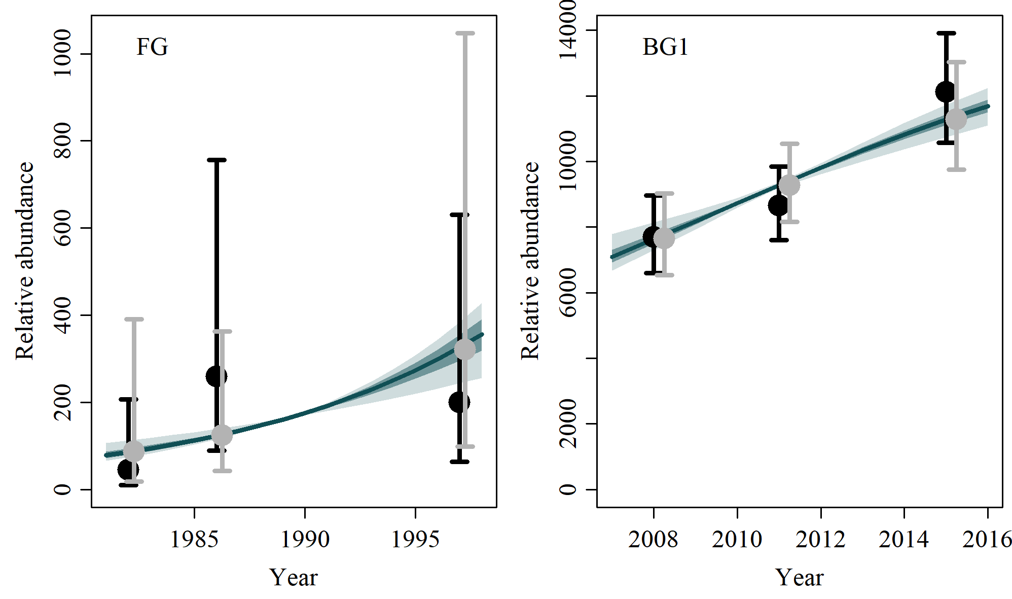
G-1 | G-2
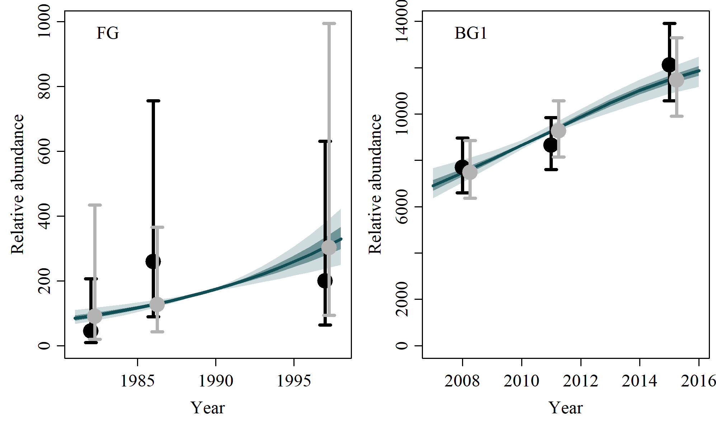 | 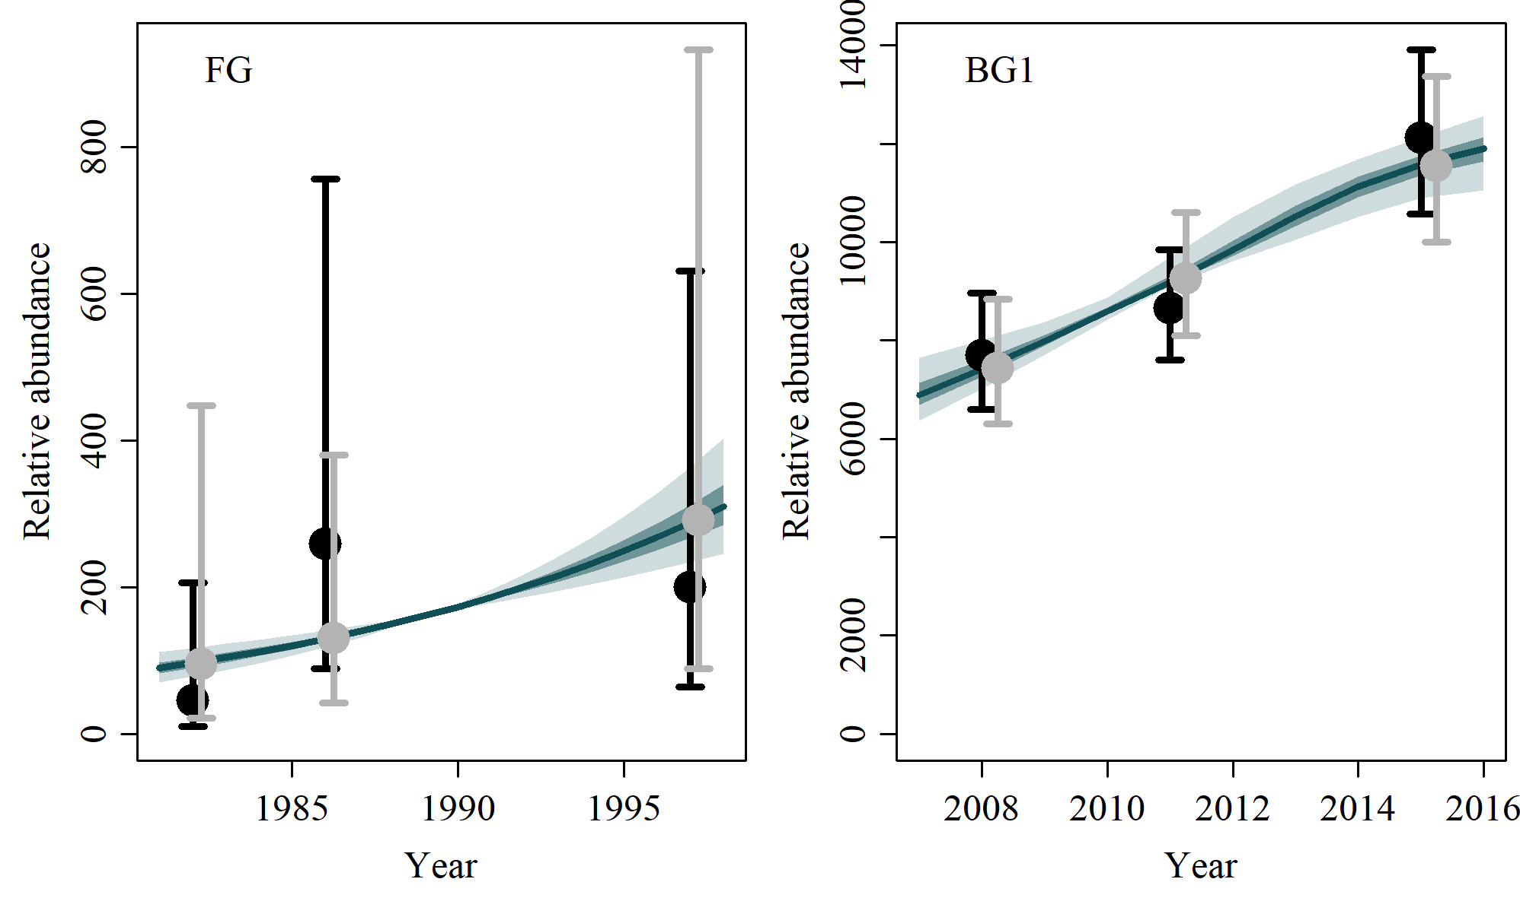
M-1 | M-2

5) Posterior Density Plots

5.1) Model average

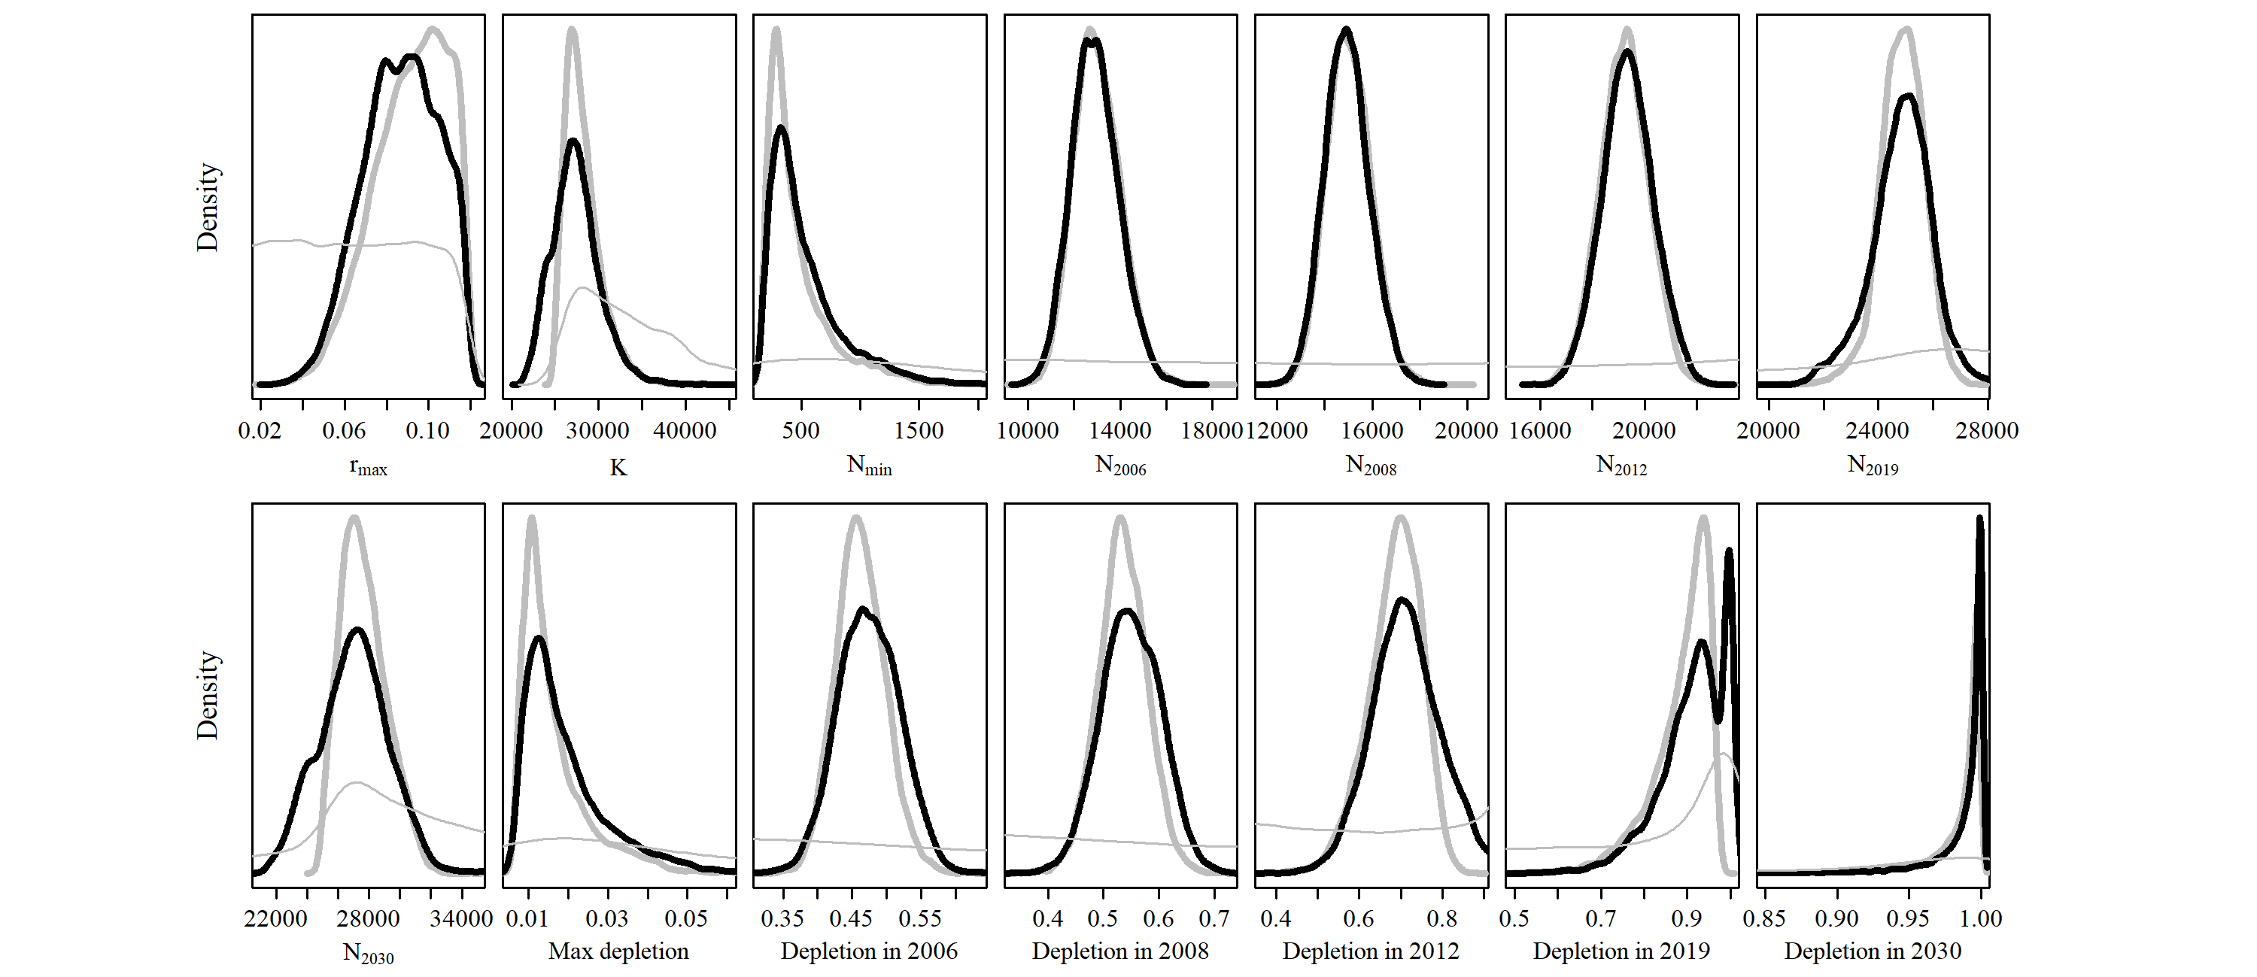

5.2) Reference Case

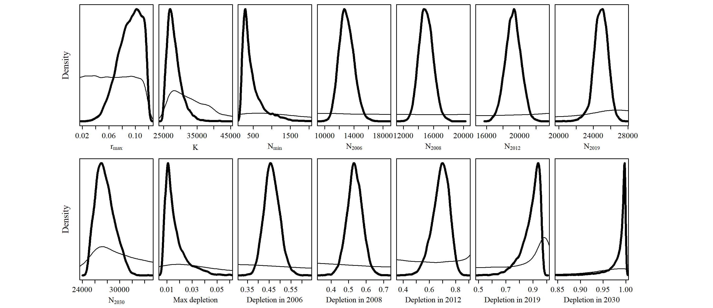

5.3) Scenario D-1

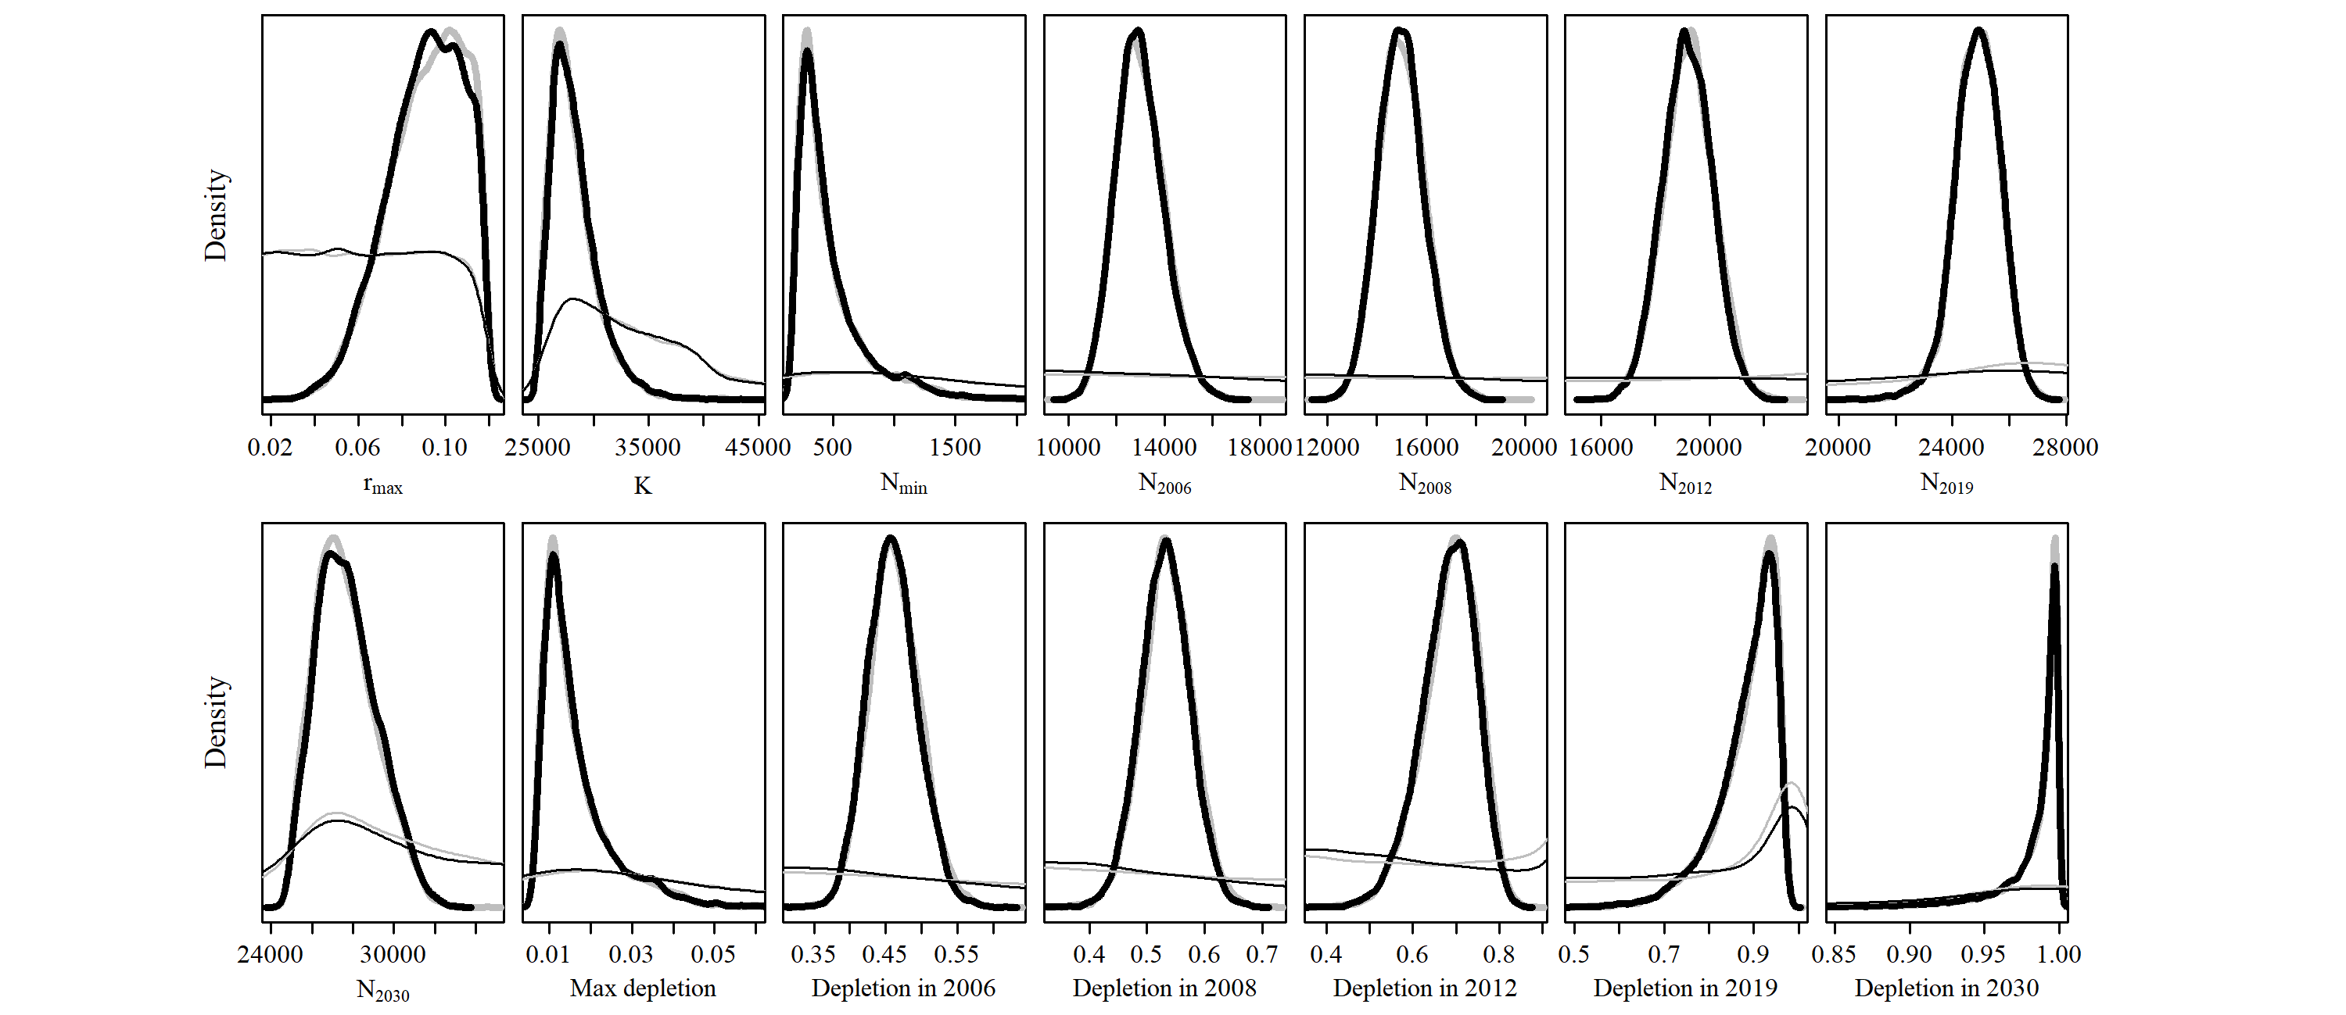

5.4) Scenario D-2

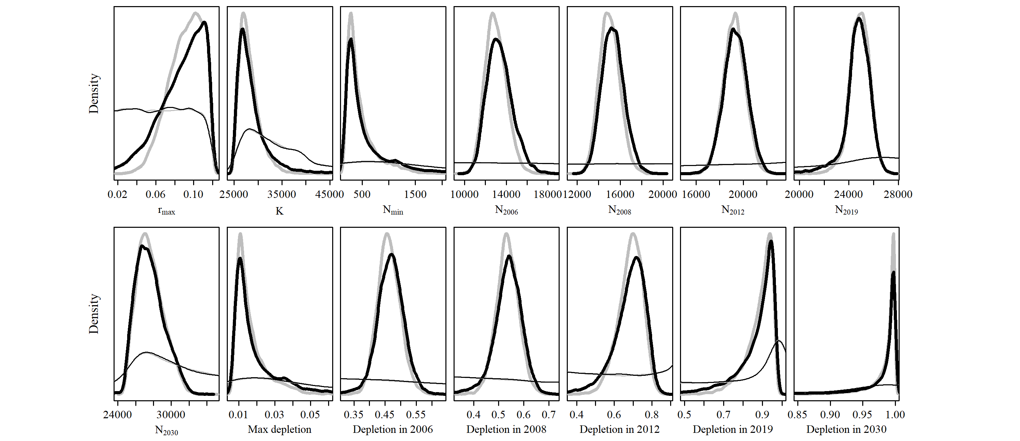

5.5) Scenario D-3

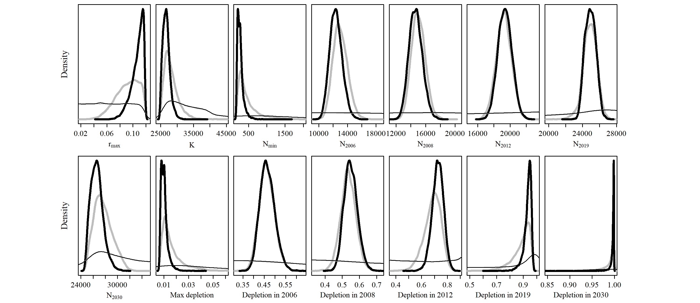

5.6) Scenario D-4

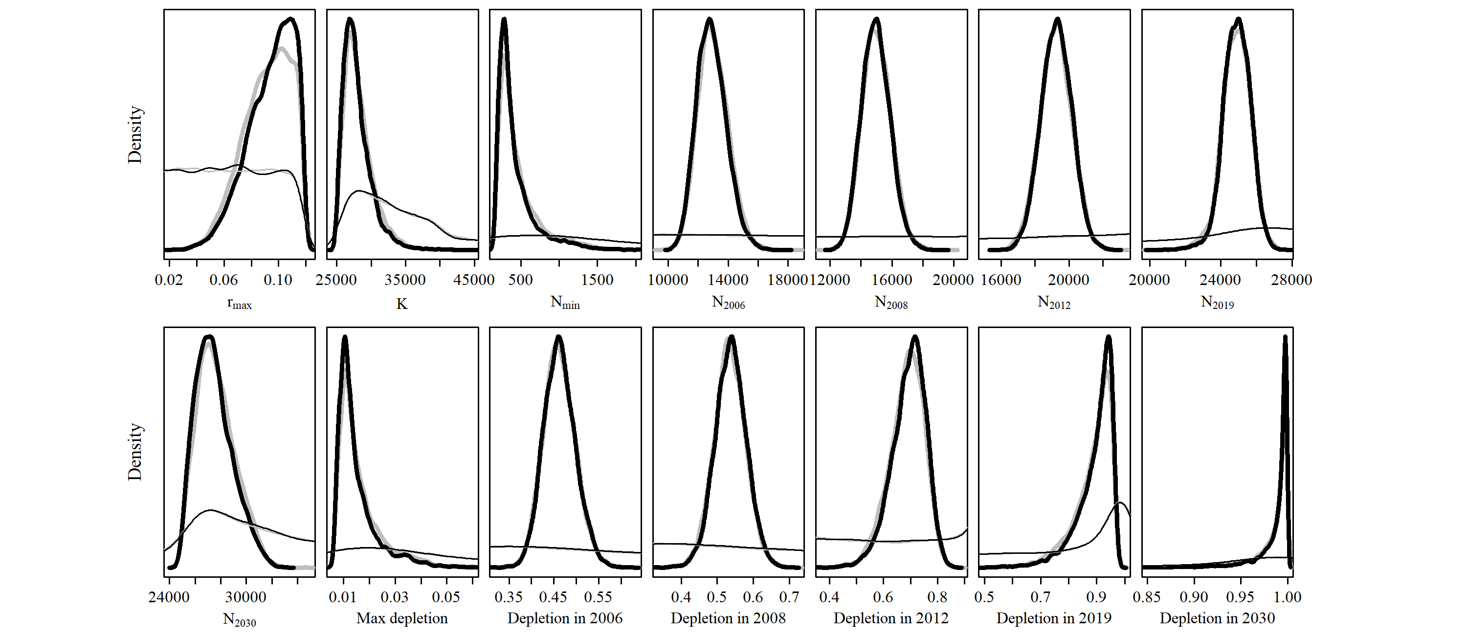

5.7) Scenario D-5

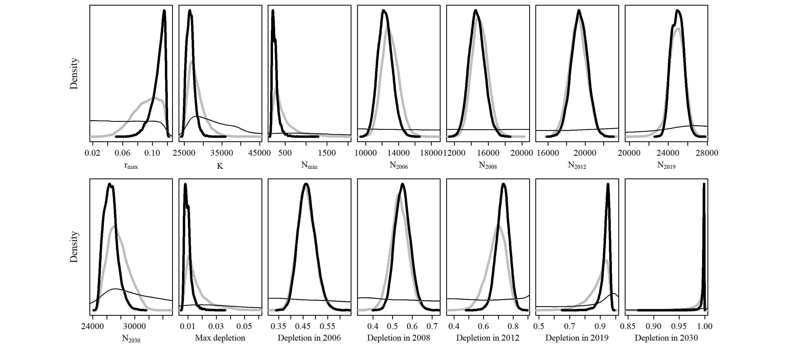

5.8) Scenario D-6

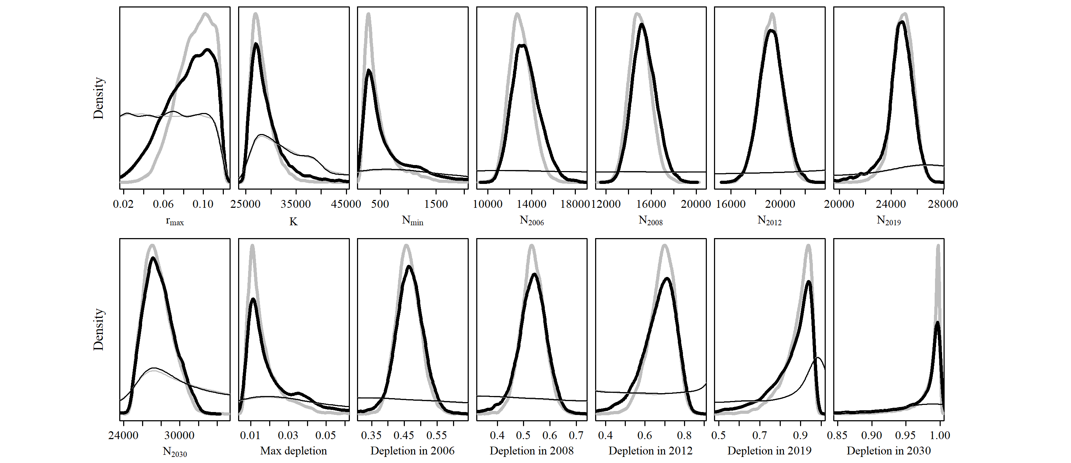

5.9) Scenario D-7

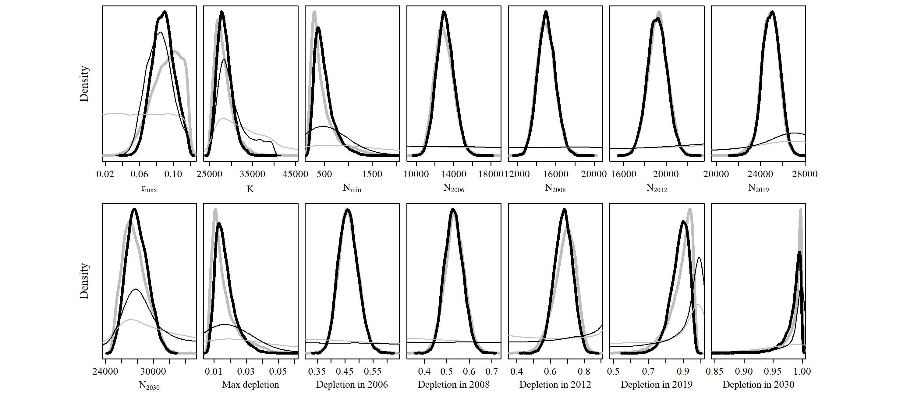

5.10) Scenario C-1

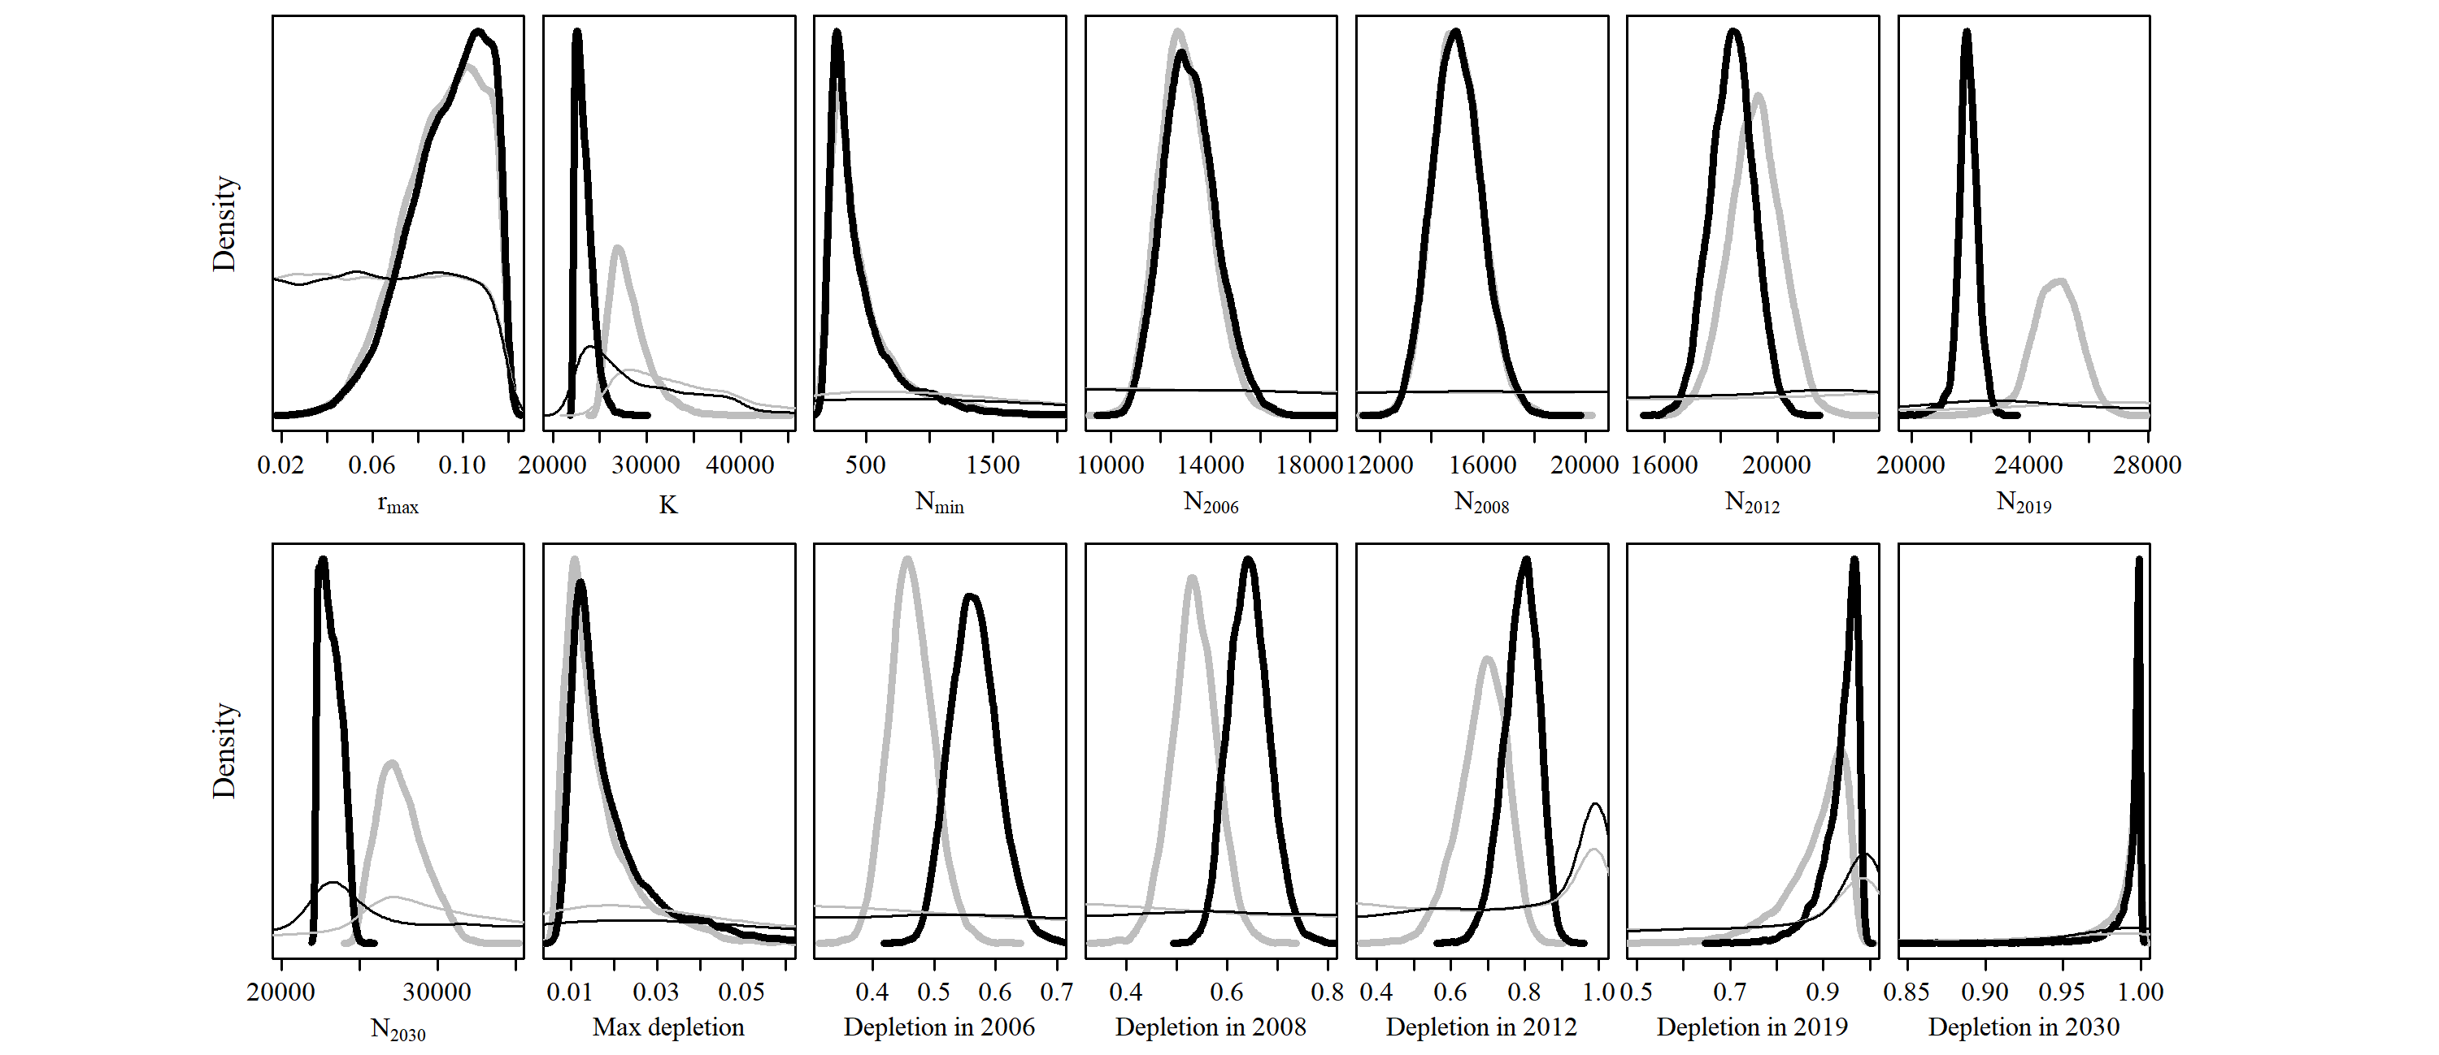

5.11) Scenario C-2

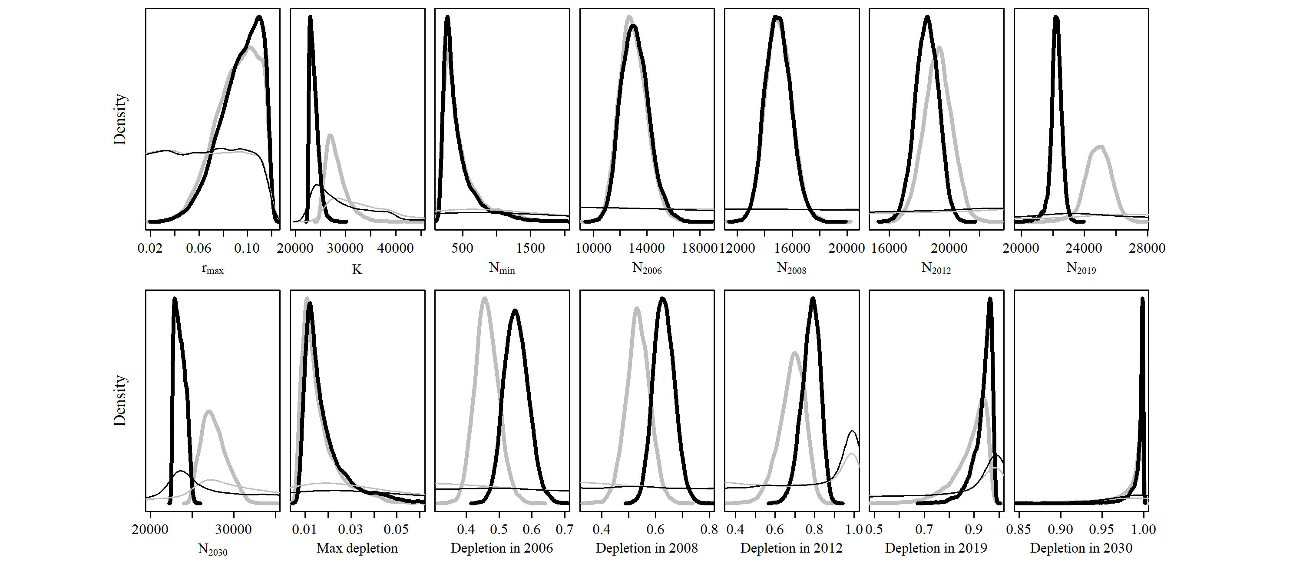

5.12) Scenario C-3

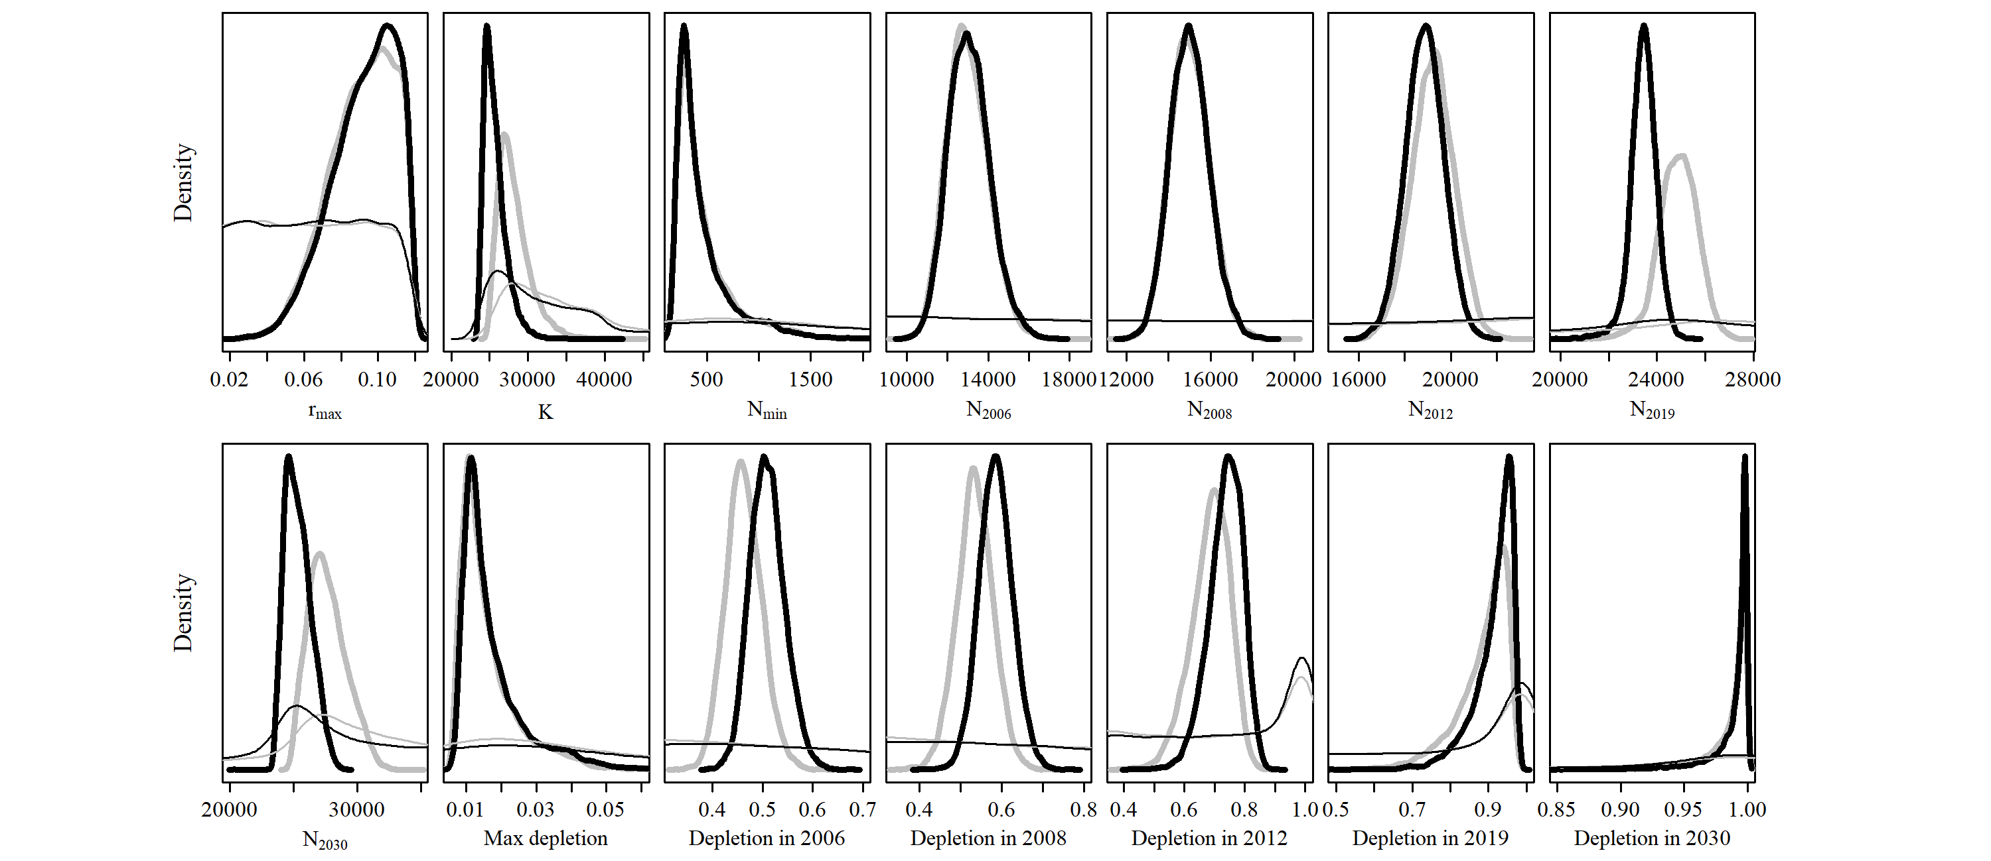

5.13) Scenario C-4

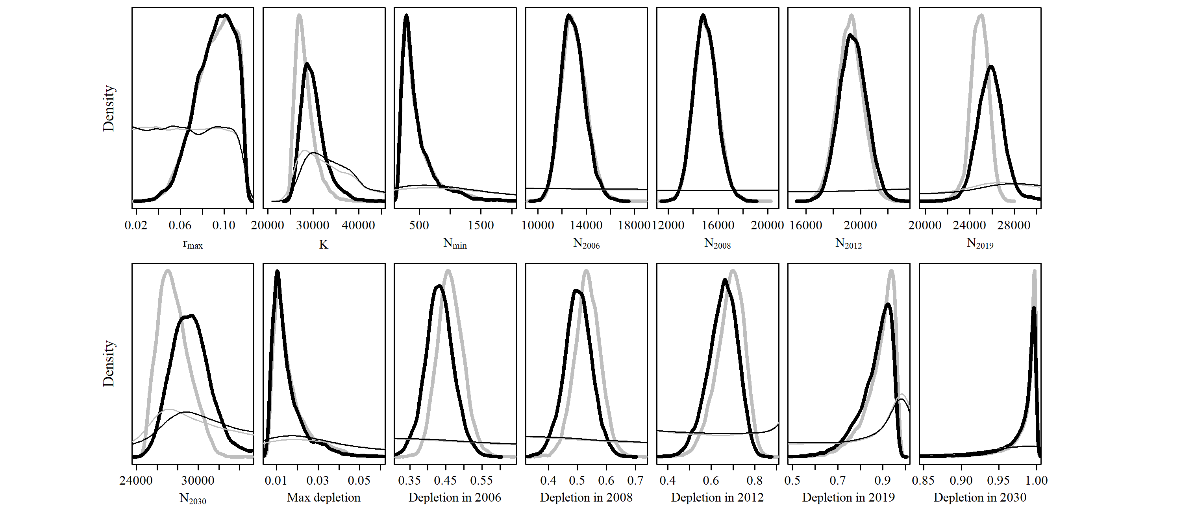

5.14) Scenario C-5

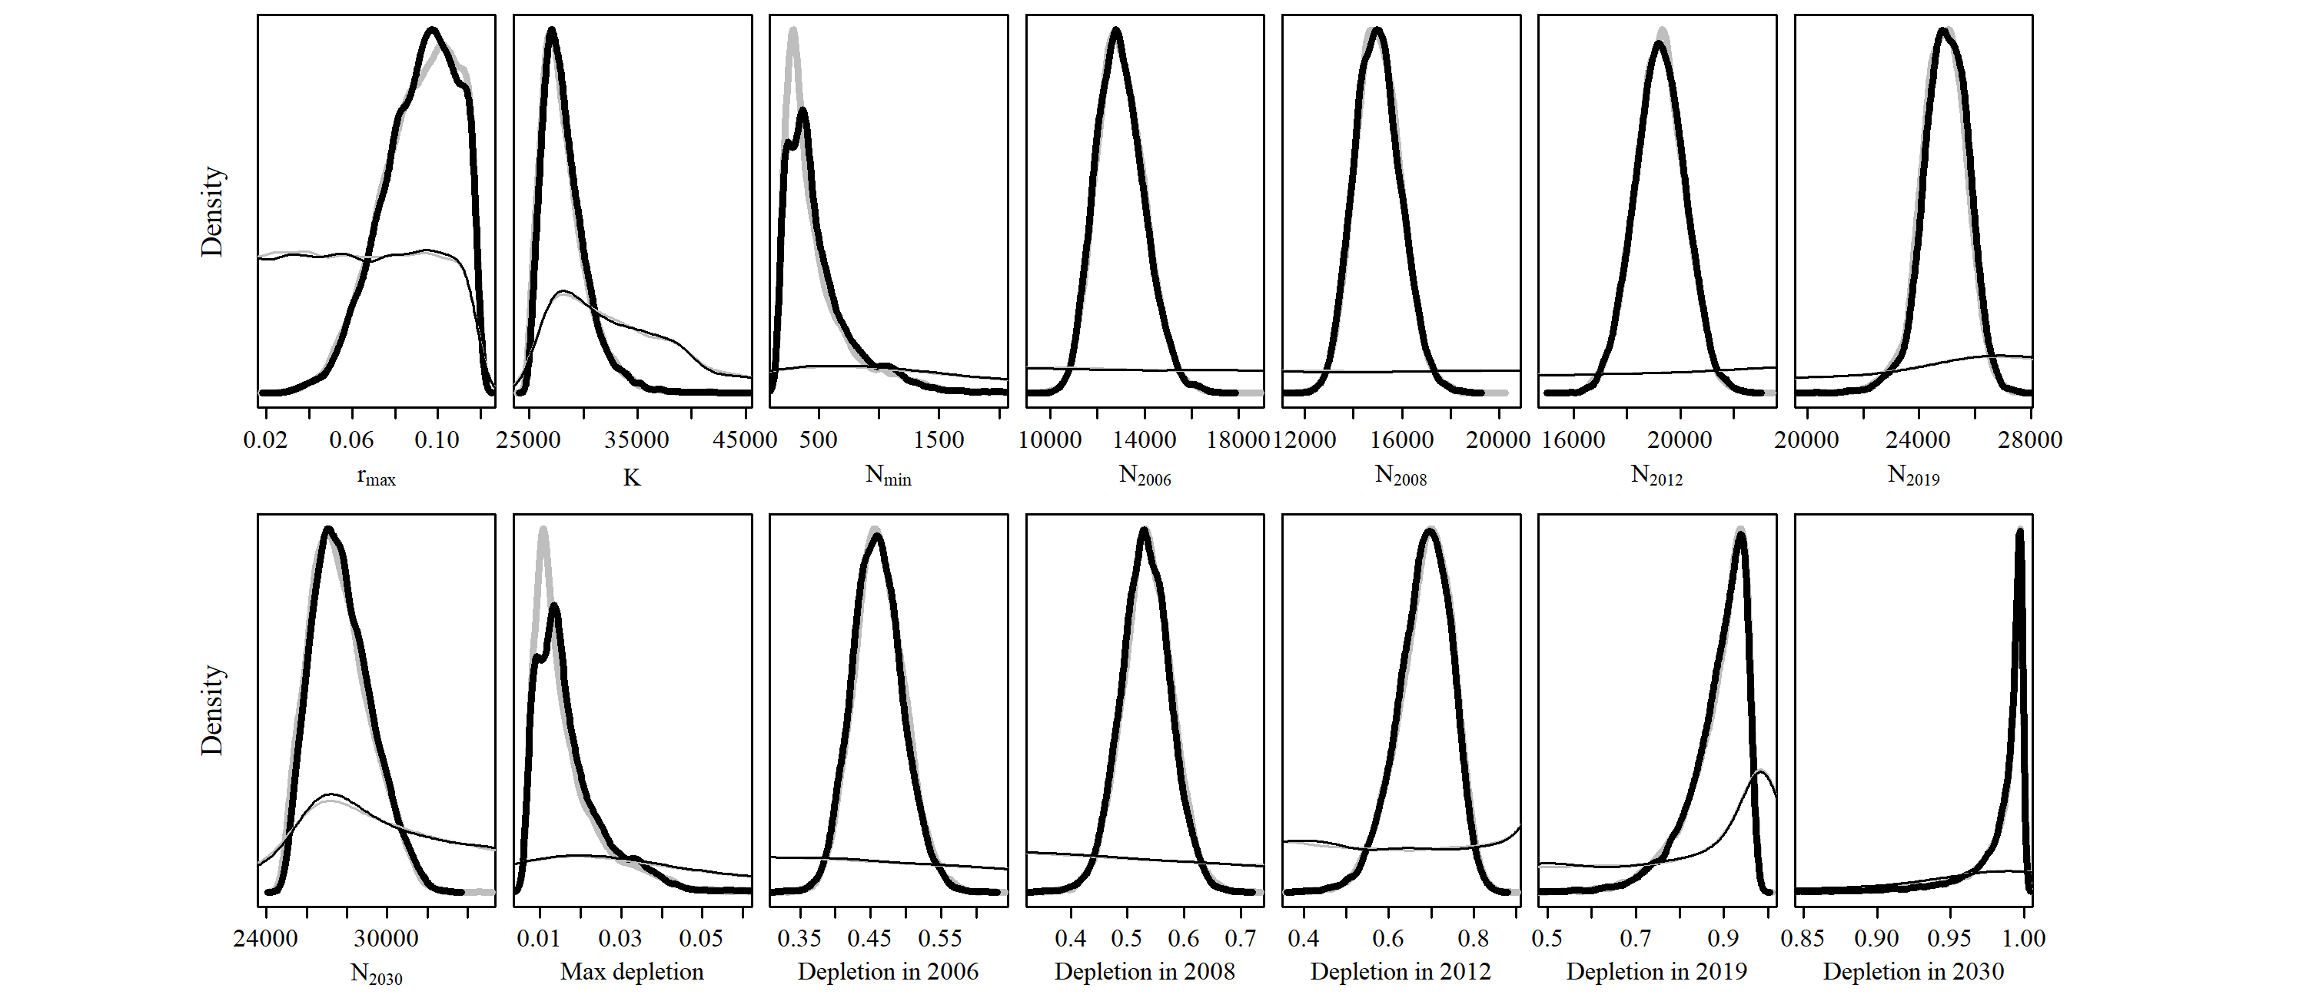

5.15) Scenario C-6

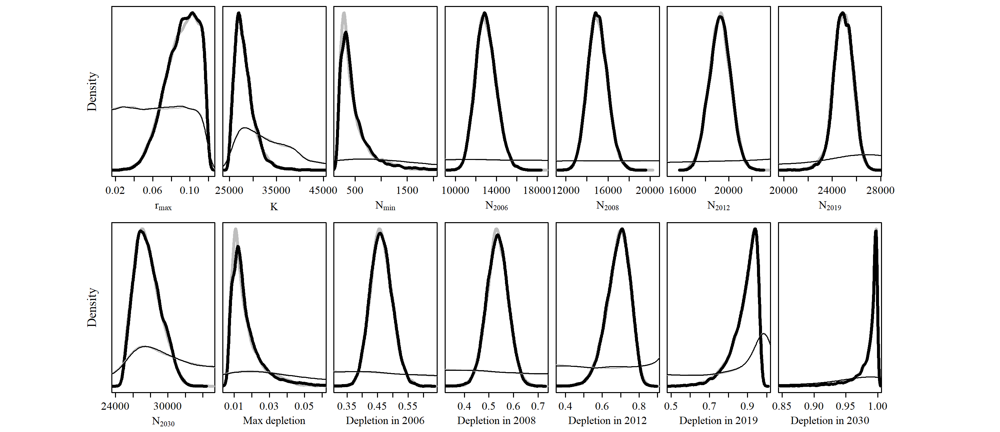

5.16) Scenario C-7

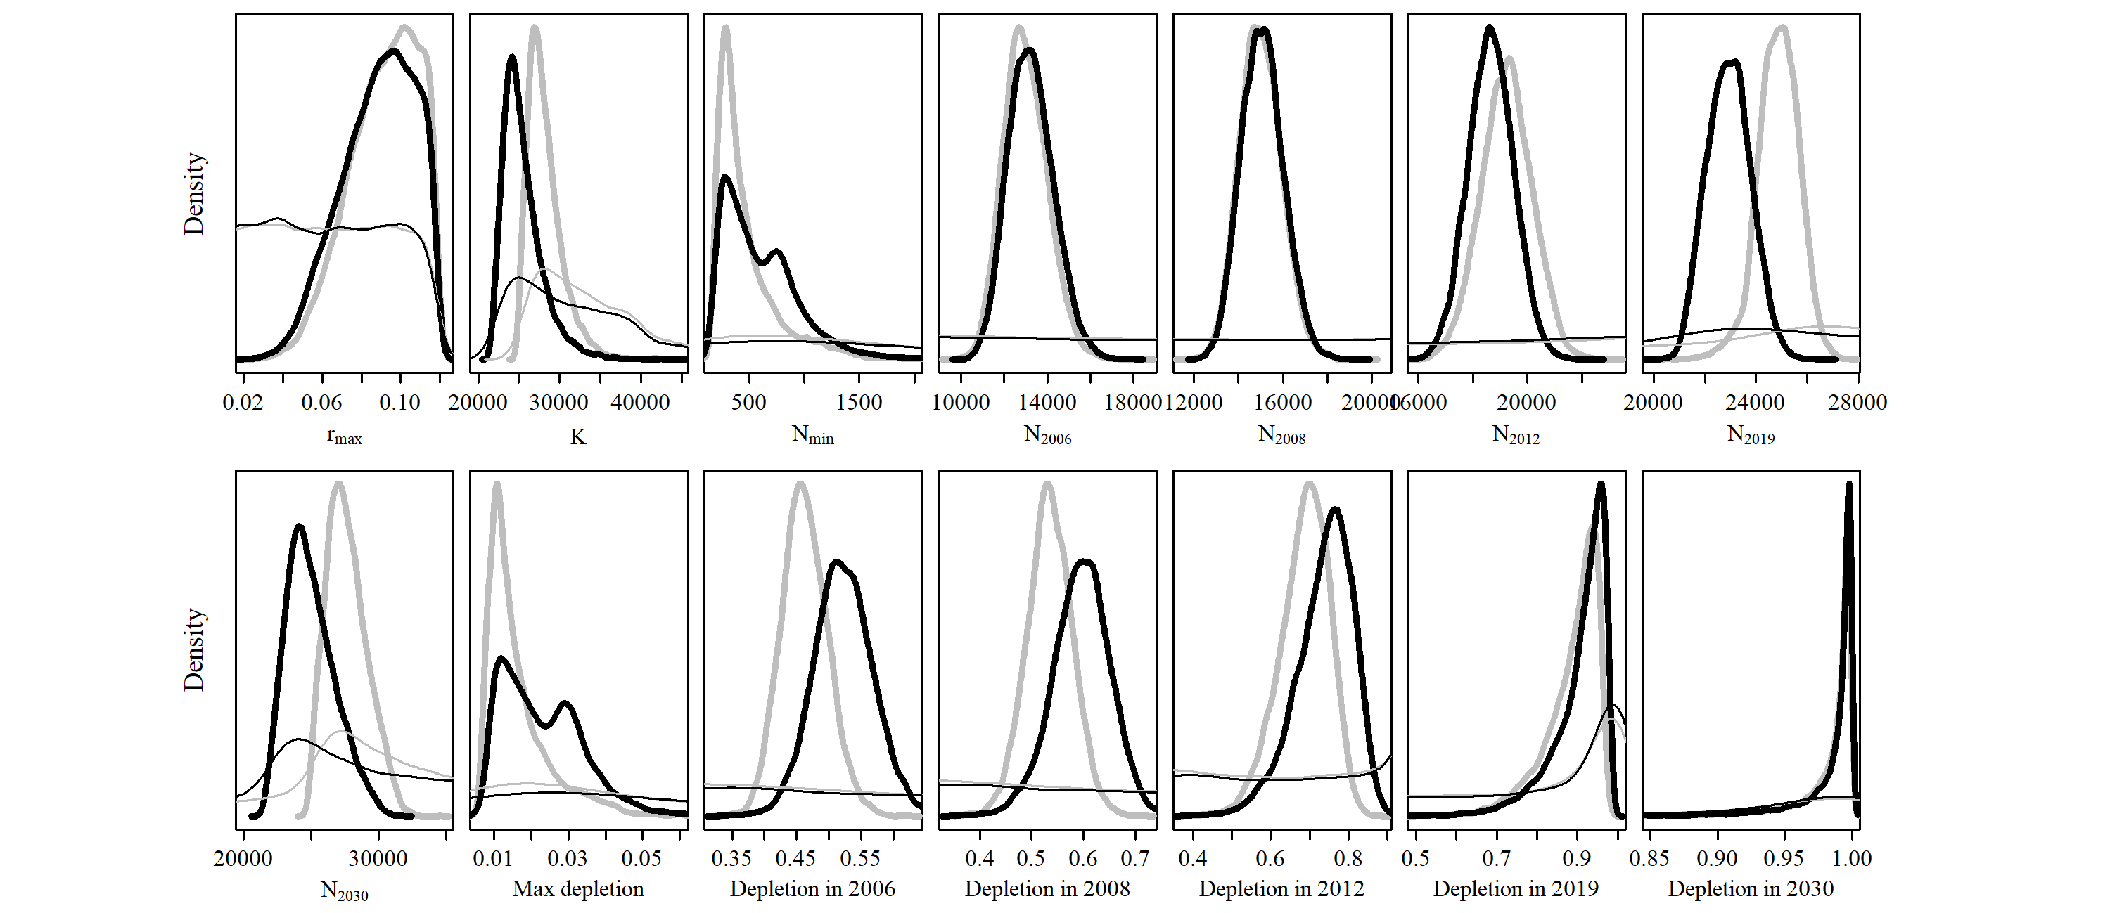

5.17) Scenario G-1

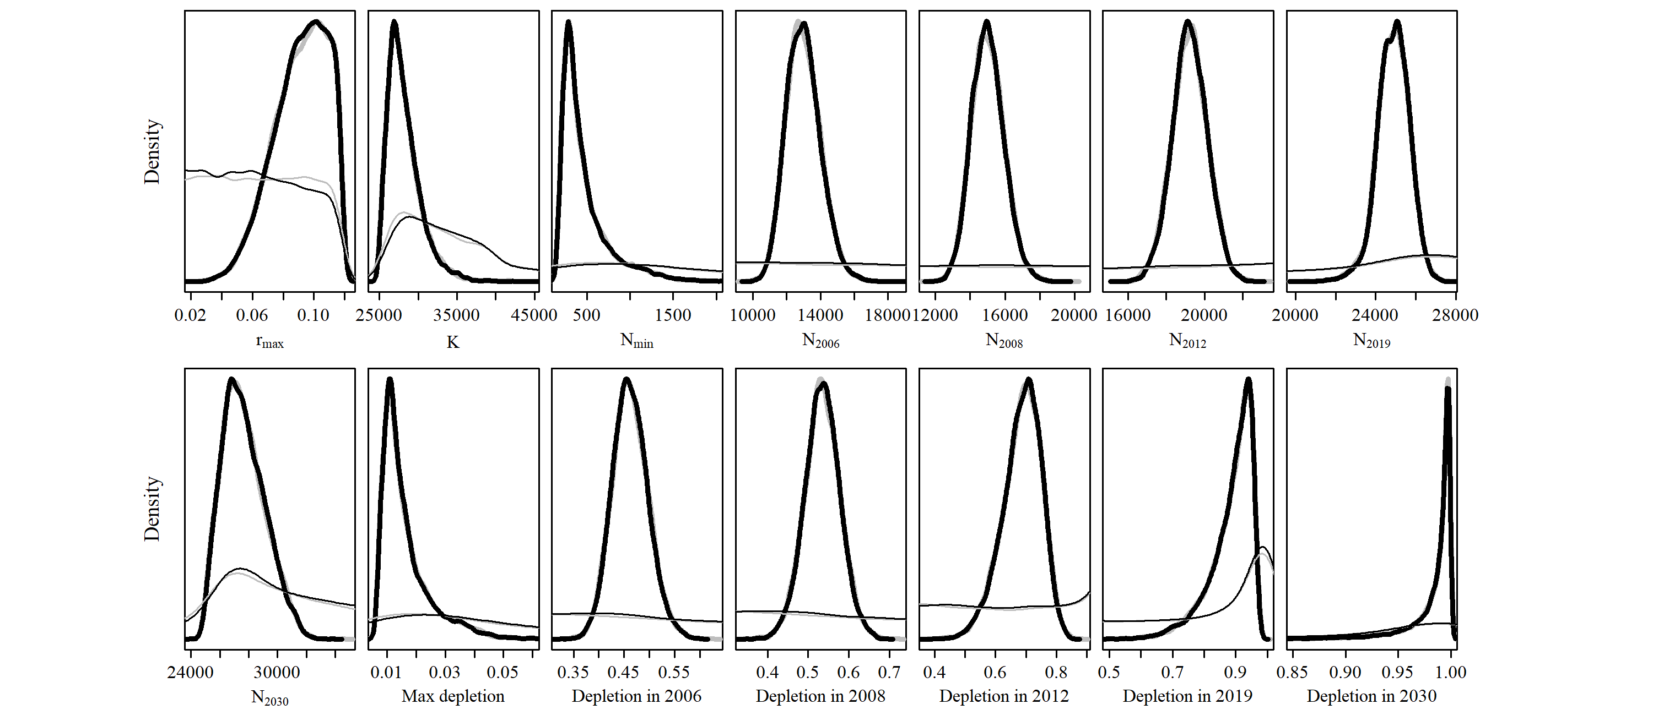

5.18) Scenario G-2

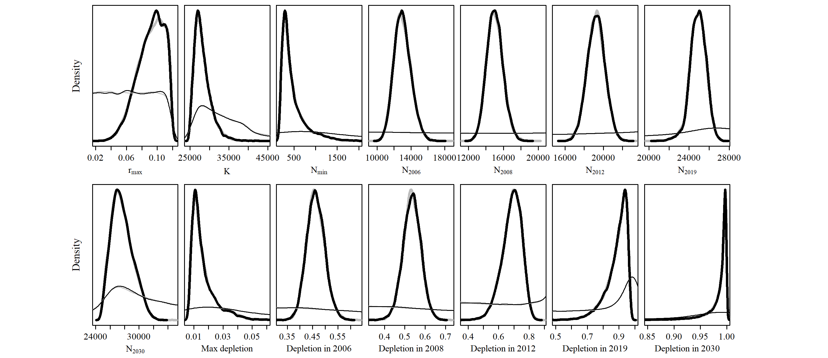

5.19) Scenario M-1

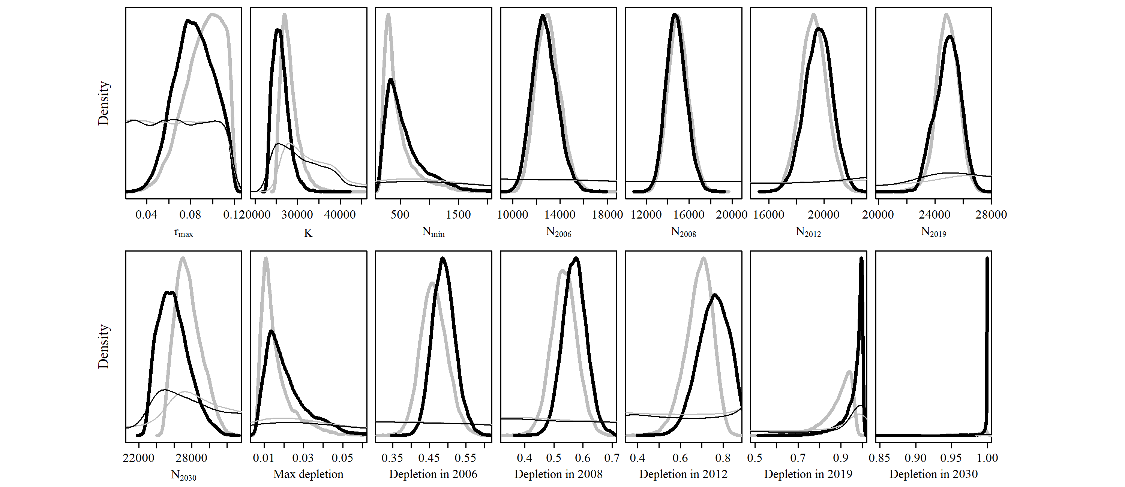

5.20) Scenario M-2

